Supplementary Information

Table of Contents

1. Construction of Remoteness Index for Kenya 3
2. Additional information on Model Fitting results and validation 4
3. References 6

Construction of Remoteness Index for Kenya

Remoteness for this study was defined using weighted spatial accessibility to basic health services provided in urban centres as explained in previous studies [1, 2]. Accessibility was measured using a combination of the Euclidean distance to the nearest urban center, number of urban centers in an average distance and the mean distance to all urban centers. Urban centers data was assembled as cities, major towns, small towns and market and trading centers and further classified into three distinct urban centers; urban centers 1 (market and trading centers, n=1557); urban centers 2 (small towns, n=264) and urban centers 3 (cities and major towns n=153).
A surface of travel time to urban centers was generated to define access to these urban centers and determine the degree of remoteness on a continuous surface of 1 × 1 km spatial resolution using a combination of land cover, roads, and DEM layers in AccessMod [3]. Access to these urban centers was calculated from the 1 × 1 km grid surfaces and assessed by travel time based on cumulative travel speeds with the assumption of the mode of transport used to reach the destination: a) by walking, (b) by cycling or (c) by vehicular transport. From each grid pixel the travel time to any category of urban center was divided by the average travel time to that category.
The result was a surface of ratio-to-mean travel time. This ratio for each pixel was capped at a value of 0.5 to be equivalent to half an hour to Service Center 1; 1.5 hours to Service Center 2 and 2 hours to Service Center 3. All pixels where ratio-to-mean to any service center was ≥ 0.5 were then assigned a ratio-to-mean of 0.5. This was done to reduce the influence of the longer travel times to larger but fewer service centers on the overall index. The capped ratio-to-mean surfaces to each type of Service Center were summed resulting in a continuous index of remoteness ranging from 0 to 1.5. The continuous surface was then classified into four categories as follows: (a)highly Accessible (0 - ≤ 0.3), (b) accessible (> 0.3 - ≤ 0.6), (c) moderately accessible (> 0.6 - ≤ 0.9), (d) remote (> 0.9 - ≤ 1.2) and (d) very remote (> 1.2 – 1.5). These categories were further aggregated into urban (0 - ≤0.75); and rural (>0.75).
SI Figure 1: (A) Ratio-to-mean travel time to urban centers as a continuous surface of 1 × 1 km spatial resolution ranging from 0 to 1.5. (B) Categories of spatial accessibility to urban centers (C) Remoteness classification map showing the two major classes as urban and rural.

Additional information on Model Fitting results and validation

Model fitting results are summarized in supplementary table 1. Model 1 was a null model with no adjustments and covariates, model 2 included geospatial covariates and temporal adjustments and model 3 included an addition of spatial effects (fixed and random) to the basic temporal model. The DICs for model 3 was consistently lower compared to the other two models suggesting that better estimates would be obtained from the model with additional correlated spatial effect. Thus, model 3 was considered the best model choice for indicator estimation.

SI Table 1: Model goodness of fit and comparison of the three fitted Bayesian models.
Indicator | Model | DIC | Marginal Likelihood | $$R^{2}$$ | RMSE | MAE
FP | Model 1 | 3,171,729 | -162,8645.4 | - | - | -
FP | Model 2 | 2,566,264 | -1,322,236 | - | - | -
FP | Model 3 | 897,264.1 | -495,929.8 | 0.68 | 0.1 | 0.08
ANC | Model 1 | 616790.57 | -308470.59 | - | - | -
ANC | Model 2 | 540796.54 | -270521.60 | - | - | -
ANC | Model 3 | 255503.40 | -128649.87 | 0.54 | 0.1 | 0.05
SBA | Model 1 | 580,758.6 | -290,860.2 | - | - | -
SBA | Model 2 | 549,424.5 | -275,213 | - | - | -
SBA | Model 3 | 155,456.4 | -79,835.1 | 0.78 | 0.1 | 0.07
FMMR | Model 1 | 15,674.3 | -7,842.8 | - | - | -
FMMR | Model 2 | 14,393.1 | -7,240.3 | - | - | -
FMMR | Model 3 | 11,662.2 | -5,924.9 | 0.39 | 0.06 | 0.24
FIC | Model 1 | 268,894.4 | -13,4641.7 | - | - | -
FIC | Model 2 | 255,449.9 | -12,7962.2 | - | - | -
FIC | Model 3 | 195,813.5 | -98,794.7 | 0.78 | 0.13 | 0.01
Underweighting | Model 1 | 1,273,867 | -63,8175.1 | - | - | -
Underweighting | Model 2 | 888,429.5 | -445,299.2 | - | - | -
Underweighting | Model 3 | 305,648.2 | -158,276.3 | 0.81 | 0.02 | 0.01

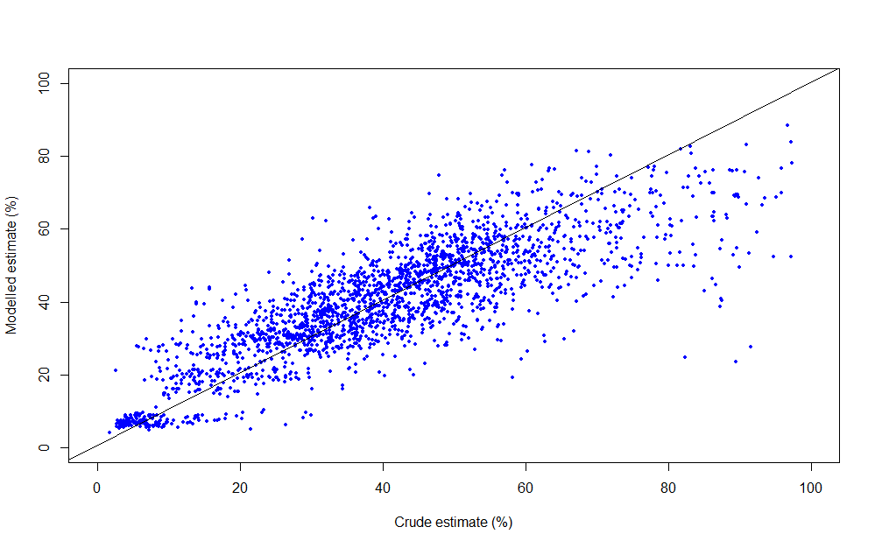
SI Figure 2: Scatter plot showing comparison between crude and modelled estimate of percentage of women of child-bearing age receiving family planning commodities from the 20% subset data (n=2861) across the years.

References

1. Health AIo, Welfare. Rural, regional and remote health: a guide to remoteness classifications. Canberra: Australian Institute of Health and Welfare. 2004.
2. Noor A, Alegana V, Yé Y, Arnold F. Defining remoteness in Kenya, Ghana and Madagascar for the evaluation of the phase 1 AMFm project. A report for Affordable Medicines Facility-malaria (AMFm), independent evaluation. Calverton, MD: ICF-Macro; 2012.
3. Ray N, Ebener S. AccessMod 3.0: computing geographic coverage and accessibility to health care services using anisotropic movement of patients. International journal of health geographics. 2008;7(1):1-17.

