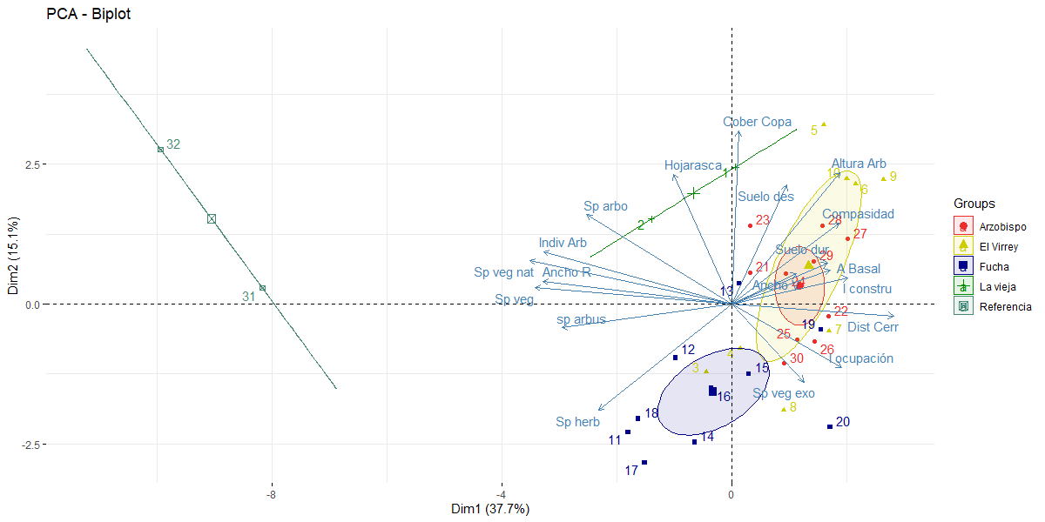
Annex 1 Principal Component Analysis (PCA) of urban variables recorded in urban gradient
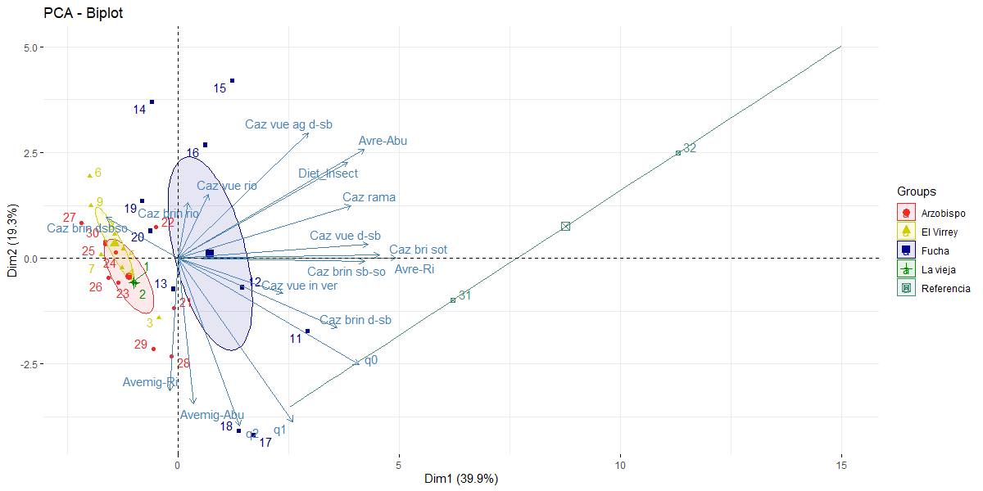
Annex 2 Principal Component Analysis (PCA) of the predatory bird variables recorded in the urban gradient

