A
B
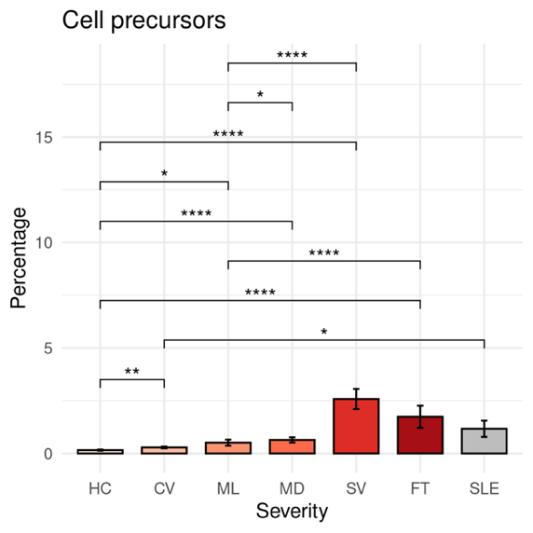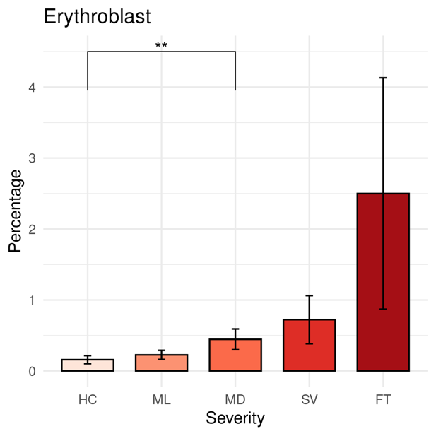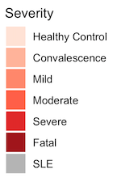

Supplementary Figure 1. PBMC profiling from healthy controls, sepsis, similar symptom hospitalized, COVID-19 and SLE patients. (A-C) Bar plots depicting the percentage of different cell types under different disease severities. A) Cell precursors, B) Erythroblast

The differences in percentages associated with adjusted P-values below 0.05, 0.01, 0.001, and 0.0001 are indicated as *, **, ***, and ****, respectively and not significant are not shown. The significance analysis was performed using Wilcoxon tests. Standard error bars were also added.

A

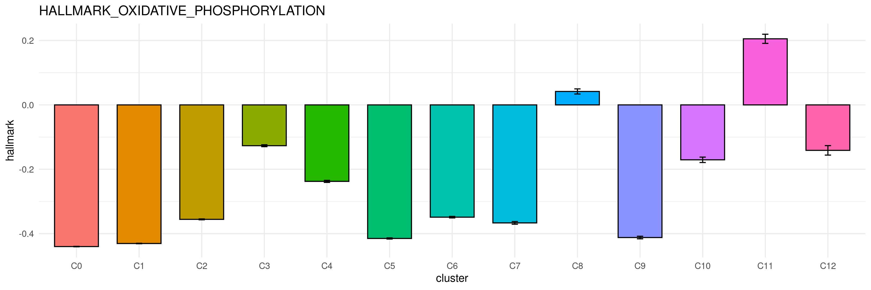
B
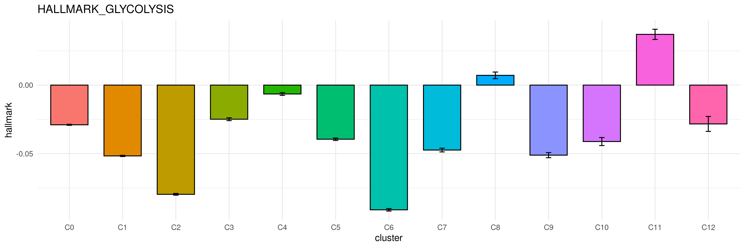
C
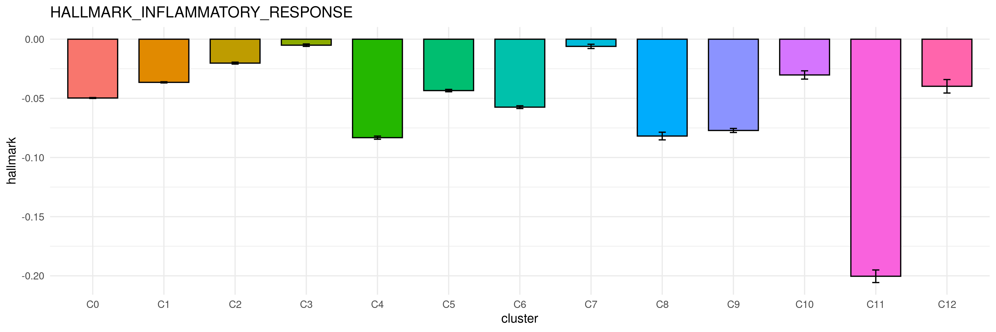
D
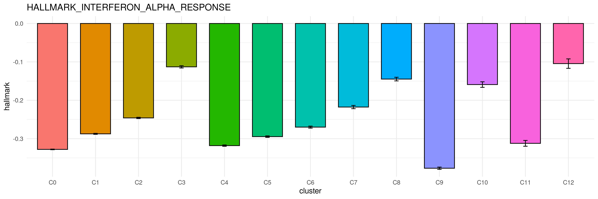

E
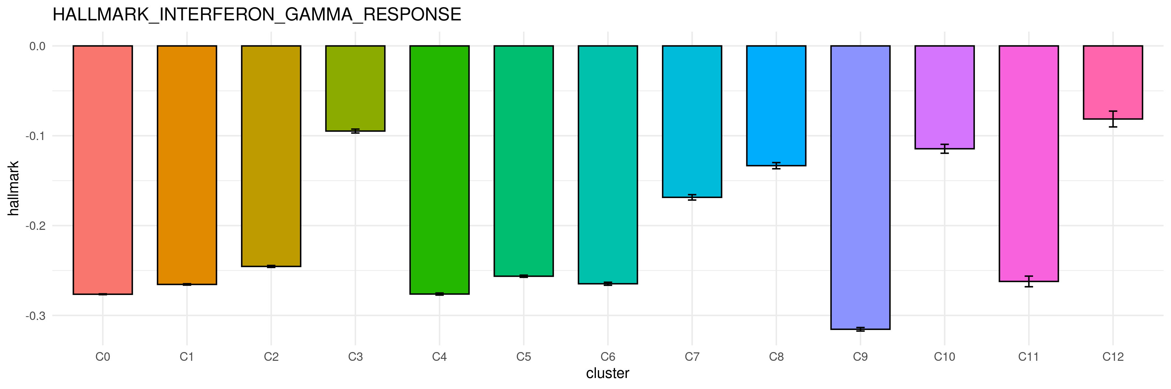
F
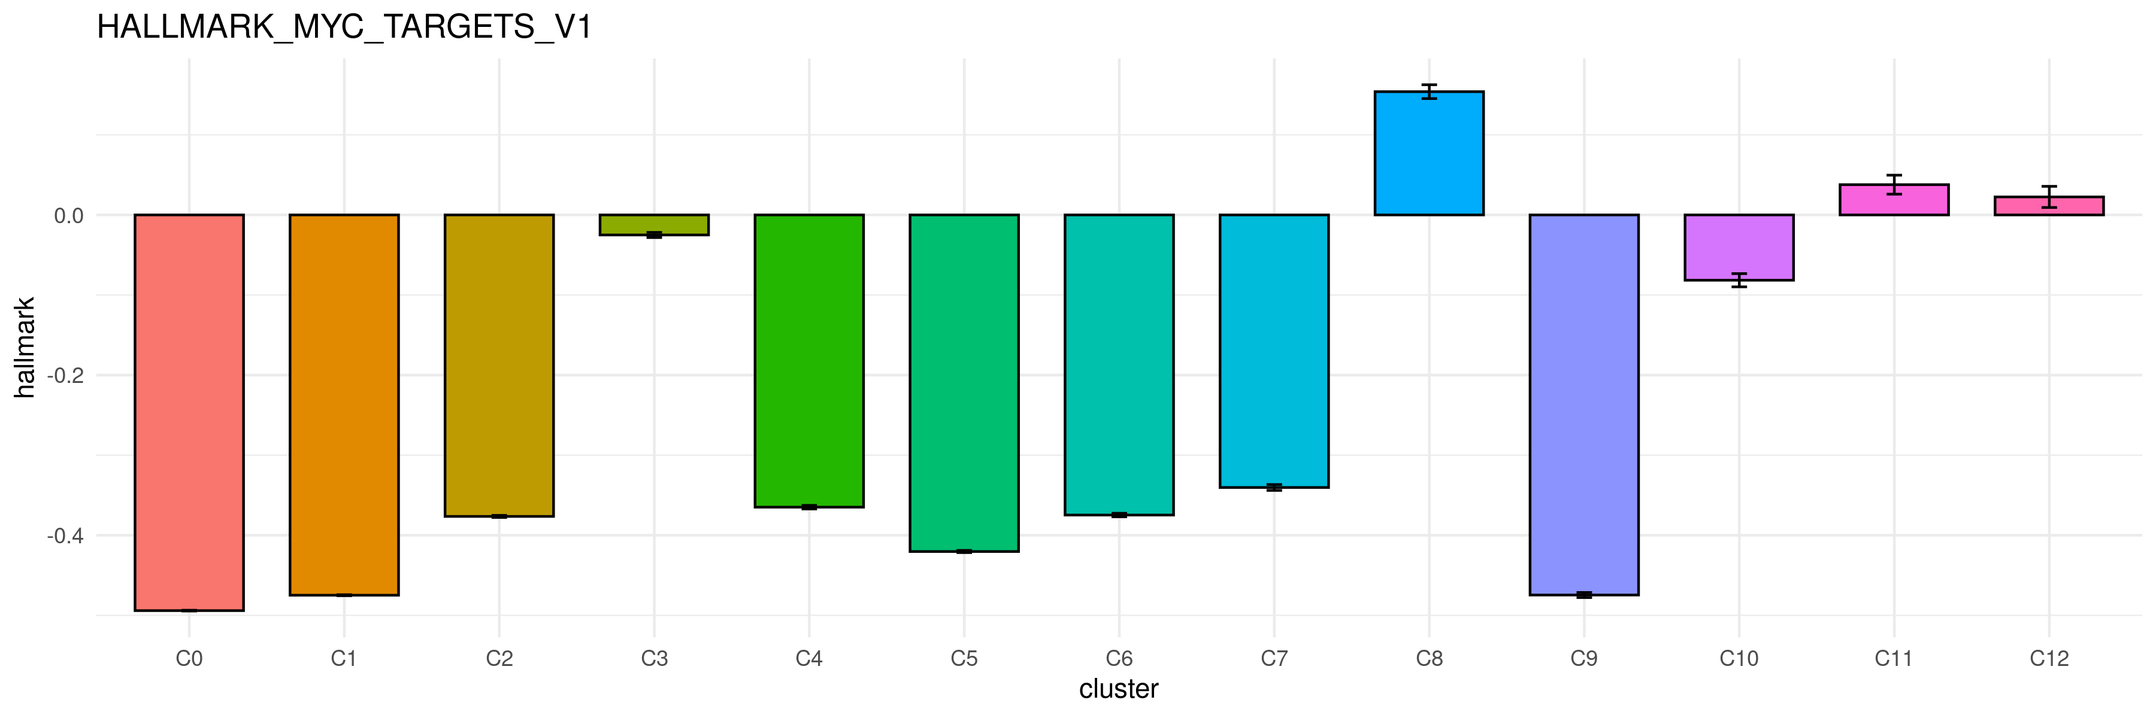
G

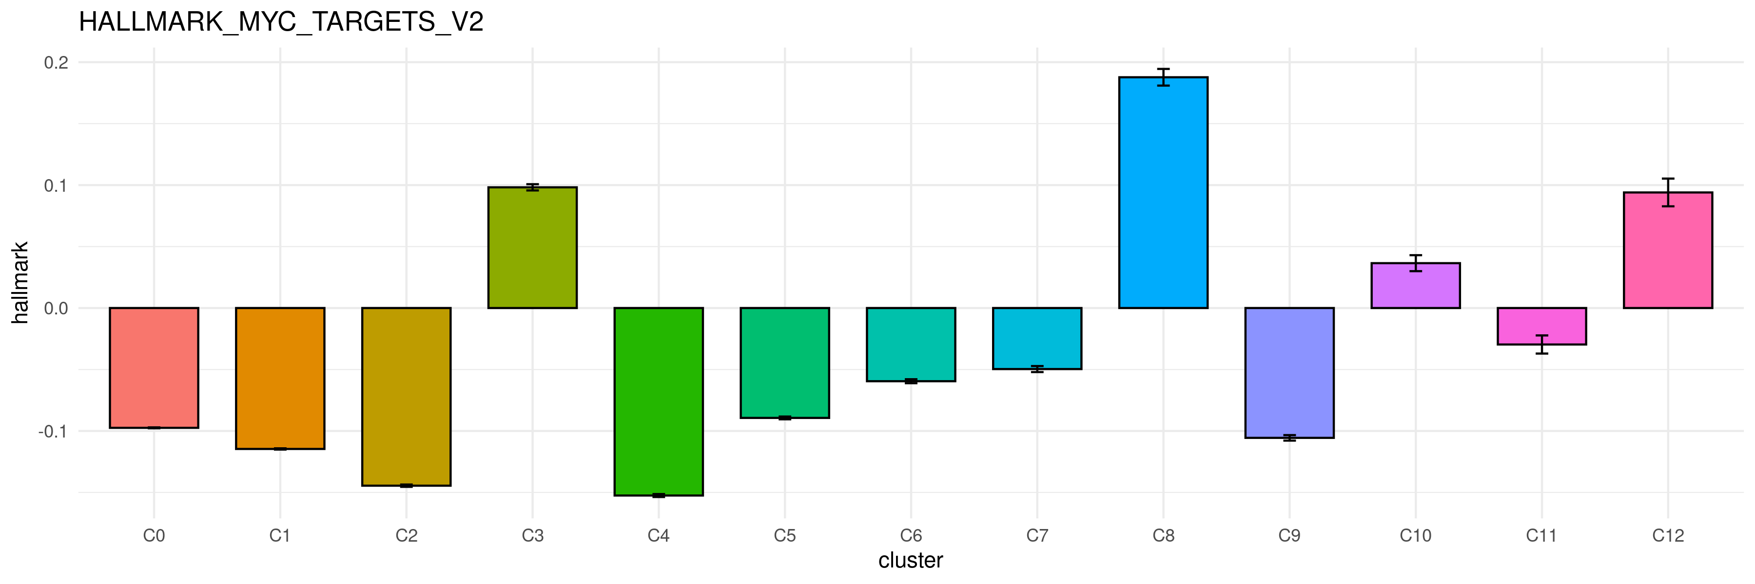
H
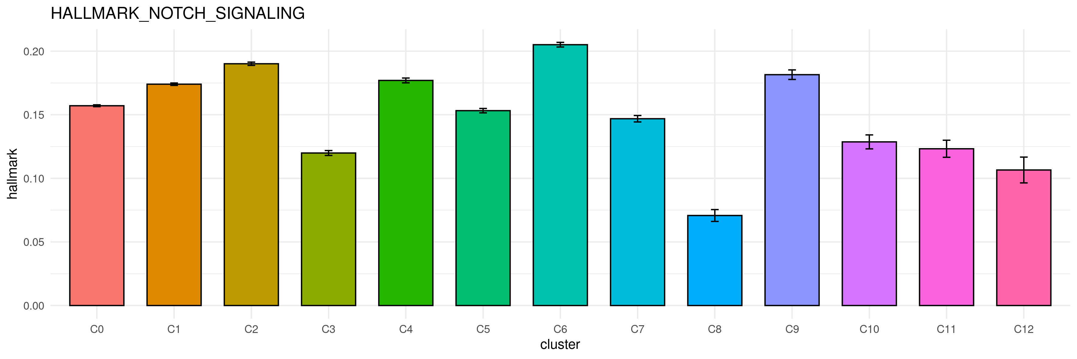

I

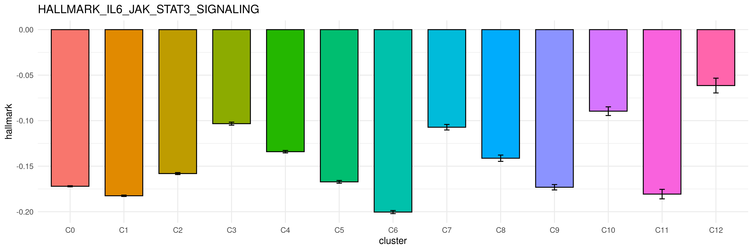
J

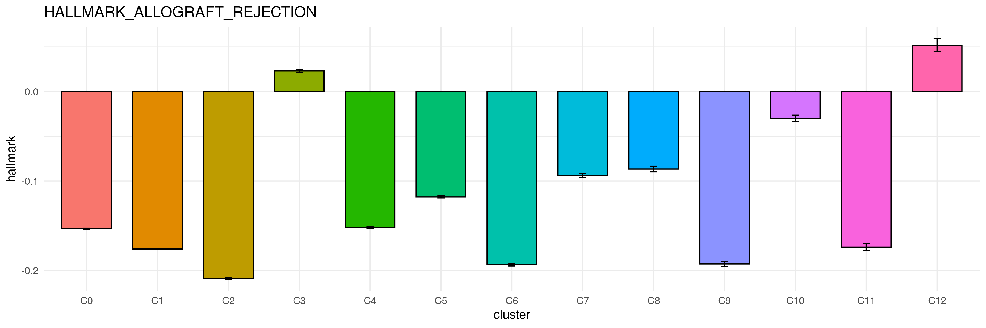
K

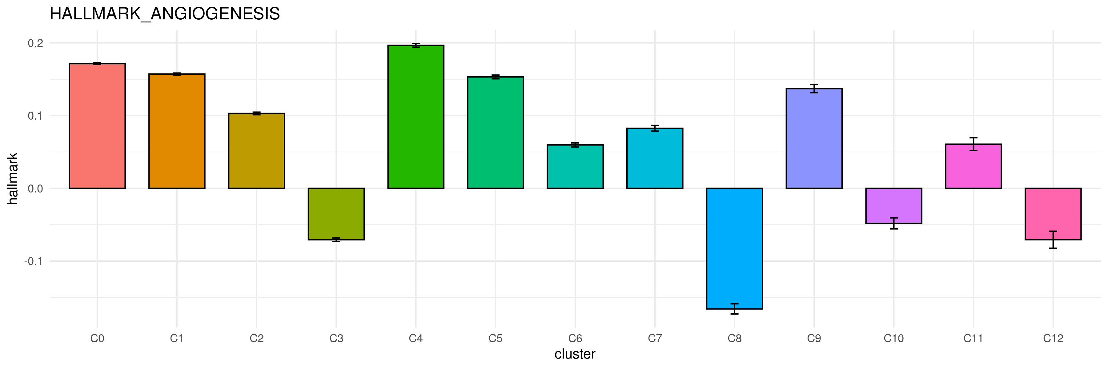

L

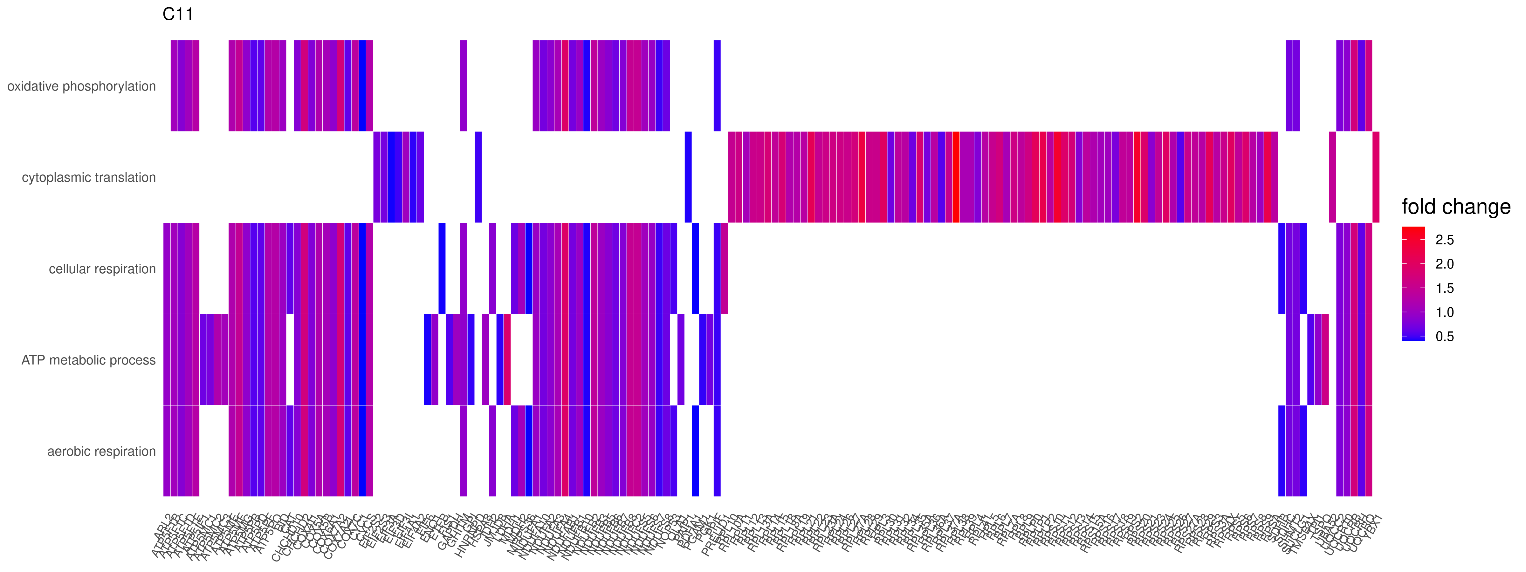
M

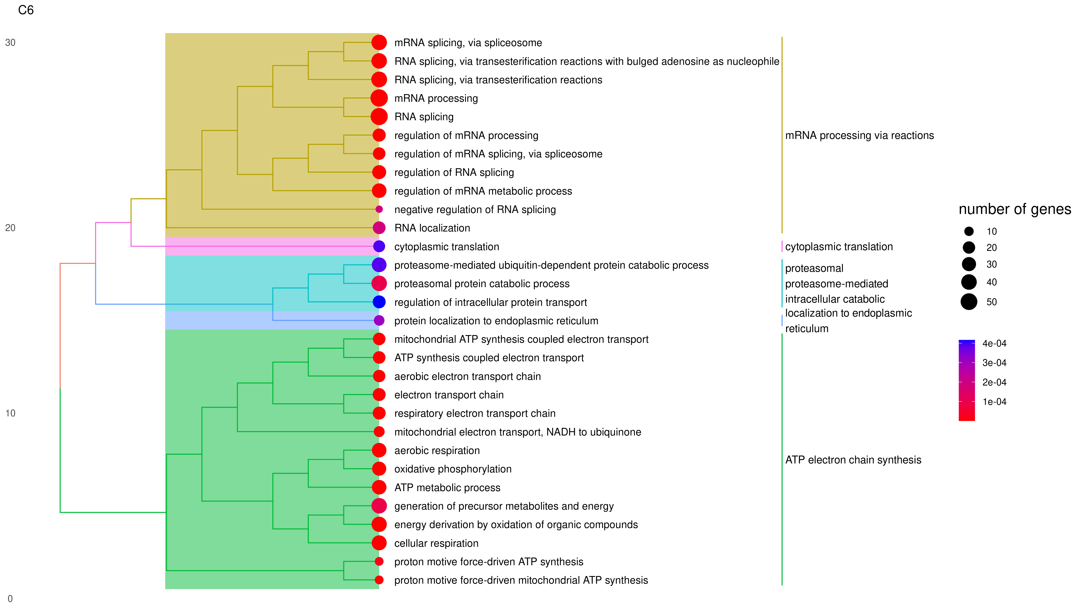
N

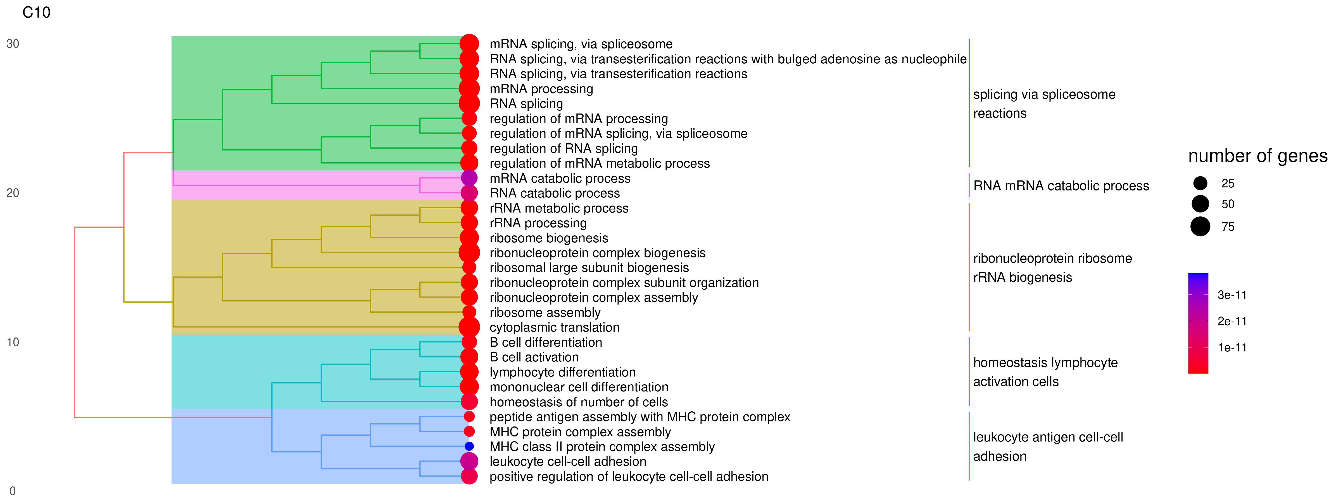

Supplementary Figure 2. Clustered platelets and their unique pathway expression changes.
(A - K) Bar plot of hallmark gene sets expression among clusters. A) MYC_targets_v1, B)MYC_targets_v1, C) Oxidative phosphorylation D) Glycolysis E) Inflammatory response F) Interferon alpha response, G) Interferon gamma response, H) Notch signaling I) IL6/JAK/STAT3 signaling. (L) Heatmap display fatal cluster C11 up-regulated genes and enriched pathways in gene ontology (GO). (M, N) Tree plot display survival cluster C6 and C10 enriched pathways in GO.

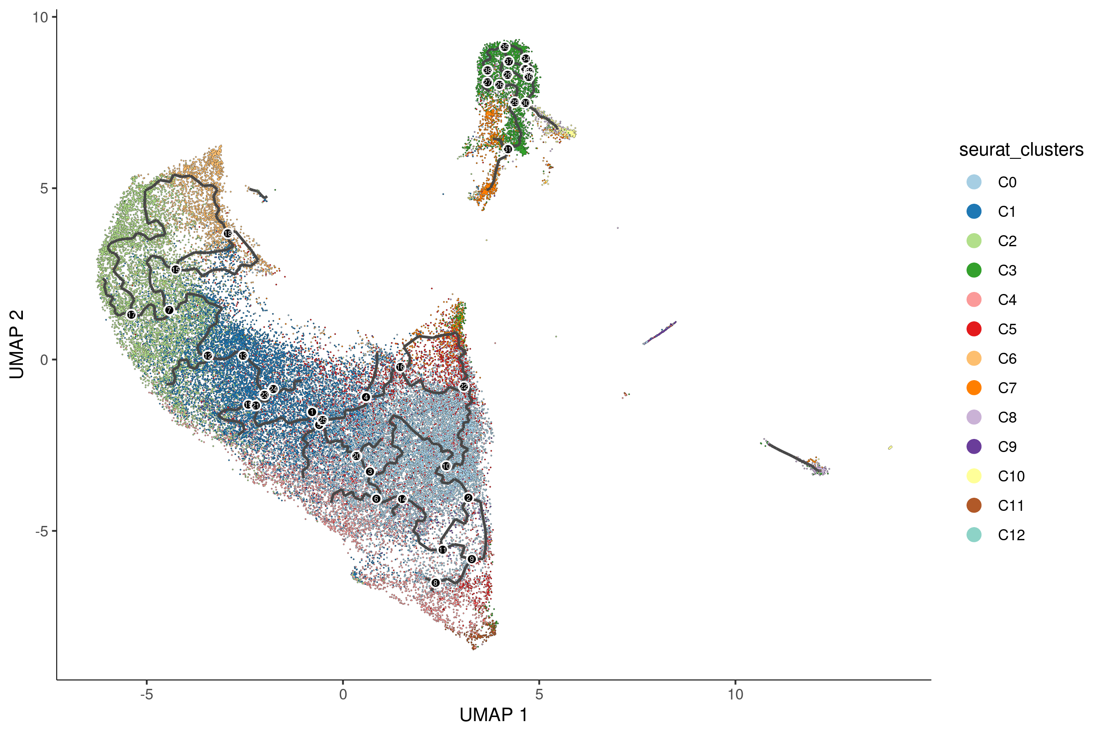
A
B
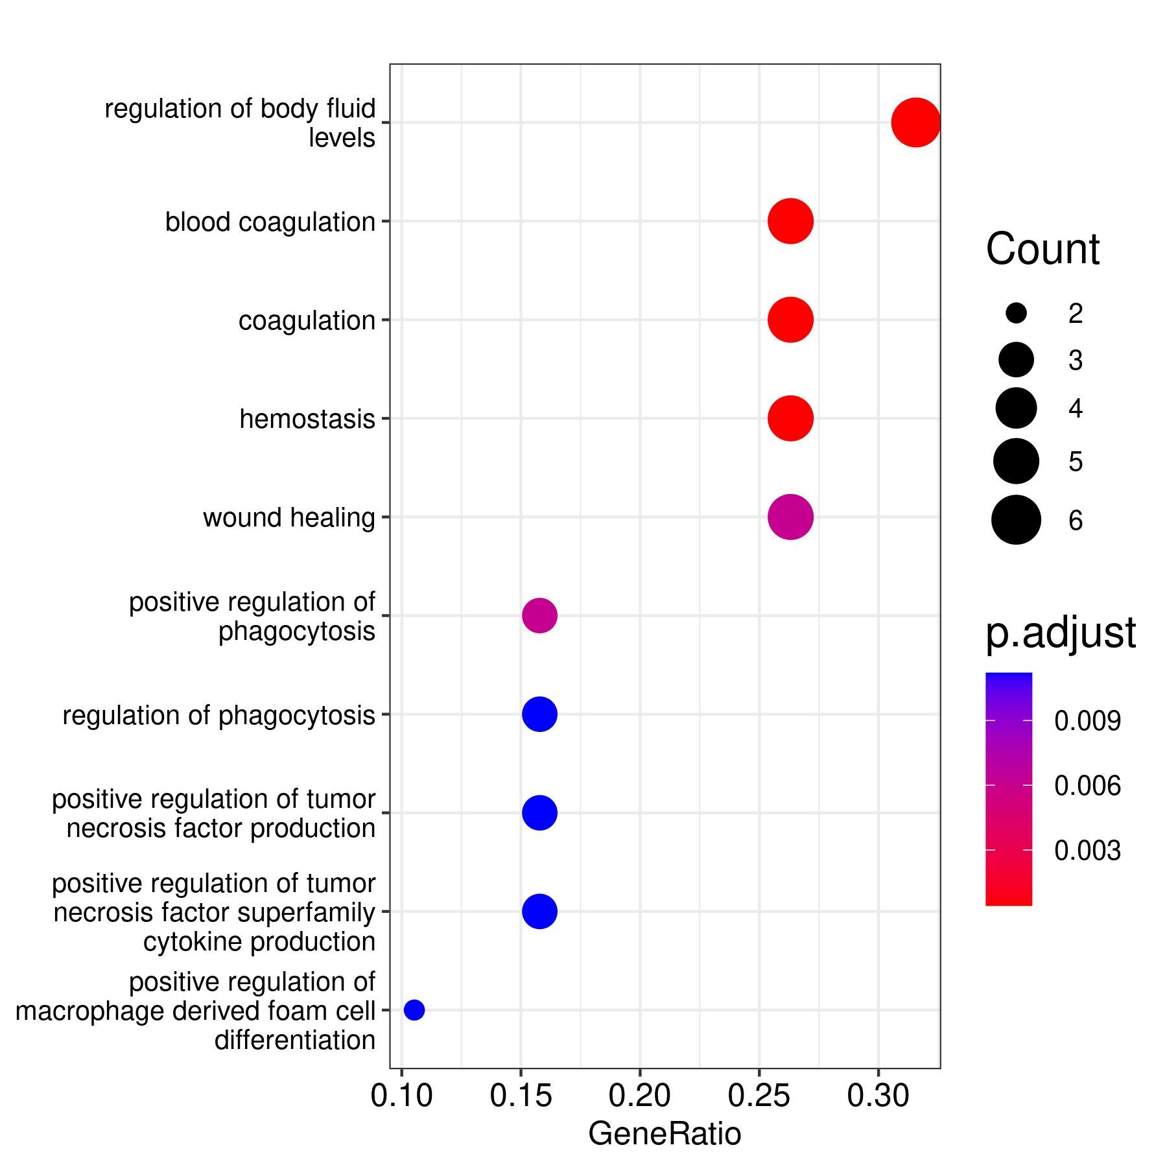
Supplementary Figure 3. (A) Pseudo-time plot of platelets from all clusters exhibiting trajectory fates. (B) The fatal gene module list enriched pathways from GO, KEGG, and Reactome databases. The circle size represents the gene counts included in the pathway; color represents the adjusted P value.

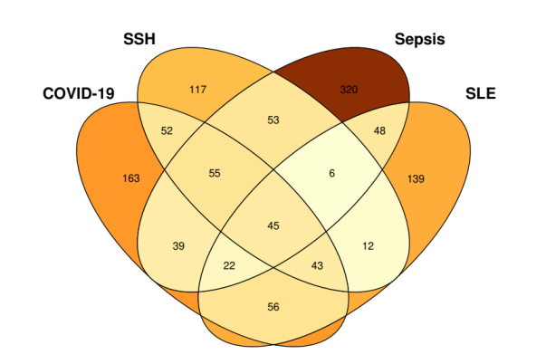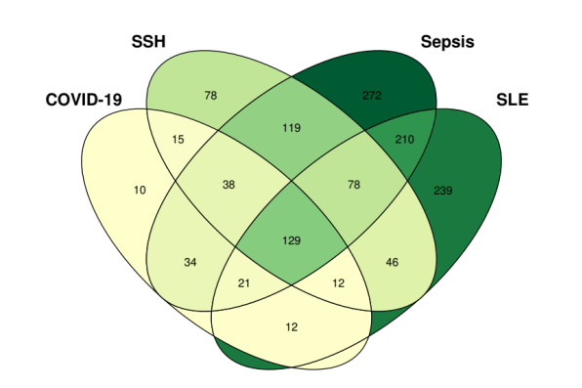
Similar Symptoms Hospitalized
Similar Symptoms Hospitalized
B
Sepsis
SLE
Sepsis
A
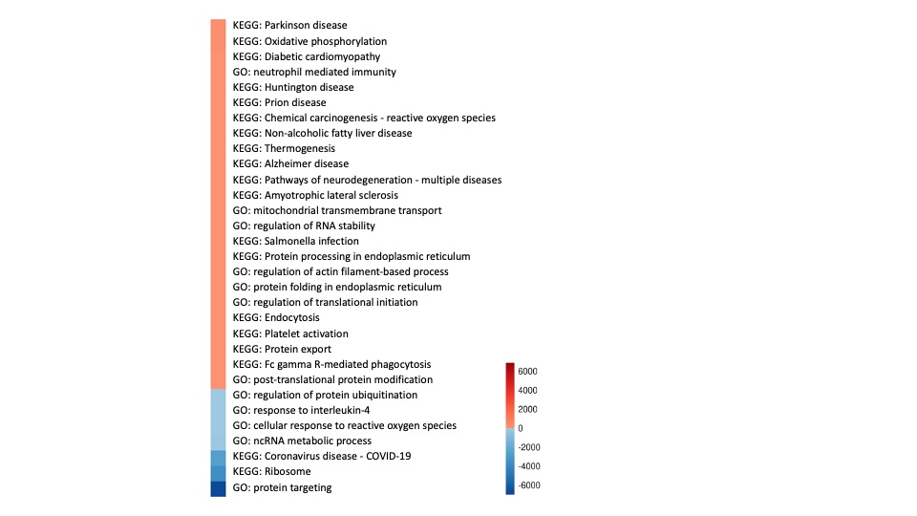
C

Supplementary Figure 4. Platelets expression changes among healthy controls, sepsis, similar symptom hospitalized, COVID-19 and SLE patients. Venn diagrams describing changes in differential expression genes (DEGs) from COVID-19, similar symptoms hospitalized (SSH), sepsis, and systemic sclerosis lupus (SLE) vs. healthy controls (HC), A) Up-regulated genes. B) Down-regulated genes. DEGs with adjusted p value below 0.05 and log2 fold change over 0.25 were used for generation of the VENN figure. (C) Heatmap illustration of COVID-19 and sepsis patients vs healthy contol pathways. Color are decided by the product of the COVID-19 and sepsis up/down-regulated enriched pathway log10 (adjusted p value). The GO terms were reduced to representative ones using Revigo [PMID: 21789182] (the cutoffs were similarity > 0.4) then overlapped the terms.

C
B
A
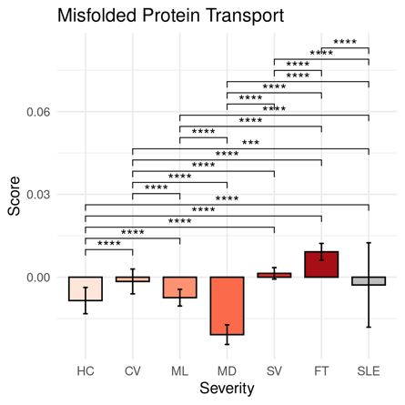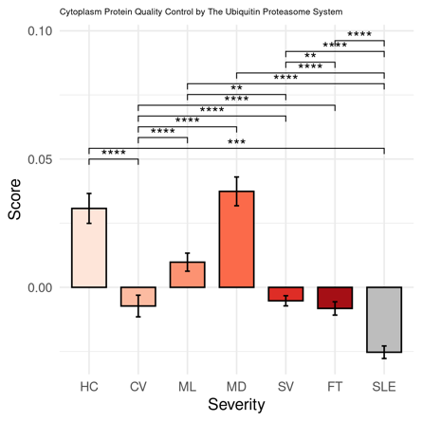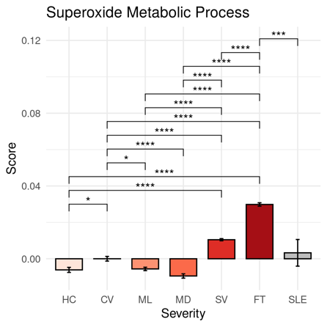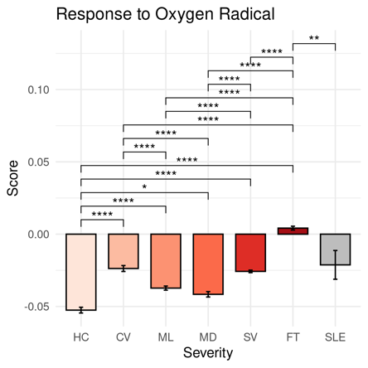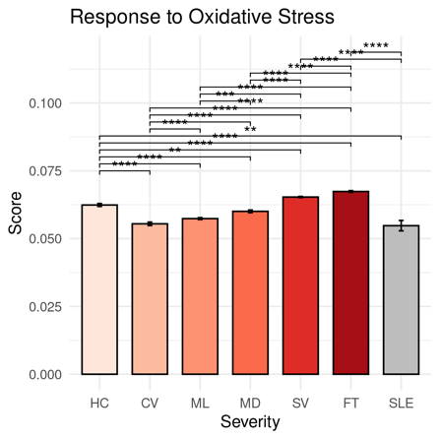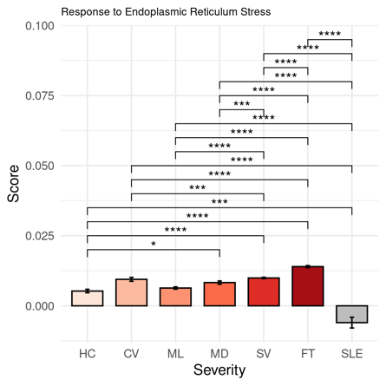
H
G
F
E
D
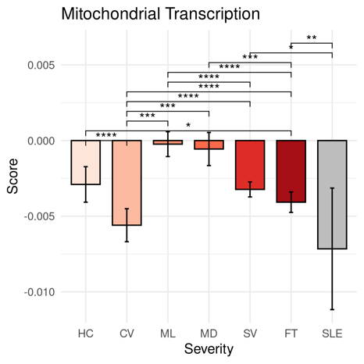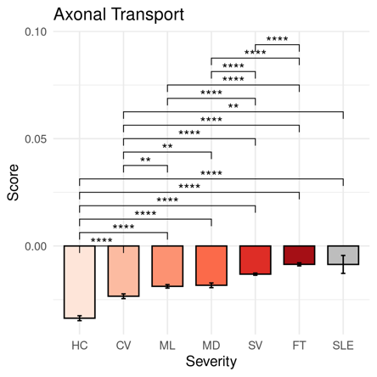
Supplementary Figure 5. Platelet transcriptional changes under different disease severity related to neurodegeneration diseases.
(A– H) Comparisons of pathway module scores across disease severities in platelets. The included modules contain genes related to A) Misfolded Protein Transport, (B) Cytoplasm Protein Quality Control by The Ubiquitin Proteasome System, (C) Superoxide Metabolic Process, (D) Response to Oxygen Radical, (E) Response to Oxidative Stress, (F) Response to Endoplasmic Reticulum Stress, (G) Mitochondrial Transcription, (H) Axonal Transport.

The differences in scores associated with adjusted P-values below 0.05, 0.01, 0.001, and 0.0001 are indicated as *, **, ***, and ****, respectively and not significant ones are not shown. The significance analysis was performed using Wilcoxon tests.

Clusters | Severity | Number | Frequency
C0 | CV | 1107 | 0.082
C0 | FT | 2876 | 0.214
C0 | HC | 743 | 0.055
C0 | MD | 1027 | 0.076
C0 | ML | 1959 | 0.146
C0 | SLE | 53 | 0.004
C0 | SV | 5688 | 0.423
C1 | CV | 879 | 0.083
C1 | FT | 2101 | 0.2
C1 | HC | 608 | 0.058
C1 | MD | 949 | 0.09
C1 | ML | 1839 | 0.175
C1 | SLE | 51 | 0.005
C1 | SV | 4102 | 0.39
C2 | CV | 561 | 0.073
C2 | FT | 1377 | 0.179
C2 | HC | 305 | 0.04
C2 | MD | 722 | 0.094
C2 | ML | 1338 | 0.174
C2 | SLE | 17 | 0.002
C2 | SV | 3373 | 0.438
C3 | CV | 81 | 0.021
C3 | FT | 202 | 0.052
C3 | HC | 636 | 0.165
C3 | MD | 712 | 0.184
C3 | ML | 962 | 0.249
C3 | SLE | 4 | 0.001
C3 | SV | 1267 | 0.328
C4 | CV | 137 | 0.043
C4 | FT | 1224 | 0.385
C4 | HC | 139 | 0.044
C4 | MD | 127 | 0.04
C4 | ML | 264 | 0.083
C4 | SLE | 4 | 0.001
C4 | SV | 1284 | 0.404
C5 | CV | 155 | 0.055
C5 | FT | 520 | 0.185
C5 | HC | 472 | 0.167
C5 | MD | 310 | 0.11
C5 | ML | 263 | 0.093
C5 | SLE | 10 | 0.004
C5 | SV | 1088 | 0.386
C6 | CV | 168 | 0.072
C6 | FT | 262 | 0.112
C6 | HC | 18 | 0.008
C6 | MD | 293 | 0.125
C6 | ML | 375 | 0.16
C6 | SLE | 11 | 0.005
C6 | SV | 1211 | 0.518
C7 | CV | 125 | 0.081
C7 | FT | 211 | 0.137
C7 | HC | 65 | 0.042
C7 | MD | 150 | 0.097
C7 | ML | 212 | 0.138
C7 | SLE | 13 | 0.008
C7 | SV | 764 | 0.496
C8 | CV | 370 | 0.36
C8 | FT | 86 | 0.084
C8 | HC | 57 | 0.055
C8 | MD | 15 | 0.015
C8 | ML | 38 | 0.037
C8 | SLE | 0 | 0
C8 | SV | 462 | 0.449
C9 | CV | 28 | 0.047
C9 | FT | 263 | 0.442
C9 | HC | 102 | 0.171
C9 | MD | 9 | 0.015
C9 | ML | 37 | 0.062
C9 | SLE | 0 | 0
C9 | SV | 156 | 0.262
C10 | CV | 51 | 0.105
C10 | FT | 62 | 0.127
C10 | HC | 36 | 0.074
C10 | MD | 8 | 0.016
C10 | ML | 42 | 0.086
C10 | SLE | 6 | 0.012
C10 | SV | 282 | 0.579
C11 | CV | 6 | 0.021
C11 | FT | 221 | 0.784
C11 | HC | 3 | 0.011
C11 | MD | 0 | 0
C11 | ML | 10 | 0.035
C11 | SLE | 0 | 0
C11 | SV | 42 | 0.149
C12 | CV | 27 | 0.158
C12 | FT | 9 | 0.053
C12 | HC | 21 | 0.123
C12 | MD | 8 | 0.047
C12 | ML | 20 | 0.117
C12 | SLE | 0 | 0
C12 | SV | 86 | 0.503

Supplementary Table 1. Number and frequency of each cluster of platelets composed of each disease severity.

Clusters | Outcomes | Number | Frequency
C0 | HC | 743 | 0.055
C0 | FT | 2876 | 0.214
C0 | S | 7135 | 0.53
C0 | Unknown | 2699 | 0.201
C1 | HC | 608 | 0.058
C1 | FT | 2101 | 0.2
C1 | S | 5527 | 0.525
C1 | Unknown | 2293 | 0.218
C2 | HC | 305 | 0.04
C2 | FT | 1377 | 0.179
C2 | S | 4325 | 0.562
C2 | Unknown | 1686 | 0.219
C3 | HC | 636 | 0.165
C3 | FT | 202 | 0.052
C3 | S | 2394 | 0.62
C3 | Unknown | 632 | 0.164
C4 | HC | 139 | 0.044
C4 | FT | 1224 | 0.385
C4 | S | 1106 | 0.348
C4 | Unknown | 710 | 0.223
C5 | HC | 472 | 0.167
C5 | FT | 520 | 0.185
C5 | S | 1190 | 0.422
C5 | Unknown | 636 | 0.226
C6 | HC | 18 | 0.008
C6 | FT | 262 | 0.112
C6 | S | 1675 | 0.716
C6 | Unknown | 383 | 0.164
C7 | HC | 65 | 0.042
C7 | FT | 211 | 0.137
C7 | S | 1020 | 0.662
C7 | Unknown | 244 | 0.158
C8 | HC | 57 | 0.055
C8 | FT | 86 | 0.084
C8 | S | 774 | 0.753
C8 | Unknown | 111 | 0.108
C9 | HC | 102 | 0.171
C9 | FT | 263 | 0.442
C9 | S | 156 | 0.262
C9 | Unknown | 74 | 0.124
C10 | HC | 36 | 0.074
C10 | FT | 62 | 0.127
C10 | S | 350 | 0.719
C10 | Unknown | 39 | 0.08
C11 | HC | 3 | 0.011
C11 | FT | 221 | 0.784
C11 | S | 45 | 0.16
C11 | Unknown | 13 | 0.046
C12 | HC | 21 | 0.123
C12 | FT | 9 | 0.053
C12 | S | 53 | 0.31
C12 | Unknown | 88 | 0.515

Supplementary Table 2. Number and frequency of each cluster of platelets composed of each outcome situation.

Cluster | Gene | avg_log2FC | pct.1 | pct.2 | p_val | p_val_adj
C0 | MYL9 | 1.44979842 | 0.927 | 0.676 | 0 | 0
C0 | FCER1G | 1.3785031 | 0.695 | 0.431 | 0 | 0
C0 | PARVB | 1.36861383 | 0.659 | 0.433 | 0 | 0
C1 | TMEM140 | 1.08200129 | 0.626 | 0.378 | 0 | 0
C1 | PNMA1 | 1.05784379 | 0.356 | 0.22 | 0 | 0
C1 | CDKN1A | 1.04413495 | 0.608 | 0.41 | 0 | 0
C2 | DEPP1 | 2.46460805 | 0.233 | 0.014 | 0 | 0
C2 | INKA1 | 2.3932049 | 0.64 | 0.103 | 0 | 0
C2 | FAM110A | 2.21126078 | 0.805 | 0.225 | 0 | 0
C3 | JUNB | 3.28521179 | 0.807 | 0.137 | 0 | 0
C3 | JUN | 3.27880346 | 0.79 | 0.12 | 0 | 0
C3 | RPL34 | 3.17377804 | 0.975 | 0.319 | 0 | 0
C4 | HPSE | 1.46464595 | 0.6 | 0.148 | 0 | 0
C4 | WFDC1 | 1.41410805 | 0.354 | 0.058 | 0 | 0
C4 | PF4 | 1.31987935 | 0.998 | 0.93 | 0 | 0
C5 | JCHAIN | 1.46558029 | 0.258 | 0.105 | 7.35E-164 | 9.60E-160
C5 | TMSB10 | 0.31795166 | 0.651 | 0.491 | 7.48E-66 | 9.77E-62
C5 | PSME2 | 0.28101928 | 0.076 | 0.104 | 1.21E-64 | 1.58E-60
C6 | CRBN | 2.57584885 | 0.717 | 0.227 | 0 | 0
C6 | CD58 | 2.54909621 | 0.334 | 0.049 | 0 | 0
C6 | SRSF3 | 2.50170105 | 0.639 | 0.197 | 0 | 0
C7 | S100A8 | 2.77269395 | 0.73 | 0.434 | 0 | 0
C7 | MALAT1 | 2.75406188 | 0.965 | 0.655 | 0 | 0
C7 | NEAT1 | 2.34567652 | 0.645 | 0.245 | 0 | 0
C8 | RPLP0 | 3.02681342 | 0.967 | 0.261 | 0 | 0
C8 | RPS6 | 2.84360105 | 0.974 | 0.266 | 0 | 0
C8 | RPS23 | 2.84118611 | 0.994 | 0.323 | 0 | 0
C9 | HBB | 6.9482949 | 0.576 | 0.212 | 0 | 0
C9 | HBA2 | 6.53307512 | 0.45 | 0.084 | 0 | 0
C9 | HBA1 | 5.67655265 | 0.501 | 0.101 | 0 | 0
C10 | CD74 | 3.89201311 | 0.986 | 0.299 | 0 | 0
C10 | HLA-DRA | 3.41506579 | 0.899 | 0.094 | 0 | 0
C10 | CD79A | 2.77837866 | 0.674 | 0.019 | 0 | 0
C11 | TPT1 | 2.24007978 | 0.996 | 0.635 | 1.13E-210 | 1.48E-206
C11 | POLR2L | 2.34141381 | 0.904 | 0.143 | 7.60E-195 | 9.93E-191
C11 | CSRP1 | 1.94266214 | 0.798 | 0.093 | 3.92E-171 | 5.12E-167
C12 | MALAT1 | 2.74811184 | 1 | 0.663 | 1.09E-122 | 1.42E-118
C12 | RPL3 | 2.48307029 | 0.971 | 0.29 | 1.54E-117 | 2.02E-113
C12 | RPS16 | 2.21622308 | 0.977 | 0.26 | 7.54E-106 | 9.85E-102

Supplementary Table 3. Up-regulated genes in each platelet cluster compared to other clusters of platelets.

COVID-19, SSH, sepsis, SLE compare to HC
Overlapped up-regulated genes | Overlapped down-regulated genes
AP2B1 | ANXA1
ATP5F1E | BTG1
ATP5MPL | BTG2
BEX3 | CABP5
BRK1 | CD3E
C9orf16 | CD48
CASP4 | CD52
CD226 | CD7
CYTOR | COMMD6
DNAJC15 | CORO1A
DSTN | CRIP1
DYNLRB1 | CXCR4
EIF1 | DDX5
FCER1G | DUSP1
GLA | EEF1A1
GNG5 | EEF1B2
GPX4 | EEF1D
GTF2A2 | EEF2
HSPB1 | EIF2S3
IFI27L2 | EIF3E
IFITM2 | EIF3F
IFITM3 | EIF3H
ISCA1 | EIF3K
KIFAP3 | EIF3L
LCN2 | ETS1
MAPRE1 | FAU
NAA38 | FOS
NAP1L1 | GIMAP7
NDUFS5 | GRHL1
OST4 | GTPBP2
RHEB | HNRNPA1
RHOC | HNRNPDL
S100A8 | HSPA8
S100A9 | ICAM3
SERF2 | IDS
SMIM27 | IER2
STMP1 | IL32
TBC1D15 | IL7R
TIMP1 | JUN
TMEM219 | JUNB
UBL5 | KLF2
UQCR11 | LCK
XK | LDHB
YWHAE | LEF1
ZFAND3 | LEPROTL1
 | LIMD2
 | LINC00861
 | LITAF
 | LSP1
 | LTB
 | MAL
 | MALAT1
 | MRFAP1
 | NACA
 | NOSIP
 | NPM1
 | ODC1
 | PABPC1
 | PFDN5
 | PTPRC
 | RACK1
 | RGCC
 | RPL10
 | RPL10A
 | RPL11
 | RPL12
 | RPL13
 | RPL14
 | RPL17
 | RPL18
 | RPL18A
 | RPL19
 | RPL22
 | RPL23A
 | RPL24
 | RPL26
 | RPL28
 | RPL29
 | RPL3
 | RPL30
 | RPL32
 | RPL34
 | RPL35
 | RPL36
 | RPL37
 | RPL39
 | RPL4
 | RPL5
 | RPL6
 | RPL7
 | RPL7A
 | RPL8
 | RPLP0
 | RPLP2
 | RPS12
 | RPS13
 | RPS14
 | RPS15
 | RPS15A
 | RPS16
 | RPS18
 | RPS19
 | RPS2
 | RPS21
 | RPS23
 | RPS24
 | RPS25
 | RPS26
 | RPS27A
 | RPS28
 | RPS3
 | RPS3A
 | RPS4X
 | RPS5
 | RPS6
 | RPS7
 | RPS8
 | RPSA
 | SARAF
 | SLC25A6
 | SNRPD2
 | SSR2
 | TCF7
 | TNS1
 | TOMM20
 | TOMM7
 | TSPAN18
 | TUBA1C
 | ZFP36L2

Supplementary Table 4. Consistently up/down regulated genes in COVID-19, similar symptom hospitalized (SSH), sepsis, and SLE patients compared to healthy controls (HC).

