Supplemental information
Insight into enhancing the performance of sludge dewatering using a novel flocculant CS-TA prepared through free radical-mediated conjugation
Yuejin Liuª, Xiaojun Niu^{a,b,c,}*, Dongqing Zhang^{b}, Lingling Zhouª, Chunyang Taoª, Yu Lin^{d}， Siping, Chen^{b}, Yawen Chen^{b}, Zhang Linª
a School of Environment and Energy, South China University of Technology, Guangzhou, 510006, PR China
b School of Environmental Science and Engineering, Guangdong University of Petrochemical Technology, Maoming, 525000, PR China
c The Key Lab of Pollution Control and Ecosystem Restoration in Industry Clusters, Ministry of Education, South China University of Technology, Guangzhou Higher
Education Mega Centre, Guangzhou, 510006, PR China
d Guangzhou Urban Drainage Company Limited, Guangzhou, 510006, PR China

∗ Corresponding author:
Xiaojun Niu, Ph.D. Professor
Address: School of Environment and Energy, South China University of Technology, 382 Waihuan East Road, Guangzhou Higher Education Mega Center, Guangzhou, 510006, PR China.
Email: scutenv@outlook.com

Text S1 The analysis method of Three-dimensional fluorescence excitation emission matrix
Three-dimensional fluorescence excitation emission matrix (EEM) spectrophotometer (F-7000, Hitachi, Japan) was employed to examine the variation of EPS fractions. The emission (Em) wavelength ranged from 200 to 500 nm, while the excitation (Ex) wavelength was in the range of 200-500 nm. The spectra were recorded at a scanning rate of 12,000 nm min⁻¹ using excitation and emission slit bandwidths of 5 nm.

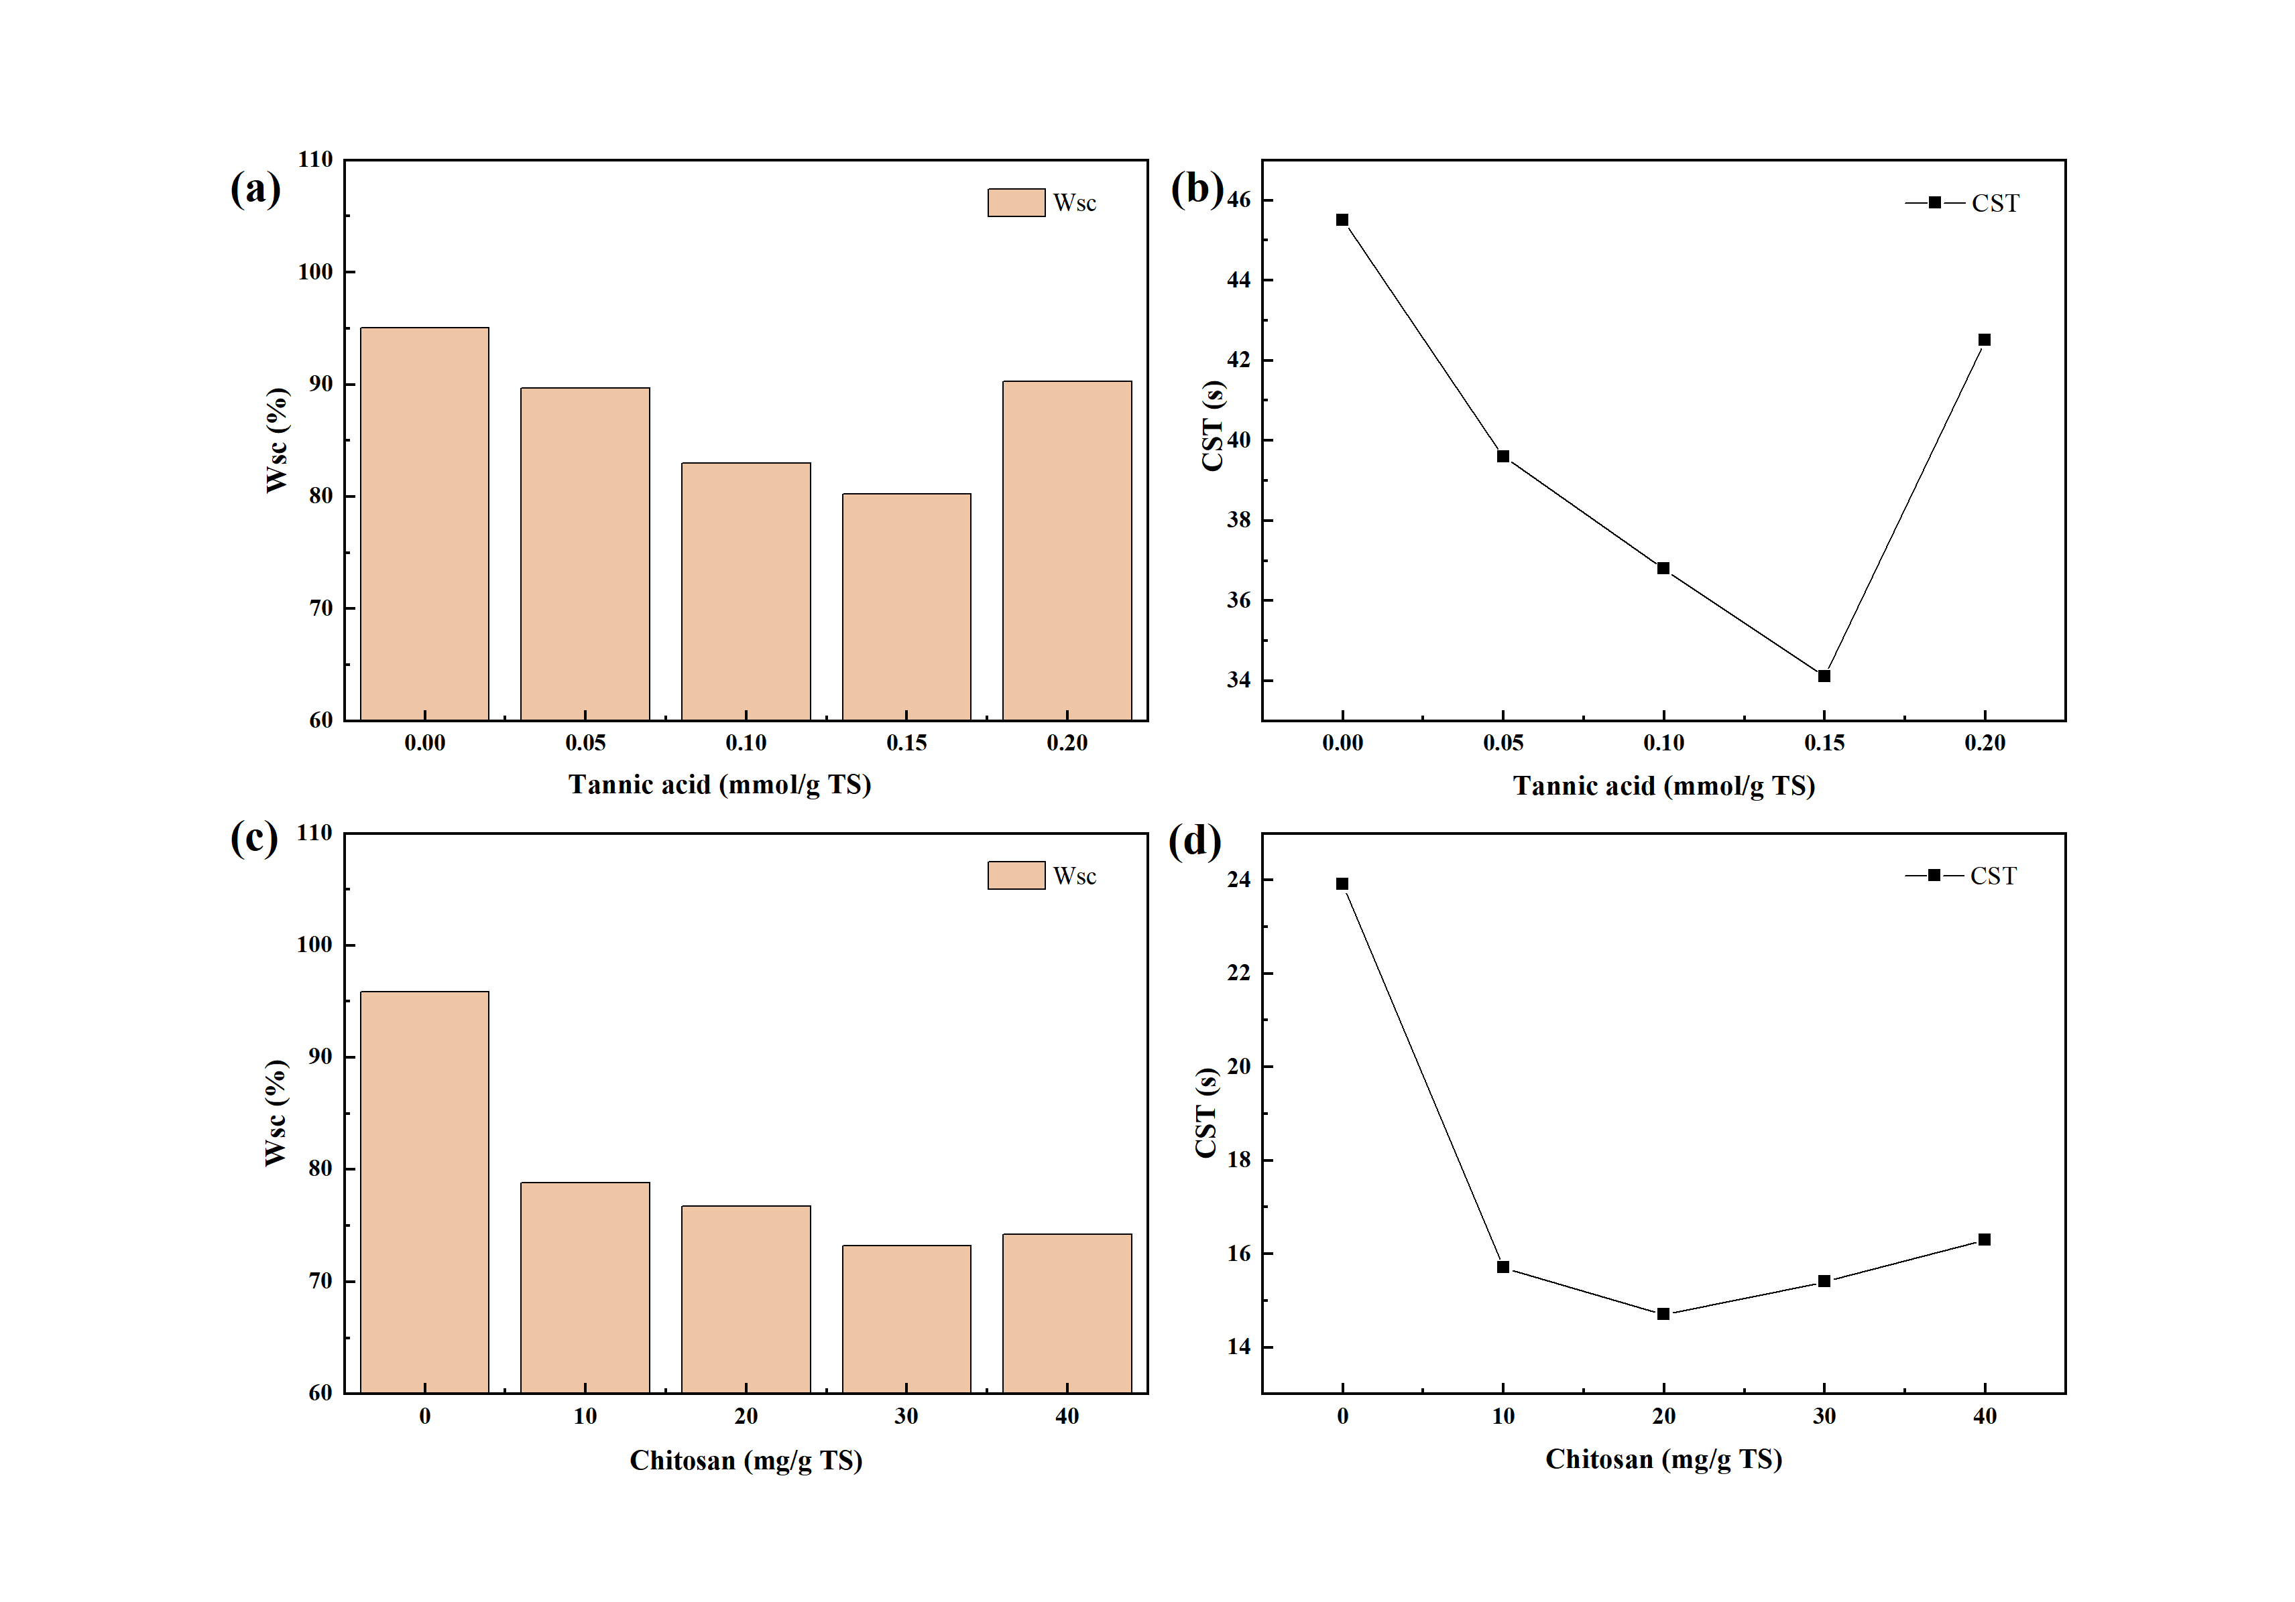
Fig S1 Effect of tannic acid on (a)Wsc and (b)CST; Chitosan on (c)Wsc and (d)CST

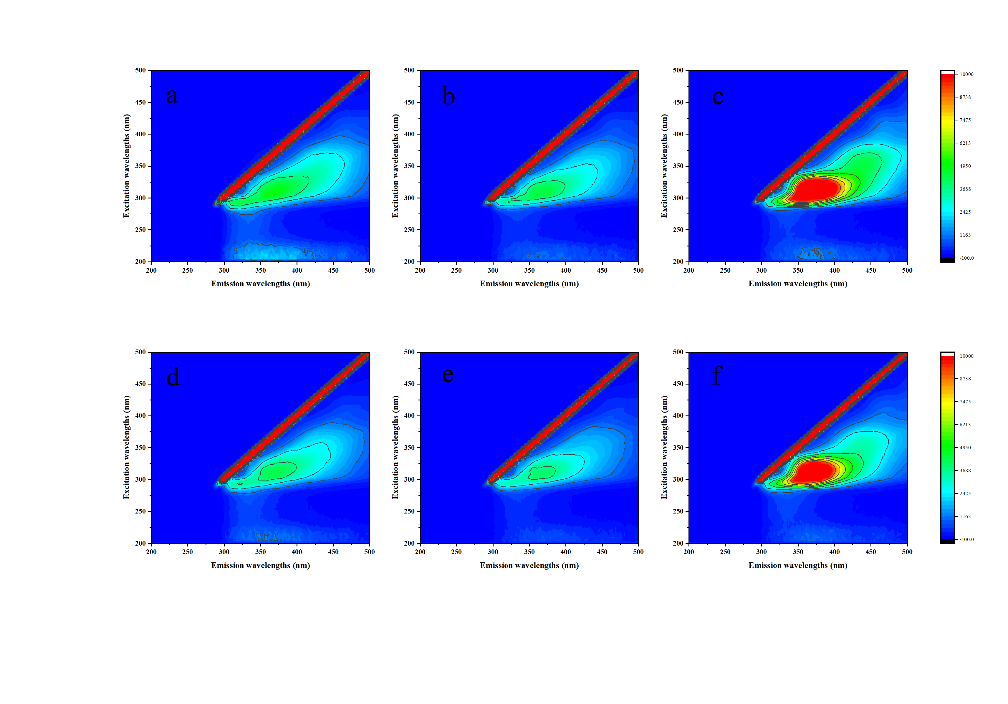
Fig S2 3D-EEMs fluorescence spectrum of: raw sludge (a)S-EPS, (b)LB-EPS, (c) TB-EPS fractions; CS-TA treated sludge (d)S-EPS, (e)LB-EPS, (f) TB-EPS fractions.

