Supplementary Figures
Development of feedforward and feedback connections between the dorsal lateral geniculate nucleus and the thalamic reticular nucleus
Peter W Campbell, Gubbi Govindaiah, and William Guido
Department of Anatomical Sciences and Neurobiology, University of Louisville School of Medicine, Louisville, KY, 40292 USA

Supplementary Figure 1. ChR2 expression in developing feedforward and feedback thalamic circuits. A. Left: wiring diagram illustrating somatic blue light stimulation of thalamocortical (TC) neurons comprising the feedforward circuit to TRN. Right: Examples of intrinsic ChR2-EYFP expression in TC neurons and their projections in P5 CRH-Cre x Ai32 mice. There was robust EYFP in TC neurons of dLGN (outlined) ventrobasal complex (VB) as well as in their projections coursing through TRN (outlined) and terminating in a barrel like arrangement of the somatosensory cortex. B. Left: Coronal slice through the thalamus of a P4 CRH-Cre x Ai32 mice showing ChR2-EYFP expression in dLGN and VB along with the location of biocytin filled TC neurons (white). Middle: Z-stack confocal images of biocytin filled TC neurons from adjacent slice. Right: Voltage responses and spikes evoked by blue light stimulation (blue trace, 1ms pulse) of TC neurons. C. Left: wiring diagram illustrating somatic blue light stimulation of TRN neurons comprising feedback circuit to dLGN. Right: Examples of intrinsic ChR2-EYFP expression in TRN neurons and their projections to dLGN at P2 and P6 of SST-Cre x Ai32 mice. There was robust EYFP in TRN neurons (outlined) as well as their terminal fields in dLGN (outlined). D. Left: Coronal slice through the thalamus of a P2 SST-Cre x Ai32 mice showing ChR2-EYFP expression in TRN along with the location of biocytin filled neurons (white). Middle: Z-stack confocal images of biocytin filled TRN neurons from adjacent slice. Right: Voltages responses and spikes evoked by blue light stimulation (blue trace, 1ms pulse) of TRN neuron.
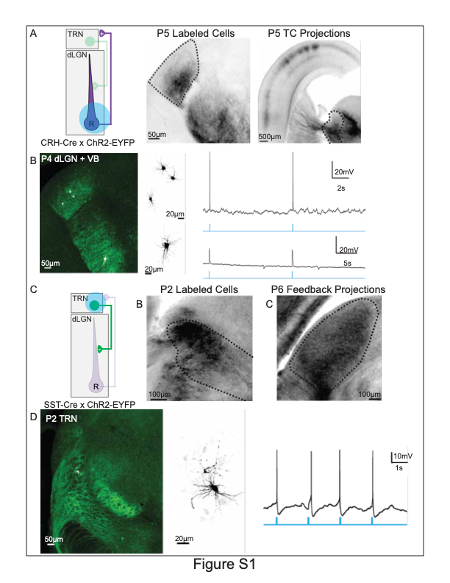

Supplementary Figure 2. Development of TRN-mediated inhibition of dLGN activity. Examples of voltage responses obtained from SST-Cre x ChR2 WT (top) and SST-Cre x ChR2 mice crossed on a Math5^{-/-} background (bottom). Responses are organized by postnatal week and stimulation frequency (10Hz and 50Hz). All other conventions same as Figure 10A.

