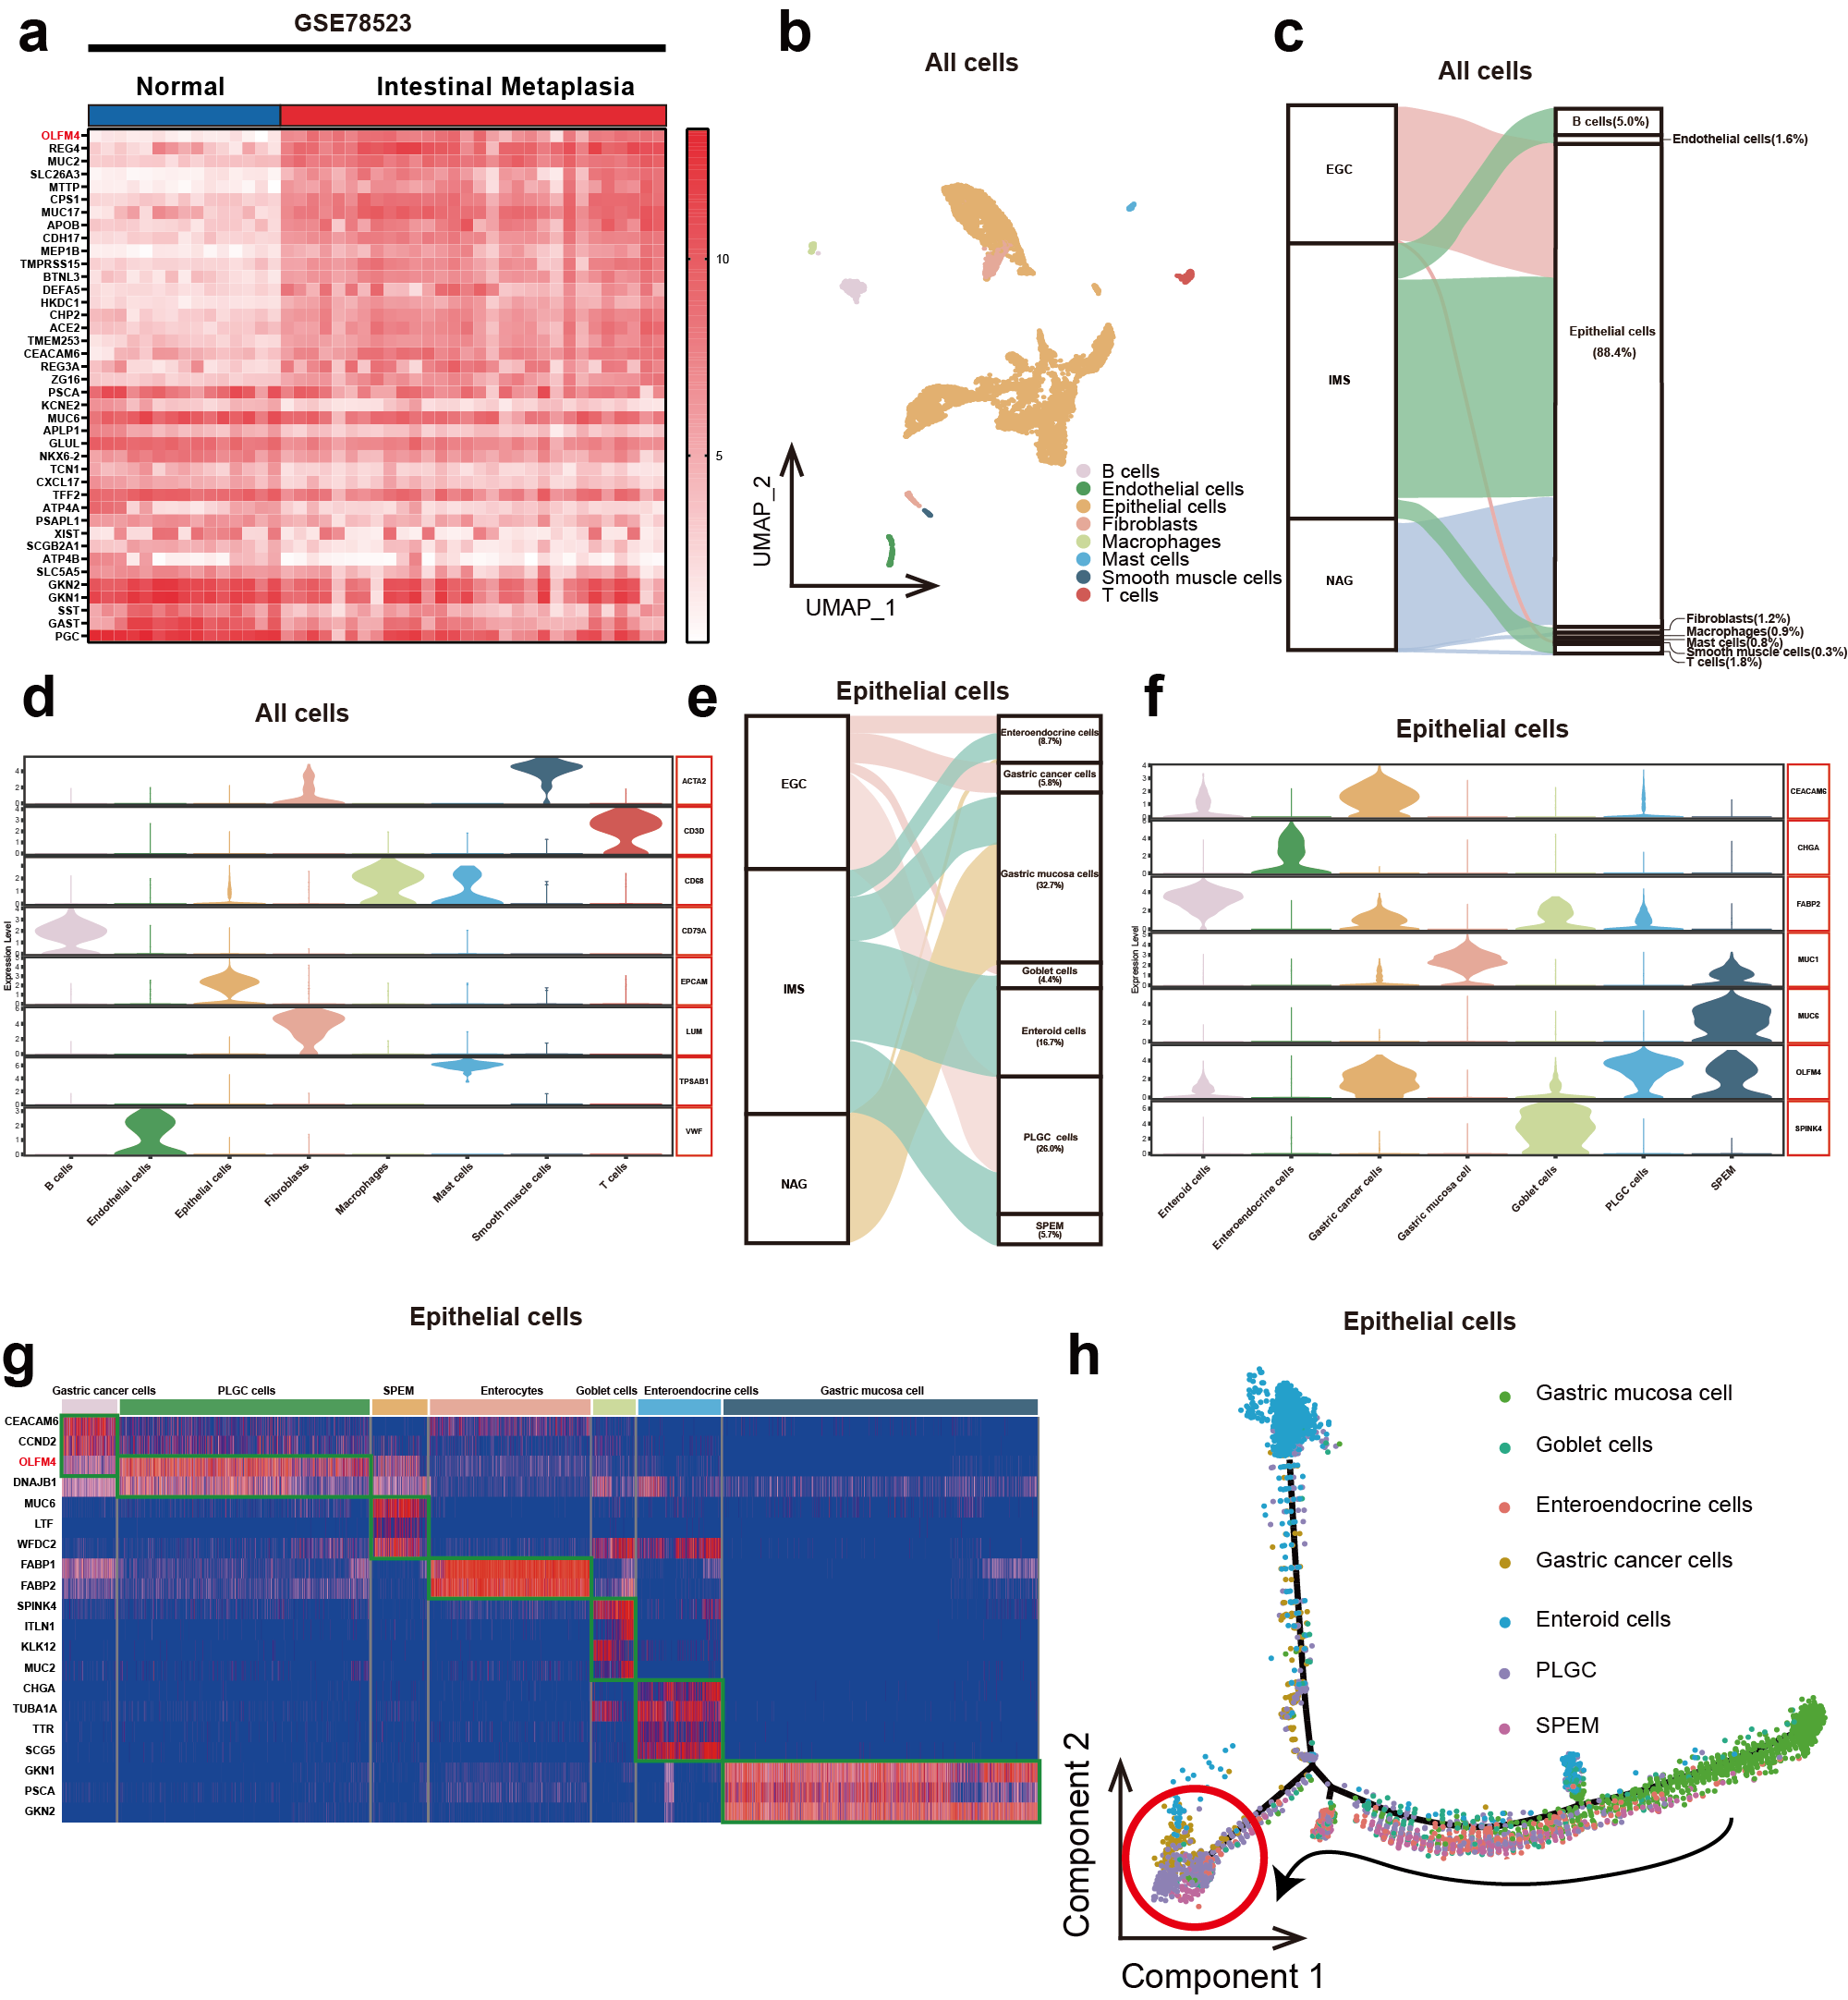
Figure S1 OLFM4 was the biomarker of PLGC tissue: (a) Heatmap displaying the top 20 DEGs in intestinal metaplasia, with OLFM4 ranking as the most highly expressed. (b-d) Analysis of cell subgroup proportions and identification following the initial clustering of data from GSE134520. (e-g) Assessment of epithelial cell subpopulation proportions and identification of cell subpopulations through the second cluster analysis of GSE134520 data. (h) Monocle analysis depicting the differentiation trajectories of epithelial cell subgroups.

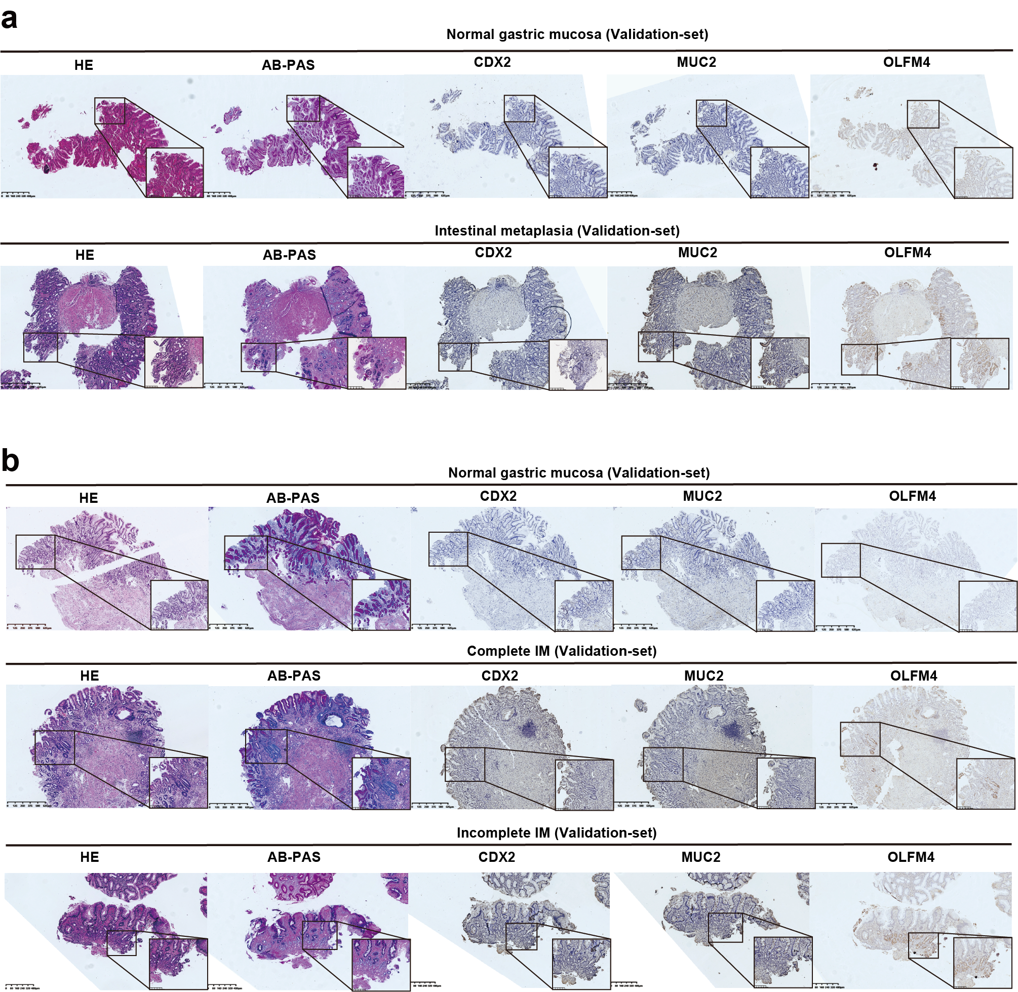
Figure S2 OLFM4 was the biomarker of IIM tissue: (a) HE staining and AB-PAS staining were employed to confirm the diagnosis of intestinal metaplasia and assess the immunohistochemical expression of CDX2, MUC2, and OLFM4 in the Validation-set. (b) HE staining and AB-PAS staining were utilized to confirm the diagnosis of intestinal metaplasia subtypes and evaluate the immunohistochemical expression of CDX2, MUC2, and OLFM4 in the Validation-set.

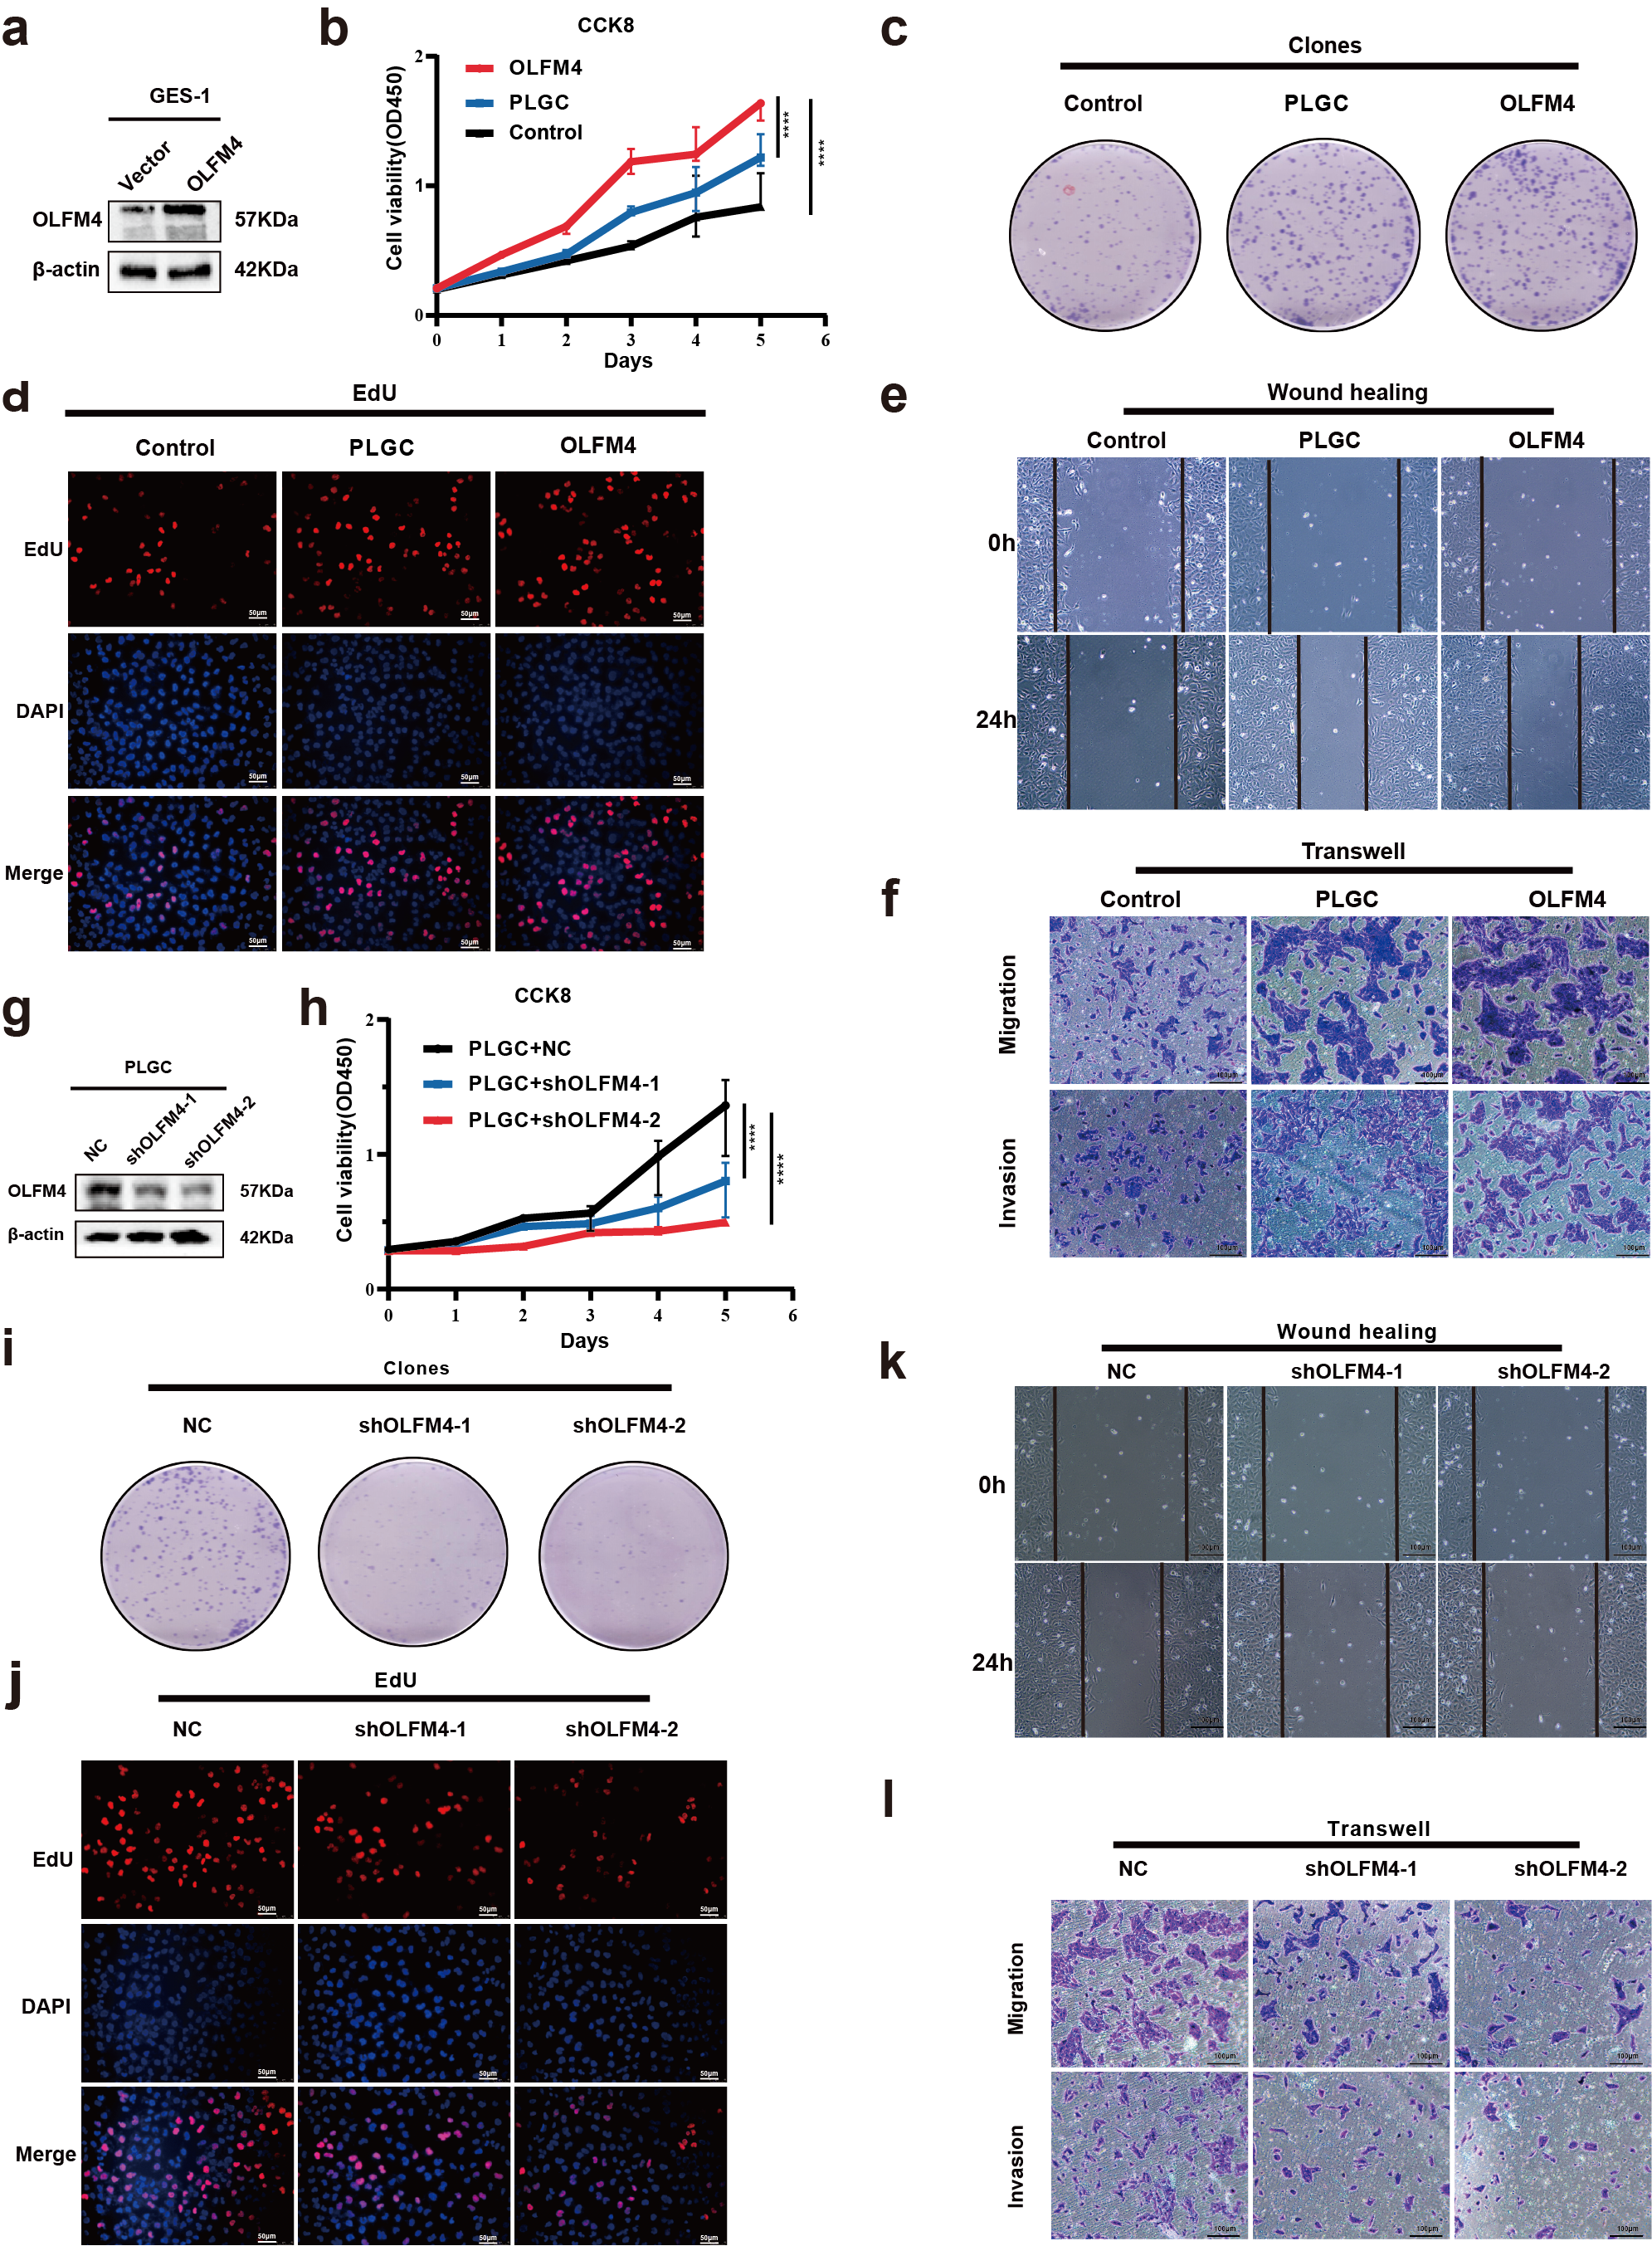
Figure S3 OLFM4 promoted the ability of proliferation and invasion: (a) Western Blotting confirmed increased OLFM4 expression in oeOLFM4 cells. (b-f) CCK8, cell cloning, EdU, wound healing, and transwell assays collectively demonstrated enhanced proliferation and invasion abilities in PLGC cells and oeOLFM4 cells. (g) Western Blotting confirmed decreased OLFM4 expression in shOLFM4 cells. (h-l) CCK8, cell cloning, EdU, wound healing, andtranswell assays collectively revealed weakened proliferation and invasion abilities in shOLFM4 cells.

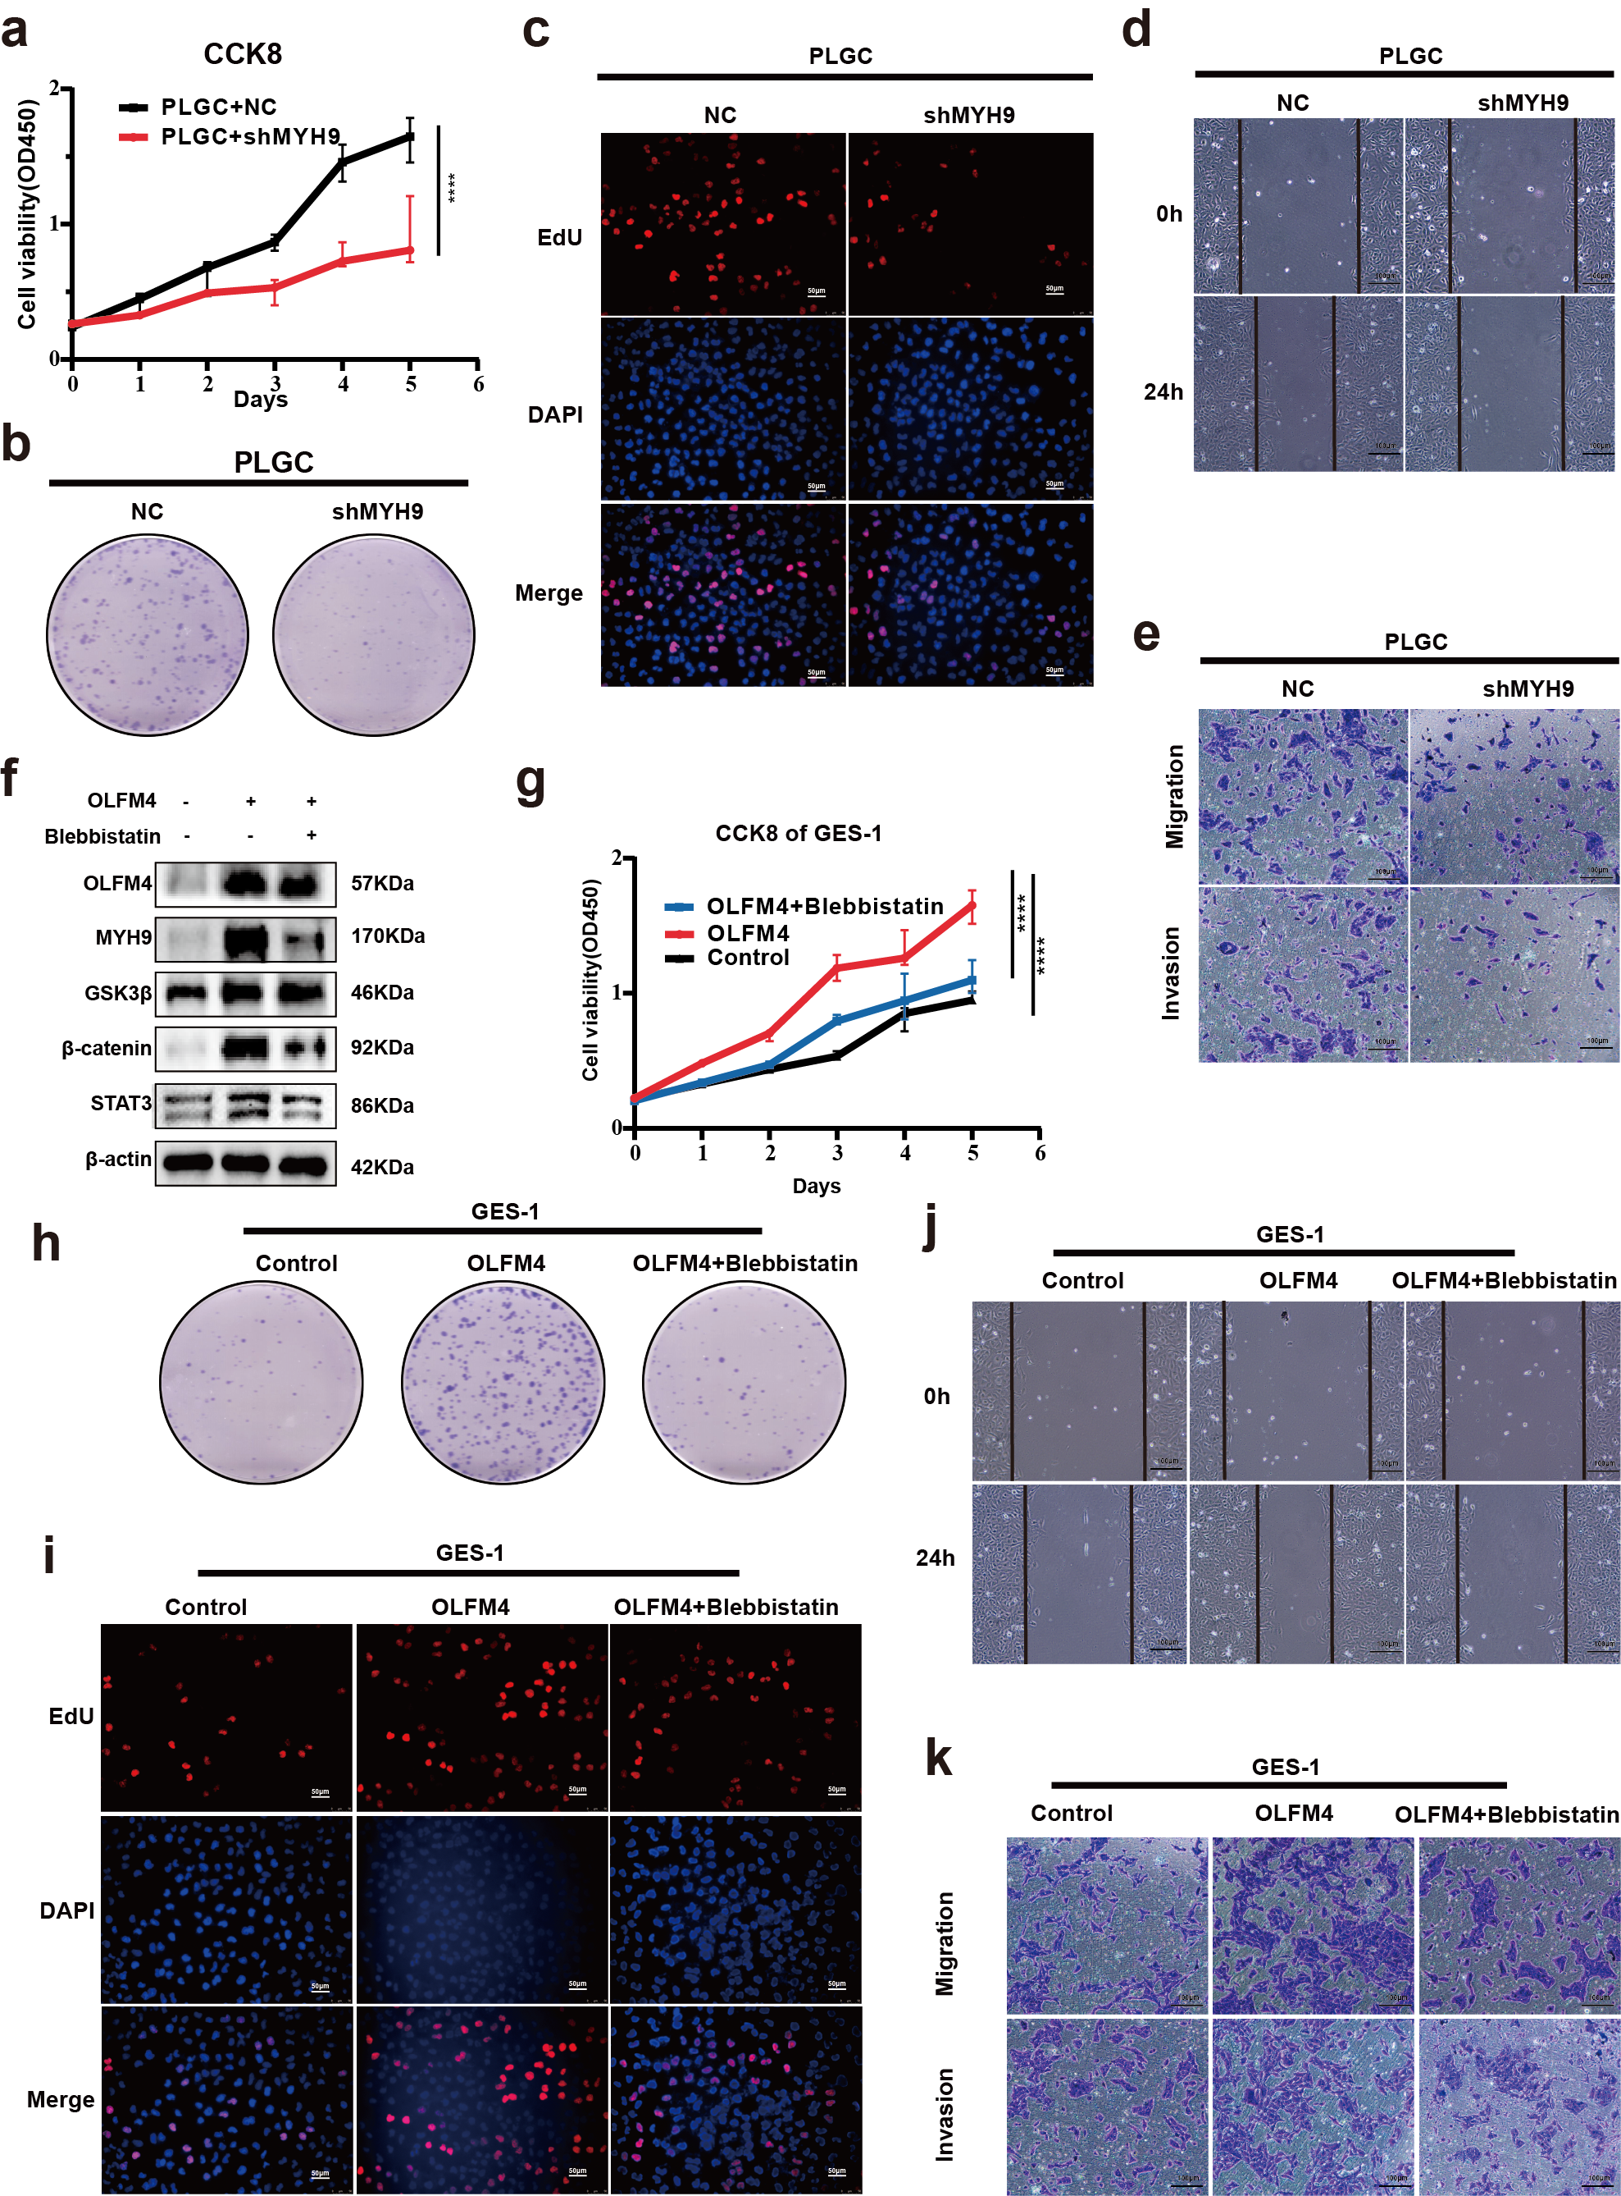
Figure S4 OLFM4 interacted with MYH9 to promote proliferation and invasion (a-e) CCK8, cell cloning, EdU, wound healing, and transwell assays collectively demonstrated reduced proliferation and invasion capabilities in shMYH9 cells. (g-k) CCK8, cell cloning, EdU, wound healing, and transwell assays collectively revealed weakened proliferation and invasion in oeOLFM4 cells treated with the MYH9 inhibitor Blebbistatin.

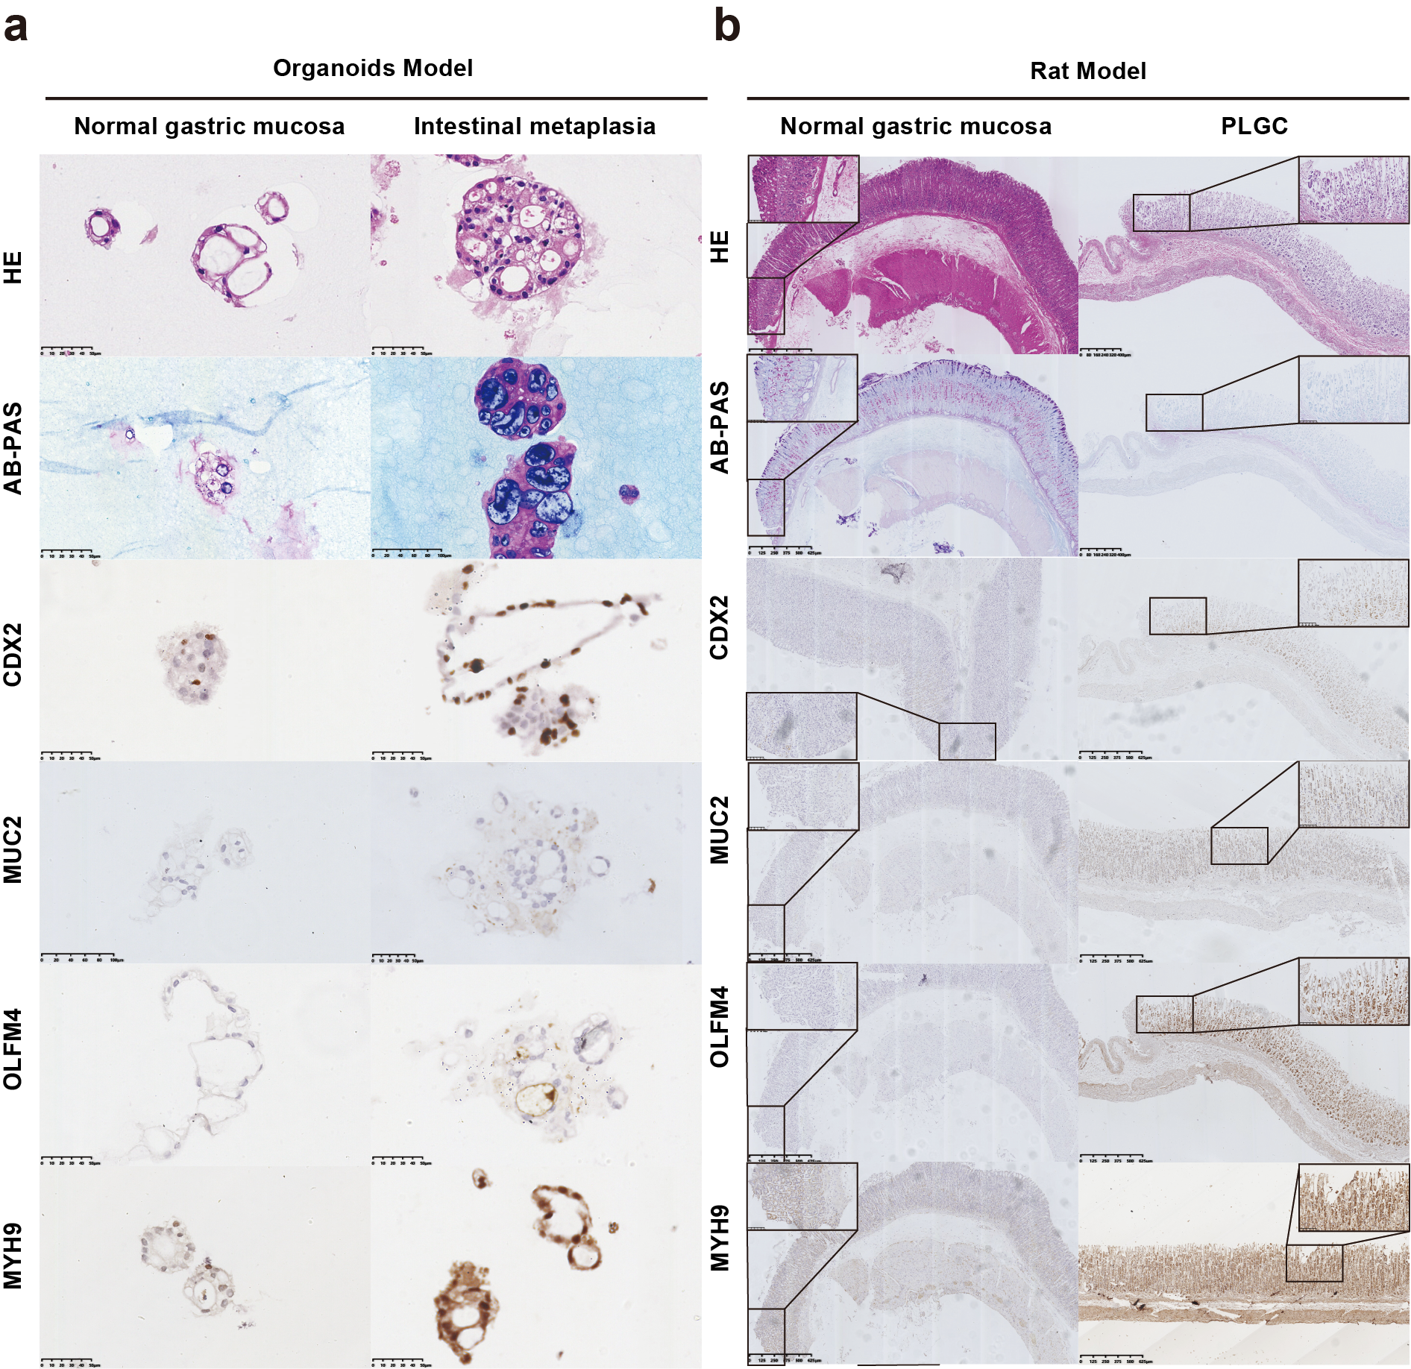
Figure S5 OLFM4 and MYH9 expressed highly in IM tissues: (a) HE staining, AB-PAS staining, and immunohistochemical expression of CDX2, MUC2, OLFM4, and MYH9 in intestinal metaplasia organoids. (b) HE staining, AB-PAS staining and immunohistochemical expression of CDX2, MUC2, OLFM4 and MYH9 in PLGC animal models.

