Supplementary Information
Iodine Coadsorbed OH-Copper Phthalocyanine for Dopamine Sensing – A DFT Study
Thekkayil Sangeetha, Senthilkumar Lakshmipathi*
Department of Physics, Bharathiar University, Coimbatore 641016, Tamil Nadu, INDIA

Figure S1 Optimized geometries of Dopamine in the gas phase and water
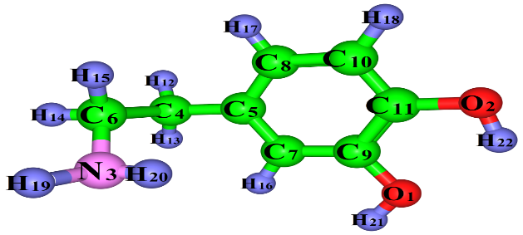

DA_{g}
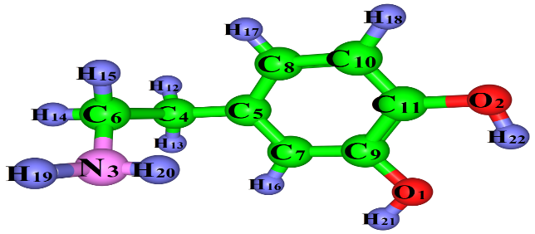

DA_{w}

*Subscripts g and w represent gas and water medium
Color-code: Green-Carbon(C), Pink-Nitrogen(N), Red-Oxygen(O), Blue-Hydrogen(H)

Table S1 Computed and experimental geometrical parameters of neutral Dopamine (DA)

Parameters | Experimental | Calculated
Parameters | Gas | Gas | Water
r(C11-C10) | 1.39 | 1.385 | 1.386
r(C11-C9) | 1.4 | 1.395 | 1.396
r(C11-O2) | 1.37 | 1.363 | 1.368
r(C10-C8) | 1.39 | 1.389 | 1.390
r(C10-H18) | 1.01 | 1.080 | 1.081
r(C8-C5) | 1.38 | 1.393 | 1.394
r(C8-H17) | 0.96 | 1.081 | 1.081
r(C5-C7) | 1.4 | 1.395 | 1.395
r(C5-C4) | 1.52 | 1.506 | 1.395
r(C7-C9) | 1.37 | 1.385 | 1.386
r(C7-H16) | 0.95 | 1.083 | 1.083
r(C9-O1) | 1.38 | 1.376 | 1.372
r(C4-H12) | 0.97 | 1.091 | 1.091
r(C4-H13) | 0.98 | 1.090 | 1.090
r(C4-C6) | 1.52 | 1.532 | 1.531
r(O1-H21) | 0.9 | 0.961 | 0.963
r(O2-H22) | 0.83 | 0.964 | 0.965
r(C6-H14) | - | 1.091 | 1.091
r(C6-H15) | - | 1.098 | 1.097
α(C10-C11-C9) | 120 | 119.037 | 119.296
α (C10-C11-O2) | 123.2 | 120.116 | 120.016
α (C9-C11-O2) | 116.9 | 120.847 | 120.687
α (C11-C10-C8) | 120 | 120.225 | 120.167
α (C11-C10-H18) | 126 | 118.594 | 118.871
α (C8-C10-H18) | 114 | 121.180 | 120.961
α (C10-C8-C5) | 121 | 121.219 | 121.091
α (C10-C8-H17) | 117 | 119.238 | 119.263
α (C5-C8-H17) | 122 | 119.542 | 119.263
α (C8-C5-C7) | 119 | 118.158 | 118.300
α (C8-C5-C4) | 123 | 121.149 | 120.848
α (C7-C5-C4) | 118.4 | 120.644 | 120.813
α (C5-C7-C9) | 121 | 120.812 | 120.846
α (C5-C7-H16) | 118 | 119.667 | 119.995
α (C9-C7-H16) | 120 | 119.520 | 119.159
α (C11-C9-C7) | 119 | 120.548 | 120.300
α (C11-C9-O1) | 119.7 | 115.533 | 115.329
α (C7-C9-O1) | 120.8 | 123.919 | 124.089
α (C5-C4-H12) | 111 | 109.642 | 109.639
α (C5-C4-H13) | 109.8 | 109.947 | 109.885
α (H12-C4-C6) | 108.2 | 108.404 | 108.130
α (H13-C4-C6) | 108.3 | 108.456 | 108.814
α (C9-O1-H21) | 110.4 | 110.077 | 110.538
α (C11-O2-H22) | 108.3 | 108.378 | 108.534
α (C4-C6-N3) | 111.2 | 110.806 | 111.113
α (H14-C6-N3) | 107.8 | 107.913 | 108.016
α (H15-C6-N3) | 113.4 | 113.317 | 112.849
r: Bond lengths in Å, α: bond angles in degree (⁰)

Table S2 frequency shift analysis of phthalocyanine/dopamine complexes.
System | Bond type | Frequency in cm⁻¹ |  | Shift nature
System | Bond type | Complex | Monomer | Shift nature
CuPc/DA_{g} | C-H∙∙∙O | 3037.07 | 3047.67 | Red shift
CuIPc/DA_{g} | C-H∙∙∙O | 3023.68 | 3047.67 | Red shift
CuPc/DA_{w} | C-H∙∙∙O | 3057.70 | 3065.52 | Red shift
CuIPc/DA_{w} | C-H∙∙∙O | 3059.45 | 3065.52 | Red shift

Figure S2 Optimized geometries of phthalocyanine/dopamine complexes.
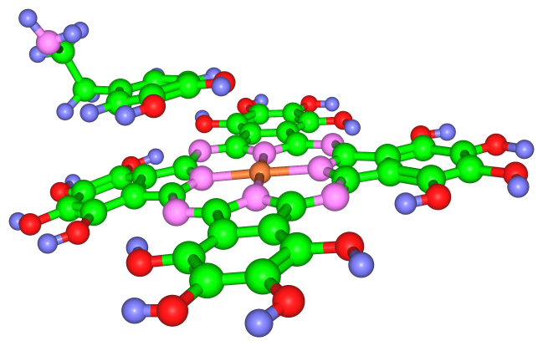 | 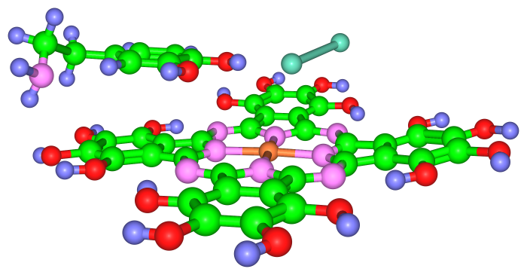
CuPc/DA_{g} | CuIPc/DA_{g}
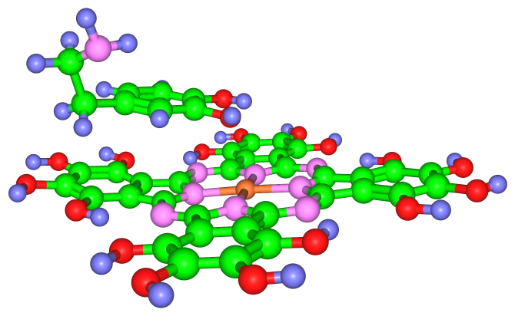 | 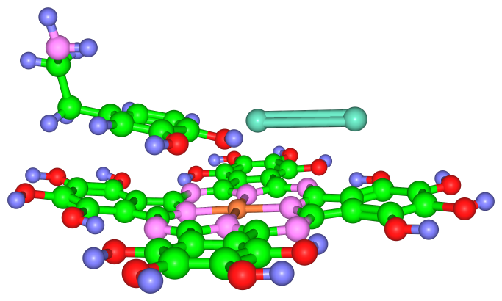
CuPc/DA_{w} | CuIPc/DA_{w}
* ª Represents monomer values, subscripts g and w represent gas and water, respectively.
Color-code: Green-Carbon (C), Pink-Nitrogen (N), Red-Oxygen (O), Blue-Hydrogen (H), Orange-copper (Cu), Light Blue-iodine (I).

