Supplement Figures

Supplement Figure S1 Forest plot for the causal effect of the single SNP on the risk of calcific aortic valve stenosis derived from inverse variance weighted (IVW).OR, odds ratio; CI, confidence interval; PTH, parathyroid hormone; FGF23, fibroblast growth factor 23

Supplement Figure S2. Forest plots for the Mendelian randomization (MR) leave-one-out analysis of the inverse variance weighted (IVW) estimates. OR, odds ratio; CI, confidence interval; PTH, parathyroid hormone; FGF23, fibroblast growth factor 23

Supplement Figure S1. Forest plot for the causal effect of the single SNP on the risk of calcific aortic valve stenosis derived from inverse variance weighted (IVW)
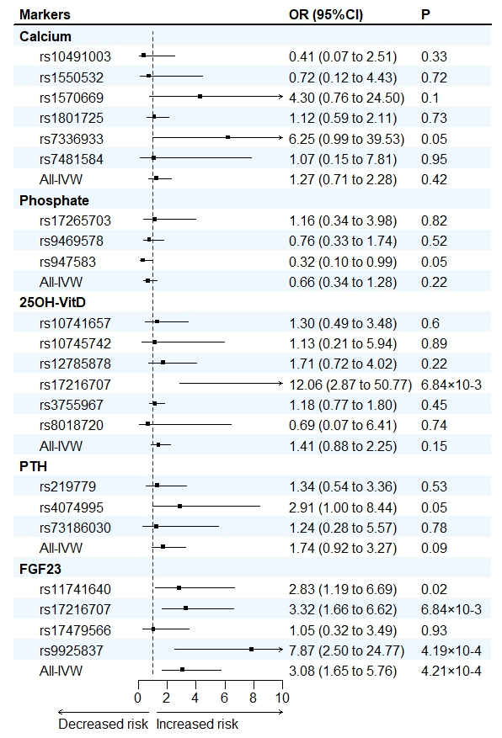

Supplement Figure S2. Forest plots for the Mendelian randomization (MR) leave-one-out analysis of the inverse variance weighted (IVW) estimates.
