Supplementary Information

Table S1 List of single metal catalysts used to screen the active components.
Catalyst | X_{6-HCM}/% | S_{CPL}/% | Y_{CPL}/%
TiO₂ | 73.7% | 5% | 3.7%
Ru/TiO₂ | 93.6% | 13.4% | 12.5%
Rh/TiO₂ | 70.5% | 2.7% | 1.9%
Pd/TiO₂ | 72.3% | 9.3% | 6.7%
Pt/TiO₂ | 72.7% | 10.0% | 7.3%
Cu/TiO₂ | 77.0% | 1.8% | 1.4%
Co/TiO₂ | 77.7% | 3.2% | 2.5%
Reaction conditions: 6-HCM (1.5 mmol), catalyst (0.05 g), H₂O (10 mL), NH₃·H₂O (5 mL), 250 °C, 5 h, 1 MPa N₂.

Figure S1
Analysis of LC-MS.
Mass spectrometry analysis of the reaction solution showed that C₆H₁₂NO₂ (6-hydroxycaproamide,6-HCM) corresponded to m/z = 132.1023[M+H]⁺ in the mass spectrum, closely aligning with the theoretical value of m/z = 132.1025. C₆H₁₁NO (caprolactam, CPL) exhibited a m/z = 114.0908[M+H]⁺ in the mass spectrum, which agreed well with the theoretical value of m/z = 114.0919. C₆H₉NO₂ (adipimide) displayed a m/z = 128.0701[M+H]⁺, which was consistent with the theoretical value of m/z = 128.0712. C₆H₁₄N₂O (6-aminocaproamide) demonstrated a m/z = 131.1176 [M+H]⁺, close to the theoretical value of m/z = 131.1184.

GC-MS of Valeramide and CPL.
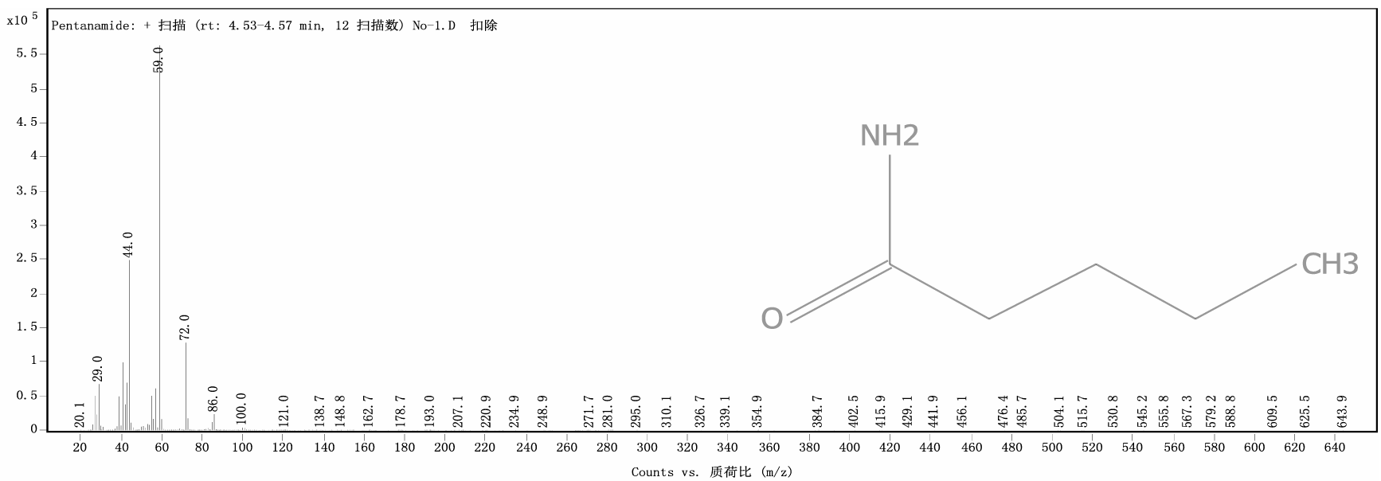
Valeramide
m/z:101.1(98.4%)
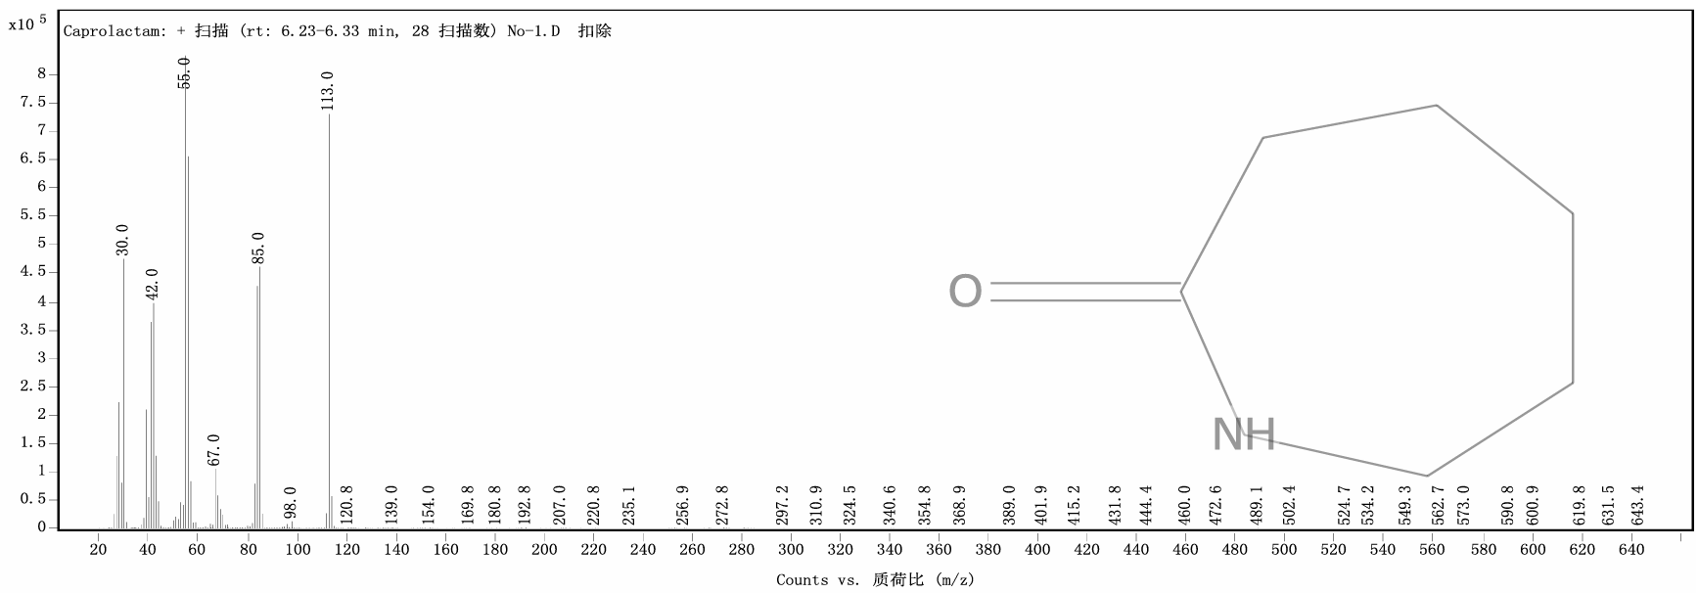
Caprolactam，CPL
m/z:113.1(99.4%)
Figure S2 HRTEM images of the Ru₅Co₆/TiO₂.
