Additional file
Contents

Methods 1
Results 1
Tables 2
Table 1. Assessment of MBD conditions, NSCH 2016-2021 2
Table 2. Assessment of 24-HMB guidelines, NSCH 2016-2021 3
Table 3. Assessment of sociodemographic characteristics, NSCH 2016-2021 4
Table 4. Weighted logistic regression models of 24 HMB guidelines adjusted for sociodemographic factors (Model 1), NSCH 2016-2021 5
Table 5. Weighted logistic regression of 24-HMB guidelines among 10- 17 years’ participants with MBD conditions, adjusted for sociodempgraphic and BMI characteristics, NSCH 2016-2021 6
Table 6. Sample size for crude weighted counts in 24-HMB guidelines among youth with MBD conditions, NSCH 2016-2021 8
Table 7. Sample size for crude weighted participants among youth with MBD conditions, NSCH 2016-2021 9
Table 8. Prevalence of meeting 24-HMB guidelines for U.S. youth with MBD conditions (in the years 2016-2021) a 10
Table 9. Crude-weighted linear regression models of 24-HMB guidelines (continuous), adjusted for sociodemographic factors, NSCH 2016-2021 12
Table 10. Weighted% (95%CI) crude weighted trends in 24-HMB guidelines youth with anxiety, NSCH 2016-2021 14
Table 11. Weighted% (95%CI) crude weighted trends in 24-HMB guidelines youth with depression, NSCH 2016-2021 15
Table 12. Weighted% (95%CI) crude weighted trends in 24-HMB guidelines youth with comorbidity of anxiety and depression, NSCH 2016-2021 16
Table 13. Weighted% (95%CI) crude weighted trends in 24-HMB guidelines youth with ASD, NSCH 2016-2021 17
Table 14. Weighted% (95%CI) crude weighted trends in 24-HMB guidelines youth with ADHD, NSCH 2016-2021 18
Table 15. Weighted% (95%CI) crude weighted trends in 24-HMB guidelines youth with comorbidity of ASD and ADHD, NSCH 2016-2021 19
Table 16. Weighted% (95%CI) crude weighted trends in 24-HMB guidelines youth with speech disorder, NSCH 2016-2021 20
Table 17. Weighted% (95%CI) crude weighted trends in 24-HMB guidelines youth with learning disability, NSCH 2016-2021 21
Table 18. Weighted% (95%CI) crude weighted trends in 24-HMB guidelines youth with developmental delay, NSCH 2016-2021 22
Table 19. Weighted% (95%CI) crude weighted trends in 24-HMB guidelines youth with behavior problem, NSCH 2016-2021 23
Table 20. Weighted% (95%CI) crude weighted trends in 24-HMB guidelines youth with brain injury, NSCH 2016-2021 24
Figures 25
Figure 1. Estimated prevalence of meeting 24-HMB according to disparities 25
Figure 1.1. Estimated prevalence of meeting 24-HMB guidelines according to age, NSCH 2016-2021 25
Figure 1.2. Estimated prevalence of meeting 24-HMB guidelines according to sex, NSCH 2016-2021 26
Figure 1.3. Estimated prevalence of meeting 24-HMB guidelines according to ethnicity, NSCH 2016-2021 27
Figure 1.4. Estimated prevalence of meeting 24-HMB guidelines according to FPL, NSCH 2016-2021 27
Figure 2. Crude weighted trends in 24-HMB guidelines among youth with MBD conditions 28
Figure 2.1 Crude weighted trends in 24-HMB guidelines among youth with anxiety/depression, NSCH 2016-2021 28
Figure 2.2. Crude weighted trends in 24-HMB guidelines among youth with ASD/ADHD, NSCH 2016-2021 29
Figure 2.3. Crude weighted trends in 24-HMB guidelines among youth with speech disorder, NSCH 2016-2021 30
Figure 2.4. Crude weighted trends in 24-HMB guidelines among youth with learning disability, NSCH 2016-2021 30
Figure 2.5. Crude weighted trends in 24-HMB guidelines among youth with developmental delay, NSCH 2016-2021 31
Figure 2.6. Crude weighted trends in 24-HMB guidelines among youth with behavior problem, NSCH 2016-2021 31
Figure 2.7. Crude weighted trends in 24-HMB guidelines among youth with brain injury, NSCH 2016-2021 32

Methods
Assessment of 24-HMB guidelines
Three different questions were used to determine whether a participant met 24-HMB guidelines (PA, ST, and SL). To assess PA, parents were asked: “DURING THE PAST WEEK, on how many days did this child exercise, play a sport, or participate in physical activity for at least 60 minutes?”, with four response options being offered (0 days, 1-3 days, 4-6 days, and every day). To assess ST, parents were asked: “ON MOST WEEKDAYS, about how much time does this child usually spend in front of a TV, computer, cellphone or other electronic device watching programs, playing games, accessing the internet or using social media? (Do not include time spent doing schoolwork.)”, while five response options were proposed (Less than 1 hour per day, 1 hour per day, 2 hours per day, 3 hours per day, and 4 or more hours per day). To assess SL, parents were asked: “DURING THE PAST WEEK, how many hours of sleep did this child on most weeknights]?”, while seven response options were offered (Less than 6 hours, 6 hours, 7 hours, 8 hours, 9 hours, 10 hours, and 11 hours or more). Of note, SL guidelines vary slightly across age groups: (i) 5 to 7 hours for 5 to 13-year-old youth; (ii) 4 to 6 hours for 14 to 17-year-old youth.

Results
The estimated prevalence of meeting SL + ST guidelines showed a slight decrease among children and adolescents (both P-value for trend < 0.001). The estimated prevalence of meeting PA + SL guidelines showed a decrease among children and adolecents over the six years (P-value for trend < 0.001). For children, the estimated prevalence of meeting PA + ST guidelines showed an increase (P-value for trend < 0.001) while the number among adolescents was stable over time(see Additional Figure 1.1).
The estimated prevalence of meeting SL + ST guidelines showed a significant decrease among boys and girls (P-value for trend < 0.001). Meeting PA + ST guidelines showed a decrease among boys (P-value for trend < 0.001) and girls (P-value for trend = 0.004)over time. (see Aditional Figure 1.2).
Meeting integrated ( PA + ST, SL + ST, and PA + SL) guidelines was significantly declined among non-Hispanic White over time (all P-value for temporal trend < 0.001) (see Aditional Figure1.3). Given the majority of participants were non-Hispanic white (n=38,385), descriptive results are presented above for this group, while trends for other participants (including Black, Hispanic, Asian, and Other/Muti-racial participants) can be visually observed in Figure 2c and see Aditional Figure 1.3.
The estimated prevalence of meeting integrated (PA + ST and PA + SL) guidelines showed a stable among participants who reported FPL level of less than 99% ( P-value for trend > 0.05) while among 100% and more showed increase in meeting PA + SL guidelines and decrease in meeting PA + ST guidelines (both P-value for temporal trend < 0.001). The estimated prevalence of SL + ST guidelines showed a significant decrease among participants both who reported FPL level of less than 99% and 100% and more (P-value for trend < 0.001). (see Aditional Figure1.4).

Tables

Table 1. Assessment of MBD conditions, NSCH 2016-2021
Variable | Item | Response
K2Q43B  BLINDNESS  K2Q46A(CONCUSSION)  K2Q61A  DOWNSYN  K2Q42A  K2Q38A  K2Q33A  K2Q32A  K2Q34A  K2Q36A  K2Q60A  K2Q37A  K2Q30A  K2Q35A  K2Q31A | Does this child have any of the following? Deafness or problems with hearing/ Blindness or problems with seeing, even when wearing glasses  Has a doctor or other health care provider ever told you that this child has: Brain Injury, Concussion or Head injury/Cerebral Palsy/ Down Syndrome/ Epilepsy or Seizure Disorder/ Tourette Syndrome/ Anxiety problems/ Depression?  Has a doctor, other health care provider, or educator ever told you that this child has: Behavioral or Conduct problems/ Developmental Delay/ Intellectual Disability (also known as Mental Retardation)/Speech or Other Language Disorder/ Learning Disability?  Has a doctor or other health care provider ever told you that this child has Autism or Autism Spectrum Disorder (ASD)? Include diagnoses of Asperger’s Disorder or Pervasive Developmental Disorder(PDD).  Has a doctor or other health care provider ever told you that this child has Attention Deficit Disorder or Attention Deficit/ Hyperactivity Disorder, that is, ADD or ADHD?  PS: Change K2Q46A to CONCUSSION in 2020 and 2021  Item: Do you think this child has ever had a concussion or brain injury? [2020/2021] | Yes / No

Abbreviations: MBD=mental, behavioral, neurodevelopmental.

Table 2. Assessment of 24-HMB guidelines, NSCH 2016-2021

24-HMB guidelines | Variables | Item | Response
Physical activity | PHYSACTIV | During the past week, on how many days did this child exercise, play a sport, or participate in physical activity for at least 60 minutes? | - “0 days”  - “1-3 days”  - “4-6 days”  - “Everyday”
Sleep | HOURSLEEP | During the past week, how many hour of sleep did this child get on most weeknights? | - “Less than 6 hours”  - “6 hours”  - “7 hours”  - “8 hours’  - “9 hours”  - “10 hours”  - “11 hours or more hours”
Screen time | SCREENTIME/  K7Q91_R | On most weekdays, about how much time does this child usually spend in front of a TV, computer, cellphone or other electronic device watching programs, playing games, accessing the internet or using social media ? (Do not include time spent doing homework.) | - “None”  - “Less than 1 hour”  - “1 hour”  - “2 hours”  - “3 hours”  - “4 or more hours”

Abbreviations: 24-HMB= 24-hour movement behaviors.

Table 3. Assessment of sociodemographic characteristics, NSCH 2016-2021
Variable | Item | Response
SC_AGE_YEARS | How old is this child? | 0-17 years
SC_SEX | What is this child’s sex? | - “male”  - “female”
raceAISA_years | What is this child’s race? | - “Hispanic”  - “White, non-Hispanic”  - “Black, non-Hispanic”  - “Asian, non-Hispanic”  - “Other/Multi-racial, non-Hispanic”
BronPre_years | Was this child born more than 3 weeks before their due date? | - “Yes”  - “No”
AdultEduc_years | What is the highest grade or level of school you/ this caregiver have completed? | - “Less than high school”  - “High school or GED”  - “Some college or technical school”  - “College degree or higher”
Povlev4_years | What is the income level (federal poverty level, FPL) of the household that this child lives in? | - “0-99% FPL”  - “100-199% FPL”  - “200-399% FPL”  - “400% FOL or greater”
BMI4_years | Weight status of children based on Body Mass Index for age-4 categories, 10-17years. | - “Underweight (less than 5th percentile)”  - “Healthy weight (5th to 84th percentile)”  - “Overweight (85th to 94th percentile)”  - “Obese (95th percentile or above)”

Table 4. Weighted logistic regression models of 24 HMB guidelines adjusted for sociodemographic factors (Model 1), NSCH 2016-2021

 |  | Odds Ratio (95% CI)¹
 |  | 24-HMB guidelines (Categorical)
 |  | PA only | SL only | ST only | PA + ST | PA + SL | SL + ST | PA+ST+SL | None
 | Model 1
 | Year (Categorical)
 | 2016 | 1[Reference] | 1[Reference] | 1[Reference] | 1[Reference] | 1[Reference] | 1[Reference] | 1[Reference] | 1[Reference]
 | 2017 | 0.8 (0.5-1.4) | 0.8 (0.7-1.0) | 1.2 (1.0-1.4) | 0.9 (0.6-1.4) | 1.2 (0.7-1.9) | 0.9 (0.8-1.1) | 1.0 (0.8-1.2 | 1.2 (1.0-1.4)
 | 2018 | 1.3 (0.9-1.9) | 1.8 1.5-2.1)*** | 0.7 (0.6-0.8)*** | 0.7 (0.5-0.9) | 1.6 (1.2-2.3)** | 0.6 (0.5-0.7)*** | 0.9 (0.7-1.0) | 1.7 (1.5-2.0***
 | 2019 | 1.1 (0.7-1.7) | 1.9 (1.6-2.2)*** | 0.6 (0.5-0.8***) | 0.6 (0.5-0.8)** | 1.9 (1.3-2.5)*** | 0.6 (0.5-0.7)*** | 0.8 (0.6-0.9) | 1.8 (1.5-2.2)***
 | 2020 | 1.5 (1.0-2.2) | 2.6 (2.3-3.0)*** | 0.5 (0.4-0.6)*** | 0.5 (0.4-0.7)*** | 1.9 (1.4-2.5)*** | 0.4 (0.4-0.5)*** | 0.6 (0.5-0.8)*** | 2.0 (1.8-2.4)***
 | 2021 | 1.2 (0.8-1.7) | 2.4 (2.0-2.7)*** | 0.6 (0.5-0.7)*** | 0.4(0.3-0.6)*** | 1.9 (1.4-2.6)*** | 0.5 (0.4-0.5)*** | 0.7 (0.6-0.8)*** | 2.0 (1.7-2.3)***
 | P for trend ² | 0.03 | <0.001 | <0.001 | <0.001 | <0.001 | <0.001 | <0.001 | <0.001

Note: ¹ For categorical variables, the Coefficient (β) represent the change in odds expected in each category compared with the reference group. ² P for trend over years was calculated using the 2016 to 2021years as a continuous variable.**p <0.005, ***p <0.001.

Table 5. Weighted logistic regression of 24-HMB guidelines among 10- 17 years’ participants with MBD conditions, adjusted for sociodempgraphic and BMI characteristics, NSCH 2016-2021

 |  | Odds Ratio (95% CI)¹ (N=39,622)
 |  | 24-HMB guidelines (Categorical)
 |  | PA only | SL only | ST only | PA + ST | PA + SL | SL + ST | PA+ST+SL | None
 | Age (years )
 | 10-13 | 1[Reference] | 1[Reference] | 1[Reference] | 1[Reference] | 1[Reference] | 1[Reference] | 1[Reference] | 1[Reference]
 | 14-17 | 0.7 (0.5-0.9) | 2.5 (2.3-2.8)*** | 0.5 (0.4-0.5)*** | 0.3 (0.3-0.4)*** | 1.6 (1.2-2.1)*** | 0.8 (0.7-0.9)** | 0.5 (0.5-0.6)*** | 1.0 (0.9-1.2)
 | Sex
 | Boys | 1[Reference] | 1[Reference] | 1[Reference] | 1[Reference] | 1[Reference] | 1[Reference] | 1[Reference] | 1[Reference]
 | Girls | 0.7 (0.5-0.8)** | 1.1 (1.0-1.2) | 1.3 (1.1-1.5)** | 0.6 (0.5-0.8)** | 0.4 (0.4-0.6)*** | 1.1 (1.0-1.2) | 0.7 (0.5-0.8)*** | 1.1 (1.0-1.3)
 | Ethnicity
 | Non-Hispanic white | 1[Reference] | 1[Reference] | 1[Reference] | 1[Reference] | 1[Reference] | 1[Reference] | 1[Reference] | 1[Reference]
 | Hispanic | 0.9 (0.6-1.4) | 1.1 (0.9-1.3) | 1.1 (0.9-1.4) | 0.8 (0.5-1.4) | 0.9 (0.6-1.4) | 0.8 (0.61.0) | 0.7 (0.5-1.0) | 1.3 (1.1-1.5)**
 | Non-Hispanic Black | 2.0 (1.3-3.0)** | 0.7 (0.6-0.9)** | 1.1 (0.9-1.4) | 0.9 (0.6-1.3) | 1.1 (0.8-1.6) | 0.6 (0.4-0.7)*** | 0.5 (0.3-0.7)** | 1.9 (1.6-2.3)***
 | Non-Hispanic Asian | 0.9 (0.3-2.4) | 0.9 (0.6-1.2) | 1.1 (0.8-1.7) | 0.7 (0.3-1.5) | 0.5 (0.2-0.9) | 1.0 (0.7-1.3) | 0.8 (0.3-1.9) | 1.5 (1.1-2.1)
 | Other/Multi-racial | 1.0 (0.7-1.5) | 1.1 (0.9-1.3) | 1.1 (0.9-1.4) | 1.6 (1.0-2.7) | 1.1 (0.7-1.7) | 0.8 (0.6-0.9) | 0.8 (0.6-1.0) | 1.0 (0.8-1.2)
 | Household poverty level (FPL)
 | Less than 99% | 1[Reference] | 1[Reference] | 1[Reference] | 1[Reference] | 1[Reference] | 1[Reference] | 1[Reference] | 1[Reference]
 | 100% and more | 0.7 (0.5-1.0) | 1.1 (1.0-1.4) | 0.9 (0.7-1.2) | 0.7 (0.4-1.1) | 1.0 (0.7-1.4) | 1.2 (1.0-1.4) | 0.7 (0.6-1.0) | 1.1 (0.9-1.3)
 | Highest level of education of primary caregivers
 | Less than highs school | 1[Reference] | 1[Reference] | 1[Reference] | 1[Reference] | 1[Reference] | 1[Reference] | 1[Reference] | 1[Reference]
 | High school or GED | 0.9 (0.5-1.5) | 1.0 (0.7-1.4) | 0.7 (0.5-1.1) | 1.3 (0.6-2.4) | 1.1 (0.5-2.3) | 1.0 (0.6-1.5) | 1.7 (0.9-3.1) | 1.1 (0.8-1.6)
 | Some colleges credit | 1.0 (0.6-1.6) | 1.2 (0.8-1.6) | 0.7 (0.5-1.1) | 1.3 (0.6-2.9) | 1.0 (0.5-1.8) | 1.0 (0.6-1.5) | 1.5 (0.8-2.8) | 1.0 (0.7-1.3)
 | College degree or higher | 0.7 (0.4-1.2) | 1.2 (0.9-1.7) | 0.8 (0.5-1.1) | 0.7 (0.3-1.4) | 0.9 (0.5-1.6) | 1.4 (0.9-2.1) | 1.8 (1.0-3.4) | 0.7 (0.5-1.0)
 | Born≥3weeks before due date
 | No | 1[Reference] | 1[Reference] | 1[Reference] | 1[Reference] | 1[Reference] | 1[Reference] | 1[Reference] | 1[Reference]
 | Yes | 0.9 (0.6-1.2) | 0.9 (0.8-1.1) | 1.2 (1.0-1.5) | 1.1 (0.8-1.6) | 1.1 (0.8-1.6) | 0.9 (0.8-1.1) | 1.0 (0.8-1.2) | 1.0 (0.9-1.2)
 | Weight status²
 | Underweight | 1[Reference] | 1[Reference] | 1[Reference] | 1[Reference] | 1[Reference] | 1[Reference] | 1[Reference] | 1[Reference]
 | Healthy weight | 1.5 (1.0-2.3) | 0.9 (0.7-1.1) | 1.1 (0.8-1.5) | 1.7 (1.1-2.7) | 0.7 (0.5-1.0) | 0.9 (0.8-1.1) | 0.9 (0.7-1.1) | 1.1 (0.9-1.4)
 | Overweight | 1.4 (0.8-2.2) | 0.9 (0.7-1.2) | 1.0 (0.7-1.4) | 1.3 (0.8-2.1) | 0.6 (0.4-1.1) | 0.9 (0.7-1.2) | 0.5 (0.4-0.8)** | 1.5 (1.1-1.8)**
 | Obese | 0.8 (0.5-1.3) | 1.1 (0.8-1.4) | 1.3 (0.9-1.8) | 1.1 (0.6-1.8) | 0.4 (0.2-0.6)*** | 0.7 (0.6-0.9) | 0.4 (0.3-0.6)*** | 1.7 (1.3-2.1)***
 | P for trend ³ | 0.002 | 0.18 | 0.12 | 0.07 | <0.001 | 0.01 | <0.001 | <0.001
 | Year (Categorical)
 | 2016 | 1[Reference] | 1[Reference] | 1[Reference] | 1[Reference] | 1[Reference] | 1[Reference] | 1[Reference] | 1[Reference]
 | 2017 | 1.0 (0.6-1.8) | 0.8 (0.7-1.0) | 1.2 (0.9-1.5) | 0.9 (0.5-1.6) | 1.0 (0.6-1.9) | 0.9 (0.8-1.2) | 0.9 (0.7-1.2) | 1.2 (0.9-1.5)
 | 2018 | 1.2 (0.7-2.0) | 1.7 (1.4-2.0)*** | 0.7 (0.6-0.9)** | 0.7 (0.4-1.0) | 1.4 (0.9-2.0) | 0.5 (0.4-0.6)*** | 0.7 (0.5-0.9) | 1.7 (1.5-2.1)***
 | 2019 | 1.1 (0.6-1.8) | 1.8 (1.5-2.2)*** | 0.6 (0.5-0.7)*** | 0.7 (0.5-1.1) | 1.5 (1.0-2.2) | 0.5 (0.4-0.6)*** | 0.8 (0.6-1.1) | 1.7 (1.4-2.1)***
 | 2020 | 1.4 (0.9-2.2) | 2.3 (2.0-2.7)*** | 0.4 (0.3-0.5)*** | 0.6 (0.4-0.9) | 1.5 (1.0-2.0) | 0.4 (0.3-0.5)*** | 0.6 (0.5-0.8)*** | 1.9 (1.6-2.3)***
 | 2021 | 1.3 (0.8-2.0) | 2.2 (1.9-2.6)*** | 0.5 (0.4-0.7)*** | 0.4 (0.3-0.6)*** | 1.6 (1.1-2.3) | 0.4 (0.3-0.5)*** | 0.6 (0.5-0.8)*** | 1.9 (1.6-2.3)***
 | P for trend ⁴ | 0.1 | <0.001 | <0.001 | <0.001 | 0.01 | <0.001 | <0.001 | <0.001
 | F⁵ | <0.001 | <0.001 | <0.001 | <0.001 | <0.001 | <0.001 | <0.001 | <0.001

¹ For categorical variables, the odds ratios (ORs) represent the change in odds expected in each category compared with the reference group.
² For weight status definitions, see the Table 1 footnotes; Only youths who aged 10-17 years were reported the BMI categories in NSCH.
³ Calculated using BMI as a continuous variable; ⁴ P for trend over years was calculated using the 2016 to 2021years as a continuous variable.⁵ Means overall model F statistic; **p <0.005, ***p <0.001.

Table 6. Sample size for crude weighted counts in 24-HMB guidelines among youth with MBD conditions, NSCH 2016-2021
 |  | No. Participants in 24-HMB guidelines
24-HMB guidelines (Categorical) |  | 2016 | 2017 | 2018 | 2019 | 2020 | 2021 | Total
PA only | N | 209 | 116 | 221 | 209 | 343 | 369 | 1,467
 | Weighted N | 387,879 | 339,432 | 544,299 | 463,022 | 633,688 | 527,092 | 2,895,412
SL only | N | 1,859 | 715 | 1,964 | 1,995 | 3,778 | 3,317 | 13,628
 | Weighted N | 2,031,061 | 1,768,963 | 3,594,879 | 3,666,255 | 4,821,792 | 4,582,533 | 20,465,484
ST only | N | 1,846 | 902 | 899 | 925 | 914 | 1,027 | 6,513
 | Weighted N | 2,524,296 | 2,984,965 | 2,018,216 | 1,854,350 | 1,518,244 | 1,771,843 | 12,671,914
PA + ST | N | 502 | 211 | 282 | 298 | 301 | 320 | 1,914
 | Weighted N | 870,700 | 825,304 | 647,610 | 616,399 | 526,203 | 448,290 | 3,934,506
PA + SL | N | 281 | 121 | 306 | 330 | 555 | 534 | 2,127
 | Weighted N | 368,563 | 444,170 | 654,054 | 730,815 | 750,405 | 793,596 | 3,741,602
SL + ST | N | 3,604 | 1,742 | 1,668 | 1,656 | 1,871 | 2,027 | 12,568
 | Weighted N | 4,345,600 | 4,309,393 | 3,148,953 | 3,263,373 | 2,503,492 | 2,812,516 | 20,383,326
PA + ST + SL | N | 1165 | 453 | 633 | 607 | 705 | 851 | 4,414
 | Weighted N | 1,393,098 | 1,440,104 | 1,327,141 | 1,194,204 | 1,002,428 | 1,104,644 | 7,461,619
None | N | 1,500 | 783 | 1,416 | 1,450 | 2,404 | 2,450 | 10,003
 | Weighted N | 1,815,542 | 2,177,379 | 3,125.082 | 3,246,734 | 3,668,166 | 3,688,684 | 17,721,587
Note: PA = physical activity; SL = sleep; ST = screen time; None = meeting none of the guidelines.

Table 7. Sample size for crude weighted participants among youth with MBD conditions, NSCH 2016-2021
 |  | No. Participants in Psychiatric disorders
 |  | 2016 | 2017 | 2018 | 2019 | 2020 | 2021 | Total
Tourette Syndrome | N | 115 | 58 | 67 | 76 | 97 | 126 | 539
 | Weighted N | 137,484 | 128,560 | 119,840 | 220,660 | 130,290 | 157.,804 | 894,639
speech disorder | N | 2,441 | 1,140 | 1,699 | 1,748 | 2,329 | 2,591 | 11,948
 | Weighted N | 3,342,833 | 3,554,410 | 3,721,011 | 3,742,725 | 3,746,383 | 4,183,744 | 22,291,105
learning disability | N | 2,648 | 1,672 | 1,790 | 1,794 | 2,665 | 2,763 | 12,932
 | Weighted N | 3,504,884 | 4,072,507 | 3,898,089 | 3,830,273 | 4,118,148 | 4,389,505 | 23,813,407
intellectual disability | N | 382 | 206 | 234 | 245 | 366 | 395 | 1,828
 | Weighted N | 517,154 | 724,222 | 580,044 | 530,154 | 605,732 | 636,180 | 3,593,486
epilepsy | N | 405 | 173 | 234 | 250 | 333 | 332 | 1,727
 | Weighted N | 449,347 | 446,997 | 514,103 | 483,507 | 519,919 | 523,547 | 2,937,420
developmental delay | N | 2,123 | 1,037 | 1,463 | 1,479 | 2,151 | 2,225 | 10,478
 | Weighted N | 2,660,877 | 3,118,132 | 3,117,541 | 3,298,059 | 3,475,074 | 3,341,863 | 19,011,546
depression | N | 1,946 | 894 | 1,432 | 1,454 | 2,114 | 2,366 | 10,206
 | Weighted N | 2,158,296 | 2,029,070 | 2,740,270 | 2,725,826 | 2,595,189 | 2,999,593 | 15,248,244
deafness | N | 401 | 156 | 261 | 260 | 362 | 351 | 1,791
 | Weighted N | 643,197 | 434,492 | 626,508 | 601,360 | 527,335 | 513,973 | 3,346,865
down syndrome | N | 67 | 31 | 39 | 36 | 64 | 59 | 296
 | Weighted N | 68,349 | 103,405 | 66,841 | 42,696 | 108,405 | 119,780 | 509,475
cerebral Palsy | N | 113 | 58 | 75 | 69 | 88 | 87 | 490
 | Weighted N | 159,197 | 139,406 | 164,704 | 130,122 | 157,985 | 124,575 | 875,988
blindness | N | 440 | 214 | 344 | 331 | 442 | 445 | 2,216
 | Weighted N | 883,483 | 920,552 | 1,007,830 | 1,083,915 | 899,963 | 791,207 | 5,586,950
behavior problem | N | 3,224 | 1,525 | 2,000 | 2,014 | 2,995 | 3,165 | 14,923
 | Weighted N | 4,439,145 | 4,502,652 | 4,361,279 | 4,356,078 | 4,783,838 | 4,522,284 | 26,965,285
brain injury | N | 1,876 | 845 | 1,292 | 1,180 | 2,292 | 1,897 | 9,382
 | Weighted N | 1,835,909 | 1,746,792 | 2,077,461 | 1,792,904 | 2,513,970 | 2,226,887 | 12,193,924
anxiety | N | 3,906 | 1,814 | 2,889 | 3,082 | 4,459 | 4,718 | 20,868
 | Weighted N | 4,345,705 | 4,522,651 | 5,295,134 | 6,023,913 | 5,659,076 | 5,996,767 | 31,843,245
ASD | N | 994 | 494 | 673 | 691 | 1,017 | 1,075 | 4,944
 | Weighted N | 1,228,131 | 1,688,461 | 1,410,066 | 1,50,182 | 1,392,444 | 1,641,702 | 9,010,987
ADHD | N | 4,080 | 1,851 | 2,696 | 2,734 | 3,833 | 4,107 | 19,301
 | Weighted N | 4,907,162 | 5,211,224 | 5,407,040 | 5,101,034 | 5,338,692 | 5,809,554 | 31,774,706

Note: Abbreviation: ASD= autism / autism spectrum disorder; ADHD = attention deficit hyperactivity disorder.

Table 8. Prevalence of meeting 24-HMB guidelines for U.S. youth with MBD conditions (in the years 2016-2021) ¹

 | No. of Participants |  | (Weighted %)
Individual guidelines
PA guideline only | 1,467 |  | 3.2
SL guideline only | 13,628 |  | 22.9
ST guideline only |  | 6,513 | 14.2
Specific integrated guidelines
PA + ST guideline | 1,914 |  | 4.4
PA + SL guideline | 2,127 |  | 4.2
SL + ST guideline | 12,568 |  | 22.8
Continuous guidelines
Meeting no guideline | 10,003 |  | 19.9
Meeting any one guideline | 21,608 |  | 40.4
Meeting any 2 guidelines | 16,609 |  | 31.4
Meeting all 3 guidelines | 4,414 |  | 8.4
¹ Data are presented as unweighted counts and weighted percentages. Abbreviations: PA= physical activity; ST = screen time; and SL = sleep.

Table 9. Crude-weighted linear regression models of 24-HMB guidelines (continuous), adjusted for sociodemographic factors, NSCH 2016-2021
Regression Coefficient (95% CI)¹
24-HMB guidelines (Continuous)
Model 1 | Year (Categorical)
Model 1 | 2016 | 0 [Reference]
Model 1 | 2017 | -3.8 (-9.7 to 2.2)
Model 1 | 2018 | -21.3 (-26.5 to -16.1)***
Model 1 | 2019 | -22.8 (-28.4 to -17.1)***
Model 1 | 2020 | -34.0 (-39.0 to -29.0)***
Model 1 | 2021 | -31.4 (-36.1 to -26.6)***
Model 1 | P for trend | -7.1 (-7.9 to -6.2)***
Model 2 | Age (years )
Model 2 | 6-13 | 0 [Reference]
Model 2 | 14-17 | -36.5 (-39.7 to -33.3)***
Model 2 | Sex
Model 2 | Boys | 0 [Reference]
Model 2 | Girls | -6.3 (-9.5 to -3.1)***
Model 2 | Ethnicity
Model 2 | Non-Hispanic white | 0 [Reference]
Model 2 | Hispanic | -15.4 (-20.1 to -10.6)***
Model 2 | Non-Hispanic Black | -34.0 (-39.8 to -28.3)***
Model 2 | Non-Hispanic Asian | -20.1 (-29.8 to -10.4)***
Model 2 | Other/Multi-racial | -8.1 (-13.7 to -2.5)
Model 2 | Household poverty level (FPL)
Model 2 | Less than 99% | 0 [Reference]
Model 2 | 100% and more | -1.0 (-6.2 to 4.3)
Model 2 | Highest level of education of primary caregivers
Model 2 | Less than high school | 0 [Reference]
Model 2 | High school or GED | 3.8 (-5.7 to 13.3)
Model 2 | Some colleges credit or associated degree | 6.6 (-2.6 to 15.7)
Model 2 | College degree or higher | 19.4 (10.4 to 28.4)***
Model 2 | Born≥ 3 weeks before due date
Model 2 | No | 0 [Reference]
Model 2 | Yes | 2.4 (-2.1 to 6.8)
Model 2 | Year (Categorical)
Model 2 | 2016 | 0 [Reference]
Model 2 | 2017 | -3.4 (-9.3 to 2.5)
Model 2 | 2018 | -22.0 (-26.9 to -17.0)***
Model 2 | 2019 | -23.1 (-28.5 to -17.7)***
Model 2 | 2020 | -34.1 (-38.9 to -29.3)***
Model 2 | 2021 | -31.0 (-35.6 to -26.4)***
Model 2 | P for trend ² | <0.001

Note: ¹ For categorical variables, the Coefficient (β) represent the change in odds expected in each category compared with the reference group.² P for trend over years was calculated using the 2016 to 2021years as a continuous variable.**p <0.005, ***p <0.001.

Table 10. Weighted% (95%CI) crude weighted trends in 24-HMB guidelines youth with anxiety, NSCH 2016-2021

 | Trends in 24-HMB guidelines of anxiety, weighted % (95% CI) (N=20,868)
24-HMB guidelines (Categorical) | 2016 | 2017 | 2018 | 2019 | 2020 |  | 2021 | β | P for trend
PA only | 2.9 | 1.8 | 3.7 | 2.7 | 3.6 |  | 3.1 | 1.4 | 0.30
 | (1.9-4.6) | (1.0-3.2) | (2.6-5.3) | (1.9-4.1) | (2.6-5.0) |  | (2.3-4.2) | (-1.2 to 0.4)
SL only | 17.9 | 15.0 | 25.1 | 26.9 | 33.4 |  | 32.5 | 3.7 | <0.001
 | (15.6-20.5) | (12.2-18.3) | (22.4-28.0) | (23.6-30.4) | (30.6-36.3) |  | (29.5-35.6) | (3.0 to 4.4)
ST only | 17.3 | 20.9 | 12.3 | 13.5 | 9.1 |  | 11.2 | -2.8 | <0.001
 | (14.4-20.7) | (17.0-25.3) | (10.2-28.0) | (11.1-16.2) | (7.6-11.0) |  | (8.7-14.2) | (-3.5 to -1.1)
PA + ST | 5.8 | 3.4 | 4.3 | 3.2 | 2.3 |  | 2.0 | -.7 | <0.001
 | (4.1-8.3) | (2.3-5.1) | (3.1-5.9) | (2.1-4.8) | (1.6-3.4) |  | (1.4-2.8) | (-1.0 to -0.3)
PA + SL | 1.5 | 2.3 | 3.1 | 4.6 | 3.5 |  | 3.7 | 0.4 | <0.001
 | (1.1-2.2) | (1.3-4.1) | (2.3-4.1) | (3.1-6.7) | (2.8-4.4) |  | (3.0-4.6) | (0.2 to 0.6)
SL + ST | 29.7 | 29.9 | 19.2 | 18.3 | 15.7 |  | 14.9 | -3.3 | <0.001
 | (26.4-33.3) | (25.6-34.6) | (16.5-22.2) | (15.8-21.0) | (13.4-18.4) |  | (12.9-17.1) | (-4.0 to -2.6)
PA + ST + SL | 7.9 | 6.6 | 5.8 | 6.5 | 5.2 |  | 4.8 | -0.5 | 0.007
 | (6.0-10.5) | (5.0-8.7) | (4.3-7.8) | (4.8-8.9) | (3.9-6.8) |  | (3.9-5.9) | (-0.9 to -0.1)
None | 16.8 | 20.0 | 26.5 | 24.3 | 27.1 |  | 27.8 | 2.0 | <0.001
 | (14.3-19.6) | (16.2-24.5) | (23.0-30.2) | (20.7-28.3) | (24.1-30.4) |  | (25.0-30.9) | (1.3-2.8)

Note: The trend was estimated as categorical and continuous guidelines. Weighted estimates and 95% CIs were estimated for each year. All estimates were weighted to be nationally representative. The estimate β, 95%CI and P for trend were calculated using linear regression that included the NSCH 6 year as a continuous variable.

Table 11. Weighted% (95%CI) crude weighted trends in 24-HMB guidelines youth with depression, NSCH 2016-2021

Trends in 24-HMB guidelines of depression, weighted % (95% CI) (N=10,206)
24-HMB guidelines (Categorical) | 2016 | 2017 | 2018 | 2019 | 2020 | 2021 | β | P for trend
PA only | 4.1 | 3.9 | 2.0 | 3.6 | 6.8 | 3.3 | 1.7 | 0.53
 | (2.3-7.4) | (1.9-7.8) | (1.1-3.5) | (2.0-6.2) | (4.1-11.1) | (2.1-5.2) | (-0.4 to 0.7)
SL only | 21.0 | 17.6 | 28.6 | 29.5 | 34.8 | 34.2 | 3.3 | <0.001
 | (17.7-24.7) | (13.9-22.0) | (24.3-33.3) | (24.1-35.6) | (30.9-38.9) | (30.1-38.6) | (2.3 to 4.3)
ST only | 17.1 | 17.7 | 13.9 | 12.2 | 8.6 | 12.1 | -1.5 | 0.003
 | (13.8-21.0) | (13.0-23.7) | (9.1-20.7) | (9.2-16.0) | (6.6-11.3) | (8.7-16.7) | (-2.4 to -0.5)
PA + ST | 6.2 | 2.7 | 2.6 | 3.8 | 1.6 | 1.0 | -0.8 | 0.001
 | (3.6-10.4) | (1.5-4.9) | (1.2-5.8) | (2.0-16.0) | (0.8-3.2) | (0.6-1.8) | (-1.3 to -0.3)
PA + SL | 2.5 | 4.9 | 2.5 | 3.1 | 2.5 | 1.9 | -0.3 | 0.38
 | (1.5-4.3) | (1.0-20.6) | (1.7-3.8) | (1.8-5.2) | (1.6-3.8) | (1.3-2.7) | (-0.9 to 0.4)
SL + ST | 23.5 | 18.3 | 13.1 | 16.3 | 10.7 | 9.4 | -2.5 | <0.001
 | (19.7-27.8) | (14.1-23.4) | (9.9-17.1) | (11.9-22.0) | (7.9-14.4) | (7.7-11.5) | (-3.3 to -1.7)
PA + ST + SL | 4.0 | 4.7 | 2.8 | 3.5 | 2.8 | 1.9 | -0.4 | 0.02
 | (2.8-5.8) | (2.3-9.2) | (1.6-5.1) | (1.8-6.6) | (1.4-5.8) | (1.3-2.7) | (-0.8 to -0.05)
None | 21.5 | 30.2 | 34.5 | 28.0 | 32.2 | 36.2 | 2.0 | <0.001
 | (17.9-25.8) | (24.2-36.9) | (29.2-40.2) | (1.8-6.6) | (27.9-36.8) | (31.2-40.9) | (0.9 to 3.2)

Note: The trend was estimated as categorical and continuous guidelines. Weighted estimates and 95% CIs were estimated for each year. All estimates were weighted to be nationally representative. The estimate β, 95%CI and P for trend were calculated using linear regression that included the NSCH 6 year as a continuous variable.

Table 12. Weighted% (95%CI) crude weighted trends in 24-HMB guidelines youth with comorbidity of anxiety and depression, NSCH 2016-2021

Trends in 24-HMB guidelines of comorbidity of anxiety and depression, weighted % (95% CI) (N=8,094)
24-HMB guidelines (Categorical) | 2016 | 2017 | 2018 | 2019 | 2020 | 2021 | β | P for trend
PA only | 4.0 | 3.5 | 2.5 | 3.5 | 5.9 | 3.0 | -0.1 | 0.79
 | (1.9-8.4) | (1.5-7.8) | (1.3-4.5) | (1.9-6.4) | (3.6-9.5) | (1.7-5.1) | (-0.5 to 0.7)
SL only | 21.3 | 18.6 | 30.1 | 30.5 | 35.2 | 32.6 | 2.8 | <0.001
 | (17.4-25.8) | (14.5-23.6) | (25.3-35.4) | (24.4-37.4) | (31.0-39.7) | (28.0-37.6) | (1.7 to 3.9)
ST only | 17.4 | 17.5 | 11.6 | 12.5 | 8.7 | 11.8 | -1.4 | 0.01
 | (13.4-22.2) | (13.2-22.9) | (7.9-16.8) | (9.1-17.1) | (6.4-11.8) | (7.9-17.3) | (-2.5 to -0.3)
PA + ST | 7.4 | 3.1 | 2.0 | 4.0 | 2.0 | 1.0 | -0.9 | 0.004
 | (4.1-12.9) | (1.6-6.1) | (0.8-5.1) | (1.9-8.3) | (1.0-4.1) | (0.5-2.0) | (-1.5 to -0.3)
PA + SL | 1.8 | 1.1 | 2.4 | 2.8 | 2.4 | 2.0 | 0.1 | 0.31
 | (0.9-3.5) | (0.6-2.0) | (1.5-4.0) | (1.6-5.1) | (1.5-3.9) | (1.3-3.1) | (-0.1 to 0.4)
SL + ST | 22.9 | 21.7 | 14.0 | 14.3 | 10.7 | 9.3 | -2.8 | <0.001
 | (18.5-28.1) | (16.5-28.0) | (10.2-18.9) | (10.9-18.5) | (8.0-14.3) | (7.4-11.5) | (-3.7 to -1.9)
PA + ST + SL | 3.3 | 4.2 | 14.0 | 3.6 | 3.4 | 2.1 | -0.2 | 0.23
 | (2.1-5.1) | (2.2-7.8) | (10.2-18.9) | (1.7-7.3) | (1.5-7.3) | (1.4-3.1) | (-0.6 to 0.2)
None | 22.0 | 30.4 | 2.9 | 28.7 | 31.6 | 38.2 | 2.3 | 0.001
 | (17.5-27.2) | (24.4-37.0) | (1.4-5.6) | (23.6-34.4) | (26.8-36.8) | (32.9-43.8) | (1.0 to 3.6)

Note: The trend was estimated as categorical and continuous guidelines. Weighted estimates and 95% CIs were estimated for each year. All estimates were weighted to be nationally representative. The estimate β, 95%CI and P for trend were calculated using linear regression that included the NSCH 6 year as a continuous variable.

Table 13. Weighted% (95%CI) crude weighted trends in 24-HMB guidelines youth with ASD, NSCH 2016-2021

Trends in 24-HMB guidelines of ASD, weighted % (95% CI) (N=4,944)
24-HMB guidelines (Categorical) | 2016 | 2017 | 2018 | 2019 | 2020 | 2021 | β | P for trend
PA only | 2.2 | 1.4 | 3.1 | 3.1 | 5.8 | 4.1 | 0.7 | 0.007
 | (1.2-4.3) | (0.5-3.8) | (1.3-7.1) | (1.3-7.1) | (3.7-9.0) | (2.4-7.1) | (0.2 to 1.1)
SL only | 13.8 | 15.6 | 26.3 | 24.8 | 30.4 | 31.5 | 3.7 | <0.001
 | (10.3-18.2) | (10.4-22.8) | (20.5-32.9) | (18.7-32.1) | (25.2-36.1) | (25.0-38.8) | (2.3 to 5.2)
ST only | 22.7 | 23.0 | 13.0 | 12.1 | 13.1 | 7.6 | -3.1 | <0.001
 | (17.1-29.4) | (12.9-37.5) | (8.7-19.1) | (8.4-17.3) | (8.3-20.0) | (5.5-10.4) | (-4.7 to -1.5)
PA + ST | 5.8 | 7.0 | 4.3 | 2.7 | 4.1 | 2.3 | -0.8 | 0.19
 | (3.5-9.4) | (1.4-28.8) | (2.2-8.2) | (1.4-5.2) | (2.0-8.1) | (1.1-4.7) | (-2.1 to 0.4)
PA + SL | 2.6 | 2.5 | 3.5 | 3.0 | 4.6 | 4.4 | 0.4 | 0.13
 | (1.1-5.8) | (1.2-5.4) | (1.9-6.5) | (1.6-5.3) | (2.9-7.3) | (2.4-8.0) | (-0.1 to 1.0)
SL + ST | 32.9 | 33.1 | 17.2 | 17.2 | 11.3 | 18.0 | -3.9 | <0.001
 | (27.4-39.0) | (22.7-45.4) | (11.9-24.1) | (13.0-22.5) | (8.1-15.6) | (12.4-25.4) | (-5.7 to -2.1)
PA + ST + SL | 5.9 | 5.3 | 5.6 | 6.4 | 5.1 | 5.1 | -0.09 | 0.74
 | (4.1-8.4) | (3.2-8.5) | (3.4-9.1) | (3.6-11.2) | (3.3-7.8) | (3.4-7.6) | (-0.6 to 0.5)
None | 14.1 | 12.2 | 27.1 | 30.7 | 25.7 | 26.9 | 3.1 | <0.001
 | (10.8-18.3) | (7.6-19.0) | (20.3-35.0) | (21.9-41.1) | (20.9-31.1) | (21.4-33.2) | (1.8 to 4.5)

Note: The trend was estimated as categorical and continuous guidelines. Weighted estimates and 95% CIs were estimated for each year. All estimates were weighted to be nationally representative. The estimate β, 95%CI and P for trend were calculated using linear regression that included the NSCH 6 year as a continuous variable.

Table 14. Weighted% (95%CI) crude weighted trends in 24-HMB guidelines youth with ADHD, NSCH 2016-2021

Trends in 24-HMB guidelines of ADHD, weighted % (95% CI) (N=18,740)
24-HMB guidelines (Categorical) | 2016 | 2017 | 2018 | 2019 | 2020 | 2021 | β | P for trend
PA only | 3.3 | 2.0 | 4.0 | 4.1 | 5.0 | 3.8 | 0.3 | 0.03
 | (2.2-4.9) | (1.2-3.3) | (2.9-5.5) | (2.9-5.7) | (3.5-7.1) | (3.0-4.9) | (0.03 to 0.06)
SL only | 15.1 | 10.3 | 24.6 | 23.4 | 28.0 | 28.1 | 3.3 | <0.001
 | (13.0-17.4) | (8.3-12.8) | (21.2-28.3) | (20.5-26.7) | (25.4-30.9) | (25.5-30.8) | (2.7 to 3.9)
ST only | 20.1 | 21.1 | 13.4 | 11.5 | 10.1 | 12.2 | -2.1 | <0.001
 | (17.6-22.9) | (17.2-25.7) | (11.0-16.2) | (9.7-13.6) | (8.4-12.2) | (9.9-14.9) | (-2.8 to -1.4)
PA + ST | 6.4 | 6.3 | 5.8 | 5.0 | 3.8 | 2.3 | -0.8 | <0.001
 | (5.1-8.1) | (4.2-9.3) | (3.9-8.5) | (3.7-6.7) | (2.8-5.1) | (1.7-3.1) | (-1.2 to -0.5)
PA + SL | 3.0 | 2.6 | 4.5 | 5.4 | 5.2 | 4.9 | 0.5 | 0.001
 | (2.1-4.4) | (1.7-4.2) | (3.0-6.7) | (3.9-7.3) | (4.1-6.5) | (3.7-6.6) | (0.2 to 0.8)
SL + ST | 29.1 | 31.7 | 19.4 | 20.4 | 14.8 | 16.9 | -3.1 | <0.001
 | (26.5-31.7) | (27.1-36.6) | (16.8-22.4) | (17.5-23.6) | (12.8-17.1) | (14.3-19.8) | (-3.8 to -2.4)
PA + ST + SL | 9.1 | 9.5 | 6.5 | 8.3 | 5.6 | 6.9 | -0.6 | 0.008
 | (7.7-10.6) | (7.2-12.5) | (5.1-8.3) | (6.4-10.6) | (4.3-7.2) | (5.2-9.0) | (-1 to 0.2)
None | 13.9 | 16.4 | 21.8 | 22.0 | 27.5 | 24.9 | 2.5 | <0.001
 | (12.1-16.0) | (13.5-19.8) | (18.7-25.2) | (19.2-25.2) | (24.5-30.8) | (22.4-27.6) | (1.9 to 3.1)

Note: The trend was estimated as categorical and continuous guidelines. Weighted estimates and 95% CIs were estimated for each year. All estimates were weighted to be nationally representative. The estimate β, 95%CI and P for trend were calculated using linear regression that included the NSCH 6 year as a continuous variable.

Table 15. Weighted% (95%CI) crude weighted trends in 24-HMB guidelines youth with comorbidity of ASD and ADHD, NSCH 2016-2021

Trends in 24-HMB guidelines of comorbidity of ASD and ADHD, weighted % (95% CI) (N=2,598)
24-HMB guidelines (Categorical) | 2016 | 2017 | 2018 | 2019 | 2020 | 2021 | β | P for trend
PA only | 2.6 | 0.9 | 1.8 | 5.7 | 4.2 | 4.2 | 0.6 | 0.08
 | (1.1-6.1) | (0.2-3.1) | (0.4-6.8) | (2.3-13.2) | (2.0-8.5) | (1.7-10.2) | (-0.7 to 1.4)
SL only | 13.1 | 18.2 | 26.9 | 23.3 | 36.3 | 28.7 | 3.6 | <0.001
 | (8.5-19.6) | (10.7-29.4) | (19.4-36.0) | (16.3-32.3) | (28.6-44.7) | (22.3-36.1) | (1.8 to 5.4)
ST only | 20.3 | 23.1 | 13.8 | 14.1 | 13.4 | 6.4 | -2.9 | 0.001
 | (15.2-26.6) | (12.0-39.8) | (3.6-25.9) | (9.0-21.5) | (8.6-20.4) | (4.2-9.6) | (-4.6 to -1.2)
PA + ST | 6.2 | 1.9 | 5.5 | 3.5 | 1.1 | 2.8 | -0.6 | 0.11
 | (3.3-11.4) | (0.6-5.8) | (2.3-12.7) | (1.4-8.4) | (0.6-2.2) | (1.2-6.4) | (-1.2 to 0.1)
PA + SL | 3.4 | 2.9 | 2.0 | 3.0 | 5.4 | 5.8 | 0.6 | 0.24
 | (1.1-9.9) | (0.9-8.8) | (1.0-3.9) | (1.2-7.3) | (3.0-9.5) | (2.4-13.0) | (-0.4 to 1.6
SL + ST | 33.8 | 36.6 | 14.8 | 17.0 | 13.7 | 19.6 | -3.9 | 0.004
 | (26.6-41.9) | (21.8-54.4) | (10.4-20.7) | (11.2-24.9) | (8.6-21.1) | (11.2-32.1) | (-6.6 to -1.2)
PA + ST + SL | 6.1 | 5.6 | 5.1 | 8.3 | 3.4 | 3.7 | -0.4 | 0.21
 | (3.6-10.3) | (3.0-10.3) | (2.6-9.7) | (3.8-17.3) | (1.8-6.2) | (1.9-6.9) | (-1.2 to 0.3)
None | 14.4 | 10.9 | 30.1 | 25.0 | 22.5 | 28.9 | 3.0 | 0.001
 | (10.1-20.2) | (5.5-20.4) | (19.6-43.4) | (17.9-33.8) | (16.7-29.7) | (21.3-37.9) | (1.2 to 4.8)

Note: The trend was estimated as categorical and continuous guidelines. Weighted estimates and 95% CIs were estimated for each year. All estimates were weighted to be nationally representative. The estimate β, 95%CI and P for trend were calculated using linear regression that included the NSCH 6 year as a continuous variable.

Table 16. Weighted% (95%CI) crude weighted trends in 24-HMB guidelines youth with speech disorder, NSCH 2016-2021

Trends in 24-HMB guidelines of speech disorder, weighted % (95% CI) (N=11,948)
24-HMB guidelines (Categorical) | 2016 | 2017 | 2018 | 2019 | 2020 | 2021 | β | P for trend
PA only | 1.8 | 2.6 | 3.5 | 3.5 | 4.0 | 4.1 | 0.4 | 0.005
 | (1.1-2.9) | (1.4-4.6) | (2.2-5.5) | (2.2-5.4) | (2.6-5.9) | (2.9-5.6) | (0.1 to 0.7)
SL only | 11.2 | 9.6 | 25.0 | 20.6 | 27.7 | 26.6 | 3.6 | <0.001
 | (8.9-13.9) | (7.1-12.9) | (21.3-29.1) | (17.3-24.3) | (23.9-31.9) | (22.8-30.9) | (2.7 to 4.4)
ST only | 19.4 | 20.4 | 11.7 | 10.5 | 11.2 | 10.3 | -2.1 | <0.001
 | (15.9-23.5) | (14.9-27.3) | (9.1-14.9) | (8.5-13.0) | (8.5-14.6) | (8.1-12.9) | (-3.0 to -1.2)
PA + ST | 6.6 | 7.6 | 3.6 | 3.4 | 4.0 | 4.4 | -0.6 | 0.08
 | (4.3-10.1) | (3.5-15.6) | (2.3-5.4) | (2.4-4.9) | (2.7-5.9) | (3.2-6.0) | (-1.3 to 0.1)
PA + SL | 1.9 | 2.1 | 3.6 | 4.7 | 3.4 | 5.4 | 0.1 | <0.001
 | (1.2-3.1) | (1.1-4.1) | (2.4-5.3) | (2.9-7.5) | (2.5-4.7) | (3.9-7.3) | (-0.3 to 1)
SL + ST | 38.7 | 34.2 | 22.7 | 25.9 | 18.0 | 24.3 | -3.2 | <0.001
 | (34.3-43.3) | (28.3-40.5) | (19.0-26.9) | (21.9-30.3) | (14.8-20.8) | (20.4-28.6) | (-4.3 to -2.2)
PA + ST + SL | 11.4 | 13.5 | 13.3 | 11.1 | 9.4 | 6.8 | -1.1 | <0.001
 | (9.5-13.7) | (10.1-17.9) | (10.6-16.7) | (8.1-15.1) | (6.4-13.6) | (5.4-8.6) | (-1.7 to -0.5)
None | 9.0 | 9.9 | 16.7 | 20.2 | 22.6 | 18.2 | 2.4 | <0.001
 | (7.1-11.3) | (7.1-13.7) | (13.3-20.7) | (16.0-25.3) | (18.5-27.2) | (15.4-21.3) | (1.7 to 3.1)

Note: The trend was estimated as categorical and continuous guidelines. Weighted estimates and 95% CIs were estimated for each year. All estimates were weighted to be nationally representative. The estimate β, 95%CI and P for trend were calculated using linear regression that included the NSCH 6 year as a continuous variable.

Table 17. Weighted% (95%CI) crude weighted trends in 24-HMB guidelines youth with learning disability, NSCH 2016-2021

Trends in 24-HMB guidelines of learning disability, weighted % (95% CI) (N=12,932)
24-HMB guidelines (Categorical) | 2016 | 2017 | 2018 | 2019 | 2020 | 2021 | β | P for trend
PA only | 2.8 | 2.4 | 4.2 | 4.2 | 4.3 | 4.6 | 0.4 | 0.02
 | (1.7-4.8) | (1.3-4.2) | (2.4-7.3) | (2.7-6.4) | (2.9-6.2) | (3.4-6.2) | (0.1 to 0.8)
SL only | 16.7 | 12.4 | 21.6 | 20.2 | 28.0 | 29.8 | 3.3 | <0.001
 | (13.6-20.3) | (9.2-16.5) | (18.3-25.2) | (16.7-24.1) | (24.5-31.8) | (25.6-34.4) | (2.3 to 4.2)
ST only | 18.5 | 22.0 | 16.1 | 14.1 | 10.7 | 9.4 | -2.4 | <0.001
 | (15.7-21.6) | (16.2-29.1) | (13.0-19.7) | (11.1-17.8) | (8.5-13.4) | (7.5-11.7) | (-3.2 to -1.5)
PA + ST | 6.8 | 6.6 | 3.8 | 4.6 | 4.5 | 3.0 | -0.7 | 0.02
 | (4.9-9.3) | (3.0-13.6) | (2.5-5.8) | (3.4-6.4) | (3.1-6.5) | (2.1-4.3) | (-1.3 to -0.1)
PA + SL | 2.4 | 3.2 | 4.8 | 5.6 | 4.6 | 5.3 | 0.5 | 0.003
 | (1.4-3.9) | (2.0-5.3) | (3.1-7.3) | (4.0-7.9) | (3.4-6.1) | (3.8-7.2) | (0.2 to 0.9)
SL + ST | 31.4 | 29.0 | 19.2 | 20.4 | 15.1 | 18.3 | -3.0 | <0.001
 | (27.5-35.6) | (23.7-34.9) | (15.7-23.2) | (17.1-24.3) | (12.5-18.1) | (14.8-22.3) | (-3.9 to -2.0)
PA + ST + SL | 9.7 | 9.9 | 9.9 | 6.7 | 6.6 | 6.4 | -8.5 | 0.002
 | (8.0-11.8) | (7.0-13.9) | (7.6-12.7) | (4.6-9.6) | (4.9-8.9) | (4.7-8.6) | (-1.4 to -0.3)
None | 11.8 | 14.6 | 20.5 | 24.2 | 26.3 | 23.2 | 2.7 | <0.001
 | (9.8-14.1) | (11.0-19.0) | (16.9-24.7) | (19.3-29.8) | (22.8-30.0) | (20.2-26.5) | (1.9 to 3.4)

Note: The trend was estimated as categorical and continuous guidelines. Weighted estimates and 95% CIs were estimated for each year. All estimates were weighted to be nationally representative. The estimate β, 95%CI and P for trend were calculated using linear regression that included the NSCH 6 year as a continuous variable.

Table 18. Weighted% (95%CI) crude weighted trends in 24-HMB guidelines youth with developmental delay, NSCH 2016-2021

Trends in 24-HMB guidelines of development delay, weighted % (95% CI) (N=10,478)
24-HMB guidelines (Categorical) | 2016 | 2017 | 2018 | 2019 | 2020 | 2021 | β | P for trend
PA only | 1.7 | 3.6 | 4.2 | 3.7 | 4.9 | 4.2 | 0.4 | 0.05
 | (1.0-2.9) | (1.6-8.2) | (2.6-6.6) | (2.2-5.9) | (3.3-7.1) | (2.9-6.1) | (-0.004 to 0.9)
SL only | 14.0 | 14.4 | 23.1 | 20.0 | 29.4 | 27.2 | 3.1 | <0.001
 | (11.3-17.2) | (10.6-19.1) | (19.6-27.0) | (16.4-24.1) | (25.3-33.8) | (23.3-31.6) | (2.2 to 4.0)
ST only | 17.9 | 23.4 | 14.0 | 12.6 | 10.2 | 10.0 | -2.4 | <0.001
 | (15.3-20.9) | (16.9-31.5) | (10.9-17.9) | (9.8-16.0) | (7.5-13.7) | (7.9-12.6) | (-3.3 to -1.4)
PA + ST | 5.4 | 3.9 | 4.1 | 3.0 | 3.7 | 3.4 | -0.3 | 0.15
 | (3.9-7.5) | (2.0-7.4) | (2.6-6.5) | (2.0-4.4) | (2.4-5.7) | (2.2-5.2) | (-0.7 to 0.1)
PA + SL | 2.1 | 3.3 | 5.6 | 5.5 | 5.1 | 3.2 | 0.3 | 0.12
 | (1.2-3.6) | (1.9-5.7) | (3.6-8.6) | (3.8-7.8) | (3.8-6.8) | (2.1-5.0) | (-0.07 to 0.6)
SL + ST | 36.6 | 29.9 | 19.9 | 22.6 | 16.2 | 22.3 | -3.0 | <0.001
 | (32.5-40.9) | (25.1-35.1) | (16.3-24.0) | (19.0-26.7) | (13.2-19.6) | (18.0-27.3) | (-4.1 to -1.9)
PA + ST + SL | 11.2 | 9.5 | 9.1 | 7.2 | 8.2 | 5.7 | -0.9 | 0.002
 | (9.0-13.7) | (7.0-12.8) | (6.6-12.4) | (4.7-11.0) | (5.1-12.8) | (4.3-7.6) | (-1.5 to -0.3)
None | 11.2 | 12.1 | 20.0 | 25.6 | 22.4 | 23.9 | 2.8 | <0.001
 | (8.9-13.9) | (8.7-16.4) | (16.2-24.5) | (20.0-32.0) | (19.1-26.1) | (20.4-27.8) | (2.0 to 3.6)

Note: The trend was estimated as categorical and continuous guidelines. Weighted estimates and 95% CIs were estimated for each year. All estimates were weighted to be nationally representative. The estimate β, 95%CI and P for trend were calculated using linear regression that included the NSCH 6 year as a continuous variable.

Table 19. Weighted% (95%CI) crude weighted trends in 24-HMB guidelines youth with behavior problem, NSCH 2016-2021

Trends in 24-HMB guidelines of behavior problem, weighted % (95% CI) (N=14,923)
24-HMB guidelines (Categorical) | 2016 | 2017 | 2018 | 2019 | 2020 | 2021 | β | P for trend
PA only | 4.0 | 2.8 | 5.0 | 3.6 | 5.7 | 4.4 | 0.3 | 0.22
 | (2.3-7.0) | (1.7-4.5) | (3.4-7.2) | (2.5-5.3) | (3.9-8.1) | (3.3-5.8) | (-0.2 to 0.7)
SL only | 15.5 | 11.1 | 22.5 | 22.1 | 26.1 | 28.1 | 3.1 | <0.001
 | (12.8-18.8) | (8.5-14.3) | (19.4-25.9) | (18.9-25.5) | (22.9-29.6) | (24.7-31.8) | (2.2 to 3.9)
ST only | 18.4 | 24.4 | 11.6 | 11.6 | 10.2 | 10.5 | -2.4 | <0.001
 | (15.6-21.6) | (19.1-30.6) | (9.1-14.7) | (9.3-14.4) | (8.0-12.9) | (8.5-12.9) | (-3.1 to -1.6)
PA + ST | 7.6 | 4.9 | 6.3 | 3.7 | 4.8 | 3.1 | -0.7 | 0.001
 | (5.8-10.0) | (3.5-6.9) | (4.2-9.3) | (2.7-5.1) | (3.0-7.6) | (2.2-4.4) | (-1.1 to -3.0)
PA + SL | 3.5 | 3.5 | 5.1 | 6.1 | 4.6 | 5.0 | 0.3 | 0.06
 | (2.3-5.2) | (2.2-5.4) | (3.6-7.1) | (4.1-9.1) | (3.5-6.0) | (3.7-6.8) | (--0.01 to 0.7)
SL + ST | 28.8 | 25.2 | 18.7 | 20.2 | 13.6 | 15.3 | -2.9 | <0.001
 | (25.6-32.1) | (20.9-30.0) | (15.8-22.1) | (16.7-24.1) | (11.2-16.4) | (12.4-18.6) | (-3.7 to -2.1)
PA + ST + SL | 10.1 | 9.9 | 7.6 | 6.4 | 5.2 | 6.5 | -1.0 | <0.001
 | (8.0-12.8) | (7.5-13.1) | (5.8-9.8) | (4.9-8.2) | (3.8-7.0) | (5.1-8.3) | (-1.5 to -0.5)
None | 12.1 | 18.2 | 23.2 | 26.4 | 29.9 | 27.2 | 3.2 | <0.001
 | (10.1-14.3) | (14.6-22.6) | (19.6-27.3) | (22.2-31.1) | (25.8-34.2) | (23.9-30.8) | (2.5 to 4.0)

Note: The trend was estimated as categorical and continuous guidelines. Weighted estimates and 95% CIs were estimated for each year. All estimates were weighted to be nationally representative. The estimate β, 95%CI and P for trend were calculated using linear regression that included the NSCH 6 year as a continuous variable.

Table 20. Weighted% (95%CI) crude weighted trends in 24-HMB guidelines youth with brain injury, NSCH 2016-2021

Trends in 24-HMB guidelines of brain injury, weighted % (95% CI) (N=9,192)
24-HMB guidelines (Categorical) | 2016 | 2017 | 2018 | 2019 | 2020 | 2021 | β | P for trend
PA only | 3.0 | 2.5 | 2.7 | 1.9 | 3.7 | 5.1 | 0.4 | 0.04
 | (1.9-4.7) | (1.4-4.3) | (1.7-4.3) | (1.1-3.1) | (2.4-5.7) | (3.5-7.4) | (-0.03 to 0.8)
SL only | 15.3 | 9.8 | 21.9 | 22.9 | 31.7 | 27.4 | 3.6 | <0.001
 | (12.5-18.7) | (7.3-13.2) | (18.2-26.2) | (18.9-27.5) | (27.8-36.0) | (23.4-31.8) | (2.7 to 4.5)
ST only | 15.9 | 23.6 | 15.6 | 12.5 | 9.7 | 7.0 | -2.6 | <0.001
 | (13.2-19.0) | (17.5-31.0) | (11.6-20.7) | (9.1-17.0) | (6.8-13.6) | (5.2-9.5) | (-3.4 to -1.7)
PA + ST | 7.0 | 2.8 | 3.7 | 7.3 | 3.0 | 3.3 | -0.5 | 0.05
 | (5.0-9.7) | (1.6-5.0) | (2.3-5.8) | (4.8-10.8) | (1.8-4.8) | (2.0-5.4) | (-0.9 to -0.01)
PA + SL | 4.1 | 3.3 | 6.1 | 6.4 | 7.8 | 7.5 | 0.9 | 0.002
 | (2.6-6.5) | (1.7-6.2) | (3.8-9.7) | (4.7-8.8) | (5.6-10.8) | (5.4-10.3) | (0.3 to 1.4)
SL + ST | 27.1 | 31.7 | 20.8 | 21.4 | 17.2 | 17.9 | -2.5 | <0.001
 | (23.6-30.8) | (26.4-37.4) | (16.9-25.3) | (17.5-25.8) | (14.4-20.5) | (14.9-21.3) | (-3.4 to -1.6)
PA + ST + SL | 13.6 | 13.1 | 9.5 | 9.2 | 6.8 | 8.5 | -1.3 | <0.001
 | (10.8-17.0) | (9.7-17.4) | (7.1-12.5) | (6.2-13.7) | (5.2-8.9) | (6.4-11.2) | (-1.9 to -0.6)
None | 14.0 | 13.2 | 19.6 | 18.4 | 20.1 | 23.3 | 1.9 | <0.001
 | (10.9-17.7) | (9.9-17.2) | (15.4-24.6) | (14.3-23.2) | (17.0-23.6) | (19.1-28.0) | (0.9 to 2.8)

Note: The trend was estimated as categorical and continuous guidelines. Weighted estimates and 95% CIs were estimated for each year. All estimates were weighted to be nationally representative. The estimate β, 95%CI and P for trend were calculated using linear regression that included the NSCH 6 year as a continuous variable.

Figures

Figure 1. Estimated prevalence of meeting 24-HMB according to disparities

Figure 1.1. Estimated prevalence of meeting 24-HMB guidelines according to age, NSCH 2016-2021
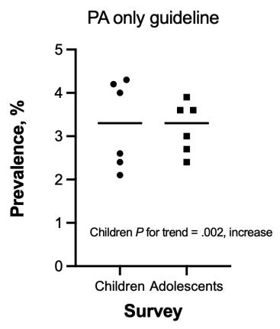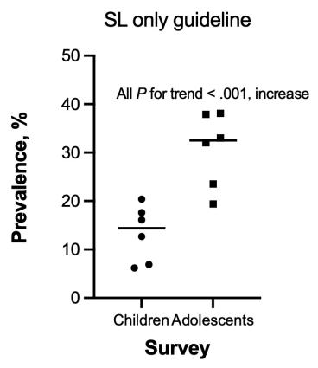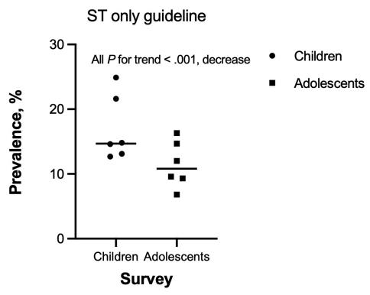
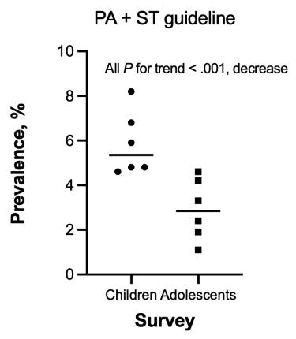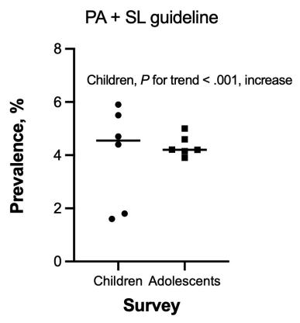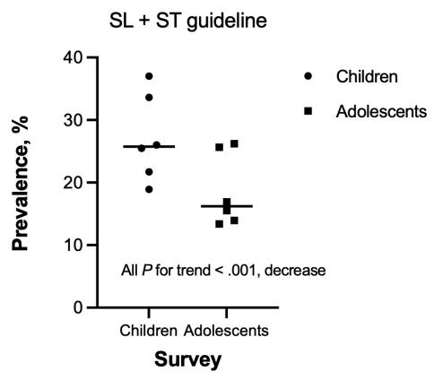

Abbreviations: PA= physical activity; ST= screen time; and SL= sleep duration.

Figure 1.2. Estimated prevalence of meeting 24-HMB guidelines according to sex, NSCH 2016-2021

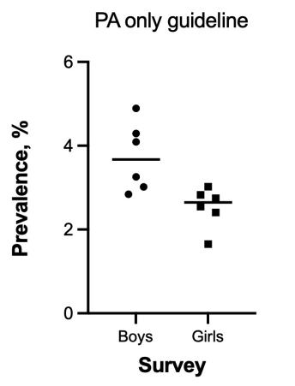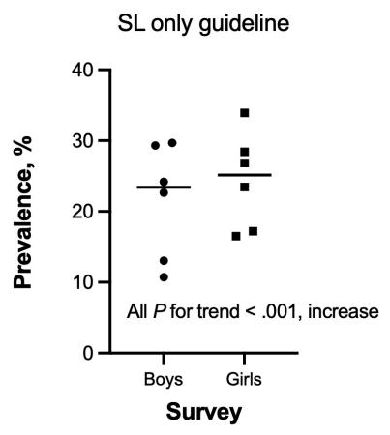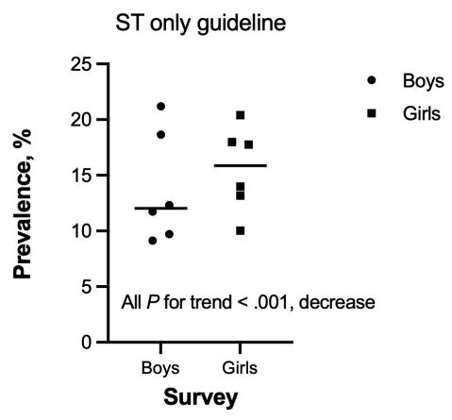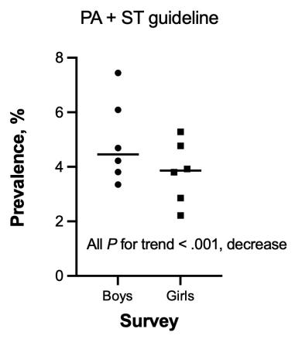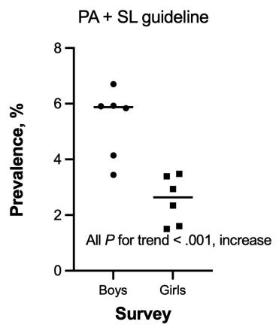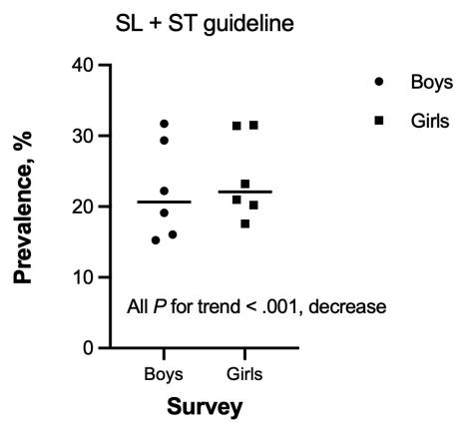
Abbreviations: PA= physical activity; ST= screen time; and SL= sleep duration

Figure 1.3. Estimated prevalence of meeting 24-HMB guidelines according to ethnicity, NSCH 2016-2021
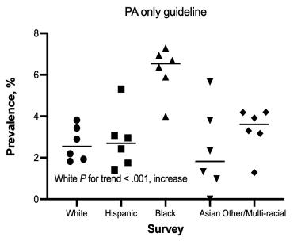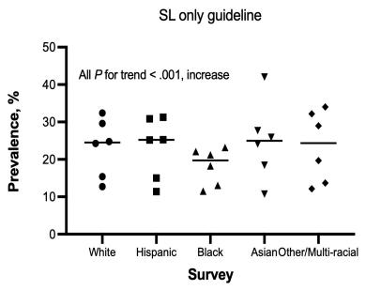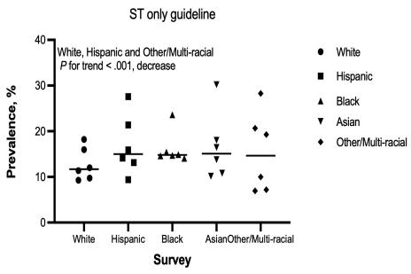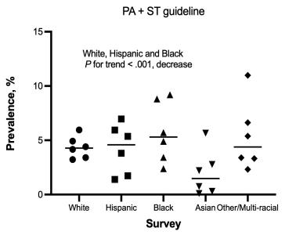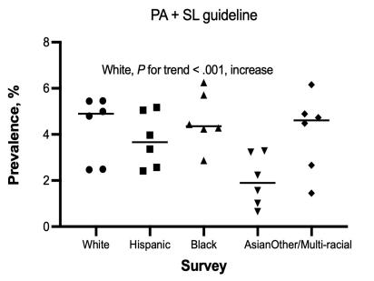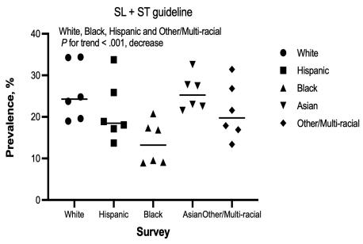
Abbreviations: PA=physical activity; SL= sleep; ST=screen time.

Figure 1.4. Estimated prevalence of meeting 24-HMB guidelines according to FPL, NSCH 2016-2021
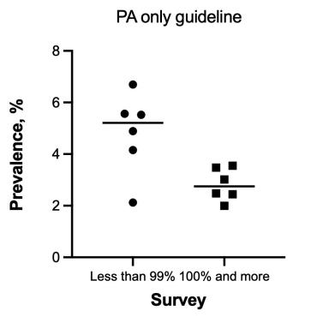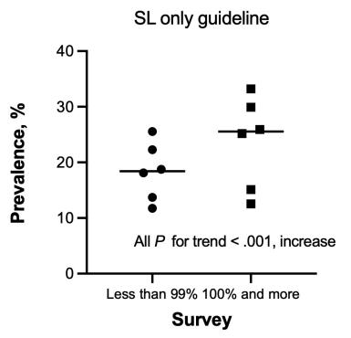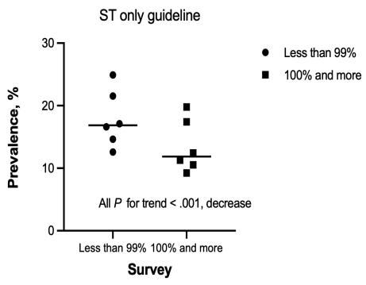
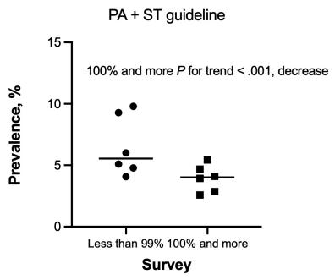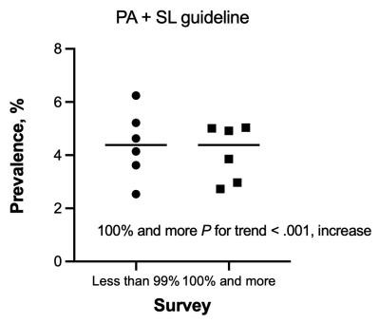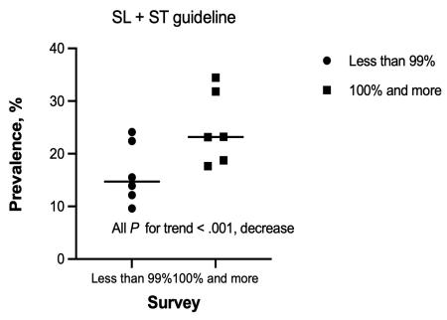

Abbreviations: PA=physical activity; SL= sleep; ST=screen time; FPL = Federal Poverty Level.

Figure 2. Crude weighted trends in 24-HMB guidelines among youth with MBD conditions

Figure 2.1 Crude weighted trends in 24-HMB guidelines among youth with anxiety/depression, NSCH 2016-2021
a)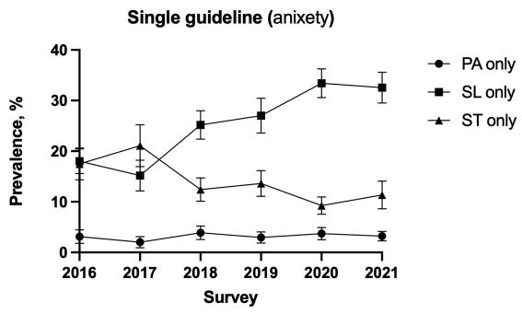b)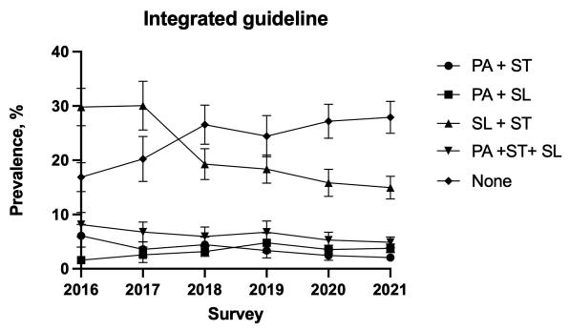
c)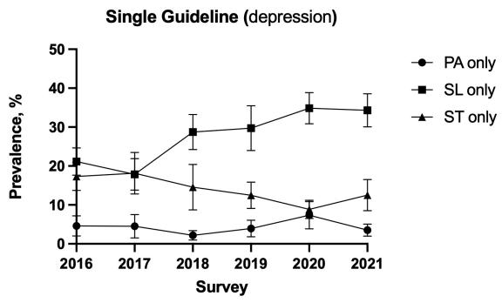 d)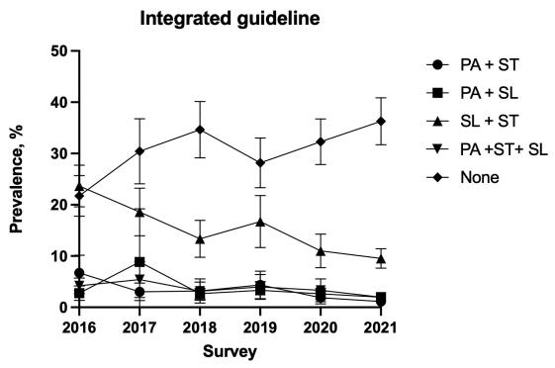
e)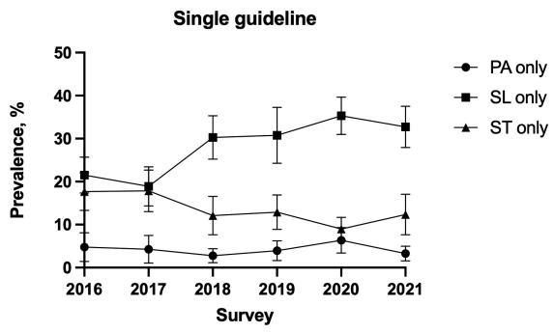f)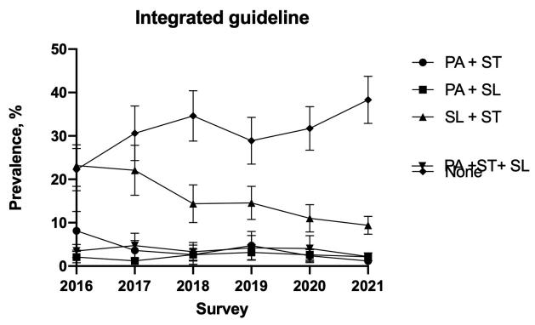
Note: a (independent guideline) and b (integrated guidelines) represent the estimated prevalence trend of 24-HMB guideline adherence among youth with anxiety (N=20,868), c (independent guideline) and d (integrated guidelines) represent the estimated prevalence trend of meeting 24-HMB guidelines among youth with depression (N=10,206), and e (independent guideline) and f (integrated guidelines) represent the estimated prevalence trend of meeting 24-HMB guidelines among youth with comorbidity of anxiety and depression (N=8,094). Figure a-f exhibited trends in categorical guidelines (single/integrated) over a span of 6 years,PA=physical activity; SL= sleep; ST=screen time; None= meeting none of the guidelines, ALL = meeting PA + ST + SL guidelines, and MBD=mental, behavioral, neurodevelopmental.

Figure 2.2. Crude weighted trends in 24-HMB guidelines among youth with ASD/ADHD, NSCH 2016-2021

a)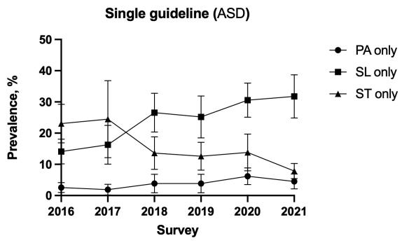 b)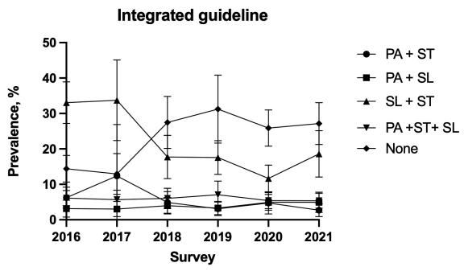
c)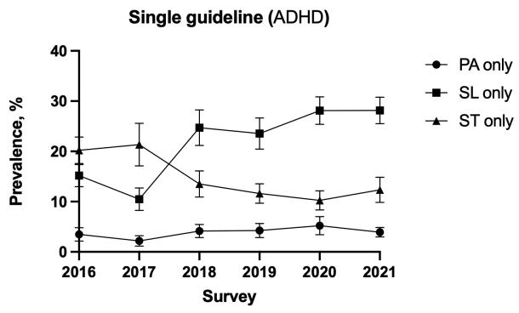d) 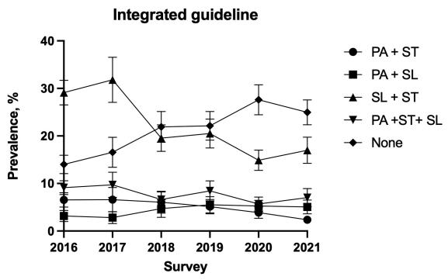
e)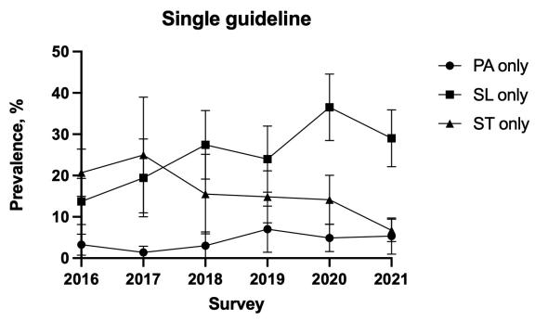 f)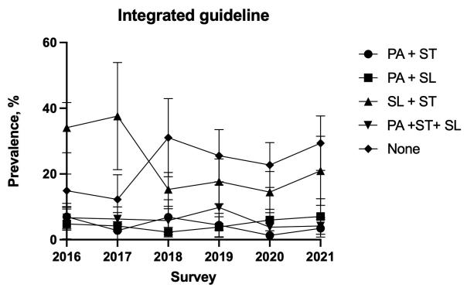
Note: a (independent guideline) and b (integrated guidelines) represent the estimated prevalence trend of meeting 24-HMB guideline among youth with ASD (N=4,944), c (independent guideline) and d (integrated guidelines) represent the estimated prevalence trend of meeting 24-HMB guidelines among youth with ADHD (N=19,301), and e (independent guideline) and f (integrated guidelines) represent the estimated prevalence trend of meeting 24-HMB guidelines among youth with comorbidity of ASD and ADHD (N=2,598). Figure a-f exhibited trends in categorical guidelines (single/integrated) over a span of 6 years,PA=physical activity; SL= sleep; ST=screen time; None= meeting none of the guidelines, and ALL = meeting PA + ST + SL guidelines.

Figure 2.3. Crude weighted trends in 24-HMB guidelines among youth with speech disorder, NSCH 2016-2021

a)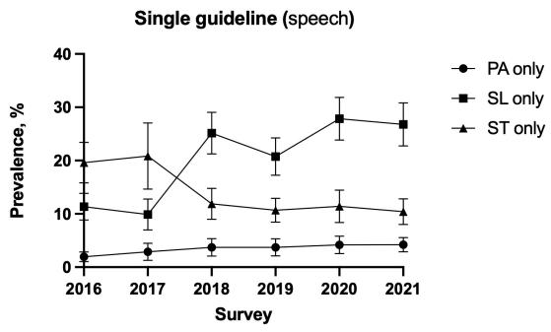b)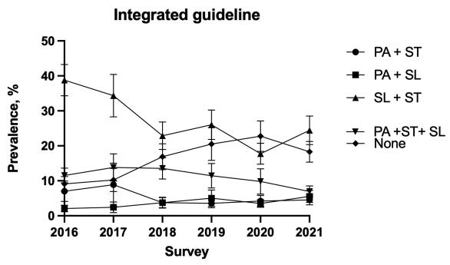
Note: a (independent guideline) and b (integrated guidelines) represent the estimated prevalence trend of meeting 24-HMB guideline among youth with speech disorder (N=11,948), Figure a-b exhibited trends in categorical guidelines (single/integrated) over a span of 6 years, PA=physical activity; SL= sleep; ST=screen time; None= meeting none of the guidelines, and ALL = meeting PA + ST + SL guidelines.

Figure 2.4. Crude weighted trends in 24-HMB guidelines among youth with learning disability, NSCH 2016-2021

a)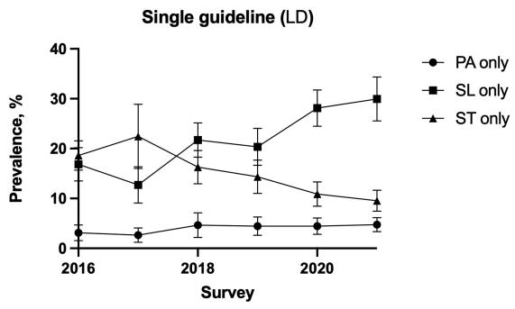 b)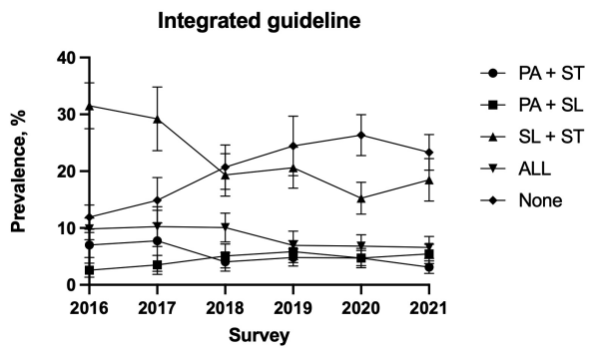

Note: a (independent guideline) and b (integrated guidelines) represent the estimated prevalence trend of meeting 24-HMB guideline among youth with learning disability (N=12,932), Figure a-b exhibited trends in categorical guidelines (single/integrated) over a span of 6 years, PA=physical activity; SL= sleep; ST=screen time; None= meeting none of the guidelines, and ALL = meeting PA + ST + SL guidelines.

Figure 2.5. Crude weighted trends in 24-HMB guidelines among youth with developmental delay, NSCH 2016-2021

- 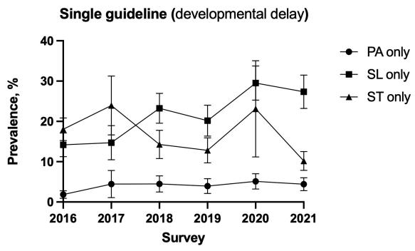b)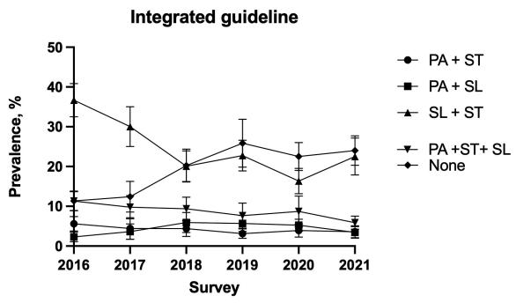

Note: a (independent guideline) and b (integrated guidelines) represent the estimated prevalence trend of meeting 24-HMB guideline among youth with developmental delay (N=10,478), Figure a-b exhibited trends in categorical guidelines (single/integrated) over a span of 6 years, PA=physical activity; SL= sleep; ST=screen time; None= meeting none of the guidelines, and ALL = meeting PA + ST + SL guidelines.

Figure 2.6. Crude weighted trends in 24-HMB guidelines among youth with behavior problem, NSCH 2016-2021

- 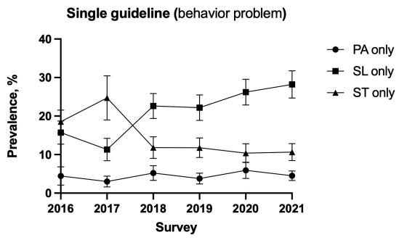b)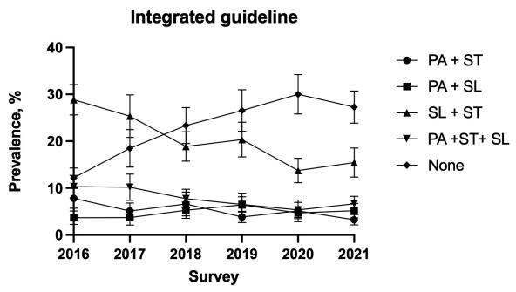
Note: a (independent guideline) and b (integrated guidelines) represent the estimated prevalence trend of meeting 24-HMB guideline among youth with behavior problem population (N=14,923) , Figure a-b exhibited trends in categorical guidelines (single/integrated) over a span of 6 years, PA=physical activity; SL= sleep; ST=screen time; None= meeting none of the guidelines, and ALL = meeting PA + ST + SL guidelines.

Figure 2.7. Crude weighted trends in 24-HMB guidelines among youth with brain injury, NSCH 2016-2021

- 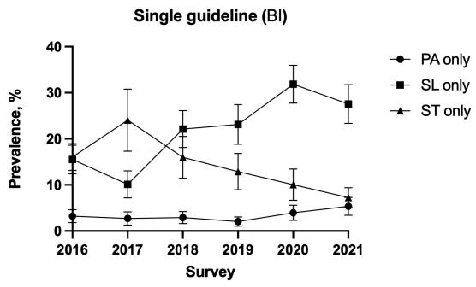b)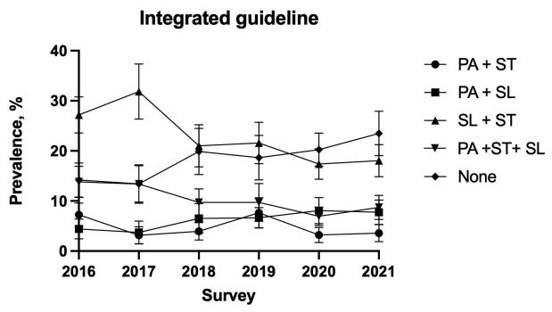

Note: a (independent guideline) and b (integrated guidelines) represent the estimated prevalence trend of meeting 24-HMB guideline among youth with brain injury (N=9,382), Figure a-b exhibited trends in categorical guidelines (single/integrated) over a span of 6 years, PA=physical activity; SL= sleep; ST=screen time; None= meeting none of the guidelines, and ALL = meeting PA + ST + SL guidelines.

