Supplementary table 1: Information on stations and catchments. Station names, coordinates (decimal degrees), catchment areas (km²), land cover (% of total watershed area) and % of catchment below the highest coastline (High coastline %). River mouth locations are sorted from north to south.
The land cover is divided into wetland (Wetl.), agriculture (Agr.), urbanised area (Urban), open water, forest on mineral soil (Forest min. soil), forest on peat (Forest peat) and other. Land cover estimates are based on CORINE data. Data for percent area above the highest coastline are from the Swedish Geological Survey.
Station | Decimal Latitude | Decimal Longitude | Area (km²) | Wetland %. | Agriculture %. | Urban % | Open water % | Forest mineral soil % | Forest peat % | Other % | Above Highest coastline %.
Råne älv Niemisel | 66.02 | 21.97 | 3714 | 27.2 | 0.1 | 0.0 | 4.1 | 61.4 | 4.0 | 3.2 | 23.0
Töre älv Infl.Bölträsket | 65.93 | 22.64 | 437 | 19.9 | 0.2 | 0.1 | 3.2 | 66.4 | 7.0 | 3.3 | 76.6
Torne älv Mattila | 65.88 | 24.13 | 267 | 16.2 | 4.1 | 0.1 | 4.7 | 45.7 | 10.3 | 18.7 | 21.8
Kalix älv Karlsborg | 65.84 | 23.17 | 23230 | 19.5 | 0.1 | 0.4 | 4.6 | 47.0 | 2.8 | 25.5 | 20.6
Skellefte älv Slagnäs | 65.67 | 18.15 | 2097 | 12.3 | 0.0 | 0.1 | 26.0 | 52.8 | 1.4 | 7.5 | 0
Lule älv Luleå | 65.60 | 22.01 | 24462 | 10.9 | 0.3 | 0.1 | 10.0 | 37.8 | 1.4 | 39.5 | 8.1
Alterälven Norrfjärden | 65.42 | 21.49 | 445 | 8.4 | 2.7 | 0.1 | 4.3 | 73.5 | 7.9 | 3.2 | 91.5
Pite älv Bölebyn | 65.38 | 21.30 | 6848 | 11.7 | 0.5 | 0.1 | 6.2 | 71.0 | 3.0 | 7.4 | 12.2
Skellefte älv. Kvistforsen | 64.74 | 20.77 | 3062 | 14.5 | 1.1 | 0.3 | 7.2 | 66.9 | 5.5 | 4.5 | 4.6
Vindelälven Maltbrännan | 64.58 | 19.29 | 9820 | 12.0 | 0.1 | 0.1 | 6.5 | 49.9 | 1.7 | 29.8 | 0.5
Rickleån Robertsfors | 64.20 | 20.82 | 1595 | 9.1 | 2.1 | 0.1 | 9.9 | 69.9 | 5.8 | 3.2 | 30.3
Öre älv Torrböle | 63.70 | 19.60 | 2863 | 16.3 | 1.1 | 0.1 | 3.2 | 70.9 | 5.4 | 3.0 | 19.4
Lögde älv Lögdeå | 63.55 | 19.41 | 1606 | 13.4 | 0.4 | 0.1 | 4.7 | 74.9 | 3.4 | 3.1 | 25.7
Ammerån Skyttmon | 63.42 | 15.57 | 2271 | 19.4 | 0.9 | 0.1 | 6.4 | 58.3 | 6.7 | 8.3 | 0
Gide älv Gideåbacka | 63.35 | 19.12 | 3422 | 11.2 | 0.8 | 0.1 | 6.2 | 74.3 | 4.6 | 2.9 | 15.9
Ångermanälven Sollefteå | 63.17 | 17.26 | 29030 | 12.6 | 0.4 | 0.1 | 8.9 | 60.7 | 3.3 | 14.1 | 6.5
Indalsälven Hammarstrand | 63.11 | 16.36 | 21417 | 11.9 | 1.5 | 0.1 | 10.8 | 51.6 | 3.6 | 20.6 | 0.9
Ljusnan Funäsdalen | 62.55 | 12.57 | 295 | 5.8 | 0.2 | 0.1 | 1.6 | 29.7 | 0.2 | 62.4 | 0.5
Indalsälven Bergeforsen | 62.52 | 17.40 | 23349 | 11.4 | 1.5 | 0.2 | 10.3 | 53.8 | 3.8 | 19.1 | 2.7
Ljungan Skallböleforsen | 62.36 | 16.96 | 12063 | 8.1 | 0.8 | 0.1 | 7.8 | 69.2 | 4.0 | 9.9 | 9.2
Ljusnan, Ljusne Strömmar | 61.21 | 17.08 | 19803 | 10.8 | 1.5 | 0.2 | 5.7 | 67.3 | 3.4 | 11.3 | 14.5
Dalälven Älvkarleby | 60.56 | 17.44 | 27558 | 9.8 | 2.5 | 0.3 | 7.3 | 67.4 | 4.3 | 8.3 | 20.3
V. Dalälven Mockfjärd | 60.48 | 14.90 | 7464 | 14.3 | 0.6 | 0.2 | 5.5 | 66.0 | 5.5 | 8.0 | 7.8
Forsmarksån Johannisfors | 60.35 | 18.20 | 374 | 9.2 | 4.3 | 0.1 | 4.4 | 64.9 | 12.0 | 5.0 | 100
Klarälven Edsforsen | 60.07 | 13.53 | 2608 | 11.0 | 0.8 | 0.1 | 5.6 | 72.2 | 4.9 | 5.4 | 3.7
Sävjaån Ingvasta | 60.01 | 17.85 | 24 | 0.3 | 2.7 | 0.4 | 0.7 | 83.0 | 9.1 | 3.9 | 100
Klarälven  Norra Råda | 60.00 | 13.59 | 1667 | 9.7 | 0.6 | 0.2 | 10.3 | 70.4 | 5.5 | 3.3 | 8.4
Klarälven Almar | 59.45 | 13.45 | 6219 | 9.2 | 2.0 | 0.2 | 7.7 | 70.6 | 4.8 | 5.5 | 55.8
Gullspångsälv. Gullspång | 58.98 | 14.11 | 4942 | 6.0 | 3.4 | 0.4 | 13.5 | 67.6 | 4.9 | 4.3 | 38.0
Upperudsälv. Köpmannebro | 58.78 | 12.51 | 3040 | 2.0 | 2.9 | 0.3 | 16.5 | 68.5 | 3.0 | 6.7 | 66.9
Svedån Sved | 58.02 | 14.13 | 39 | 1.8 | 2.6 | 0.1 | 4.7 | 74.2 | 9.7 | 7.0 | 0.8
Emån Emsfors | 57.14 | 16.45 | 4 | 2.5 | 0.4 | 0.1 | 0.3 | 80.5 | 9.8 | 6.5 | 12.6
Nissan Halmstad | 56.69 | 12.87 | 2676 | 7.4 | 4.4 | 0.7 | 5.3 | 60.5 | 13.3 | 8.4 | 2.6
Lyckebyån Lyckeby | 56.20 | 15.66 | 795 | 3.0 | 2.8 | 0.6 | 4.4 | 75.9 | 5.0 | 8.5 | 2.8

Supplementary table 2: Nominal p-values and number of sampling years (n) per river for temporal analysis of total phosphorus (TP) and the annual areal flux of TP (TP-flux). Temporal trends were investigated using Mann-Kendell´s tau.
Station | TP |  | TP-flux
Station | p-value | n | p-value | n
Råne älv Niemisel | 1,4E-08 | 42 | 8,7E-03 | 42
Töre älv Infl.Bölträsket | 3,6E-06 | 42 | 1,9E-03 | 42
Torne älv Mattila | 1,1E-06 | 42 | 9,5E-02 | 42
Kalix älv Karlsborg | 5,0E-05 | 42 | 3,0E-01 | 42
Skellefte älv Slagnäs | 1,2E-12 | 42 | 2,2E-07 | 42
Lule älv Luleå | 5,7E-08 | 39 | 2,3E-03 | 42
Alterälven Norrfjärden | 7,5E-02 | 42 | 9,0E-01 | 42
Pite älv Bölebyn | 1,1E-08 | 42 | 2,9E-01 | 42
Skellefte älv. Kvistforsen | 3,6E-12 | 40 | 8,3E-07 | 42
Vindelälven Maltbrännan | 2,8E-11 | 42 | 6,7E-05 | 42
Rickleån Robertsfors | 9,6E-09 | 41 | 7,8E-04 | 42
Öre älv Torrböle | 5,9E-05 | 42 | 6,9E-02 | 42
Lögde älv Lögdeå | 5,7E-03 | 40 | 1,2E-01 | 42
Ammerån Skyttmon | 3,5E-09 | 41 | 2,8E-05 | 42
Gide älv Gideåbacka | 1,4E-05 | 31 | 1,6E-03 | 42
Ångermanälven Sollefteå | 2,7E-08 | 42 | 1,5E-05 | 42
Indalsälven Hammarstrand | 8,5E-12 | 41 | 1,5E-05 | 42
Ljusnan Funäsdalen | 7,5E-10 | 39 | 9,5E-06 | 42
Indalsälven Bergeforsen | 2,6E-10 | 41 | 4,6E-07 | 42
Ljungan Skallböleforsen | 8,2E-10 | 40 | 5,3E-08 | 42
Ljusnan, Ljusne Strömmar | 1,9E-09 | 40 | 5,2E-06 | 42
Dalälven Älvkarleby | 1,4E-05 | 38 | 3,2E-04 | 42
V. Dalälven Mockfjärd | 3,7E-07 | 42 | 4,2E-05 | 42
Forsmarksån Johannisfors | 5,3E-02 | 42 | 2,1E-03 | 42
Klarälven Edsforsen | 4,5E-09 | 42 | 2,9E-05 | 42
Sävjaån Ingvasta | 5,9E-01 | 42 | 1,1E-02 | 42
Klarälven  Norra Råda | 7,4E-07 | 42 | 7,2E-04 | 42
Klarälven Almar | 7,2E-08 | 42 | 6,2E-04 | 42
Gullspångsälv. Gullspång | 8,4E-07 | 42 | 9,1E-04 | 42
Upperudsälv. Köpmannebro | 7,2E-10 | 42 | 1,0E-04 | 42
Svedån Sved | 4,8E-09 | 42 | 5,5E-05 | 42
Emån Emsfors | 4,2E-05 | 42 | 9,1E-02 | 42
Nissan Halmstad | 1,5E-08 | 42 | 2,1E-05 | 42
Lyckebyån Lyckeby | 5,7E-01 | 41 | 3,2E-01 | 42

Supplementary table 3: Direction of temporal trends. Number of rivers showing a positive, negative or non significant temporal trend for each of the potential drivers. Significance was assessed at a nominal p-value of 0.05. Temporal trends were investigated using Mann-Kendell´s tau.
* TOC data was available for 26/34 rivers.
 | Positive | Negative | No trend
Alkalinity | 23 | - | 11
pH | 18 | 1 | 15
Calcium | 5 | 8 | 21
Total organic carbon (TOC)* | 16 | - | 10
Growing degree days (GDD) | 34 | - | -
Precipitation | 4 | 1 | 29
Air temperature | 34 | - | -
Runoff | 2 | - | 32

Supplementary table 4: Pearson´s correlation between TP and each of air temperature (Air Temp.), alkalinity (Alk), calcium (Ca), growing degree days (GDD), pH, precipitation (Prec.), runoff (Q), and total organic carbon (TOC). Sites are sorted by river mouth location from north to south.
TOC was available for 26 of the 34 rivers.
Station | AirTemp | Alk | Ca | GDD | pH | Prec. | Q | TOC
Råne älv Niemisel | -0,46 | 0,11 | 0,38 | -0,37 | 0,10 | -0,32 | -0,21 | -0,43
Töre älv Infl.Bölträsket | -0,43 | 0,36 | 0,54 | -0,24 | 0,03 | -0,27 | -0,23
Torne älv Mattila | -0,28 | -0,14 | 0,01 | -0,19 | -0,29 | -0,04 | -0,04
Kalix älv Karlsborg | -0,46 | -0,30 | -0,30 | -0,48 | -0,42 | -0,01 | 0,02 | 0,16
Skellefte älv Slagnäs | -0,44 | -0,67 | -0,15 | -0,34 | -0,42 | -0,18 | -0,12
Lule älv Luleå | -0,55 | -0,60 | -0,43 | -0,53 | -0,60 | -0,33 | -0,14 | -0,03
Alterälven Norrfjärden | -0,21 | 0,24 | 0,09 | 0,24 | 0,22 | -0,32 | -0,09 | 0,00
Pite älv Bölebyn | -0,51 | -0,41 | -0,10 | -0,31 | -0,16 | -0,28 | 0,05 | 0,09
Skellefte älv. Kvistforsen | -0,62 | -0,34 | -0,07 | -0,49 | -0,46 | -0,11 | -0,09
Vindelälven Maltbrännan | -0,49 | -0,54 | -0,15 | -0,38 | -0,49 | -0,06 | -0,02
Rickleån Robertsfors | -0,61 | -0,55 | -0,09 | -0,53 | -0,54 | 0,04 | 0,04 | -0,29
Öre älv Torrböle | -0,39 | -0,15 | 0,02 | -0,36 | -0,46 | 0,26 | 0,16 | -0,11
Lögde älv Lögdeå | -0,26 | -0,30 | -0,16 | -0,11 | -0,35 | 0,15 | 0,18 | -0,00
Ammerån Skyttmon | -0,36 | -0,12 | 0,09 | -0,34 | -0,47 | 0,10 | 0,11 | -0,19
Gide älv Gideåbacka | -0,53 | -0,14 | 0,43 | -0,58 | 0,26 | -0,03 | 0,05 | -0,41
Ångermanälven Sollefteå | -0,52 | -0,56 | 0,15 | -0,30 | -0,39 | 0,04 | 0,24 | -0,01
Indalsälven Hammarstrand | -0,44 | -0,61 | -0,34 | -0,43 | -0,31 | -0,00 | 0,08 | -0,05
Ljusnan Funäsdalen | -0,52 | -0,02 | 0,29 | -0,37 | -0,14 | -0,08 | -0,00 | -0,19
Indalsälven Bergeforsen | -0,48 | -0,49 | -0,18 | -0,41 | -0,38 | -0,16 | 0,13 | -0,11
Ljungan Skallböleforsen | -0,46 | -0,71 | -0,31 | -0,38 | -0,36 | -0,06 | 0,16 | -0,04
Ljusnan, Ljusne Strömmar | -0,58 | -0,62 | -0,52 | -0,57 | -0,55 | 0,10 | 0,28 | -0,22
Dalälven Älvkarleby | -0,26 | -0,59 | 0,27 | -0,20 | -0,65 | 0,31 | 0,24 | -0,28
V. Dalälven Mockfjärd | -0,53 | -0,36 | 0,06 | -0,47 | -0,47 | 0,05 | 0,20
Forsmarksån Johannisfors | -0,40 | 0,09 | 0,05 | -0,27 | -0,65 | 0,48 | 0,43 | 0,19
Klarälven Edsforsen | -0,31 | -0,33 | -0,19 | -0,36 | -0,36 | -0,01 | -0,02 | -0,42
Sävjaån Ingvasta | -0,02 | -0,03 | -0,10 | -0,05 | -0,04 | 0,02 | -0,01 | 0,09
Klarälven Norra Råda | -0,28 | -0,59 | -0,47 | -0,21 | -0,62 | -0,10 | -0,07 | -0,44
Klarälven Almar | -0,29 | -0,72 | -0,34 | -0,30 | -0,67 | -0,03 | 0,19 | -0,34
Gullspångsälv. Gullspång | -0,38 | -0,81 | 0,52 | -0,40 | -0,48 | -0,16 | 0,16 | -0,23
Upperudsälv. Köpmannebro | -0,46 | -0,41 | 0,74 | -0,53 | -0,30 | -0,15 | -0,15
Svedån Sved | -0,51 | -0,35 | 0,13 | -0,55 | -0,10 | 0,07 | -0,06
Emån Emsfors | -0,54 | -0,64 | -0,08 | -0,58 | -0,41 | 0,19 | 0,27 | 0,13
Nissan Halmstad | -0,43 | -0,46 | 0,09 | -0,50 | -0,60 | -0,05 | -0,07 | -0,52
Lyckebyån Lyckeby | -0,14 | -0,37 | -0,35 | -0,08 | -0,34 | 0,13 | 0,53 | 0,63

Supplementary figure 1: Spaghetti plot of median TP concentration over time. Blue line shows the overall median concentration and the black lines the min and max concentrations.

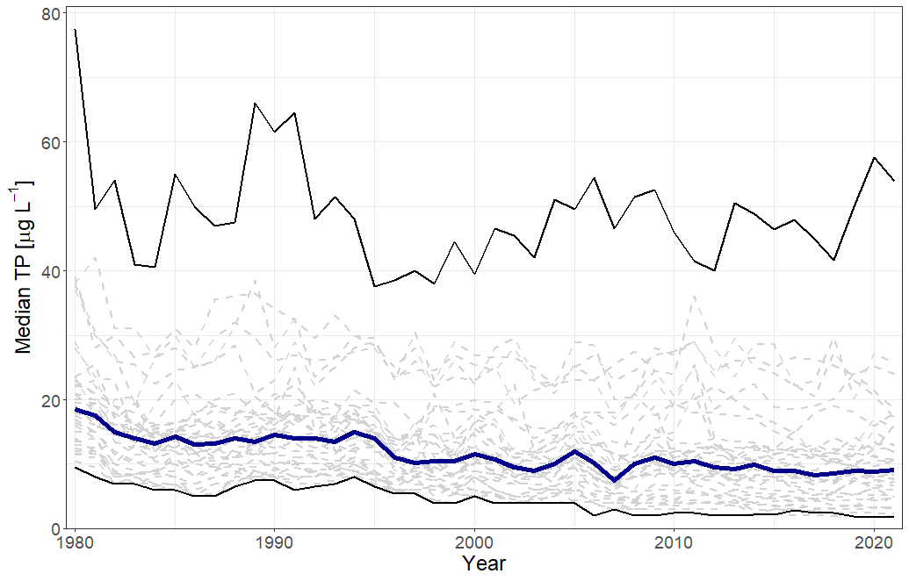

Supplementary figure 2: Spaghetti plot of median TP-flux over time. The blue line represents the overall median while the black lines show min and max values.

