Evidence for widespread thermal acclimation of canopy photosynthesis

Jiangong Liu^{1*}, Youngryel Ryu^{1,2*}, Xiangzhong Luo³, Benjamin Dechant^{1,4,5}, Benjamin D. Stocker^{6,7}, Trevor F. Keenan^{8,9}, Pierre Gentine^{10,11}, Xing Li¹, Bolun Li^{1,12}, Sandy P. Harrison^{13,14}, Iain Colin Prentice^{14,15}

¹ Research Institute of Agriculture and Life Sciences, Seoul National University, Seoul, Republic of Korea
² Department of Landscape Architecture and Rural Systems Engineering, Seoul National University, Seoul, Republic of Korea
³ Department of Geography, National University of Singapore, 1 Arts Link, Singapore 117570
⁴ German Centre for Integrative Biodiversity Research (iDiv) Halle-Jena-Leipzig, Leipzig, Germany
⁵ Leipzig University, Leipzig, Germany
⁶ Institute of Geography, University of Bern, Bern, Switzerland
⁷ Oeschger Centre for Climate Change Research, University of Bern, Bern, Switzerland
⁸ Climate and Ecosystem Sciences Division, Lawrence Berkeley National Laboratory, 1 Cyclotron Road, Berkeley, CA 94720, USA
⁹ Department of Environmental Science, Policy, and Management, University of California, Berkeley, CA 94720, USA
¹⁰ Earth and Environmental Engineering Department, Columbia University, New York, NY 10027, USA
¹¹ Climate School, Columbia University, New York, NY 10025, USA
¹² School of Geographical Sciences, Nanjing University of Information Science and Technology, Nanjing 210044, China
¹³ School of Archaeology, Geography and Environmental Science (SAGES), University of Reading, Reading RG6 6AH, United Kingdom
¹⁴ Department of Earth System Science, Ministry of Education Key Laboratory for Earth System Modeling, Institute for Global Change Studies, Tsinghua University, Beijing 100084, China
¹⁵ Georgina Mace Centre for the Living Planet, Department of Life Sciences, Imperial College London, Silwood Park Campus, Buckhurst Road, Ascot SL5 7PY, United Kingdom

*Corresponding author: Jiangong Liu (jl6314@columbia.edu); Youngryel Ryu (yryu@snu.ac.kr)

The SI contains 2 Supplementary Texts, 2 Supplementary Tables, 5 Supplementary Figures, and Supplementary References.

Supplementary Text 1. Farquhar-von Caemmerer-Berry model (FvCB) for estimating CO₂ assimilation rate
We employ the standard FvCB model¹, which comprises the photosynthetic module of the Breathing Earth System Simulator (BESS)^{2,3}, to estimate the canopy-scale CO₂ assimilation rate (A) of C₃ plants in a big-leaf framework. Within the big-leaf framework, we assume the canopy functions as a single bulk plane that serves as the source and sink for all mass and energy fluxes⁴. The model determines A based on the slower rate of two biochemical processes: A_{j}, which is the electron transport for ribulose-1,5-bisphosphate (RuBP) at low light and is dependent on the capacity of the electron transport chain (J_{max}; μmol m⁻² s⁻¹), and A_{c}, which is the carboxylation of RuBP and is dependent on ribulose-1,5-bisphosphate carboxylase/oxygenase (Rubisco) activities (V_{cmax}; μmol m⁻² s⁻¹). Both A_{j} and A_{c} are influenced by intercellular CO₂ concentrations (C_{i}). For non-optimality-based BESS versions (i.e., BESS_{PFT} and BESS_{LAI}), we assume a fixed ratio of C_{i} to the ambient CO₂ concentration (C_{a}), which is referred to as χ and set at 0.7⁵. The eco-evolutionary optimality (EEO) theory suggests that plants tend to maximize carbon gain and minimize water loss by regulating stomatal conductance, which results in an optimal χ value⁶. We use optimal χ for optimality-based BESS (BESS_{EEO}) (Supplementary Text 2).
$$\begin{aligned}A_{j}=\frac{αIJ_{max}}{αI+2.1J_{max}}\frac{\left(C_{i}-Γ^{*}\right)}{4\left(C_{i}+2Γ^{*}\right)} \#\left(1\right)\end{aligned}$$
$$\begin{aligned}A_{c}=\frac{V_{cmax}\left(C_{i}-Γ^{*}\right)}{C_{i}+K_{c}\left(1+\frac{O}{K_{o}}\right)} \#\left(2\right)\end{aligned}$$
$$\begin{aligned}A=\min\left(A_{c},A_{j}\right) \#\left(3\right)\end{aligned}$$
where I (μmol photons m⁻² s⁻¹) is incident photosynthetically photon flux density, $α$ (mol mol⁻¹) is the intrinsic quantum yield based on incident light, $Γ^{*}$ (Pa) is the CO₂ compensation point in the absence of dark respiration, O (Pa) is oxygen partial pressure, and K_{c} (Pa) and K_{o} (Pa) are Michaelis-Menten constants of Rubisco for CO₂ and O₂, respectively⁷.

In this study, we integrate the parameters characterizing acclimation and adaptation following ref⁸ into the BESS code. An Arrhenius function is used to describe the temperature dependencies of V_{cmax} and J_{max} for the baseline BESS⁹:
$$\begin{aligned}k=k^{25C}×exp\left[\frac{H_{a}×1000×\left(T-298.15\right)}{298.15×R×T}\right]×\frac{\left[1+\exp\left(\frac{298.15×S-H_{d}}{298.15×R}\right)\right]}{\left[1+\exp\left(\frac{S×T-H_{d}}{R×T}\right)\right]} \#\left(4\right)\end{aligned}$$
where $k^{25C}$ represents $V_{cmax}^{25C}$ and $J_{max}^{25C}$, and R is the universal gas constant (8.31 J K⁻¹ mol⁻¹). T is the canopy temperature in °K. H_{a}, H_{d} and S are activation energy (kJ mol⁻¹), deactivation energy fixed at 200 kJ mol⁻¹, and entropy factor (kJ mol⁻¹ K⁻¹), respectively.

We use three empirical approaches to estimate V_{cmax} variants at a reference temperature of 25 °C ($V_{cmax}^{25C}$) (see Methods), and calculate $J_{max}^{25C}$ as a function of $V_{cmax}^{25C}$, home temperature (T_{home}, °C) and growth temperature ($\overline{T_{air}}$, °C)⁸. Here, T_{home} is defined as the average air temperature of the warmest month over the measurement period following ref¹⁰. The values of H_{a} and S are estimated as functions of $\overline{T_{air}}$ and T_{home} to account for acclimation, with a general form as:
$\begin{aligned}H_{a} or S = a\overline{T_{air}}+bT_{home}+c\left(\overline{T_{air}} -T_{home}\right)+d \#\left(5\right)\end{aligned}$
where parameters a, b, c and d are set, following refs^{8,10} and can be found in Supplementary Table 2. We test two approaches to estimate T, which assume that T is equivalent to either the air temperature (T_{air}, °K) or the aerodynamic surface temperature (T_{s}, °K) of the big-leaf plane:
$$\begin{aligned}T_{s}=T_{air}+\frac{H}{ρG_{ah}c_{p}} \#\left(6\right)\end{aligned}$$
where H is the sensible heat flux (W m⁻²), ρ is the air density (kg m⁻³), G_{ah} is the aerodynamic conductance to heat transfer (m s⁻¹), and C_{p} is the heat capacity of dry air (J K⁻¹ kg⁻¹). G_{ah} is calculated as the sum of aerodynamic conductance to momentum transfer¹¹ and canopy boundary layer conductance to heat transfer¹² with R package bigleaf⁴. The estimated T_{s} shows a strong correlation with T_{air} with an R² of 0.95 ± 0.06 and Slope of 0.94 ± 0.09 (mean ± 1–SD, model: T_{air} ∼ T_{s}) over FLUXNET2015 sites. Overall, T_{air} and T_{s} achieve highly similar results in estimating A under I equivalent to 2000 μmol m⁻² s⁻¹ (A_{max,2000}), and we finally choose T_{air} considering its better availability. A detailed description of other processes of the FvCB model in BESS is given in refs^{2,3,9}.

Supplementary Text 2. EEO-based estimate of leaf photosynthetic capacity

The coordination hypothesis posits that leaf A_{c} (equation 2) tends to be equal to A_{j} (equation 1) over intermediate time scales, meaning that photosynthesis operates at a co-limitation point of A_{c} and A_{j}^{13,14}. To account for the effect of finite J_{max}^{6,15}, we modify equation (1) using a non-rectangular hyperbola function¹⁶:
$$\begin{aligned}A_{j}=\frac{αI}{\sqrt{1+{\left(\frac{αI}{J_{max}}\right)}^{2}}}\frac{\left(C_{i}-Γ^{*}\right)}{\left(C_{i}+2Γ^{*}\right)} \#\left(7\right)\end{aligned}$$
$$\begin{aligned}α=\frac{a_{L}b_{L}}{4}Φ_{PSII,max}M \#\left(8\right)\end{aligned}$$
where a_{L} = 0.8 represents the leaf absorptance, b_{L} = 0.5 represents the fraction of absorbed light for photosystem II (PSII), and the factor 4 accounts for the number of electron equivalents required to assimilate one CO₂ molecule. The constant M = 12 (g) represents the weight of 1 mol carbon. $Φ_{PSII,max}$ represents the maximum quantum yield of PSII for a representative light-adapted leaf, and is dependent on temperature (T)¹⁷:
$$\begin{aligned}Φ_{PSII,max}=0.352+0.022T-0.00034T^{2} \#\left(9\right)\end{aligned}$$
The least-cost theory proposes that plants can optimize $χ$ by minimizing the combined unit costs per carbon assimilation of maintaining carbon assimilation and water transpiration (E)¹⁸:
$$\begin{aligned}e\frac{∂\left(E/A\right)}{∂χ}=-f\frac{∂\left(V_{cmax}/A\right)}{∂χ} \#\left(10\right)\end{aligned}$$
where e and f (unitless) are the unit costs for E and A, respectively. One optimal $χ$ value can be resolved from equation (10) through an application of Fick’s law of diffusion for H₂O and CO₂¹⁸:
$$\begin{aligned}χ=\frac{\sqrt{β\frac{K+Γ^{*}}{1.6η^{*}}}+\frac{Γ^{*}\sqrt{VPD}}{C_{a}}}{\sqrt{β\frac{K+Γ^{*}}{1.6η^{*}}}+\sqrt{VPD}} \#\left(11\right)\end{aligned}$$
where VPD (Pa) is the vapor pressure deficit, and K (Pa) is the effective Michaelis-Menten coefficient of Rubisco¹⁹. $η^{*}$ (Pa s), which represents the viscosity of water at 25 °C, can be estimated using a T dependence function⁶. The parameter $β$ is the ratio of the unit costs a and b (equation 9) when standardized to their values at 25 °C, and is fixed at 146 based on an updated isotope-derived $χ$ database^{6,15}.

Furthermore, we assume that the optimal J_{max} value maximizes the difference between carbon gain (A_{j}) and the cost of c$×$J_{max}, where c (unitless) is a cost factor. We estimate c to be 0.103 based on a typical value of J_{max}/V_{cmax} = 1.88^{6,20}. By establishing an equivalence between equations (2) and (7), we can solve for an EEO-based leaf-scale V_{cmax} value (V_{cmax_EEO}):
$$\begin{aligned}V_{cmax_EEO}=αI\frac{C_{i}+K}{C_{i}+2Γ^{*}}\sqrt{1-{\left[\frac{4c\left(C_{i}+2Γ^{*}\right)}{C_{i}-Γ^{*}}\right]}^{\frac{2}{3}}} \#\left(12\right)\end{aligned}$$
For the seasonally-fixed $V_{cmax}^{25C}$ ($V_{cmax_PFT}^{25C}$) and phenology-based $V_{cmax}^{25C}$ ($V_{cmax_LAI}^{25C}$), they are derived for the top leaves. When calculating $V_{cmax_EEO}^{25C}$, we assume a fraction of 1 for absorbed photosynthetically active radiation to represent leaves located at the top of a canopy. This assumption ensures consistency in the derivation of canopy $V_{cmax}^{25C}$ among the three BESS variants.

To convert top-leaf $V_{cmax}^{25C}$ ($V_{cmax,top}^{25C}$) to representative-leaf $V_{cmax}^{25C}$ ($V_{cmax,ave}^{25C}$), we use a satellite-based clumping index (k_{n}, unitless) derived from a global map²¹, which indicates the non-randomness of leaf distribution⁷:
$$\begin{aligned}V_{cmax,ave}^{25C}=V_{cmax,top}^{25C}×\frac{1-e^{-k_{n}}}{k_{n}}\#\left(12\right)\end{aligned}$$
We calculate canopy-scale representative $V_{cmax}^{25C}$ ($V_{cmax,canopy}^{25C}$) following:
$$\begin{aligned}V_{cmax,canopy}^{25C}=V_{cmax,ave}^{25C}×LAI \#\left(13\right)\end{aligned}$$
Detailed deduction of V_{cmax_EEO} can be found in ref²².

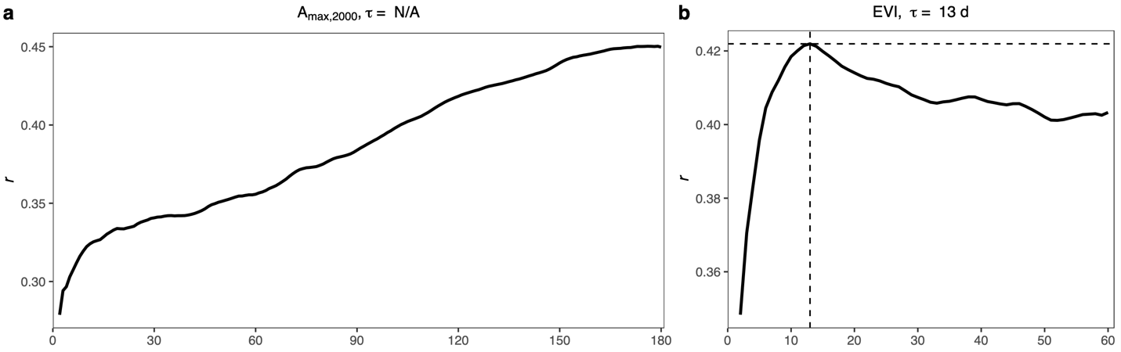
Supplementary Fig. 1: Responses of the 5-d moving average of correlation (r) between photosynthetic capacity metrics and $\overline{T_{air}}$ to the number of days used for averaging daytime T_{air} for evergreen broadleaf forests (EBF). a-b, A_{max,2000} (a) and enhanced vegetation index (EVI) (b) are used to indicate canopy photosynthetic capacity. Daily EVI for each EBF flux site is derived from MODIS MCD43A4.
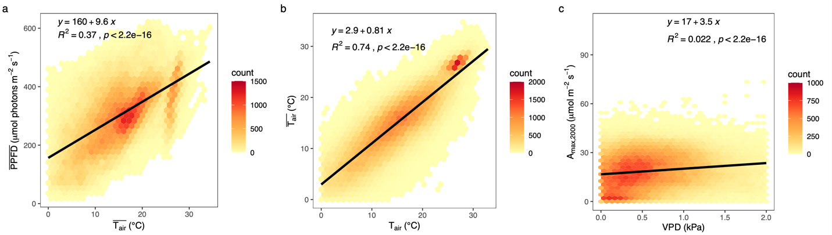
Supplementary Fig. 2: Relationships among environmental variables and A_{max,2000}. a–c, The relationships between $\overline{T_{air}}$ and $\overline{PPFD}$ (a), between $\overline{T_{air}}$ and T_{air} (b) and between A_{max,2000} and VPD (c). Black lines represent linear fits (Y ∼ X).

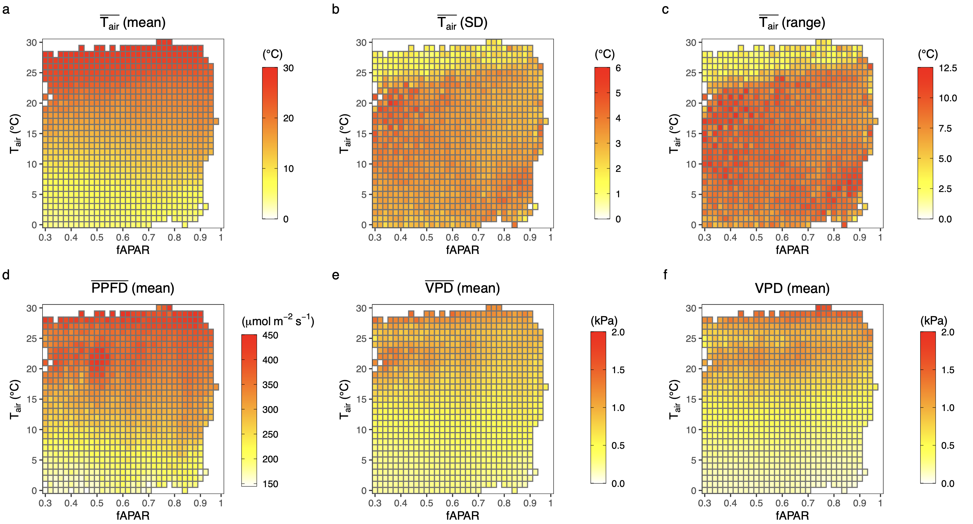
Supplementary Fig. 3: Averages (mean), standard deviations (SD) and ranges of environmental variables in the fPAR-T_{air} bin pairs for the cross-site analysis. a–c, The mean (a),SD (b) and range (c) of $\overline{T_{air}}$ (°C), d, the mean of $\overline{PPFD}$ (μmol m⁻² s⁻¹), and e–f, the mean of $\overline{VPD}$ (kPa) and VPD (kPa) in each fPAR-T_{air} bin pair.

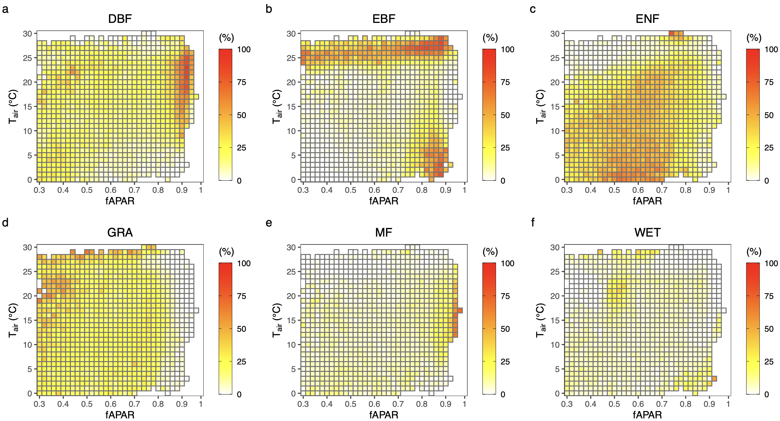
Supplementary Fig. 4: Percentage of each plant functional type (PFT) in fPAR-T_{air} bin pairs for the cross-site analysis. a–f, The ratio (%) of the number of each PFT to the total sampling number in each fPAR-T_{air} bin pair, for deciduous broadleaf forests (DBF) (a), evergreen broadleaf forests (EBF) (b), evergreen needle-leaf forests (ENF) (c), grasslands (GRA) (d), mixed forests (MF) (e), and wetlands (WET) (f).

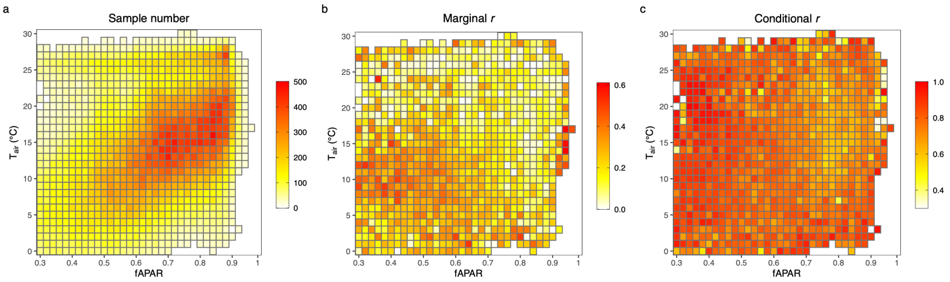
Supplementary Fig. 5: Statistical metrics for the cross-site analysis. a–c, The sampling number (a), marginal correlation coefficient (marginal r) (b), and conditional correlation coefficient (conditional r) (c) for the cross-site analysis using linear mix-effect models (A_{max,2000} ∼ $\overline{T_{air}}$ + (1⏐Site)).

Supplementary Table 1: Site information of the FLUXNET2015 database
Site | Latitude | Longitude | IGBPª | Period | Model^{b} | DOI
AR-SLu | -33.4648 | -66.4598 | MF | 2009-2011 | No | 10.18140/FLX/1440191
AR-Vir | -28.2395 | -56.1886 | ENF | 2009-2012 | No | 10.18140/FLX/1440192
AT-Neu | 47.11667 | 11.3175 | GRA | 2002-2012 | Yes | 10.18140/FLX/1440121
AU-Ade | -13.0769 | 131.1178 | WSA | 2007-2009 | No | 10.18140/FLX/1440193
AU-ASM | -22.283 | 133.249 | SAV | 2010-2014 | No | 10.18140/FLX/1440194
AU-Cpr | -34.0021 | 140.5891 | SAV | 2010-2014 | No | 10.18140/FLX/1440195
AU-Cum | -33.61518 | 150.72362 | EBF | 2012-2014 | No | 10.18140/FLX/1440196
AU-DaP | -14.0633 | 131.3181 | GRA | 2007-2013 | Yes | 10.18140/FLX/1440123
AU-DaS | -14.1593 | 131.3881 | SAV | 2008-2014 | No | 10.18140/FLX/1440122
AU-Dry | -15.2588 | 132.3706 | SAV | 2008-2014 | No | 10.18140/FLX/1440197
AU-Emr | -23.8587 | 148.4746 | GRA | 2011-2013 | No | 10.18140/FLX/1440198
AU-Fog | -12.5452 | 131.3072 | WET | 2006-2008 | No | 10.18140/FLX/1440124
AU-Gin | -31.3764 | 115.7138 | WSA | 2011-2014 | No | 10.18140/FLX/1440199
AU-GWW | -30.1913 | 120.6541 | SAV | 2013-2014 | No | 10.18140/FLX/1440200
AU-How | -12.4943 | 131.1523 | WSA | 2001-2014 | No | 10.18140/FLX/1440125
AU-Lox | -34.4704 | 140.6551 | DBF | 2008-2009 | Yes | 10.18140/FLX/1440247
AU-RDF | -14.5636 | 132.4776 | WSA | 2011-2013 | No | 10.18140/FLX/1440201
AU-Rig | -36.6499 | 145.5759 | GRA | 2011-2014 | Yes | 10.18140/FLX/1440202
AU-Rob | -17.1175 | 145.6301 | EBF | 2014-2014 | No | 10.18140/FLX/1440203
AU-Stp | -17.1507 | 133.3502 | GRA | 2008-2014 | No | 10.18140/FLX/1440204
AU-TTE | -22.287 | 133.64 | GRA | 2012-2014 | No | 10.18140/FLX/1440205
AU-Tum | -35.6566 | 148.1517 | EBF | 2001-2014 | No | 10.18140/FLX/1440126
AU-Wac | -37.4259 | 145.1878 | EBF | 2005-2008 | No | 10.18140/FLX/1440127
AU-Whr | -36.6732 | 145.0294 | EBF | 2011-2014 | No | 10.18140/FLX/1440206
AU-Wom | -37.4222 | 144.0944 | EBF | 2010-2014 | No | 10.18140/FLX/1440207
AU-Ync | -34.9893 | 146.2907 | GRA | 2012-2014 | Yes | 10.18140/FLX/1440208
BE-Bra | 51.30761 | 4.51984 | MF | 1996-2014 | No | 10.18140/FLX/1440128
BE-Lon | 50.55162 | 4.74623 | CRO | 2004-2014 | No | 10.18140/FLX/1440129
BE-Vie | 50.30493 | 5.99812 | MF | 1996-2014 | No | 10.18140/FLX/1440130
BR-Sa1 | -2.85667 | -54.95889 | EBF | 2002-2011 | No | 10.18140/FLX/1440032
BR-Sa3 | -3.01803 | -54.97144 | EBF | 2000-2004 | No | 10.18140/FLX/1440033
CA-Gro | 48.2167 | -82.1556 | MF | 2003-2014 | Yes | 10.18140/FLX/1440034
CA-Man | 55.87962 | -98.48081 | ENF | 1994-2008 | No | 10.18140/FLX/1440035
CA-NS1 | 55.87917 | -98.48389 | ENF | 2001-2005 | Yes | 10.18140/FLX/1440036
CA-NS2 | 55.90583 | -98.52472 | ENF | 2001-2005 | Yes | 10.18140/FLX/1440037
CA-NS3 | 55.91167 | -98.38222 | ENF | 2001-2005 | Yes | 10.18140/FLX/1440038
CA-NS4 | 55.91437 | -98.380645 | ENF | 2002-2005 | Yes | 10.18140/FLX/1440039
CA-NS5 | 55.86306 | -98.485 | ENF | 2001-2005 | Yes | 10.18140/FLX/1440040
CA-NS6 | 55.91667 | -98.96444 | OSH | 2001-2005 | No | 10.18140/FLX/1440041
CA-NS7 | 56.63583 | -99.94833 | OSH | 2002-2005 | No | 10.18140/FLX/1440042
CA-Oas | 53.62889 | -106.19779 | DBF | 1996-2010 | Yes | 10.18140/FLX/1440043
CA-Obs | 53.98717 | -105.11779 | ENF | 1997-2010 | Yes | 10.18140/FLX/1440044
CA-Qfo | 49.6925 | -74.34206 | ENF | 2003-2010 | Yes | 10.18140/FLX/1440045
CA-SF1 | 54.48503 | -105.81757 | ENF | 2003-2006 | No | 10.18140/FLX/1440046
CA-SF2 | 54.25392 | -105.8775 | ENF | 2001-2005 | Yes | 10.18140/FLX/1440047
CA-SF3 | 54.09156 | -106.00526 | OSH | 2001-2006 | No | 10.18140/FLX/1440048
CA-TP1 | 42.6609361 | -80.559519 | ENF | 2002-2014 | No | 10.18140/FLX/1440050
CA-TP2 | 42.7744194 | -80.458775 | ENF | 2002-2007 | No | 10.18140/FLX/1440051
CA-TP3 | 42.7068111 | -80.348314 | ENF | 2002-2014 | No | 10.18140/FLX/1440052
CA-TP4 | 42.710161 | -80.357376 | ENF | 2002-2014 | Yes | 10.18140/FLX/1440053
CA-TPD | 42.635328 | -80.557731 | DBF | 2012-2014 | Yes | 10.18140/FLX/1440112
CG-Tch | -4.28917 | 11.65642 | SAV | 2006-2009 | No | 10.18140/FLX/1440142
CH-Cha | 47.21022 | 8.41044 | GRA | 2005-2014 | No | 10.18140/FLX/1440131
CH-Dav | 46.81533 | 9.85591 | ENF | 1997-2014 | No | 10.18140/FLX/1440132
CH-Fru | 47.11583 | 8.53778 | GRA | 2005-2014 | No | 10.18140/FLX/1440133
CH-Lae | 47.47833 | 8.36439 | MF | 2004-2014 | No | 10.18140/FLX/1440134
CH-Oe1 | 47.28583 | 7.73194 | GRA | 2002-2008 | No | 10.18140/FLX/1440135
CH-Oe2 | 47.28642 | 7.73375 | CRO | 2004-2014 | No | 10.18140/FLX/1440136
CN-Cha | 42.4025 | 128.0958 | MF | 2003-2005 | No | 10.18140/FLX/1440137
CN-Cng | 44.5934 | 123.5092 | GRA | 2007-2010 | Yes | 10.18140/FLX/1440209
CN-Dan | 30.4978 | 91.0664 | GRA | 2004-2005 | No | 10.18140/FLX/1440138
CN-Din | 23.1733 | 112.5361 | EBF | 2003-2005 | No | 10.18140/FLX/1440139
CN-Du2 | 42.0467 | 116.2836 | GRA | 2006-2008 | Yes | 10.18140/FLX/1440140
CN-Du3 | 42.0551 | 116.2809 | GRA | 2009-2010 | Yes | 10.18140/FLX/1440210
CN-Ha2 | 37.6086 | 101.3269 | WET | 2003-2005 | No | 10.18140/FLX/1440211
CN-HaM | 37.37 | 101.18 | GRA | 2002-2004 | Yes | 10.18140/FLX/1440190
CN-Qia | 26.7414 | 115.0581 | ENF | 2003-2005 | No | 10.18140/FLX/1440141
CN-Sw2 | 41.7902 | 111.8971 | GRA | 2010-2012 | No | 10.18140/FLX/1440212
CZ-BK1 | 49.50208 | 18.53688 | ENF | 2004-2014 | No | 10.18140/FLX/1440143
CZ-BK2 | 49.49443 | 18.54285 | GRA | 2004-2012 | No | 10.18140/FLX/1440144
CZ-wet | 49.02465 | 14.77035 | WET | 2006-2014 | Yes | 10.18140/FLX/1440145
DE-Akm | 53.86617 | 13.68342 | WET | 2009-2014 | No | 10.18140/FLX/1440213
DE-Geb | 51.09973 | 10.91463 | CRO | 2001-2014 | No | 10.18140/FLX/1440146
DE-Gri | 50.95004 | 13.51259 | GRA | 2004-2014 | No | 10.18140/FLX/1440147
DE-Hai | 51.07921 | 10.45217 | DBF | 2000-2012 | Yes | 10.18140/FLX/1440148
DE-Kli | 50.89306 | 13.52238 | CRO | 2004-2014 | Yes | 10.18140/FLX/1440149
DE-Lkb | 49.09962 | 13.30467 | ENF | 2009-2013 | No | 10.18140/FLX/1440214
DE-Lnf | 51.32822 | 10.3678 | DBF | 2002-2012 | Yes | 10.18140/FLX/1440150
DE-Obe | 50.78666 | 13.72129 | ENF | 2008-2014 | No | 10.18140/FLX/1440151
DE-RuR | 50.62191 | 6.30413 | GRA | 2011-2014 | No | 10.18140/FLX/1440215
DE-RuS | 50.86591 | 6.44714 | CRO | 2011-2014 | Yes | 10.18140/FLX/1440216
DE-Seh | 50.87062 | 6.44965 | CRO | 2007-2010 | No | 10.18140/FLX/1440217
DE-SfN | 47.80639 | 11.3275 | WET | 2012-2014 | Yes | 10.18140/FLX/1440219
DE-Spw | 51.89225 | 14.03369 | WET | 2010-2014 | Yes | 10.18140/FLX/1440220
DE-Tha | 50.96256 | 13.56515 | ENF | 1996-2014 | Yes | 10.18140/FLX/1440152
DE-Zrk | 53.87594 | 12.88901 | WET | 2013-2014 | Yes | 10.18140/FLX/1440221
DK-Eng | 55.69053 | 12.19175 | GRA | 2005-2008 | No | 10.18140/FLX/1440153
DK-Fou | 56.4842 | 9.58722 | CRO | 2005-2005 | No | 10.18140/FLX/1440154
DK-Sor | 55.48587 | 11.64464 | DBF | 1996-2014 | Yes | 10.18140/FLX/1440155
ES-Amo | 36.83361 | -2.25232 | OSH | 2007-2012 | No | 10.18140/FLX/1440156
ES-LgS | 37.09794 | -2.96583 | OSH | 2007-2009 | No | 10.18140/FLX/1440225
ES-LJu | 36.92659 | -2.75212 | OSH | 2004-2013 | No | 10.18140/FLX/1440157
ES-Ln2 | 36.9695 | -3.47582 | OSH | 2009-2009 | No | 10.18140/FLX/1440226
FI-Hyy | 61.84741 | 24.29477 | ENF | 1996-2014 | Yes | 10.18140/FLX/1440158
FI-Jok | 60.8986 | 23.51345 | CRO | 2000-2003 | Yes | 10.18140/FLX/1440159
FI-Let | 60.64183 | 23.95952 | ENF | 2009-2012 | Yes | 10.18140/FLX/1440227
FI-Lom | 67.99724 | 24.20918 | WET | 2007-2009 | Yes | 10.18140/FLX/1440228
FI-Sod | 67.36239 | 26.63859 | ENF | 2001-2014 | Yes | 10.18140/FLX/1440160
FR-Fon | 48.47636 | 2.7801 | DBF | 2005-2014 | Yes | 10.18140/FLX/1440161
FR-Gri | 48.84422 | 1.95191 | CRO | 2004-2014 | No | 10.18140/FLX/1440162
FR-LBr | 44.71711 | -0.7693 | ENF | 1996-2008 | No | 10.18140/FLX/1440163
FR-Pue | 43.7413 | 3.5957 | EBF | 2000-2014 | No | 10.18140/FLX/1440164
GF-Guy | 5.27877 | -52.92486 | EBF | 2004-2014 | No | 10.18140/FLX/1440165
GH-Ank | 5.26854 | -2.69421 | EBF | 2011-2014 | No | 10.18140/FLX/1440229
GL-NuF | 64.13083 | -51.38611 | WET | 2008-2014 | No | 10.18140/FLX/1440222
GL-ZaF | 74.48143 | -20.55452 | WET | 2008-2011 | No | 10.18140/FLX/1440223
GL-ZaH | 74.47328 | -20.5503 | GRA | 2000-2014 | No | 10.18140/FLX/1440224
IT-BCi | 40.52375 | 14.95744 | CRO | 2004-2014 | No | 10.18140/FLX/1440166
IT-CA1 | 42.38041 | 12.02656 | DBF | 2011-2014 | No | 10.18140/FLX/1440230
IT-CA2 | 42.37722 | 12.02604 | CRO | 2011-2014 | No | 10.18140/FLX/1440231
IT-CA3 | 42.38 | 12.0222 | DBF | 2011-2014 | No | 10.18140/FLX/1440232
IT-Col | 41.84936 | 13.58814 | DBF | 1996-2014 | Yes | 10.18140/FLX/1440167
IT-Cp2 | 41.70427 | 12.35729 | EBF | 2012-2014 | No | 10.18140/FLX/1440233
IT-Cpz | 41.70525 | 12.37611 | EBF | 1997-2009 | No | 10.18140/FLX/1440168
IT-Isp | 45.81264 | 8.63358 | DBF | 2013-2014 | Yes | 10.18140/FLX/1440234
IT-La2 | 45.9542 | 11.2853 | ENF | 2000-2002 | No | 10.18140/FLX/1440235
IT-Lav | 45.9562 | 11.28132 | ENF | 2003-2014 | No | 10.18140/FLX/1440169
IT-MBo | 46.01468 | 11.04583 | GRA | 2003-2013 | Yes | 10.18140/FLX/1440170
IT-Noe | 40.60618 | 8.15169 | CSH | 2004-2014 | No | 10.18140/FLX/1440171
IT-PT1 | 45.20087 | 9.06104 | DBF | 2002-2004 | Yes | 10.18140/FLX/1440172
IT-Ren | 46.58686 | 11.43369 | ENF | 1998-2013 | No | 10.18140/FLX/1440173
IT-Ro1 | 42.40812 | 11.93001 | DBF | 2000-2008 | Yes | 10.18140/FLX/1440174
IT-Ro2 | 42.39026 | 11.92093 | DBF | 2002-2012 | No | 10.18140/FLX/1440175
IT-SR2 | 43.73202 | 10.29091 | ENF | 2013-2014 | No | 10.18140/FLX/1440236
IT-SRo | 43.72786 | 10.28444 | ENF | 1999-2012 | No | 10.18140/FLX/1440176
IT-Tor | 45.84444 | 7.57806 | GRA | 2008-2014 | Yes | 10.18140/FLX/1440237
JP-MBF | 44.3869 | 142.3186 | DBF | 2003-2005 | Yes | 10.18140/FLX/1440238
JP-SMF | 35.2617 | 137.0788 | MF | 2002-2006 | No | 10.18140/FLX/1440239
MY-PSO | 2.973 | 102.3062 | EBF | 2003-2009 | No | 10.18140/FLX/1440240
NL-Hor | 52.24035 | 5.0713 | GRA | 2004-2011 | Yes | 10.18140/FLX/1440177
NL-Loo | 52.16658 | 5.74356 | ENF | 1996-2014 | No | 10.18140/FLX/1440178
PA-SPn | 9.31814 | -79.6346 | DBF | 2007-2009 | No | 10.18140/FLX/1440180
PA-SPs | 9.31378 | -79.63143 | GRA | 2007-2009 | No | 10.18140/FLX/1440179
RU-Che | 68.61304 | 161.34143 | WET | 2002-2005 | Yes | 10.18140/FLX/1440181
RU-Cok | 70.82914 | 147.49428 | OSH | 2003-2014 | No | 10.18140/FLX/1440182
RU-Fyo | 56.46153 | 32.92208 | ENF | 1998-2014 | No | 10.18140/FLX/1440183
RU-Ha1 | 54.72517 | 90.00215 | GRA | 2002-2004 | Yes | 10.18140/FLX/1440184
SD-Dem | 13.2829 | 30.4783 | SAV | 2005-2009 | No | 10.18140/FLX/1440186
SJ-Adv | 78.186 | 15.923 | WET | 2011-2014 | No | 10.18140/FLX/1440241
SJ-Blv | 78.92163 | 11.83109 | SNO | 2008-2009 | No | 10.18140/FLX/1440242
SN-Dhr | 15.40278 | -15.43222 | SAV | 2010-2013 | No | 10.18140/FLX/1440246
US-AR1 | 36.4267 | -99.42 | GRA | 2009-2012 | No | 10.18140/FLX/1440103
US-AR2 | 36.6358 | -99.5975 | GRA | 2009-2012 | No | 10.18140/FLX/1440104
US-ARb | 35.5497 | -98.0402 | GRA | 2005-2006 | Yes | 10.18140/FLX/1440064
US-ARc | 35.54649 | -98.04 | GRA | 2005-2006 | Yes | 10.18140/FLX/1440065
US-ARM | 36.6058 | -97.4888 | CRO | 2003-2012 | No | 10.18140/FLX/1440066
US-Atq | 70.4696 | -157.4089 | WET | 2003-2008 | No | 10.18140/FLX/1440067
US-Blo | 38.8953 | -120.6328 | ENF | 1997-2007 | No | 10.18140/FLX/1440068
US-Cop | 38.09 | -109.39 | GRA | 2001-2007 | No | 10.18140/FLX/1440100
US-CRT | 41.628495 | -83.347086 | CRO | 2011-2013 | No | 10.18140/FLX/1440117
US-GBT | 41.36579 | -106.2397 | ENF | 1999-2006 | Yes | 10.18140/FLX/1440118
US-GLE | 41.36653 | -106.2399 | ENF | 2004-2014 | Yes | 10.18140/FLX/1440069
US-Goo | 34.2547 | -89.8735 | GRA | 2002-2006 | No | 10.18140/FLX/1440070
US-Ha1 | 42.5378 | -72.1715 | DBF | 1991-2012 | Yes | 10.18140/FLX/1440071
US-IB2 | 41.84062 | -88.24103 | GRA | 2004-2011 | Yes | 10.18140/FLX/1440072
US-Ivo | 68.4865 | -155.7503 | WET | 2004-2007 | Yes | 10.18140/FLX/1440073
US-KS1 | 28.4583 | -80.6709 | ENF | 2002-2002 | No | 10.18140/FLX/1440074
US-KS2 | 28.6086 | -80.6715 | CSH | 2003-2006 | No | 10.18140/FLX/1440075
US-Lin | 36.3566 | -119.8423 | CRO | 2009-2010 | No | 10.18140/FLX/1440107
US-Los | 46.0827 | -89.9792 | WET | 2000-2014 | Yes | 10.18140/FLX/1440076
US-LWW | 34.9604 | -97.9789 | GRA | 1997-1998 | No | 10.18140/FLX/1440077
US-Me1 | 44.5794 | -121.5 | ENF | 2004-2005 | No | 10.18140/FLX/1440078
US-Me2 | 44.4523 | -121.5574 | ENF | 2002-2014 | No | 10.18140/FLX/1440079
US-Me3 | 44.3154 | -121.6078 | ENF | 2004-2009 | No | 10.18140/FLX/1440080
US-Me4 | 44.4992 | -121.6224 | ENF | 1996-2000 | No | 10.18140/FLX/1440081
US-Me5 | 44.43719 | -121.56676 | ENF | 2000-2002 | No | 10.18140/FLX/1440082
US-Me6 | 44.3232842 | -121.6078 | ENF | 2010-2014 | No | 10.18140/FLX/1440099
US-MMS | 39.3232 | -86.4131 | DBF | 1999-2014 | Yes | 10.18140/FLX/1440083
US-Myb | 38.049861 | -121.76498 | WET | 2010-2014 | No | 10.18140/FLX/1440105
US-Ne1 | 41.16506 | -96.47664 | CRO | 2001-2013 | No | 10.18140/FLX/1440084
US-Ne2 | 41.16487 | -96.4701 | CRO | 2001-2013 | No | 10.18140/FLX/1440085
US-Ne3 | 41.17967 | -96.43965 | CRO | 2001-2013 | No | 10.18140/FLX/1440086
US-NR1 | 40.0329 | -105.5464 | ENF | 1998-2014 | Yes | 10.18140/FLX/1440087
US-Oho | 41.5545 | -83.8438 | DBF | 2004-2013 | Yes | 10.18140/FLX/1440088
US-ORv | 40.0201 | -83.0183 | WET | 2011-2011 | No | 10.18140/FLX/1440102
US-PFa | 45.9459 | -90.2723 | MF | 1995-2014 | No | 10.18140/FLX/1440089
US-Prr | 65.12367 | -147.48756 | ENF | 2010-2014 | Yes | 10.18140/FLX/1440113
US-SRC | 31.9083 | -110.8395 | MF | 2008-2014 | No | 10.18140/FLX/1440098
US-SRG | 31.789379 | -110.82768 | GRA | 2008-2014 | No | 10.18140/FLX/1440114
US-SRM | 31.8214 | -110.8661 | WSA | 2004-2014 | No | 10.18140/FLX/1440090
US-Sta | 41.3966 | -106.8024 | OSH | 2005-2009 | No | 10.18140/FLX/1440115
US-Syv | 46.242 | -89.3477 | MF | 2001-2014 | No | 10.18140/FLX/1440091
US-Ton | 38.4316 | -120.96598 | WSA | 2001-2014 | No | 10.18140/FLX/1440092
US-Tw1 | 38.1074 | -121.6469 | WET | 2012-2014 | No | 10.18140/FLX/1440108
US-Tw2 | 38.1047 | -121.6433 | CRO | 2012-2013 | No | 10.18140/FLX/1440109
US-Tw3 | 38.1159 | -121.6467 | CRO | 2013-2014 | No | 10.18140/FLX/1440110
US-Tw4 | 38.10298 | -121.6414 | WET | 2013-2014 | No | 10.18140/FLX/1440111
US-Twt | 38.1087204 | -121.6531 | CRO | 2009-2014 | No | 10.18140/FLX/1440106
US-UMB | 45.5598 | -84.7138 | DBF | 2000-2014 | Yes | 10.18140/FLX/1440093
US-UMd | 45.5625 | -84.6975 | DBF | 2007-2014 | Yes | 10.18140/FLX/1440101
US-Var | 38.4133 | -120.9507 | GRA | 2000-2014 | Yes | 10.18140/FLX/1440094
US-WCr | 45.8059 | -90.0799 | DBF | 1999-2014 | Yes | 10.18140/FLX/1440095
US-Whs | 31.7438 | -110.0522 | OSH | 2007-2014 | No | 10.18140/FLX/1440097
US-Wi0 | 46.618778 | -91.081444 | ENF | 2002-2002 | Yes | 10.18140/FLX/1440055
US-Wi1 | 46.730472 | -91.232944 | DBF | 2003-2003 | Yes | 10.18140/FLX/1440054
US-Wi2 | 46.686889 | -91.152833 | ENF | 2003-2003 | No | 10.18140/FLX/1440056
US-Wi3 | 46.634722 | -91.098667 | DBF | 2002-2004 | Yes | 10.18140/FLX/1440057
US-Wi4 | 46.739333 | -91.16625 | ENF | 2002-2005 | No | 10.18140/FLX/1440058
US-Wi5 | 46.653083 | -91.085806 | ENF | 2004-2004 | Yes | 10.18140/FLX/1440059
US-Wi6 | 46.624889 | -91.298222 | OSH | 2002-2003 | No | 10.18140/FLX/1440060
US-Wi7 | 46.649111 | -91.069278 | OSH | 2005-2005 | No | 10.18140/FLX/1440061
US-Wi8 | 46.722333 | -91.252417 | DBF | 2002-2002 | Yes | 10.18140/FLX/1440062
US-Wi9 | 46.618778 | -91.081444 | ENF | 2004-2005 | No | 10.18140/FLX/1440063
US-Wkg | 31.7365 | -109.9419 | GRA | 2004-2014 | No | 10.18140/FLX/1440096
US-WPT | 41.464639 | -82.996157 | WET | 2011-2013 | No | 10.18140/FLX/1440116
ZM-Mon | -15.4391 | 23.2525 | DBF | 2000-2009 | No | 10.18140/FLX/1440189
ªThe land cover classification defined by The International Geosphere–Biosphere Programme (IGBP) (definitions are as in Fig. 2)
^{b}If the site is C₃, non-cropland and non-dryland, and demonstrates acceptable model performance (R² > 0.5) across all three model variants
Supplementary Table 2: Parameter values for temperature dependency functions of V_{cmax} and J_{max} (equation 5)

Parameters | H_{a,v}ª | H_{a,j}^{b} | S_{v}^{c} | S_{j}^{d} | b_{jv}^{e}
a | 1.14 | 0 | -0.38 | 0 | 0
b | 0 | 0 | 0 | -0.84 | -0.0375
c | 0 | 0 | 0 | -0.52 | -0.0202
d | 42.6 | 40.71 | 645.13 | 658.77 | 2.56
ªActivation energy of V_{cmax}
^{b}Activation energy of J_{max}
^{c}Entropy term of V_{cmax}
^{d}Entropy term of J_{max}
^{e}The ratio of $J_{max}^{25C}$ to $V_{cmax}^{25C}$
References

1. Farquhar, G. D., von Caemmerer, S. & Berry, J. A. A biochemical model of photosynthetic CO₂ assimilation in leaves of C₃ species. Planta 149, 78–90 (1980).
2. Jiang, C. & Ryu, Y. Multi-scale evaluation of global gross primary productivity and evapotranspiration products derived from Breathing Earth System Simulator (BESS). Remote Sensing of Environment 186, 528–547 (2016).
3. Ryu, Y. et al. Integration of MODIS land and atmosphere products with a coupled-process model to estimate gross primary productivity and evapotranspiration from 1 km to global scales. Global Biogeochemical Cycles 25, 1–24 (2011).
4. Knauer, J., El-Madany, T. S., Zaehle, S. & Migliavacca, M. Bigleaf—An R package for the calculation of physical and physiological ecosystem properties from eddy covariance data. PLoS ONE 13, 1–26 (2018).
5. Baldocchi, D. An analytical solution for coupled leaf photosynthesis and stomatal conductance models. Tree Physiology 14, 1069–1079 (1994).
6. Wang, H. et al. Towards a universal model for carbon dioxide uptake by plants. Nature Plants 3, 734–741 (2017).
7. De Pury, D. G. G. & Farquhar, G. D. Simple scaling of photosynthesis from leaves to canopies without the errors of big-leaf models. Plant, Cell and Environment 20, 537–557 (1997).
8. Kumarathunge, D. P. et al. Acclimation and adaptation components of the temperature dependence of plant photosynthesis at the global scale. New Phytologist 222, 768–784 (2019).
9. Li, B. et al. BESSv2.0: A satellite-based and coupled-process model for quantifying long-term global land–atmosphere fluxes. Remote Sensing of Environment 295, 113696 (2023).
10. Knauer, J. et al. Higher global gross primary productivity under future climate with more advanced representations of photosynthesis. Sci. Adv. 9, eadh9444 (2023).
11. Verma, S. B. Aerodynamic resistances to transfers of heat, mass and momentum. in Estimation of areal evapotranspiration (pp. 13–20) (Wallingford, UK: International Association of Hydrological Sciences IAHS Publication No. 177, 1989).
12. Thom, A. S. Momentum, mass and heat exchange of vegetation. Q.J Royal Met. Soc. 98, 124–134 (1972).
13. Chen, J. L., Reynolds, J. F., Harley, P. C. & Tenhunen, J. D. Coordination theory of leaf nitrogen distribution in a canopy. Oecologia 93, 63–69 (1993).
14. Maire, V. et al. The coordination of leaf photosynthesis links C and N fluxes in C₃ plant species. PLoS ONE 7, 1–15 (2012).
15. Stocker, B. D. et al. P-model v1.0: An optimality-based light use efficiency model for simulating ecosystem gross primary production. Geoscientific Model Development 13, 1545–1581 (2020).
16. Smith, E. L. The influence of light and carbon dioxide on photosynthesis. Journal of General Physiology 20, 807–830 (1937).
17. Bernacchi, C. J., Pimentel, C. & Long, S. P. In vivo temperature response functions of parameters required to model RuBP-limited photosynthesis: Modelling RuBP-limited photosynthesis. Plant, Cell & Environment 26, 1419–1430 (2003).
18. Prentice, I. C., Dong, N., Gleason, S. M., Maire, V. & Wright, I. J. Balancing the costs of carbon gain and water transport: Testing a new theoretical framework for plant functional ecology. Ecology Letters 17, 82–91 (2014).
19. Bernacchi, C. J., Singsaas, E. L., Pimentel, C., Portis, A. R. & Long, S. P. Improved temperature response functions for models of Rubisco-limited photosynthesis. Plant, Cell and Environment 24, 253–259 (2001).
20. Kattge, J. & Knorr, W. Temperature acclimation in a biochemical model of photosynthesis: A reanalysis of data from 36 species. Plant, Cell and Environment 30, 1176–1190 (2007).
21. He, L., Chen, J. M., Pisek, J., Schaaf, C. B. & Strahler, A. H. Global clumping index map derived from the MODIS BRDF product. Remote Sensing of Environment 119, 118–130 (2012).
22. Jiang, C., Ryu, Y., Wang, H. & Keenan, T. F. An optimality-based model explains seasonal variation in C3 plant photosynthetic capacity. Global Change Biology 26, 6493–6510 (2020).

