Supplementary Table 1. Methodology of defining high v. low dose ranges for immunosuppressants
Drug | Low dose | High dose
Azathioprine | ≤100mg/day | >100mg/day^{a,b}
Mycophenalate mofetil | ≤1000mg/day | >1000mg/day^{c}
Leflunomide | ≤20mg/day | >20mg/day^{d}
Methotrexate | ≤25mg/week | >25mg/week^{e}
Glucocorticoids  (Dose equivalent of prednisolone) | Any dose <7days  <40mg 7-13 days  <20mg long-term (≥14 days) | ≥20mg/day long-term (≥14 days)  ≥40mg/day for 7-13 days^{f,g}
Hydroxycarbamide | ≤1000mg | >1000mg/dayª
Tacrolimus | ≤1.5mg/day | >1.5mg/day^{h}
Rituximab | Single dose 1000mg every 6 months (or less) | >1000mg every 6 months^{i}
Infliximab | <10mg/kg at standard intervals | ≥10mg/kg at standard intervals^{,j}
Secukinumab | 150mg S/C at standard intervals | 300mg S/C at standard intervals^{a,k}
Ibrutinib | <420mg/day | ≥420mg/day^{l}
Lenvatinib | <24mg/day | ≥24mg/day^{m,n}
Afatinib | <40mg/day | ≥40mg/day^{o,p}
Note: doses for cytotoxic agents were universally missing from the data, hence high/low ranges are not included. Cytotoxics were almost always prescribed in combinations or with other immunosuppressive agents, hence for dose analysis the overall immunosuppressive dose was generally ‘high’.

References for Supplementary Table 1
- British National Formulary, 2020. Available at https://bnf.nice.org.uk/
- Yun Shi H, Chan F, Keung Leung W et al. Low-dose azathioprine is effective in maintaining remission in steroid-dependent ulcerative colitis: results from a territory-wide Chinese population-based IBD registry. Therap Adv Gastroenterol. 2016; 9(4): 449-456
- W Yau et al. Is a standard fixed dose of mycophenolate mofetil ideal for all patients? Nephrol Dial Transplant. 2007 Dec;22(12):3638-45
- Mladenovic V. et al Safety and effectiveness of leflunomide in the treatment of patients with active rheumatoid arthritis. Arthritis and Rheumatology. Nov 1995
- Malaviya A, Sharma A, Agarwal D et al. Low-dose and high-dose methotrexate are two different drugs in practical terms. Int J Rheum Dis. 2010 Oct;13(4):288-93
- Rubin L, Levin M, Ljungman P et al. 2013 IDSA Clinical Practice Guideline for Vaccination of the Immunocompromised Host. ISDA Guidelines, 2013. Clinical Infectious Diseases. 2014; 58(3): e44-100.
- British Society for Rheumatology. COVID-19 - Identifying patients for shielding in England. 24th March 2020. Accessed on 12th May 20 at https://www.rheumatology.org.uk/Portals/0/Documents/Rheumatology_advice_coronavirus_immunosuppressed_patients_220320.pdf?ver=2020-03-24-171132-407
- Bruno K et al. Comparison of low and high initial dosing in primary heart transplant recipients: a prospective European multicenter study. Transplantation. 01 Jan 2005, 79(1): 65-71
- Verhoef LM, den Broeder N, Thurlings RM. Ultra-low dose of Rituximab for continued treatment of Rheumatoid Arthritis (REDO study): A randomized controlled non-inferiority trial. Nov 2019; 1(3): E145-E153
- Christophi GP, Ciorba MA. Lower Dose Infliximab for Ulcerative Colitis: How Low Can We Go and How Much Can be Saved?. J Clin Gastroenterol. 2015;49(7):539-540. doi:10.1097/MCG.0000000000000352
- Steven A Hendler, Benjamin L Cohen, Jean-Frédéric Colombel, Bruce E Sands, Lloyd Mayer, Shradha Agarwal, High-Dose Infliximab Therapy in Crohn’s Disease: Clinical Experience, Safety, and Efficacy, Journal of Crohn's and Colitis, Volume 9, Issue 3, March 2015, Pages 266–275, https://doi.org/10.1093/ecco-jcc/jju026
- Uminski K, Brown K, Bucher O, et al. Descriptive analysis of dosing and outcomes for patients with ibrutinib-treated relapsed or refractory chronic lymphocytic leukemia in a Canadian centre. Curr Oncol. 2019;26(5):e610-e617. doi:10.3747/co.26.4957
- Tahara M, Brose MS, Wirth LJ, et al. Impact of dose interruption on the efficacy of lenvatinib in a phase 3 study in patients with radioiodine-refractory differentiated thyroid cancer. Eur J Cancer. 2019;106:61-68. doi:10.1016/j.ejca.2018.10.002
- Yamazaki H, Iwasaki H, Takasaki H, et al. Efficacy and tolerability of initial low-dose lenvatinib to treat differentiated thyroid cancer. Medicine (Baltimore). 2019;98(10):e14774. doi:10.1097/MD.0000000000014774
- Tan WL, Ng QS, Lim C, et al. Influence of afatinib dose on outcomes of advanced EGFR-mutant NSCLC patients with brain metastases [published correction appears in BMC Cancer. 2018 Dec 24;18(1):1288]. BMC Cancer. 2018;18(1):1198. Published 2018 Dec 3. doi:10.1186/s12885-018-5110-2
- Yokoyama T, Yoshioka H, Fujimoto D, et al. A phase II study of low starting dose of afatinib as first-line treatment in patients with EGFR mutation-positive non-small-cell lung cancer (KTORG1402). Lung Cancer. 2019;135:175-180. doi:10.1016/j.lungcan.2019.03.030

Supplementary Table 2. Demographics by immunosuppressant use
 | None | Any Immunosuppressant | Total
Sites | (n=1,071) | (n=113) | (n=1,184)
Hospital A | 99 (86.1) | 16 (13.9) | 115 (9.7)
Hospital B | 46 (92.0) | 4 (8.0) | 50 (4.2)
Hospital C | 137 (89.5) | 16 (10.5) | 153 (12.9)
Hospital D | 36 (83.7) | 7 (16.3) | 43 (3.6)
Hospital E | 111 (90.2) | 12 (9.8) | 123 (10.4)
Hospital F | 143 (92.9) | 11 (7.1) | 154 (13.0)
Hospital G | 105 (93.7) | 7 (6.3) | 112 (9.5)
Hospital H | 226 (91.9) | 20 (8.1) | 246 (20.8)
Hospital I | 161 (89.9) | 18 (10.1) | 179 (15.1)
Hospital J | 7 (77.8) | 2 (22.2) | 9 (0.8)
Age
Under 65 yrs | 320 (91.7) | 29 (8.3) | 349 (29.5)
65 to 79 yrs | 370 (88.9) | 46 (11.1) | 416 (35.1)
Over 80 yrs | 381 (90.9) | 38 (9.1) | 419 (35.4)
Sex
Female | 451 (88.8) | 57 (11.2) | 508 (42.9)
Male | 620 (91.7) | 56 (8.3) | 676 (57.1)
Smoking Status
Never smokers | 579 (91.9) | 51 (8.1) | 630 (53.2)
Ex smokers | 393 (90.1) | 43 (9.9) | 436 (36.8)
Current smokers | 80 (83.3) | 16 (16.7) | 96 (8.1)
Missing | 19 | 3 | 22
CRP& | 79 (33-148) | 80 (36-155) | 79 (33.5-150)
eGFR < 60
No | 678 (90.8) | 69 (9.2) | 747 (63.1)
Yes | 386 (90.0) | 43 (10.0) | 429 (36.2)
Missing | 7 | 1 | 8
Hypertension
No | 499 (89.8) | 57 (10.3) | 556 (47.0)
Yes | 567 (91.0) | 56 (9.0) | 623 (52.6)
Missing | 5 | 0 | 5
Coronary Artery disease
No | 807 (89.2) | 98 (10.8) | 905 (76.4)
Yes | 259 (94.5) | 15 (5.5) | 274 (23.1)
Missing | 5 | 0 | 5
Diabetes
No | 787 (90.7) | 81 (9.3) | 868 (73.3)
Yes | 279 (89.7) | 32 (10.3) | 311 (26.4)
Missing | 5 | 0 | 5
Clinical Frailty Score (CFS)
1, Very Fit | 77 (92.8) | 6 (7.2) | 83 (7.0)
2, Fit | 139 (95.2) | 7 (4.8) | 146 (12.3)
3, Managing well | 176 (93.6) | 12 (6.4) | 188 (15.9)
4, Vulnerable | 122 (84.7) | 22 (15.3) | 144 (12.2)
5, Mildly frail | 127 (88.8) | 16 (11.2) | 143 (12.1)
6, Frail | 166 (87.8) | 23 (12.2) | 189 (16.0)
7, Severely frail | 180 (92.8) | 14 (7.2) | 194 (16.4)
8, Very severely frail | 62 (91.2) | 6 (8.8) | 68 (5.7)
9, Terminally ill | 17 (70.8) | 7 (29.2) | 24 (2.0)
Missing | 5 | 0 | 5
&Note: Presented as median (IQR)
Supplementary Table 3. Frequency of use of Immunosuppressants in 113 patients who routinely use immunosuppressants
Total Number of Immunosuppressants prescribed: n=178
 | Total | Low dose | High dose | Unknown dose
 | n = number of prescriptions (% of immunosuppressant users prescribed these drugs, n/113)
Corticosteroids | 103 (91.2) | 84 (74.3) | 11 (9.7) | 8 (7.1)
Prednisolone | 86 (76.1) | 73 (64.6) | 11 (9.7) | 2 (1.8)
Methylprednisolone | 4 (3.5) | 3 (2.7) | 0 (0.0) | 1 (0.9)
Dexamethasone | 9 (8.0) | 5 (4.4) | 0 (0.0) | 4 (3.5)
Hydrocortisone | 3 (2.7) | 3 (2.7) | 0 (0.0) | 0 (0.0)
Deflazacort | 1 (0.9) | 0 (0.0) | 0 (0.0) | 1 (0.9)
Antimetabolites | 37 (32.7) | 31 (27.4) | 2 (1.8) | 4 (3.5)
Azathioprine | 3 (2.7) | 2 (1.8) | 0 (0.0) | 1 (0.9)
Mycophenalate Mofetil | 8 (7.1) | 6 (5.3) | 0 (0.0) | 2 (1.8)
Methotrexate | 21 (18.6) | 20 (17.7) | 1 (0.9) | 0 (0.0)
Leflunomide | 2 (1.8) | 2 (1.8) | 0 (0.0) | 0 (0.0)
Hydroxycarbamide | 2 (1.8) | 1 (0.9) | 1 (0.9) | 0 (0.0)
Capecitabine | 1 (0.9) | 0 (0.0) | 0 (0.0) | 1 (0.9)
Agents with a specific cytokine target | 0 (0.0) | 0 (0.0) | 0 (0.0) | 0 (0.0)
T-Cell Inhibitors | 9 (8.0) | 1 (0.9) | 6 (5.3) | 2 (1.8)
Tacrolimus | 8 (7.1) | 0 (0.0) | 6 (5.3) | 2 (1.8)
Abatacept | 1 (0.9) | 1 (0.9) | 0 (0.0) | 0 (0.0)
Monoclonal Antibodies | 8 (7.1) | 2 (1.8) | 3 (2.7) | 3 (2.7)
Rituximab | 4 (3.5) | 0 (0.0) | 1 (0.9) | 3 (2.7)
Infliximab | 1 (0.9) | 0 (0.0) | 1 (0.9) | 0 (0.0)
Secukinumab | 2 (1.8) | 2 (1.8) | 0 (0.0) | 0 (0.0)
Daratumumab | 1 (0.9) | 0 (0.0) | 0 (0.0) | 1 (0.9)
Protein Kinase Inhibitors | 3 (2.7) | 0 (0.0) | 0 (0.0) | 3 (2.7)
Ibrutinib | 1 (0.9) | 0 (0.0) | 1 (0.9) | 0 (0.0)
Lenvatinib | 1 (0.9) | 0 (0.0) | 0 (0.0) | 0 (0.0)
Afatinib | 1 (0.9) | 1 (0.9) | 0 (0.0) | 0 (0.0)
Chemotherapy/cytotoxics#$ | 24 (11.5*) | 0 (0.0) | 0 (0.0) | 22 (11.5*)
Unknown | 4 (3.5) | 0 (0.0) | 0 (0.0) | 4 (3.5)
#Cytotoxic agents varied widely and therefore a breakdown is not included. Drug examples include paclitaxel, fluorouracil, cyclophosphamide, docetaxel, vincristine and oxaliplatin.
$Cytotoxic agents were almost always prescribed in combination with other agents, therefore although the dose data was missing, the overall immunosuppressive dose used for analysis was generally ‘high’.
*several patients were prescribed >1 cytotoxic agent as part of chemotherapeutic regimens, therefore although the number of individual drugs prescribed is 24, these were prescribed to 13 patients, representing 11.5% of IS users.
Note that some patients used more than one type of immunosuppressants and therefore total number and % in table are higher than sample and 100%.

Supplementary Figure 1. Subgroup Analyses for the time to mortality (presenting the adjusted& Hazard Ratio with 95% CI) to compare those patients that were prescribed an immunosuppressant, compared to those patients that were not.

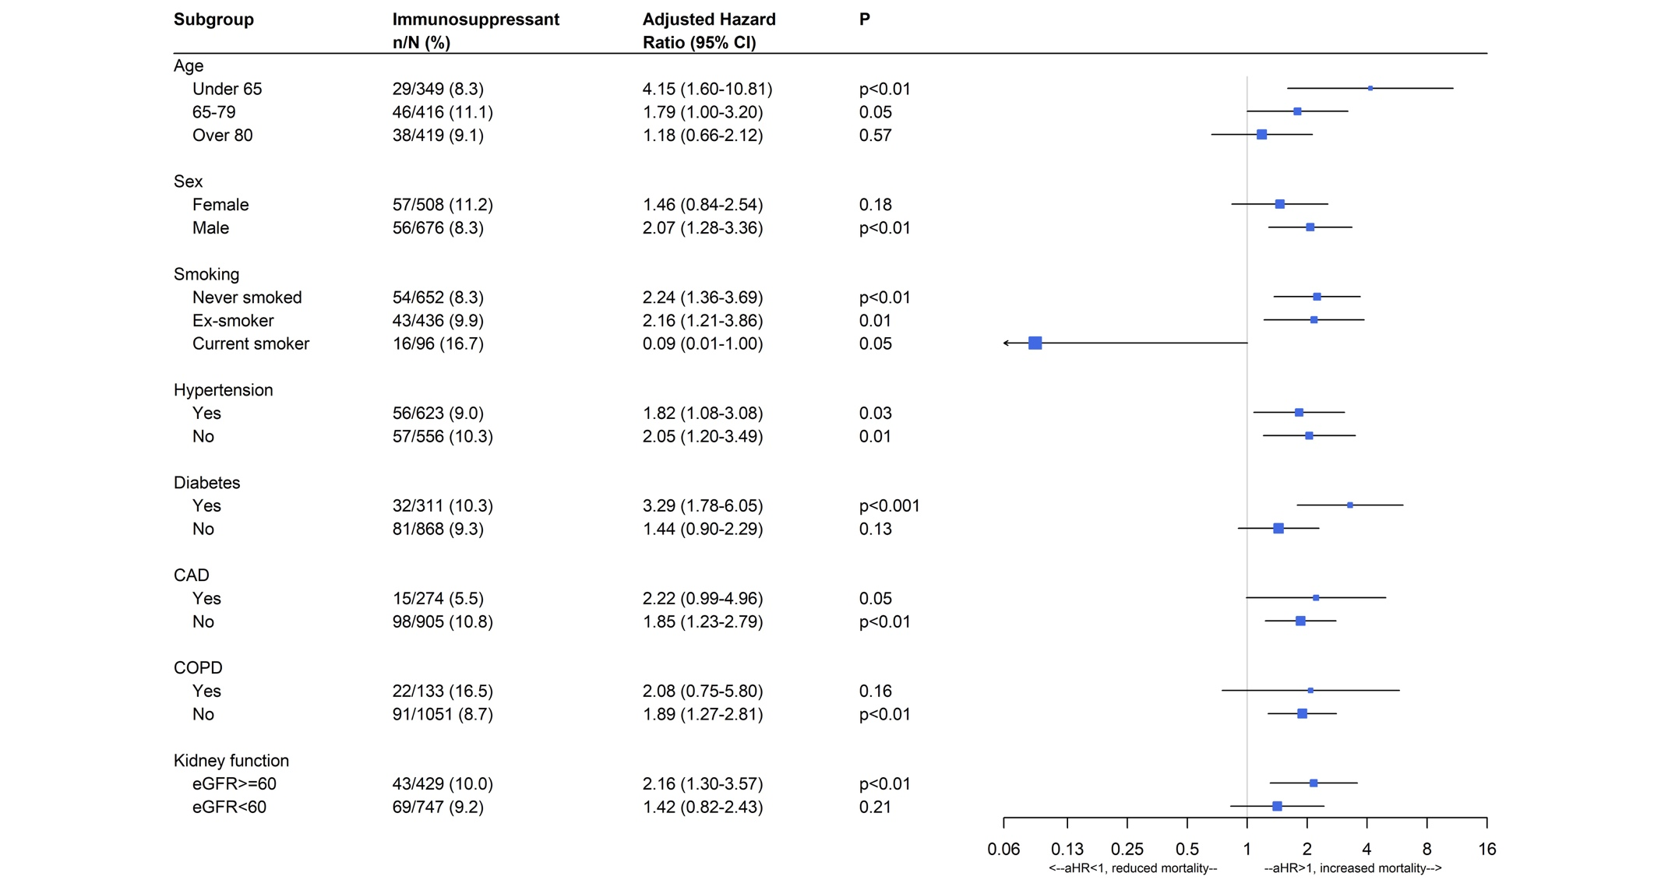
Note: & The multivariable mixed-effects logistic and cox regressions were adjusted for: age group; sex; smoking; CRP; diabetes; CAD; hypertension; eGFR, and the Clinical Frailty Scale
Supplementary Figure 2. Subgroup Analyses Day-14 Mortality (presenting the adjusted& Odds Ratio with 95% CI) to compare those patients that were prescribed an immunosuppressant, compared to those patients that were not.
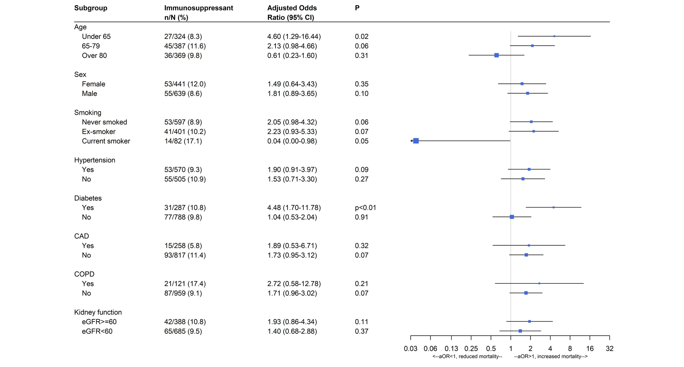

Note: & The multivariable mixed-effects logistic and cox regressions were adjusted for: age group; sex; smoking; CRP; diabetes; CAD; hypertension; eGFR and the Clinical Frailty Scale
Supplementary Figure 3. Subgroup Analyses for the time to discharge (presenting the adjusted& Hazard Ratio with 95% CI) to compare those patients that were prescribed an immunosuppressant, compared to those patients that were not.
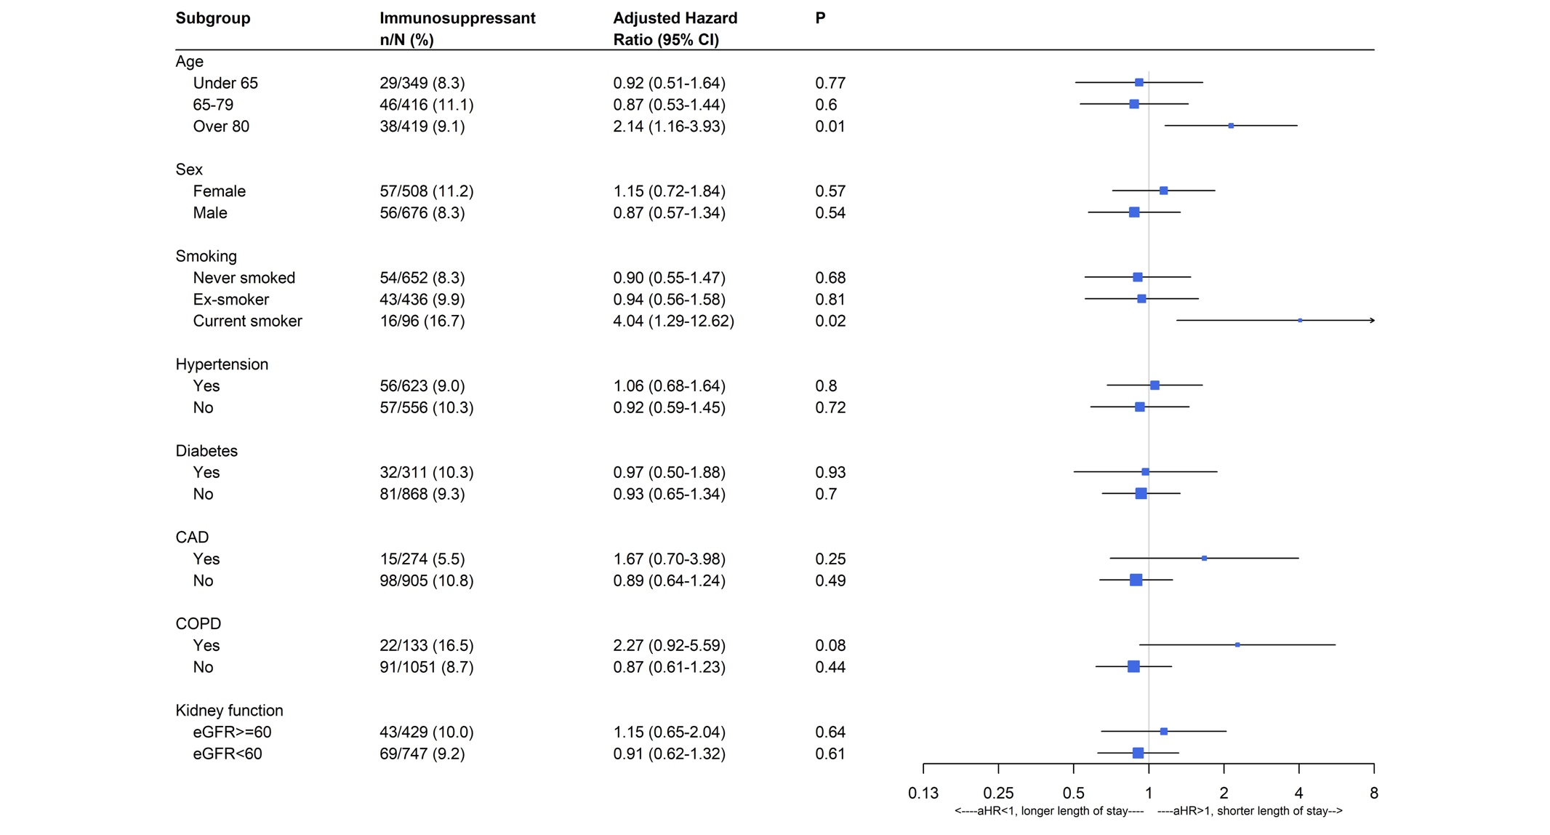
Note: & The multivariable mixed-effects logistic and cox regressions were adjusted for: age group; sex; smoking; CRP; diabetes; CAD; hypertension; eGFR and the Clinical Frailty Scale

