Irritable Bowel Syndrome and Migraine: Evidence from Mendelian Randomization Analysis in the UK Biobank

Figure S1. Single SNPs used in the Mendelian randomization analysis of the effects of Irritable Bowel Syndrome on Migraine.

Figure S2. Funel plot of single SNPs used in the Mendelian randomization analysis of the effects of Irritable Bowel Syndrome on Migraine.

Figure S3 Leave-one-out sensitivity analysis for SNPs of Irritable Bowel Syndrome on Migraine.

Table S1 Single SNPs Used in the Two- sample Mendelian Randomization Analysis of the Causal Effect of Irritable Bowel Syndrome on Migraine.

Table S2 Leave-one-out sensitivity analysis of causal effects of Irritable Bowel Syndrome on Migraine.

Figure S1. Single SNPs used in the Mendelian randomization analysis of the effects of Irritable Bowel Syndrome on Migraine.

It means the effect scale of IBS on migraine of single SNP.
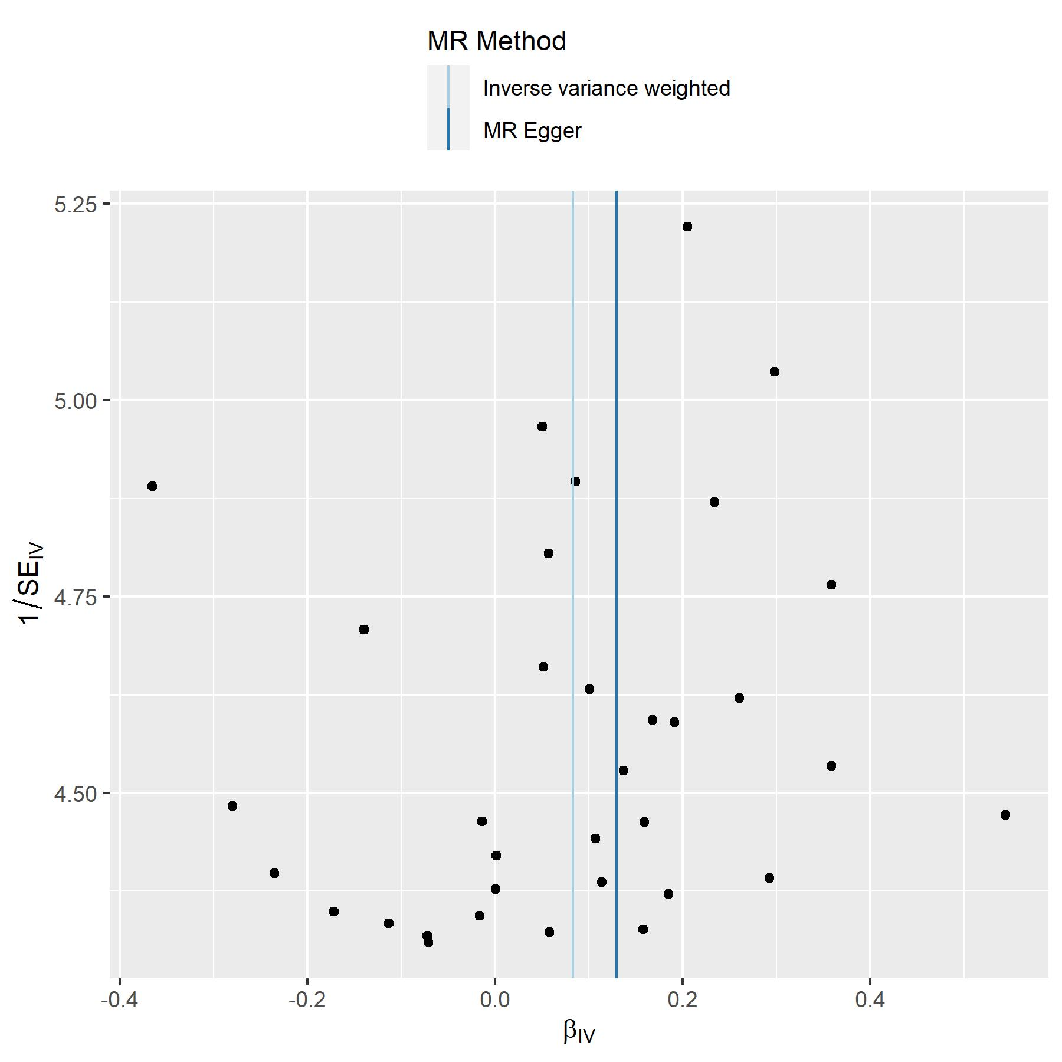

Figure S2. Funel plot of single SNPs used in the Mendelian randomization analysis of the effects of Irritable Bowel Syndrome on Migraine.

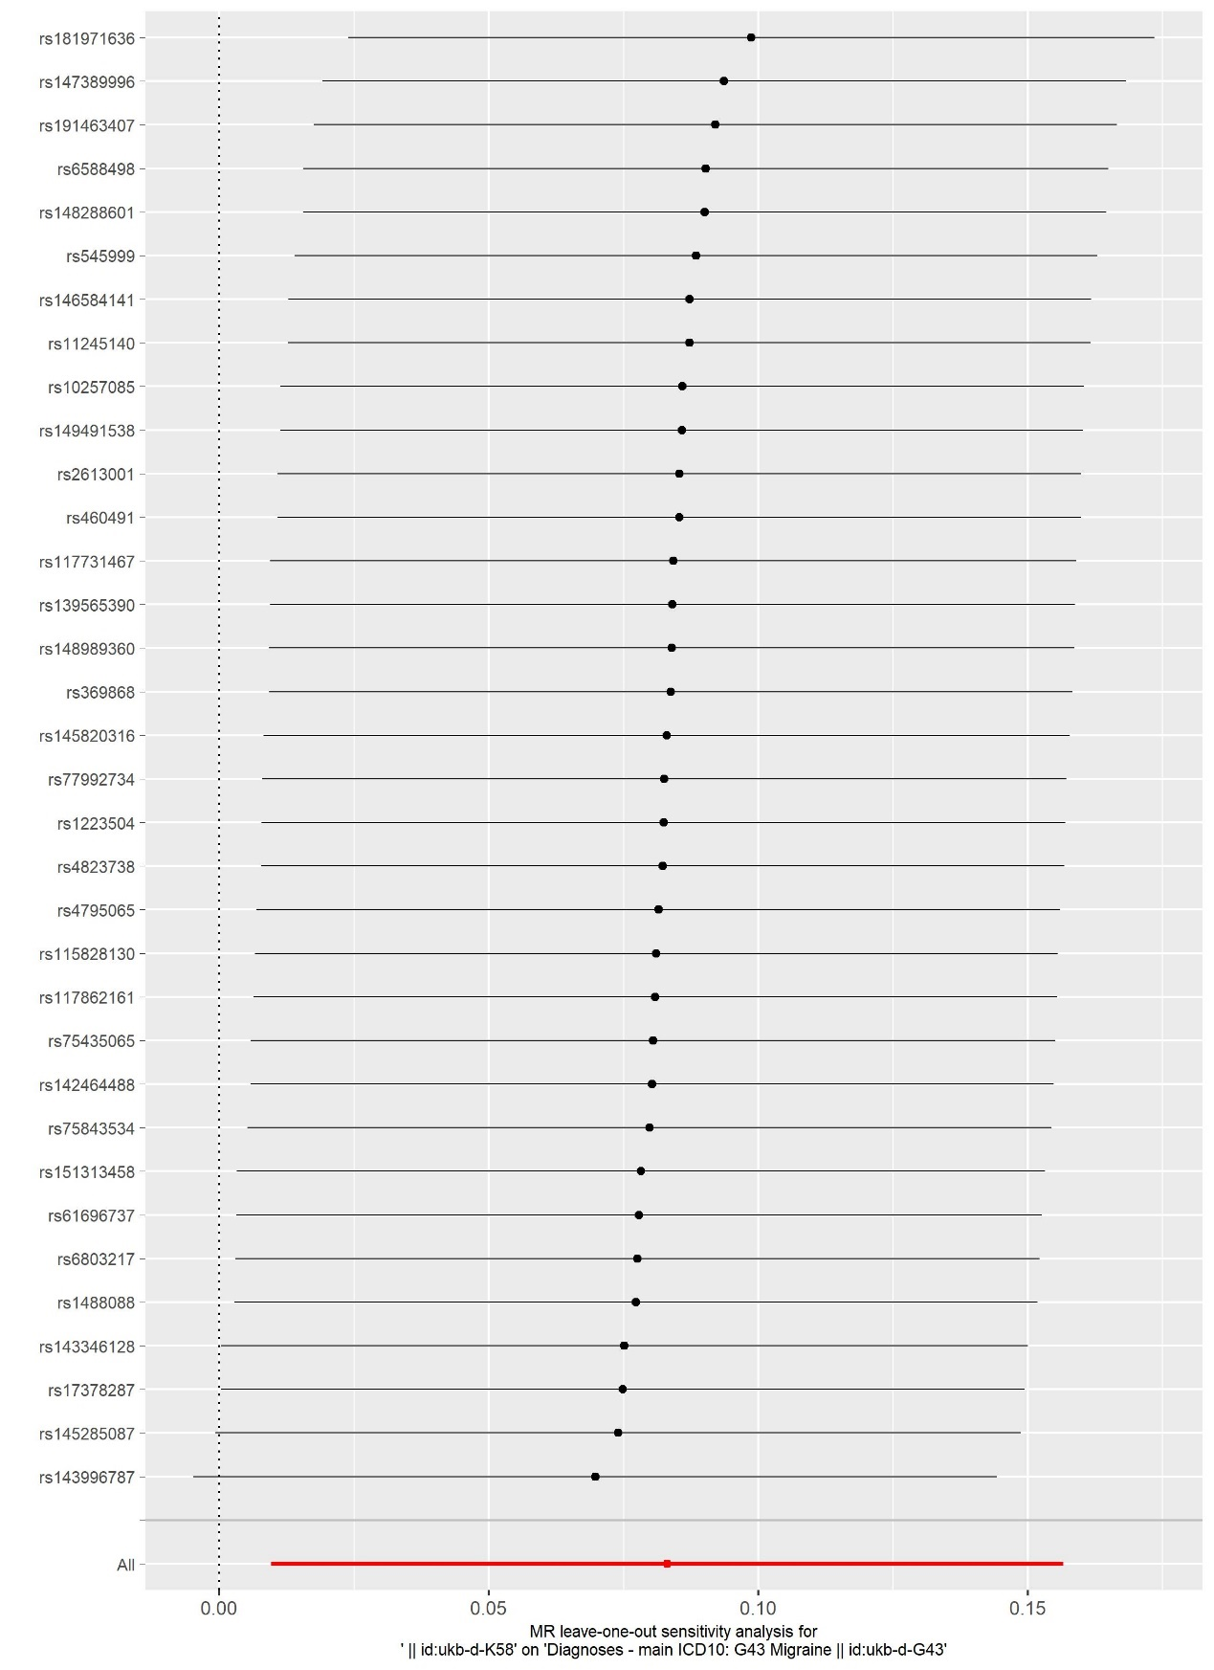

Figure S3 Leave-one-out sensitivity analysis for SNPs of Irritable Bowel Syndrome on Migraine.

It means the effect scale of IBS on migraine when excluding the single SNP. The results indicated that no specific single SNP had played an decisive role in the estimation.

Table S1 Single SNPs Used in the Two- sample Mendelian Randomization Analysis of the Causal Effect of Irritable Bowel Syndrome on Migraine.
 | SNP | b | se | p | β-exposure | se.exposure | F
1 | rs10257085 | -0.01 | 0.22 | 0.95 | <0.01 | <0.01 | 20.96
2 | rs11245140 | -0.07 | 0.23 | 0.76 | <0.01 | <0.01 | 19.54
3 | rs115828130 | 0.16 | 0.23 | 0.49 | <0.01 | <0.01 | 19.69
4 | rs117731467 | 0.05 | 0.20 | 0.80 | <0.01 | <0.01 | 25.94
5 | rs117862161 | 0.16 | 0.22 | 0.48 | <0.01 | <0.01 | 20.96
6 | rs1223504 | 0.11 | 0.23 | 0.63 | <0.01 | <0.01 | 20.76
7 | rs139565390 | 0.05 | 0.21 | 0.81 | <0.01 | <0.01 | 22.85
8 | rs142464488 | 0.19 | 0.23 | 0.42 | <0.01 | <0.01 | 20.10
9 | rs143346128 | 0.30 | 0.20 | 0.13 | <0.01 | <0.01 | 26.67
10 | rs143996787 | 0.54 | 0.22 | 0.01 | <0.01 | <0.01 | 21.03
11 | rs145285087 | 0.36 | 0.21 | 0.09 | <0.01 | <0.01 | 23.88
12 | rs145820316 | 0.09 | 0.20 | 0.68 | <0.01 | <0.01 | 25.22
13 | rs146584141 | -0.07 | 0.23 | 0.76 | <0.01 | <0.01 | 19.62
14 | rs147389996 | -0.28 | 0.22 | 0.21 | <0.01 | <0.01 | 21.15
15 | rs148288601 | -0.17 | 0.23 | 0.46 | <0.01 | <0.01 | 19.90
16 | rs1488088 | 0.29 | 0.23 | 0.20 | <0.01 | <0.01 | 20.29
17 | rs148989360 | 0.06 | 0.21 | 0.78 | <0.01 | <0.01 | 24.28
18 | rs149491538 | -0.02 | 0.23 | 0.94 | <0.01 | <0.01 | 19.84
19 | rs151313458 | 0.21 | 0.19 | 0.28 | <0.01 | <0.01 | 28.67
20 | rs17378287 | 0.36 | 0.22 | 0.10 | <0.01 | <0.01 | 21.63
21 | rs181971636 | -0.37 | 0.20 | 0.07 | <0.01 | <0.01 | 25.16
22 | rs191463407 | -0.24 | 0.23 | 0.30 | <0.01 | <0.01 | 20.34
23 | rs2613001 | 0.00 | 0.23 | 0.99 | <0.01 | <0.01 | 20.55
24 | rs369868 | 0.06 | 0.23 | 0.80 | <0.01 | <0.01 | 19.65
25 | rs460491 | 0.00 | 0.23 | 1.00 | <0.01 | <0.01 | 20.16
26 | rs4795065 | 0.14 | 0.22 | 0.54 | <0.01 | <0.01 | 21.57
27 | rs4823738 | 0.11 | 0.23 | 0.62 | <0.01 | <0.01 | 20.24
28 | rs545999 | -0.11 | 0.23 | 0.62 | <0.01 | <0.01 | 19.75
29 | rs61696737 | 0.23 | 0.21 | 0.25 | <0.01 | <0.01 | 24.95
30 | rs6588498 | -0.14 | 0.21 | 0.51 | <0.01 | <0.01 | 23.31
31 | rs6803217 | 0.26 | 0.22 | 0.23 | <0.01 | <0.01 | 22.46
32 | rs75435065 | 0.17 | 0.22 | 0.44 | <0.01 | <0.01 | 22.19
33 | rs75843534 | 0.19 | 0.22 | 0.38 | <0.01 | <0.01 | 22.16
34 | rs77992734 | 0.10 | 0.22 | 0.64 | <0.01 | <0.01 | 22.57
 | All - MR Egger | 0.13 | 0.07 | 0.07
 | All- IVW | 0.08 | 0.04 | 0.03
 | All - ML | 0.09 | 0.04 | 0.02
 | All - WM | 0.09 | 0.05 | 0.08
 | All - RAPS | 0.09 | 0.04 | 0.03
All the SNPs come from 361194 samples. The exposure is Diagnoses - main ICD10: K58 Irritable bowel syndrome (ukb-d-K58), while the outcome is Diagnoses - main ICD10: G43 Migraine (ukb-d-G43).
Table S2 Leave-one-out sensitivity analysis of causal effects of Irritable Bowel Syndrome on Migraine.
 | id.exposure | id.outcome | samplesize | SNP | b | se | p
1 | ukb-d-K58 | ukb-d-G43 | 361194 | rs10257085 | 0.09 | 0.04 | 0.02
2 | ukb-d-K58 | ukb-d-G43 | 361194 | rs11245140 | 0.09 | 0.04 | 0.02
3 | ukb-d-K58 | ukb-d-G43 | 361194 | rs115828130 | 0.08 | 0.04 | 0.03
4 | ukb-d-K58 | ukb-d-G43 | 361194 | rs117731467 | 0.08 | 0.04 | 0.03
5 | ukb-d-K58 | ukb-d-G43 | 361194 | rs117862161 | 0.08 | 0.04 | 0.03
6 | ukb-d-K58 | ukb-d-G43 | 361194 | rs1223504 | 0.08 | 0.04 | 0.03
7 | ukb-d-K58 | ukb-d-G43 | 361194 | rs139565390 | 0.08 | 0.04 | 0.03
8 | ukb-d-K58 | ukb-d-G43 | 361194 | rs142464488 | 0.08 | 0.04 | 0.03
9 | ukb-d-K58 | ukb-d-G43 | 361194 | rs143346128 | 0.08 | 0.04 | 0.05
10 | ukb-d-K58 | ukb-d-G43 | 361194 | rs143996787 | 0.07 | 0.04 | 0.07
11 | ukb-d-K58 | ukb-d-G43 | 361194 | rs145285087 | 0.07 | 0.04 | 0.05
12 | ukb-d-K58 | ukb-d-G43 | 361194 | rs145820316 | 0.08 | 0.04 | 0.03
13 | ukb-d-K58 | ukb-d-G43 | 361194 | rs146584141 | 0.09 | 0.04 | 0.02
14 | ukb-d-K58 | ukb-d-G43 | 361194 | rs147389996 | 0.09 | 0.04 | 0.01
15 | ukb-d-K58 | ukb-d-G43 | 361194 | rs148288601 | 0.09 | 0.04 | 0.02
16 | ukb-d-K58 | ukb-d-G43 | 361194 | rs1488088 | 0.08 | 0.04 | 0.04
17 | ukb-d-K58 | ukb-d-G43 | 361194 | rs148989360 | 0.08 | 0.04 | 0.03
18 | ukb-d-K58 | ukb-d-G43 | 361194 | rs149491538 | 0.09 | 0.04 | 0.02
19 | ukb-d-K58 | ukb-d-G43 | 361194 | rs151313458 | 0.08 | 0.04 | 0.04
20 | ukb-d-K58 | ukb-d-G43 | 361194 | rs17378287 | 0.07 | 0.04 | 0.05
21 | ukb-d-K58 | ukb-d-G43 | 361194 | rs181971636 | 0.10 | 0.04 | 0.01
22 | ukb-d-K58 | ukb-d-G43 | 361194 | rs191463407 | 0.09 | 0.04 | 0.02
23 | ukb-d-K58 | ukb-d-G43 | 361194 | rs2613001 | 0.09 | 0.04 | 0.02
24 | ukb-d-K58 | ukb-d-G43 | 361194 | rs369868 | 0.08 | 0.04 | 0.03
25 | ukb-d-K58 | ukb-d-G43 | 361194 | rs460491 | 0.09 | 0.04 | 0.02
26 | ukb-d-K58 | ukb-d-G43 | 361194 | rs4795065 | 0.08 | 0.04 | 0.03
27 | ukb-d-K58 | ukb-d-G43 | 361194 | rs4823738 | 0.08 | 0.04 | 0.03
28 | ukb-d-K58 | ukb-d-G43 | 361194 | rs545999 | 0.09 | 0.04 | 0.02
29 | ukb-d-K58 | ukb-d-G43 | 361194 | rs61696737 | 0.08 | 0.04 | 0.04
30 | ukb-d-K58 | ukb-d-G43 | 361194 | rs6588498 | 0.09 | 0.04 | 0.02
31 | ukb-d-K58 | ukb-d-G43 | 361194 | rs6803217 | 0.08 | 0.04 | 0.04
32 | ukb-d-K58 | ukb-d-G43 | 361194 | rs75435065 | 0.08 | 0.04 | 0.03
33 | ukb-d-K58 | ukb-d-G43 | 361194 | rs75843534 | 0.08 | 0.04 | 0.04
34 | ukb-d-K58 | ukb-d-G43 | 361194 | rs77992734 | 0.08 | 0.04 | 0.03
 | ukb-d-K58 | ukb-d-G43 | 361194 | All | 0.08 | 0.04 | 0.03
The exposure is Diagnoses - main ICD10: K58 Irritable bowel syndrome (ukb-d-K58), while the outcome is Diagnoses - main ICD10: G43 Migraine (ukb-d-G43).

