Supplementary Table 1: Information of the samples on the flowering plants investigated
ID | Compartment | Species | Family | Location | GPS | Coordinates | Date | ApproximateAltitude | Altitude | Soil_Type
1f | flowers | Achillea_millefolium | Asteraceae | Sablatnighof | 242 | 46.571; 14.602 | 28.07.2021; 08:59:41 | 490 | 490 | carbonate
1l | leaves | Achillea_millefolium | Asteraceae | Sablatnighof | 242 | 46.571; 14.602 | 28.07.2021; 08:59:41 | 490 | 490 | carbonate
2f | flowers | Acinos_alpinus | Lamiaceae | Petzen | 252 | 47.008; 13.100 | 30.07.2021; 12:20:43 | 1770 | 1850 | carbonate
2l | leaves | Acinos_alpinus | Lamiaceae | Petzen | 252 | 47.008; 13.100 | 30.07.2021; 12:20:43 | 1770 | 1850 | carbonate
3f | flowers | Acinos_alpinus_ | Lamiaceae | Jamnigalm | 239 | 46.511; 14.769 | 27.07.2021; 11:41:48 | 1770 | 1860 | carbonate
3l | leaves | Acinos_alpinus_ | Lamiaceae | Jamnigalm | 239 | 46.511; 14.769 | 27.07.2021; 11:41:48 | 1770 | 1860 | carbonate
4f | flowers | Aconitum_lycoctonum | Ranunculaceae | Jamnigalm | 254 | 47.002; 13.119 | 30.07.2021; - | 1770 | 1486 | carbonate
4l | leaves | Aconitum_lycoctonum | Ranunculaceae | Jamnigalm | 254 | 47.002; 13.119 | 30.07.2021; - | 1770 | 1486 | carbonate
5f | flowers | Alchemilla_vulgaris | Rosaceae | Petzen | 237 | 46.515; 14.772 | 27.07.2021; 10:24:08 | 1770 | 1750 | carbonate
5l | leaves | Alchemilla_vulgaris | Rosaceae | Petzen | 237 | 46.515; 14.772 | 27.07.2021; 10:24:08 | 1770 | 1750 | carbonate
6f | flowers | Armeria_alpina | Plumbaginaceae | Petzen | 241 | 46.505; 14.766 | 27.07.2021; 15:12:36 | 2225 | 2010 | carbonate
7f | flowers | Armeria_alpina_ | Plumbaginaceae | Moelltaler_Glacier | 244 | 47.015; 13.016 | 29.07.2021; 10:33:23 | 2225 | 2120 | silicate
8f | flowers | Arnica_montana | Asteraceae | Jamnigalm | 251 | 47.006; 13.109 | 30.07.2021; 11:07:33 | 1770 | 1800 | carbonate
8l | leaves | Arnica_montana | Asteraceae | Jamnigalm | 251 | 47.006; 13.109 | 30.07.2021; 11:07:33 | 1770 | 1800 | carbonate
9f | flowers | Astrantia_major | Apiaceae | Petzen | 238 | 46.513; 14.771 | 27.07.2021; 11:03:41 | 1770 | 1795 | carbonate
9l | leaves | Astrantia_major | Apiaceae | Petzen | 238 | 46.513; 14.771 | 27.07.2021; 11:03:41 | 1770 | 1795 | carbonate
10f | flowers | Betonica_officinalis | Lamiaceae | Sablatnighof | 242 | 46.571; 14.602 | 28.07.2021; 08:59:41 | 490 | 490 | carbonate
10l | leaves | Betonica_officinalis | Lamiaceae | Sablatnighof | 242 | 46.571; 14.602 | 28.07.2021; 08:59:41 | 490 | 490 | carbonate
11f | flowers | Campanula_barbata | Campanulaceae | Jamnigalm | 251 | 47.006; 13.109 | 30.07.2021; 11:07:33 | 1770 | 1800 | carbonate
11l | leaves | Campanula_barbata | Campanulaceae | Jamnigalm | 251 | 47.006; 13.109 | 30.07.2021; 11:07:33 | 1770 | 1800 | carbonate
12f | flowers | Centaurea_nigrescens | Asteraceae | Ebenthalerschlucht | 233 | 46.598; 14.355 | 25.07.2021; - | 490 | 450 | carbonate
12l | leaves | Centaurea_nigrescens | Asteraceae | Ebenthalerschlucht | 233 | 46.598; 14.355 | 25.07.2021; - | 490 | 450 | carbonate
13f | flowers | Daucus_carota | Apiaceae | Sablatnighof | 242 | 46.571; 14.602 | 28.07.2021; 08:59:41 | 490 | 490 | carbonate
13l | leaves | Daucus_carota | Apiaceae | Sablatnighof | 242 | 46.571; 14.602 | 28.07.2021; 08:59:41 | 490 | 490 | carbonate
14f | flowers | Dianthus_superbus | Caryophyllaceae | Jamnigalm | 250 | 47.004; 13.112 | 30.07.2021; 10:03:34 | 1770 | 1730 | carbonate
14l | leaves | Dianthus_superbus | Caryophyllaceae | Jamnigalm | 250 | 47.004; 13.112 | 30.07.2021; 10:03:34 | 1770 | 1730 | carbonate
15f | flowers | Digitalis_grandiflora | Plantaginaceae | Jamnigalm | 254 | 47.002; 13.119 | 30.07.2021; - | 1770 | 1486 | carbonate
15l | leaves | Digitalis_grandiflora | Plantaginaceae | Jamnigalm | 254 | 47.002; 13.119 | 30.07.2021; - | 1770 | 1486 | carbonate
16f | flowers | Epilobium_angustifolium | Onagraceae | Jamnigalm | 254 | 47.002; 13.119 | 30.07.2021; - | 1770 | 1486 | carbonate
16l | leaves | Epilobium_angustifolium | Onagraceae | Jamnigalm | 254 | 47.002; 13.119 | 30.07.2021; - | 1770 | 1486 | carbonate
17f | flowers | Erigeron_annuus | Asteraceae | Turnersee | 235 | 46.579; 14.581 | 26.07.2021; 12:33:30 | 490 | 512 | carbonate
17l | leaves | Erigeron_annuus | Asteraceae | Turnersee | 235 | 46.579; 14.581 | 26.07.2021; 12:33:30 | 490 | 512 | carbonate
18f | flowers | Galium_mollugo | Rubiaceae | Sablatnighof | 242 | 46.571; 14.602 | 28.07.2021; 08:59:41 | 490 | 490 | carbonate
18l | leaves | Galium_mollugo | Rubiaceae | Sablatnighof | 242 | 46.571; 14.602 | 28.07.2021; 08:59:41 | 490 | 490 | carbonate
19f | flowers | Galium_verum | Rubiaceae | Sablatnighof | 242 | 46.571; 14.602 | 28.07.2021; 08:59:41 | 490 | 490 | carbonate
19l | leaves | Galium_verum | Rubiaceae | Sablatnighof | 242 | 46.571; 14.602 | 28.07.2021; 08:59:41 | 490 | 490 | carbonate
20f | flowers | Gentiana_bavarica | Gentanaceae | Moelltaler_Glacier | 246 | 47.015; 13.015 | 29.07.2021; 11:19:29 | 2225 | 2220 | silicate
20l | leaves | Gentiana_bavarica | Gentanaceae | Moelltaler_Glacier | 246 | 47.015; 13.015 | 29.07.2021; 11:19:29 | 2225 | 2220 | silicate
21f | flowers | Geranium_pratense | Geraniaceae | Zedlitzberg | 243 | 46.775; 14.066 | 28.07.2021; 13:27:02 | 900 | 900 | silicate
21l | leaves | Geranium_pratense | Geraniaceae | Zedlitzberg | 243 | 46.775; 14.066 | 28.07.2021; 13:27:02 | 900 | 900 | silicate
22f | flowers | Geranium_robertianum | Geraniaceae | Turnersee | 234 | 46.579; 14.582 | 26.07.2021; 12:09:07 | 490 | 500 | carbonate
22l | leaves | Geranium_robertianum | Geraniaceae | Turnersee | 234 | 46.579; 14.582 | 26.07.2021; 12:09:07 | 490 | 500 | carbonate
23f | flowers | Geum_montanum | Rosaceae | Moelltaler_Glacier | 246 | 47.015; 13.015 | 29.07.2021; 11:19:29 | 2225 | 2220 | silicate
23l | leaves | Geum_montanum | Rosaceae | Moelltaler_Glacier | 246 | 47.015; 13.015 | 29.07.2021; 11:19:29 | 2225 | 2220 | silicate
24f | flowers | Helianthemum_grandiflorum | Cistaceae | Petzen | 239 | 46.511; 14.769 | 27.07.2021; 11:41:48 | 1770 | 1860 | carbonate
25f | flowers | Heliosperma_quadrifida | Caryophyllaceae | Petzen | 237 | 46.515; 14.772 | 27.07.2021; 10:24:08 | 1770 | 1750 | carbonate
25l | leaves | Heliosperma_quadrifida | Caryophyllaceae | Petzen | 237 | 46.515; 14.772 | 27.07.2021; 10:24:08 | 1770 | 1750 | carbonate
26f | flowers | Heracleum_austriacum | Apiaceae | Petzen | 237 | 46.515; 14.772 | 27.07.2021; 10:24:08 | 1770 | 1750 | carbonate
26l | leaves | Heracleum_austriacum | Apiaceae | Petzen | 237 | 46.515; 14.772 | 27.07.2021; 10:24:08 | 1770 | 1750 | carbonate
27f | flowers | Hypericum_maculatum | Hypericaceae | Jamnigalm | 250 | 47.004; 13.112 | 30.07.2021; 10:03:34 | 1770 | 1730 | carbonate
27l | leaves | Hypericum_maculatum | Hypericaceae | Jamnigalm | 250 | 47.004; 13.112 | 30.07.2021; 10:03:34 | 1770 | 1730 | carbonate
28f | flowers | Imaptiens_glandulifera | Balsaminaceae | Ebenthalerschlucht | 233 | 46.598; 14.355 | 25.07.2021; - | 490 | 450 | carbonate
28l | leaves | Imaptiens_glandulifera | Balsaminaceae | Ebenthalerschlucht | 233 | 46.598; 14.355 | 25.07.2021; - | 490 | 450 | carbonate
29f | flowers | Impatiens_parviflora | Balsaminaceae | Turnersee | 235 | 46.579; 14.581 | 26.07.2021; 12:33:30 | 490 | 512 | carbonate
29l | leaves | Impatiens_parviflora | Balsaminaceae | Turnersee | 235 | 46.579; 14.581 | 26.07.2021; 12:33:30 | 490 | 512 | carbonate
30f | flowers | Knautia_arvensis | Caprifoliaceae | Turnersee | 236 | 46.586; 14.582 | 26.07.2021; 15:22:35 | 490 | 512 | carbonate
30l | leaves | Knautia_arvensis | Caprifoliaceae | Turnersee | 236 | 46.586; 14.582 | 26.07.2021; 15:22:35 | 490 | 512 | carbonate
31f | flowers | Knautia_drymeia | Caprifoliaceae | Petzen | 238 | 46.513; 14.771 | 27.07.2021; 11:03:41 | 1770 | 1795 | carbonate
31l | leaves | Knautia_drymeia | Caprifoliaceae | Petzen | 238 | 46.513; 14.771 | 27.07.2021; 11:03:41 | 1770 | 1795 | carbonate
32f | flowers | Lotus_corniculatus | Fabaceae | Jamnigalm | 253 | 47.009; 13.100 | 30.07.2021; 13:07:08 | 1770 | 1880 | carbonate
32l | leaves | Lotus_corniculatus | Fabaceae | Jamnigalm | 253 | 47.009; 13.100 | 30.07.2021; 13:07:08 | 1770 | 1880 | carbonate
33f | flowers | Minuartia_austriaca | Caryophyllaceae | Petzen | 238 | 46.513; 14.771 | 27.07.2021; 11:03:41 | 1770 | 1795 | carbonate
33l | leaves | Minuartia_austriaca | Caryophyllaceae | Petzen | 238 | 46.513; 14.771 | 27.07.2021; 11:03:41 | 1770 | 1795 | carbonate
34f | flowers | Mycelis_muralis | Asteraceae | Turnersee | 234 | 46.579; 14.582 | 26.07.2021; 12:09:07 | 490 | 500 | carbonate
34l | leaves | Mycelis_muralis | Asteraceae | Turnersee | 234 | 46.579; 14.582 | 26.07.2021; 12:09:07 | 490 | 500 | carbonate
35f | flowers | Origanum_vulgare | Lamiaceae | Turnersee | 236 | 46.586; 14.582 | 26.07.2021; 15:22:35 | 490 | 512 | carbonate
35l | leaves | Origanum_vulgare | Lamiaceae | Turnersee | 236 | 46.586; 14.582 | 26.07.2021; 15:22:35 | 490 | 512 | carbonate
36f | flowers | Peucedanum_ostruthium | Apiaceae | Petzen | 238 | 46.513; 14.771 | 27.07.2021; 11:03:41 | 1770 | 1795 | carbonate
36l | leaves | Peucedanum_ostruthium | Apiaceae | Petzen | 238 | 46.513; 14.771 | 27.07.2021; 11:03:41 | 1770 | 1795 | carbonate
37f | flowers | Pimpinella_saxifraga | Apiaceae | Sablatnighof | 242 | 46.571; 14.602 | 28.07.2021; 08:59:41 | 490 | 490 | carbonate
37l | leaves | Pimpinella_saxifraga | Apiaceae | Sablatnighof | 242 | 46.571; 14.602 | 28.07.2021; 08:59:41 | 490 | 490 | carbonate
38f | flowers | Potentilla_aurea | Rosaceae | Moelltaler_Glacier | 246 | 47.015; 13.015 | 29.07.2021; 11:19:29 | 2225 | 2220 | silicate
38l | leaves | Potentilla_aurea | Rosaceae | Moelltaler_Glacier | 246 | 47.015; 13.015 | 29.07.2021; 11:19:29 | 2225 | 2220 | silicate
39f | flowers | Ranunculus_acris | Ranunculaceae | Zedlitzberg | 243 | 46.775; 14.066 | 28.07.2021; 13:27:02 | 900 | 900 | silicate
39l | leaves | Ranunculus_acris | Ranunculaceae | Zedlitzberg | 243 | 46.775; 14.066 | 28.07.2021; 13:27:02 | 900 | 900 | silicate
40f | flowers | Ranunculus_glacialis | Ranunculaceae | Moelltaler_Glacier | 249 | 47.031; 13.009 | 29.07.2021; 15:16:01 | 2225 | 2760 | silicate
40l | leaves | Ranunculus_glacialis | Ranunculaceae | Moelltaler_Glacier | 249 | 47.031; 13.009 | 29.07.2021; 15:16:01 | 2225 | 2760 | silicate
41f | flowers | Rhododendron_ferrugineum | Ericaceae | Moelltaler_Glacier | 247 | 47.015; 13.014 | 29.07.2021; 11:54:32 | 2225 | 2250 | silicate
41l | leaves | Rhododendron_ferrugineum | Ericaceae | Moelltaler_Glacier | 247 | 47.015; 13.014 | 29.07.2021; 11:54:32 | 2225 | 2250 | silicate
42f | flowers | Rhododendron_hirsutum | Ericaceae | Petzen | 237 | 46.515; 14.772 | 27.07.2021; 10:24:08 | 1770 | 1750 | carbonate
42l | leaves | Rhododendron_hirsutum | Ericaceae | Petzen | 237 | 46.515; 14.772 | 27.07.2021; 10:24:08 | 1770 | 1750 | carbonate
43f | flowers | Salvia_pratensis | Lamiaceae | Turnersee | 236 | 46.586; 14.582 | 26.07.2021; 15:22:35 | 490 | 512 | carbonate
43l | leaves | Salvia_pratensis | Lamiaceae | Turnersee | 236 | 46.586; 14.582 | 26.07.2021; 15:22:35 | 490 | 512 | carbonate
44f | flowers | Saxifraga_moschata | Saxifragaceae | Moelltaler_Glacier | 245 | 47.015; 13.017 | 29.07.2021; 10:50:50 | 2225 | 2175 | silicate
44l | leaves | Saxifraga_moschata | Saxifragaceae | Moelltaler_Glacier | 245 | 47.015; 13.017 | 29.07.2021; 10:50:50 | 2225 | 2175 | silicate
45f | flowers | Silene_acaulis | Caryophyllaceae | Petzen | 240 | 46.505; 14.766 | 27.07.2021; 14:34:12 | 2225 | 2000 | carbonate
45l | leaves | Silene_acaulis | Caryophyllaceae | Petzen | 240 | 46.505; 14.766 | 27.07.2021; 14:34:12 | 2225 | 2000 | carbonate
46f | flowers | Trifolium_badium | Fabaceae | Moelltaler_Glacier | 248 | 47.016; 13.013 | 29.07.2021; 12:23:57 | 2225 | 2270 | silicate
46l | leaves | Trifolium_badium | Fabaceae | Moelltaler_Glacier | 248 | 47.016; 13.013 | 29.07.2021; 12:23:57 | 2225 | 2270 | silicate
47f | flowers | Trifolium_pratense | Fabaceae | Zedlitzberg | 243 | 46.775; 14.066 | 28.07.2021; 13:27:02 | 900 | 900 | silicate
47l | leaves | Trifolium_pratense | Fabaceae | Zedlitzberg | 243 | 46.775; 14.066 | 28.07.2021; 13:27:02 | 900 | 900 | silicate
48f | flowers | Trifolium_repens | Fabaceae | Zedlitzberg | 243 | 46.775; 14.066 | 28.07.2021; 13:27:02 | 900 | 900 | silicate
48l | leaves | Trifolium_repens | Fabaceae | Zedlitzberg | 243 | 46.775; 14.066 | 28.07.2021; 13:27:02 | 900 | 900 | silicate
49f | flowers | Verbascum_austriacum | Scrophulariaceae | Turnersee | 236 | 46.586; 14.582 | 26.07.2021; 15:22:35 | 490 | 512 | carbonate
49l | leaves | Verbascum_austriacum | Scrophulariaceae | Turnersee | 236 | 46.586; 14.582 | 26.07.2021; 15:22:35 | 490 | 512 | carbonate
50f | flowers | Viola_bilflora | Violaceae | Moelltaler_Glacier | 245 | 47.015; 13.017 | 29.07.2021; 10:50:50 | 2225 | 2175 | silicate
50l | leaves | Viola_bilflora | Violaceae | Moelltaler_Glacier | 245 | 47.015; 13.017 | 29.07.2021; 10:50:50 | 2225 | 2175 | silicate

Flowers - Leaves | Plant compartment
Flowers - Leaves | Bacteria |  | Fungi
Flowers - Leaves | P | R² | P | R²
Species richness | 5.85E-08 | 0.234 | 1.04E-10 | 0.286
Shannon diversity | 2.20E-16 | 0.412 | 1.66E-04 | 0.115
Abundance | 0.950 | 4.0E-05 | 0.874 | 3.0E-05
Community Composition | 0.001 | 0.069 | 0.001 | 0.037
Supplementary Table 2a: Comparison of microbial diversity, abundance, and community composition between flowers and leaves (p-values and R-squared values)

Supplementary Table 2b: Comparison of microbial diversity, abundance, and community composition across geographical locations, soil types, altitudes, and plant families (p-values and R-squared values)

Flowers | Locations |  |  |  | Soil Types |  |  |  | Altitude |  |  |  | Family Identity
Flowers | Bacteria |  | Fungi |  | Bacteria |  | Fungi |  | Bacteria |  | Fungi |  | Bacteria |  | Fungi
Flowers | P | R² | P | R² | P | R² | P | R² | P | R² | P | R² | P | R² | P | R²
Species richness | 0.025 | 0.206 | 0.003 | 0.338 | 0.625 | 0.000 | 0.420 | 0.086 | 0.381 | < 0.001 | 0.004 | 0.251 | 0.038 | 0.092 | 0.285 | 0.280
Shannon diversity | 0.166 | 0.151 | 0.001 | 0.306 | 0.270 | 0.011 | 0.724 | 0.008 | 0.040 | 0.001 | 0.066 | 0.192 | 0.462 | 0.004 | 0.152 | 0.408
Abundance | 0.223 | 0.104 | 0.412 | 0.099 | 0.435 | 0.005 | 0.077 | 0.006 | 0.133 | 0.310 | 0.027 | 0.001 | < 0.001 | 0.006 | 0.693 | 0.396
Community Composition | 0.001 | 0.150 | 0.001 | 0.193 | 0.001 | 0.052 | 0.001 | 0.075 | 0.001 | 0.001 | 0.058 | 0.085 | 0.091 | 0.075 | 0.245 | 0.252
Leaves | Bacteria |  | Fungi |  | Bacteria |  | Fungi |  | Bacteria |  | Fungi |  | Bacteria |  | Fungi
Leaves | P | R² | P | R² | P | R² | P | R² | P | R² | P | R² | P | R² | P | R²
Species richness | 0.138 | 0.151 | 0.041 | 0.236 | 0.650 | 0.000 | 0.855 | 0.099 | 0.719 | 0.165 | 0.019 | 0.021 | 0.740 | 0.688 | 0.112 | 0.123
Shannon diversity | 0.051 | 0.223 | 0.000 | 0.470 | 0.460 | 0.037 | 0.707 | 0.034 | 0.998 | 0.002 | 0.022 | 0.174 | 0.291 | 0.482 | 0.208 | 0.139
Abundance | 0.333 | 0.111 | 0.221 | 0.141 | 0.308 | 0.000 | 0.259 | 0.011 | 0.204 | 0.248 | 0.014 | 0.008 | < 0.001 | < 0.001 | 0.651 | 0.656
Community Composition | 0.001 | 0.184 | 0.001 | 0.250 | 0.002 | 0.042 | 0.001 | 0.064 | 0.001 | 0.001 | 0.091 | 0.115 | 0.091 | 0.178 | 0.240 | 0.236

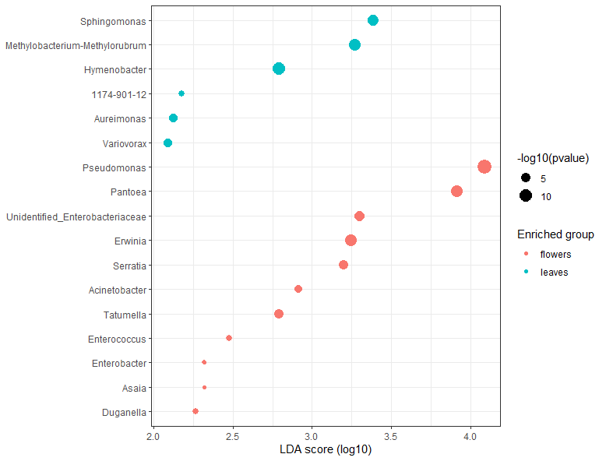
- Bacteria
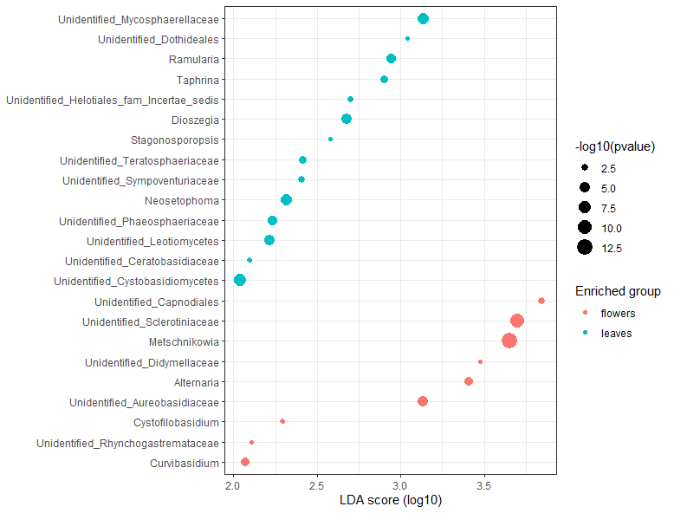
- Fungi

Fungi

Supplementary Figure 1: Linear discriminant analysis Effect Size (LefSe) plots was used to identify significantly different genera between leaves and flowers (P-value cutoff = 0.05; Log LDA Score = 2).

