Liver fibrosis negatively impacts in vivo gene transfer to hepatocytes

Chiara Simoni^{1,2}, Justine Nozi³, Francesco Starinieri¹, Tiziana La Bella³, Elisabetta Manta¹, Camilla Negri¹, Mauro Biffi¹, Rossana Norata¹, Martina Rocchi⁴, Francesca Sanvito⁴, Giuseppe Ronzitti³, Elena Barbon¹, Alessio Cantore^{1,2}

¹ San Raffaele Telethon Institute for Gene Therapy, IRCCS San Raffaele Scientific Institute, Milan, Italy
² Vita Salute San Raffaele University, Milan, Italy
³ Genethon, Evry-Courcouronnes, France
⁴ IRCCS San Raffaele Scientific Institute, Milan, 20132, Italy

Address for Correspondence:
Barbon Elena and Cantore Alessio, San Raffaele Telethon Institute for Gene Therapy, IRCCS San Raffaele Scientific Institute, Via Olgettina 58, Milan, Italy.
Email: barbon.elena@hsr.it, cantore.alessio@hsr.it

Supplementary Figures and Figure Legends

Supplementary Figure 1:
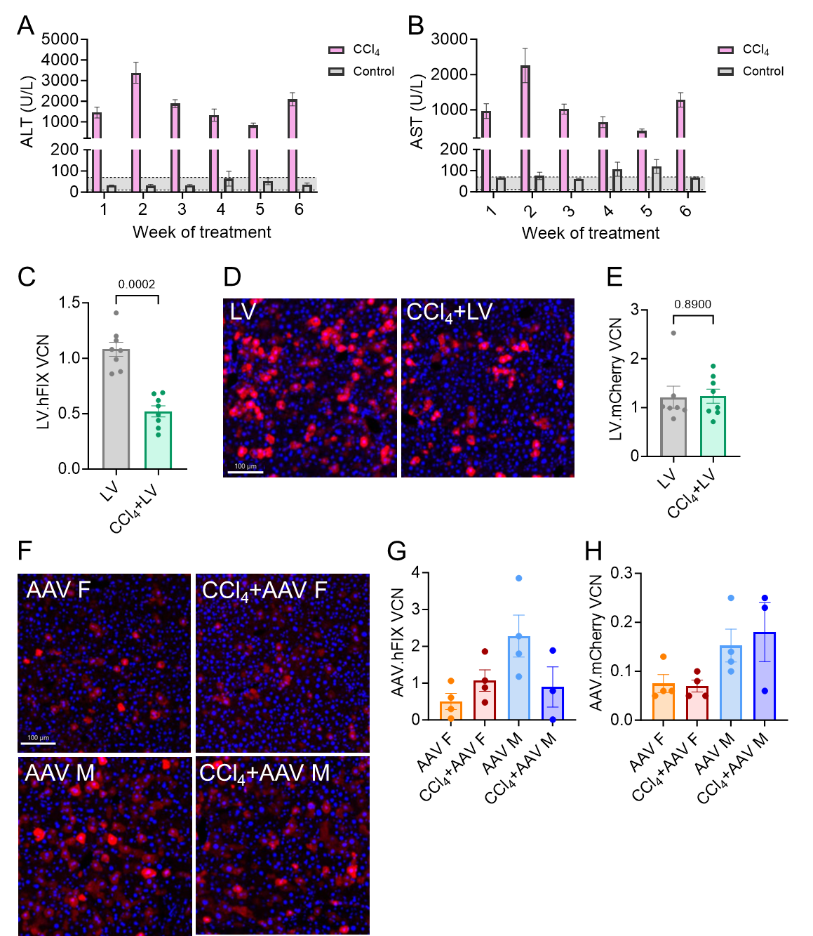

A, B: Mean ± SEM of ALT (A) or AST (B) concentration in the serum of experimental mice. C: Individual values and mean ± SEM of VCN in the liver of mice administered with LV.hFIX (p=0.0002, Mann-Whitney test). D: Representative immunofluorescence images of liver sections from control mice (left) or CCl₄-treated mice (right) administered with LV.mCherry (bar=100 µm). Anti-mCherry antibody (red) and Hoechst (blue) staining. E: Individual values and mean ± SEM of VCN in the liver of mice administered with LV.mCherry (p=0.89, Mann-Whitney test). F: Representative immunofluorescence images of liver sections from female (F) and male (M) control mice (left) or CCl₄-treated mice (right) administered with AAV.mCherry (bar=100 µm). Anti-mCherry antibody (red) and Hoechst (blue) staining. G, H: Individual values and mean ± SEM of VCN in the liver of mice administered with (E) AAV.hFIX or (F) AAV.mCherry.

Supplementary Figure 2:
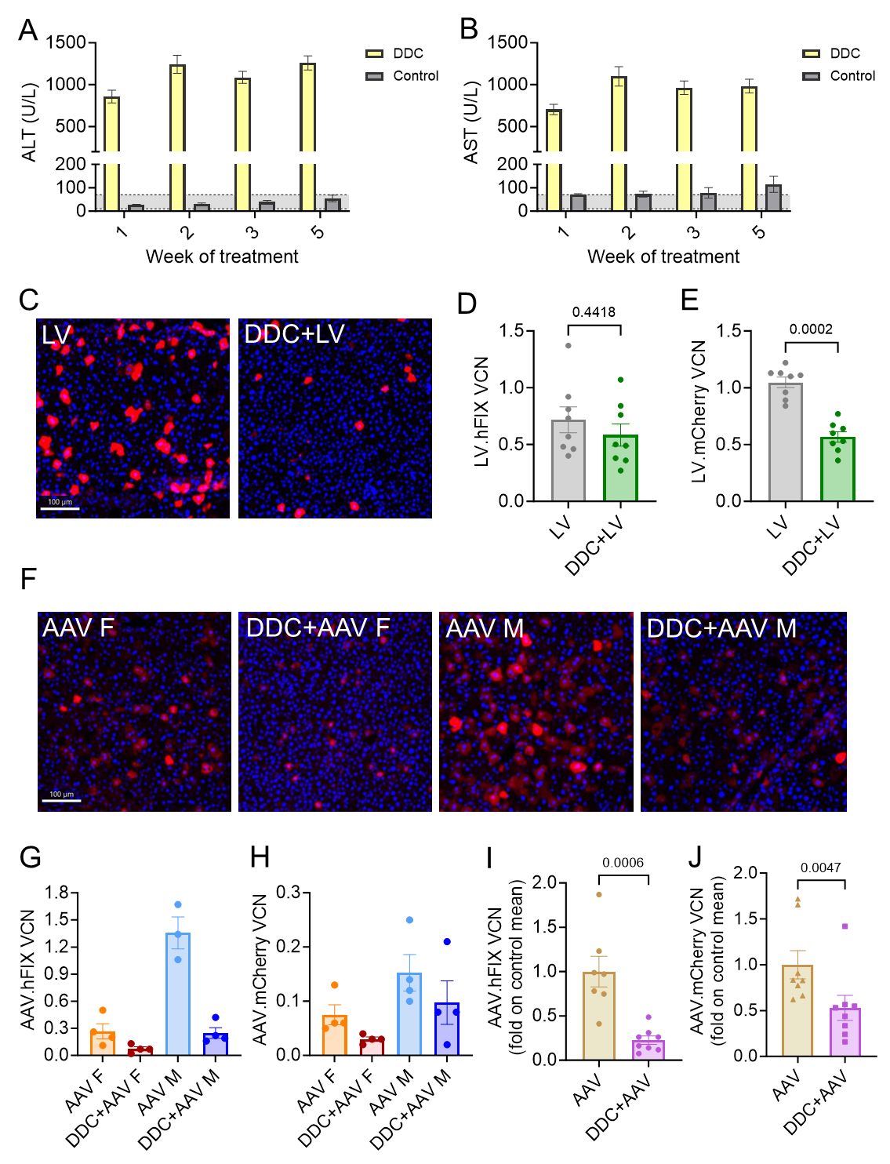
A, B: Mean ± SEM of ALT (A) or AST (B) concentration in the serum of experimental mice. C: Representative immunofluorescence images of liver sections from control mice (left) or DDC-treated mice (right) administered with LV.mCherry (bar=100 µm). Anti-mCherry antibody (red) and Hoechst (blue) staining. D, E: Individual values and mean ± SEM of VCN in the liver of mice administered with (C) LV.hFIX or (D) LV.mCherry (C, p=0.4418, D, p=0.0002, Mann-Whitney test). F: Representative immunofluorescence images of liver sections from female (F) and male (M) control mice or DDC-treated mice administered with AAV.mCherry (bar=100 µm). Anti-mCherry antibody (red) and Hoechst (blue) staining. G, H: Individual values and mean ± SEM of VCN in the liver of mice administered with (E) AAV.hFIX or (F) AAV.mCherry. I, J: AAV VCN expressed as fold on the mean of each respective control group (G, p=0.0006, H, p=0.0047, Mann-Whitney test). Data are individual values and mean ± SEM.

Supplementary Figure 3:
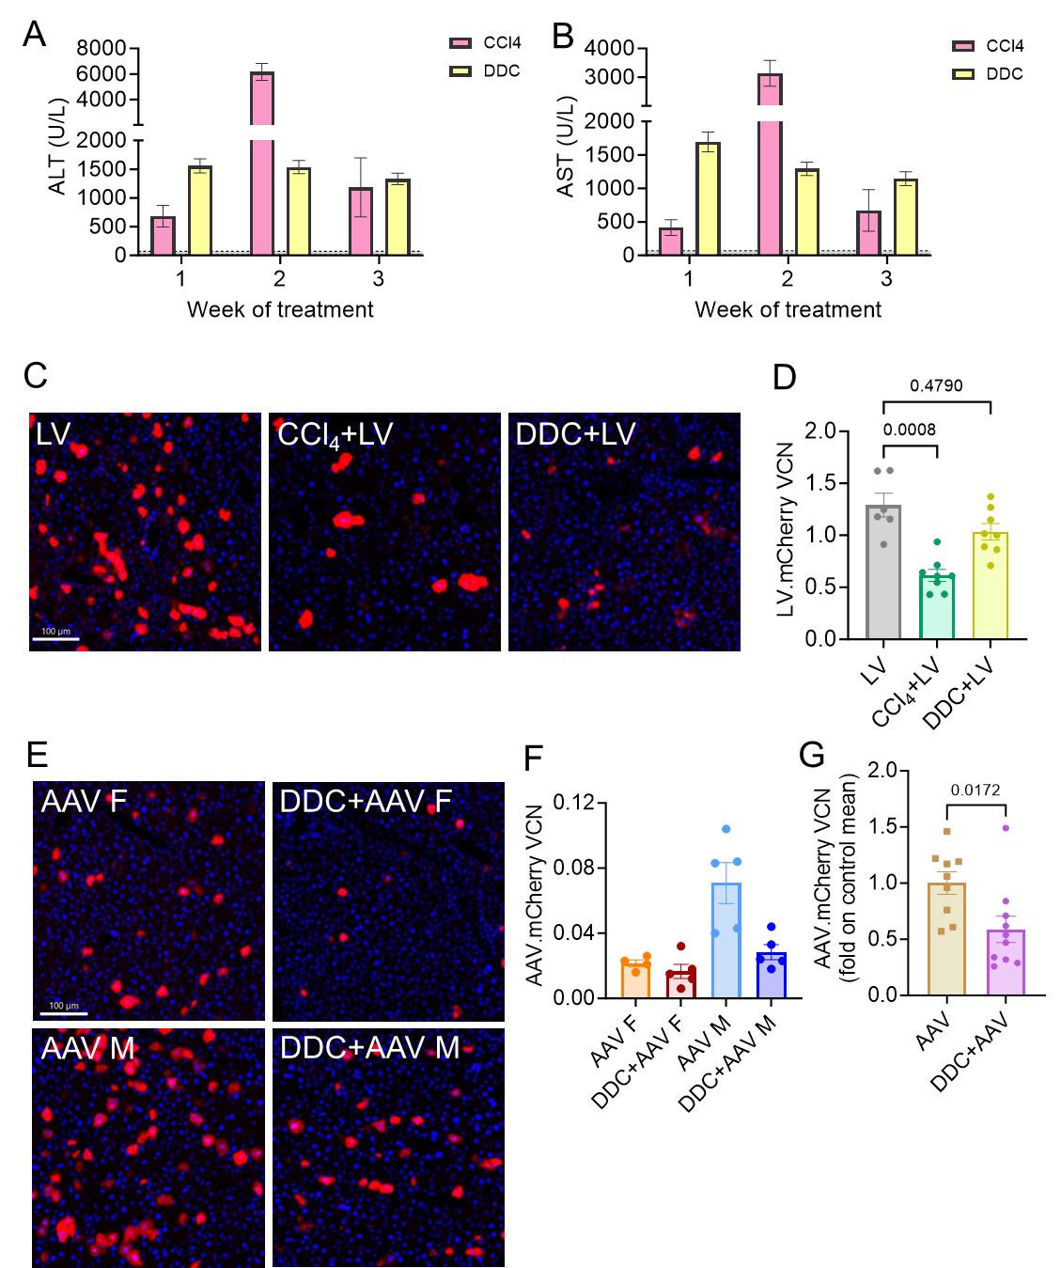

A, B: Mean ± SEM of ALT (A) or AST (B) concentration in the serum of experimental mice. C: Representative immunofluorescence images of liver sections from control mice (left) or CCl₄-treated mice (middle) or DDC-treated mice (right) administered with LV.mCherry (bar=100 µm). Anti-mCherry antibody (red) and Hoechst (blue) staining. D: Individual values and mean ± SEM of VCN in the liver of mice administered with LV.mCherry (Kruskal-Wallis test, p values are shown). E: Representative immunofluorescence images of liver sections from female (F) and male (M) control mice (left) or DDC-treated mice (right) administered with AAV.mCherry (bar=100 µm). Anti-mCherry antibody (red) and Hoechst (blue) staining. F: Individual values and mean ± SEM of VCN in the liver of mice administered with AAV.mCherry. G: AAV VCN expressed as fold on the mean of each respective control group (p=0.0172, Mann-Whitney test). Data are individual values and mean ± SEM.

Supplementary Figure 4:
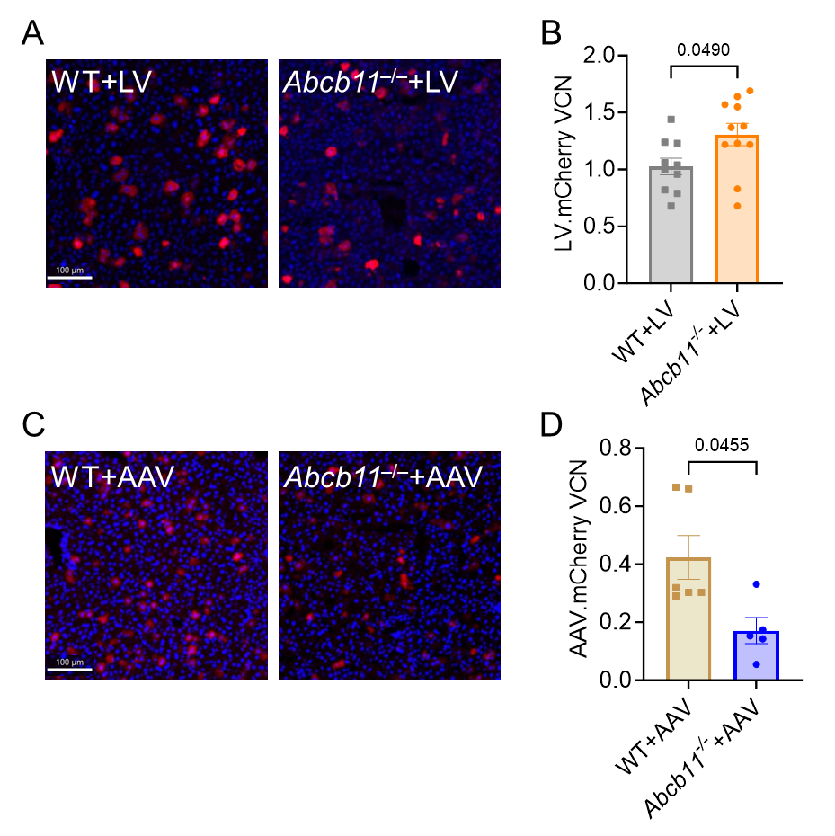
A: Representative immunofluorescence images of liver sections from WT control mice (left) or Abcb11^{-/-} mice (right) administered with LV.mCherry (bar=100 µm). Anti-mCherry antibody (red) and Hoechst (blue) staining. B: Individual values and mean ± SEM of VCN in the liver of WT or Abcb11^{-/-} mice administered with LV.mCherry (p=0.049, Mann-Whitney test). C: Representative immunofluorescence images of liver sections from WT control mice (left) or Abcb11^{-/-} mice (right) administered with AAV.mCherry (bar=100 µm). Anti-mCherry antibody (red) and Hoechst (blue) staining. D: Individual values and mean ± SEM of VCN in the liver of WT or Abcb11^{-/-} mice administered with AAV.mCherry (p=0.0455, Mann-Whitney test).

Supplementary Figure 5:
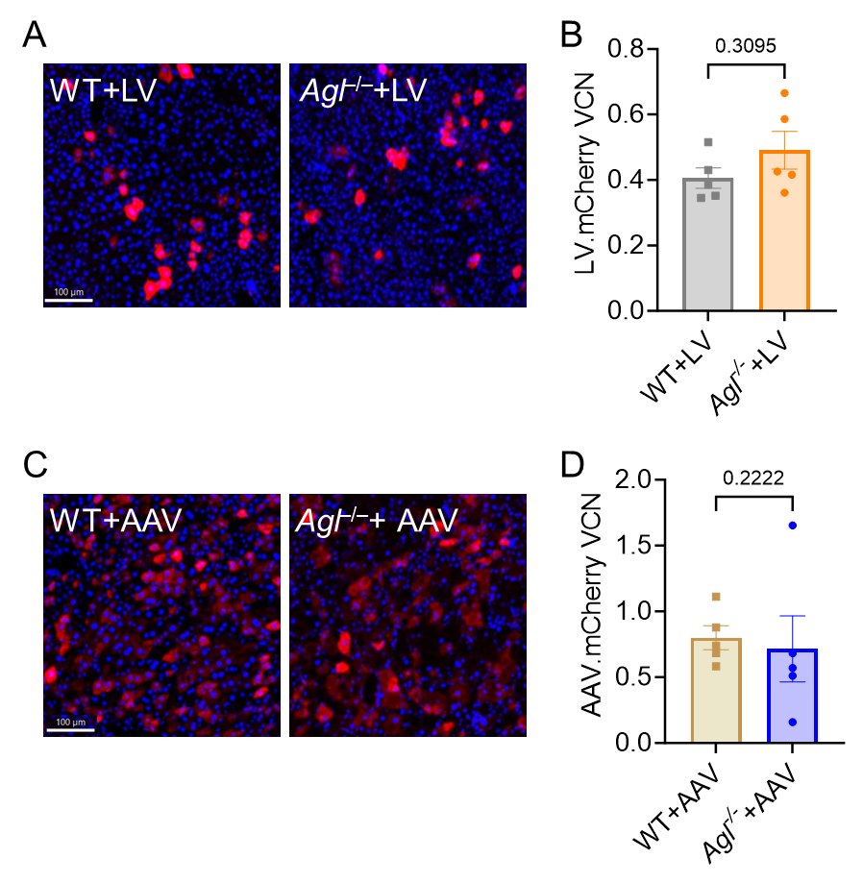
A: Representative immunofluorescence images of liver sections from WT control mice (left) or Agl^{-/-} mice (right) administered with LV.mCherry (bar=100 µm). Anti-mCherry antibody (red) and Hoechst (blue) staining. B: Individual values and mean ± SEM of VCN in the liver of WT or Agl^{-/-} mice administered with LV.mCherry (p=0.3095, Mann-Whitney test). C: Representative immunofluorescence images of liver sections from WT control mice (left) or Agl^{-/-} mice (right) administered with AAV.mCherry (bar=100 µm). Anti-mCherry antibody (red) and Hoechst (blue) staining. D: Individual values and mean ± SEM of VCN in the liver of WT or Agl^{-/-} mice administered with AAV.mCherry (p=0.2222, Mann-Whitney test).

