TABLE 1. Johnsen testicular biopsy score
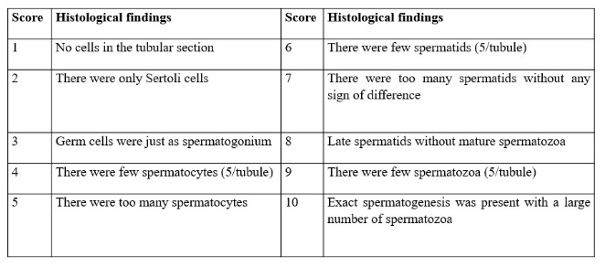

TABLE 2. Sperm count and motility
