Supplementary Data

Plant Encroachment Increase Microbial Diversity, Network Complexity and Multifunctionality in Bauxite Residue
Dandan Deng¹, Wei Sun², Hao Wu^{1,2}*, Xiyun Yang¹, Feng Zhu¹, Yifan Jiang¹, Shiwei Huang¹, Shengguo Xue¹, Jun Jiang¹*.
1 School of Metallurgy and Environment, Central South University, Changsha 410083, People’s Republic of China
2 School of Minerals Processing and Bioengineering, Central South University, Changsha 410083, People’s Republic of China

List of Tables
Table S1 Relative abundance of the major phyla in bauxite residues
Table S2 Relative abundance of the major family in bauxite residues

Table S1 Relative abundance of the major phyla in bauxite residues
Phylum | The relative abundance of predominant phyla*
Phylum | CK | BA | BC | BH
Proteobacteria | 15.84±2.31c | 24.16±4.21b | 26.89±2.59b | 38.72±2.25a
Firmicutes | 42.83±1.69a | 20.7±3.39b | 13.41±1.33c | 9.06±1.83d
Actinobacteria | 12.89±3.14b | 19.21±3.98a | 18.79±4.23a | 18.98±1.42a
Acidobacteria | 4.67±1.18b | 6.14±1.13b | 10.66±2.58a | 11.5±1.27a
Chloroflexi | 4.36±0.62b | 8.61±2.08a | 8.73±1.1a | 6.89±1.55a
Planctomycetes | 3.32±0.38b | 4.78±0.74a | 4.81±0.81a | 4.61±1.15a
Euryarchaeota | 2.07±0.66b | 3.75±1.28a | 4.99±1.21a | 0.64±0.21c
Bacteroidetes | 4.52±1.92a | 1.51±0.39b | 1.48±0.22b | 1.63±0.11b
Gemmatimonadetes | 1.69±0.29a | 2.29±0.33a | 2.19±0.28a | 2.6±1.23a
CK, unvegetated sites; BA, Artemisia sites; BC, Cynodon sites; BH, Hedysarum sites; Different letters mean significant difference by LSD tests following One-way ANOVA (P < 0.05).

Table S2 Relative abundance of the major family in bauxite residues
Phylum | The relative abundance of predominant phyla*
Phylum | CK | BA | BC | BH
Streptococcaceae | 16.44±1.13a | 9.14±2.05b | 5.54±1.16c | 3.8±0.94c
Bacillaceae | 13.29±1.28a | 4.93±0.95b | 3.97±1.21b | 2.48±0.55c
Sphingomonadaceae | 2.25±0.61b | 5.36±1.36a | 5.53±1.62a | 5.76±1.41a
Acidobacteriaceae | 2.6±0.46c | 4.45±0.77b | 5.95±0.68a | 5.89±0.53a
Frankiaceae | 1.73±0.41b | 3.73±0.4a | 4.23±0.94a | 3.51±0.56a
Rhizobiaceae | 1.16±0.25b | 1.87±0.65b | 2.56±0.24b | 6.92±1.94a
Blastocatellaceae | 1.58±1.03b | 1.35±0.37b | 4.27±1.86a | 4.84±0.98a
Burkholderiaceae | 2.85±0.48ab | 2.44±0.57ab | 1.93±0.5b | 3.02±0.7a
Thermoplasmataceae | 1.17±0.8b | 3.25±1.26a | 4.46±1.23a | 0.4±0.22b
Geodermatophilaceae | 5.11±2.41 | 1.28±0.48 | 1.37±0.56 | 1.16±0.5
Chloroflexaceae | 0.82±0.27b | 2.96±1.62a | 2.72±0.6a | 2.01±1.08ab
Solirubrobacteraceae | 0.65±0.28a | 3.08±1.84a | 2±1.63a | 2.15±0.7a
Gemmatimonadaceae | 1.39±0.29a | 1.66±0.26a | 2.02±0.25a | 2.34±1.07a
Nitrosomonadaceae | 0.83±0.25c | 1.05±0.26c | 2.27±0.28b | 2.77±0.51a
Thermomicrobiaceae | 0.81±0.27c | 1.7±0.31b | 2.53±0.54a | 1.84±0.77ab
Pirellulaceae | 1.34±0.21a | 2.02±0.91a | 1.97±0.33a | 1.4±0.37a
Beijerinckiaceae | 0.51±0.09c | 1.59±0.65b | 1.79±0.45b | 2.57±0.31a
Devosiaceae | 1.65±1.06a | 1.13±0.66a | 1.55±0.45a | 2.07±0.22a
Nocardioidaceae | 0.18±0.11b | 1.73±0.79a | 1.83±0.72a | 2.41±0.43a
CK, unvegetated sites; BA, Artemisia sites; BC, Cynodon sites; BH, Hedysarum sites; Different letters mean significant difference by LSD tests following One-way ANOVA (P < 0.05)

List of Figures
Fig. S1 The random forest analysis of multifunctionality to microbial diversity in bauxite residue
Fig. S2 The random forest analysis of multifunctionality to microbial stability in bauxite residue
Fig. S3 Principal coordinate analysis (PCoA) of microbial communities in bauxite residue

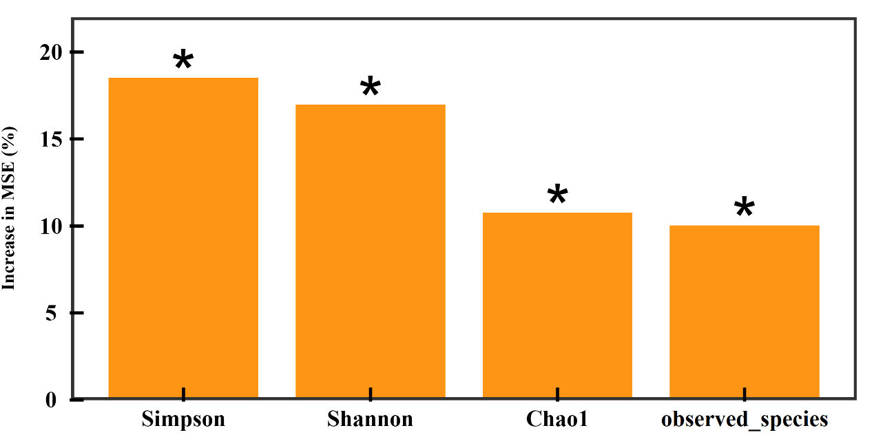

Fig. S1 The random forest analysis of multifunctionality to microbial diversity in bauxite residue

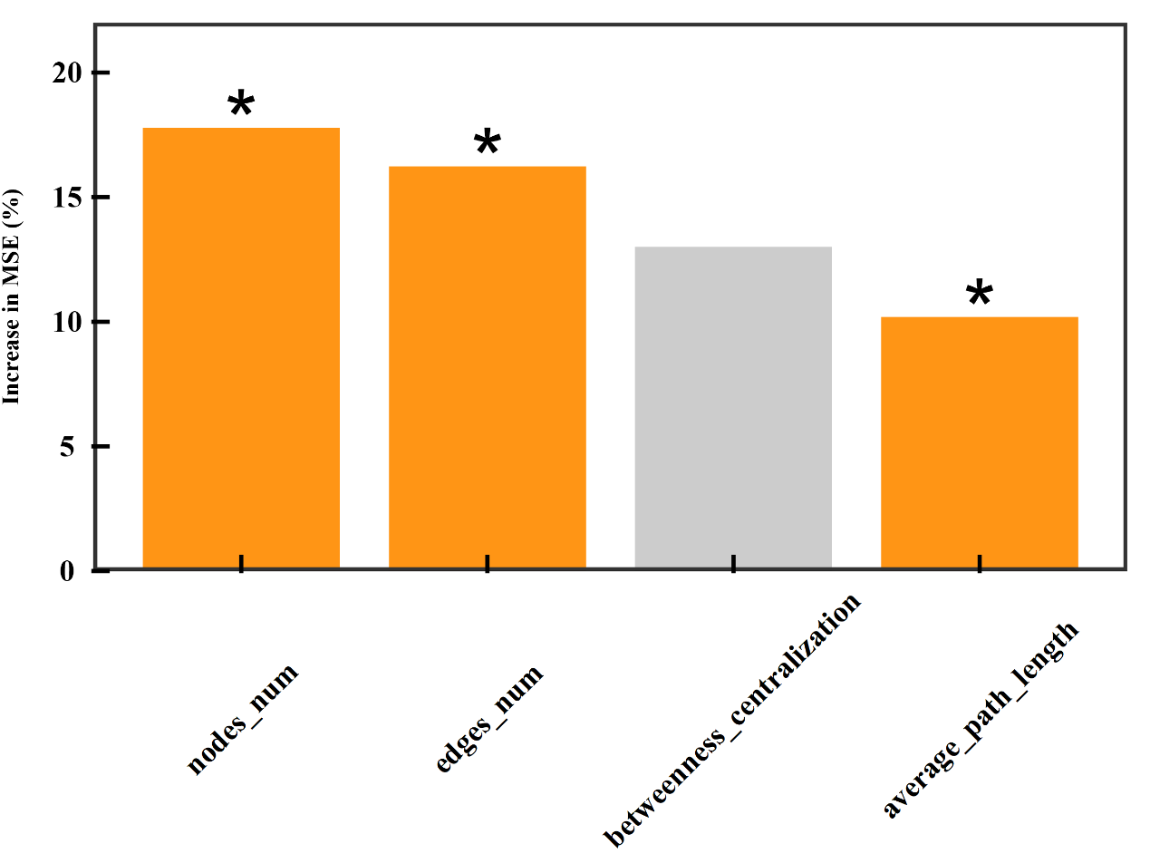

Fig. S2 The random forest analysis of multifunctionality to microbial stability in bauxite residue

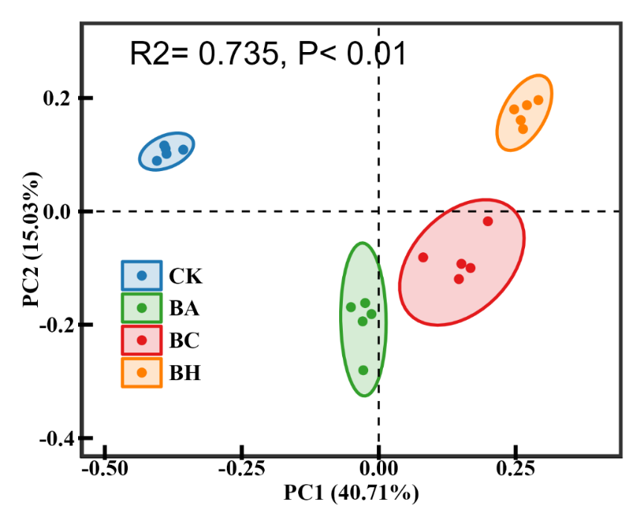

Fig. S3 Principal coordinate analysis (PCoA) of microbial communities in bauxite residue

