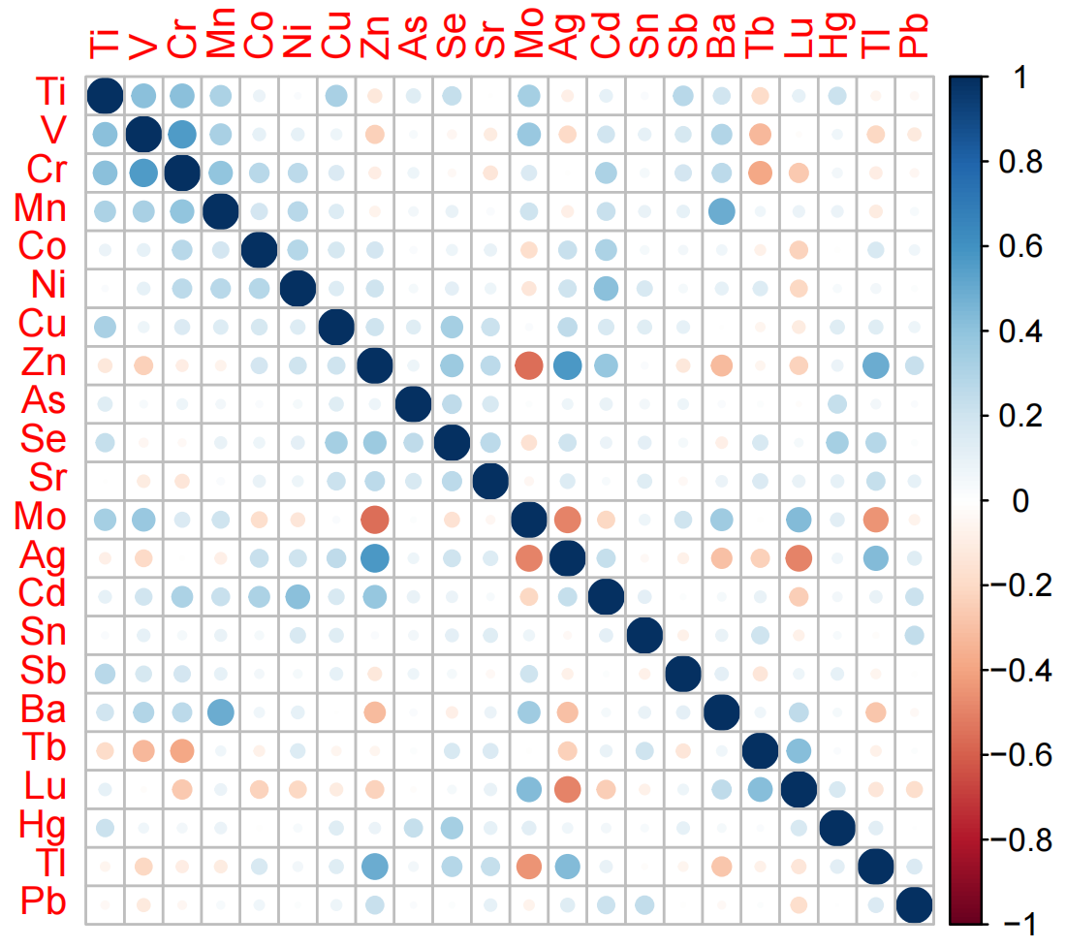
Figure S2 Correlations between metals

Note: The figure shows the relationship between the size of Spearman's correlation coefficient. The larger the bubble, the more correlated it is. Meanwhile, blue represents positive correlation and red represents negative correlation; The darker the color, the more salient it is.

