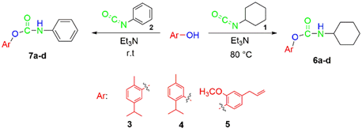
Scheme 1. The reaction of synthesis of carbamate derivatives using Carvacrol, Thymol and Eugenol with cyclohexyl and phenyl isocyanate.
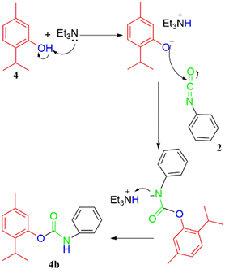
Scheme 2. An illustrative mechanism for the reaction between Thymol and phenyl isocyanate.
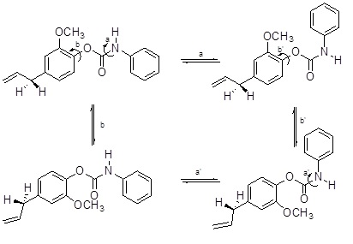

Scheme 3. The pathways for observed dynamic processes in compound 7d.

