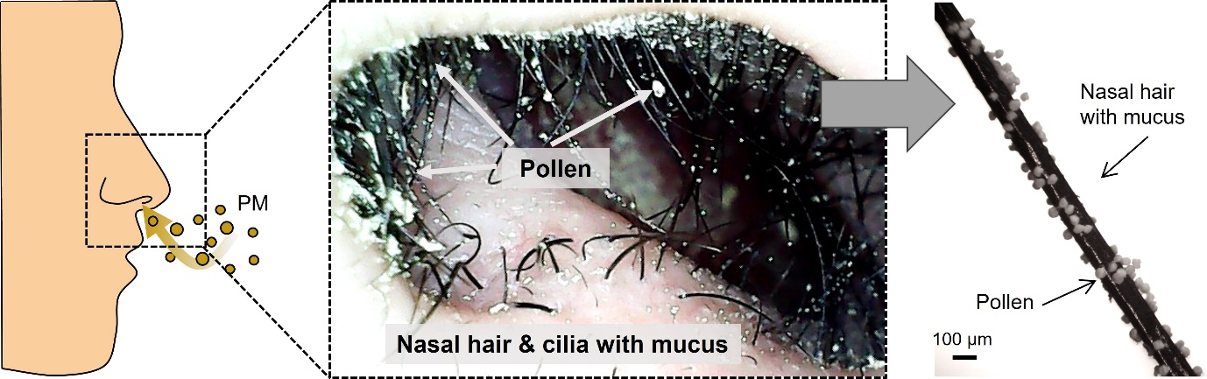
Extended Data Fig. 1. PM filtering at nasal cavity. Schematic illustration of PM filtering during inhalation (left). Photograph of the nasal cavity capturing pine pollens at nasal hairs and cilia (middle). Optical microscope image of single nasal hair (right), cut from the nasal cavity. We received informed consent from the volunteer for utilization of nasal cavity and hairs.

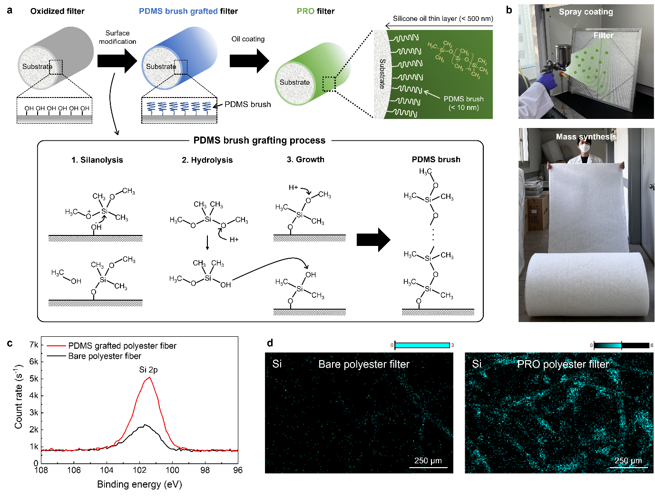
Extended Data Fig. 2. Fabrication method of the PRO filter and Elemental characterization. a, Schematics of fabrication procedure of the PRO filter. The box includes a schematic outline of the grafting process of PDMS brush. The PDMS brush grafting process consists of following sequential steps: silanolysis, hydrolysis, and growth of the PDMS brush. b, Right photos depicts a fabrication method using spray gun enabling mass production. c, XPS spectra indicating Si 2p element on the surface of bare (black line) and PDMS grafted (red line) polyester filter fiber. d, EDS analysis images representing Si of polyester filter. Left and right are bare and PRO filters, respectively.

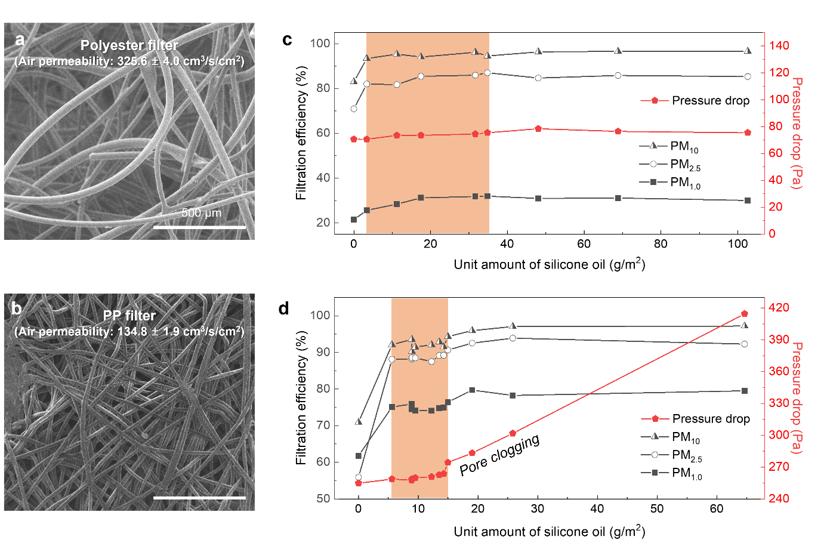
Extended Data Fig. 3. Filtration performances with varied amounts of silicone oil. a,b, SEM images of (a) polyester and (b) PP non-woven filters. c,d, Filtration performances of (c) polyester and (d) PP filters by coating amounts of silicone oil. Red and black lines represent ΔP and FEs of filter with 3 different size distributions, respectively. Orange boxes indicate optimum ranges of the amounts of silicone oil, achieving maximum FEs with negligible ΔP changes. Even though the ΔP of polyester filter was not enhanced, we applied silicone oil of less than 35 g/m² to avoid serious Plateau-Rayleigh instability at the fibers, as shown in Supplementary Information Fig. S2.

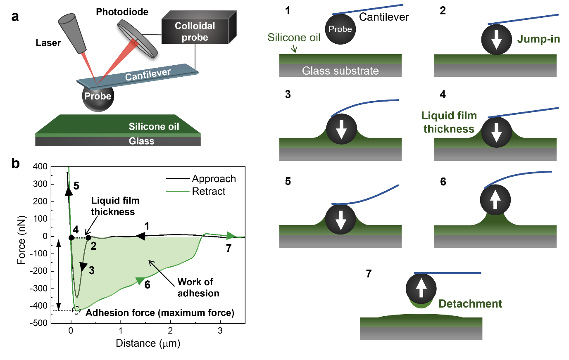

Extended Data Fig. 4. Principles of colloidal probe-based force measurement. (a) Schematic illustration of colloidal probe technique interacting with oil-coated substrate and (b) its force-distance curve. Numbers in the curve corresponding to each step are shown on the right images.

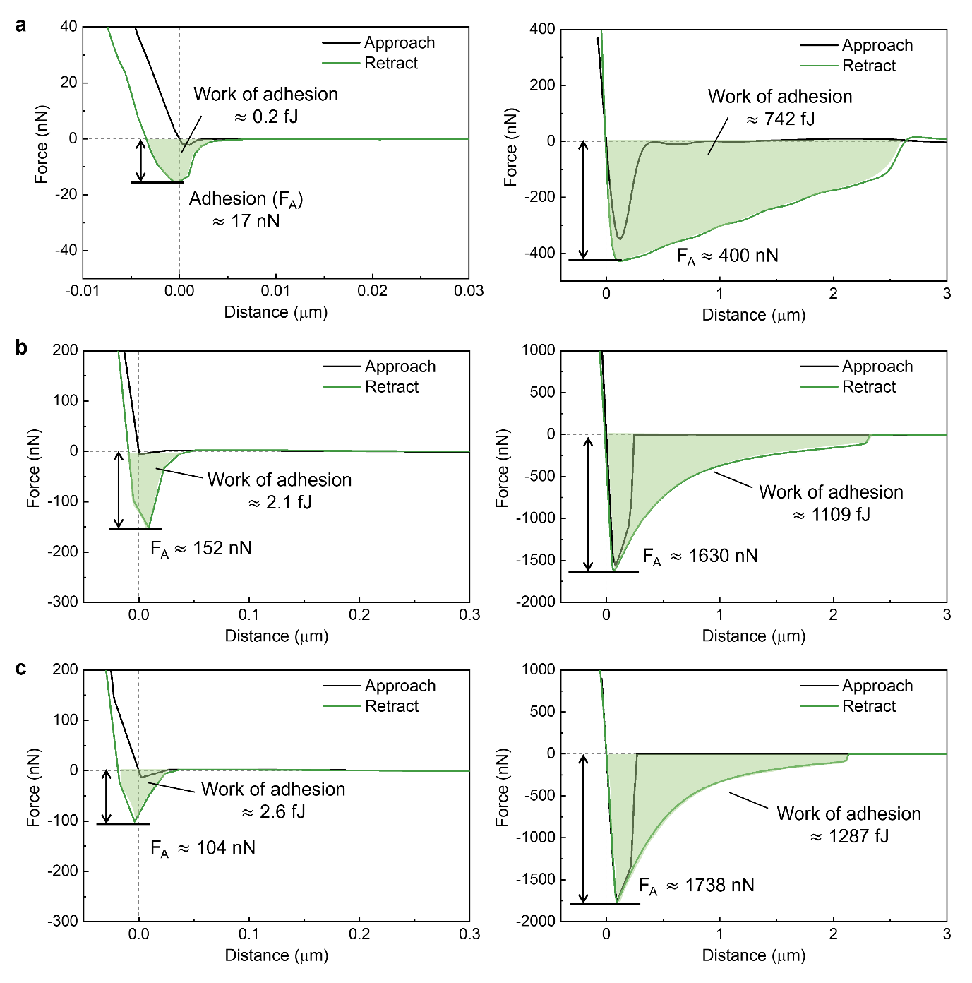
Extended Data Fig. 5. Force-distance curves of varied particles. Force-distance curves measured by a colloidal probe using (a) 7 μm and (b) 15 μm silica, and (c) 15 μm polyethylene beads in diameter, on bare (left) and oil-coated (right) cover glass substrates. Thickness of silicone oil layer on the PRO glass was approximately 200 nm.

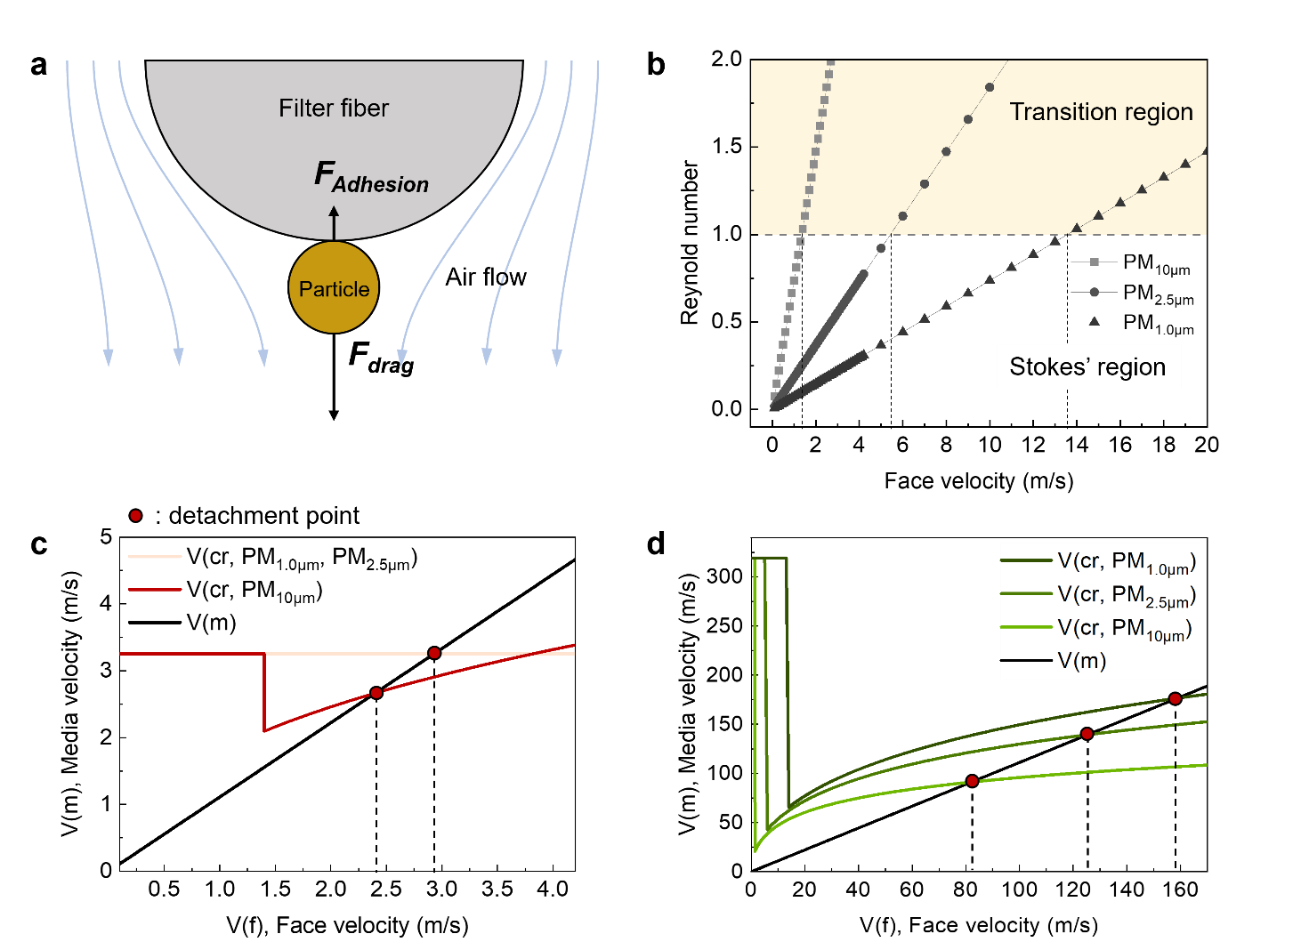
Extended Data Fig. 6. Particle resuspension critical velocity analysis. a, Schematic representing forces exerted on particles adhering to filter fiber. Position of particle on filter fiber was postulated that it was repositioned along the rounded surface of fiber by drag forces, as depicted. b, Reynolds numbers corresponding to PM_{1.0µm}, PM_{2.5µm}, and PM_{10µm} plotting as a function of face velocity, with a demarcation at a Reynolds number of 1 to separate Stokes' region from transition region. c,d, The theoretical computations for critical detachment velocities $V_{(cr)}$ for (c) bare and (d) PRO filters as functions of particle size and face velocity. Points of intersection between media velocity $V_{(m)}$ and critical detachment velocity $V_{(cr)}$ are highlighted in red dots, indicating the onset of particle detachment. Detailed numerical calculation corroborated in Supplementary Information Section 3.

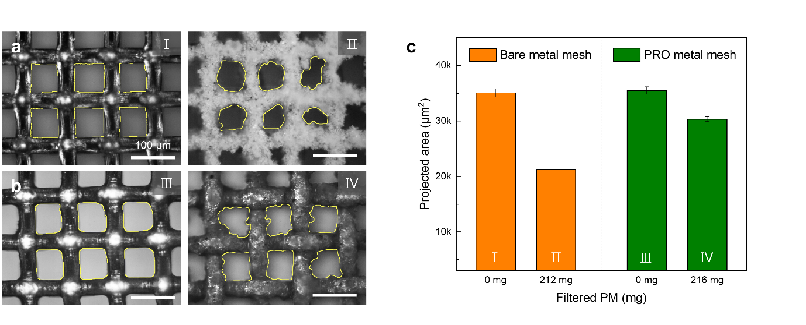
Extended Data Fig. 7. Projection pore area analysis during filtration. a,b, SEM images of the (a) bare and (b) PRO stainless steel metal mesh during filtration. Yellow boxes of each image represents the pores of metal meshes. c, Projected pore areas of metal mesh before (Ⅰ and Ⅲ) and after (Ⅱ and Ⅳ) filtration. The weights of filtered PMs were similar, which was 212 mg on bare and 216 mg on PRO metal mesh over unit area of 100 cm². Error bars show s.d.; $n$ = 6.

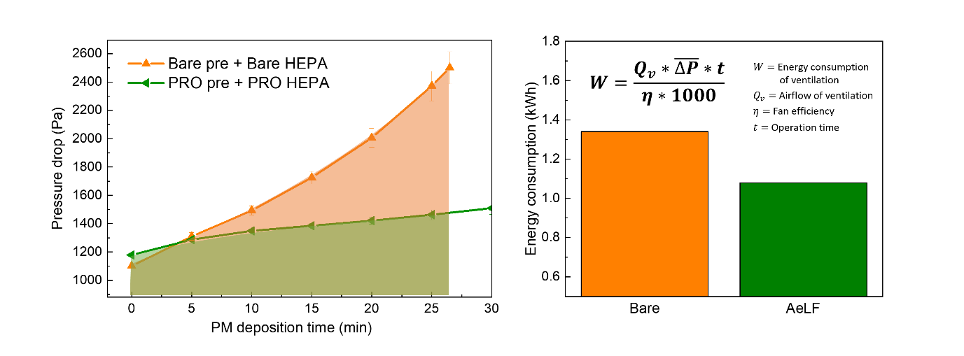
Extended Data Fig. 8. Electricity consumption in ventilation. Calculation of electricity consumption from the ΔP-deposition time curve using the equation stipulated in ventilation standard: SPS-KACA-0026-7175:2017. Airflow rate as 0.9 m³/s and fan efficiency as 0.5 were employed following the ventilation standard. The operation time was selected as 27 min based on the moment at which the ΔP across the bare pre- / HEPA filter (orange line) doubled its initial value. The energy consumption of the PRO pre- / HEPA filter (green box) was calculated as 1.08 kWh, marking an approximate 20% reduction compared to the bare pre- / HEPA filter (orange box), which consumed 1.34 kWh.

Extended Data Table 1. Filtering performances. Filtering performances in detail, shown in Fig. 2a, including air permeability at 125 Pa, FE of PM_{1.0} (0.3 ~ 1 μm in diameter), PM_{2.5} (1 ~ 2.5 μm in diameter), and PM₁₀ (2.5 ~ 10 μm in diameter) and ΔP. Testing area is 100 cm². Errors show s.d.; $n$ = 3.
