Supporting information

Synergetic hydrogen-bond network of functionalized graphene and cations for enhanced atmospheric water capture
Xiaojun Ren ¹, Xiao Sui ², Llewellyn Owens ³, Dali Ji ¹, Xinyue Wen ¹, Yuta Nishina ⁴, Kamal K. Pant ⁵, Vanesa Quintano ^{1,6}, Daria V. Andreeva ^{7,8}, Kostya S. Novoselov ^{7,8}, Amir Karton ^{9 *}, Tobias Foller ^{1 *}, Rakesh Joshi ^{1 *}
¹School of Materials Science and Engineering, University of New South Wales Sydney, NSW 2052, Australia
²Harbin Institute of Technology (Weihai), School of Marine Science and Technology, Weihai 264209, China
³Vesi Water Pty Ltd, NSW 2340, Australia
⁴Graduate School of Natural Science and Technology, Okayama University, Kita-ku, Okayama, Japan
⁵Department of Chemical Engineering, Indian Institute of Technology Roorkee, Roorkee 247667, India
⁶Catalan Institute of Nanoscience and Nanotechnology (ICN2), CSIC and BIST, Campus UAB, Bellaterra, 08193 Barcelona, Spain
⁷Institute for Functional Intelligent Materials, National University of Singapore, Singapore, 117575 Singapore
⁸Department of Materials Science and Engineering, National University of Singapore, 117575, Singapore
⁹School of Science and Technology, University of New England, Armidale, NSW 2351, Australia

This file includes:

I. Supplementary Note 1 to 9
II. Supplementary Figures 1 to 6
III. Supplementary Tables 1

Other Supplementary files for this manuscript includes:
I. Supplementary Table 2.1 to 2.9

Supplementary Note 1. Synthesis of calcium intercalated graphene oxide aerogel (Ca-GOA)
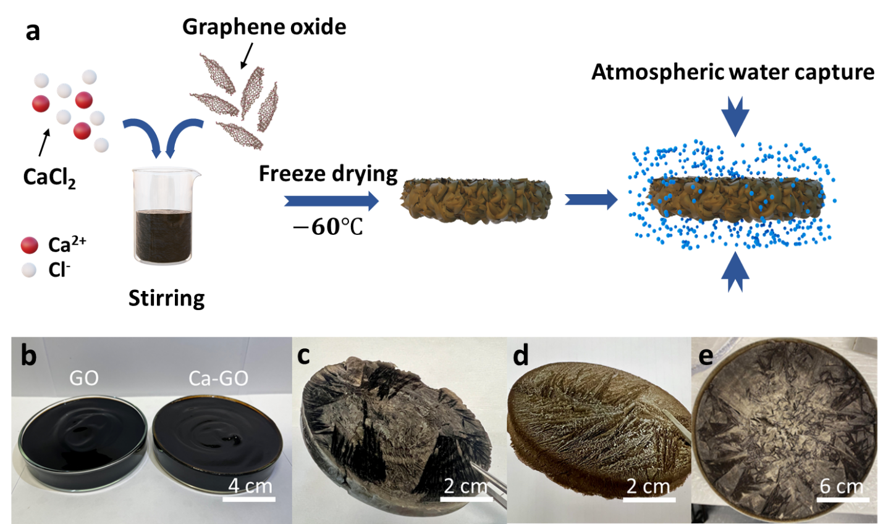
Fig.S1 Synthesis of graphene oxide aerogels (GOA). a Schematic diagram of Ca-GOA synthesis and atmospheric water capture process. b-e Photographs of graphene oxide (GO) and calcium-intercalated GO (Ca-GO) solutions (b), freeze-dried GOA (c), Ca-GOA with a radius of 4 cm (d) and large-scale Ca-GOA with a radius of 10 cm (e)¹.

Supplementary Note 2. GOA atmospheric water capture ability and morphology
We ruled out the morphology impacts of atmospheric water capture (AWC) abilities for graphene oxide aerogels (GOA) and graphene oxide membranes (GOM). Our experimental results (Fig. S2a) illustrate that GOA samples exhibit AWC abilities within a comparable range to those of GOMs. The scanning electron microscope (SEM) images of GOA are shown in Fig. S2 b-c.
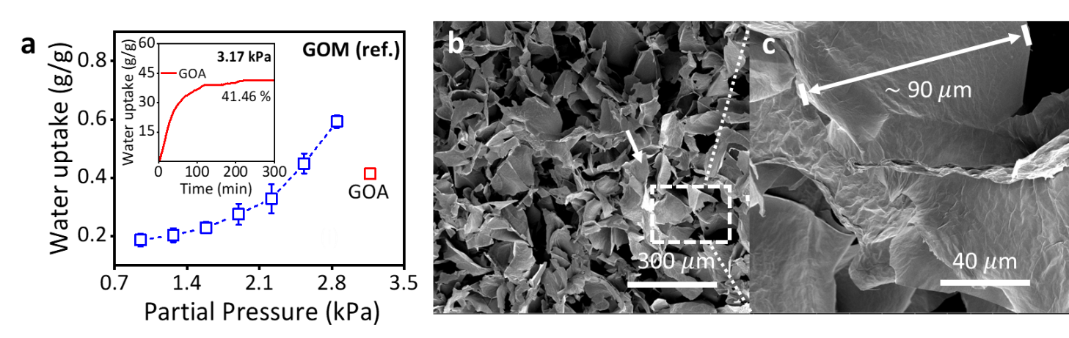
Fig.S2 GOA/GOM atmospheric water capture (AWC). a Water uptake of GOAs (red square) and GOMs (blue squares with dashed line) at different ambient water partial pressure (kPa), values of GOM are obtained from our previous work². The inset displays the AWC of GOA vs. time at constant pressure of 3.17 kPa. The error bar indicates the standard deviation. b-c Scanning electron microscope (SEM) images of GOA.

Supplementary Note 3. X-ray photoelectron spectra (XPS)

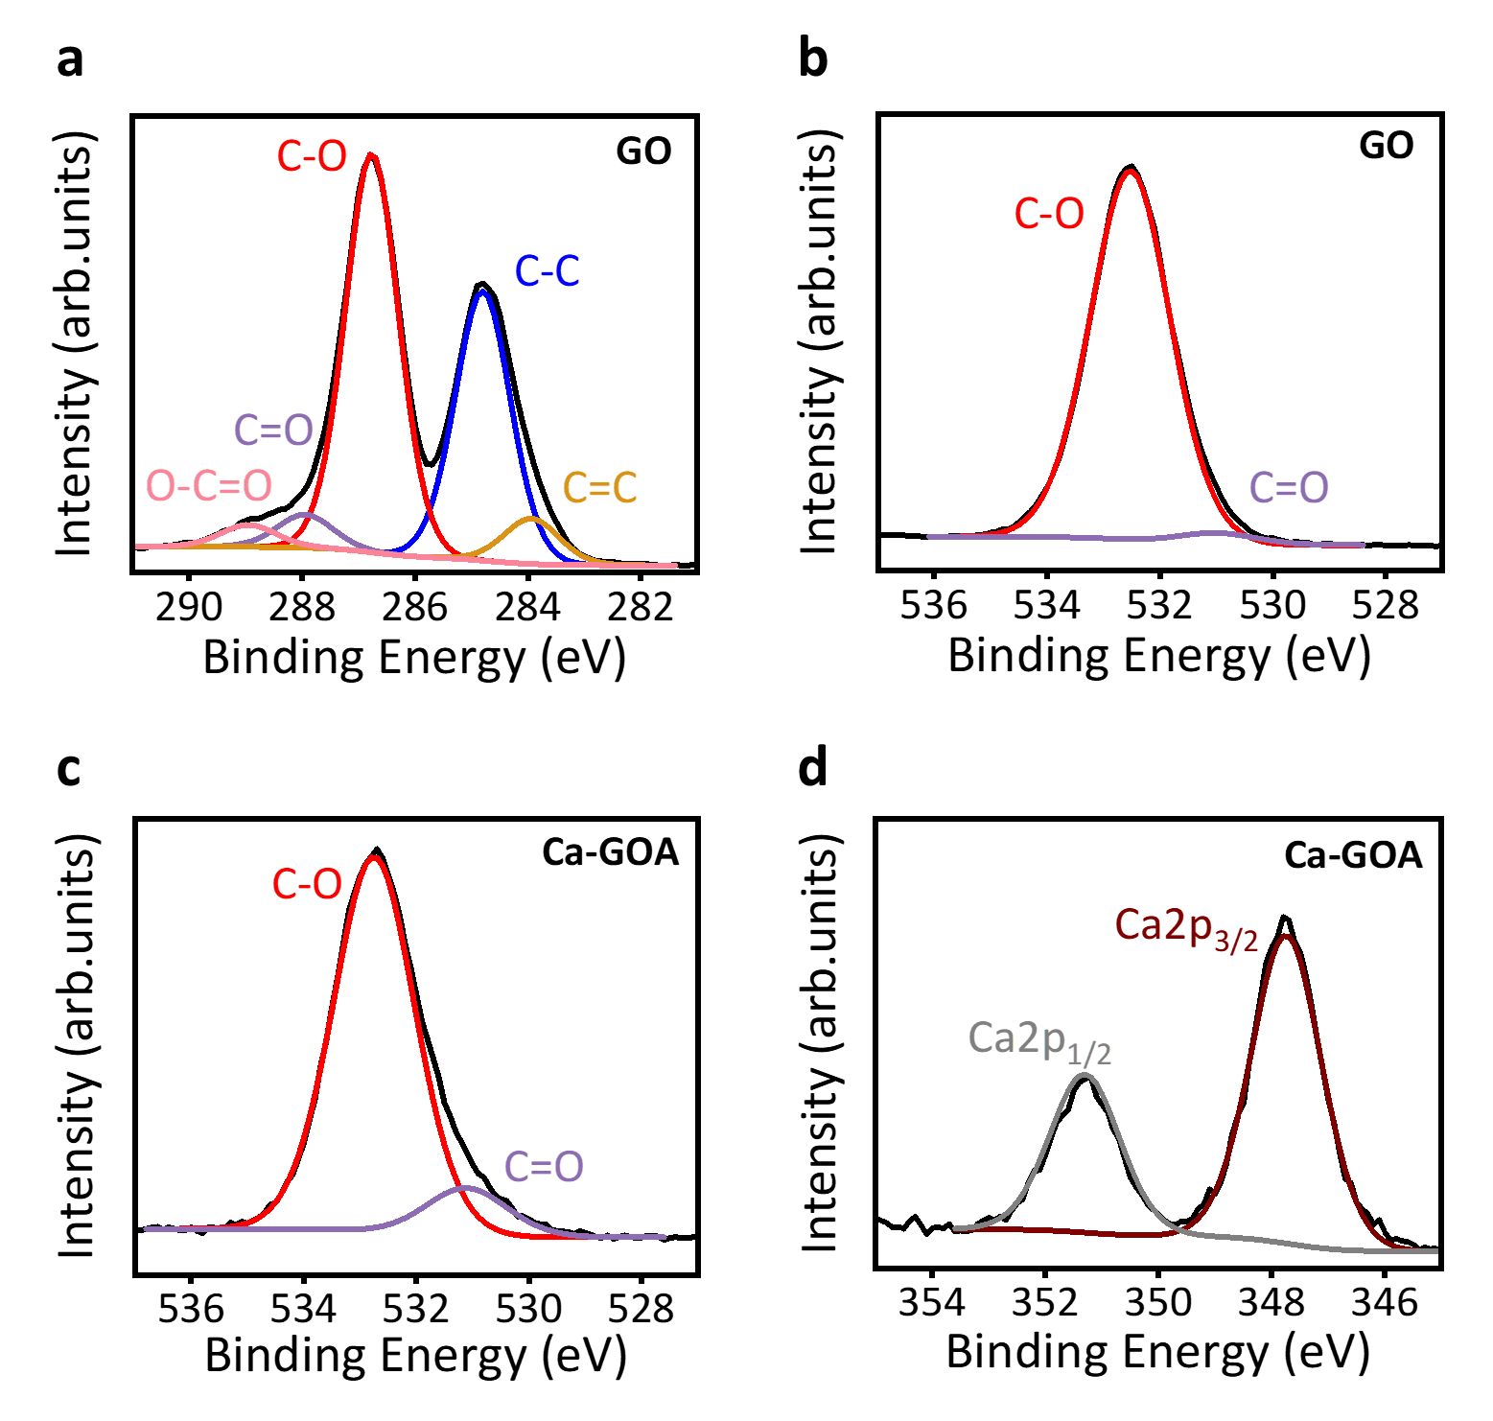
Fig.S3 XPS spectra of GO and Ca-GOA. a C1s XPS spectra (black curve) of GO with peak fitting of C=C bond at $\sim$284.5 eV and C-C bond (blue curve) at $\sim$284.8 eV, C-O bond (red curve) at $\sim$286 eV, C=O bond (purple curve) at $\sim$288 eV, O-C=O (pink curve) at $\sim$289 eV. b O1s XPS spectra (black curve) of GO and c Ca-GOA sample, with peak fitting of organic C=O bond at $\sim$531.5 eV and organic C-O bond (purple curve) at $\sim$533 eV. d Ca2ps XPS spectra (black curve) of Ca-GOA, with peak fitting of Ca2p_{3/2} (brown curve) at $\sim$347.2 eV and Ca2p_{1/2} (gray) at $\sim$350.7 eV.

Supplementary Note 4. Brunauer–Emmett–Teller (BET) adsorption model fitting
We analysed the AWC behaviours of CaCl₂, GOM, and Ca-GOA using fractal dimension corrected BET model^{3,4}. Brunauer–Emmett–Teller (BET) adsorption model is a multilayer-extended derivation from Langmuir adsorption model⁵ and widely used to present gas-solid equilibrium systems^{4,6–8}. The BET model can be expressed as^{3,9} ,
$\frac{m}{m_{s}}=\frac{C\sum_{i=1}^{n}{i^{2-d_{Γ}}P^{i}}}{1+(C-1)P}$ (S4.1)
Here, $m$ represents the water uptake in g/g, $m_{s}$ represents the adsorption capacity to reach a monolayer coverage of water molecules on material surface, $n$ is the number of layers of adsorbed water molecules, $C$ is a derived coefficient depending on the kinetic constants, surface adsorption energy and temperature during surface water adsorption, $d_{Γ}$ is a derived fractal dimension coefficient related to the intrinsic geometric irregularity of the material surface and $P$ is the water partial pressure.
The equation S4.1 is a typical polynomial equation which $n-1$ equals to the degree of the polynomial equation. This approach allows us to polynomial fit the AWC data of CaCl₂, GOM, and Ca-GOA, respectively, to investigate whether each adheres to the BET adsorption model during AWC process. We conducted individual polynomial fits with degrees ranging from 1 to 6 ($n$ = 1 to 7) for the water uptake of CaCl₂, GOM, and Ca-GOA, selecting the fitted curves with the highest coefficient of determination (R²) as the respective results for each material.
In the case of CaCl₂, the polynomial fits with a degree of 6 ($n$ = 7) has the highest R². We therefore suggest that the AWC of CaCl₂ follows BET adsorption model and 7 layers of water molecules may be adsorbed on the surface. Within the same methodology, we obtained $n$ = 4 for GOM and $n$ = 6 for Ca-GOA. From here we can conclude that the AWC of CaCl₂, GOM and Ca-GOA all follows BET adsorption model however each of the polynomial fitted equations is within different degree. The water uptake and BET fitting results are shown in Fig.S4 a-c for CaCl₂, GOM and Ca-GOA respectively.
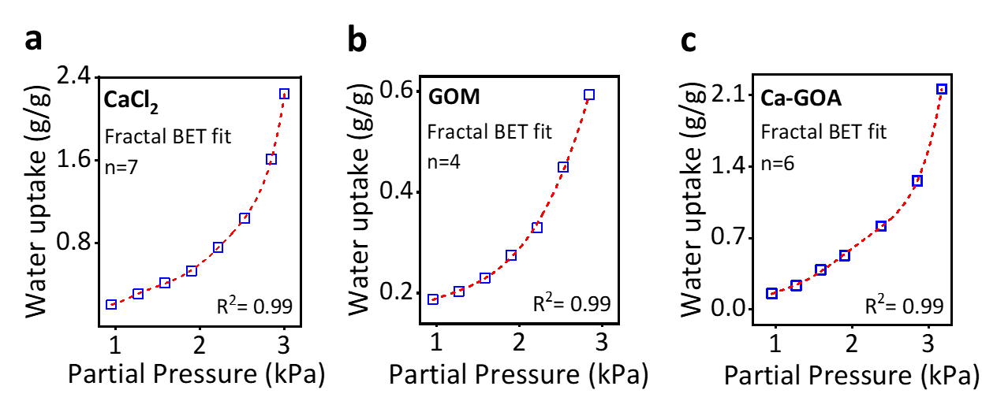
Fig.S4 Fractal BET fitting. Ambient water partial pressure vs. water uptake of CaCl₂ (a), GOM (b), and Ca-GOA (c) with BET fitting curves (red dashed line).
Supplementary Note 5. Freundlich model fitting
We analysed the AWC behaviours of CaCl₂, GOM, and Ca-GOA using Freundlich isotherm model. The Freundlich isotherm model is an empirical model ¹⁰ which is used to describe reversible adsorption process following inhomogeneous affinities on non-uniform surface^{4,7,8,11}. Freundlich model can be expressed by the following equation in linear form ¹⁰,
$log\frac{m}{m_{0}}=logK+\frac{1}{n}logP$ (S5.1)
where m/m₀ represents the water uptake (g/g) and P represents the water partial pressure (Kpa). K and $n$ are empirical constants depend on the adsorbate and adsorbents at given temperature, which in our case the adsorbate is water molecules and adsorbents are CaCl₂, GOM, Ca-GOA respectively and the temperature is 298K.
We conducted the linear fit of the AWC data of CaCl₂, GOM, and Ca-GOA respectively to investigate whether each material adheres to the Freundlich isotherm model during AWC process. In our case, higher coefficient of determination (R²) of the linear fit represents this material has higher adherence to Freundlich isotherm water adsorption. In our case, this suggests that the material surface exhibits heterogeneous adsorption of water molecules at different position on surface with variations in the adsorption energy ^{4,10}. In the case of Ca-GOA, the of the linear fit is the highest (R²=0.96), followed by CaCl₂ (R²=0.91) and GOM (R²=0.86). From here we can conclude that water adsorption of Ca-GOA adheres to the Freundlich isotherm model more significant than CaCl₂ and GOM. The results are shown in Fig.2d-f in the main text.

Supplementary Note 6. Atomic ratio between C, O and Ca atoms and captured water molecules in various materials
We estimated the atomic ratio between C, O and Ca atoms and captured water molecules in CaCl₂, GOM and Ca-GOA based on the XPS survey spectra (Fig.1c-d). Namely, GO contains 66.2% carbon, and 33.1% oxygen while Ca-GOA mainly consists by 56.8% carbon, 27.5% oxygen and 5.14% of calcium in atomic percentage. With this, we can first estimate the molecular weight of each material, for example for GO,
$M_{n (GO)}$ = ${a×M}_{n (C)}+{b×M}_{n (O)}$ = $0.662×12.01+0.331×15.99$ = 13.227 g/mol (S6.1)
where $M_{n}$ represents the molecular weight (g/mol), a and b represent atomic percentage of calculated element, i.e. C and O.
From here, we can further estimate the number of moles ratio between captured water molecules and desired atoms on CaCl₂, GOM and Ca-GOA, i.e. O and Ca (main text Fig.2g-i). To help with understanding the estimation process, we present an example. At ambient pressure of 3.17 kPa, Ca-GOA can uptake 36.63 g of water per mol of Ca-GOA (Fig.2c), as we assume there is 1 mol of Ca-GOA, the water uptake is,
$n_{water }$ = $\frac{m}{M_{water}}$ = $\frac{36.63 g}{18.00 g/mol}$ = 2.0352 mol (S6.2)
where $n_{water }$ represents the number of moles (mol) of water uptake, m represents the mass of the water uptake per mol of the material (g/mol) and M represents the mole mass of the water (g/mol).
Knowing that in Ca-GOA, the atom percentage of calcium is 5.14%, the ratio between captured water molecules ($n_{water }$) and calcium atom( $n_{Ca }$) is,
$\frac{n_{water}}{n_{Ca}}$ = $\frac{2.0352 mol}{0.0514 mol}$ = 39.6 (S6.3)
This indicates that at ambient pressure of 3.17 kPa, each calcium atom on Ca-GOA captures 39.6 water molecules. This example illustrates the calculation of the data point at ambient pressure of 3.17 kPa in the main text (Fig.2h). All the data points are estimated following the same process and concluded in Fig 2g-I in the main text.
Supplementary Note 7. Density functional theory (DFT) calculations of two epoxides on graphene plane coordinated to one hydrated calcium ion
We performed the DFT calculations to investigate the hydrogen bond properties in the system with two epoxides on graphene plane and coordinated to a single hydrated calcium ion. The models for DFT calculations are shown in Fig. S5, and the results are listed in Table. S1 in detail.
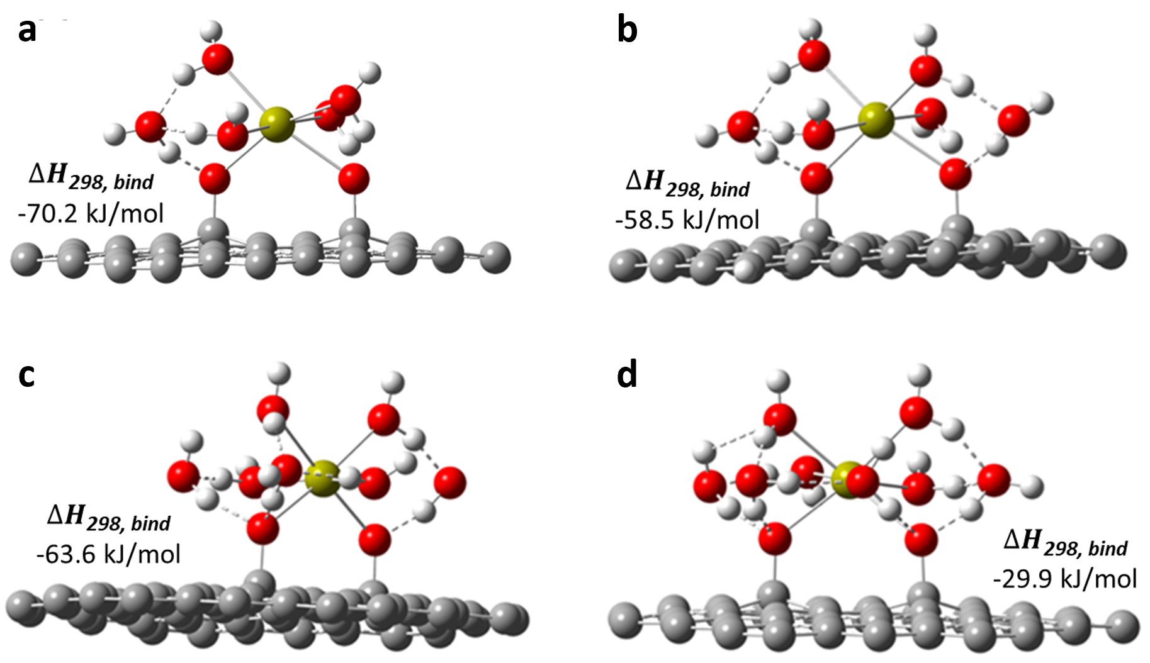
Figure S5. Graphene plane-based models with two epoxides for DFT calculations. a–d Systems include 1–4 water molecules H-bonded to the GO oxygens. The PBE0-D3BJ/Def2-QZVPP binding enthalpies at 298 K (∆H_{298,bind}) between the Ca²⁺/epoxy-decorated graphene and water molecules are given in kJ/mol.

Table S1. Atomic polar tensor (APT) charges (q) in a.u. involved in the H-bonds and on the Ca atom for the systems in Figure S5 (H-bond enthalpies are given in kJ/mol). The systems are labelled by the part in Fig. S5 where they are displayed.
Model | q(O_{water}) | q(H_{water}) | q(O_{epoxy}) | q(Ca) | ∆H_{298, bind} (kJ/mol)
S5a  (1 H₂O molecule) | –0.71 | +0.52 | –0.70,  –0.70 | +1.18 | –70.2
S5b  (2 H₂O molecules) | –0.71, –0.67 | +0.52, +0.45 | –0.71,  –0.69 | +1.18 | –58.5
S5c  (3 H₂O molecules) | –0.70, –0.69,  –0.52 | +0.50, +0.50, +0.31 | –0.74,  –0.71 | +1.17 | –63.6
S5d  (4 H₂O molecules) | –0.70, –0.64,  –0.58, –0.54 | +0.52, +0.39, +0.30, +0.29 | –0.72,  –0.70 | +1.13 | –29.9

Supplementary Note 8. AWC experimental setup

We evaluated the atmospheric water capture (AWC) of the aerogels using a custom-made, humidity-controlled system as shown in Fig. S6. Humidity control within the system was achieved by regulating the flow rate of compressed dry air and served as the carrier of moisture generated by heating the DI water. Two humidity sensors were strategically positioned within the system to monitor the uniform distribution of the humidity.

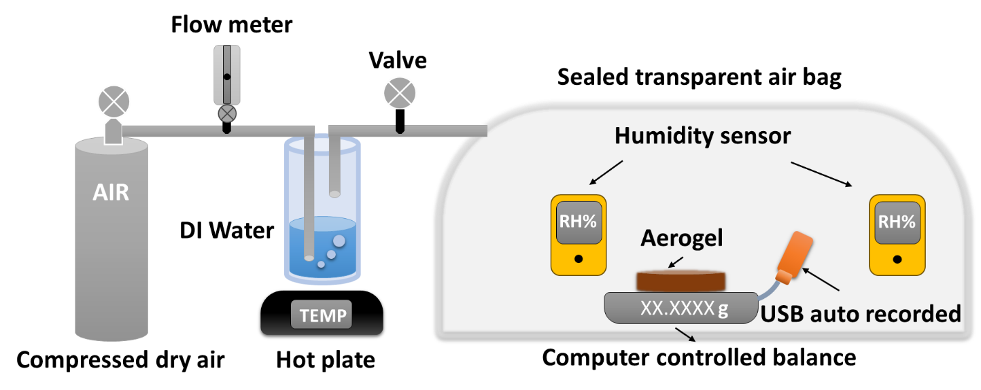
Fig.S6 Schematics of the experimental setup to measure AWC.

Supplementary Note 9. PBE0-D3BJ/def2-SVP optimized geometries in DFT calculations

The PBE0-D3BJ/def2-SVP optimized geometries of Fig.3 a-e and Fig.S5 a-d are summarized in the supplementary excel file.

References
1. Joshi, R. et al. A GRAPHENE OXIDE AEROGEL. (2023).
2. Lian, B. et al. Extraordinary water adsorption characteristics of graphene oxide. Chem Sci 9, 5106–5111 (2018).
3. Fripiat, J. J., Gatineau, L. & Van Damme, H. Multilayer physical adsorption on fractal surfaces. Langmuir 2, 562–567 (1986).
4. Foo, K. Y. & Hameed, B. H. Insights into the modeling of adsorption isotherm systems. Chemical Engineering Journal 156, 2–10 (2010).
5. Langmuir, I. THE CONSTITUTION AND FUNDAMENTAL PROPERTIES OF SOLIDS AND LIQUIDS. PART I. SOLIDS. J Am Chem Soc 38, 2221–2295 (1916).
6. Brunauer, S., Emmett, P. H. & Teller, E. Adsorption of Gases in Multimolecular Layers. J Am Chem Soc 60, 309–319 (1938).
7. Kalam, S., Abu-Khamsin, S. A., Kamal, M. S. & Patil, S. Surfactant Adsorption Isotherms: A Review. ACS Omega 6, 32342–32348 (2021).
8. Swenson, H. & Stadie, N. P. Langmuir’s Theory of Adsorption: A Centennial Review. Langmuir 35, 5409–5426 (2019).
9. Zhang, X. J., Sumathy, K., Dai, Y. J. & Wang, R. Z. Parametric study on the silica gel-calcium chloride composite desiccant rotary wheel employing fractal BET adsorption isotherm. Int J Energy Res 29, 37–51 (2005).
10. Freundlich, H. Über die Adsorption in Lösungen. Zeitschrift für Physikalische Chemie 57U, 385–470 (1907).
11. Zeldowitsch, J. Adsorption site energy distribution. Acta phys. chim. URSS 1, 961–973 (1934).

