Supplemental File SF1. Bioinformatic pipeline for the bacterial genome assembly

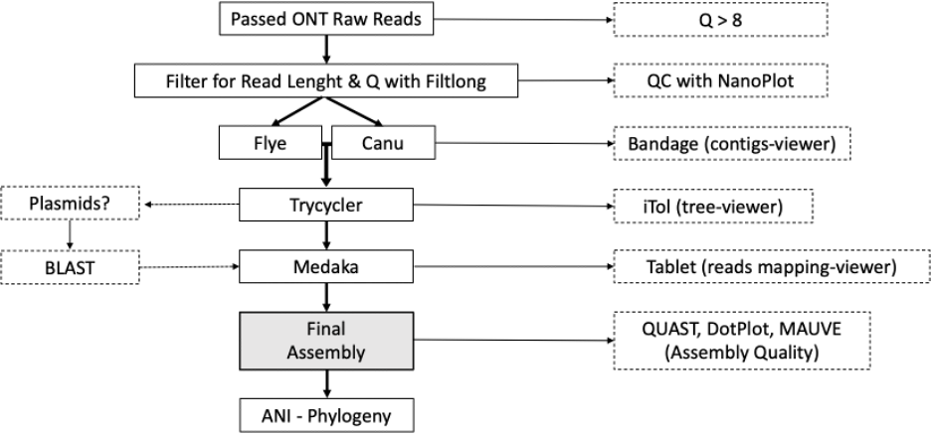

Figure S1. Flow chart illustrating the pipeline for the bacterial genome assembly. This pipeline utilized a consensus (generated using Trycicler) of the output of two de novo assemblers (Flye and Canu), followed by a polishing stage using Medaka. The assembly was evaluated with QUAST and BUSCO after the polishing stage. ONT = Oxford Nanopore Technologies, QC = quality control.

Supplemental File SF2. Quality assessment of the ONT sequencing run

Reads Quality (Nanoplot)

Isolates | Mean read length | Mean read quality | Number of reads | Read length N50 | Percentage of reads >Q10
MJ 1-1 | 1,161.4 | 11.4 | 68,193 | 2,162 | 92.2%
MJ 5-2 | 3,580.2 | 11.6 | 87,952 | 6,578 | 93.1%
MJ 7-1 | 3,194.3 | 11.7 | 121,220 | 6,220 | 94.5%
MJ 8-1 | 3,029.8 | 11.2 | 14,365 | 5,515 | 87.1%
MJ 9-1 | 2,777.8 | 11.1 | 73,436 | 6,645 | 85.0%

Q-score distributions (Nanoplot)

MJ 1-1
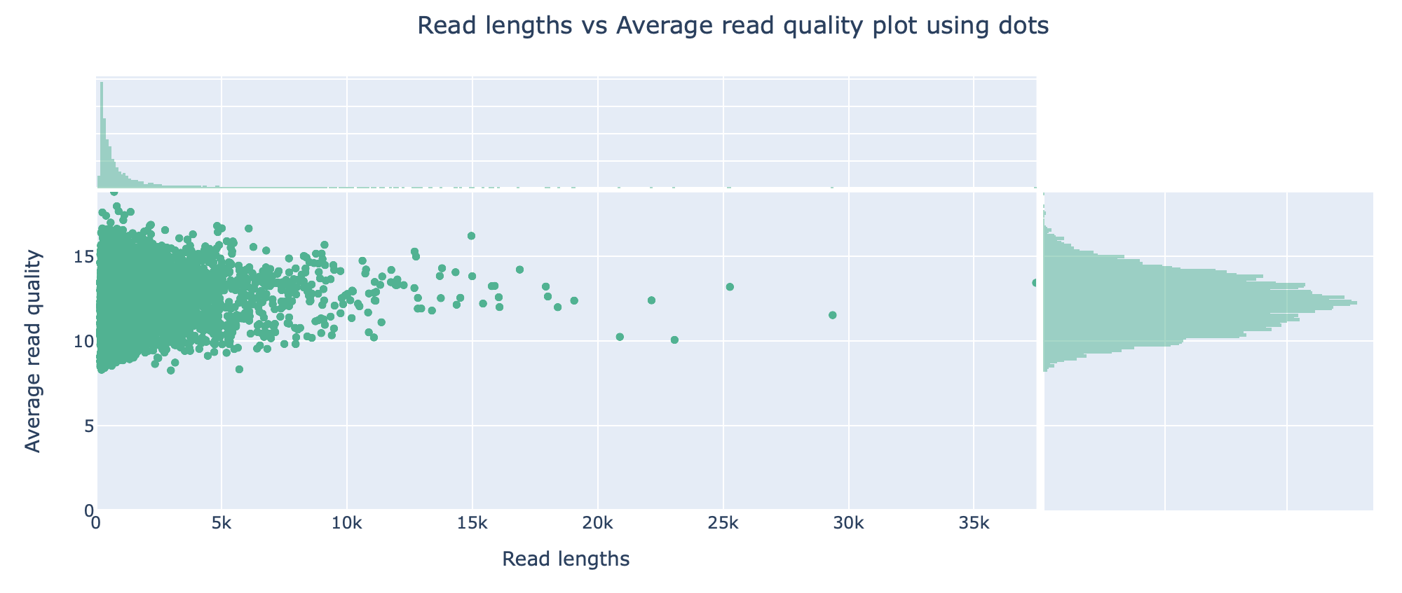

MJ 5-2
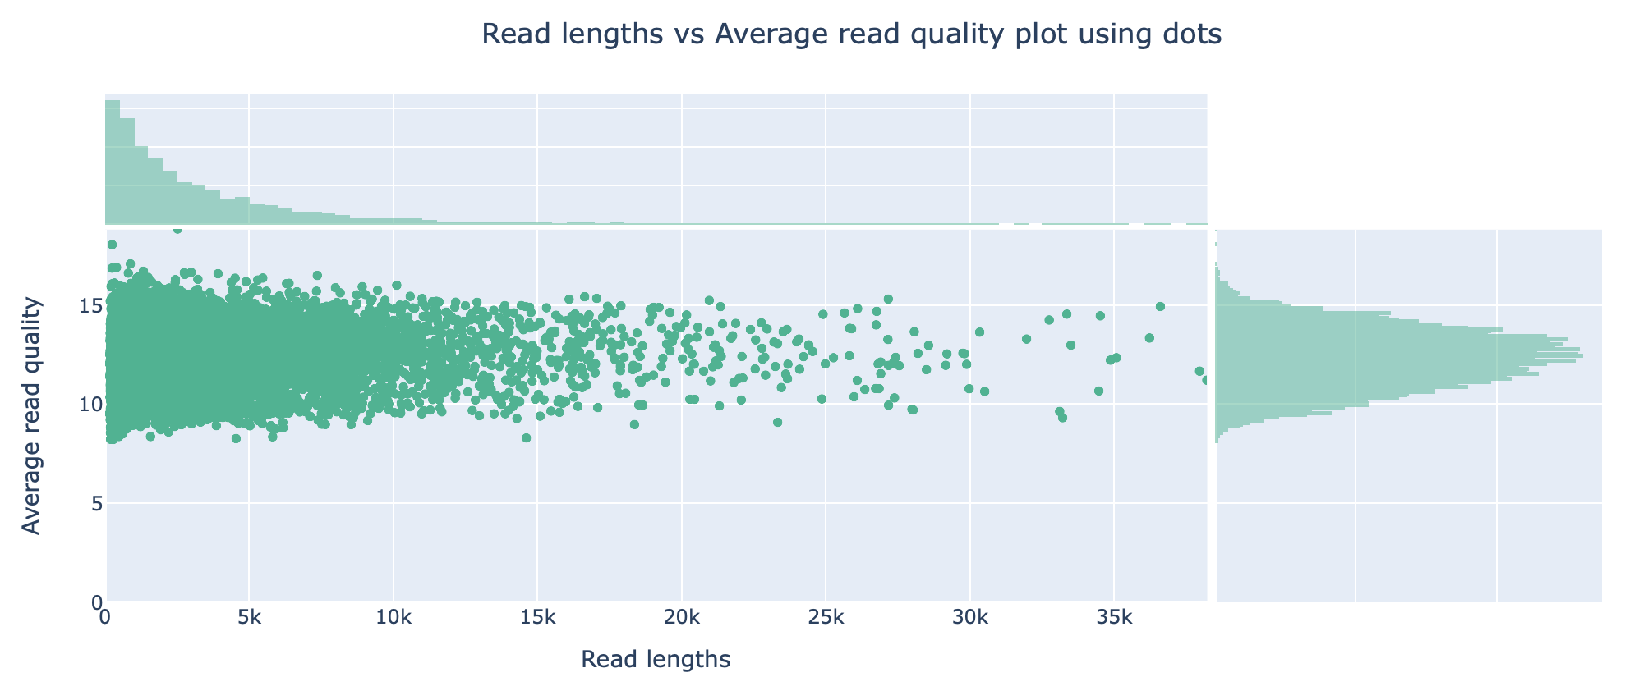
MJ 7-1

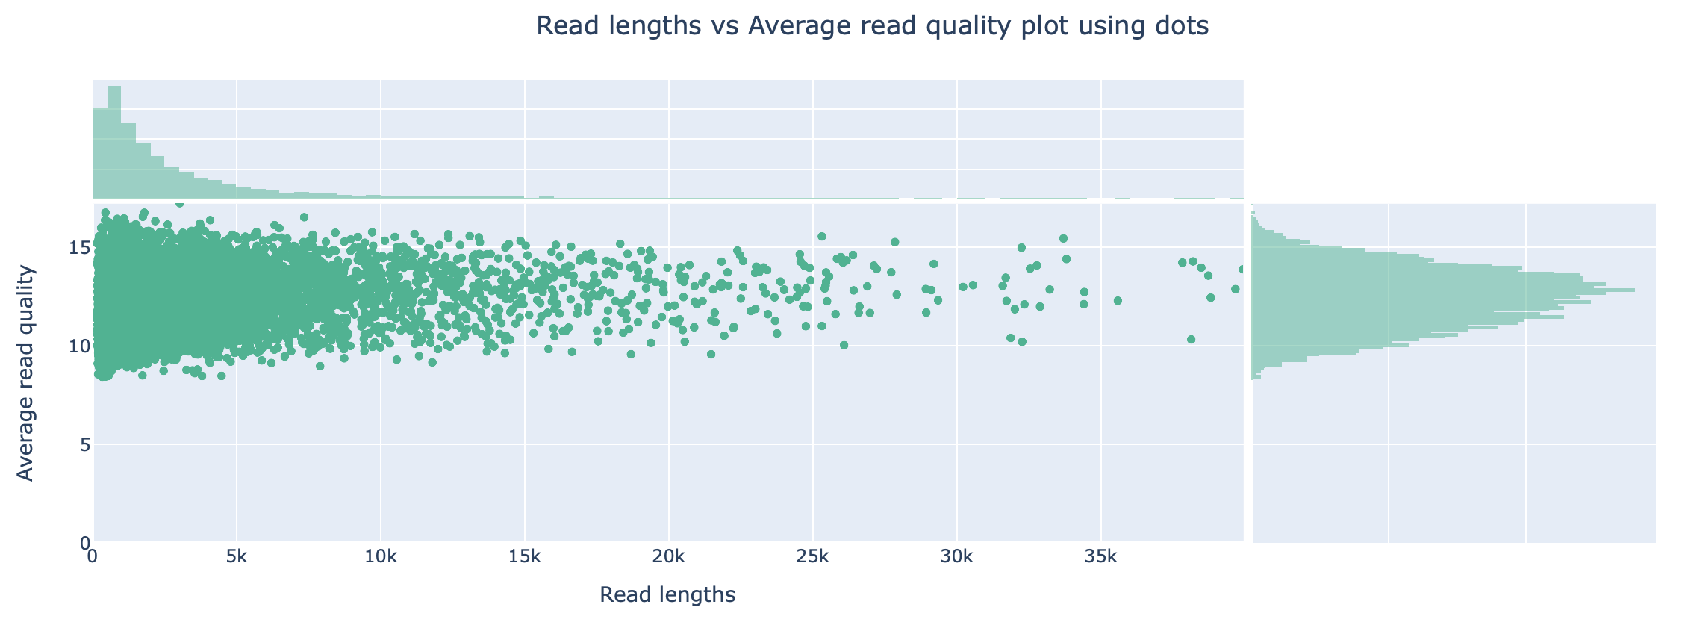
MJ 8-1
MJ 9-1

