Supplementary Note 1. Nitric Oxide Titration
Control and quantification of the atomic oxygen flowing over the sample surface is crucial to accurately interpreting the oxidation rate results. This was achieved by a NO titration method [18] which takes advantage of the reaction in Equation 1. This is a very rapid reaction with a room-temperature rate coefficient of 3×10⁻¹¹ cm³ molecule⁻¹ s⁻¹. When the power was turned on, the N₂ dissociated into atomic nitrogen and was mixed with NO to produce atomic oxygen. To maximize the amount of atomic oxygen produced, the plasma was run at a particular pressure, RF power, flow rate, and gas mixture ratio of argon and nitrogen. Initially, a small amount of NO was introduced to the plasma downstream of the powered electrode where it was completely consumed by the atomic nitrogen. As the flow rate of NO was increased, it approached the titration endpoint where the reaction was stoichiometrically balanced. Here, the atomic nitrogen was completely consumed and the molar flow rate of atomic oxygen was equal to that of the NO. Increasing the flow of NO beyond this point resulted in an excess of NO confirmed by mass spectrometry. The precise titration endpoint was found by recording the relative intensity of the mass spectrometer at 30 m/z (molar mass of NO) for a range of NO flow rates above and below this endpoint. A linear profile was fit to the data before and after the change in slope and the intersection was the titration endpoint. Thus, at a given pressure, power, and flow rate the amount of atomic oxygen could be controlled and was known for graphite oxidation experiments.
The effect of the NO titration could also be observed without the aid of any diagnostic equipment simply by the change in the plasma emission wavelength (color). In Figure 9, the nitrogen plasma is initially observed to be orange. Upon increasing NO flow rate, atomic nitrogen is consumed and the plasma becomes purple, indicative of an argon plasma containing atomic oxygen. In order to determine the optimal conditions for producing atomic oxygen, NO titrations were run at a range of different plasma power settings and gas mixture ratios which can be seen in the lower plots of Figures 9. As the power is increased from 50 to 300 W, the dissociation fraction of the nitrogen plasma increases. More NO is required to consume the additional atomic nitrogen which in turn produces more atomic oxygen. As the ratio of the nitrogen to argon in the plasma decreased, the titration endpoint increased until the plasma was almost entirely argon at which point the dissociation fraction of the nitrogen began to decline. Between 2.5% and 1% N₂ the nitrogen dissociation and atomic oxygen production reached a maximum. Using these results, the optimal test condition was selected to maximize atomic oxygen production for treatment of graphite samples.
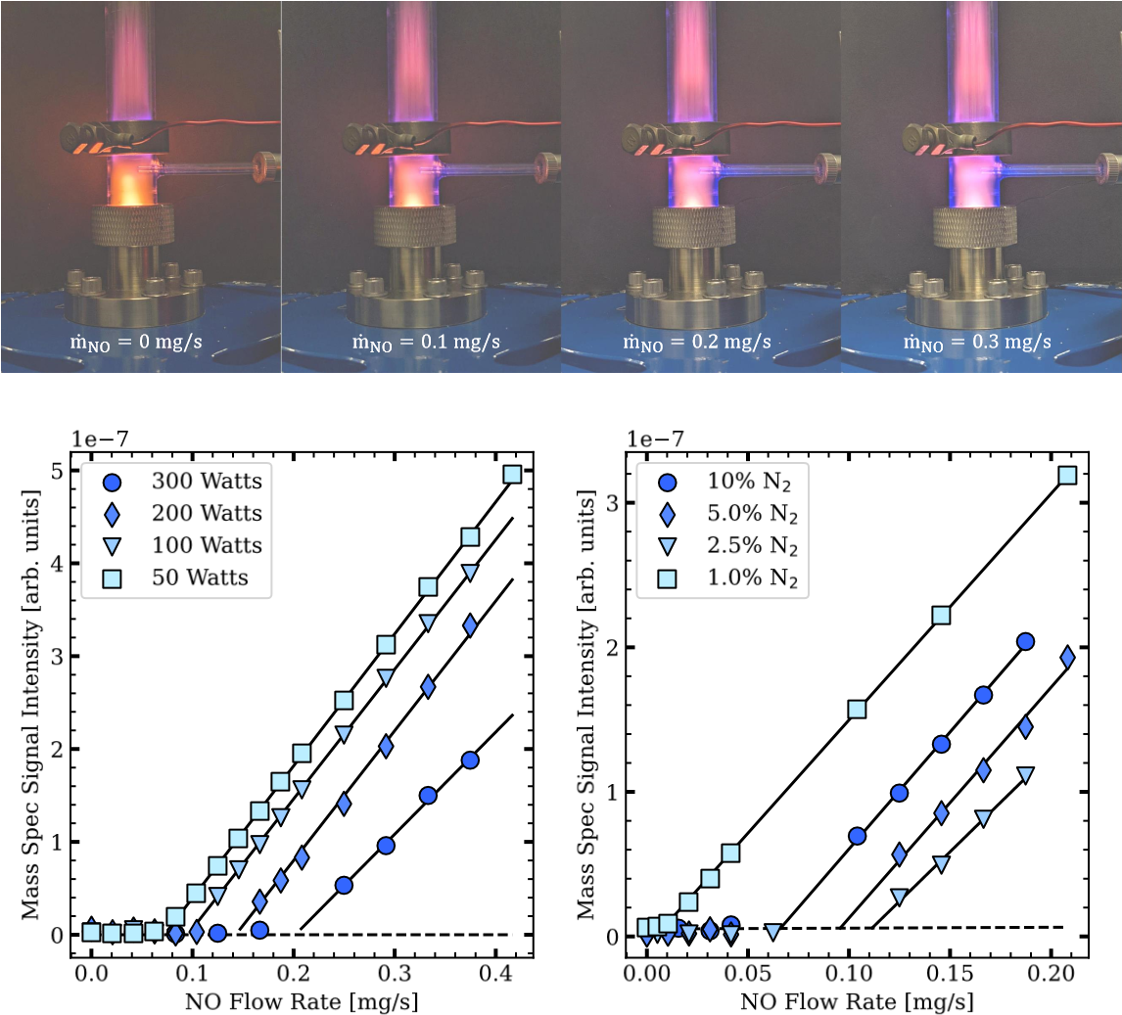
Figure 9: Detection of the titration endpoint visually (Top), NO titration results over power
(Left), NO titration results over pressures (Right)

Selecting NO Introduction Point
Atomic oxygen recombination and the reaction in Equation 1 take place on different time scales relative to the gas flow velocity and the choice of where to introduce NO to the flow has a strong influence on the chemical state of the gas when it reaches the sample surface. The experimental facility was designed with the capability of adding the NO at two locations: below the powered electrode where the plasma discharge is strongest (0.19 m from the sample), or directly above the sample surface. Using custom glass capillaries the distance above the surface in the second case could either be 1.5 or 7 mm from the graphite. Introducing the NO at the closest possible position to the sample surface, 1.5 mm, resulted in a surface recession profile of the graphite that was axially asymmetric with more severe recession occurring along the leading edge of the cylindrical sample (see Figure 10). This response was also observed when molecular oxygen was delivered to the sample surface in the same way. Tests that were conducted with the NO inserted 7 mm away from the sample had a uniform surface recession around the circumference of the cylinder. The carbon mass flux of the graphite was compared between tests that introduced the NO at 7 mm away to those that introduced it at the powered electrode, and the results are shown in Figure 11. The graphite oxidizes faster when using the injection port under the powered electrode, suggesting that at the lower injection port, the NO is being swept beyond the sample before it can react with the atomic nitrogen.
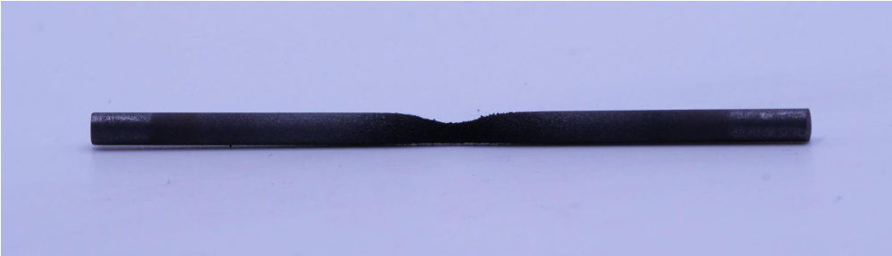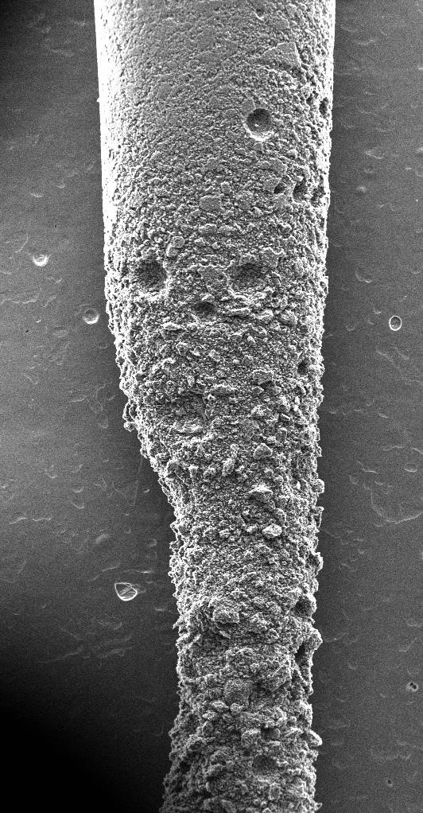
1
cm
3

m
m
Figure 10: Graphite sample that was tested 1.5 mm away from the source of oxidant shows a surface recession profile that is non-uniform and biased toward the leading edge.
Under otherwise identical conditions, two titration experiments were conducted introducing the NO at the two locations: at the powered electrode 0.19 m upstream of the sample and at a point 7 mm upstream of the sample. The second titration endpoint was lower by a factor of three compared to the first (see Figure 11) indicating that the degree of recombination of the atomic nitrogen is significant along the length of the flow tube. Since there are fewer N atoms to react with the NO, there are fewer O atoms produced to react with the graphite.
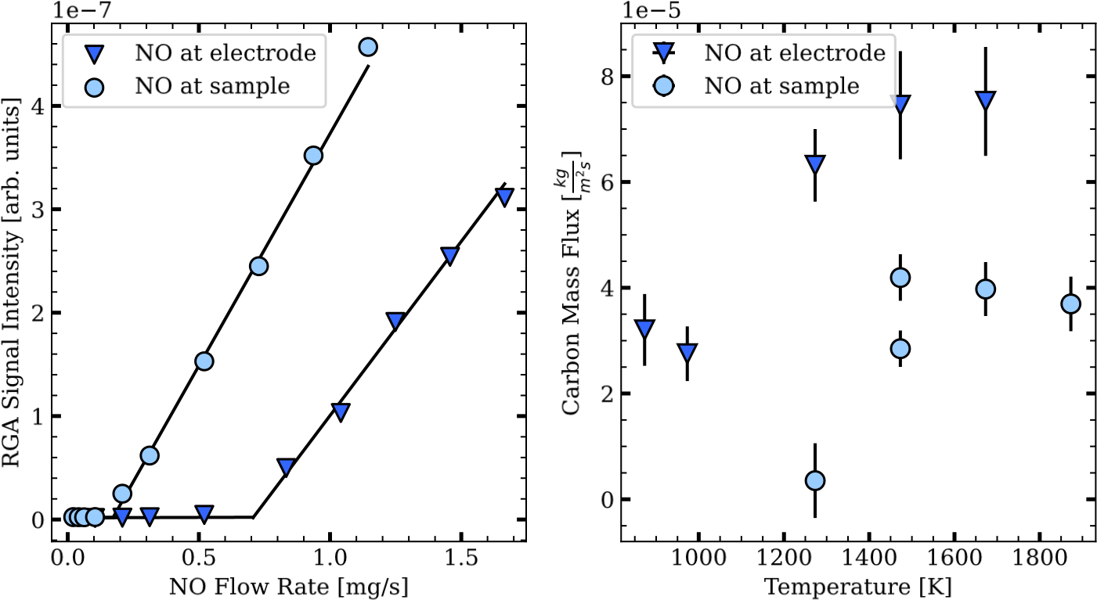
Figure 11: Comparison between two NO insertion sites: at sample (7 mm upstream of the sample) and at powered electrode. Carbon mass flux (Left), NO titration (Right)
The effects of nitrogen recombination and the leading edge recession profile made the lower NO introduction point less desirable for the purpose of these tests compared to the gas port at the powered electrode. All results presented in this work used the injection at the plasma discharge.

