Supplementary Note 2. Langmuir Probe and RF Power Meter Diagnostics of the Plasma
Electrical measurements of the RF matching network are necessary to calculate the electron density. An RF power probe (Octive Poly, Impedans Ltd.) was used to measure the discharge voltage with the plasma on at 100, 150 and 200 W. It was also measured at a power of 5 W when the plasma discharge was not activated which allowed for the subtraction of the stray impedance of the matching network. The plasma resistance for each case was calculated using the equivalent circuit model from [26]. Then the electron density was calculated from the equation:
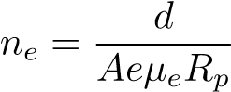 (3)
where d is the electrode distance, A is the reactor cross-sectional area, e is the elementary charge, µ_{e} is the electron mobility, and R_{p} is the plasma resistance [27]. The results are shown in Figure 12.
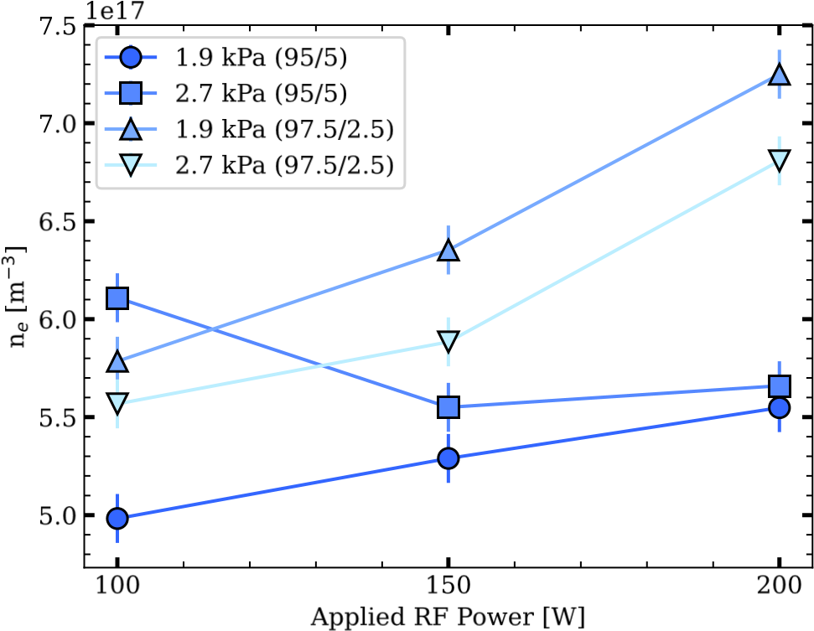
Figure 12: RF power meter results results. Electron density for alternate pressures and gas mixture ratios.
A double langmuir probe was used to measure the electron temperature, T_{e}, ion density, n_{i}, and the debye length, λ_{D}. The results are shown in Figure 13. Data was collected at two pressures, 1.9 and 2.7 kPa, and at two ratios of Ar/N₂, 95/5 and 97.5/2.5. The plots in the right column of Figure 13 show the change in the plasma properties with the addition of nitric oxide.
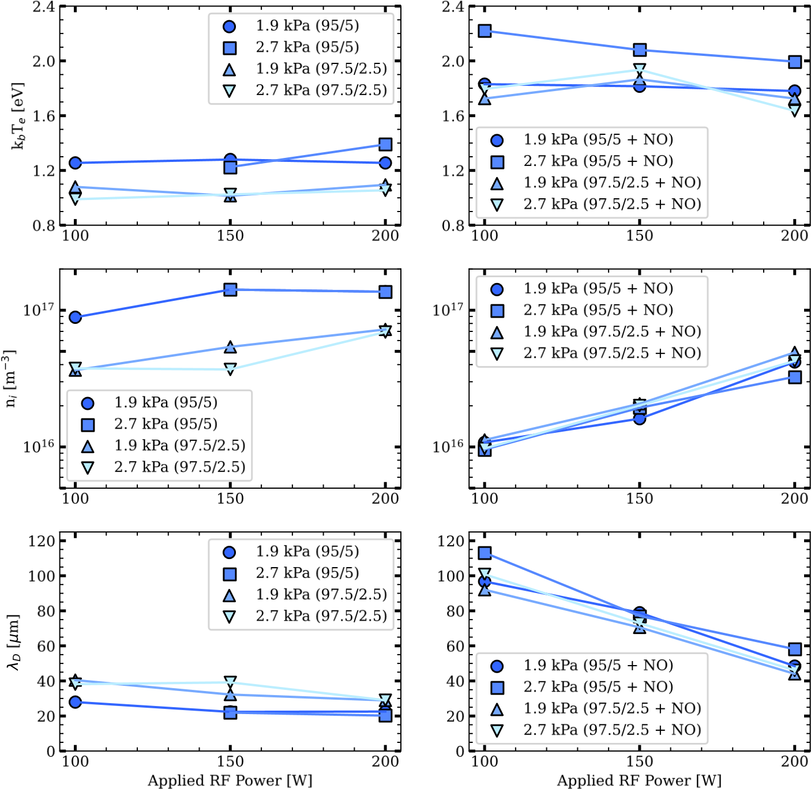
Figure 13: Langmuir probe results. Electron temperature, ion density, and debye length for alternate pressures and gas mixture ratios.

