Supplementary Materials

Sequential and hierarchical single-crystal-to-single-crystal transformations of a monomer to a 1D-polymer and then to a 2D-polymer
Haripriya Balan & Kana M. Sureshan*
School of Chemistry, Indian Institute of Science Education and Research Thiruvananthapuram, Vithura, Thiruvananthapuram 695551, India. *Email: kms@iisertvm.ac.in

Table of Contents

- Materials and methods …………………………………………………………….. 2
1.1 General procedure ……………………………………………………………... 2
1.2 Synthetic procedure ……….…………………………………………………... 3
- Thermogravimetric analysis ………………………………………………………. 5
- Crystal packing diagrams …………………………………………………………. 5
- BFDH morphology and experimental face indexing ……………………………... 8
- Additional exfoliation images of 2D-P ………………………………………….... 9
- AFM images ………………………………………………………………………. 10
- Crystallographic information table ………………………………………………... 10
- Interaction tables ………………………………………………………………….. 11
- Spectral Information ………………………………………………………………. 13
- References ………………………………………………………………………… 19

1. Materials and methods
1.1. General procedures

Dimethyl 1,4-cyclohexanedione-2,5-dicarboxylate, phenylhydrazine, acetic acid, oxalyl chloride, lithium hydroxide monohydrate, EDC.HCl, N, N-Diisopropylethylamine (DIPEA) and HOBt were purchased from Spectrochem. Propargylamine and 2-aminoisobutyric acid were purchased from TCI and BLDpharm respectively. All these chemicals were used without further purification. Dichloromethane (DCM), dimethylformamide (DMF), Methanol (MeOH) and THF were purchased from Merck and distilled before use. Pre-coated TLC silica gel (60 F254) plates were purchased from Merck.

Reactions were monitored using thin-layer chromatography (TLC) using pre-coated silica gel plates (60 F₂₅₄). TLCs were visualized under UV light (254 nm and 365 nm) and by heating the plates after dipping in ceric ammonium molybdate solution. Intermediates were purified by column chromatography using silica gel (230−400 mesh size) as the stationary phase. ¹H, ¹³C NMR, distortionless enhancement by polarization transfer (DEPT), correlation spectroscopy (COSY), heteronuclear multiple bond correlation (HMBC), and heteronuclear multiple quantum coherence (HMQC) spectra were recorded on 500 MHz Bruker Avance NMR spectrometer using tetramethylsilane (TMS) as internal standard (TMS, δ = 0.0). ¹H NMR spectra were recorded at 500 MHz and ¹³C NMR spectra were recorded at 125 MHz. Chemical shift (δ) is expressed in parts per million. Melting points were recorded on Stanford Research Systems (EZ-Melt) melting point apparatus. Thermogravimetric analysis (TGA) was performed in a universal V 4.7A TA instrument. Differential Scanning Calorimetry (DSC) thermograms were recorded on DSC Q20 Differential Scanning Calorimeter. IR spectra were recorded on an IR Prestige-21 instrument by making thin pallets of KBr with compound. Optical microscope images and videos were recorded with a Qimaging Qclick camera mounted on the Olympus BX51 microscope or on Olympus DSX1000 microscope. Scanning electron microscopy (SEM) images were recorded using Nova NANOSEM 450 (with WDS and EDS). Samples were drop-casted on silicon wafer (SiO₂ (280 nm)/Si), sputter coated with gold and imaging was done at 15kV. Atomic force microscopy (AFM) analyses were carried out on JPK Nanowizard 4AF. Samples were prepared by drop casting 4 μL suspension of the sample in TFA on silicon wafer (SiO₂ (280 nm)/Si), followed by drying under air. Imaging was done under ambient conditions in tapping mode. The probe used for imaging was reflective aluminum coated HQ:NSC15/Al BS cantilever with a resonant frequency of 325 kHz and spring constant of 40 N/m. Number of samples per line was kept 512. Single crystal X-ray diffraction data of the obtained crystals were collected on Bruker-KAPPA APEX II CCD diffractometer with graphite-monochromatized (Mo Kα radiation (λ= 0.71073 Å) and APEX2 software, at temperature 100K, maintained using OxfordCryostems low-temperature device. The X-ray generator was operated at 50 kV and 30 mA. Data reduction was performed using Bruker Apex III software Suite. Absorption correction was done with SADABS-2016. Structure solution was done with SHELXT-2014. Structure refinement was done with full-matrix least-squares method using ShelXL-2018 present in the Olex2 interface. All non-hydrogen atoms were refined anisotropically and hydrogen atoms were placed on geometrically calculated positions and refined using a riding model. All the geometrical calculations were done using PARST and PLATON. Packing diagrams were generated using Mercury 4.2.0 software. Molecular rotations were done using GaussView software.

1.2. Synthetic procedure

Supplementary Scheme 1. Synthesis of Monomer M.
Synthesis of 2: Dimethyl 2,5-diaminoterephthalate was synthesized from commercially available dimethyl 1,4-cyclohexanedione-2,5-dicarboxylate following the reported procedure¹. Dimethyl 1,4-cyclohexanedione-2,5-dicarboxylate (2.74 g, 12 mmol) was taken in 120 mL acetic acid. To the mixture, phenylhydrazine (2.6 mL, 26.4 mmol) was added and stirred at room temperature for two hours in open atmosphere. The reaction mixture was filtered by vacuum filtration and the crude filtrate was purified by column chromatography using silica gel as the stationary phase and a 1:20 v/v mixture of ethyl acetate and petroleum ether as the eluent to afford compound 2 in 69% yield.
Synthesis of 3: Compound 3 was synthesized from commercially available 2-aminoisobutyric acid by copper (II) catalysed diazotransfer reaction². Sodium azide (19 g, 291 mmol) was added to a mixture of distilled water (100 mL) and DCM (140 mL) and the mixture was then cooled to 0 °C. Triflic anhydride (9.7 mL, 58.2 mmol) was then added to the reaction mixture slowly. After addition, the reaction mixture was warmed to room temperature and stirred for 3 hours. The DCM layer was separated out and washed with saturated sodium bicarbonate solution. 2-aminoisobutyric (3g, 29.1 mmol), K₂CO₃ (6 g, 43.6 mmol) and CuSO₄.5H₂O (72 mg, 0.29 mmol) were dissolved in a mixture of MeOH (480 mL) and distilled water (240 mL), and added to the previously collected DCM layer and stirred for overnight at room temperature. Organic solvents were evaporated under reduced pressure and the aqueous phase was acidified to pH 6 by adding con. HCl. Then phosphate buffer was added to the aqueous phase and washed with ethyl acetate to remove non-polar impurities. Aqueous phase was again acidified to pH 2-3 by adding con. HCl. The product was extracted with ethyl acetate, dried over anhydrous sodium sulfate and concentrated under reduced pressure to afford compound 3 as yellowish liquid in 79 % yield.
Synthesis of 4: To a solution of 3 (700 mg, 5.5 mmol) in dry DCM (20 mL), oxalyl chloride (0.71 mL, 8.3 mmol) and 3 drops of dry DMF were added at 0 °C. After the addition, the reaction mixture was warmed to room temperature and stirred for 1 hour. Acid chloride 4 formed in situ was directly used for the next step.
Synthesis of 5: To a solution of 2 (500 mg, 2.23 mmol) in dry DCM (50 mL), triethylamine (1.2 mL, 8.9 mmol) was added under N₂ atmosphere and stirred for 15 minutes. Intermediate 4 in dry DCM was added dropwise to the reaction mixture at 0 °C and then stirred at room temperature. The reaction progress was monitored using TLC, which showed complete consumption of the starting material after 4 hours. After reaction completion, solvent was evaporated under reduced pressure and the crude product was purified by column chromatography using silica gel as the stationary phase and a 1:9 v/v mixture of ethyl acetate and petroleum ether as eluent to afford compound 5 as a white solid in 84 % yield. ¹H NMR (500 MHz, CDCl₃) δ (ppm): 11.61 (s, 2 H), 9.39 (s, 2 H), 3.93 (s, 6 H), 1.57 (s, 12 H). ¹³C NMR (125 MHz, CDCl₃) δ (ppm): 170.72, 166.51, 134.36, 121.66, 119.53, 63.81, 52.04, 23.66.
Synthesis of 6: To a solution of compound 5 (360 mg, 0.8 mmol) in THF (50 mL), LiOH.H₂O (336 mg, 8 mmol) was added and the mixture was stirred at room temperature. The reaction progress was monitored using TLC, which showed complete consumption of the starting material after overnight stirring. The solvent was evaporated completely under reduced pressure. The residue was dissolved in water (20 mL) and was acidified using dilute HCl (pH 3-4). The resultant white precipitate was extracted using ethyl acetate, washed with brine solution and dried over anhydrous sodium sulfate. Solvent was evaporated to obtain compound 6 as a white solid in 96 % yield which was used for the next step without further purification. ¹H NMR (500 MHz, DMSO-d₆) δ (ppm): 14.37-13.99 (br, 2 H), 11.72 (s, 2 H), 9.21 (s, 2 H), 1.56 (s, 12 H).
Synthesis of monomer M: To a solution of compound 6 (300 mg, 0.71 mmol) in dry DMF (30 mL), EDC.HCl (325 mg, 1.7 mmol) and HOBt (230 mg, 1.7 mmol) were added and the mixture was stirred at 0 °C under N₂ atmosphere. After 30 minutes, propargylamine (110 µL, 1.7 mmol) and triethylamine (0.49 mL, 3.5 mmol) were added dropwise to the reaction mixture and stirred at room temperature. The reaction progress was monitored using TLC, which showed complete consumption of the starting material after overnight stirring. Solvent was evaporated under reduced pressure. The crude product was dissolved in ethyl acetate, washed with saturated sodium bicarbonate and brine solution and dried over anhydrous sodium sulfate. Solvent was evaporated under reduced pressure and the crude product was purified by column chromatography using silica gel as stationary phase and a 1:2 v/v mixture of ethyl acetate and petroleum ether as eluent to afford monomer M as a white solid in 79 % yield. ¹H NMR (500 MHz, CDCl₃) δ (ppm): 11.75 (s, 2 H), 8.86 (s, 2 H), 7.08 (br, 2 H), 4.23-4.22 (m, 4 H), 2.27 (br ,2 H), 1.60 (s, 12 H). ¹³C NMR (125 MHz, CDCl₃) δ (ppm): 172.45, 167.39, 134.61, 123.96, 119.96, 79.01, 72.68, 64.94, 30.20, and 25.00.

2. Thermogravimetric analysis
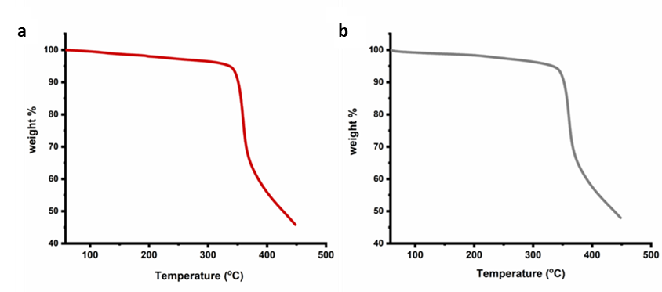
Supplementary Figure 1. a, TGA thermogram of monomer M. b, TGA thermogram of 2D polymer 2D-P.

3. Crystal packing diagrams
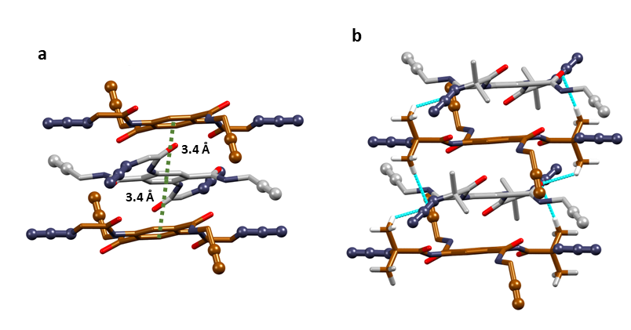
Supplementary Figure 2. a, π…π stacking between the conformers down a axis. b, C-H…O hydrogen bonding interactions stabilizing the pi column along a axis.
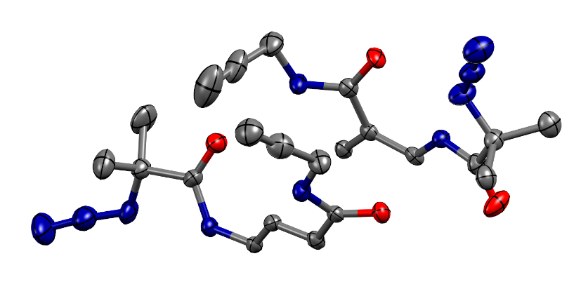
Supplementary Figure 3. ORTEP diagram of the asymmetric unit of monomer M.

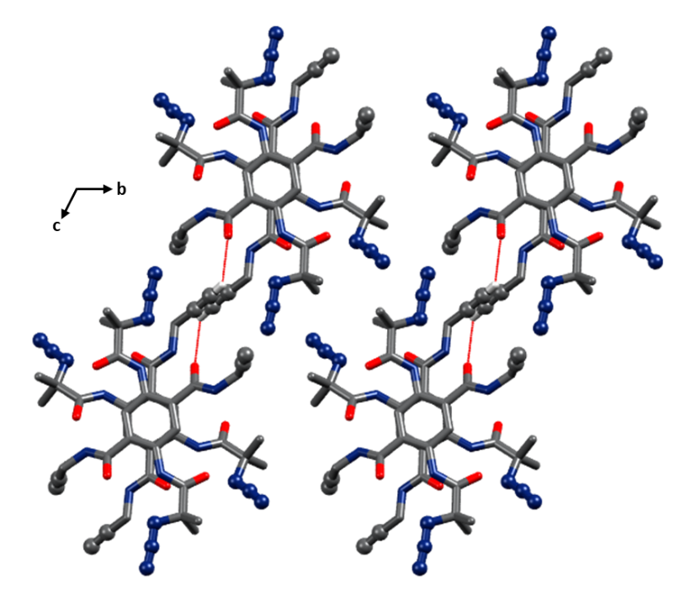
Supplementary Figure 4. Crystal packing of monomer M along bc plane depicting intermolecular C-H…O hydrogen bonding connecting molecules along c axis.

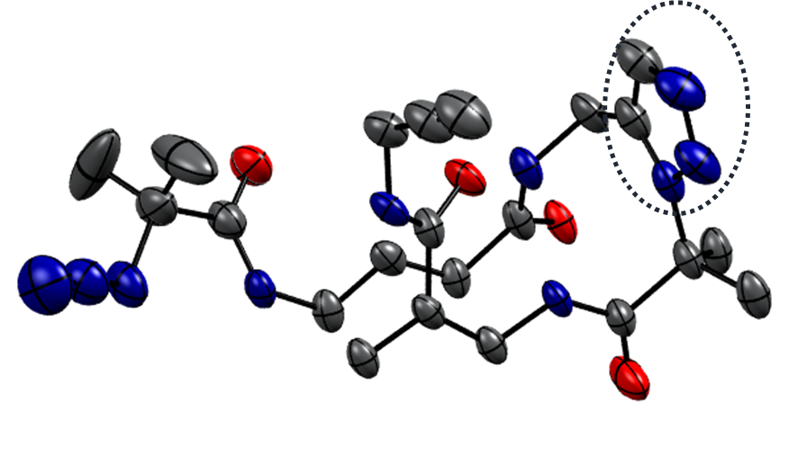
Supplementary Figure 5. ORTEP diagram of the asymmetric unit of polymer 1D-P. Triazole linkage is circled.
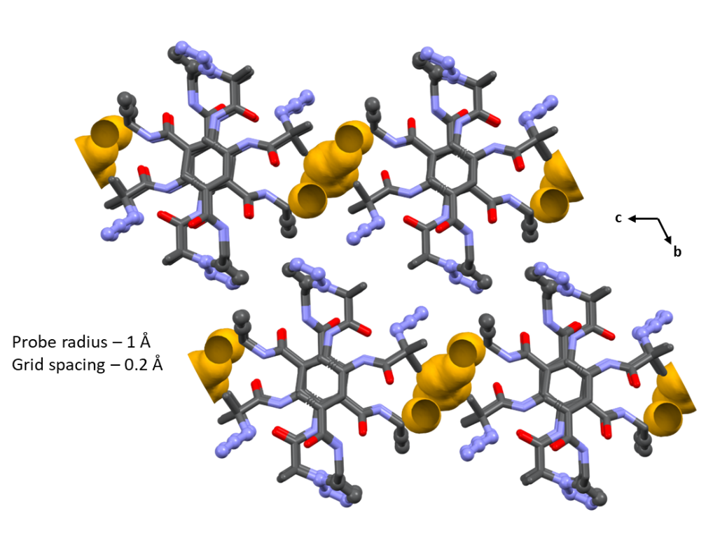
Supplementary Figure 6. Crystal packing of 1D polymer 1D-P along bc plane showing the largest voids in the crystal lattice. (The voids account for 7.2% of the unit cell volume, i.e., 83.52 Å³).
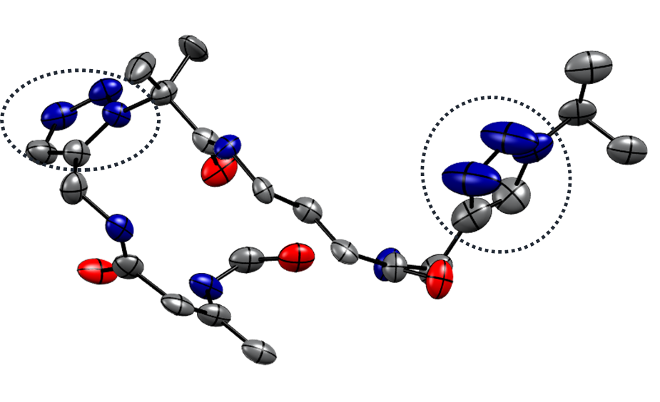
Supplementary Figure 7. ORTEP diagram of the asymmetric unit of polymer 2D-P. Triazole linkages are circled.
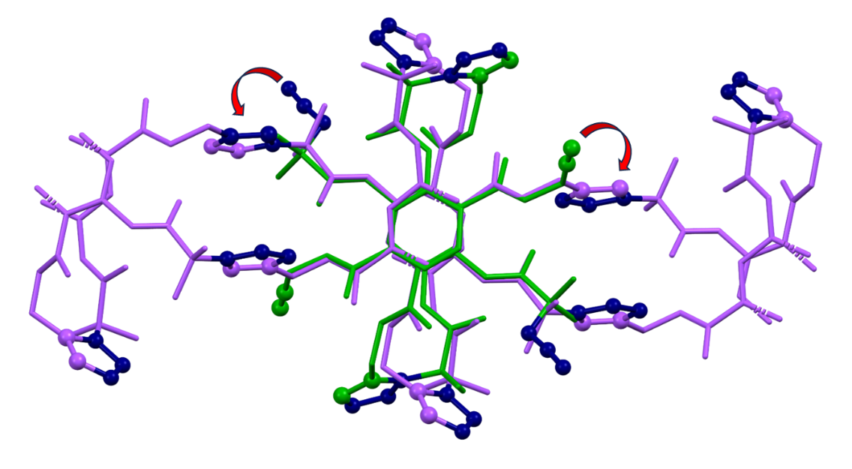
Supplementary Figure 8. Overlay of 1D-P (Green) and 2D-P (Purple).

4. BFDH morphology and experimental face indexing

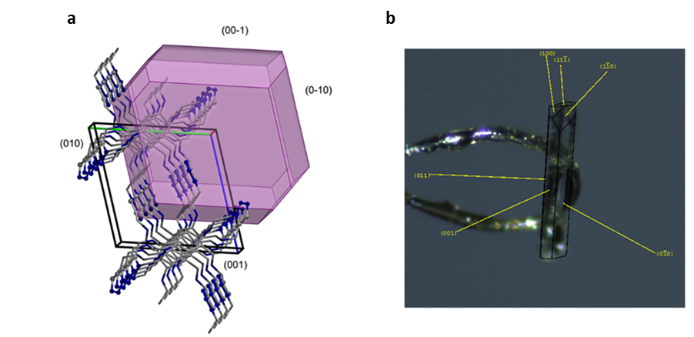
Supplementary Figure 9. a. BFDH morphology of 2D-P depicting (001) and (010) faces. b. experimental face indexing of the 2D-P crystal.

5. Additional exfoliation images of 2D-P

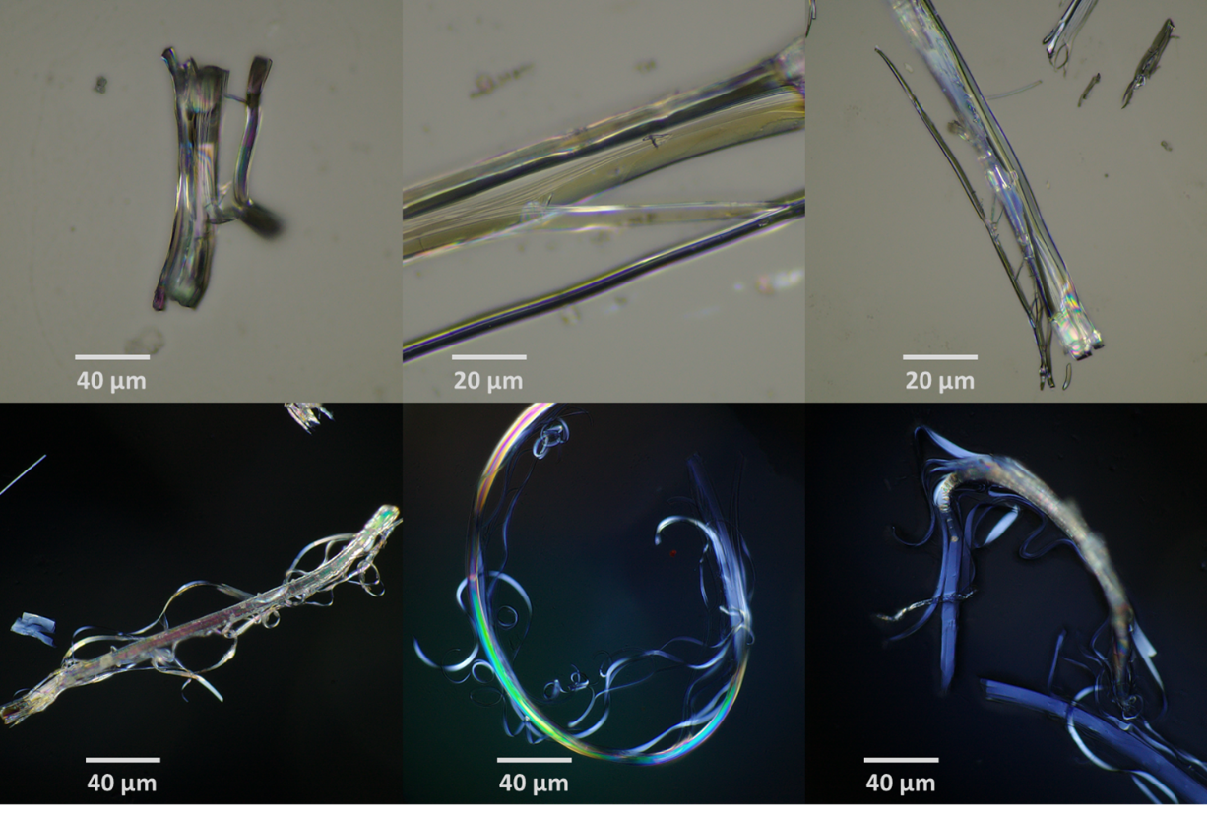
Supplementary Figure 10. Microscopic images of exfoliating crystals.

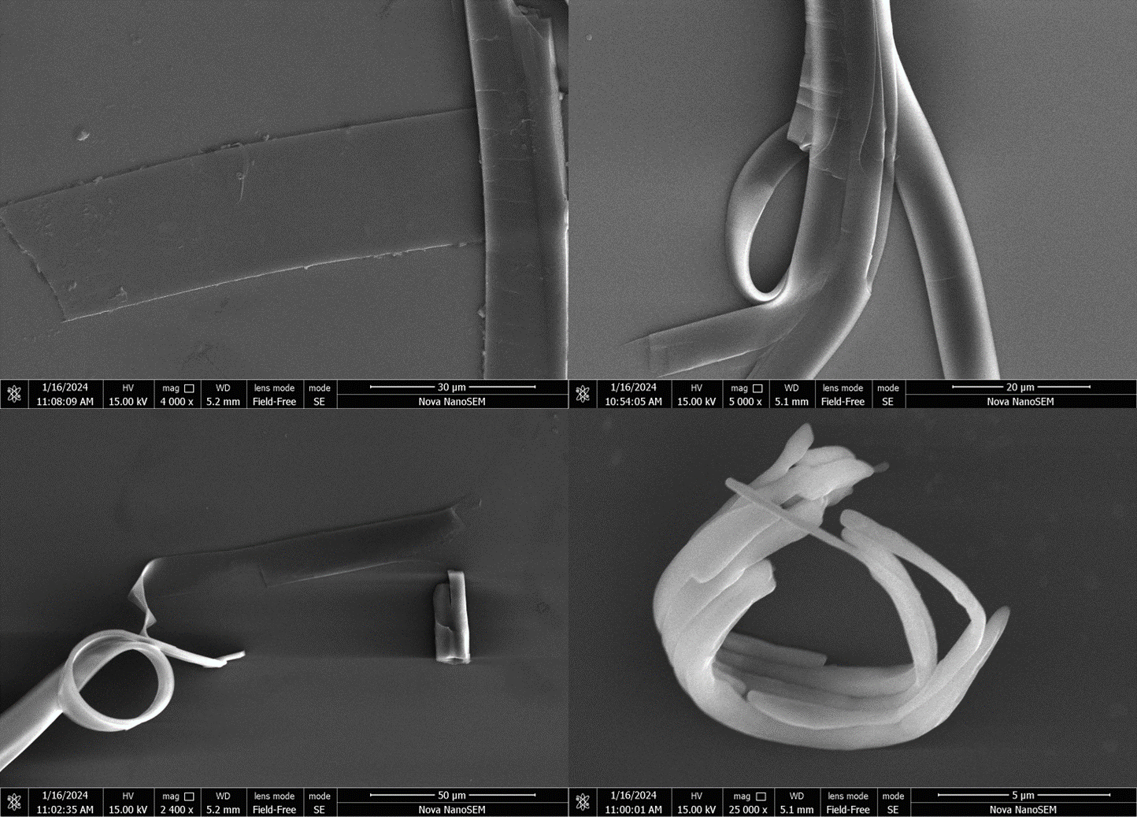
Supplementary Figure 11. SEM images of exfoliating crystals.

6. AFM images

Supplementary Figure 12. AFM images and height profiles of exfoliated 2D-P crystals.

7. Crystallographic information table

Supplementary Table 1. Crystallographic information table for M, 1D-P and 2D-P

Identification code | M | 1D-P | 2D-P (1)  (Polymerized from 1D-P) | 2D-P (2)  (Polymerized from M)
CCDC | 2332792 | 2332791 | 2332793 | 2337070
Empirical formula | C₂₂H₂₄N₁₀O₄ | C₂₂H₂₄N₁₀O₄ | C₂₂H₂₄N₁₀O₄ | C₂₂H₂₄N₁₀O₄
Formula weight | 492.51 | 492.51 | 492.51 | 492.51
Temperature/K | 100 K | 100 | 100 | 100
Crystal system | triclinic | triclinic | triclinic | triclinic
Space group | P-1 | P-1 | P-1 | P-1
a/Å | 7.108(5) | 6.994(7) | 7.626(8) | 7.597(14)
b/Å | 13.864(9) | 13.820(14) | 12.386(13) | 12.34(2)
c/Å | 13.961(9) | 14.080(15) | 12.460(13) | 12.41(2)
α/° | 115.481(18) | 116.74(3) | 105.98(3) | 105.91(4)
β/° | 101.63(2) | 102.35(3) | 97.75(3) | 97.41(5)
γ/° | 92.63(2) | 95.34(3) | 93.00(2) | 92.91(4)
Volume/Å³ | 1202.7(13) | 1159(2) | 1116(2) | 1104(4)
Z | 2 | 2 | 2 | 2
ρ_{calc}g/cm³ | 1.360 | 1.411 | 1.465 | 1.481
μ/mm⁻¹ | 0.099 | 0.103 | 0.106 | 0.108
F(000) | 516.0 | 516.0 | 516.0 | 516.0
Crystal size/mm³ | 0.11 × 0.05 × 0.02 | 0.11 × 0.05 × 0.02 | 0.11 × 0.05 × 0.02 | 0.10 × 0.04 × 0.02
Radiation | MoKα (λ = 0.71073) | MoKα (λ = 0.71073) | MoKα (λ = 0.71073) | MoKα (λ = 0.71073)
2Θ range for data collection/° | 3.334 to 55.756 | 5.826 to 57.804 | 3.436 to 55.75 | 4.13 to 52.744
Index ranges | -9 ≤ h ≤ 9, -18 ≤ k ≤ 18, -18 ≤ l ≤ 18 | -9 ≤ h ≤ 9, -18 ≤ k ≤ 18, -18 ≤ l ≤ 19 | -10 ≤ h ≤ 10, -16 ≤ k ≤ 16, -16 ≤ l ≤ 16 | -9 ≤ h ≤ 9, -15 ≤ k ≤ 15, -15 ≤ l ≤ 15
Reflections collected | 32312 | 31745 | 37312 | 20877
Independent reflections | 5739 [R_{int} = 0.1746, R_{sigma} = 0.1799] | 6010 [R_{int} = 0.2243, R_{sigma} = 0.2610] | 5333 [R_{int} = 0.3375, R_{sigma} = 0.3416] | 4532 [R_{int} = 0.3382, R_{sigma} = 0.3707]
Data/restraints/parameters | 5739/0/329 | 6010/0/328 | 5333/0/341 | 4532/0/333
Goodness-of-fit on F² | 0.990 | 0.946 | 0.917 | 0.923
Final R indexes [I>=2σ (I)] | R₁ = 0.0826, wR₂ = 0.1990 | R₁ = 0.0869, wR₂ = 0.1948 | R₁ = 0.1022, wR₂ = 0.2488 | R₁ = 0.0957, wR₂ = 0.1984
Final R indexes [all data] | R₁ = 0.2090, wR₂ = 0.2616 | R₁ = 0.2774, wR₂ = 0.2794 | R₁ = 0.3440, wR₂ = 0.3792 | R₁ = 0.3255, wR₂ = 0.2970
Largest diff. peak/hole / e Å⁻³ | 0.55/-0.32 | 0.37/-0.34 | 0.42/-0.43 | 0.38/-0.33

8. Interaction tables

Supplementary Table 2. Non-covalent interactions present in M, 1D-P and 2D-P.
Monomer -M
Motifs | Interactions | Symmetry code | D∙∙∙A (Å)/H…A(Å) /D-H…A (°)
N-H…O | N8B-H8B…O2B | x, y, z | 2.74/2.08/134
N-H…O | N13A-H13A…O2B | x+1, +y, +z | 3.01/2.26/147
N-H…O | N8A-H8A…O2A | x, y, z | 2.70/2.10/127
 | N13B-H13B…O1A | x, y, z | 2.83/2.04/154
C-H…O | C11B-H11B…O1B | -x, -y+1, -z+1 | 2.81/2.19/124
C-H…O | C16-H16A…O2B | -x+1, -y+1, -z+2 | 3.42/2.66/140
 | C6B-H6BC…O2A | x, y, z | 3.29/2.55/134
 | C5B-H5BA…O2A | x-1, +y, +z | 3.62/2.66/178
π…π | Centroid-to-centroid  (C9B-C11B & C9A-C11A) |  | 3.554

Polymer - 1D-P
Motifs | Interactions | Symmetry code | D∙∙∙A (Å)/H…A(Å) /D-H…A (°)
N-H…O | N13-H13…O4 | x, y, z | 3.00/2.22/148
N-H…O | N24-H24…O4 | x, y, z | 2.69/2.02/131
N-H…O | N29-H29…O1 | x-1, +y, +z | 2.77/1.99/148
 | N8-H8…O2 | -x+2, -y+1, -z+1 | 2.69/2.10/124
C-H…O | C21-H21A…O2 | x, y, z | 3.31/2.36/163
C-H…O | C22-H22C…O2 | x-1, +y, +z | 3.38/2.51/147
C-H…O | C27-H27…O3 | -x+1, -y+1, -z+1 | 2.83/2.20/123
π…π | Centroid-to-centroid  (C25-C27 & C9-C11) |  | 3.497

Polymer -2D-P (2)
Motifs | Interactions | Symmetry code | D∙∙∙A (Å)/H…A(Å) /D-H…A (°)
N-H…O | N13-H13…O3 | x, y, z | 2.87/2.05/156
N-H…O | N29-H29…O2 | -x+1, -y+1, -z | 2.91/2.13/147
N-H…O | N8-H8…O4 | x+1, +y, +z | 2.90/2.17/141
C-H…O | C22-H22B…O1 | -x+1, -y+1, -z+1 | 3.36/2.60/134
C-H…O | C5-H5A…O4 | x+1, +y, +z | 3.26/2.32/160
π…π | Centroid-to-centroid  (C25-C27 & C9-C11) |  | 3.813

9. Spectral Information

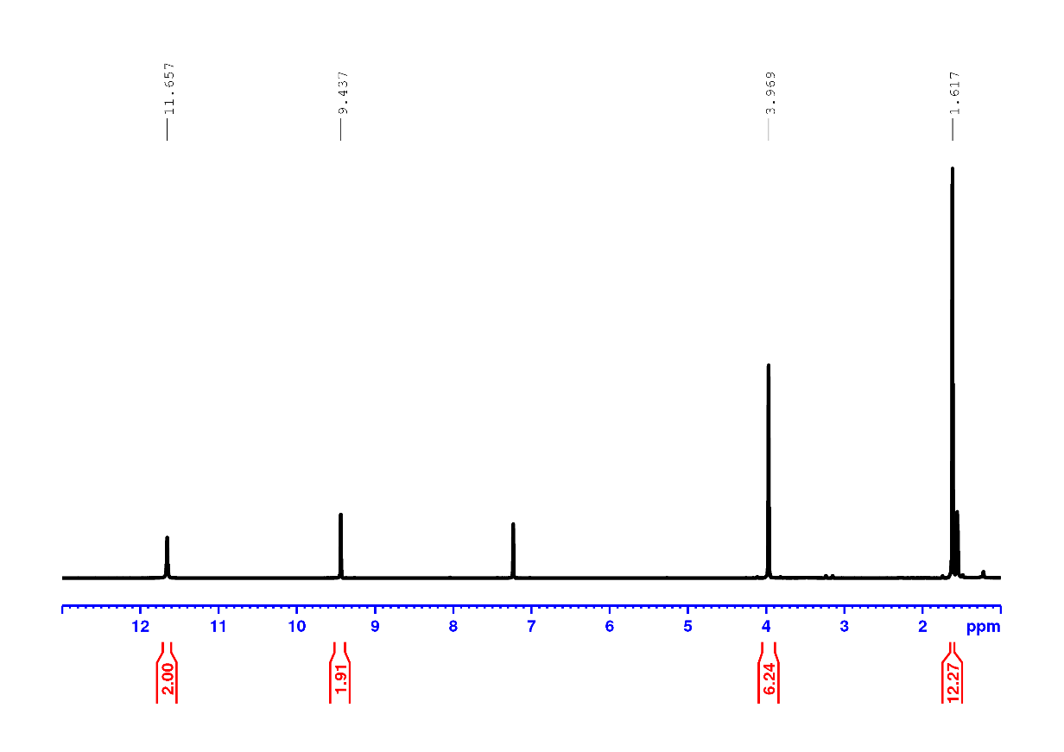
Supplementary Figure 13. ¹H NMR spectrum of compound 5 in CDCl₃.
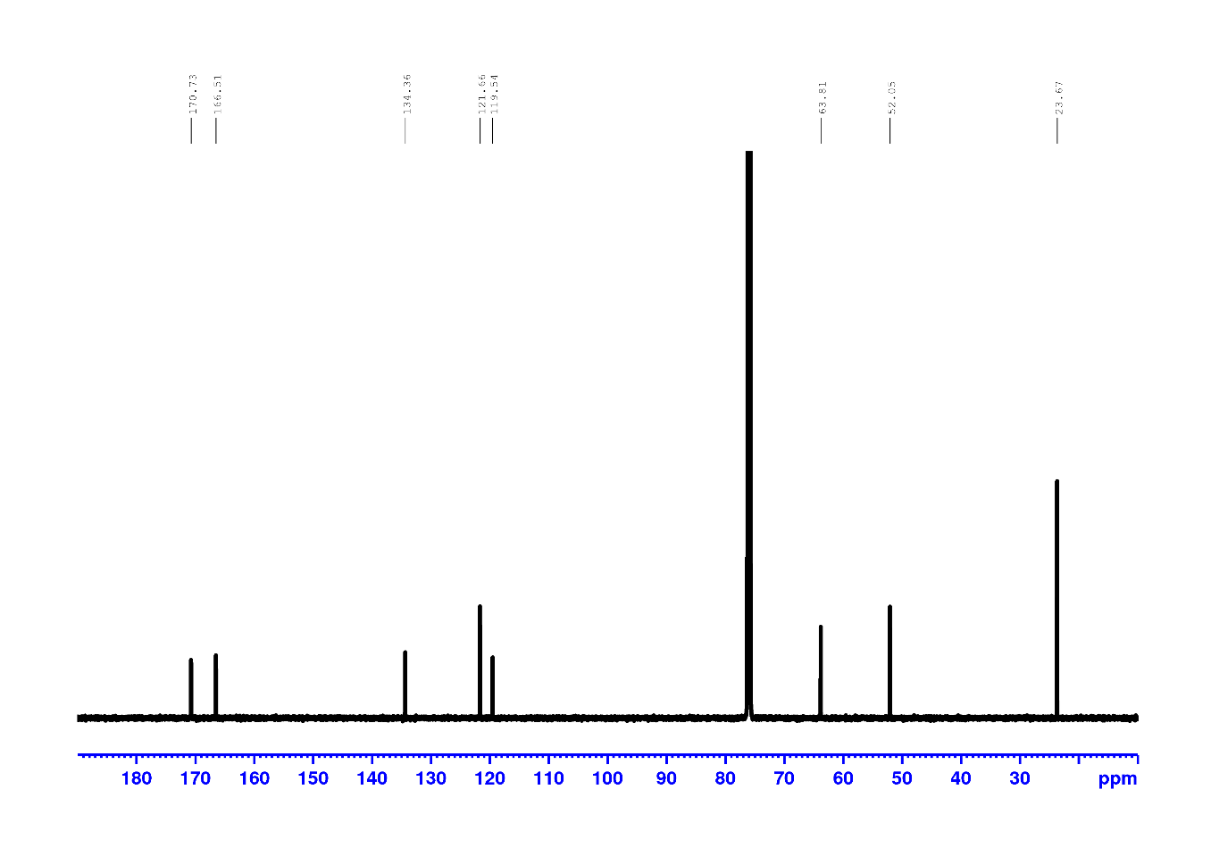
Supplementary Figure 14. ¹³C spectrum of compound 5 in CDCl₃.
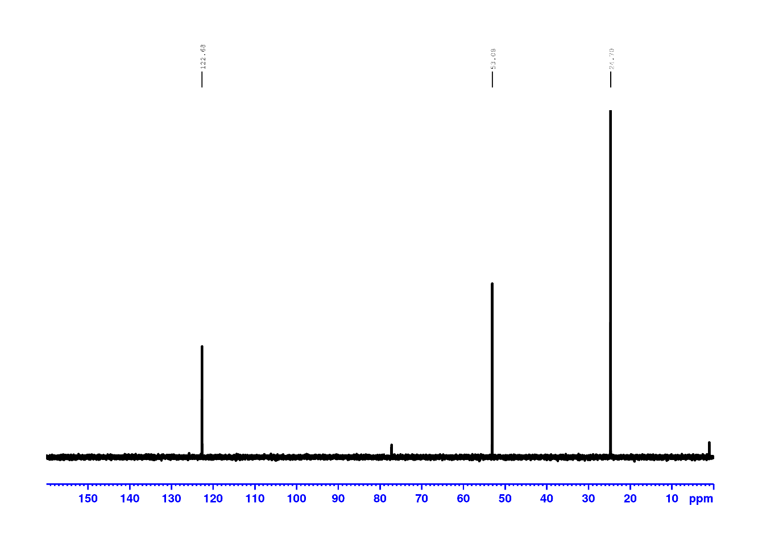
Supplementary Figure 15. DEPT 135 spectrum of compound 5 in CDCl₃.
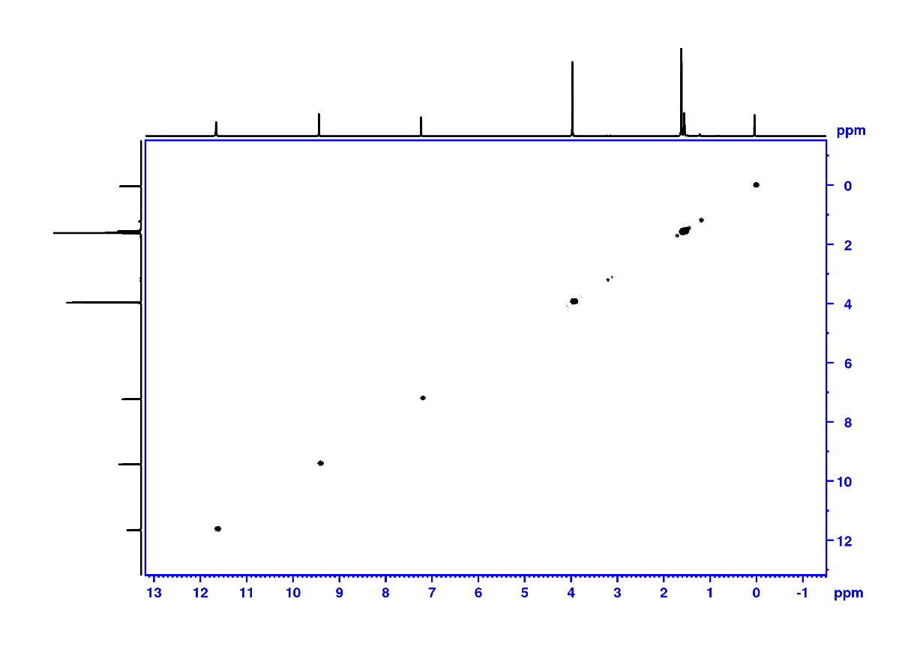
Supplementary Figure 16. COSY spectrum of compound 5 in CDCl₃.

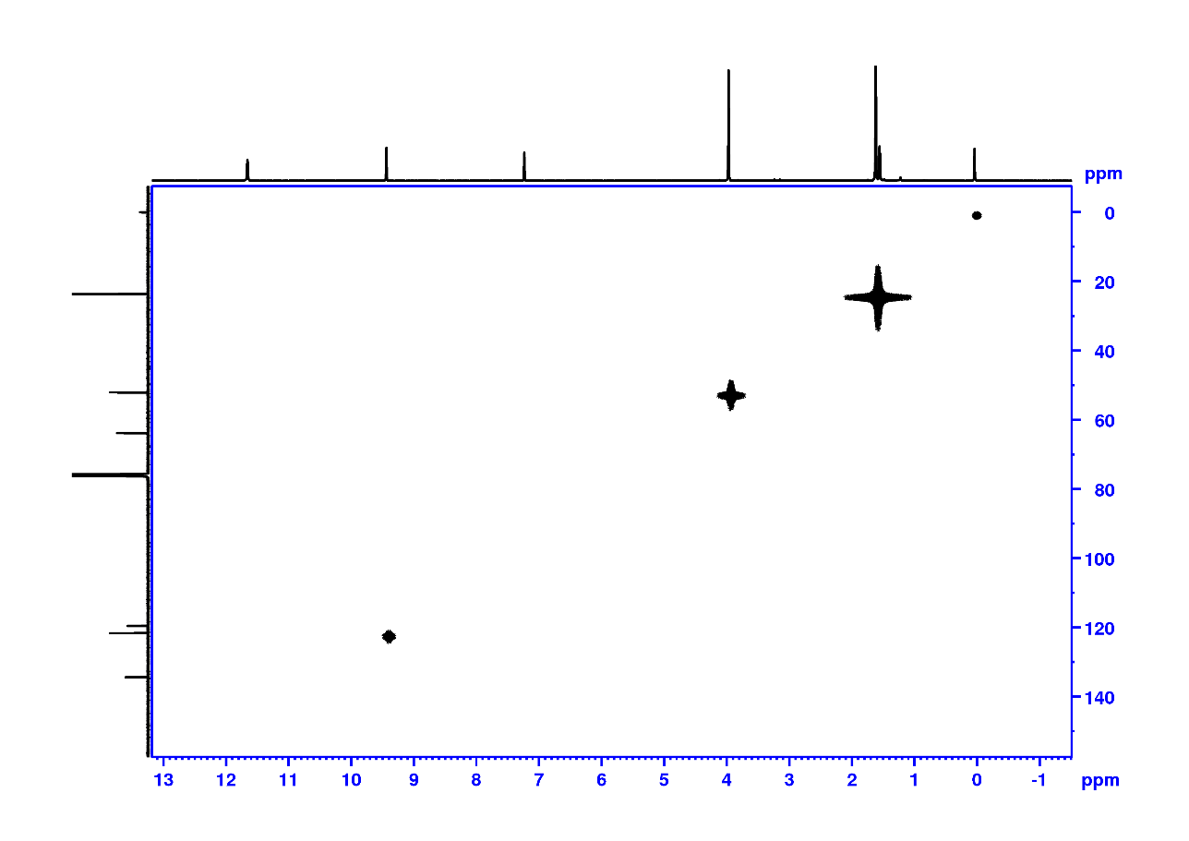
Supplementary Figure 17. HMQC spectrum of compound 5 CDCl₃.
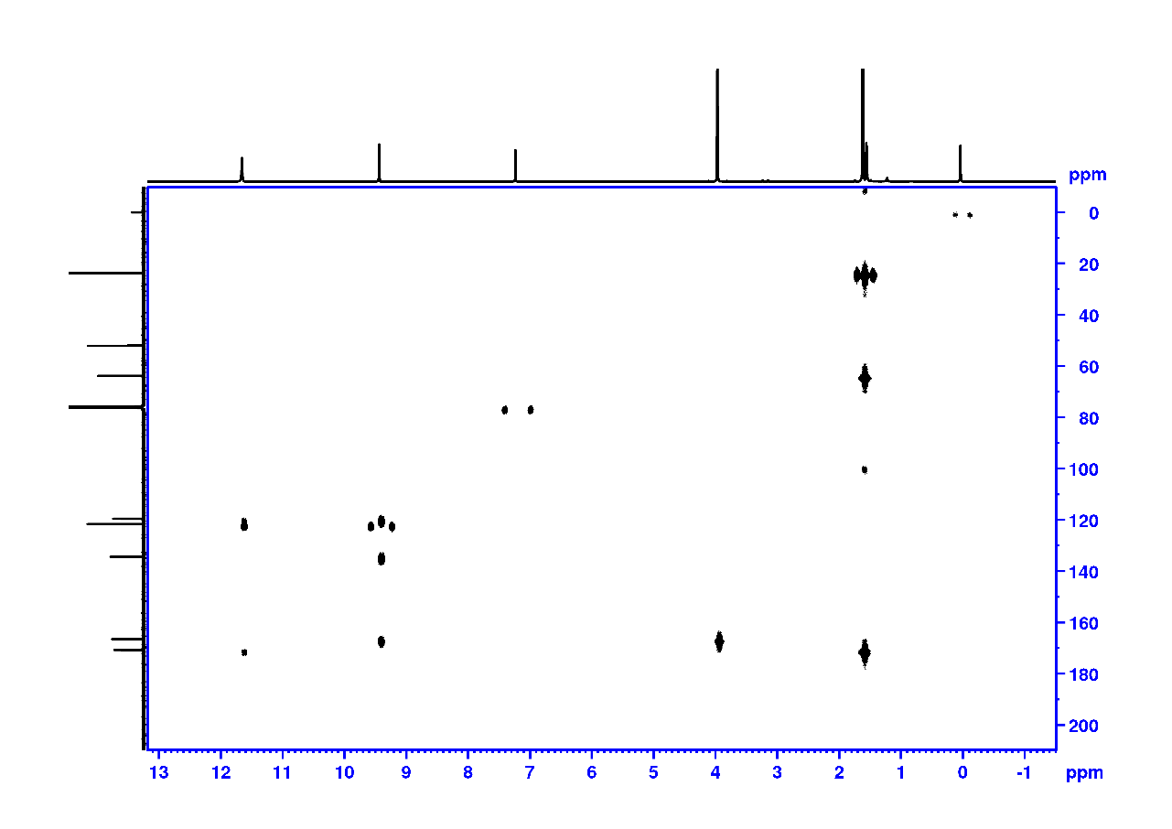
Supplementary Figure 18. HMBC spectrum of compound 5 CDCl₃.

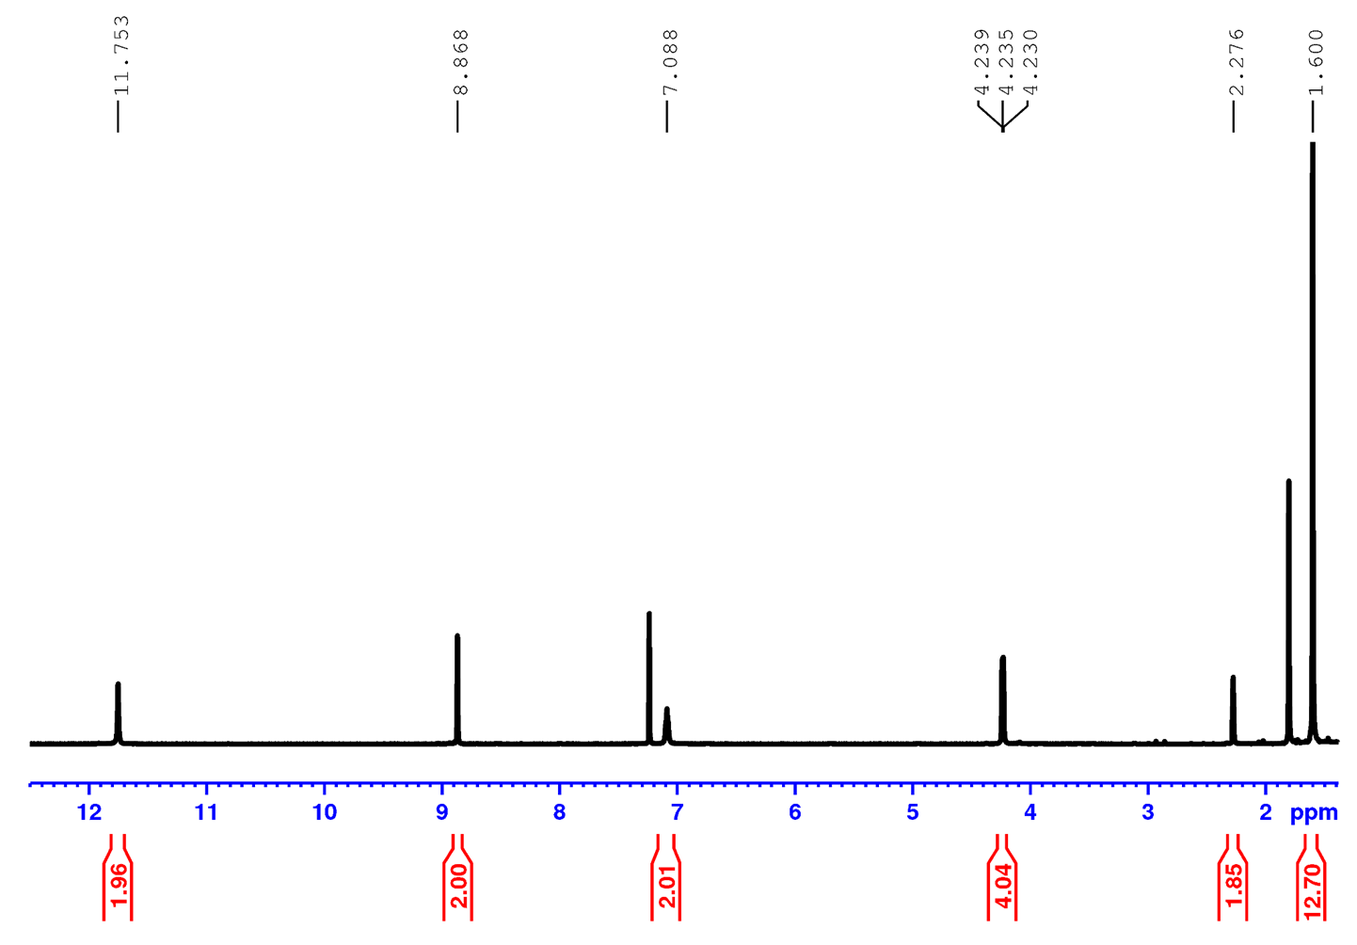
Supplementary Figure 19. ¹H NMR spectrum of monomer M in CDCl₃.
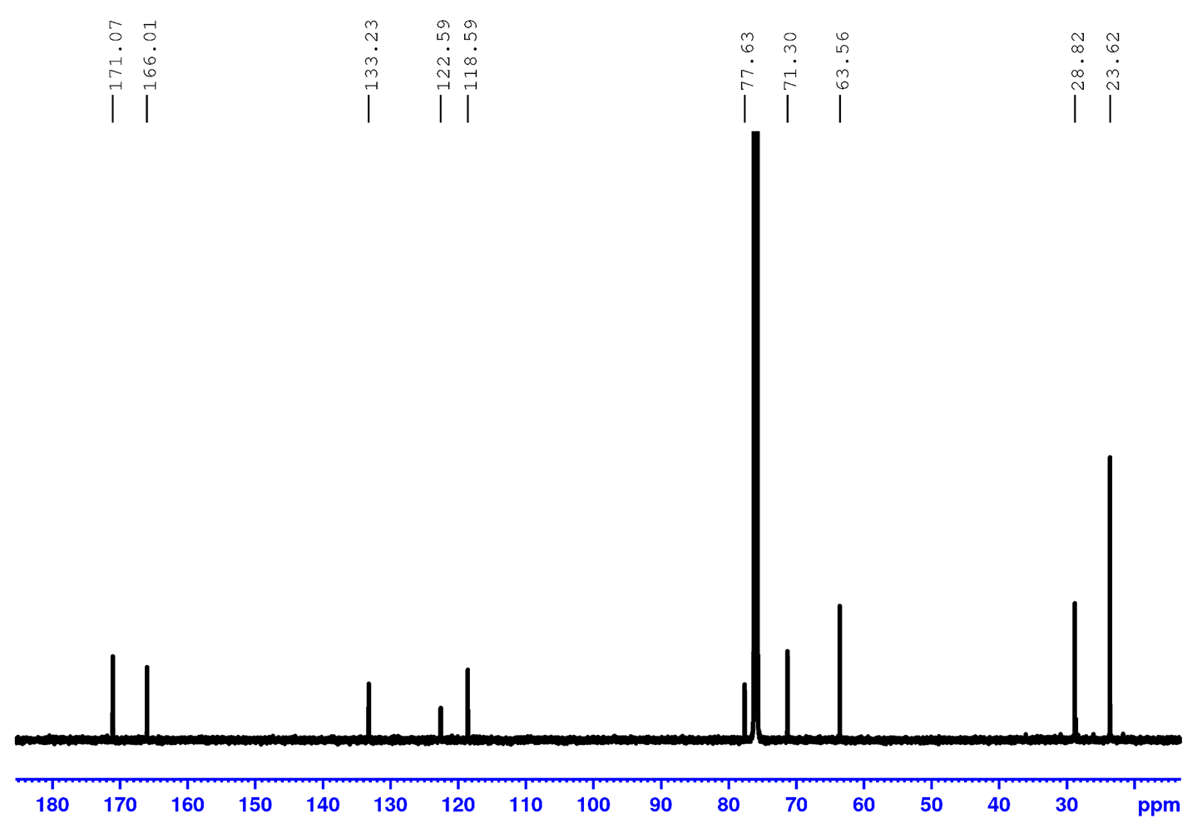
Supplementary Figure 20. ¹³ C spectrum of monomer M in CDCl₃.
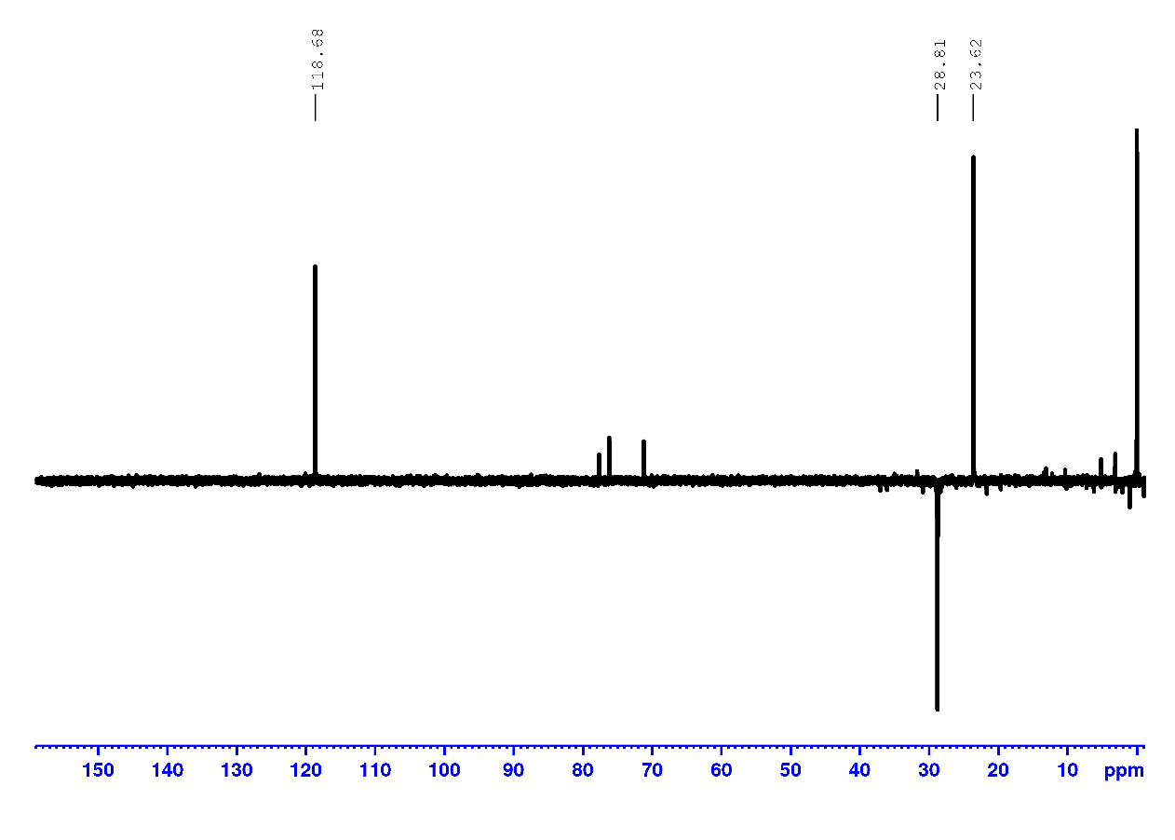
Supplementary Figure 21. DEPT 135 spectrum of monomer M in CDCl₃.
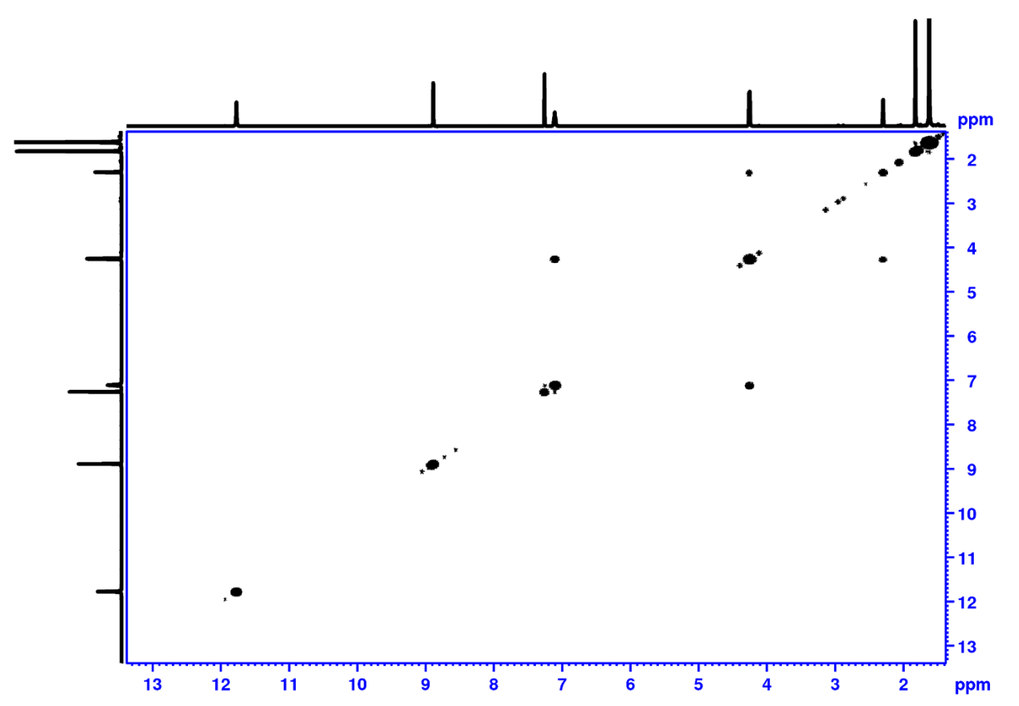
Supplementary Figure 22. COSY spectrum of monomer M in CDCl₃.
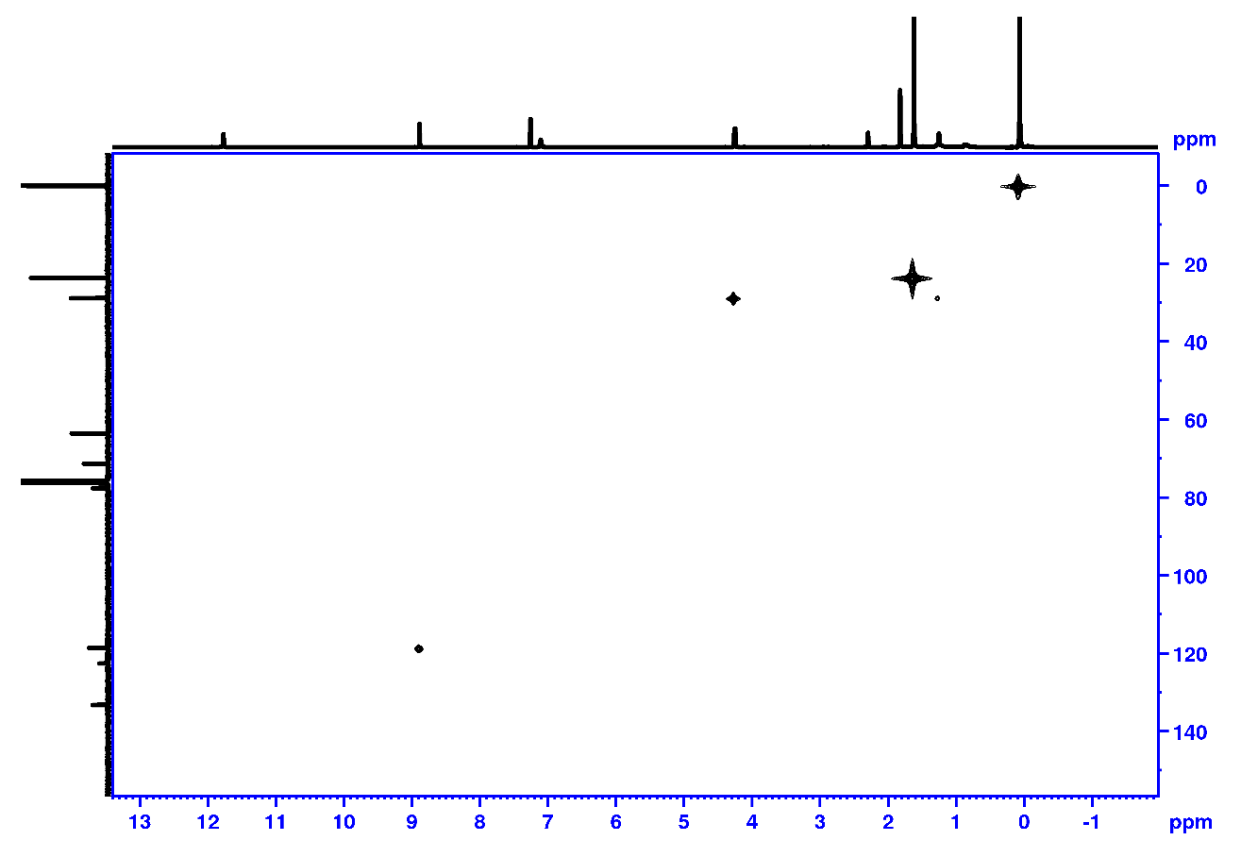
Supplementary Figure 23. HMQC spectrum of monomer M CDCl₃.
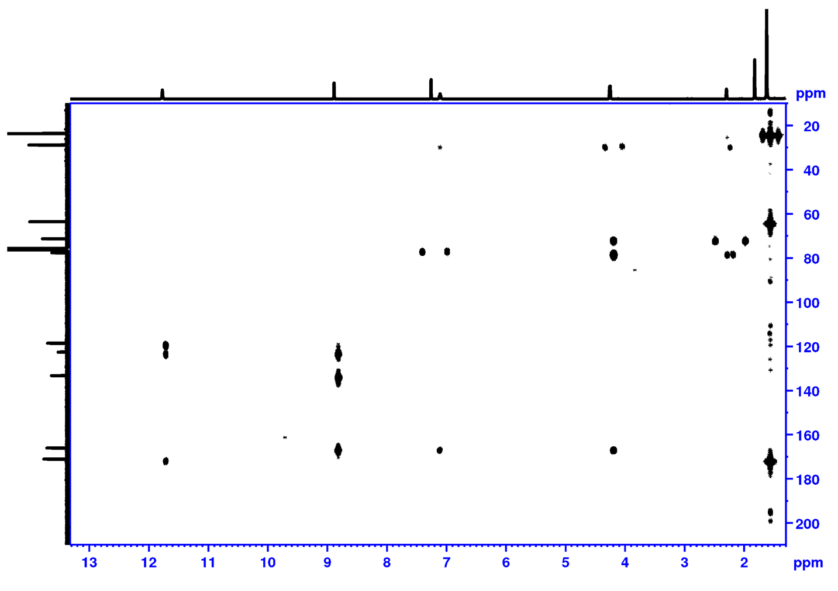
Supplementary Figure 24. HMBC spectrum of monomer M CDCl₃.

10. References
1. Huang, R., Tang, B., Ye, K., Wang, C. & Zhang, H. Flexible Luminescent Organic Bulk Crystal: 2D Elasticity toward 3D Optical Waveguide. Adv. Optical Mater. 7, 1900927 (2019).
2. Jo, H. Y. et al. Generation of N–H Imines from α-Azidocarboxylic Acids through Ru-Catalyzed Decarboxylation. J. Org. Chem. 86, 17409–17417 (2021).

