Supplemental Material

Analysis of retrospective natural history data collected from patients with SYNGAP1-related disorders: a preliminary examination of the Ciitizen database

Scott et al. 2025

Table 1. Standardized clinical scale data availability

Table 1.A. Scale frequency
Scale | No records | 1 record | 2 records | 3 or more records
PEABODY DEVELOPMENTAL MOTOR SCALES, 2ND EDITION | 25 | 12 | 5 | 2
VINELAND ADAPTIVE BEHAVIOR SCALES | 28 | 11 | 5 | 0
MULLEN SCALES OF EARLY LEARNING | 34 | 8 | 1 | 1
CAPUTE SCALES | 34 | 7 | 1 | 2
ADOS | 38 | 6 | 0 | 0
BAYLEY SCALES OF INFANT DEVELOPMENT | 36 | 6 | 2 | 0
GESELL DEVELOPMENTAL OBSERVATION REVISED | 37 | 6 | 0 | 1
PLS-5 - PRESCHOOL LANGUAGE SCALE FIFTH EDITION | 36 | 6 | 1 | 1
ABAS-3 - ADAPTIVE BEHAVIOR ASSESSMENT SYSTEM THIRD EDITION | 40 | 4 | 0 | 0
BEERY-BUKTENICA TEST OF VISUAL MOTOR INTEGRATION | 40 | 4 | 0 | 0
CARS2 - CHILDHOOD AUTISM RATING SCALE, 2ND EDITION | 40 | 4 | 0 | 0
REEL-3 - RECEPTIVE EXPRESSIVE EMERGENT LANGUAGE TEST THIRD EDITION | 39 | 4 | 1 | 0
DAYC-2 - DEVELOPMENTAL ASSESSMENT OF YOUNG CHILDREN SECOND EDITION | 40 | 3 | 1 | 0
PLS-4 - PRESCHOOL LANGUAGE SCALE FOURTH EDITION | 39 | 3 | 2 | 0
WECHSLER PRE-SCHOOL AND PRIMARY SCALE OF INTELLIGENCE | 39 | 3 | 2 | 0
BAYLEY SCALE OF INFANT DEVELOPMENT | 42 | 2 | 0 | 0
BEHAVIOUR ASSESSMENT SYSTEM FOR CHILDREN | 42 | 2 | 0 | 0
STANFORD BINET INTELLIGENCE SCALE | 42 | 2 | 0 | 0
AUTISM DIAGNOSTIC OBSERVATION SCHEDULE (ADOS) | 43 | 1 | 0 | 0
BATELLE DEVELOPMENTAL INVENTORY | 43 | 1 | 0 | 0
BATTELLE DEVELOPMENTAL INVENTORY SCREENING TOOL | 43 | 1 | 0 | 0
BRACKEN BASIC CONCEPT SCALE EXPRESSIVE | 43 | 1 | 0 | 0
CBCL - CHILDHOOD BEHAVIOR CHECKLIST | 43 | 1 | 0 | 0
DAS - DIFFERENTIAL ABILITY SCALES | 43 | 1 | 0 | 0
M-CHAT | 43 | 1 | 0 | 0
NEPSY-II | 43 | 1 | 0 | 0
PEABODY PICTURE VOCABULARY TEST | 43 | 1 | 0 | 0
PEDI - PEDIATRIC EVALUATION OF DISABILITY INVENTORY | 43 | 1 | 0 | 0
REEL-2 - RECEPTIVE EXPRESSIVE EMERGENT LANGUAGE TEST THIRD EDITION | 43 | 1 | 0 | 0
RESCA-E - RECEPTIVE, EXPRESSIVE, AND SOCIAL COMMUNICATION ASSESSMENT | 43 | 1 | 0 | 0
WECHSLER INTELLIGENCE SCALE FOR CHILDREN | 43 | 1 | 0 | 0
WIAT - WECHSLER INDIVIDUAL ACHIEVEMENT TEST | 43 | 1 | 0 | 0
WJ IV - WOODCOCK-JOHNSON TESTS OF COGNITIVE ABILITIES | 43 | 1 | 0 | 0
WOODCOCK-JOHNSON IV | 43 | 1 | 0 | 0
GROSS MOTOR FUNCTION CLASSIFICATION SYSTEM FOR CEREBRAL PALSY | 43 | 0 | 1 | 0

Table 1.B Peabody Development Motor Scale (PDMS) 2nd Edition frequency

PDMS-2 Domain | No records | 1 record | 2 records | 3 or more records
GRASPING STANDARD SCORE | 9 | 7 | 2 | 1
LOCOMOTION STANDARD SCORE | 13 | 5 | 1 | 0
VISUAL MOTOR INTEGRATION STANDARD SCORE | 12 | 5 | 2 | 0
GRASPING PERCENTILE | 14 | 4 | 1 | 0
GROSS MOTOR QUOTIENT | 15 | 4 | 0 | 0
STATIONARY STANDARD SCORE | 13 | 4 | 2 | 0
LOCOMOTION PERCENTILE | 14 | 3 | 2 | 0
OBJECT MANIPULATION STANDARD SCORE | 15 | 3 | 1 | 0
VISUAL MOTOR PERCENTILE | 16 | 3 | 0 | 0
VISUAL MOTOR STANDARD SCORE | 15 | 3 | 0 | 1
FINE MOTOR QUOTIENT PERCENTILE | 16 | 2 | 1 | 0
FINE MOTOR QUOTIENT STANDARD SCORE | 16 | 2 | 1 | 0
GRASPING AGE EQUIVALENT | 16 | 2 | 0 | 1
OBJECT MANIPULATION PERCENTILE | 16 | 2 | 1 | 0
STATIONARY PERCENTILE | 15 | 2 | 2 | 0
VISUAL MOTOR INTEGRATION PERCENTILE | 16 | 2 | 1 | 0
FINE MOTOR PERCENTILE | 18 | 1 | 0 | 0
FMQ STANDARD SCORE | 18 | 1 | 0 | 0
GRASPING LEVEL AGE EQUIVALENT | 18 | 1 | 0 | 0
GROSS MOTOR QUOTIENT PERCENTILE | 18 | 1 | 0 | 0
LOCOMOTION AGE EQUIVALENT | 16 | 1 | 2 | 0
OBJECT MANIPULATION AGE EQUIVALENT | 18 | 1 | 0 | 0
REFLEXES AGE EQUIVALENT | 18 | 1 | 0 | 0
REFLEXES PERCENTILE | 18 | 1 | 0 | 0
REFLEXES PERCENTILE RANKING | 18 | 1 | 0 | 0
REFLEXES STANDARD SCORE | 18 | 1 | 0 | 0
STATIONARY SKILLS AGE EQUIVALENT | 18 | 1 | 0 | 0
STATIONARY SKILLS PERCENTILE | 18 | 1 | 0 | 0
STATIONARY SKILLS STANDARD SCORE | 18 | 1 | 0 | 0
TOTAL LANGUAGE SCORE | 18 | 1 | 0 | 0
VISUAL FINE MOTOR AGE EQUIVALENT | 18 | 1 | 0 | 0
VISUAL MOTOR AGE EQUIVALENT | 17 | 1 | 0 | 1
VISUAL MOTOR INTEGRATION AGE EQUIVALENT | 18 | 1 | 0 | 0
VISUAL MOTOR LEVEL AGE EQUIVALENT | 18 | 1 | 0 | 0
VMI STANDARD SCORE | 18 | 1 | 0 | 0
GRASPING PERCENTILE RANKING | 18 | 0 | 0 | 1
GROSS MOTOR QUOTIENT STANDARD SCORE | 18 | 0 | 1 | 0
LOCOMOTION PERCENTILE RANKING | 18 | 0 | 1 | 0
STATIONARY AGE EQUIVALENT | 17 | 0 | 2 | 0
STATIONARY PERCENTILE RANKING | 18 | 0 | 1 | 0
VISUAL MOTOR PERCENTILE RANKING | 18 | 0 | 0 | 1

Table 2. Growth parameter data availability
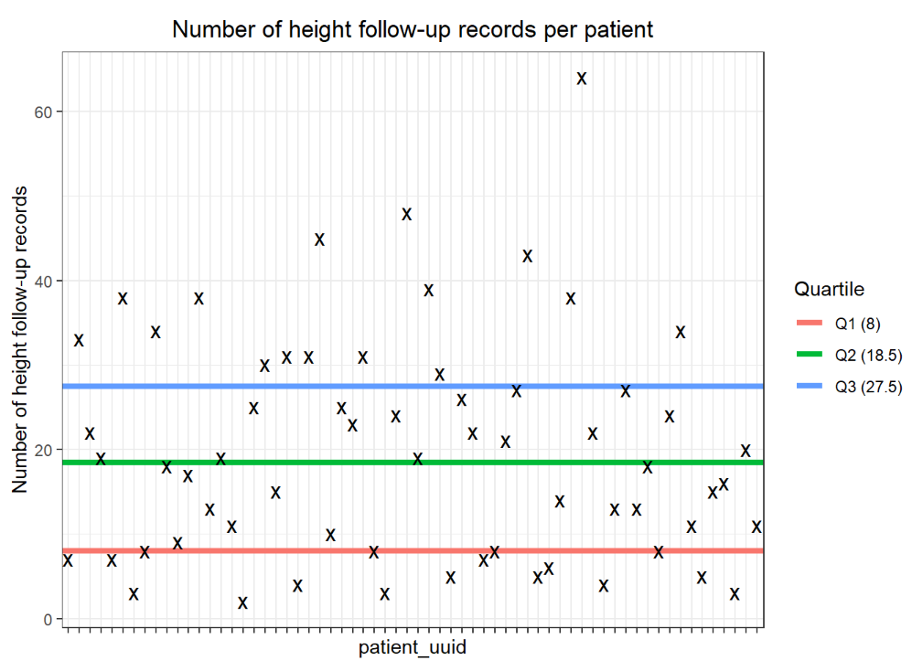
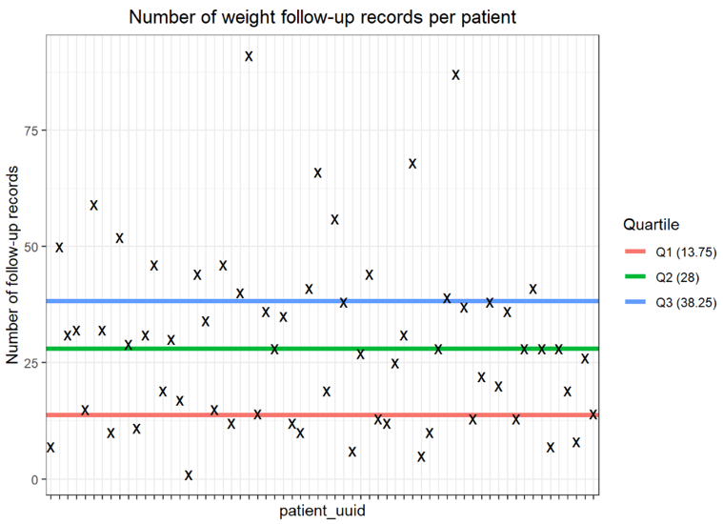
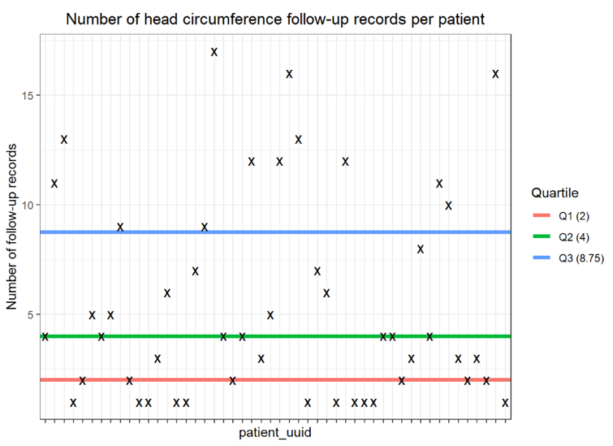

Table 3. Developmental skills availability

Table 3.A. Total records in each domain
Domain | Freq
Academic Performance | 74
Fine Motor Development | 158
Gross Motor Development | 567
Language Development | 420

Table 3.B. Academic domain frequencies
Domain Skill | N Patients | Median Age of Ability | N Patients with Ability | N Multiple Ability Records | Median Age of Inability | N Patients  with Inability | N Multiple Inability Records
Ability to identify colours | 17 | 4.245038 | 12 | 1 | 3.195072 | 6 | 0
Ability to recognize letters of the alphabet | 15 | 5.488022 | 12 | 0 | 5.37577 | 4 | 0
Ability to write | 8 | 5.69473 | 6 | 0 | 2.195756 | 3 | 0
Ability to count up to 10 | 8 | 5.117043 | 6 | 0 | 6.205339 | 2 | 0
Ability to recognize written words | 5 | 11.82752 | 5 | 0 | NA | 0 | 0
Ability to recognize numbers | 5 | 4.339493 | 3 | 0 | 4.276523 | 2 | 0
Ability to read | 4 | 15.62765 | 3 | 0 | 4.049281 | 1 | 0
Ability to recognize symbols | 4 | 5.125257 | 4 | 0 | NA | 0 | 0
Ability to understand and use numbers | 4 | 8.246407 | 4 | 0 | NA | 0 | 0

Table 3.C. Gross motor domain frequencies

Domain Skill | N Patients | Median Age  of Ability | N Patients  with Ability | N Multiple  Ability Records | Median Age  of Inability | N Patients  with Inability | N Multiple  Inability Records
Ability to walk | 64 | 1.831622 | 62 | 0 | 1.341547 | 29 | 0
Ability to crawl | 53 | 1.015743 | 49 | 0 | 0.966461 | 15 | 0
Ability to sit | 48 | 0.71321 | 44 | 0 | 0.503765 | 9 | 0
Ability to run | 34 | 2.799452 | 24 | 0 | 3.127995 | 18 | 0
Ability to pull to stand | 34 | 1.058179 | 28 | 0 | 0.966461 | 13 | 0
Ability to stand | 31 | 1.382615 | 25 | 0 | 1.368925 | 6 | 0
Ability to roll | 29 | 0.501027 | 27 | 0 | 0.5859 | 3 | 0
Ability to sit unsupported | 29 | 0.813142 | 28 | 0 | 0.709103 | 8 | 0
Ability to jump | 28 | 4.66256 | 18 | 0 | 4.013689 | 17 | 0
Ability to cruise | 24 | 1.345654 | 20 | 0 | 1.218344 | 8 | 0
Ability to walk with assistance | 20 | 1.941136 | 19 | 0 | 1.319644 | 3 | 0
Ability to control head posture | 17 | 0.243669 | 15 | 0 | 1.054073 | 3 | 0
Ability to roll (front-to-back) | 11 | 0.50924 | 11 | 0 | 0.334018 | 1 | 0
Ability to throw | 11 | 3.268994 | 9 | 0 | 2.684463 | 2 | 0
Ability to stand alone | 10 | 1.255305 | 2 | 0 | 1.190965 | 8 | 0
Ability to roll (back-to-front) | 9 | 0.501027 | 8 | 0 | 0.784394 | 2 | 0
Ability to squat | 6 | 2.113621 | 5 | 0 | 1.28679 | 1 | 0
Ability to belly crawl | 4 | 1.259411 | 4 | 0 | 0.887064 | 1 | 0
Ability to scoot | 3 | 0.999316 | 3 | 0 | 0.887064 | 1 | 0
Ability to stand on one leg | 3 | 7.682409 | 2 | 0 | 3.356605 | 1 | 0
Ability to skip | 3 | 8.213552 | 3 | 0 | NA | 0 | 0
Ability to stand from sitting | 3 | 1.494867 | 2 | 0 | 2.338125 | 1 | 0
Ability to kneel | 2 | 2.095825 | 2 | 0 | 1.319644 | 1 | 0
Ability to crouch | 1 | NA | 0 | 0 | 1.226557 | 1 | 0
Ability to walk with maximal assistance | 1 | 1.467488 | 1 | 0 | NA | 0 | 0
Developmental regression | 0 | NA | 0 | 0 | NA | 0 | 0

Table 3.D. Fine motor domain frequencies
Domain Skill | N Patients | Median Age  of Ability | N Patients  with Ability | N Multiple  Ability Records | Median Age  of Inability | N Patients  with Inability | N Multiple  Inability Records
Ability to use pincer grasp | 38 | 1.468857 | 26 | 1 | 1.223819 | 17 | 0
Ability to reach | 31 | 1.155373 | 31 | 1 | 1.054073 | 1 | 0
Ability to perform hand functions | 31 | 1.418207 | 31 | 1 | 1.054073 | 1 | 0
Ability to grasp | 27 | 0.850103 | 26 | 0 | 0.856947 | 2 | 0
Ability to write | 9 | 4.5859 | 6 | 0 | 4.071184 | 3 | 0
Ability to use palmar grasp | 9 | 1.984942 | 8 | 0 | 3.066393 | 1 | 0
Ability to use tripod grip | 1 | 1.330596 | 1 | 0 | NA | 0 | 0
Developmental regression | 0 | NA | 0 | 0 | NA | 0 | 0

Table 3.E. Language frequencies
Domain Skill | N Patients | Median Age  of Ability | N Patients  with Ability | N Multiple  Ability Records | Median Age  of Inability | N Patients  with Inability | N Multiple  Inability Records
Ability to use at least one word | 53 | 1.763176 | 44 | 1 | 1.404517 | 27 | 3
Ability to use sign language | 41 | 2.587269 | 41 | 0 | 1.333333 | 1 | 0
Ability to babble | 40 | 1.206023 | 32 | 1 | 1.189596 | 16 | 0
Ability to use verbal communication | 36 | 7.679671 | 7 | 0 | 2.595483 | 31 | 0
Ability to vocalize | 32 | 1.208761 | 32 | 3 | 1.578371 | 2 | 0
Ability to use short phrase | 31 | 3.251198 | 20 | 0 | 2.475017 | 14 | 0
Ability to use non-verbal communication | 28 | 2.505133 | 27 | 0 | 1.690623 | 4 | 0
Ability to recognize spoken words | 23 | 1.672827 | 23 | 1 | 1.138946 | 3 | 0
Ability to follow commands | 16 | 2.951403 | 15 | 0 | 2.190281 | 5 | 0
Ability to speak | 10 | 4.709103 | 5 | 0 | 3.559206 | 5 | 0
Ability to use sentences | 9 | 7.151266 | 5 | 0 | 4.199863 | 5 | 0
Ability to use augmentative and alternative communication | 9 | 4.629706 | 8 | 0 | 2.951403 | 1 | 0
Ability to use word approximations | 8 | 2.176591 | 6 | 0 | 2.043806 | 2 | 0
Ability to communicate | 6 | 4.621492 | 5 | 0 | 5.067762 | 1 | 0
Ability to speak intelligibly | 5 | 5.511294 | 1 | 0 | 3.262149 | 4 | 0
Ability to speak fluently | 3 | 6.316222 | 1 | 0 | 3.472964 | 2 | 0
Ability to use language | 2 | 3.208761 | 1 | 0 | 3.011636 | 1 | 0
Ability to speak own name | 2 | 4.010951 | 1 | 0 | 3.356605 | 1 | 0
Developmental regression | 0 | NA | 0 | 0 | NA | 0 | 0

