Supplementary Information
For
Optimal use of urban rooftops can synergize food and energy production objectives
Rui Yang^{1,a}, Chao Xu^{2,a}, Haoran Zhang¹, Zhen Wang³, Prajal Pradhan⁴, Xihong Lian¹, Limin Jiao¹, Xuemei Bai^{5,}*, Shenghui Cui⁶, Yuanchao Hu^{1,}*, Yongguan Zhu⁶
1. School of Resource and Environmental Sciences, Wuhan University, Wuhan 430079, China
2. Institute of Geography, Humboldt University of Berlin, Berlin 12489, Germany
3. College of Resource and Environment, Huazhong Agricultural University, Wuhan 430070, China
4. Integrated Research on Energy, Environment and Society (IREES), Energy and Sustainability Research Institute Groningen (ESRIG), University of Groningen, Groningen 9747 AG, Netherlands
5. Fenner School of Environment and Society, Australian National University, Canberra, Australian Capital Territory, Australia
6. Key Laboratory of Urban Environment and Health, Institute of Urban Environment, Chinese Academy of Sciences, Xiamen, 361021, China
a. These authors contributed equally to this work.
Corespondance: xuemei.bai@anu.edu.au, yuanchao.hu@whu.edu.cn.

Supplementary Notes

Supplementary Note 1: Supplementary formulas of RPV power generation potential calculation
$$∑_{k}=1.3793+θ*(1.201+θ*\left(-0.014404+θ*0.000080509\right))$$
$$ε_{direct}=\cos{∑_{k}}+\frac{\sin{∑_{k}}}{\tan{β}}\cos{φ}$$
$$ε_{diffuse}=\frac{1+\cos{∑_{k}}}{2}$$
$$ε_{reflect}=\frac{1-\cos{∑_{k}}}{2}*ρ$$
$$I_{direct}=I*\frac{\sin{β}}{\sin{β}+C}$$
$$I_{diffuse}=I-I_{direct}$$
$$C=0.095+0.04\sin\left(\frac{360}{365}*(N-100)\right)$$
$$β_{tmp}=\tan^{-1}\left(\frac{\tan{β}}{\cos{φ_{s}}}\right)$$

where $θ$ denotes the latitude of each city; ρ represents the surface reflectance with a typical default value of 0.2^{1–3}; N denotes the order of days. other variables have been mentioned in main text.

Supplementary Note 2: Classification of rooftops
We classified rooftop colors and types based on random forest classification model. The trained model was tested to correctly predict more than 90% according to the RGB values. This is indispensable for making pricing proposals referring to our respondents. We are suggested to get PV installation unit price from Engineering Procurement Construction (EPC), which will give a collective average price including BOS every week. Since the PV installation unit price have little fluctuation, we collect the price data on 23th March, 2023 (Supplementary Table 2). Prices installed on color steel tile are generally lower, but it may involve a series of invisible costs such as roof reinforcement, renovation, maintenance and so on. Prices installed on cement roof is higher, but there is less invisible cost and basically no reinforcement problem except for the precast board. Flat green roofs take a very small proportion in 124 cities and most probably represents gardens, which were considered unavailable to install RPV.

Supplementary Note 3: Labor cost of RA and RPV
Here we only considered labor cost of RA greenhouse and RPV area larger than 4000m². It is assumed that open-air planting is a non-commercial operation, requiring human labor but no labor cost. We suppose that greenhouse farmers work 261 days per year and 10 hours per day, while RPV watch keepers work 247 days per year and 8 hours per day. Their hourly wage both are 30 CNY per hour.

Supplementary Note 4: Abandonment rate of solar power in China
In 2019⁴, the country's photovoltaic power generation reached 224.3 billion KWH, an increase of 26.3%, and the number of photovoltaic utilization hours was 1,169 hours, an increase of 54 hours. The national solar abandonment rate dropped to 2%, down 1 percentage point year-on-year, and the solar abandonment power was 4.6 billion KWH. From the perspective of key regions, the photovoltaic consumption problem mainly appears in northwest, where the abandonment solar power accounts for 87% of the country, and the solar abandonment rate decreased by 2.3 percentage points to 5.9%. The abandonment rate in North China, Northeast China and South China is 0.8%, 0.4% and 0.2%, respectively, while there is no abandonment rate in East and Central China. In terms of key provinces, the abandonment rates in Tibet, Xinjiang and Gansu were 24.1%, 7.4% and 4.0%, respectively, down 19.5, 8.2 and 5.6 percentage points year-on-year. Affected by factors such as a substantial increase in new energy installed capacity and a decrease in load, the solar abandonment rate in Qinghai increased to 7.2%, an increase of 2.5 percentage points year-on-year. Besides, we assumed that electricity can be fully absorbed in Hongkong and Macau (Supplementary Table 4).

Supplementary Tables

Supplementary Table 1: The relative rate of change (rrc) of each benefit relative to the maximum value under three hypothetic scenarios and all Pareto-optimal solutions. Pareto-optimal solutions with the highest synergy (84th) is shown in detail and others simply show the range of variation.
rrc | average self-sufficiency of RA | average self-sufficiency of RPV | total economic income | total GHG mitigation | tradeoff | synergy
RA priority | 0.00% | 81.61% | 0.50% | 79.36% | 0.82 | 0.18
RPV priority | 100.00% | 0.00% | 62.85% | 0.00% | 1.00 | 0.00
Economic priority | 4.40% | 70.42% | 0.00% | 70.26% | 0.70 | 0.30
84 | 43.63% | 44.39% | 26.11% | 41.83% | 0.18 | 0.82
Other solutions (90+) | 38% ~ 44% | 44% ~ 47% | 23% ~ 26.11 % | 41.8% ~ 45% | 0.18 ~ 0.24 | 0.76 ~ 0.82

Supplementary Table 2: Optimized allocation of RA and RPV in each city and the urban properties. Note that the proportion of RA only takes up Low-rise flat roofs, and the proportion of RPV is the rest of Low-rise flat roofs plus pitched and high-rise flat roofs suitable for power generations.
City | self-sufficiency of RA | self-sufficiency of RPV | RA yield  kg/m²/yr | RPV yield  kWh/m²/yr | Proportion of RA | Building density | Population density, 10k person/km² | RA GHG mitigation, kg CO₂e/m²
Anshan | 4.36% | 2.38% | 7.14 | 162.50 | 36.74% | 13.40% | 1.29 | -1.2
Anyang | 16.44% | 4.07% | 16.12 | 186.22 | 50.16% | 13.74% | 1.12 | 0.6
Baoding | 2.25% | 2.20% | 7.57 | 183.02 | 25.22% | 10.03% | 1.49 | -2.2
Bazhong | 1.88% | 4.95% | 2.16 | 182.46 | 32.51% | 13.03% | 0.76 | -2.4
Beijing | 9.29% | 5.20% | 9.28 | 171.21 | 60.35% | 7.35% | 0.47 | -1.4
Cangzhou | 4.68% | 1.25% | 6.25 | 170.18 | 49.85% | 10.59% | 0.70 | -1.8
Changchun | 20.74% | 3.17% | 13.16 | 138.35 | 82.31% | 8.39% | 0.66 | 4.1
Changsha | 5.25% | 1.88% | 7.25 | 190.06 | 95.69% | 5.62% | 0.86 | -0.9
Changzhou | 3.90% | 1.80% | 9.88 | 184.06 | 50.01% | 4.24% | 0.56 | -1.0
Chaoyang | 9.92% | 3.53% | 6.80 | 165.56 | 45.32% | 15.63% | 0.81 | -0.9
Chengdu | 5.44% | 3.86% | 10.37 | 201.43 | 59.39% | 7.70% | 1.20 | -0.9
Chifeng | 7.71% | 2.77% | 7.83 | 163.99 | 50.34% | 10.25% | 0.75 | -1.1
Chongqing | 4.96% | 0.97% | 9.18 | 184.70 | 93.66% | 5.55% | 1.09 | -0.8
Dalian | 8.28% | 2.16% | 10.20 | 174.66 | 73.98% | 5.08% | 0.55 | 0.0
Datong | 7.19% | 3.64% | 5.77 | 179.82 | 99.72% | 12.05% | 1.06 | -1.4
Dazhou | 1.82% | 1.79% | 3.30 | 181.47 | 48.53% | 17.00% | 2.18 | -2.1
Deyang | 8.96% | 3.43% | 4.41 | 196.38 | 57.95% | 16.91% | 0.86 | -2.1
Dongguan | 4.62% | 3.17% | 6.58 | 234.11 | 55.90% | 5.61% | 0.71 | -1.1
Foshan | 41.81% | 26.97% | 12.52 | 234.63 | 42.28% | 21.27% | 0.45 | 0.4
Fushun | 10.46% | 4.90% | 6.68 | 153.24 | 54.51% | 9.70% | 0.53 | -1.1
Fuzhou | 1.47% | 2.05% | 3.80 | 222.03 | 50.04% | 7.81% | 1.47 | -1.2
Guangzhou | 1.65% | 5.48% | 6.28 | 229.98 | 32.50% | 6.36% | 0.97 | -1.1
Guilin | 52.15% | 2.72% | 17.88 | 208.33 | 97.39% | 17.43% | 0.88 | 0.9
Guiyang | 2.01% | 2.03% | 5.28 | 209.51 | 70.01% | 3.41% | 0.88 | -1.8
Harbin | 3.62% | 3.13% | 6.79 | 125.67 | 67.74% | 5.04% | 0.84 | 1.2
Haikou | 1.98% | 5.12% | 6.27 | 241.60 | 61.50% | 13.71% | 2.43 | 0.5
Handan | 27.20% | 8.58% | 27.06 | 180.55 | 24.73% | 15.02% | 0.55 | -2.3
Hangzhou | 1.13% | 7.50% | 5.69 | 197.22 | 9.66% | 6.94% | 0.53 | -0.7
Hanzhong | 5.83% | 3.07% | 8.04 | 198.63 | 45.23% | 13.56% | 1.30 | -1.4
Hefei | 2.29% | 5.41% | 11.70 | 195.87 | 23.93% | 5.64% | 0.86 | 0.1
Hengshui | 98.81% | 9.33% | 21.07 | 169.27 | 60.72% | 13.82% | 0.23 | -2.0
Hengyang | 6.00% | 2.90% | 5.58 | 206.93 | 71.69% | 10.04% | 0.96 | -1.4
Hong Kong | 2.85% | 0.41% | 14.95 | 236.26 | 99.30% | 10.83% | 2.74 | 0.5
Huhehaote | 2.39% | 2.94% | 6.68 | 175.25 | 28.94% | 17.56% | 2.16 | -1.7
Huizhou | 2.49% | 1.18% | 4.66 | 240.36 | 75.36% | 1.71% | 0.28 | -1.3
Jiangmen | 88.90% | 4.04% | 13.21 | 232.25 | 89.72% | 19.03% | 0.43 | 0.6
Jiaozuo | 9.26% | 3.77% | 9.43 | 181.80 | 32.94% | 17.69% | 0.97 | -0.2
Jiaxing | 22.67% | 2.87% | 7.68 | 197.96 | 74.54% | 7.44% | 0.29 | -0.2
Jilin | 4.51% | 2.33% | 8.38 | 135.80 | 60.21% | 7.72% | 0.92 | 1.5
Jinan | 4.80% | 1.93% | 6.62 | 183.70 | 83.70% | 5.47% | 0.71 | -2.3
Jinhua | 11.71% | 0.91% | 5.48 | 199.74 | 99.92% | 5.16% | 0.38 | -1.3
Jiujiang | 27.06% | 2.61% | 9.46 | 193.78 | 92.34% | 19.90% | 0.85 | 0.0
Kaifeng | 33.19% | 6.75% | 14.12 | 183.87 | 62.76% | 21.46% | 0.92 | 0.4
Kunming | 3.12% | 2.31% | 6.79 | 256.93 | 92.76% | 3.44% | 0.89 | -0.4
Langfang | 16.94% | 1.79% | 7.72 | 168.70 | 58.25% | 12.78% | 0.44 | -2.0
Lanzhou | 2.67% | 3.02% | 6.63 | 200.88 | 39.74% | 17.03% | 2.91 | -1.6
Lhasa | 0.68% | 15.58% | 0.66 | 263.53 | 26.34% | 15.76% | 0.71 | -3.2
Leshan | 2.29% | 1.04% | 4.37 | 192.77 | 29.12% | 17.22% | 1.52 | -2.3
Liaocheng | 9.50% | 6.19% | 16.78 | 180.31 | 11.77% | 10.86% | 0.31 | -1.9
Liuzhou | 3.48% | 11.79% | 8.58 | 197.97 | 22.06% | 15.82% | 0.97 | -0.5
Longyan | 5.04% | 3.19% | 3.27 | 232.68 | 50.17% | 12.06% | 0.67 | -1.5
Luohe | 8.07% | 7.35% | 8.04 | 185.35 | 40.17% | 20.16% | 1.29 | -0.1
Luoyang | 9.23% | 1.59% | 9.31 | 187.00 | 81.68% | 5.84% | 0.63 | -0.6
Luzhou | 9.16% | 1.07% | 3.68 | 190.63 | 99.95% | 13.18% | 0.75 | -1.9
Macau | 5.34% | 2.59% | 8.54 | 233.86 | 66.09% | 13.03% | 2.01 | -0.1
Meishan | 2.84% | 1.34% | 2.83 | 197.08 | 60.27% | 10.72% | 0.98 | -2.3
Mianyang | 8.21% | 6.23% | 7.68 | 188.00 | 44.82% | 14.26% | 0.94 | -1.3
Nanchang | 7.16% | 8.77% | 5.06 | 196.29 | 66.07% | 14.06% | 1.03 | -0.1
Nanchong | 2.49% | 4.87% | 4.59 | 180.02 | 41.27% | 11.16% | 1.26 | -1.9
Nanjing | 3.55% | 3.11% | 6.38 | 210.02 | 51.49% | 6.82% | 0.93 | -1.6
Nanning | 1.55% | 4.87% | 4.49 | 219.39 | 51.10% | 6.18% | 1.24 | -1.5
Nantong | 9.99% | 1.58% | 8.53 | 187.55 | 97.98% | 1.53% | 0.16 | -1.2
Nanyang | 20.87% | 4.95% | 18.46 | 187.69 | 29.51% | 18.29% | 0.85 | 1.2
Neijiang | 1.69% | 2.90% | 5.44 | 180.13 | 27.00% | 15.29% | 1.72 | -1.6
Ningbo | 7.20% | 4.04% | 6.47 | 170.57 | 48.56% | 6.11% | 0.38 | -0.6
Pingdingshan | 9.22% | 4.32% | 9.72 | 184.31 | 40.05% | 17.05% | 1.20 | -0.5
Putian | 9.36% | 18.25% | 8.34 | 215.63 | 25.76% | 12.71% | 0.41 | 0.4
Qingdao | 3.82% | 2.56% | 8.25 | 182.78 | 66.63% | 3.76% | 0.61 | -1.8
Qinhuangdao | 90.26% | 8.03% | 27.48 | 169.34 | 74.76% | 14.57% | 0.51 | -2.4
Quanzhou | 2.07% | 2.15% | 6.41 | 236.95 | 55.19% | 1.60% | 0.41 | -0.2
Qujing | 15.94% | 1.54% | 7.68 | 251.52 | 70.82% | 14.76% | 0.81 | 0.0
Sanya | 4.09% | 6.99% | 5.04 | 260.59 | 51.37% | 9.16% | 0.90 | -0.1
Shanghai | 3.33% | 5.26% | 11.64 | 194.41 | 33.50% | 5.23% | 0.80 | 0.3
Shangqiu | 39.92% | 6.93% | 27.79 | 183.54 | 26.76% | 25.45% | 0.77 | 1.4
Shangrao | 2.89% | 3.88% | 3.44 | 211.34 | 32.03% | 16.64% | 0.83 | -1.6
Shantou | 29.12% | 12.76% | 21.76 | 243.26 | 64.03% | 9.83% | 0.81 | 2.7
Shaoxing | 6.28% | 2.43% | 5.77 | 202.83 | 50.58% | 7.40% | 0.56 | -1.0
Shenyang | 0.48% | 10.55% | 8.07 | 159.23 | 3.72% | 8.83% | 0.85 | -0.9
Shenzhen | 1.88% | 8.77% | 7.36 | 245.76 | 22.22% | 13.08% | 1.38 | -0.7
Shijiazhuang | 3.03% | 5.05% | 7.28 | 179.37 | 34.82% | 6.57% | 0.71 | -1.9
Suining | 2.95% | 6.11% | 7.28 | 183.45 | 31.76% | 9.28% | 0.90 | -1.3
Suzhou | 89.50% | 9.63% | 15.48 | 182.65 | 68.95% | 16.55% | 0.27 | -0.6
Taian | 15.12% | 3.62% | 10.05 | 179.05 | 58.47% | 10.76% | 0.57 | -1.0
Taiyuan | 1.67% | 2.60% | 5.69 | 192.49 | 39.71% | 9.46% | 2.05 | -1.2
Taizhou | 28.63% | 11.47% | 8.14 | 203.18 | 56.11% | 13.98% | 0.37 | -0.3
Tangshan | 4.44% | 0.52% | 8.93 | 175.93 | 65.78% | 4.49% | 0.72 | -1.8
Tianjin | 5.94% | 3.00% | 5.06 | 169.69 | 75.70% | 6.48% | 0.48 | -1.8
Tianshui | 4.82% | 8.46% | 3.42 | 199.01 | 52.94% | 14.66% | 0.88 | -2.2
Urumqi | 4.18% | 0.62% | 5.37 | 150.02 | 84.95% | 8.33% | 1.61 | -1.7
Weifang | 70.63% | 2.03% | 22.48 | 182.08 | 82.87% | 12.10% | 0.47 | -1.8
Wenzhou | 2.53% | 3.71% | 4.61 | 211.58 | 67.90% | 5.16% | 0.93 | -1.5
Wuhan | 3.74% | 4.26% | 8.94 | 194.13 | 49.65% | 5.69% | 0.88 | -1.1
Wuhu | 7.39% | 1.23% | 9.25 | 196.30 | 76.97% | 9.92% | 1.33 | -0.6
Wuxi | 6.35% | 1.59% | 9.10 | 193.18 | 62.99% | 4.20% | 0.49 | -1.2
Xiamen | 2.54% | 6.23% | 8.16 | 256.89 | 37.51% | 5.53% | 0.79 | 0.6
Xian | 3.32% | 8.54% | 8.82 | 194.41 | 29.72% | 7.77% | 1.01 | -1.6
Xiangtan | 16.32% | 8.98% | 12.39 | 192.19 | 41.98% | 12.81% | 0.67 | 0.1
Xiangyang | 21.44% | 4.47% | 13.38 | 182.97 | 65.15% | 11.16% | 0.54 | 0.3
Xingtai | 3.94% | 3.71% | 7.30 | 187.53 | 23.34% | 11.41% | 0.79 | -1.9
Xining | 2.26% | 0.58% | 5.10 | 198.00 | 67.35% | 9.27% | 2.15 | -1.0
Xinxiang | 19.90% | 3.85% | 11.50 | 186.99 | 54.93% | 19.70% | 1.00 | -0.2
Xinyang | 21.17% | 3.09% | 9.35 | 192.69 | 58.25% | 13.23% | 0.60 | -0.1
Xuchang | 49.59% | 8.97% | 16.68 | 184.04 | 54.08% | 22.21% | 0.66 | 1.2
Xuzhou | 7.92% | 0.91% | 9.76 | 189.77 | 77.36% | 6.29% | 0.99 | -1.1
Yancheng | 29.59% | 3.51% | 9.65 | 183.67 | 69.79% | 7.89% | 0.23 | -1.0
Yangzhou | 25.48% | 14.45% | 10.21 | 191.13 | 34.92% | 15.19% | 0.36 | -1.1
Yantai | 8.86% | 2.54% | 8.71 | 177.45 | 32.66% | 9.33% | 0.45 | -1.8
Yibin | 12.07% | 1.55% | 8.08 | 208.39 | 51.35% | 25.20% | 1.60 | -1.5
Yichang | 5.92% | 2.10% | 5.53 | 186.28 | 60.74% | 9.50% | 0.72 | -1.6
Yinchuan | 46.67% | 7.83% | 11.59 | 192.84 | 51.96% | 29.10% | 0.65 | 1.4
Yueyang | 7.09% | 2.66% | 5.92 | 183.98 | 62.86% | 11.82% | 0.89 | -1.4
Zaozhuang | 10.00% | 7.97% | 7.18 | 182.34 | 42.81% | 13.89% | 0.70 | -1.9
Zhangjiakou | 3.21% | 5.39% | 5.00 | 177.10 | 31.63% | 8.72% | 0.66 | -2.4
Zhangzhou | 34.51% | 10.61% | 11.63 | 242.64 | 42.74% | 12.46% | 0.32 | 2.5
Zhengzhou | 4.45% | 3.55% | 8.27 | 184.84 | 58.08% | 4.04% | 0.59 | -1.0
Zhenjiang | 32.23% | 9.23% | 17.01 | 189.41 | 40.09% | 9.67% | 0.32 | -0.4
Zhongshan | 2.47% | 3.11% | 4.41 | 238.37 | 44.60% | 2.51% | 0.33 | -1.8
Zhoukou | 21.26% | 3.44% | 11.17 | 191.14 | 59.87% | 20.79% | 1.21 | -0.1
Zhuhai | 2.55% | 2.52% | 2.74 | 239.41 | 56.13% | 14.03% | 1.30 | -2.1
Zhumadian | 35.21% | 3.66% | 17.14 | 191.51 | 49.86% | 22.25% | 1.04 | 1.8
Zhuzhou | 7.79% | 7.41% | 8.72 | 190.49 | 39.43% | 12.10% | 0.88 | -0.9
Zibo | 31.72% | 6.53% | 10.80 | 183.57 | 66.53% | 12.87% | 0.44 | -1.9
Zigong | 7.34% | 4.98% | 4.53 | 194.68 | 70.26% | 16.06% | 1.15 | -2.0
Zunyi | 11.09% | 1.98% | 3.98 | 192.55 | 80.51% | 15.44% | 0.86 | -1.0

Supplementary Table 3: PV installation unit price based on roof categories (on 23th March, 2023)
Roof categories | Unit price of installation works (CNY/W)
Cement roof: Flat grey roof | 3.5~3.5
color steel tile: Pitch roof (all colors) or flat red and blue roof | 3.2~3.5
Other: Flat green roof | unavailable

Supplementary Table 4: Annual PV cleaning unit price based on geographic zoning (1. Precipitation, wind speed, temperature, humidity, latitude and concentration of dust were considered comprehensively in each region by FCM clustering algorithm⁸; 2. Regional cleaning cycle was predicted through influence rate and accumulation velocity of dust ⁹)
Region | Unit price of dust cleaning (CNY/year/W)
I: Fujian, Guangdong, Guangxi, Hainan, Hongkong, Macau | 0.03
Ⅱ: Hubei | 0.04
Ⅲ: Zhejiang, Jiangxi | 0.05
Ⅳ: Hunan, Chongqing, Guizhou, Yunnan | 0.055
Ⅴ: Inner Mongolia, Liaoning, Jilin, Heilongjiang, Shanghai | 0.06
Ⅵ: Jiangsu, Anhui, Sichuan | 0.065
Ⅶ: Tibet, Gansu, Qinghai, Ningxia, Xinjiang | 0.07
Ⅷ: Beijing, Tianjin, Hebei, Shanxi | 0.075
Ⅸ: Shandong, Henan, Shaanxi | 0.08

Supplementary Table 5: Abandonment rate of solar power in China Data Credits: 2019年光伏发电并网运行情况---国家能源局 (nea.gov.cn).
Region | Abandonment rate of solar power
North China | 0.8%
Northeast China | 0.4%
South China | 0.2%
Northwest China | 5.9%
East and Central China, Hongkong and Macau | 0
Tibet | 24.1%
Xinjiang | 7.4%
Gansu | 4%
Qinghai | 7.2%

Supplementary Figures

Supplementary Figure 1: Research area, urban built-up area within the administrative boundary. Cities with population larger than 1 million in the urban districts were selected, which hold 38.3% of national population.
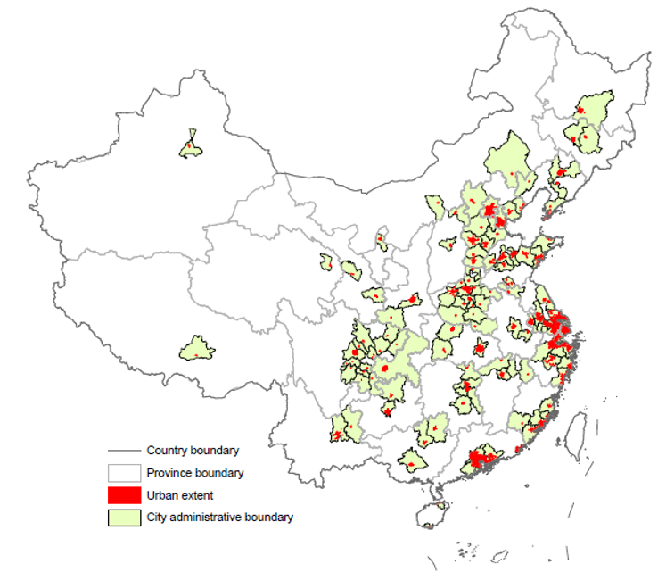

Supplementary Figure 2: Provincial photovoltaic grid purchase price (equal to benchmark price for coal-fired power generation). Data Credits: All benchmark prices for coal-fired power generation of China mainland come from National Development and Reform Commission except for Hongkong and Macau, which were collected from Hong Kong Renewable Energy Network (https://re.emsd.gov.hk/sc_chi/fit/int/fit_int.html) and Macau Energy Industry Development Office (https://www.gov.mo/zh-hans/news/191822/).
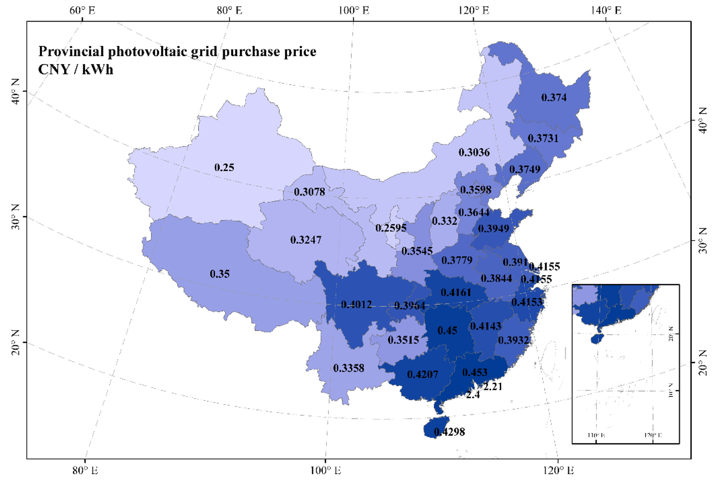

Supplementary Figure 3: Regional division of China. a Agriculture regionalization in China with potential crop yield.; b Division of the power systems in China with annual sunshine duration. Data Credits: Resource and Environment Science and Data Center (https://www.resdc.cn/).
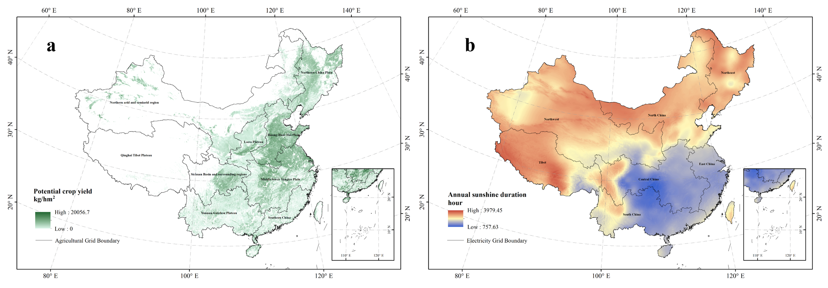

Supplementary Figure 4: Distributions of RA and RPV self-sufficiency rate, NPV and GHG mitigation volumes in 124 cities in China under four scenarios. The black box represents the mean value. Because the gap between extreme values is too large, we set breaks on the vertical axis so that no data was omitted. Under RA-prioritized scenario, only pitched rooftops would be allocated to RPV, which would end up with net-emitting vegetable productions (with total emission of 1 Mt CO2e in 124 cities annually). Focusing on RPV in all cities is still within the largest penetration potential of renewable energy (50%, see Methods), this would lead to zero RA production and fewer economic benefit. Prioritizing economic benefit would largely hamper RPV deployment (with tradeoff by 70%), and reduce a certain proportion of RA.
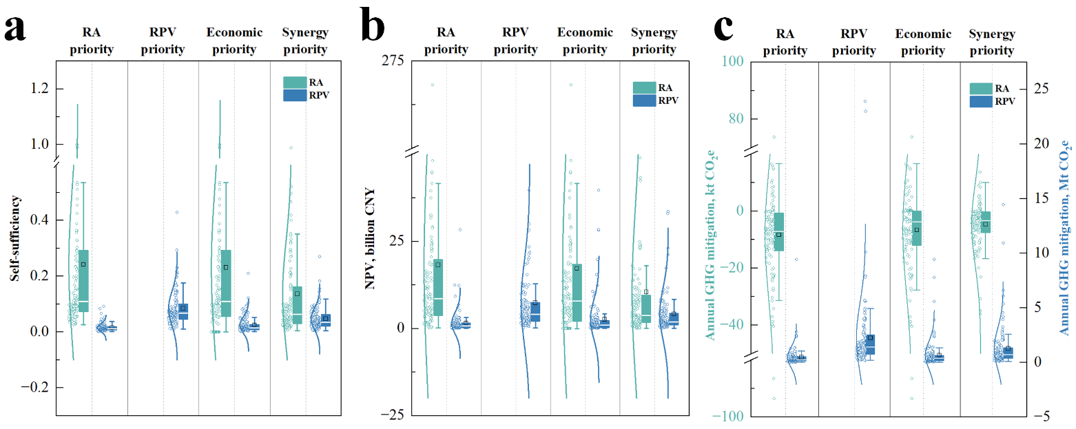

Supplementary Figure 5: Correlation between synergy and average RPV self-sufficiency in all Pareto-optimal solutions. Notably it shows negative correlation between synergy and average RA self-sufficiency with the same coefficient of determination (R²).

Supplementary Figure 6: Potential benefits and requirements produced by optimized RA-RPV allocation on urban rooftops in 124 cities. a Potential annual GHG mitigation; b Potential NPV in 30-year lifetime; c Potential cropland reduced by efficient vegetable production of RA, which is calculated based on provincial-level cropland requirement of conventional vegetable yield in China; d Potential standard coal saved by clean energy of RPV, which is calculated based on provincial-level coal consumption for power supply of accounted power plants (>6000 kW) in China30.
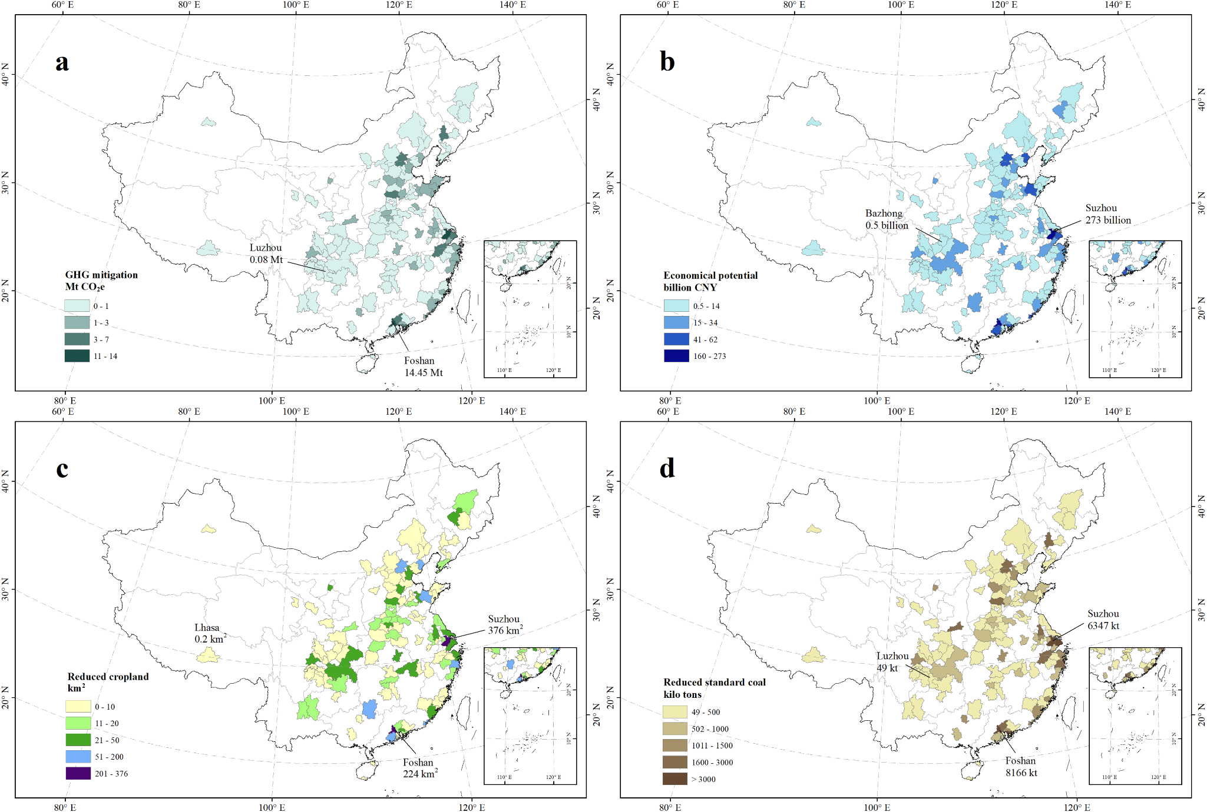

Supplementary Figure 7: Roof distribution for RA and RPV.
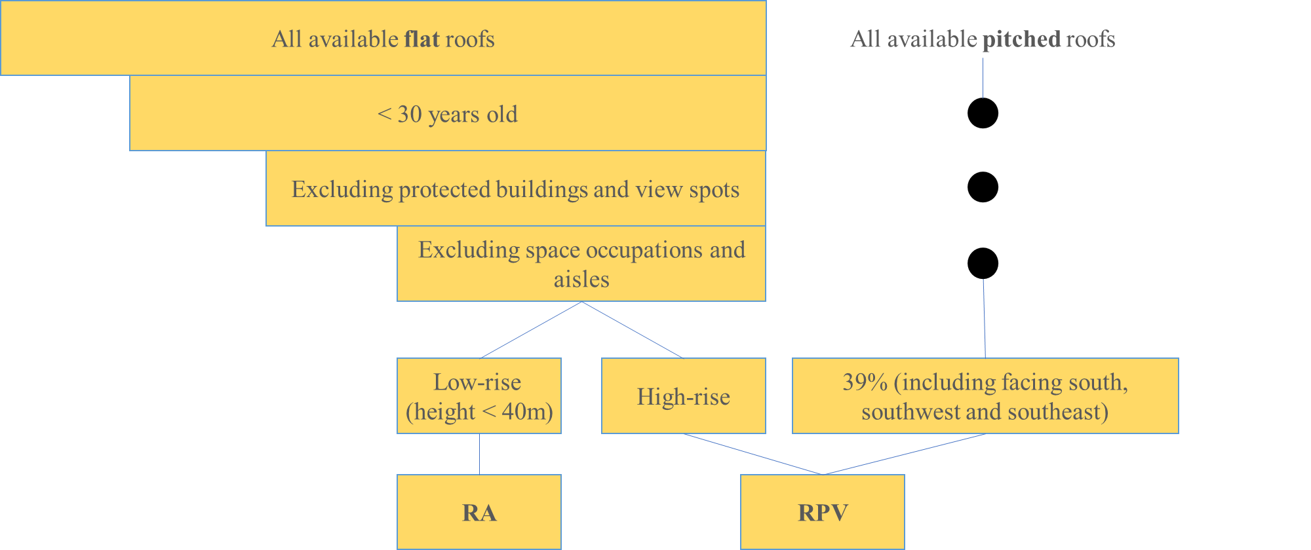

Supplementary References
1. Lu, X. et al. Combined solar power and storage as cost-competitive and grid-compatible supply for China’s future carbon-neutral electricity system. Proc. Natl. Acad. Sci. U.S.A. 118, e2103471118 (2021).
2. Chen, S. et al. The Potential of Photovoltaics to Power the Belt and Road Initiative. Joule 3, 1895–1912 (2019).
3. Qiu, T. et al. Potential assessment of photovoltaic power generation in China. Renewable and Sustainable Energy Reviews 154, 111900 (2022).
4. National Energy Administration. Grid-connected operation of photovoltaic power generation in 2019. (2020).
5. Zhao, B., Zhang, X. & Hong, B. Energy penetration of large-scale distributed photovoltaic sources integrated into smart distribution network (In Chinese). Electric Power Automation Equipment 32, 95–100 (2012).
6. Zhuo, Z., Zhang, N., Xie, X., Li, H. & Kang, C. Key Technologies and Developing Challenges of Power System with High Proportion of Renewable Energy (In Chinese). Automation of Electric Power Systems 45, 171–191 (2021).
7. Zhao, B., Xiao, C., Xu, C., Zhang, X. & Zhou, J. Pentration Based Accommodation Capacity Analysis on Distributed Photovoltaic Connection in Regional Distribution Network (In Chinese). Automation of Electric Power Systems 41, 105–111 (2017).
8. Wu, Z. Three-Dimensional Numerical Simulation of Dust Deposition on the Surface of Photovoltaic Modules (In Chinese). (Nanchang University, 2022).
9. Zhang Zhaohui et al. Cleaning effect analysis and cleaning cycle prediction of pv modules in pv power stations (In Chinese). SOLAR ENERGY 53–61 (2022) doi:10.19911/j.1003-0417.tyn20211014.01.

