Online Supplementary Appendices

Celebrating legacy: The intergenerational transmission of reproduction and human capital in Ming–Qing Chinese families

Sijie Hu
School of Economics, Renmin University of China
159 Zhongguancun Street, Beijing, China
Email: sijiehu@ruc.edu.cn
ORCID ID: 0000-0002-3680-8592

Online Appendix A: Additional tables and figures

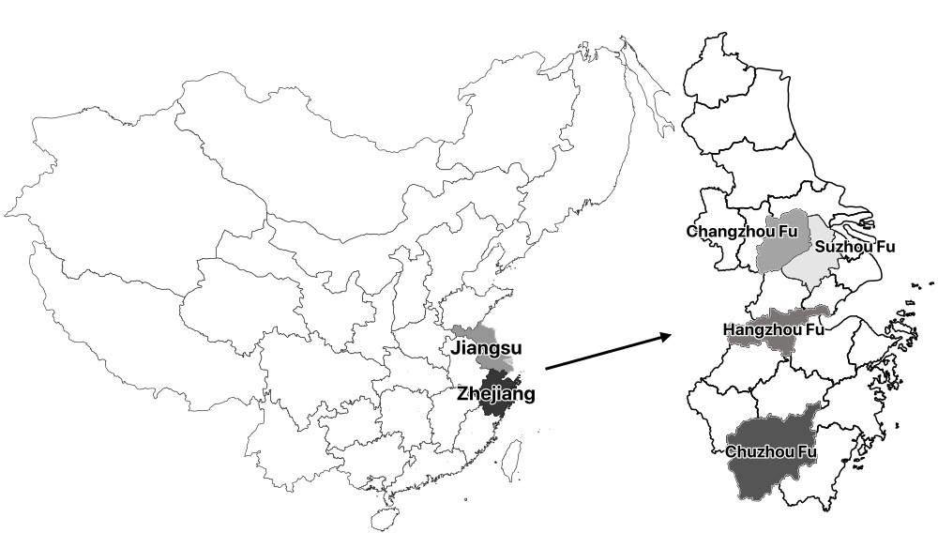
Figure A1 Map of Jiangsu and Zhejiang, China in 1820.
Source: CHGIS 2007.

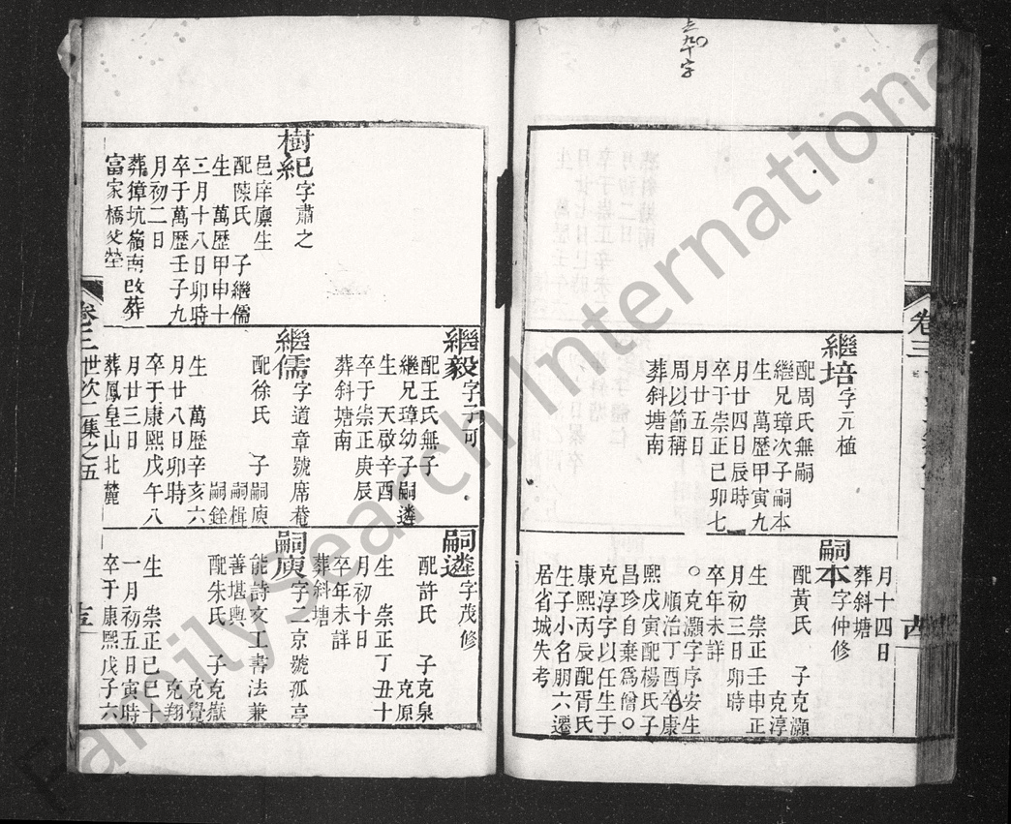
Sons’ names
Name(s)
Wife’s surname
Birth and death dates
Burial place
Status records
Figure A2 Example of a page from a Chinese genealogical book.
Source: Familysearch.org.

Table A1 Summary Statistics

Statistics | N | Mean | Std. | Min | Max
All Males
Married | 36,456 | 0.70 | 0.46 | 0 | 1
Degree | 36,456 | 0.04 | 0.20 | 0 | 1
Number of brothers | 36,456 | 2.56 | 1.49 | 1 | 12
Firstborn | 36,456 | 0.50 | 0.50 | 0 | 1
Adoptee | 36,456 | 0.06 | 0.24 | 0 | 1
Father’s class | 36,456 | 0.14 | 0.35 | 0 | 1
Father’s marriages | 36,456 | 1.16 | 0.52 | 0 | 10
Grandfather’s class | 36,456 | 0.18 | 0.38 | 0 | 1
Number of uncles | 36,422 | 2.62 | 1.55 | 1 | 12
Out-migration | 36,456 | 0.01 | 0.07 | 0 | 1
Survival to adulthood | 36,456 | 0.91 | 0.28 | 0 | 1
Birth cohort | 31,197 | 8.92 | 1.87 | 1 | 12
Lineage | 36,456 | 3.77 | 1.40 | 1 | 6
Age at death | 11,344 | 50.02 | 17.60 | 1 | 105
Zi | 36,456 | 0.38 | 0.48 | 0 | 1
Hao | 36,456 | 0.06 | 0.24 | 0 | 1
Father’s age at first son’s birth | 18,598 | 28.11 | 7.82 | 13 | 68
Ancestors
Number of sons | 9,336 | 2.06 | 1.25 | 1 | 12
Number of grandsons | 9,336 | 2.95 | 2.98 | 0 | 50
Number of great-grandsons | 9,336 | 3.64 | 5.18 | 0 | 88
Number of great-great-grandsons | 9,336 | 3.90 | 7.82 | 0 | 194
Class | 9,336 | 0.09 | 0.29 | 0 | 1
Hao | 9,336 | 0.10 | 0.29 | 0 | 1
Number of marriages | 9,336 | 1.15 | 0.46 | 1 | 10
Firstborn | 9,336 | 0.51 | 0.50 | 0 | 1
Out-migration | 9,336 | 0.001 | 0.04 | 0 | 1
Survival to adulthood | 9,336 | 1.00 | 0.06 | 0 | 1
Birth cohort | 6,992 | 7.09 | 1.87 | 1 | 12
Lineage | 9,336 | 3.83 | 1.29 | 1 | 6
Branch | 9,336 | 61.76 | 38.09 | 1 | 131
Notes: 1. The “number of brothers” includes the male individual himself, and the “number of uncles” includes the male individual’s father. 2. “Father’s class” denotes the stepfather’s class if the individual is an adoptee. 3. “Father’s age at death” denotes the biological father’s age at death for all individuals.

Table A2 Relationship between family size and marital status, OLS regression
 | Dependent Variable: Married
 | (1) | (2) | (3) | (4) | (5) | (6)
Brothers | 0.003  (0.002) | 0.011***  (0.002) | 1.018***  (0.002) | 0.021***  (0.003) | 0.014***  (0.003) | 0.014***  (0.003)
Firstborn |  |  | 0.051***  (0.005) | 0.054***  (0.005) | 0.052***  (0.005) | 0.052***  (0.005)
Adoptee |  |  |  | 0.049***  (0.009) | 0.053***  (0.009) | 0.054***  (0.009)
Father’s class |  |  |  |  | 0.097***  (0.008) | 0.095***  (0.009)
Father’s marriages |  |  |  |  | 0.028***  (0.006) | 0.029***  (0.006)
Grandfather’s class |  |  |  |  |  | 0.005  (0.010)
Uncles |  |  |  |  |  | -0.001  (0.002)
Out-migration | N | Y | Y | Y | Y | Y
Survival | N | Y | Y | Y | Y | Y
Birth cohort FE | N | Y | Y | Y | Y | Y
Lineage FE | N | Y | Y | Y | Y | Y
N | 36,360 | 31,106 | 31,106 | 31,106 | 31,106 | 31,080
Pseudo-R² | 0.0001 | 0.272 | 0.275 | 0.275 | 0.283 | 0.283
Notes: 1. If the individual is an adoptee, then “Father’s class” and “Grandfather’s class” denote his stepfather’s and step-grandfather’s social status. 2. Robust standard errors are in parentheses, clustered on fathers. 3. *p<0.1; **p<0.05; ***p<0.01.

Table A3 Relationship between family size and degree, OLS regression
 | Dependent Variable: Degree
 | (1) | (2) | (3) | (4) | (5) | (6)
Brothers | 0.010***  (0.002) | 0.011***  (0.002) | 0.013***  (0.002) | 0.014***  (0.002) | 0.004**  (0.001) | 0.003**  (0.001)
Firstborn |  |  | 0.015***  (0.003) | 0.016***  (0.003) | 0.014***  (0.002) | 0.014***  (0.002)
Adoptee |  |  |  | 0.016***  (0.005) | 0.021***  (0.005) | 0.019***  (0.005)
Father’s class |  |  |  |  | 0.184***  (0.008) | 0.159***  (0.008)
Father’s marriages |  |  |  |  | 0.028***  (0.005) | 0.027***  (0.005)
Grandfather’s class |  |  |  |  |  | 0.049***  (0.006)
Uncles |  |  |  |  |  | 0.001  (0.001)
Out-migration | N | Y | Y | Y | Y | Y
Survival | N | Y | Y | Y | Y | Y
Birth cohort FE | N | Y | Y | Y | Y | Y
Lineage FE | N | Y | Y | Y | Y | Y
N | 36,360 | 31,106 | 31,106 | 31,106 | 31,106 | 31,106
Pseudo-R² | 0.006 | 0.064 | 0.065 | 0.065 | 0.164 | 0.171
Notes: 1. If the individual is an adoptee, then “Father’s class” and “Grandfather’s class” denote his stepfather’s and step-grandfather’s social status. 2. Robust standard errors are in parentheses, clustered on fathers. 3. *p<0.1; **p<0.05; ***p<0.01.

Online Appendix B: Tables for Robustness Checks

Table B1 Effects of sons on grandsons and great-grandsons, OLS regression
Dependent Variable:
ln (Number of male descendants+1)
 | Gen.3 | Gen.4 | Gen.5 |  | Gen.3 | Gen.4 | Gen.5 |  | Gen.3 | Gen.4 | Gen.5
 | (1) | (2) | (3) |  | (4) | (5) | (6) |  | (7) | (8) | (9)
Sons | 0.410***  (0.019) | 0.377***  (0.026) | 0.307***  (0.029) |  | 0.411***  (0.022) | 0.388***  (0.029) | 0.319***  (0.030) |  | 0.405***  (0.019) | 0.375***  (0.026) | 0.308***  (0.028)
Sons² | -0.022***  (0.003) | -0.018***  (0.004) | -0.013***  (0.005) |  | -0.022***  (0.004) | -0.019***  (0.005) | -0.014***  (0.005) |  | -0.023***  (0.003) | -0.020***  (0.004) | -0.016**  (0.005)
Class |  |  |  |  |  |  |  |  | 0.131***  (0.028) | 0.194***  (0.041) | 0.174***  (0.047)
Hao |  |  |  |  |  |  |  |  | 0.190***  (0.027) | 0.323***  (0.041) | 0.303***  (0.049)
Marriages |  |  |  |  |  |  |  |  | 0.066***  (0.016) | 0.085***  (0.024) | 0.121***  (0.027)
Controls
Firstborn | N | N | N |  | Y | Y | Y |  | Y | Y | Y
Out-migration | N | N | N |  | Y | Y | Y |  | Y | Y | Y
Survival to adulthood | N | N | N |  | Y | Y | Y |  | Y | Y | Y
Birth cohort FE | N | N | N |  | Y | Y | Y |  | Y | Y | Y
Lineage & Branch FE | N | N | N |  | Y | Y | Y |  | Y | Y | Y
Constant | 0.425***  (0.022) | 0.450***  (0.030) | 0.444***  (0.034) |  | 0.703***  (0.151) | 1.046***  (0.203) | 1.382***  (0.232) |  | 0.590***  (0.147) | 0.878***  (0.195) | 1.186***  (0.230)
N | 9,336 | 9,336 | 9,336 |  | 6,992 | 6,992 | 6,992 |  | 6,992 | 6,992 | 6,992
R² | 0.278 | 0.144 | 0.083 |  | 0.335 | 0.238 | 0.237 |  | 0.349 | 0.260 | 0.254
Notes: 1. Robust standard errors are in parentheses, clustered on fathers. 2. *p<0.1; **p<0.05; ***p<0.01.

Table B2 The number of sons and the number of male descendants, conditioning on lifespan
Dependent variable:
Number of male descendants in
 | Gen.3 | Gen.4 | Gen.5
 | (1) | (2) | (3)
Sons | 1.687***  (0.057) | 1.654***  (0.067) | 1.680***  (0.081)
Sons² | 0.969***  (0.005) | 0.968***  (0.005) | 0.962***  (0.006)
Class | 1.168***  (0.040) | 1.332***  (0.073) | 1.467***  (0.114)
Hao | 1.188***  (0.043) | 1.361***  (0.078) | 1.459***  (0.121)
Marriages | 1.081***  (0.022) | 1.104***  (0.031) | 1.160***  (0.043)
Lifespan | 1.005***  (0.001) | 1.006***  (0.001) | 1.004**  (0.002)
N | 3,426 | 3,426 | 3,426
Pseudo R² | 0.138 | 0.081 | 0.082
Notes: 1. The coefficients are the incidence rate ratios (IRR) for the negative binomial model. 2. All specifications shown include firstborn, out-migration, survival to adulthood, birth cohort FE, and lineage and branch FE. 3. Robust standard errors are in parentheses, clustered on fathers. 4. *p<0.1; **p<0.05; ***p<0.01.

Table B3 The effects of Sons on the number of male descendants for males born between 1350 and 1920, negative binomial regression
 | Dependent Variable: Number of male descendants in
 | Gen.3 | Gen.4 | Gen.5
 | (1) | (2) | (3)
2 sons | 1.720***  (0.040) | 1.715***  (0.061) | 1.656***  (0.080)
3 sons | 2.532***  (0.067) | 2.329***  (0.092) | 2.166***  (0.114)
4 sons | 3.282***  (0.104) | 3.311***  (0.162) | 3.184***  (0.225)
5 sons | 4.042***  (0.191) | 3.798***  (0.278) | 3.422***  (0.354)
6 sons | 4.698***  (0.314) | 4.837***  (0.536) | 4.059***  (0.572)
7 sons | 5.948***  (0.557) | 5.047***  (0.768) | 5.125***  (1.003)
8 sons | 4.968***  (0.918) | 4.083***  (1.019) | 3.454***  (1.171)
9 sons | 5.154***  (1.358) | 2.971***  (0.901) | 2.119*  (0.866)
≥ 10 sons | 6.641***  (2.010) | 4.541***  (1.512) | 1.995*  (0.743)
N | 6,992 | 6,992 | 6,992
Pseudo R² | 0.113 | 0.064 | 0.060
Notes: 1. The coefficients are the incidence rate ratios (IRR) for the negative binomial model. 2. All specifications shown include class, number of marriages, hao, firstborn, out-migration, survival to adulthood, birth cohort FE, and lineage and branch FE. 3. Robust standard errors are in parentheses, clustered on fathers. 4. *p<0.1; **p<0.05; ***p<0.01.

Table B4 Reproduction-marriage and reproduction-degree relationships by period, logistic regression
 |  |  |  |  | Dependent Variable:
 | Married | Degree |  |  | Married | Degree |  | Married | Degree
 | Born in 1400–1600 |  |  |  | Born in 1600–1800 |  |  | Born in 1800–1900
 | (1) | (2) |  |  | (3) | (4) |  | (5) | (6)
Brothers | 1.090  (0.088) | 0.942  (0.092) |  |  | 1.080***  (0.026) | 1.031  (0.031) |  | 1.106***  (0.028) | 0.992  (0.052)
Father’s class | 1.193  (0.343) | 6.409***  (2.173) |  |  | 2.064***  (0.197) | 8.194***  (0.987) |  | 1.851***  (0.171) | 16.058***  (3.957)
Father’s marriages | 1.657**  (0.348) | 1.452**  (0.221) |  |  | 1.295***  (0.080) | 1.298***  (0.074) |  | 1.203***  (0.073) | 1.248  (0.169)
Grandfather’s class | 1.166  (0.353) | 2.284***  (0.720) |  |  | 0.866*  (0.072) | 2.791***  (0.321) |  | 1.042  (0.089) | 2.009***  (0.445)
N | 1,580 | 1,576 |  |  | 15,280 | 15,280 |  | 13,176 | 12,756
Pseudo R² | 0.205 | 0.298 |  |  | 0.160 | 0.340 |  | 0.299 | 0.304
Notes: 1. The coefficients are the odds ratio for the logistic model. 2. All specifications shown include uncles, firstborn, adoptee, out-migration, survival to adulthood, birth cohort FE, and lineage FE. 3. Robust standard errors are in parentheses, clustered on fathers. 4. *p<0.1; **p<0.05; ***p<0.01.

Table B5 Reproduction-marriage and reproduction-degree relationships, conditioning on lifespan
 | Dependent Variable:
 | Married | Degree
 | (1) | (2)
Brothers | 0.973  (0.026) | 0.987  (0.029)
Lifespan | 1.048***  (0.003) | 1.020***  (0.003)
Father’s class | 2.183***  (0.242) | 8.293***  (0.998)
Father’s marriages | 1.629***  (0.119) | 1.300***  (0.075)
Grandfather’s class | 0.944  (0.095) | 2.607***  (0.297)
N | 11,118 | 10,651
Pseudo-R² | 0.268 | 0.299
Notes: 1. The coefficients are the odds ratios for the logistic regression model. 2. All specifications shown include uncles, firstborn, adoptee, out-migration, survival to adulthood, birth cohort FE, and lineage FE. 3. Robust standard errors are in parentheses, clustered on fathers. 4. *p<0.1; **p<0.05; ***p<0.01.

Table B6 Relationship between family size and rudimentary literacy, logistic regression
 | Dependent Variable:
 | Zi |  |  | Hao
 | (1) | (2) |  | (3) | (4)
Brothers | 1.086***  (0.018) | 1.016  (0.018) |  | 1.208***  (0.032) | 1.014  (0.029)
Father’s class |  | 3.745***  (0.284) |  |  | 8.545***  (0.755)
Father’s marriages |  | 1.107**  (0.049) |  |  | 1.160***  (0.055)
Grandfather’s class |  | 1.823***  (0.121) |  |  | 2.332***  (0.204)
N | 31,080 | 31,080 |  | 31,080 | 31,080
Pseudo-R² | 0.250 | 0.289 |  | 0.149 | 0.307
Notes: 1. The coefficients are the odds ratio for the logistic model. 2. All specifications shown include uncles, firstborn, adoptee, out-migration, survival to adulthood, birth cohort FE, and lineage FE. 3. Robust standard errors are in parentheses, clustered on fathers. 4. *p<0.1; **p<0.05; ***p<0.01.

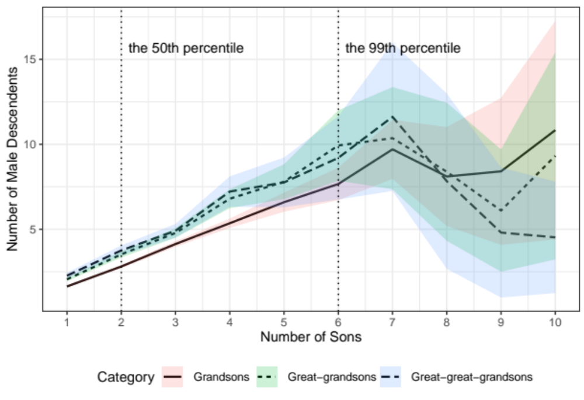
Figure B1 Predicted number of male descendants in the three generations at each level of reproduction after conditioning on all factors.
Notes: 1. The predicted values are calculated from the results in columns 1–3 of Table B3. 2. The shaded area represents the 95% confidence interval for the predicted curve.

