Table 1: PCR results of DNA, RNA, bacteria, EHP and non-EHP Microsporidia and Haplosporidia.
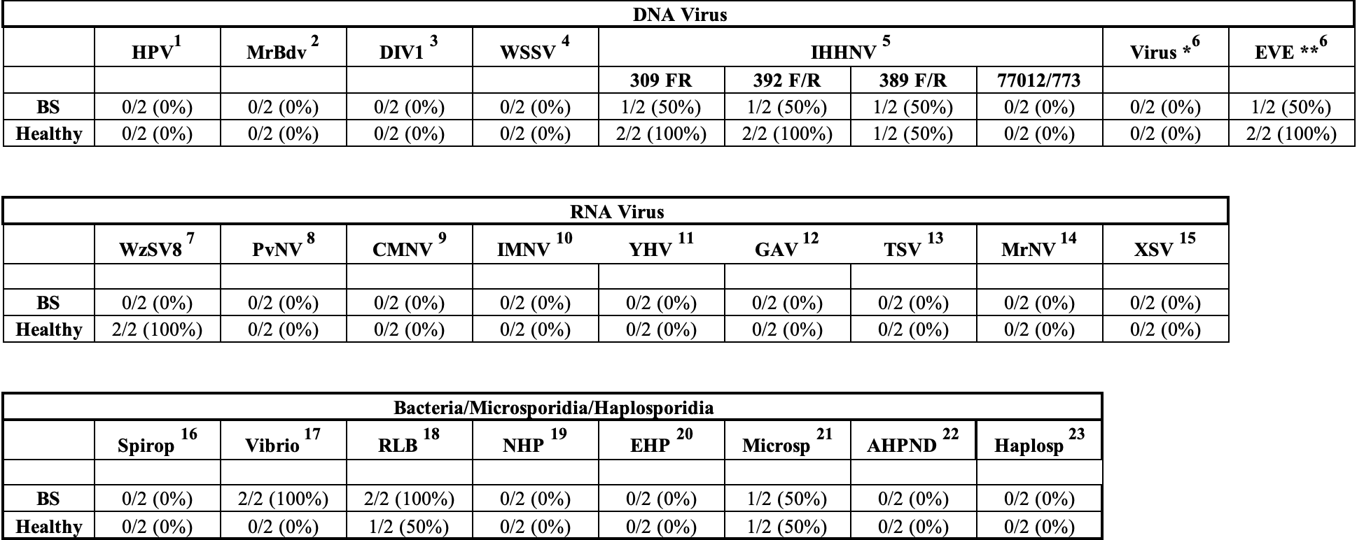

¹ Hepanhamaparvovirus (DHPV) - Phromjai et al. (2002); ² Macrobrachium Bidnavirus (MrBdv) - Gangnonngiw et al. (2023); ³ Decapod Iridescent Virus 1 (DIV1) - Qiu et al. (2017); ⁴ White Spot Syndrome Virus (WSSV) - Lo et al. (1996); ⁵ Infectious Hypodermal and Hematopoietic Necrosis Virus (IHHNV) - Nunan et al. (2000), Tang et al. (2000), Tang and Lightner (2006), Tang et al. (2007a), ; ⁶ IHHNV ** as infectious, or ** EVE; ⁷ Wenzhou shrimp virus 8 (WzSV8) - Srisala et al. (2023); ⁸ P. vannamei nodavirus - Tang et al. (2007b); ⁹ Covert Mortality Nodavirus (CMNV) - Zhang et al. (2017); ¹⁰ Infectious Myonecrosis Virus (IMNV) - Poulos & Lightner (2006); ¹¹ Yellow Head Virus (YHV) - Mohr et al. (2015); ¹² Gill-associated virus (GAV) - Mohr et al. (2015); ¹³ Taura Syndrome Virus (TSV) - Nunan et al. (1998), Navarro et al. (2009); ¹⁴ Macrobrachium Nodavirus (MrNV) - Gangnonngiw et al. (2020), ¹⁵ Extra small virus (XSV) usually associated with MrNV - Senapin et al. (2012); ¹⁶ Spiroplasma - Nunan et al. (2004); ¹⁷ Vibrio spp. - Thompson et al. (2004); ¹⁸ Rickettsia-Like Bacteria (RLB) - Nunan et al. (2003); ¹⁹ Necrotizing Hepatopancreatitis Bacteria (NHP-B) - Aranguren et al., (2010); ²⁰ Ecytonucleospora [Enterocytozoon] hepatopenaei (EHP) - Jaroenlak et al. (2016); ²¹ non-EHP Microsporidia - Pasharawipas et al. (1994); ²² Acute Hepatopancreatic Necrosis Disease (AHPND) - Dangtip et al. (2015); ²³ Haplosporidia - Utari et al. (2012).

Table 2: Microbiology results of affected and healthy zoea.

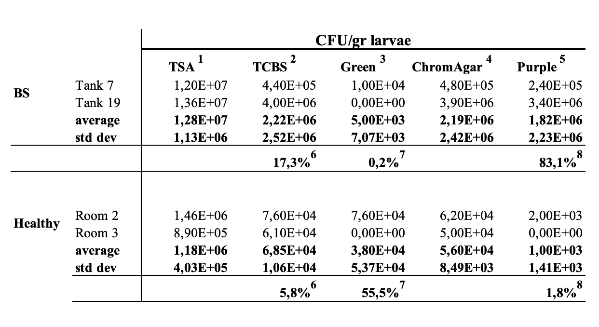

¹ Tryptic Soy Agar (TSA, Difco); ² thiosulphate-citrate-bile-sucrose agar (TCBS, Difco); ³ Green colonies in TCBS; ⁴ CHROMagarTM Vibrio; ⁵ Purple colonies in CHROMagarTM Vibrio. ⁶ Percentage of presumptive Vibrio (TCBS) of total bacterial population; ⁷ Percentage of green colonies of the total population of presumptive Vibrio (TCBS); ⁸ Percentage of purple colonies of the total population of presumptive Vibrio CHROMagarTM Vibrio.

Table 3a: Characterization of bacteria isolated from affected and healthy zoea.
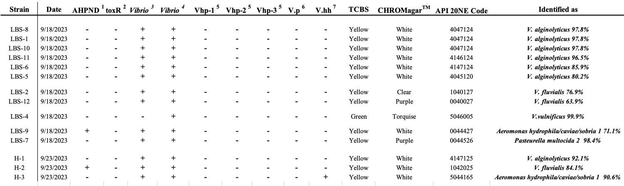

- Strains identified as LBS- were isolated from LBS affected zoea, and H- from healthy, apparently non-affected zoea.
¹Acute Hepatopancreatic Necrosis Disease (AHPND) – (Dangtip et al. 2015); ²toxR gen (Aguilera-Rivera et al. 2019); ³Vibrio spp (Thompson et al. 2004); ⁴Vibrio-specific 16S rRNA gene fragment (Wang et al. 2022); ⁵Vibrio high virulent protein gen (Liu et al. 2023); ⁶V. parahaemolyticus (Khimmakthong and Sukkarun, 2017) 2004); ⁷V. harveyi (vhh) (Wang et al. 2022).

Table 3b: API 20E characterization of bacteria isolated from affected and healthy zoea.
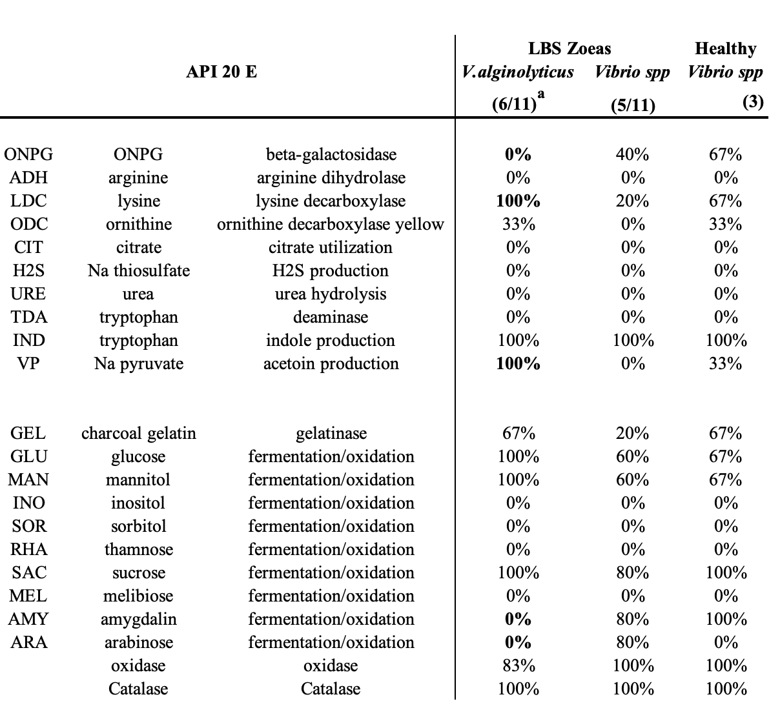

ª (numbers in parenthesis (Group/total strains)

