 |  | Accuracy | Precision | Specificity | Sensitivity | F1-score
Naïve Bayes
Binary | NAWM vs. Tumor | 0.932 | 0.986 | 0.986 | 0.876 | 0.928
Binary | NAWM vs. AFR | 0.843 | 0.984 | 0.984 | 0.698 | 0.813
Binary | WBH vs AFR | 0.720 | 0.983 | 0.903 | 0.494 | 0.638
Binary | NPF vs. PF | 0.629 | 0.766 | 0.766 | 0.443 | 0.550
Multiclass | NAWM vs. Rest | 0.799 | 0.720 | 0.720 | 0.331 | 0.443
Multiclass | NPF vs. Rest | 0.733 | 0.059 | 0.059 | 0.012 | 0.018
Multiclass | Tumor vs. Rest | 0.755 | 0.742 | 0.742 | 0.057 | 0.103
Multiclass | PF vs. Rest | 0.754 | 0.574 | 0.574 | 0.146 | 0.229
Logistic Regression
Binary | NAWM vs. Tumor | 0.969 | 0.973 | 0.973 | 0.967 | 0.970
Binary | NAWM vs. AFR | 0.829 | 0.887 | 0.887 | 0.798 | 0.821
Binary | WBH vs AFR | 0.761 | 0.762 | 0.762 | 0.773 | 0.766
Binary | NPF vs. PF | 0.594 | 0.594 | 0.594 | 0.685 | 0.633
Multiclass | NAWM vs. Rest | 0.850 | 0.766 | 0.766 | 0.599 | 0.662
Multiclass | NPF vs. Rest | 0.750 | 0.000 | 0.000 | 0.000 | 0.000
Multiclass | Tumor vs. Rest | 0.783 | 0.615 | 0.615 | 0.394 | 0.473
Multiclass | PF vs. Rest | 0.754 | 0.571 | 0.571 | 0.170 | 0.252
ANN
Binary | NAWM vs. Tumor | 0.979 | 0.979 | 0.979 | 0.979 | 0.979
Binary | NAWM vs. AFR | 0.895 | 0.907 | 0.907 | 0.897 | 0.896
Binary | WBH vs AFR | 0.835 | 0.831 | 0.831 | 0.842 | 0.837
Binary | NPF vs. PF | 0.700 | 0.685 | 0.685 | 0.773 | 0.723
Multiclass | NAWM vs. Rest | 0.899 | 0.805 | 0.805 | 0.798 | 0.793
Multiclass | NPF vs. Rest | 0.763 | 0.543 | 0.543 | 0.316 | 0.396
Multiclass | Tumor vs. Rest | 0.841 | 0.710 | 0.710 | 0.630 | 0.664
Multiclass | PF vs. Rest | 0.802 | 0.709 | 0.709 | 0.439 | 0.529
Decision Tree
Binary | NAWM vs. Tumor | 0.974 | 0.969 | 0.969 | 0.981 | 0.975
Binary | NAWM vs. AFR | 0.905 | 0.929 | 0.929 | 0.887 | 0.905
Binary | WBH vs AFR | 0.914 | 0.899 | 0.899 | 0.932 | 0.915
Binary | NPF vs. PF | 0.728 | 0.685 | 0.685 | 0.600 | 0.761
Multiclass | NAWM vs. Rest | 0.905 | 0.792 | 0.792 | 0.846 | 0.816
Multiclass | NPF vs. Rest | 0.767 | 0.602 | 0.602 | 0.235 | 0.332
Multiclass | Tumor vs. Rest | 0.799 | 0.661 | 0.661 | 0.481 | 0.529
Multiclass | PF vs. Rest | 0.776 | 0.672 | 0.672 | 0.276 | 0.383
Random Forest
Binary | NAWM vs. Tumor | 0.984 | 0.980 | 0.980 | 0.988 | 0.984
Binary | NAWM vs. AFR | 0.897 | 0.905 | 0.905 | 0.895 | 0.896
Binary | WBH vs AFR | 0.910 | 0.901 | 0.901 | 0.923 | 0.911
Binary | NPF vs. PF | 0.773 | 0.728 | 0.728 | 0.887 | 0.798
Multiclass | NAWM vs. Rest | 0.913 | 0.812 | 0.812 | 0.857 | 0.829
Multiclass | NPF vs. Rest | 0.795 | 0.681 | 0.681 | 0.363 | 0.466
Multiclass | Tumor vs. Rest | 0.938 | 0.880 | 0.880 | 0.870 | 0.875
Multiclass | PF vs. Rest | 0.889 | 0.782 | 0.782 | 0.783 | 0.781
Gradient Boosting
Binary | NAWM vs. Tumor | 0.983 | 0.975 | 0.975 | 0.991 | 0.983
Binary | NAWM vs. AFR | 0.887 | 0.890 | 0.890 | 0.894 | 0.888
Binary | WBH vs AFR | 0.958 | 0.934 | 0.934 | 0.985 | 0.959
Binary | *WBH vs AFR within FLAIR test voxels | 0.793 | 0.744 | 0.744 | 0.910 | 0.817
Binary | NPF vs. PF | 0.791 | 0.741 | 0.741 | 0.912 | 0.816
Multiclass | NAWM vs. Rest | 0.913 | 0.793 | 0.793 | 0.887 | 0.834
Multiclass | NPF vs. Rest | 0.807 | 0.685 | 0.685 | 0.433 | 0.521
Multiclass | Tumor vs. Rest | 0.941 | 0.856 | 0.856 | 0.923 | 0.888
Multiclass | PF vs. Rest | 0.896 | 0.760 | 0.760 | 0.866 | 0.808
Supplementary Table 1. Performance metrics of ML models for binary and multi-class classifications. Highest performance metric is bolded in each category.

 | Mean AUC (± 1 SD)
Naïve Bayes
NAWM vs. Tumor | 0.99 ± 0.01
NAWM vs. AFR | 0.95 ± 0.02
WBH vs AFR | 0.87 ± 0.02
NPF vs. PF | 0.74 ± 0.14
Logistic Regression
NAWM vs. Tumor | 0.99 ± 0.01
NAWM vs. AFR | 0.92 ± 0.05
WBH vs AFR | 0.91 ± 0.02
NPF vs. PF | 0.63 ± 0.13
ANN
NAWM vs. Tumor | 0.98 ± 0.02
NAWM vs. AFR | 0.90 ± 0.04
WBH vs AFR | 0.84 ± 0.02
NPF vs. PF | 0.70 ± 0.06
Decision Tree
NAWM vs. Tumor | 0.99 ± 0.01
NAWM vs. AFR | 0.94 ± 0.04
WBH vs AFR | 0.91 ± 0.01
NPF vs. PF | 0.76 ± 0.09
Random Forest
NAWM vs. Tumor | 0.99 ± 0.00
NAWM vs. AFR | 0.95 ± 0.03
WBH vs AFR | 0.93 ± 0.01
NPF vs. PF | 0.84 ± 0.08
Gradient Boosting
NAWM vs. Tumor | 0.99 ± 0.00
NAWM vs. AFR | 0.95 ± 0.03
WBH vs AFR | 0.99 ± 0.01
*WBH vs AFR within FLAIR test voxels | 0.86 ± 0.08
NPF vs. PF | 0.70 ± 0.10
Supplementary Table 2. Binary Classification ML Models and its associated AUCs +/- 1 SD. Includes all 6 machine-learning models and all 4 binary paradigms.

 | Mean AUC
Naïve Bayes
NAWM vs. Rest | 0.83 ± 0.08
NPF vs. Rest | 0.68 ± 0.19
Tumor vs. Rest | 0.71 ± 0.16
PF vs. Rest | 0.70 ± 0.15
Logistic Regression
NAWM vs. Rest | 0.92 ± 0.03
NPF vs. Rest | 0.76 ± 0.17
Tumor vs. Rest | 0.78 ± 0.14
PF vs. Rest | 0.77 ± 0.12
ANN
NAWM vs. Rest | 0.96 ± 0.01
NPF vs. Rest | 0.84 ± 0.13
Tumor vs. Rest | 0.86 ± 0.11
PF vs. Rest | 0.86 ± 0.10
Decision Tree
NAWM vs. Rest | 0.95 ± 0.01
NPF vs. Rest | 0.81 ± 0.16
Tumor vs. Rest | 0.83 ± 0.18
PF vs. Rest | 0.82 ± 0.12
Random Forest
NAWM vs. Rest | 0.97 ± 0.01
NPF vs. Rest | 0.87 ± 0.11
Tumor vs. Rest | 0.90 ± 0.11
PF vs. Rest | 0.91± 0.09
Gradient Boosting
NAWM vs. Rest | 0.96 ± 0.01
NPF vs. Rest | 0.87 ± 0.10
Tumor vs. Rest | 0.91 ± 0.10
PF vs Rest | 0.95 ± 0.02
Supplementary Table 3. Multi-class Classification ML Models observing the One vs. Rest technique and its associated AUCs

Naïve Bayes |  | Hyperparameters
Binary | NAWM vs. Tumor | GaussianNB()
Binary | NAWM vs. AFR | GaussianNB()
Binary | WBH vs AFR | GaussianNB()
Binary | NPF vs. PF | GaussianNB()
Multiclass | NAWM vs. Rest | (var_smoothing=8.111308307896873e-08)
Multiclass | NPF vs. Rest | (var_smoothing=8.111308307896873e-08)
Multiclass | Tumor vs. Rest | (var_smoothing=8.111308307896873e-08)
Multiclass | PF vs. Rest | (var_smoothing=8.111308307896873e-08)
Logistic Regression
Binary | NAWM vs. Tumor | LogisticRegression()
Binary | NAWM vs. AFR | LogisticRegression()
Binary | WBH vs AFR | (penalty='none', solver='newton-cg')
Binary | NPF vs. PF | LogisticRegression()
Multiclass | NAWM vs. Rest | (C=0.08858667904100823, multi_class = 'multinomial')
Multiclass | NPF vs. Rest | (C=0.08858667904100823, multi_class = 'multinomial')
Multiclass | Tumor vs. Rest | (C=0.08858667904100823, multi_class = 'multinomial')
Multiclass | PF vs. Rest | (C=0.08858667904100823, multi_class = 'multinomial')
ANN
Binary | NAWM vs. Tumor | (epochs=50, batch_size=10)
Binary | NAWM vs. AFR | (epochs=50, batch_size=10)
Binary | WBH vs AFR | (epochs=50, batch_size=10)
Binary | NPF vs. PF | (epochs=50, batch_size=10)
Multiclass | NAWM vs. Rest | (epochs=50, batch_size=10)
Multiclass | NPF vs. Rest | (epochs=50, batch_size=10)
Multiclass | Tumor vs. Rest | (epochs=50, batch_size=10)
Multiclass | PF vs. Rest | (epochs=50, batch_size=10)
Decision Tree
Binary | NAWM vs. Tumor | (max_depth=5, max_features=6, min_samples_leaf=8)
Binary | NAWM vs. AFR | (criterion='entropy', max_depth=3, max_features=5, min_samples_leaf=2)
Binary | WBH vs AFR | (max_features=8)
Binary | NPF vs. PF | (criterion='entropy', max_depth=3, max_features=6, min_samples_leaf=6)
Multiclass | NAWM vs. Rest | (criterion='entropy', max_depth=5, max_features=5, min_samples_leaf=8)
Multiclass | NPF vs. Rest
Multiclass | Tumor vs. Rest
Multiclass | PF vs. Rest
Random Forest
Binary | NAWM vs. Tumor | (bootstrap=False, max_depth=80, max_features='auto',min_samples_split=10, n_estimators=1000)
Binary | NAWM vs. AFR | n_estimators = 100, oob_score = True)
Binary | WBH vs AFR | (max_depth=50, max_features='auto', bootstrap=False, min_samples_leaf=2, n_estimators=2000)
Binary | NPF vs. PF | (bootstrap=False, max_depth=60, max_features='auto',min_samples_leaf=2, n_estimators=600)
Multiclass | NAWM vs. Rest | (bootstrap=False, max_depth=50, max_features='auto', min_samples_leaf=2, n_estimators=2000)
Multiclass | NPF vs. Rest
Multiclass | Tumor vs. Rest
Multiclass | PF vs. Rest
Gradient Boosting
Binary | NAWM vs. Tumor | (max_depth=5, min_samples_leaf=2, min_samples_split=4,n_estimators=500)
Binary | NAWM vs. AFR | (max_depth=5, max_features='auto', min_samples_leaf=6)
Binary | WBH vs AFR | (max_depth=15, max_features='auto', min_samples_leaf=2, n_estimators=1300)
Binary | NPF vs. PF | (max_depth=15, max_features='auto', min_samples_leaf=2, min_samples_split=10, n_estimators=1100)
Multiclass | NAWM vs Rest | (max_depth=15, max_features='sqrt',min_samples_leaf=2, n_estimators=1500)
Multiclass | NPF vs Rest
Multiclass | Tumor vs Rest
Multiclass | PF vs Rest
Supplementary Table 4. Hyperparameters used for binary and multiclass ML classification models.

Gradient Boosting | AUC: Cho/NAA Only | AUC: Relative Ratios Only
NAWM vs Tumor | 0.97 ± 0.00 | 0.99 ± 0.00
NAWM vs AFR | 0.94 ± 0.04 | 0.95 ± 0.03
WBH vs AFR | 0.88 ± 0.01 | 0.96 ± 0.01
NPF vs PF | 0.79 ± 0.03 | 0.86 ± 0.04
Supplementary Table 5. Validation of multiparametric binary ML. Gradient Boosting models were retrained with Cho/NAA only and again with only relative ratios (Cho/NAA, Cho/CR, NAA/CR; no myo-inositol or Glx). 5-fold cross-validated mean AUC with standard deviation were recorded. All mean AUC were lower than 5-fold cross-validated AUC from Gradient Boosting models trained on all 5 metabolites.

 | Accuracy | Precision | Specificity | Sensitivity | F1-Score
Cho/NAA Only
NAWM vs. Tumor | 0.930 | 0.931 | 0.931 | 0.928 | 0.930
NAWM vs. AFR | 0.894 | 0.934 | 0.934 | 0.849 | 0.888
WBH vs AFR | 0.802 | 0.802 | 0.802 | 0.804 | 0.804
NPF vs. PF | 0.704 | 0.699 | 0.699 | 0.720 | 0.709
Ratios Only
NAWM vs. Tumor | 0.962 | 0.966 | 0.966 | 0.957 | 0.962
NAWM vs. AFR | 0.904 | 0.932 | 0.932 | 0.874 | 0.900
WBH vs AFR | 0.905 | 0.888 | 0.888 | 0.928 | 0.908
NPF vs. PF | 0.788 | 0.767 | 0.767 | 0.834 | 0.798

Supplementary Table 6. Performance metrics for validation Gradient Boosting Cho/NAA only and ratios only models. Results are averaged across 5-fold cross-validation.

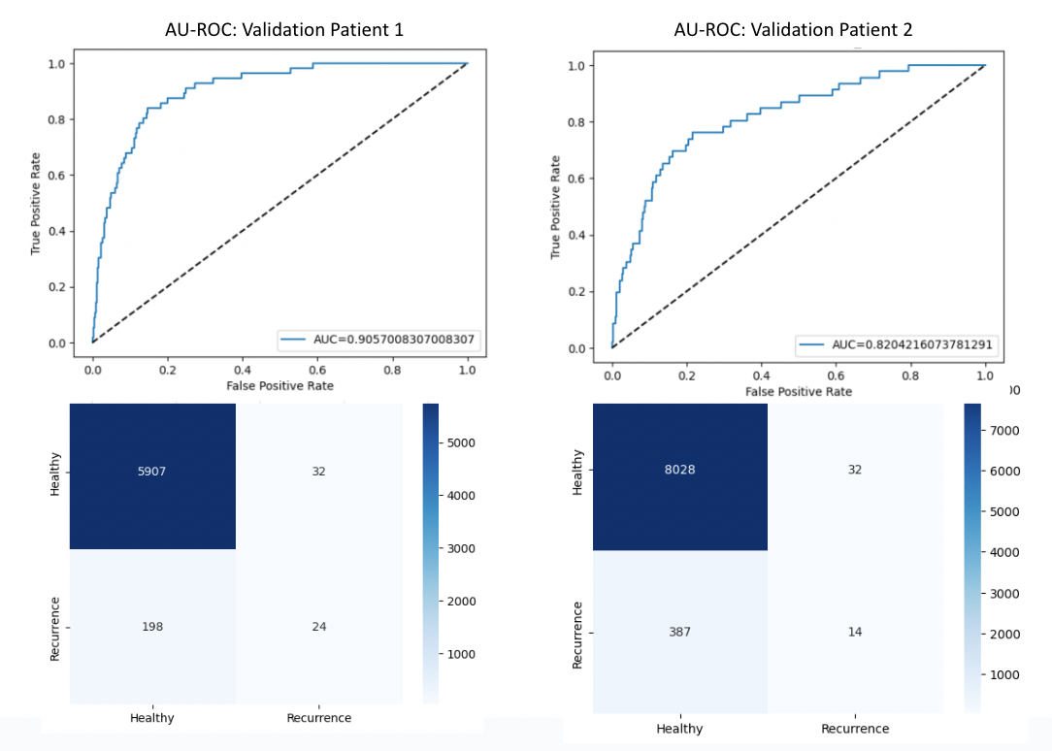
Supplemental Figure 1: Validation ROC and confusion matrices for Gradient Boosting trained and tested with WBH vs AFR voxels. Y-axis represents machine-learning predictions. X-axis represents supervised classifiers.
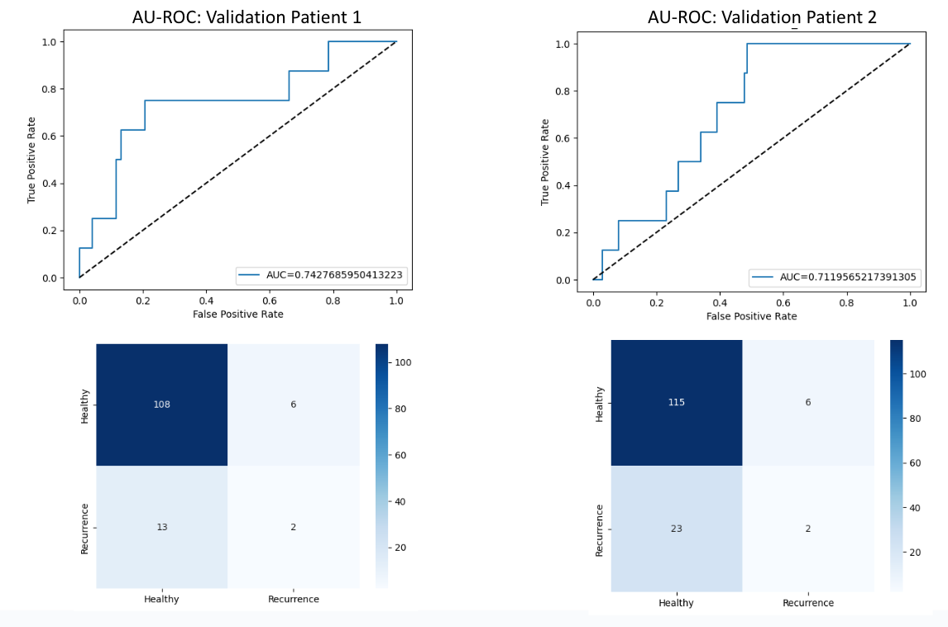

Supplemental Figure 2: Validation ROC and confusion matrices for Gradient Boosting trained with WBH vs AFR voxels and tested with NPF vs PF voxels. Confusion matrix y-axis represents machine-learning predictions; x-axis represents supervised classifiers.
`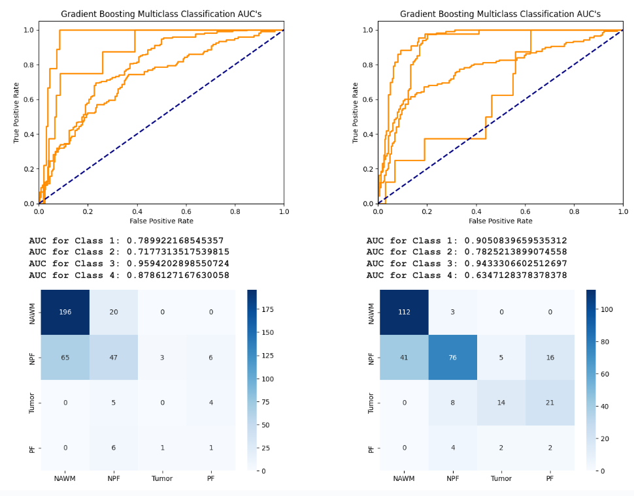

Supplemental Figure 3: Validation ROC’s and confusion matrices for Gradient Boosting Multi-Class. Results displayed per patient. Confusion matrix y-axis represents machine-learning predictions. X-axis represents supervised classifiers. Class 1: NAWM vs Rest; Class 2: NPF vs Rest; Class 3: Tumor vs Rest; Class 4: PF vs Rest.
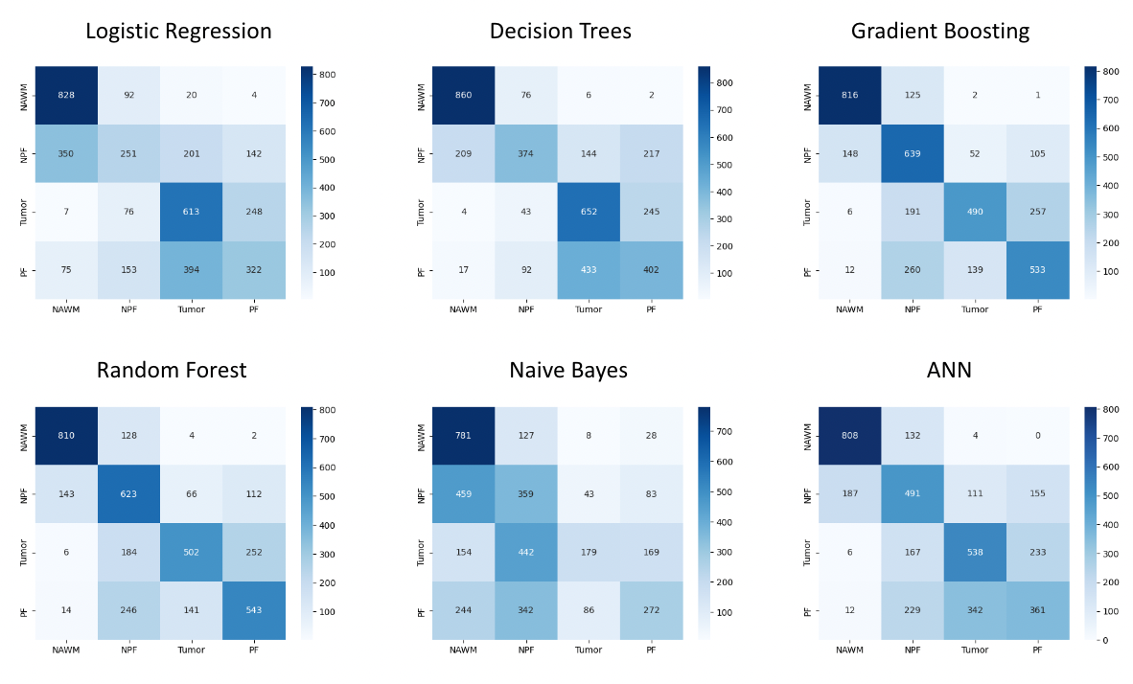
Supplemental Figure 4: Multiclass testing set confusion matrices. Y-axis represents machine-learning predictions. X-axis represents supervised classifiers.

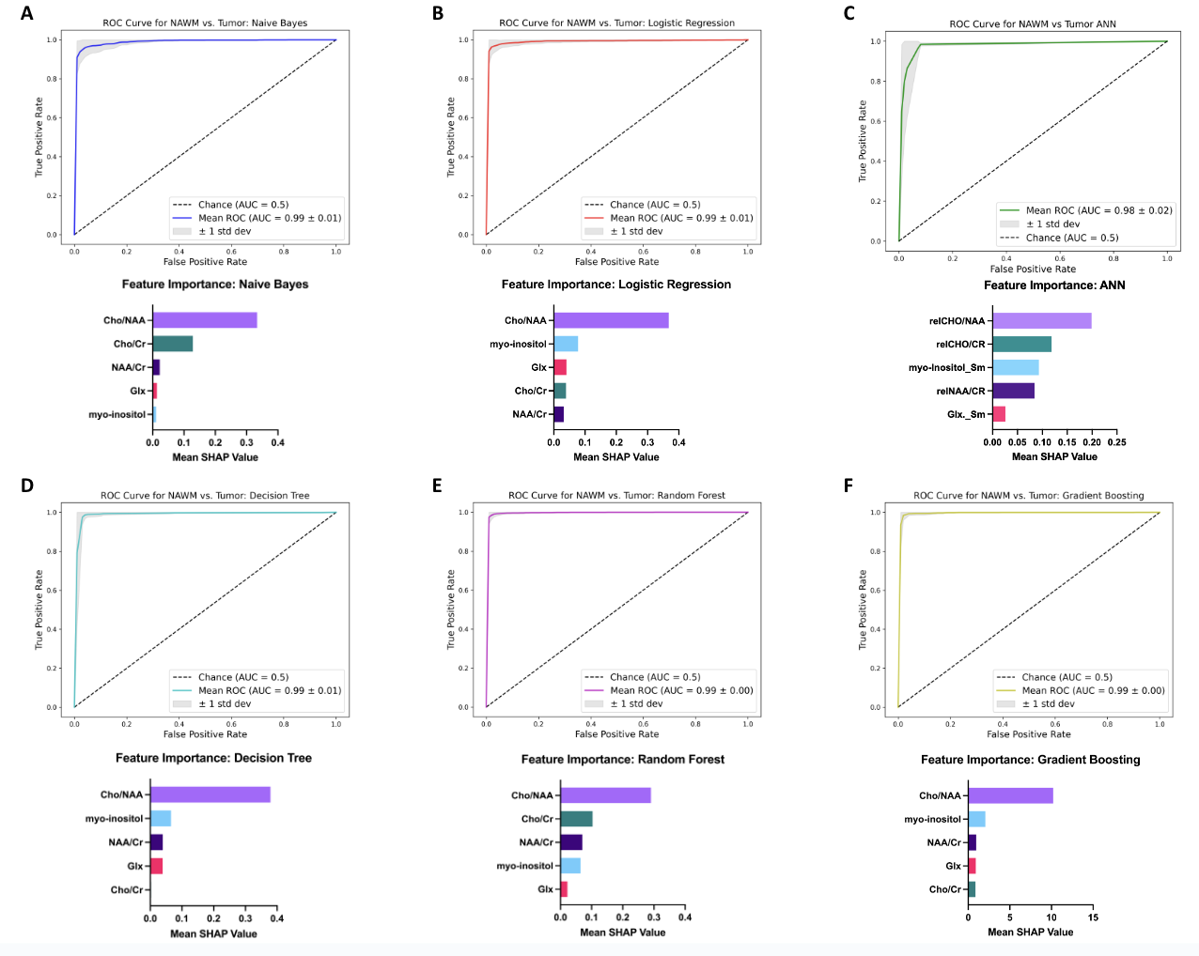
Supplemental Figure 5: NAWM vs. Tumor ROC plots and SHAP feature importance bar graphs.

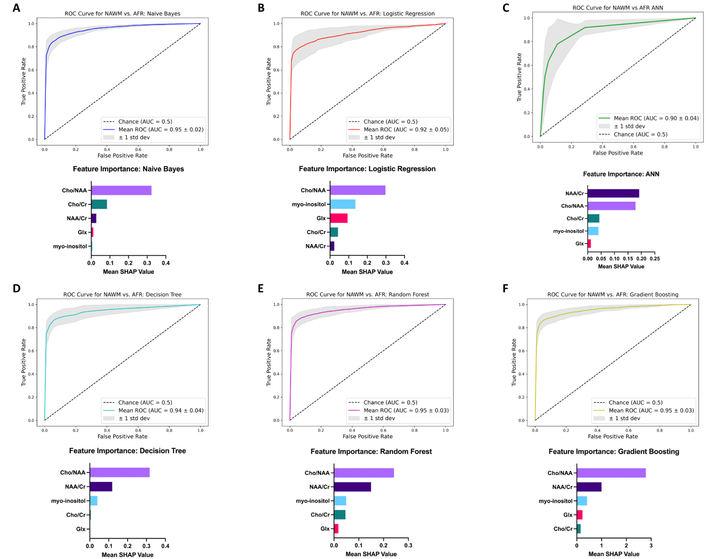
Supplemental Figure 6: NAWM vs. AFR ROC plots and SHAP feature importance bar graphs.

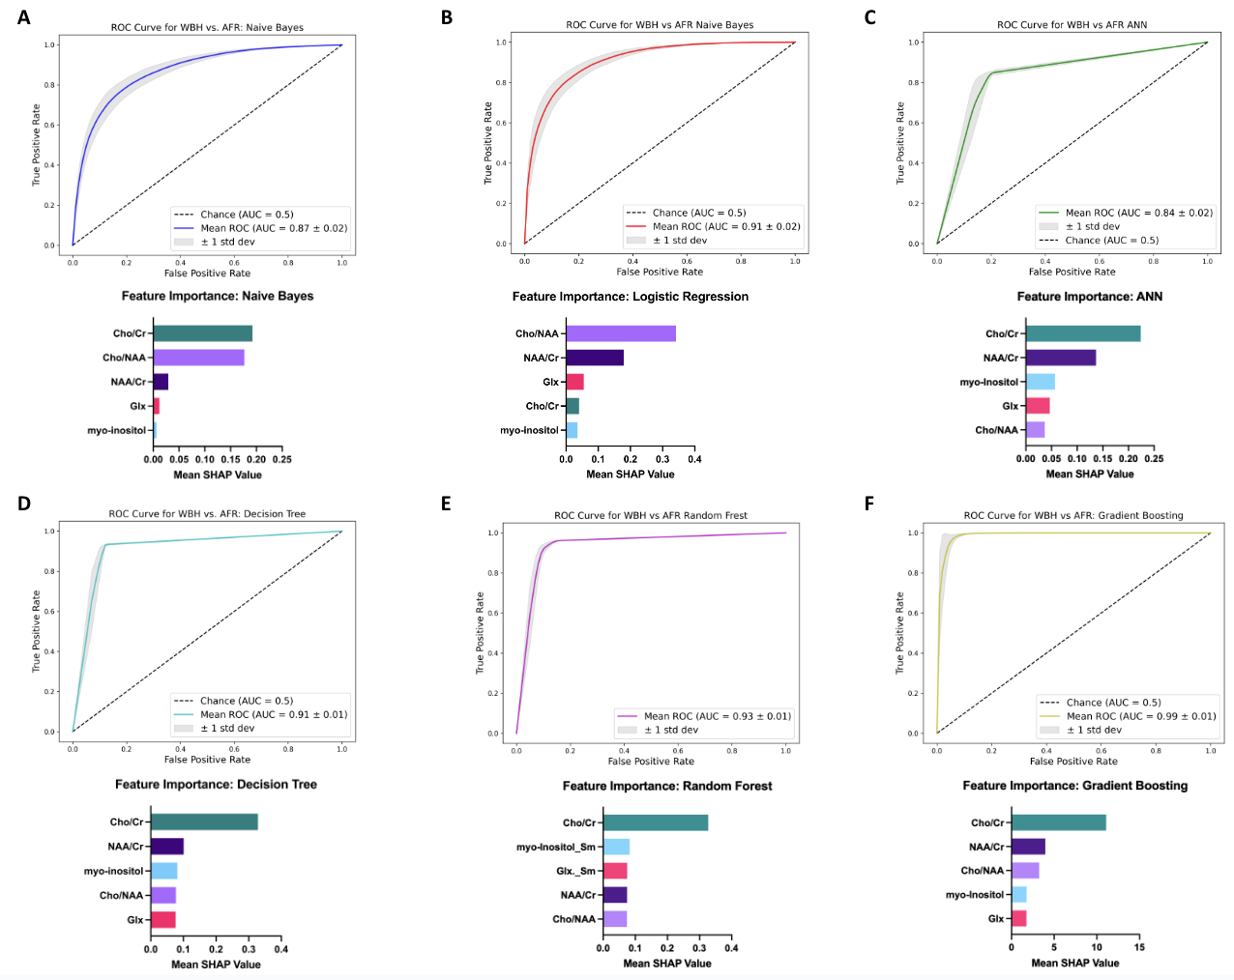
Supplemental Figure 7: WBH vs. AFR ROC plots and SHAP feature importance bar graphs.

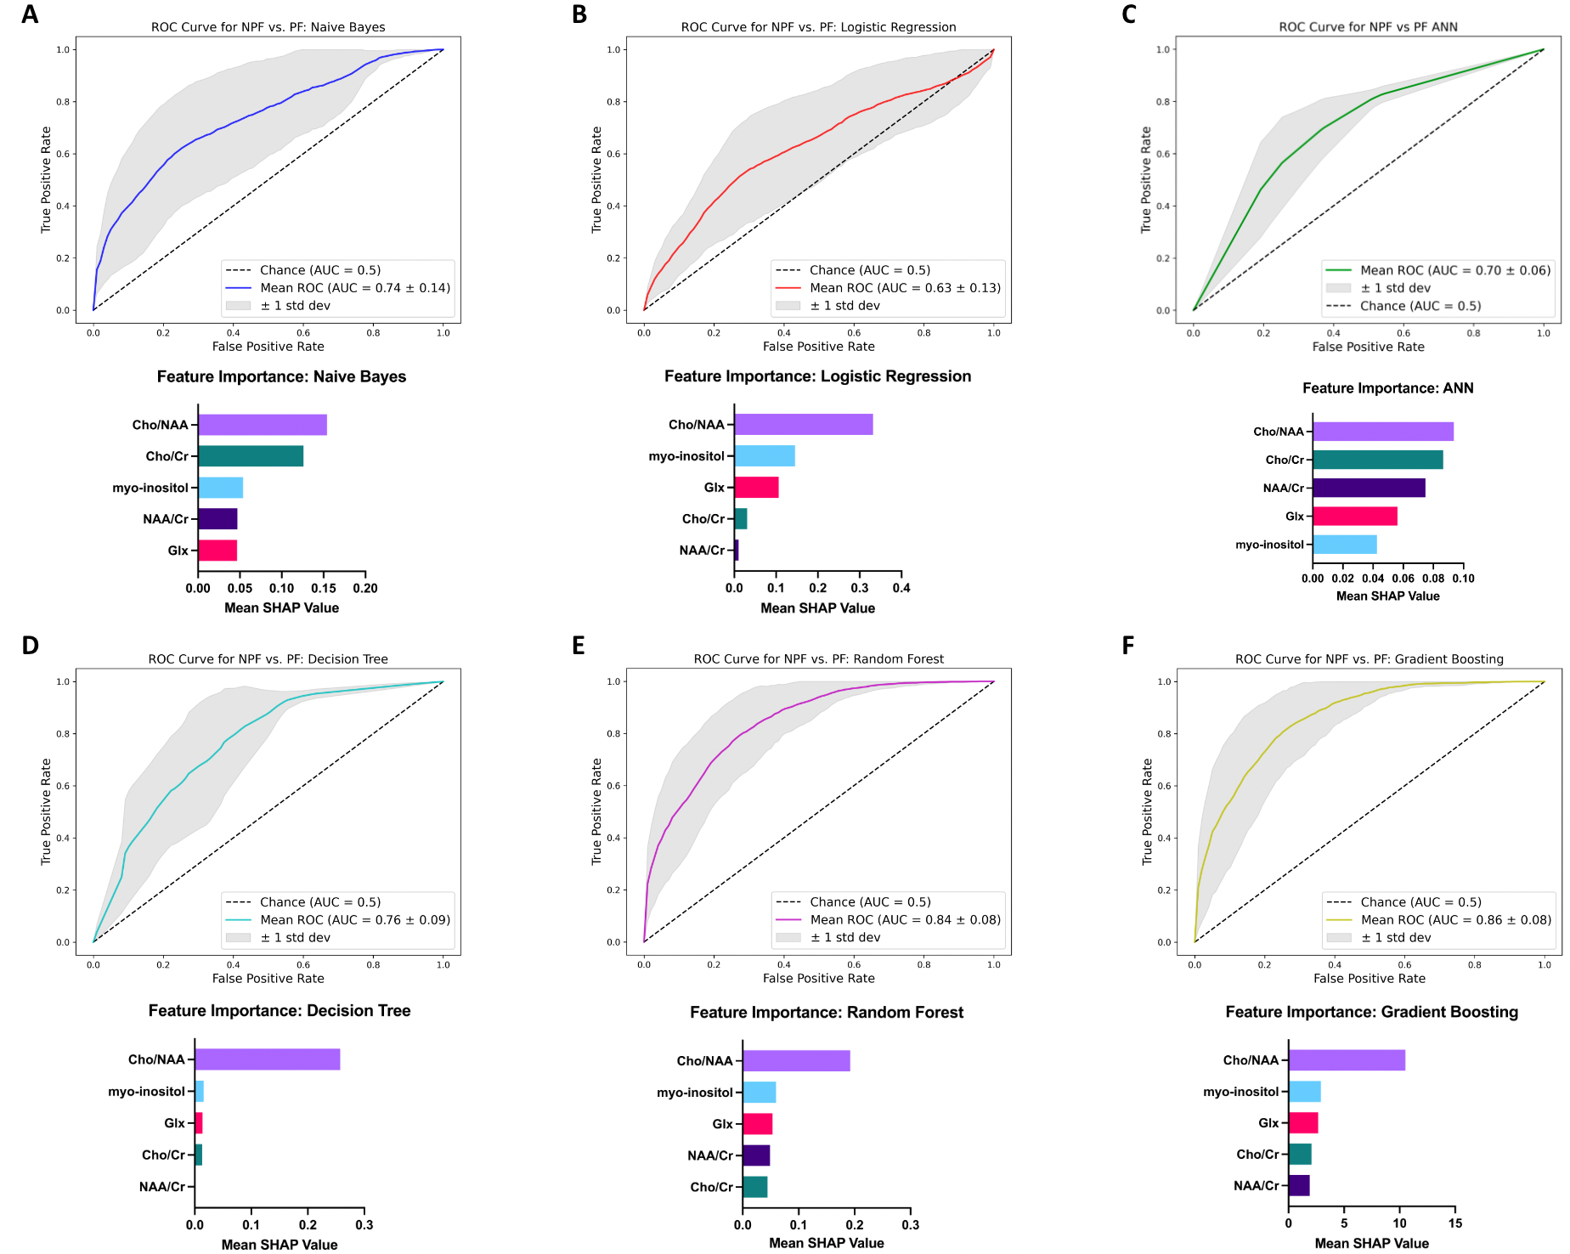
Supplemental Figure 8: NPF vs. PF ROC plots and SHAP feature importance bar graphs.

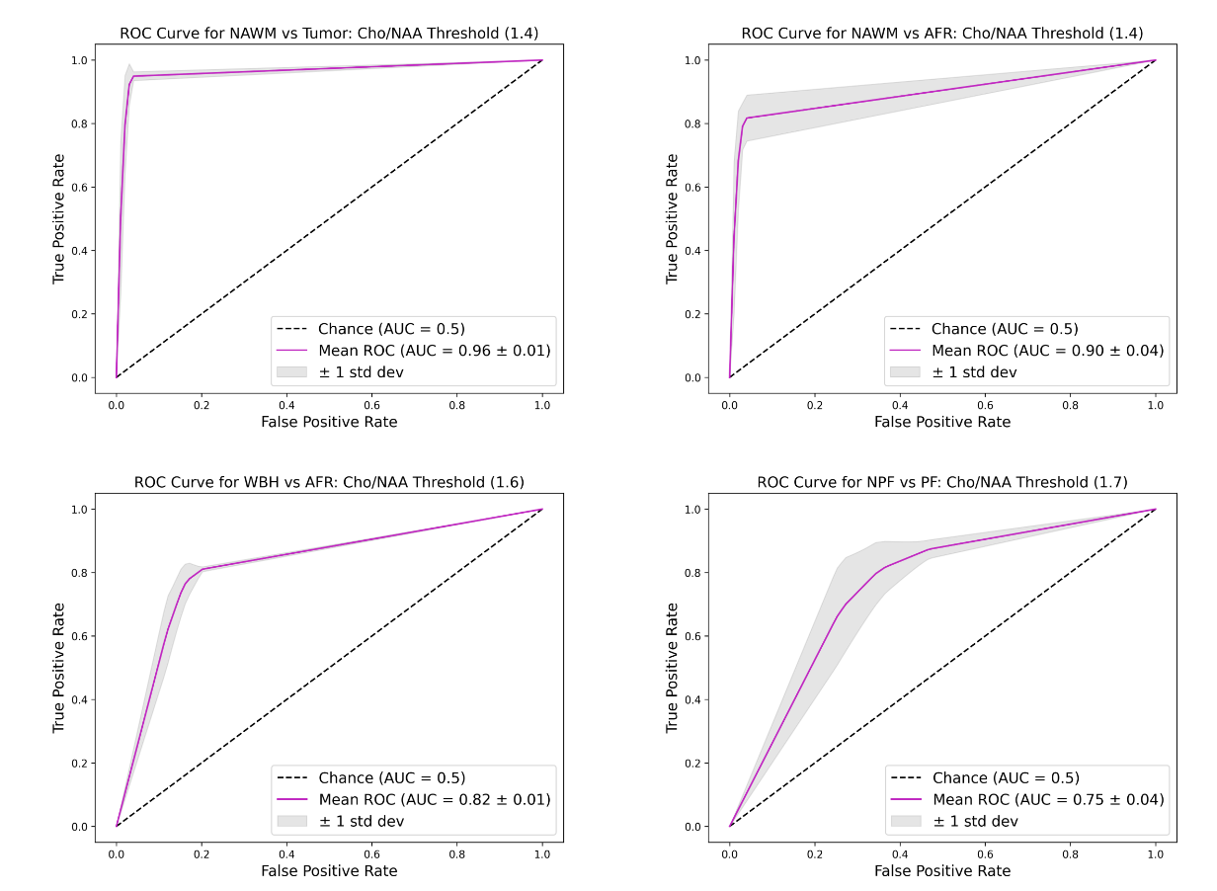
Supplemental Figure 9: Cho/NAA Threshold ROC plots with 5-fold cross-validation. Thresholds from 1.1 to 2.1 were tested with optimal mean AUC recorded. If peak mean AUC tied across groups, the threshold with the smallest standard deviation was selected. For NAWM vs AFR, a threshold value of 1.3 also produced a mean AUROC of 0.90 ± 0.04. For NPF vs PF, thresholds of 1.6 and 1.8 also produced the same mean AUROC of 0.75 ± 0.04.

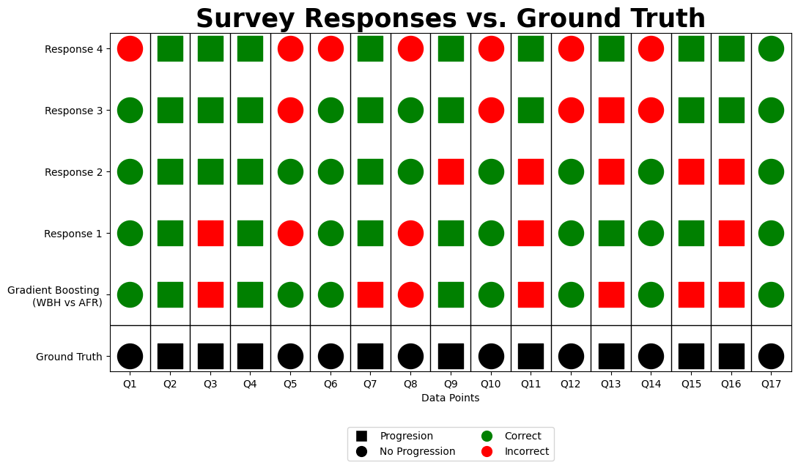
Supplemental Figure 10: Validation survey responses compared to Gradient Boosting (WBH vs AFR) and ground truth values. Cohen’s Kappa coefficient for the responses compared to the ground truth is 0.297, with the accuracy of the Gradient Boosting model of 70.6% for this subset of data.

Supplemental Methods 1

Imaging Protocol
MRI data was acquired using a 3 Tesla Siemens Skyra MRI Scanner with a 20-channel head/neck coil. WB-MRS data was acquired using a 3D echo planar spectroscopic imaging (EPSI) sequence.16,17 Imaging parameters: TR/TE/TI = 1550/17.6/198ms, excitation slab thickness = 140mm, FA = 710, FOV = 280x280x180mm, voxel resolution = 5.6x5.6x10, TA = 17min. Pre-contrast T1, T2 and FLAIR images and a post-contrast T1 image were also acquired.

WB-MRS data processing was done using the MIDAS. The metabolite maps were obtained using the FITT module and metabolite ratios were derived from these maps. The NAWM maps were derived from the T1 image segmentation white matter tissue maps from the contralateral side of the tumor. The FLAIR and enhancing ROIs were created by segmentation of the FLAIR image and subtraction of the pre-contrast T1 from the post-contrast T1 image, respectively. Metabolite data was extracted using automated spectral analysis from the MIDAS software for Cho, NAA, Cr, Glx, and myo-inositol. This data was pre-processed using a built-in quality map and linewidth filter between 2 and 12Hz.

Bone artifact around the temporal region has been shown to produce local magnetic field interference that decreases MR imaging quality²⁹, resulting in a MIDAS quality score below acceptable threshold. With multifocal lesions, the MIDAS ROI auto-segmentation capabilities struggled to classify concurrently enhancing lesions, thus precluding analysis of multifocal neoplasms.

Supplemental Methods 2

Unsupervised Cluster Analysis
Voxel clusters were found by scaling voxels across all groups and conducting hierarchical clustering of all voxels in R using the fastcluster package. The associated clustering function was passed into the R package pheatmap to visualize voxel clusters across all 5 metabolite groups. Cluster statistics were extracted and summarized to display overall trends and quantity of voxels in each cluster (Figure 4A).

Supplemental Methods 3

Hyperparameter Tuning
Hyperparameter tuning was performed using 10-fold cross validation randomized search with over 1000 iterations. This was implemented using the GridSearchCV and RandomizedSearchCV methods to achieve the best parameters with minimal error for each algorithm. The specific hyperparameters for each model are shown in detail in Supplementary Table 4.

Supplemental Methods 4

Feature Importance
Shapley Additive Explanation (SHAP) values were calculated to quantitatively interpret predictions and to determine feature importance. All SHAP values were computed using the shap package in Python.¹⁹

Model Performance
Model performance was evaluated primarily with an area under the receiver operating characteristic curve (AUC). Mean AUCs on the testing set with a 1 standard deviation were plotted following the same 5-fold cross validation used for model training. Multi-class AUC calculations used one-vs.-rest (OvR) methodology along with 5-fold cross validation, generating four values per model. Additional metrics such as the accuracy, precision, specificity, sensitivity, and F1-score were calculated on the testing set using the scikit-learn.metrics package in Python for binary models; these metrics were calculated from the confusion matrix OvR for multi-class models. All performance metrics are reported in Supplementary Tables 1-3.

