Systematic Review
Frequency of exposure to Toxoplasma gondii in COVID-19 patients. a systematic review and meta-analysis.
Darwin A. León-Figueroa ¹, Joshuan J. Barboza ², Abdelmonem Siddiq ³, Edwin Aguirre-Milachay ¹, Carlos Quispe-Vicuña ⁴, Ranjit Sah ^{5,6,7}, Mario J. Valladares-Garrido ^{8,9,} *, Suraj Adhikari ¹⁰, D. Katterine Bonilla-Aldana¹¹, Alex Ricardo-Martínez ¹², Jorge Guillermo Morales-Ramos ¹, Alfonso J. Rodriguez-Morales.^{13,14}
¹ Facultad de Medicina Humana, Universidad de San Martín de Porres, Chiclayo 15011, Peru; darwin_leon@usmp.pe (DALF); edwinh.aguirre@gmail.com (E.A.M.); jmoralesr1@usmp.pe (JGMR)
² Unidad de Revisiones Sistemáticas y Meta-análisis, Universidad San Ignacio de Loyola, Lima, Peru; jbarbozame@ucvvirtual.edu.pe
³ Faculty of Pharmacy, Mansoura University, Mansoura 35516, Egypt; Abdelmonemalsaid555@std.mans.edu.eg
⁴ Sociedad Científica de San Fernando, Lima, Perú; vicunas998@gmail.com
⁵ Department of Microbiology, Tribhuvan University Teaching Hospital, Institute of Medicine, Kathmandu 44600, Nepal; ranjitsah@iom.edu.np
⁶ Department of Microbiology, Dr. D. Y. Patil Medical College, Hospital and Research Centre, Dr. D. Y. Patil Vidyapeeth, Pune 411018, Maharashtra, India
⁷ Department of Public Health Dentistry, Dr. D.Y. Patil Dental College and Hospital, Dr. D.Y. Patil Vidyapeeth, Pune 411018, Maharashtra, India.
⁸ Universidad Continental, Lima 15046, Peru; mvalladares@continental.edu.pe
⁹ Oficina de Epidemiología, Hospital Regional Lambayeque, Chiclayo 14012, Peru
¹⁰ Manipal College of Medical Sciences, Pokhara, Nepal; adhikarisuraj012@gmail.com
¹¹ Research Unit, Universidad Continental, Huancayo 12000, Peru; dbonilla@continental.edu.pe
¹² Escuela de Medicina, Universidad Peruana de Ciencias Aplicadas, Lima 15023, Peru, 2000alex1004@gmail.com
¹³ Master of Clinical Epidemiology and Biostatistics, Universidad Cientifica del Sur, Lima 15067, Peru; arodriguezmo@cientifica.edu.pe
¹⁴ Gilbert and Rose-Marie Chagoury School of Medicine, Lebanese American University, Beirut 1102, Lebanon; alphonso.morales@lau.edu.lb

* Correspondence: E-mail: mvalladares@continental.edu.pe . Address: Chiclayo. El Bosque, Chiclayo, Peru. Tel.+51 944 655 396

Supplementary material

- Table S1: PRISMA Checklist (PRISMA 2020 Main Checklist and PRIMSA Abstract Checklist)
- Table S2: The adjusted search terms as per searched electronic databases.
- Table S3: Quality of the included studies.
- Table S4: Articles excluded after a thorough review of the complete text.
- Figure S1: The funnel plot illustrates the publication bias of the included studies on the frequency of T. gondii exposure by detection of IgG antibodies in patients with COVID-19.
- Figure S2. Country-based subgroup analysis of the frequency of Toxoplasma gondii exposure by IgG antibody detection in patients with COVID-19.

Table S1: PRISMA Checklist (PRISMA 2020 Main Checklist and PRISMA Abstract Checklist)

PRISMA 2020 Main Checklist

Topic | No. | Item | Location where item is reported
TITLE
Title | 1 | Identify the report as a systematic review. | 1
ABSTRACT
Abstract | 2 | See the PRISMA 2020 for Abstracts checklist
INTRODUCTION
Rationale | 3 | Describe the rationale for the review in the context of existing knowledge. | 3
Objectives | 4 | Provide an explicit statement of the objective(s) or question(s) the review addresses. | 3
METHODS
Eligibility criteria | 5 | Specify the inclusion and exclusion criteria for the review and how studies were grouped for the syntheses. | 3
Information sources | 6 | Specify all databases, registers, websites, organisations, reference lists and other sources searched or consulted to identify studies. Specify the date when each source was last searched or consulted. | 4
Search strategy | 7 | Present the full search strategies for all databases, registers and websites, including any filters and limits used. | 4
Selection process | 8 | Specify the methods used to decide whether a study met the inclusion criteria of the review, including how many reviewers screened each record and each report retrieved, whether they worked independently, and if applicable, details of automation tools used in the process. | 3-4
Data collection process | 9 | Specify the methods used to collect data from reports, including how many reviewers collected data from each report, whether they worked independently, any processes for obtaining or confirming data from study investigators, and if applicable, details of automation tools used in the process. | 4
Data items | 10a | List and define all outcomes for which data were sought. Specify whether all results that were compatible with each outcome domain in each study were sought (e.g. for all measures, time points, analyses), and if not, the methods used to decide which results to collect. | 4
 | 10b | List and define all other variables for which data were sought (e.g. participant and intervention characteristics, funding sources). Describe any assumptions made about any missing or unclear information. | 4
Study risk of bias assessment | 11 | Specify the methods used to assess risk of bias in the included studies, including details of the tool(s) used, how many reviewers assessed each study and whether they worked independently, and if applicable, details of automation tools used in the process. | 4
Effect measures | 12 | Specify for each outcome the effect measure(s) (e.g. risk ratio, mean difference) used in the synthesis or presentation of results. | 4
Synthesis methods | 13a | Describe the processes used to decide which studies were eligible for each synthesis (e.g. tabulating the study intervention characteristics and comparing against the planned groups for each synthesis (item 5)). | 4
 | 13b | Describe any methods required to prepare the data for presentation or synthesis, such as handling of missing summary statistics, or data conversions. | 4
 | 13c | Describe any methods used to tabulate or visually display results of individual studies and syntheses. | 4
 | 13d | Describe any methods used to synthesize results and provide a rationale for the choice(s). If meta-analysis was performed, describe the model(s), method(s) to identify the presence and extent of statistical heterogeneity, and software package(s) used. | 4
 | 13e | Describe any methods used to explore possible causes of heterogeneity among study results (e.g. subgroup analysis, meta-regression). | 4
 | 13f | Describe any sensitivity analyses conducted to assess robustness of the synthesized results. | 4
Reporting bias assessment | 14 | Describe any methods used to assess risk of bias due to missing results in a synthesis (arising from reporting biases). | 4
Certainty assessment | 15 | Describe any methods used to assess certainty (or confidence) in the body of evidence for an outcome. | 4
RESULTS
Study selection | 16a | Describe the results of the search and selection process, from the number of records identified in the search to the number of studies included in the review, ideally using a flow diagram. | 5
 | 16b | Cite studies that might appear to meet the inclusion criteria, but which were excluded, and explain why they were excluded. | 5
Study characteristics | 17 | Cite each included study and present its characteristics. | 5
Risk of bias in studies | 18 | Present assessments of risk of bias for each included study. | 5
Results of individual studies | 19 | For all outcomes, present, for each study: (a) summary statistics for each group (where appropriate) and (b) an effect estimate and its precision (e.g. confidence/credible interval), ideally using structured tables or plots. | 5
Results of syntheses | 20a | For each synthesis, briefly summarise the characteristics and risk of bias among contributing studies. | 5
 | 20b | Present results of all statistical syntheses conducted. If meta-analysis was done, present for each the summary estimate and its precision (e.g. confidence/credible interval) and measures of statistical heterogeneity. If comparing groups, describe the direction of the effect. | 5
 | 20c | Present results of all investigations of possible causes of heterogeneity among study results. | 5
 | 20d | Present results of all sensitivity analyses conducted to assess the robustness of the synthesized results. | 5
Reporting biases | 21 | Present assessments of risk of bias due to missing results (arising from reporting biases) for each synthesis assessed. | 5
Certainty of evidence | 22 | Present assessments of certainty (or confidence) in the body of evidence for each outcome assessed. | 5
DISCUSSION
Discussion | 23a | Provide a general interpretation of the results in the context of other evidence. | 5-6
 | 23b | Discuss any limitations of the evidence included in the review. | 6
 | 23c | Discuss any limitations of the review processes used. | 6
 | 23d | Discuss implications of the results for practice, policy, and future research. | 6
OTHER INFORMATION
Registration and protocol | 24a | Provide registration information for the review, including register name and registration number, or state that the review was not registered. | 3
 | 24b | Indicate where the review protocol can be accessed, or state that a protocol was not prepared. | 3
 | 24c | Describe and explain any amendments to information provided at registration or in the protocol. | 3
Support | 25 | Describe sources of financial or non-financial support for the review, and the role of the funders or sponsors in the review. | 7
Competing interests | 26 | Declare any competing interests of review authors. | 7
Availability of data, code and other materials | 27 | Report which of the following are publicly available and where they can be found: template data collection forms; data extracted from included studies; data used for all analyses; analytic code; any other materials used in the review. | 7

PRISMA Abstract Checklist

Topic | No. | Item | Reported?
TITLE
Title | 1 | Identify the report as a systematic review. | Yes
BACKGROUND
Objectives | 2 | Provide an explicit statement of the main objective(s) or question(s) the review addresses. | Yes
METHODS
Eligibility criteria | 3 | Specify the inclusion and exclusion criteria for the review. | Yes
Information sources | 4 | Specify the information sources (e.g. databases, registers) used to identify studies and the date when each was last searched. | Yes
Risk of bias | 5 | Specify the methods used to assess risk of bias in the included studies. | Yes
Synthesis of results | 6 | Specify the methods used to present and synthesize results. | Yes
RESULTS
Included studies | 7 | Give the total number of included studies and participants and summarise relevant characteristics of studies. | Yes
Synthesis of results | 8 | Present results for main outcomes, preferably indicating the number of included studies and participants for each. If meta-analysis was done, report the summary estimate and confidence/credible interval. If comparing groups, indicate the direction of the effect (i.e. which group is favoured). | Yes
DISCUSSION
Limitations of evidence | 9 | Provide a brief summary of the limitations of the evidence included in the review (e.g. study risk of bias, inconsistency and imprecision). | Yes
Interpretation | 10 | Provide a general interpretation of the results and important implications. | Yes
OTHER
Funding | 11 | Specify the primary source of funding for the review. | Yes
Registration | 12 | Provide the register name and registration number. | Yes

From: Page MJ, McKenzie JE, Bossuyt PM, Boutron I, Hoffmann TC, Mulrow CD, et al. The PRISMA 2020 statement: an updated guideline for reporting systematic reviews. MetaArXiv. 2020, September 14. DOI: 10.31222/osf.io/v7gm2. For more information, visit: www.prisma-statement.org

Table S2: The adjusted search terms as per searched electronic databases.
PubMed
 | #1 | (Toxoplasma OR Toxoplasmas OR “Toxoplasma gondii” OR “Toxoplasma gondius” OR “gondius, Toxoplasma”) | 23,768
 | #2 | (“COVID 19” OR “2019-nCoV Infection” OR “2019 nCoV Infection” OR “2019-nCoV Infections” OR “Infection, 2019-nCoV” OR “SARS-CoV-2 Infection” OR “Infection, SARS-CoV-2” OR “SARS CoV 2 Infection” OR “SARS-CoV-2 Infections” OR “2019 Novel Coronavirus Disease” OR “2019 Novel Coronavirus Infection” OR “COVID-19 Virus Infection” OR “COVID 19 Virus Infection” OR “COVID-19 Virus Infections” OR “Infection, COVID-19 Virus” OR “Virus Infection, COVID-19” OR “COVID19” OR “Coronavirus Disease 2019” OR “Disease 2019, Coronavirus” OR “Coronavirus Disease-19” OR “Coronavirus Disease 19” OR “Severe Acute Respiratory Syndrome Coronavirus 2 Infection” OR “COVID-19 Virus Disease” OR “COVID 19 Virus Disease” OR “COVID-19 Virus Diseases” OR “Disease, COVID-19 Virus” OR “Virus Disease, COVID-19” OR “SARS Coronavirus 2 Infection” OR “2019-nCoV Disease” OR “2019 nCoV Disease” OR “2019-nCoV Diseases” OR “Disease, 2019-nCoV” OR “COVID-19 Pandemic” OR “COVID 19 Pandemic” OR “Pandemic, COVID-19” OR “COVID-19 Pandemics”) | 399,881
 | #3 | #1 AND #2 | 54
Scopus
 | #1 | TITLE-ABS-KEY (Toxoplasma OR Toxoplasmas OR “Toxoplasma gondii” OR “Toxoplasma gondius” OR “gondius, Toxoplasma”) | 31,174
 | #2 | TITLE-ABS-KEY (“COVID 19” OR “2019-nCoV Infection” OR “2019 nCoV Infection” OR “2019-nCoV Infections” OR “SARS-CoV-2 Infection” OR “Infection, SARS-CoV-2” OR “SARS CoV 2 Infection” OR “SARS-CoV-2 Infections” OR “2019 Novel Coronavirus Disease” OR “2019 Novel Coronavirus Infection” OR “COVID-19 Virus Infection” OR “COVID 19 Virus Infection” OR “COVID-19 Virus Infections” OR “COVID19” OR “Coronavirus Disease 2019” OR “Coronavirus Disease-19” OR “Coronavirus Disease 19” OR “Severe Acute Respiratory Syndrome Coronavirus 2 Infection” OR “COVID-19 Virus Disease” OR “COVID 19 Virus Disease” OR “COVID-19 Virus Diseases” OR “Disease, COVID-19 Virus” OR “Virus Disease, COVID-19” OR “SARS Coronavirus 2 Infection” OR “2019-nCoV Disease” OR “2019 nCoV Disease” OR “2019-nCoV Diseases” OR “COVID-19 Pandemic” OR “COVID 19 Pandemic” OR “COVID-19 Pandemics”) | 612,632
 | #3 | #1 AND #2 | 122
Embase
 | #1 | 'toxoplasma'/exp OR 'toxoplasma' | 32,330
 | #2 | 'covid 19'/exp OR 'covid-19'/exp | 356,353
 | #3 | #1 AND #2 | 128
Web of Science
 | #1 | ALL=(Toxoplasma OR Toxoplasmas OR “Toxoplasma gondii” OR “Toxoplasma gondius” OR “gondius, Toxoplasma”) | 11,035
 | #2 | ALL=(“COVID 19” OR “2019-nCoV Infection” OR “2019 nCoV Infection” OR “2019-nCoV Infections” OR “Infection, 2019-nCoV” OR “SARS-CoV-2 Infection” OR “Infection, SARS-CoV-2” OR “SARS CoV 2 Infection” OR “SARS-CoV-2 Infections” OR “2019 Novel Coronavirus Disease” OR “2019 Novel Coronavirus Infection” OR “COVID-19 Virus Infection” OR “COVID 19 Virus Infection” OR “COVID-19 Virus Infections” OR “Infection, COVID-19 Virus” OR “Virus Infection, COVID-19” OR “COVID19” OR “Coronavirus Disease 2019” OR “Disease 2019, Coronavirus” OR “Coronavirus Disease-19” OR “Coronavirus Disease 19” OR “Severe Acute Respiratory Syndrome Coronavirus 2 Infection” OR “COVID-19 Virus Disease” OR “COVID 19 Virus Disease” OR “COVID-19 Virus Diseases” OR “Disease, COVID-19 Virus” OR “Virus Disease, COVID-19” OR “SARS Coronavirus 2 Infection” OR “2019-nCoV Disease” OR “2019 nCoV Disease” OR “2019-nCoV Diseases” OR “Disease, 2019-nCoV” OR “COVID-19 Pandemic” OR “COVID 19 Pandemic” OR “Pandemic, COVID-19” OR “COVID-19 Pandemics”) | 468,010
 | #3 | #1 AND #2 | 98
ScienceDirect
 | #1 | (Toxoplasma OR Toxoplasmas OR “Toxoplasma gondii” OR “Toxoplasma gondius” OR “gondius, Toxoplasma”) | 35,129
 | #2 | (“COVID 19” OR “2019-nCoV Infection” OR “SARS-CoV-2 Infection” OR “COVID 19 Virus Disease” OR “SARS Coronavirus 2 Infection” OR “2019-nCoV Disease” OR “COVID-19 Pandemic”) | 205,739
 | #3 | #1 AND #2 | 704
Google Scholar
 | #1 | allintitle: Toxoplasma | 59,600
 | #2 | allintitle: COVID-19 | 828,000
 | #3 | #1 AND #2 | 4,830
Total |  | PubMed (54), Scopus (122), Embase (128), Web of Science (98), ScienceDirect (704), and Google Scholar (4,830) | 5,936

Table S3: Quality of the included studies

Authors | Year | Eligibility criteria | Study subjects and the setting | Exposure measured in a valid and reliable way 'gold standard' | A specified diagnosis or definition | Confounding factors | Dealing with confounding factors | Outcomes measured in a valid and reliable way | Appropriate statistical analysis | Scores (8) | Quality (high, moderate, low)
Abdel-Hamed EF, et al. (1) | 2021 | Yes | Yes | Yes | Yes | Yes | NA | Yes | Yes | 6 | Moderate
Sharaf-El-Deen SA, et al. (2) | 2021 | Yes | Yes | Yes | Yes | Yes | NA | Yes | Yes | 6 | Moderate
Ghaffari S, et al. (3) | 2021 | Yes | Yes | Yes | Yes | Yes | NA | Yes | Yes | 6 | Moderate
Halawi M, et al. (4) | 2021 | Yes | Yes | Yes | Yes | Yes | NA | Yes | Yes | 6 | Moderate
Geraili A, et al. (5) | 2022 | Yes | Yes | Yes | Yes | Yes | NA | Yes | Yes | 6 | Moderate
Montazeri M, et al. (6) | 2022 | Yes | Yes | Yes | Yes | Yes | NA | Yes | Yes | 6 | Moderate
Galván-Ramírez MdlL, et al. (7) | 2023 | Yes | Yes | Yes | Yes | Yes | NA | Yes | Yes | 6 | Moderate
Habib S, et al. (8) | 2023 | Yes | Yes | Yes | Yes | Yes | NA | Yes | Yes | 6 | Moderate
Mahmoudi MR, et al. (9) | 2023 | Yes | Yes | Yes | Yes | Yes | NA | Yes | Yes | 6 | Moderate
Gouda MA, et al. (10) | 2023 | Yes | Yes | Yes | Yes | Yes | NA | Yes | Yes | 6 | Moderate
Gouda MA, et al. (11) | 2023 | Yes | Yes | Yes | Yes | Yes | NA | Yes | Yes | 6 | Moderate
Hasanzadeh M, et al. (12) | 2024 | Yes | Yes | Yes | Yes | Yes | NA | Yes | Yes | 6 | Moderate
Abdeltawab MSA, et al. (13) | 2024 | Yes | Yes | Yes | Yes | Yes | NA | Yes | Yes | 6 | Moderate
NA: Not assessed

Table S4: Articles excluded after a thorough review of the complete text.

Authors | Title | Year | Exclusion criteria
Jaber SM, et al. (14) | Molecular and immunological detection of Toxoplasma gondii and Cytomegalovirus in Aborted Women with Covid -19 | 2023 | Incorrect population.  Patients with toxoplasmosis are tested for the presence of COVID-19.
Dao VT, et al. (15) | First Description of Congenital Toxoplasmosis after Maternal Coinfection with Toxoplasma Gondii and Severe Acute Respiratory Syndrome Coronavirus 2: A Case Report | 2023 | Incorrect study design  Case Report
Roe K. (16) | SARS-CoV-2 and Toxoplasma gondii shared symptoms suggest muscle cells and neurons are their chronic infection reservoirs | 2023 | Incorrect study design  Comment
Ali MS, et al. (17) | Serum levels of C-reactive protein and ferritin in COVID-19 patients infected with Toxoplasma gondii | 2022 | The full version of the article could not be obtained, either through the journal or by attempting to contact the authors.
Hébert M, et al. (18) | Recurrent and De Novo Toxoplasmosis Retinochoroiditis following Coronavirus Disease 2019 Infection or Vaccination | 2022 | Incorrect study design  Evaluation of cases and reports of toxoplasmosis was conducted after infection or vaccination against COVID-19.
Erol MK, et al. (19) | Treatment of a full-thickness macular hole and retinal detachment secondary to toxoplasma chorioretinitis that developed shortly after COVID-19: A case report | 2022 | Incorrect study design  Evaluation of cases and reports of toxoplasmosis was conducted after infection against COVID-19.
Zhang R, et al. (20) | Hijacking of host mitochondria by Toxoplasma gondii and SARS-CoV-2 | 2022 | Incorrect study design  Comment
Roe K. (21) | The link between Toxoplasma gondii infections and higher mortality in COVID-19 patients having schizophrenia | 2022 | Incorrect study design  Meta-analysis
Roe K. (22) | The Symptoms and Clinical Manifestations Observed in COVID-19 Patients/Long COVID-19 Symptoms that Parallel Toxoplasma gondii Infections | 2021 | Incorrect study design  Review
Flegr J, et al. (23) | Toxoplasmosis is a risk factor for acquiring SARS-CoV-2 infection and a severe course of COVID-19 in the Czech and Slovak population: a preregistered exploratory internet cross-sectional study | 2021 | Incorrect population.  Patients with toxoplasmosis are tested for the presence of COVID-19.
Roe K. (24) | The role of polyspecific T-cell exhaustion in severe outcomes for COVID-19 patients having latent pathogen infections such as Toxoplasmagondii | 2021 | Incorrect study design  Review
Jankowiak Ł, et al. (25) | A negative covariation between toxoplasmosis and CoVID-19 with alternative interpretations | 2020 | Incorrect population  Patients with toxoplasmosis and COVID-19 are not specified.

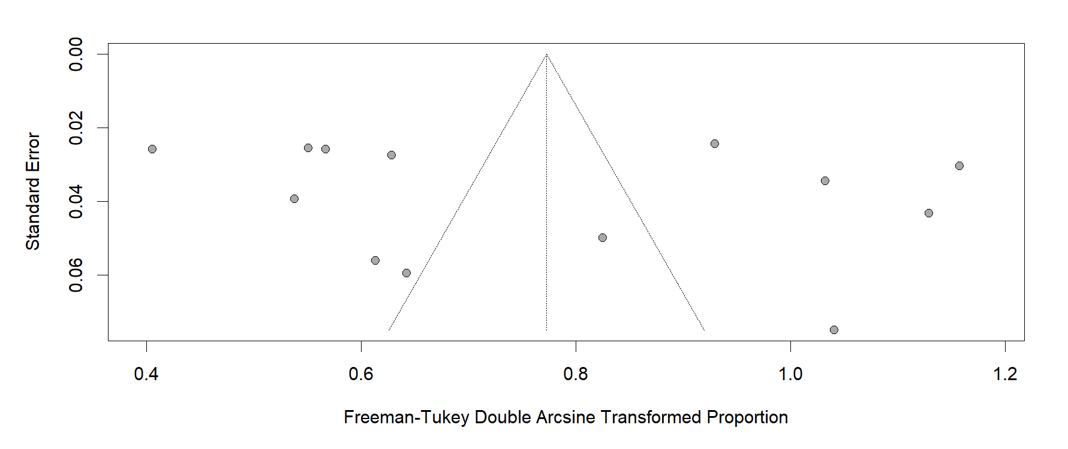

Figure S1: The funnel plot illustrates the publication bias of the included studies on the frequency of T. gondii exposure by detection of IgG antibodies in patients with COVID-19.

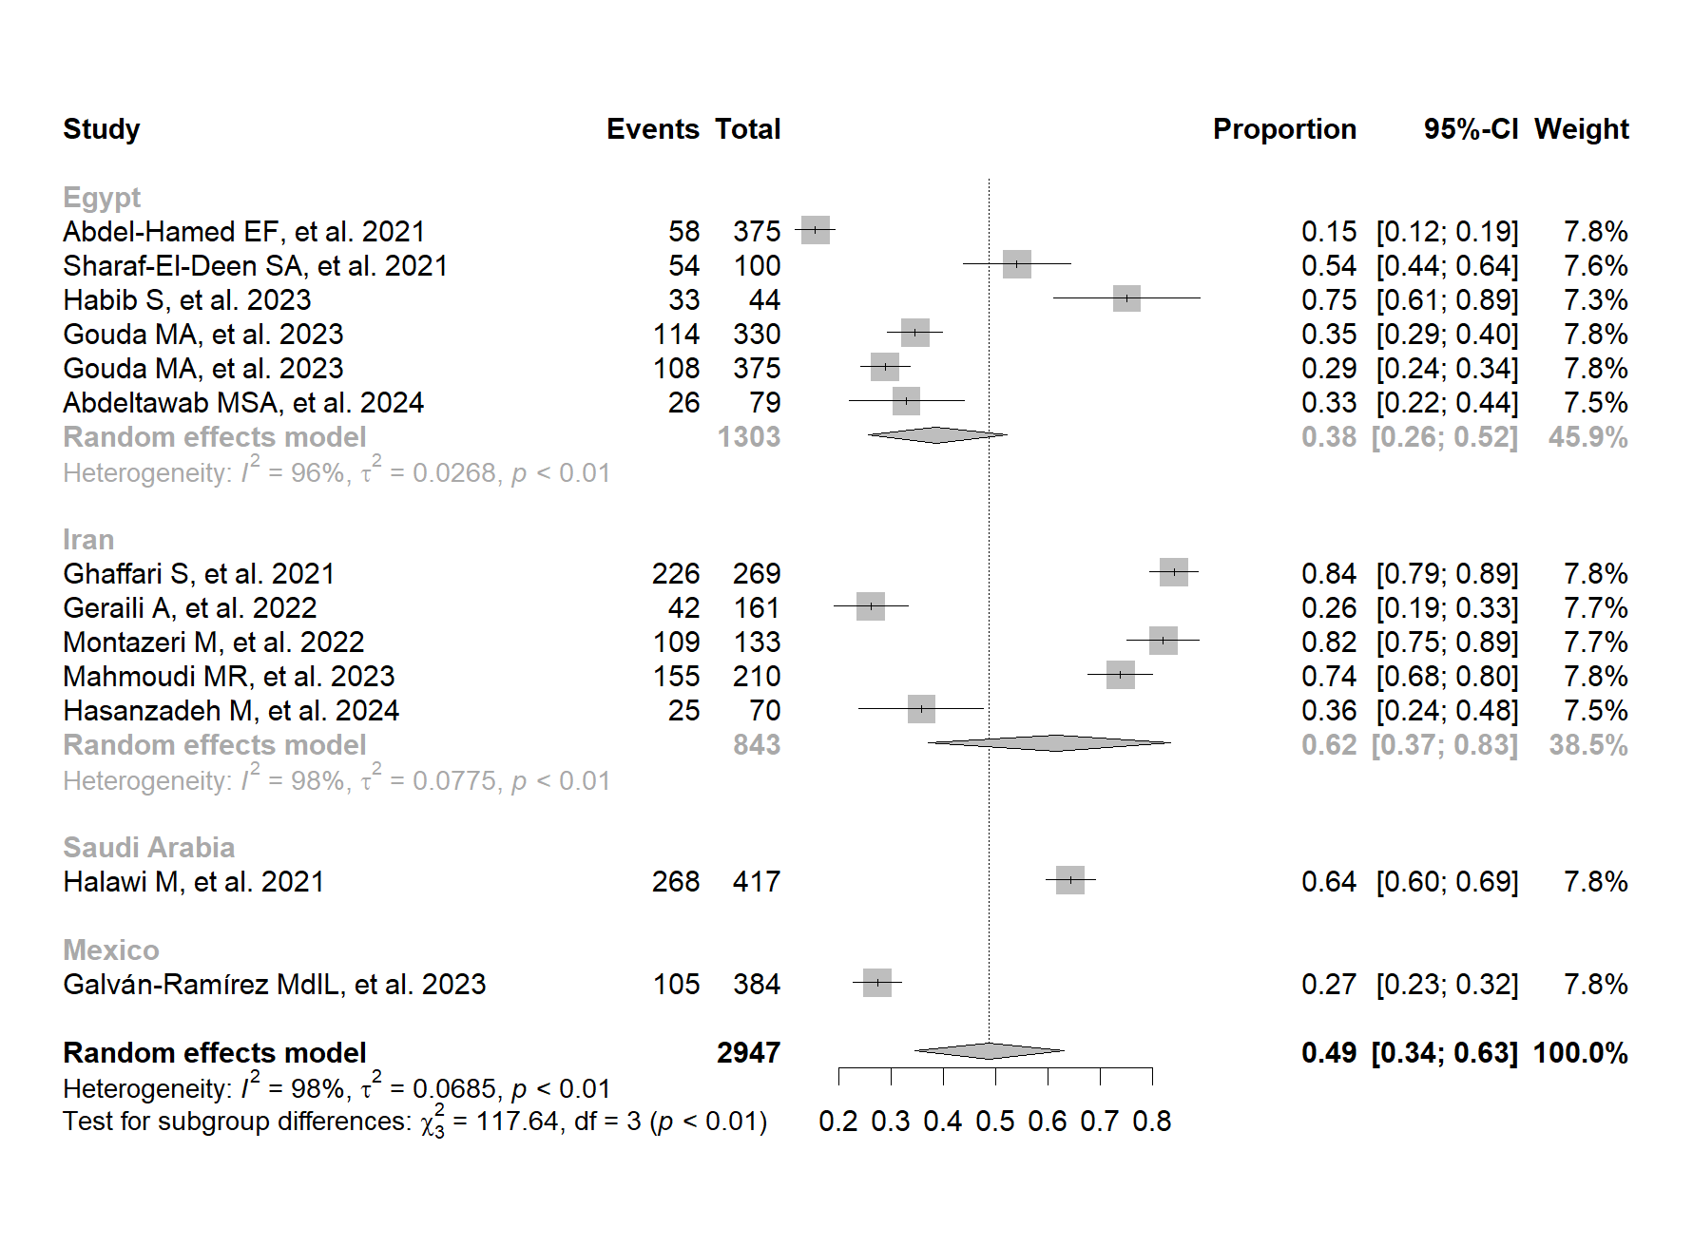

Figure S2. Country-based subgroup analysis of the frequency of T. gondii exposure by IgG antibody detection in patients with COVID-19.

Bibliographic references

1. Abdel-Hamed EF, Ibrahim MN, Mostafa NE, Moawad HSF, Elgammal NE, Darwiesh EM, et al. Role of interferon gamma in SARS-CoV-2-positive patients with parasitic infections. Gut Pathog. 4 de mayo de 2021;13(1):29.
2. Sharaf-El-Deen SA. Toxoplasma gondii as a possible risk factor for COVID-19 severity: a case-control study. Egypt J Med Microbiol. 4 de abril de 2021;30(2):125-32.
3. Ghaffari S, Kalantari N, Gorgani-Firouzjaee T, Bayani M, Jalali F, Daroonkola MA. Is COVID-19 associated with latent toxoplasmosis? Environ Sci Pollut Res Int. diciembre de 2021;28(47):67886-90.
4. Halawi M, Al-Hazmi A, Aljuaid A, Allahyani M, Abdulaziz O, A Almalki A, et al. Seroprevalence of Toxoplasma gondii, Rubella, Group A Streptococcus, CMV and HSV-1 in COVID-19 Patients with Vitamin D Deficiency. Pak J Biol Sci PJBS. enero de 2021;24(11):1169-74.
5. Geraili A, Badirzadeh A, Sadeghi M, Mousavi SM, Mousavi P, Shahmoradi Z, et al. Toxoplasmosis and symptoms severity in patients with COVID-19 in referral centers in Northern Iran. J Parasit Dis Off Organ Indian Soc Parasitol. 11 de diciembre de 2022;47(1):1-7.
6. Montazeri M, Nakhaei M, Fakhar M, Pazoki H, Pagheh AS, Nazar E, et al. Exploring the Association Between Latent Toxoplasma gondii Infection and COVID-19 in Hospitalized Patients: First Registry-Based Study. Acta Parasitol. septiembre de 2022;67(3):1172-9.
7. Galván-Ramírez M de la L, Salas-Lais AG, Muñoz-Medina JE, Fernandes-Matano L, Pérez LRR, Franco de León K. Association of Toxoplasmosis and COVID-19 in a Mexican Population. Microorganisms. junio de 2023;11(6):1441.
8. Habib S, Hamza E, El-Gamal R, Nosser NA, Aboukamar WA, Abdelsalam S, et al. Clinical and Immunological Impacts of Latent Toxoplasmosis on COVID-19 Patients. Cureus. septiembre de 2023;15(9):e45989.
9. Mahmoudi MR, Saadat F, Yaghubi Kalurazi T, Ali Verdiloo F, Karanis P. Latent toxoplasmosis in COVID-19 patients and link with higher mortality in COVID-19 male patients. Microb Pathog. 21 de octubre de 2023;185:106402.
10. Gouda MA, AboShabaan HS, Abdelgawad AS, Abdel Wahed AS, A Abd El-Razik K, Elsaadawy Y, et al. Association between breakthrough infection with COVID-19 and Toxoplasma gondii: a cross-sectional study. Sci Rep. 17 de octubre de 2023;13(1):17636.
11. Gouda MA, Aboshabaan HS, Abdelgawad AS, Wahed ASA, Ibrahim AF. TOXOPLASMOSIS IN VACCINATED COVID-19 PATIENTS. J Egypt Soc Parasitol. 1 de agosto de 2023;53(2):381-6.
12. Hasanzadeh M, Ahmadpour E, Mahami-Oskouei M, Musavi S, Parsaei M, Sarafraz N, et al. Genetic diversity and seroprevalence of Toxoplasma gondii in COVID‑19 patients; a first case-control study in Iran. BMC Infect Dis. 3 de enero de 2024;24(1):42.
13. Abdeltawab MSA, Fateen M, Saad El-Din S, Elmessiery RM, Mohammady Mohamed O, Marzouk Sadek K, et al. Effect of SARS-CoV-2 and Toxoplasma gondii co-infection on IFN-γ and TNF-α expression and its impact on disease severity. Cytokine. 17 de febrero de 2024;177:156545.
14. Jaber M shaker, Shubber HWK, Mohammed GJ. Molecular and immunological detection of Toxoplasma gondii and Cytomegalovirus in Aborted Women with Covid -19. J Surv Fish Sci. 13 de abril de 2023;10(3S):4383-402.
15. Dao VTV, Anagnostou A, Schlösser R, Rochwalsky U, Groß U, Hoehl S, et al. First description of congenital toxoplasmosis after maternal coinfection with Toxoplasma gondii and severe acute respiratory syndrome coronavirus 2: a case report. J Med Case Reports. 4 de abril de 2023;17(1):121.
16. Roe K. SARS-CoV-2 and Toxoplasma gondii shared symptoms suggest muscle cells and neurons are their chronic infection reservoirs. Hum Cell. enero de 2023;36(1):483-5.
17. Ali MS, Saheb EJ. Serum levels of C-reactive protein and ferritin in COVID-19 patients infected with Toxoplasma gondii. Ann Parasitol. 2022;68(1):47-54.
18. Hébert M, Bouhout S, Vadboncoeur J, Aubin MJ. Recurrent and De Novo Toxoplasmosis Retinochoroiditis following Coronavirus Disease 2019 Infection or Vaccination. Vaccines. 10 de octubre de 2022;10(10):1692.
19. Erol MK, Bozdogan YC, Suren E, Gedik B. Treatment of a full-thickness macular hole and retinal detachment secondary to toxoplasma chorioretinitis that developed shortly after COVID-19: A case report. J Fr Ophtalmol. abril de 2022;45(4):446-51.
20. Zhang R, Chen J, Wang D, Fu ZQ. Hijacking of host mitochondria by Toxoplasma gondii and SARS-CoV-2. Trends Parasitol. abril de 2022;38(4):269-71.
21. Roe K. The link between Toxoplasma gondii infections and higher mortality in COVID-19 patients having schizophrenia. Eur Arch Psychiatry Clin Neurosci. febrero de 2022;272(1):167-8.
22. Roe K. The Symptoms and Clinical Manifestations Observed in COVID-19 Patients/Long COVID-19 Symptoms that Parallel Toxoplasma gondii Infections. J Neuroimmune Pharmacol. 1 de septiembre de 2021;16(3):513-6.
23. Flegr J. Toxoplasmosis is a risk factor for acquiring SARS-CoV-2 infection and a severe course of COVID-19 in the Czech and Slovak population: a preregistered exploratory internet cross-sectional study. Parasit Vectors. 28 de septiembre de 2021;14(1):508.
24. Roe K. The role of polyspecific T-cell exhaustion in severe outcomes for COVID-19 patients having latent pathogen infections such as Toxoplasmagondii. Microb Pathog. diciembre de 2021;161(Pt B):105299.
25. Jankowiak Ł, Rozsa L, Tryjanowski P, Møller AP. A negative covariation between toxoplasmosis and CoVID-19 with alternative interpretations. Sci Rep. 27 de julio de 2020;10(1):12512.

