Supplementary material “Differences in clinical outcomes of bloodstream infections caused by Klebsiella aerogenes, Klebsiella pneumoniae and Enterobacter cloacae: a multicenter cohort study”

Figure 2 – Directed acyclic diagram of potential confounders, effect modifiers and other independent variables in the association between K. aerogenes, K. pneumoniae or E. cloacae BSI and clinical outcome (death or recurrence).
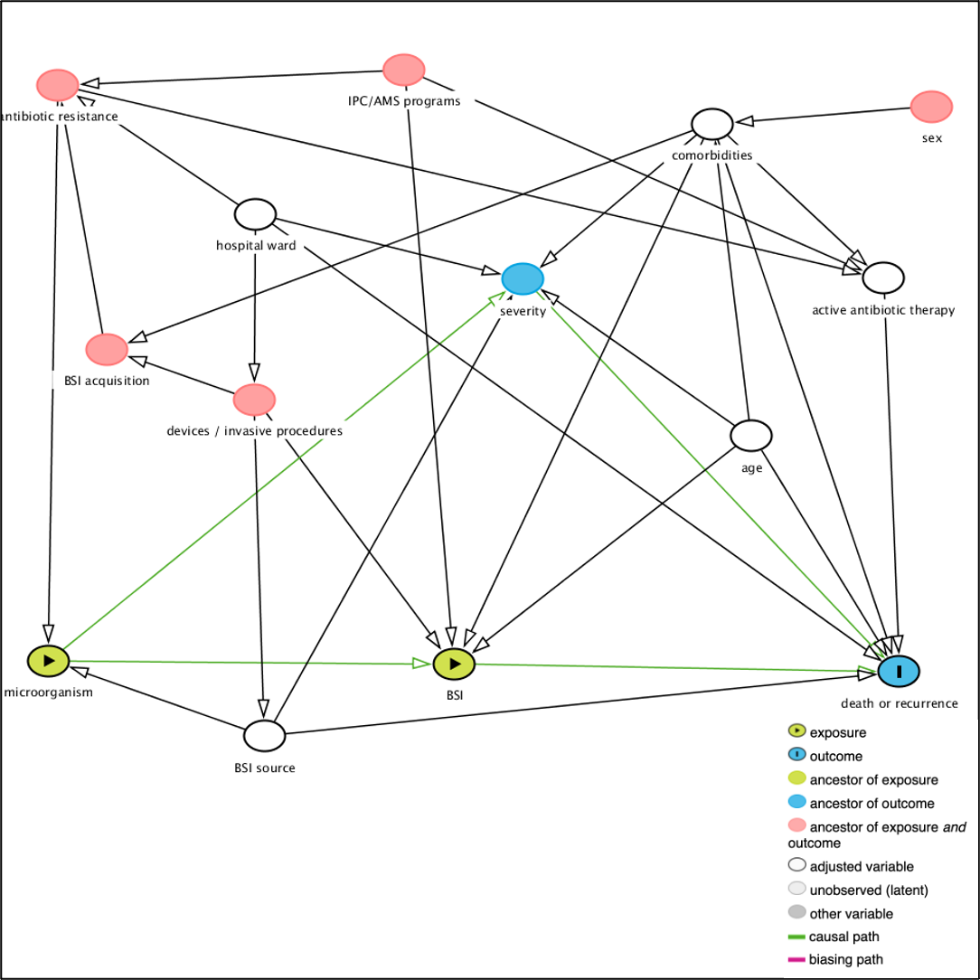
Acronyms: AMS – antimicrobial stewardship; BSI – bloodstream infection; IPC – infection prevention and control.
Notes: Directed acyclic diagram created in DAGitty online. ¹

Figure 3 – Inclusion flow diagram for data analysis
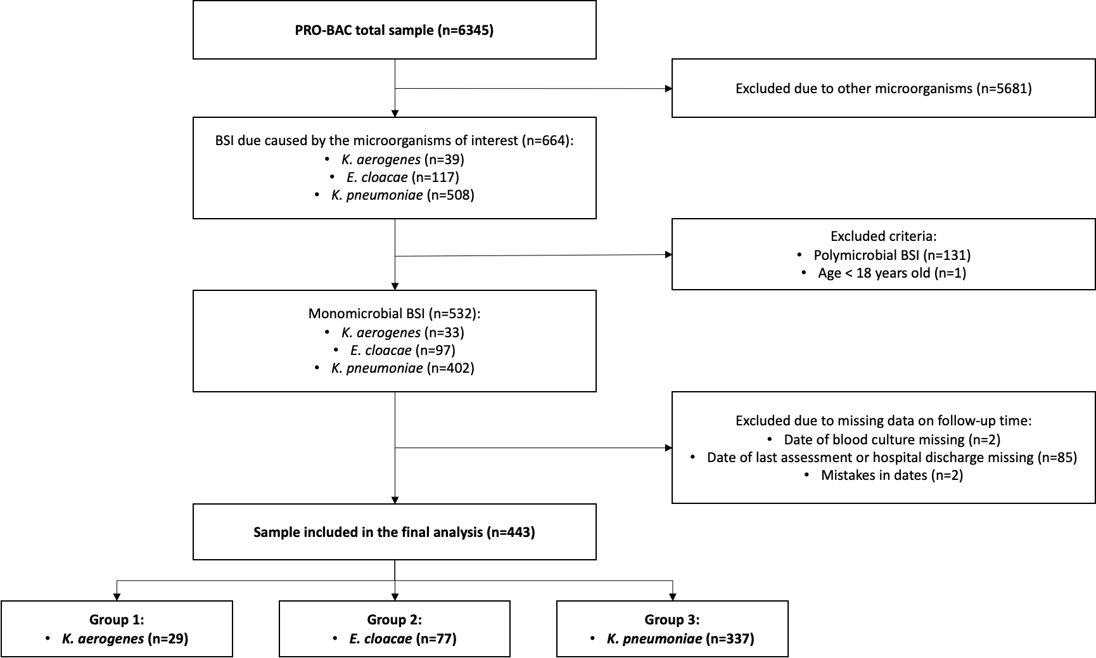

Table 4 – Characteristics of total sample, episodes included and excluded in analysis.
Variables |  | Total sample (532) | Included (n=443) | Excluded (n=89) | p-value
Microorganism | K. pneumoniae | 402 (75.6%) | 337 (76.1%) | 65 (73.0%) | 0.440*
Microorganism | E. cloacae | 97 (18.2%) | 77 (17.4%) | 20 (22.5%) | 0.440*
Microorganism | K. aerogenes | 33 (6.2%) | 29 (6.5%) | 4 (4.5%) | 0.440*
Sex | Female | 197 (37.0%) | 166 (37.5%) | 31 (34.8%) | 0.720*
Sex | Missing | 4 (0.8%) | 2 (0.5%) | 2 (2.2%) | 0.720*
Age | 18 - 59 | 123 (23.1%) | 105 (23.7%) | 18 (20.2%) | 0.820*
Age | 60 - 69 | 145 (27.3%) | 122 (27.5%) | 23 (25.8%) | 0.820*
Age | 70 - 79 | 147 (27.6%) | 123 (27.8%) | 24 (27.0%) | 0.820*
Age | ≥ 80 | 115 (21.6%) | 93 (21.0%) | 22 (24.7%) | 0.820*
Age | Missing | 2 (0.4%) | 0 (0.0%) | 2 (2.2%) | 0.820*
Charlson index | ≥ 5 | 236 (44.4%) | 208 (47.0%) | 28 (31.5%) | 0.011*
Charlson index | Missing | 2 (0.4%) | 0 (0.0%) | 2 (2.2%) | 0.011*
Department responsible | Medical | 281 (52.8%) | 242 (54.6%) | 39 (43.8%) | 0.430*
Department responsible | Surgery | 116 (21.8%) | 100 (22.6%) | 16 (18.0%) | 0.430*
Department responsible | ICU | 69 (13.0%) | 55 (12.4%) | 14 (15.7%) | 0.430*
Department responsible | Other | 45 (8.5%) | 36 (8.1%) | 9 (10.1%) | 0.430*
Department responsible | Missing | 21 (3.9%) | 10 (2.3%) | 11 (12.4%) | 0.430*
Setting of BSI acquisition | Community | 136 (25.6%) | 107 (24.2%) | 29 (32.6%) | 0.120*
Setting of BSI acquisition | Nosocomial | 256 (48.1%) | 222 (50.1%) | 34 (38.2%) | 0.120*
Setting of BSI acquisition | HAI | 135 (25.4%) | 114 (25.7%) | 21 (23.6%) | 0.120*
Setting of BSI acquisition | Missing | 5 (0.9%) | 0 (0.0%) | 5 (5.6%) | 0.120*
BSI source | Abdominal | 131 (24.6%) | 106 (23.9%) | 25 (28.1%) | 0.540*
BSI source | Catheter | 55 (10.3%) | 50 (11.3%) | 5 (5.6%) | 0.540*
BSI source | Respiratory | 34 (6.4%) | 28 (6.3%) | 6 (6.7%) | 0.540*
BSI source | Urinary | 195 (36.7%) | 166 (37.5%) | 29 (32.6%) | 0.540*
BSI source | Other | 14 (2.6%) | 11 (2.5%) | 3 (3.4%) | 0.540*
BSI source | Unknown | 93 (17.5%) | 81 (18.3%) | 12 (13.5%) | 0.540*
BSI source | Missing | 10 (1.9%) | 1 (0.2%) | 9 (10.1%) | 0.540*
Pitt score‡ | ≥ 4 | 48 (9.0%) | 44 (9.9%) | 4 (4.5%) | 0.100*
Severe sepsis‡ | Yes | 96 (18.0%) | 82 (18.5%) | 14 (15.7%) | 0.530*
Septic shock‡ | Yes | 74 (13.9%) | 63 (14.2%) | 11 (12.4%) | 0.640*
ESBL production | Yes | 95 (17.9%) | 81 (18.3%) | 14 (15.7%) | 0.170*
ESBL production | Missing | 166 (31.2%) | 117 (26.4%) | 49 (55.1%) | 0.170*
Carbapenemase production | Yes | 43 (8.1%) | 34 (7.7%) | 9 (10.1%) | 0.011*
Carbapenemase production | Missing | 203 (38.2%) | 147 (33.2%) | 56 (62.9%) | 0.011*
Active empiric antibiotic | Yes | 351 (66.0%) | 316 (71.3%) | 35 (39.3%) | 0.220*
Active empiric antibiotic | Missing | 99 (18.6%) | 57 (12.9%) | 42 (47.2%) | 0.220*
Time to start ATB | Before | 83 (15.6%) | 72 (16.3%) | 11 (12.4%) | 0.810*
Time to start ATB | Same day | 296 (55.6%) | 264 (59.6%) | 32 (36.0%) | 0.810*
Time to start ATB | ≥ 1 days after | 66 (12.4%) | 58 (13.1%) | 8 (9.0%) | 0.810*
Time to start ATB | Missing | 87 (16.4%) | 49 (11.1%) | 38 (42.7%) | 0.810*
Composite outcome‡ |  | 105 (19.7%) | 101 (22.8%) | 4 (4.5%) | <0.001*
Recurrence‡ |  | 23 (4.3%) | 23 (5.2%) | 0 (0.0%) | 0.028*
All-cause mortality‡ |  | 83 (15.6%) | 79 (17.8%) | 4 (4.5%) | 0.002*
Infection related mortality‡ |  | 49 (9.2%) | 46 (10.4%) | 3 (3.4%) | 0.037*
Persistent BSI‡ |  | 26 (4.9%) | 24 (5.4%) | 2 (2.2%) | 0.210*
Fever ≥ 72H‡ |  | 73 (13.7%) | 65 (14.7%) | 8 (9.0%) | 0.150*
Device infection‡ |  | 12 (2.3%) | 10 (2.3%) | 2 (2.2%) | 1.000*
Length of hospital stay |  | 14 (6, 29.5) (n=328) | 15 (7, 30) (n=317) | 0 (0, 0) (n=11) | <0.001†
Follow-up time, days |  | 30 (11, 68) (n=445) | 30 (11, 71) (n=443) | -5.5 (-8, -3) (n=2) | 0.015†
Acronyms: ATB – antibiotic; BSI – bloodstream infection; ESBL – extended-spectrum beta-lactamase; HAI – healthcare associated infection; ICU – intensive care unit.
Legend: * Pearson's chi-squared; † Wilcoxon rank-sum; ‡ No missing data.
Notes: Composite outcome: death or recurrence at 30-day. Categorical variables reported as frequencies and proportions. Continuous variables reported as median and IQR.

References

1. Textor J, van der Zander B, Gilthorpe MS, Liśkiewicz M, Ellison GT. Robust causal inference using directed acyclic graphs: the R package ‘dagitty’. International Journal of Epidemiology 2016; 45: 1887–94.

