Supplementary material to the article “ How post-fire succession shapes psammophilous ground-dwelling assemblages: effect of wildfire and alteration in food composition.” by Stočes, D., Šipoš, J., Špoula, J. & Kula, E.
Appendix A.
Document includes acronyms and full names of invertebrate species, along with supplementary data utilized in multivariate ordination analyses. It covers the bionomy/ecology and food preferences of these species, highlighting those that are threatened. The fourth-corner approach is illustrated through tables and biplots. Additionally, it presents an ordination diagram detailing the bionomy/ecology and another diagram illustrating the succession path of forest types.

I. Supplementary tables 2
II. Supplementary figures 10
III. References 15

Supplementary tables
Table S1: Presents the acronyms for invertebrate species, specifically beetles from the family Carabidae, as used in the datasets spanning 2013–2021 and 2016–2021 for ordination analyses (refer to Figs. 2–4 and 6 in the article). It lists the full names of these species alongside their corresponding authors, adhering to the nomenclature guidelines established by Zahradník (2017) and Löbl and Löbl (2018).
Species name | Acronym
Abax parallelepipedus (Piller et Mitterpacher, 1783) | Ab_par
Abax parallelus (Duftschmid, 1812) | Ab_prl
Agonum sexpunctatum (Linnaeus, 1758) | Ag_sex
Amara aenea (De Geer, 1774) | Am_aen
Amara apricaria (Paykull, 1790) | Am_apr
Amara bifrons (Gyllenhal, 1810) | Am_bif
Amara consularis (Duftschmid, 1812) | Am_cons
Amara convexior (Stephens, 1828) | Am_conv
Amara cursitans (Zimmermann, 1832) | Am_curs
Amara curta (Dejean, 1828) | Am_cur
Amara equestris (Duftschmid, 1812) | Am_equ
Amara familiaris (Duftschmid, 1812) | Am_fam
Amara fulva (O. F. Müller, 1776) | Am_ful
Amara lunicollis (Schiödte, 1837) | Am_lun
Amara municipalis (Duftschmid, 1812) | Am_mun
Amara plebeja (Gyllenhal, 1810) | Am_ple
Amara similata (Gyllenhal, 1810) | Am_sim
Amara tibialis (Paykull, 1798) | Am_tib
Anchomenus dorsalis (Pontoppidan, 1763) | An_dor
Anisodactylus binotatus (Fabricius, 1787) | An_bin
Anisodactylus signatus (Panzer, 1797) | An_sig
Bembidion (M.) lampros (Herbst, 1784) | Be_lam
Bembidion (M.) properans (Stephens, 1828) | Be_pro
Bradycellus caucasicus (Chaudoir, 1846) | Bra_cau
Bradycellus collaris (Chaudoir, 1846) | Bra_col
Bradycellus csikii (Lacszó, 1912) | Bra_csi
Brachinus crepitans (Linnaeus, 1758) | Br_cre
Brachinus explodens (Duftschmid, 1812) | Br_exp
Brachinus psophia (Audinet-Serville, 1821) | Br_pso
Broscus cephalotes (Linnaeus, 1758) | Bro_cep
Calathus ambiguus (Paykull, 1790) | Cal_am
Calathus cinctus (Motschulsky, 1850) | Cal_cin
Calathus erratus (C. R. Sahlberg, 1827) | Cal_err
Calathus fuscipes (Goeze, 1777) | Cal_fus
Calathus melanocephalus (Linnaeus, 1758) | Cal_mel
Calodromius spilotus (Illiger, 1798) | Cal_spi
Calosoma inquisitor (Linnaeus, 1758) | Cal_inq
Carabus coriaceus (Linnaeus, 1758) | Car_cor
Carabus granulatus granulatus (Linnaeus, 1758) | Car_gra
Carabus hortensis (Linnaeus, 1758) | Car_hor
Carabus ullrichii (Germar, 1824) | Car_ull
Carabus violaceus (Linnaeus, 1758) | Car_viol
Cicindela hybrida (Linnaeus, 1758) | Ci_hyb
Clivina fossor (Linnaeus, 1758) | Cli_fos
Cryptophonus melancholicus (Dejean, 1829) | Cr_mel
Cychrus caraboides (Linnaeus, 1758) | Cyc_car
Cymindis angularis (Gyllenhal, 1810) | Cy_ang
Cymindis humeralis (Geoffroy in Fourcroy, 1785) | Cy_hum
Cymindis macularis (Mannerheim in Fischer von Waldheim, 1824) | Cy_mac
Demetrias monostigma (Samouelle, 1819) | De_mon
Dolichus halensis (Schaller, 1783) | Do_hal
Dromius angustus (Brullé, 1834) | Dr_ang
Dromius quadrimaculatus (Linnaeus, 1758) | Dro_qua
Harpalus affinis (Schrank, 1781) | Ha_aff
Harpalus anxius (Duftschmid, 1812) | Ha_anx
Harpalus atratus (Latreille, 1804) | Ha_atr
Harpalus autumnalis (Duftschmid, 1812) | Ha_aut
Harpalus caspius roubali (Schauberger, 1928) | Ha_cas
Harpalus distinguendus (Duftschmid, 1812) | Ha_dis
Harpalus flavescens (Piller & Mitterpacher, 1783) | Ha_fla
Harpalus froelichii (Sturm, 1818) | Ha_fro
Harpalus hirtipes (Panzer, 1796) | Ha_hir
Harpalus honestus (Duftschmid, 1812) | Ha_hon
Harpalus laevipes (Zetterstedt, 1828) | Ha_lae
Harpalus latus (Linnaeus, 1758) | Ha_lat
Harpalus luteicornis (Duftschmid, 1812) | Ha_lut
Harpalus modestus (Dejean, 1829) | Ha_mod
Harpalus picipennis (Duftschmid, 1812) | Ha_pic
Harpalus pumilus (Sturm, 1818) | Ha_pum
Harpalus rubripes (Duftschmid, 1812) | Ha_rub
Harpalus rufipalpis (Sturm, 1818) | Ha_ruf
Harpalus servus (Duftschmid, 1812) | Ha_ser
Harpalus signaticornis (Duftschmid, 1812) | Ha_sig
Harpalus smaragdinus (Duftschmid, 1812) | Ha_sma
Harpalus subcylindricus (Dejean, 1829) | Ha_sub
Harpalus tardus (Panzer, 1797) | Ha_tar
Harpalus xanthopus winkleri (Schauberger, 1923) | Har_xwi
Chlaenius tristis (Schaller, 1783) | Ch_tris
Leistus ferrugineus (Linnaeus, 1758) | Lei_fer
Leistus rufomarginatus (Duftschmid, 1812) | Lei_ruf
Licinus depressus (Paykull, 1790) | Li_dep
Masoreus wetterhallii (Gyllenhal, 1813) | Ma_wet
Metallina lampros (Herbst, 1784) | Me_lam
Metallina properans (Stephens, 1828) | Me_pro
Microlestes maurus (Sturm, 1827) | Mi_mau
Microlestes minutulus (Goeze, 1777) | Mi_min
Morphocarabus scheidleri scheidleri (Panzer, 1799) | Mo_sch
Nebria brevicollis (Fabricius, 1792) | Ne_brev
Notiophilus biguttatus (Fabricius, 1779) | Not_big
Notiophilus germinyi (Fauvel in Grenier, 1863) | Not_ger
Notiophilus palustris (Duftschmid, 1812) | Not_pal
Notiophilus pusillus (Dejean, 1826) | Not_pus
Ophonus azureus (Fabricius, 1775) | Op_azu
Oxypselaphus obscurus (Herbst, 1784) | Ox_obs
Panagaeus bipustulatus (Fabricius, 1775) | Pa_bip
Paradromius linearis (Olivier, 1795) | Pa_lin
Phyla obtusa (Audinet-Serville, 1821) | Ph_obt
Poecilus cupreus (Linnaeus, 1758) | Po_cupr
Poecilus lepidus (Leske, 1785) | Po_lep
Poecilus versicolor (Sturm, 1824) | Po_ver
Pseudoophonus griseus (Panzer, 1796) | Pse_gris
Pseudoophonus rufipes (DeGeer, 1774) | Pse_ruf
Pterostichus (M.) anthracinus (Illiger, 1798) | Pt_ant
Pterostichus melanarius (Illiger, 1798) | Pte_mel
Pterostichus niger (Schaller, 1783) | Pte_nig
Pterostichus oblongopunctatus (Fabricius, 1787) | Pte_obl
Pterostichus quadrifoveolatus (Letzner, 1852) | Pte_qua
Pterostichus strenuus (Panzer, 1796) | Pte_stre
Stenolophus mixtus (Herbst, 1784) | St_mix
Stomis pumicatus (Panzer, 1796) | St_pum
Syntomus foveatus (Geoffroy in Fourcroy, 1785) | Syn_fov
Syntomus obscuroguttatus (Duftschmid, 1812) | Syn_obs
Syntomus pallipes (Dejean, 1825) | Syn_pal
Syntomus truncatellus (Linnaeus, 1761) | Syn_trun
Synuchus vivalis (Illiger, 1798) | Syn_viv
Tachyta nana (Gyllenhal, 1810) | Ta_nan
Trechus quadristriatus (Schrank, 1781) | Tre_qua

Table S2: Provides supplementary data for multivariate ordination analyses covering the period 2016–2021. This data includes species life-history traits, categorized as follows: bioindication (I–indifferent, S–dry loving, X–xerotermic, V–humid loving, H–hydrophilic), based on the works of Hůrka et al. (1996), Müller-Motzfeld (2004), and Stanovský and Puplán (2006); bionomy/ecology traits (M–macroptery, B–brachyptery, A–aptery, B/M–brachyptery with occasional macroptery indicating polymorphism, average adult size, adult spawn time spanning one or two years, brood under soil, gregarious tendencies of adults, and overwintering stage of larvae or adult), referenced from various sources including Lindroth (1949), Thiele (1977), Hůrka (1996), Holland (2002), Turin et al. (2003), Müller-Motzfeld (2004), and Trautner (2017); and food preferences (P–predators; V–omnivores; B–herbivores, including granivores; eaters focusing on Collembola, larvae of Coleoptera, Opilionides, and Gastropods). The categorization of rare species follows the IUCN status (NT–nearly threatened), as documented by Hejda et al. (2017).

Table S2
Acronym | Threatened | Moisture tolerance | Wings | Average adult size [mm] | Adult spawn time | Brood under soil | Gregarious adults | Overwintering | Food preferences
Ab_par | – | H | B | 15 | 1 | observed | – | larvae | P
Am_bif | – | S | M | 6.5 | 1 | – | observed | larvae | B
Am_cons | – | S | M | 8.3 | 1 | – | – | larvae/adult | P
Am_conv | – | S | M | 8 | 1 | – | – | adult | P/B/granivor
Am_cur | – | I | M | 6.8 | 1 | – | observed | adult | P/Gastropods/larvae
Am_fam | – | V | M | 6.5 | 1 | – | – | adult | P/B/granivor
Am_ful | – | X | M | 9.3 | 1 | – | – | larvae/adult | B/granivor
Am_lun | – | S | M | 7.5 | 1 | – | – | adult | B/granivor
Am_ple | – | I | M | 7 | 1 | – | – | adult | B
Am_sim | – | I | M | 8.8 | 1 | – | – | adult | B/granivor
An_dor | – | I | M | 5.6 | 1 | – | – | adult | P
An_bin | – | I | M | 11 | 1 | – | – | adult | P/B/granivor
Be_lam | – | I | B/M | 3.5 | 1 | observed | observed | adult | Collembola
Be_pro | – | I | B/M | 3.8 | 1 | observed | observed | adult | Collembola
Br_cre | – | I | M | 8.3 | 1 | – | observed | larvae/adult | P
Br_exp | – | I | M | 6.2 | 1 | – | – | larvae/adult | P
Bro_cep | – | X | M | 19.5 | 1 | observed | – | larvae | P
Cal_am | – | S | M | 10.5 | 1 | – | – | larvae/adult | P/B
Cal_cin | – | S | B/M | 7.5 | 1 | – | – | larvae/adult | P/B
Cal_err | – | S | B/M | 10.3 | 1 | – | – | larvae | P/B
Cal_fus | – | S | B | 11.5 | 1 | – | – | larvae/adult | P/B
Cal_mel | – | I | M | 7.5 | 2 | – | – | larvae/adult | P/B/Opiliones
Cal_spi | – | I | M | 4.1 | 1 | – | – | adult | P
Car_cor | – | V | A | 35 | 2 | – | – | adult | P/Gastropods/Opil.
Car_gra | – | V | B/M/A | 20 | 2 | – | observed | adult | P/Gastropods/Opil.
Car_hor | – | I | B | 22 | 2 | – | – | larvae | P/Gastropods/Opil.
Car_viol | – | I | B | 28.5 | 2 | – | – | larvae | P/Gastropods/Opil.
Ci_hyb | – | S | M | 13.5 | 1 | – | – | adult | P
Cy_ang | – | X | B/M | 7.2 | 1 | – | observed | larvy/adult | P
Cy_hum | – | S | B | 9.8 | 1 | – | observed | larvy/adult | P
Cy_mac | – | X | B | 8.9 | 1 | – | observed | larvy/adult | P
Dr_ang | – | V | M | 6.3 | 1 | – | observed | larvy/adult | P
Ha_aff | – | I | M | 10.2 | 1 | – | – | adult | P/B/granivor
Ha_anx | – | I | M | 7.3 | 1 | – | observed | adult | P/B/granivor
Ha_atr | – | I | B/M | 12 | 1 | – | – | adult | B
Ha_aut | – | S | B/M/A | 8.5 | 1 | – | – | adult | P/B/granivor
Ha_fla | NT | X | M | 12 | 1 | – | – | larvae | P
Ha_fro | – | S | M | 9 | 1 | – | – | adult | P/granivor
Ha_hon | – | S | B/M | 9 | 1 | – | – | adult | P
Ha_lae | – | I | M | 9.5 | 1 | – | – | larvae/adult | P/B
Ha_lat | – | I | M | 9.5 | 1 | observed | – | larvae | B
Ha_lut | – | I | M | 6.8 | 1 | – | observed | larvae | B
Ha_mod | NT | S | M | 6.2 | 1 | – | – | adult | B
Ha_pum | – | S | B/M | 9 | 1 | – | – | adult | B
Har_rub | – | S | M | 9.5 | 1 | – | – | larvae/adult | P/B/granivor
Ha_ruf | – | I | M | 9 | 1 | observed | – | adult | B
Ha_sma | – | X | M | 9.3 | 1 | – | – | larvae/adult | P/B/granivor
Ha_tar | – | X | M | 9.7 | 1 | – | – | larvae/adult | P/B/granivor/Gastr.
Ha_xwi | – | S | M | 6.3 | 1 | – | – | adult | B/granivor
Lei_fer | – | I | B | 6.3 | 1 | – | observed | larvae | Collembola
Lei_ruf | – | S | M | 8.5 | 1 | – | observed | larvae | Collembola
Ma_wet | – | X | M | 6.3 | 1 | – | – | larvae | P
Mi_mau | – | S | M | 2.6 | 1 | – | observed | adult | P
Mi_min | – | I | B/M | 3.1 | 1 | – | observed | adult | P
Ne_brev | – | I | M | 11.5 | 2 | – | observed | larvae | P
Not_big | – | I | B/M | 4.8 | 1 | – | – | adult | Collembola
Not_ger | – | I | M | 4.3 | 1 | – | – | adult | Collembola
Not_pal | – | V | B/M | 4.8 | 1 | – | – | adult | Collembola
Not_pus | – | X | B/M | 3 | 1 | – | – | adult | Collembola
Op_azu | – | S | B/M | 7 | 1 | – | – | adult | B/granivor
Ox_obs | – | V | B/M | 6.5 | 2 | – | – | larvae/adult | P/granivor
Po_cupr | – | I | M | 12 | 1 | – | – | larvae/adult | P/Gastropods
Pse_gris | – | S | M | 12 | 1 | – | – | larvae/adult | P/granivor
Pse_ruf | – | I | M | 16.9 | 2 | – | observed | larvae | P/B/granivor
Pte_nig | – | I | M | 18 | 1 | observed | – | larvae | P
Pte_obl | – | I | M | 10.5 | 1 | observed | – | adult | P
Pte_qua | – | I | M | 9.5 | 1 | observed | – | adult | P
Pte_stre | – | V | M | 6 | 1 | observed | – | adult | P/B/granivor
Syn_fov | – | X | B/M | 2.8 | 1 | observed | – | adult | P
Syn_trun | – | S | B/M | 2.8 | 2 | observed | – | adult | P
Syn_viv | – | S | M | 5.8 | 1 | observed | – | larvae | P
Ta_nan | – | V | M | 2.9 | 1 | – | – | adult | P/Ipinae
Tre_qua | – | I | B/M | 3.8 | 1 | – | – | adult | P

Table S3: Test of RLQ and fourth-corner analysis (food preferences) shows significant associations of food preferences (P, B, Collembola, Larvae of Coleoptera, Opiliones, Gastropods) with environmental variables (fire, canopy, temperature, rainfall). Methodically follows Dray (2013).
class: krandtest lightkrandtest
Monte-Carlo tests
Call: randtest.rlq (xtest = rlq.aravo, modeltype = 6)
Number of tests: 2
Adjustment method for multiple comparisons: none
Permutation number: 999
Test | Obs | Std. Obs | Alter | Pvalue
1. Model 2 | 1.728984 | 67.297477 | greater | 0.001
2. Model 4 | 1.728984 | 2.058511 | greater | 0.044

Table S4: Total inertia of RLQ analysis (food preferences) is equal to the S_{RLQ} multivariate statistic defined in Dray and Legendre (2008). This statistic is returned by the fourthcorner2 function. Methodically follows Dray (2013).
Monte-Carlo test
Call: fourthcorner2(tabR = enviro, tabL = species, tabQ = food,
modeltype = 6, p.adjust.method.G = "fdr")
Observation: 1.728984
Based on 999 replicates
Simulated p-value: 0.035
Alternative hypothesis: greater
Std. Obs | Expectation | Variance
2.0753370 | 0.8456880 | 0.1811489

Table S5: Test of RLQ and fourth-corner analysis (bionomy/ecology) shows non-significant associations of bionomy/ecology traits (M–macroptery; Size; Larvae–tendency of species to overwinter as larva; Adult– tendency of species to overwinter as adult, Gregarious–adults tend to accumulate e.g., under rock or at the top flower spikes) with environmental variables (fire, canopy, temperature, rainfall). Methodically follows Dray (2013).
class: krandtest lightkrandtest
Monte-Carlo tests
Call: randtest.rlq(xtest = rlq.aravo, modeltype = 6)
Number of tests: 2
Adjustment method for multiple comparisons: none
Permutation number: 999
Test | Obs | Std. Obs | Alter | Pvalue
1. Model 2 | 0.0004939745 | 54.44017558 | greater | 0.001
2. Model 4 | 0.0004939746 | 0.03546218 | greater | 0.375

Table S6: Total inertia of RLQ analysis (bionomy/ecology) is equal to the S_{RLQ} multivariate statistic defined in Dray and Legendre (2008). This statistic is returned by the fourthcorner2 function. Methodically follows Dray (2013).
Monte-Carlo test
Call: fourthcorner2(tabR = enviro4, tabL = species3, tabQ = ecology, modeltype = 6, p.adjust.method.G = "fdr")
Observation: 0.0004939745
Based on 999 replicates
Simulated p-value: 0.36
Alternative hypothesis: greater
Std. Obs | Expectation | Variance
3.206823e-02 | 4.824741e-04 | 1.286101e-07

Supplementary figures
Fig. S1: Ordination triplot illustrates the succession path of various forest stand types, based on a partial Constrained Correspondence Analysis (pCCA) performed on the 2013–2021 dataset. To account for potential systematic or successional changes in species composition across different forest stand types (including semi-decayed mid-aged stand, unaffected mid-aged stand, affected mature stand, and unaffected mature stand), the year was incorporated as a covariable. This approach aimed to distinguish between temporal and spatial variability without conflating the two, hence the decision to restrict randomization by shuffling temporal records within each plot. The permutation test for predictors was confined within blocks delineated by the covariable year. Species abundances were log-transformed, and rare species received lower weighting. The significance of the canonical axes was assessed using a restricted Monte Carlo permutation test, specifically tailored for time series analysis, with 999 permutations.
The result from the pCCA analysis reveal a significant shift in assemblage composition (R2=31.2%; Test on All Axes: pseudo-F=34.1, p=0.001) primarily along the first axis, which correlates with fire disturbance. The second axis is linked to the age of the stand. The diagram uses transparent triangles to denote forest stand types and filled triangles to represent species.
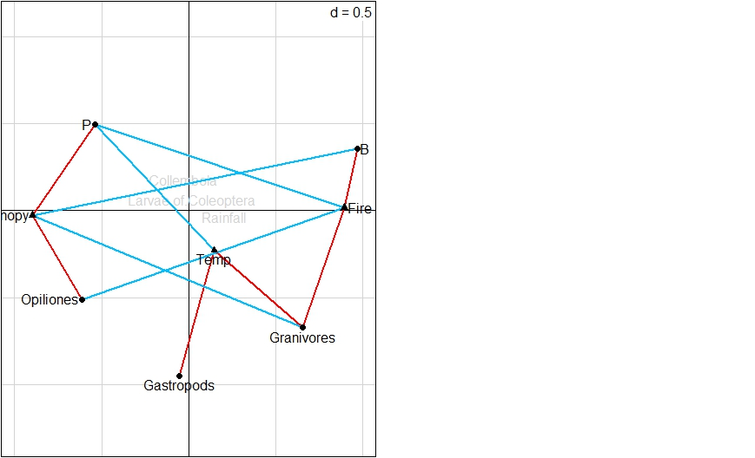
Fig. S2: The biplot illustrates the association between food preferences and environmental variables utilizes RLQ scores. This approach is chosen over the combination of methodologies outlined in Tables A.3 and A.4. Significant associations identified through the fourth-corner approach are depicted using segments: blue lines indicate negative associations, while red lines signify positive ones. The analysis only includes traits and environmental variables that demonstrate at least one significant association. This methodological approach is in accordance with the guidelines set by Dray (2013).

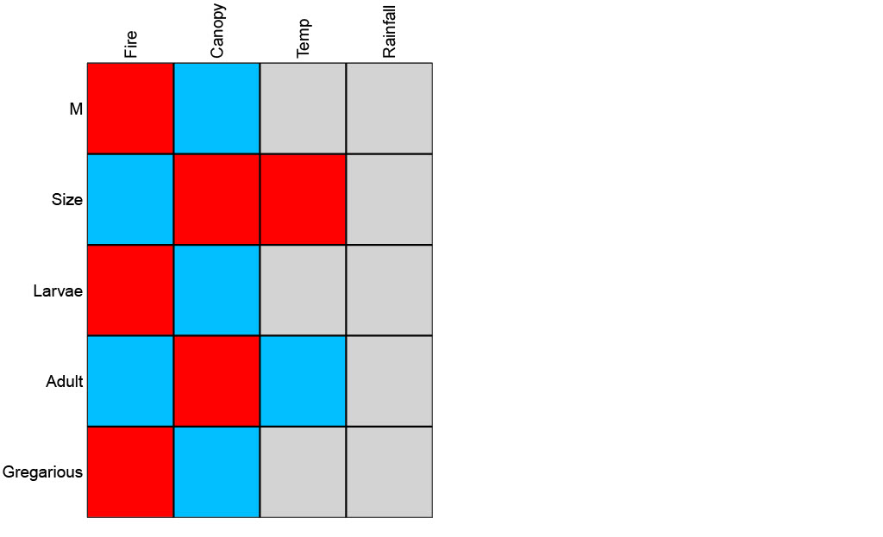Fig. S3: The plotted results from the fourth-corner analysis, focusing on bionomy/ecology, explore the associations between individual traits (such as macroptery (M), size, the tendency of species to overwinter as larvae or adults, and gregarious behavior in adults) and various environmental variables (including fire, canopy, temperature, and rainfall). The associations between these bionomy/ecology traits and environmental variables were not conclusively established with test model 4, as indicated in Table S5, and the simulated p-values were too high, as shown in Table S6. Despite this, a general tendency aligning with findings reported in existing literature (cited works include Lindroth, 1949; Thiele, 1977; Holland, 2002; Turin et al., 2003; Trautner, 2017) is observed. The methodology adheres to the framework suggested by Dray (2013).

Fig. S4: The conducted partial Detrended Constrained Correspondence Analysis (pDCCA) elucidates the connections between life-history traits (specifically bionomy/ecology) and environmental variables, as well as their distribution across various habitats: loose grassland with CWD, grassland with a scarcity of CWD, semi-decayed mid-aged stand, and unaffected mid-aged stands, observed during the 2016–2021 period (as detailed in section 2.1 of the article). The impact of individual environmental variables on these relationships is comprehensively summarized in Table 1 of the article. For visual representation, the diagram employs transparent triangles to signify the fire regime, dark arrows with annotations for the monitored environmental variables, filled triangles for species, and grey arrows with annotations to depict life-history traits.

Fig. S5: The pDCCA analysis (focusing on bionomy/ecology) presented in Fig. A.4 highlights the functional diversity (FD, measured using Rao's quadratic entropy) and its role in explaining the niche bioindicative utilization rates across different habitats: loose grassland with CWD, grassland with a scarcity of CWD, semi-decayed mid-aged stand, and unaffected mid-aged stands, all monitored during the 2016–2021 period (as detailed in section 2.1 of the article). The analysis specifically points out the adaptability of certain species, such as Carabus hortensis (a predator that also feeds on carrion), Notiophilus germinyi (a Collembola eater), and the eurytopic Leistus ferrugineus (also a Collembola eater). The diagrammatic representation uses transparent triangles to denote the fire regime, dark arrows with annotations for the environmental variables being monitored, filled triangles for species, and a grey arrow with an annotation to indicate the functional diversity as determined by the Rao index.

References
Dray S, Legendre P (2008) Testing the species traits-environment relationships: the fourth-corner problem revisited. Ecology. 89, pp 3400–3412. https://jstor.org/stable/27650916.
Dray S (2013) A tutorial to perform fourth-corner and RLQ analyses in R. 1–11. https://s3-eu-west-1.amazonaws.com/pstorage-wiley-856416/5628774/suppl1.pdf. (accessed 13.11.22)
Hejda R, Farkač J, Chobot K (eds) (2017) Červený seznam ohrožených druhů České republiky. Bezobratlí. Příroda, Praha. 36, pp 1–612. rl_bezobratli2017.pdf (nature.cz).
Holland JM (2002) The agroecology of carabid beetles. Andover: Intercept Limited, pp 356. ISBN: 1898298769.
Hůrka K (1996) Carabidae České a Slovenské republiky. [Carabidae of the Czech and Slovak republics.] Zlín, Kabourek, pp 565. ISBN 80-901466-2-7.
Hůrka K, Veselý P, Farkač J (1996) Využití střevlíkovitých (Coleoptera: Carabidae) k indikaci kvality prostředí; Die Nutzung der Laufkäfer (Coleoptera: Carabidae) zur Indikation der Umweltqualität. Klapalekiana. 32, pp 15–26. 11-15-Hejkal.pdf (entolisty.cz).
Lindroth CH (1949) Die Fennoskandischen Carabidae. Kungl. Vetensk. Vitterh. Samh. Handl. (Ser. B4) 1, Spezieller Teil. 1-709 (1945). 3, pp 1–911.
Löbl I, Löbl D (2018) Catalogue of Palaearctic Coleoptera. Volume 1: Archostemata – Myxophaga – Adephaga. Brill Academic Publishers, pp 1443. ISBN: 978-90-04-33029-0.
Müller-Motzfeld G (2004) Die Käfer Mitteleuropas, Bd. 2: Adephaga I: Carabidae. Springer Spektrum, pp 521. ISBN: 978-3-8274-1551-6.
Stanovský, J., Pulpán, J., 2006. Střevlíkovití brouci Slezka (severovýchodní Moravy). Muzeum Beskyd Frýdek-Místek, pp 160.
Thiele HU (1977) Carabid Beetles in Their Environment. Springer-Verlag, Berlin, pp 369. https://doi.org.10.1007/978-3-642-81154-8.
Trautner J (2017). Die Laufäfer Baden-Württembergs. Verlag Eugen Ulmer, pp 848. ISBN: 978-3-8001-0380-5.
Turin H, Penev L, Casale A (eds.) (2003) The Genus Carabus in Europe. A Synthesis.- Co-published by Pensoft Publishers, Sofia-Moscow & European Invertebrate Survey, Leiden: xvi+ pp 512, 24 colour plates, 217 maps. The-genus-Carabus-in-Europe-A-Synthesis.pdf (researchgate.net).
Zahradník P (2017) Seznam brouků (Coleoptera) České republiky a Slovenska. Lesnická práce, s. r. o., Kostelec nad Černými lesy, pp 544. ISBN: 978-80-7458-092-5.

