Extended data
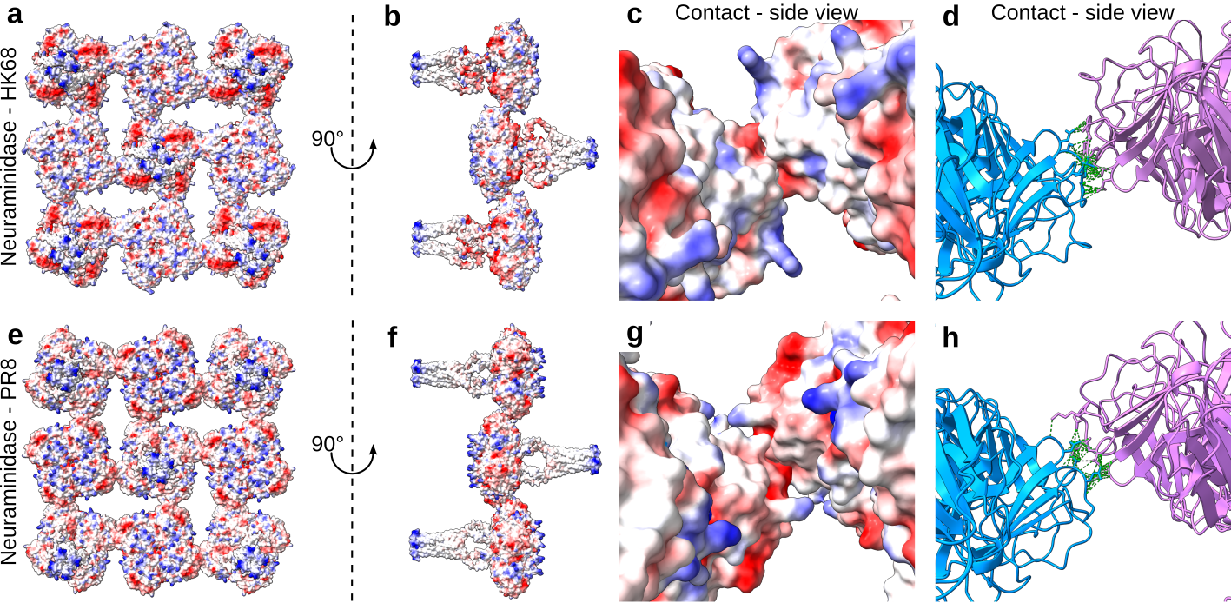
Extended data figure 1: AlphaFold2 predicted structures of HK68-NA (A–D) and PR8-NA (E–H) fitted into the subtomogram average of NA-zippers.
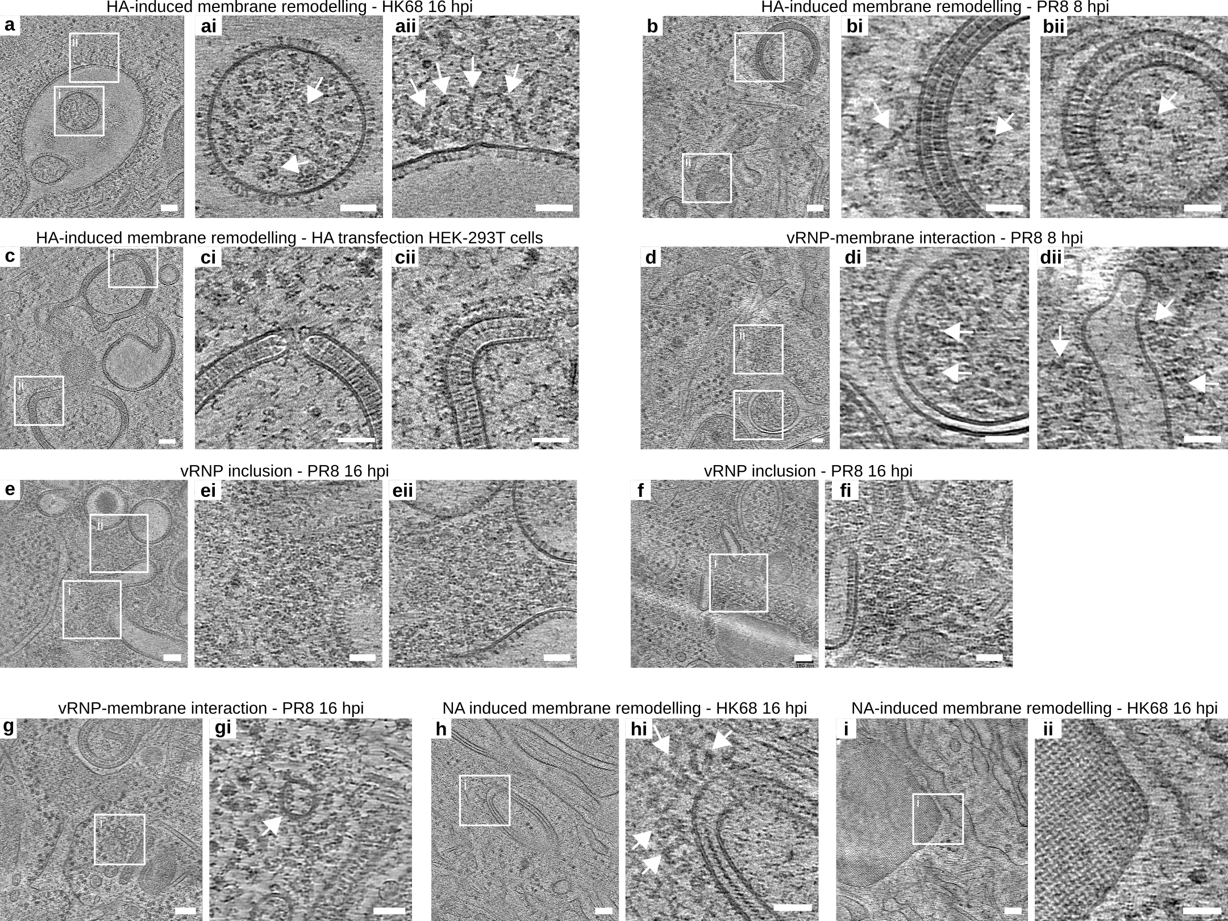
Extended data figure 2: A, B Examples of HA-remodelled membranes in a HK68-infected A549wt cell at 16 hpi (A) and a PR8-infected A549wt cell at 8 hpi (B). White arrows indicate vRNPs. C Example of HA-remodelled membranes in a HA-transfected HEK-293T cell. D Example of vRNPs (white arrows) interacting with a membrane not containing HA in a PR8-infected A549wt cell at 8 hpi. E, F Examples of vRNP inclusions in proximity to HA-remodelled membranes in a PR8-infected A549wt cell. G vRNPs (white arrow) interacting with a vesicle that does not contain HA. H, I Examples of NA-remodelled membranes in a HK68-infected A549wt cell (H) and a A549-Rab11KO cell (I). The top view (I) reveals the C4-symmetric crystalline order. White arrows indicate vRNPs. Scale bars: A–I 100 nm; Magnified views 50 nm.
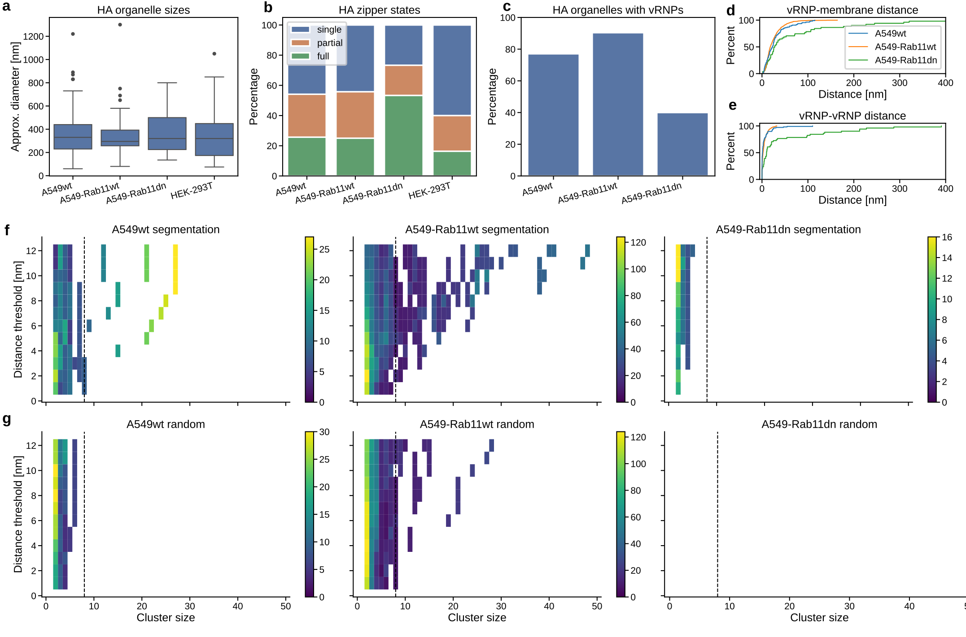
Extended data figure 3: A Approximate longest axis lengths of HA-remodelled membranes from PR8-infected A549wt, A549-Rab11wt and A549-Rab11dn cells and HA-transfected HEK-293T cells. B Zipper states of the organelles quantified in (A). Full zippers engage in head-to-head interactions along their entire observable surface, single zippers to not engage in head-to-head interactions and partial zippers show both phenotypes. C Percentage of HA-remodelled membranes quantified in (A) with vRNPs. HA-transfected HEK-293T is not shown. D–E Shortest distance between vRNP and HA-remodelled membranes (D) and between vRNPs (E) for each vRNP. P-values according to Kolmogorov-Smirnov test: vRNP-vRNP distances 0.021 (A549wt : A549-Rab11wt), 4.9e-7 (A549wt : A549-Rab11dn), 9.8e-8 (A549-Rab11wt : A549-Rab11dn); vRNP-membrane distances 0.19 (A549wt : A549-Rab11wt), 0.083 (A549wt : A549-Rab11dn), 0.0017 (A549-Rab11wt : A549-Rab11dn) F vRNP cluster sizes compared between A549wt, A549-Rab11wt and A549-Rab11dn cells and between different distance thresholds. Single vRNPs (cluster size = 1) are not shown. Dashed line indicates a cluster size of 8 vRNPs. G vRNPs quantified in (F) were randomly shifted and subjected to the same quantification.
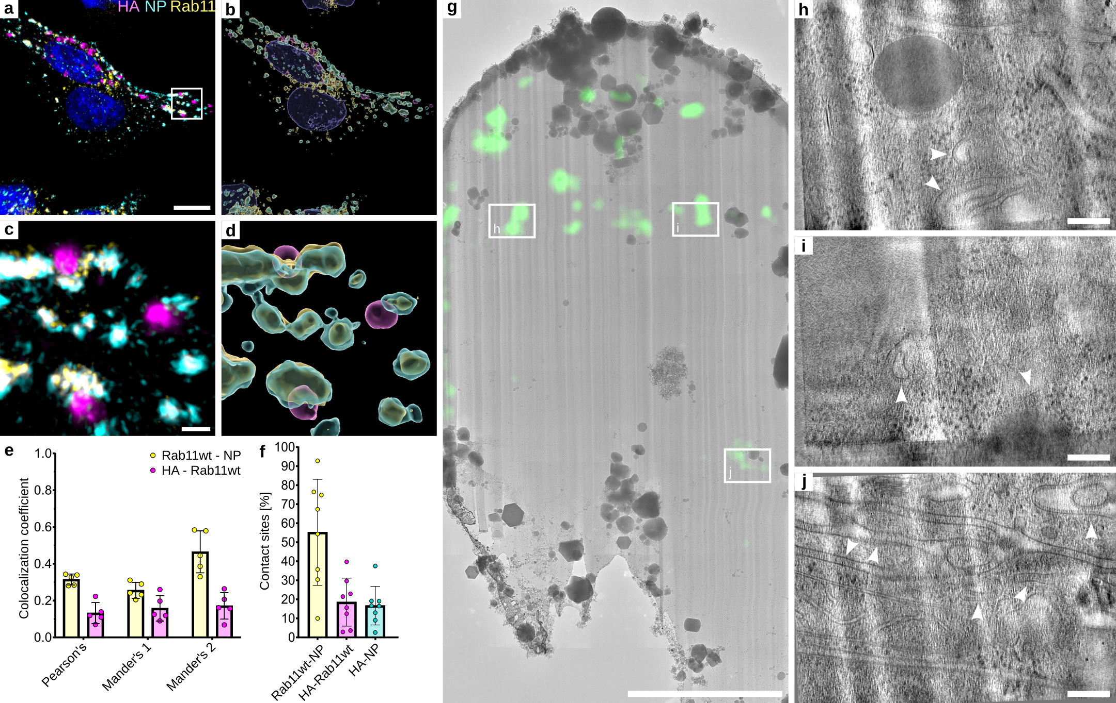
Extended data figure 4: Contact sites of HA-positive vesicles with Rab11a in A549-Rab11wt cells. Cells were infected with PR8 (MOI = 3), fixed at 16 hpi and processed for immunofluorescence staining of HA and NP (as proxy for vRNPs). A Representative confocal image of infected A549 cells overexpressing Rab11wt-GFP (yellow) with staining of HA (magenta), NP (cyan), nuclei (blue). B 3D segmentation of fluorescent signals from (A) using IMARIS. C, D Zoom-in views of (A) and (B). E Colocalization coefficients of fluorescent signals from Rab11wt with NP (yellow) and HA (magenta) from 5 infected A549-Rab11wt cells. Each dot represents the mean of 4 stacked confocal image slices after thresholding, analysed using the JACoP plugin in Fiji. Graphs were plotted with GraphPad Prism 10.1.2. Error bars indicate standard deviations. F Percentage of segmented surfaces in contact (shortest distances ≤ 0.00 μm) with indicated surfaces, analysed with IMARIS. Data from 8 infected A549-Rab11wt cells, nRab11=5834, nNP=6589, nHA=1217. G Overview map of a cryo-lamella of a PR8-infected A549-Rab11wt cell overlaid with fluorescence signal. H–J Slices through tomograms acquired at the indicated areas shown in (G). HA-remodelled membranes are indicated by white arrowheads. Scale bars: A 10 μm; C 1 μm; G 5 μm; H–J 100 nm.
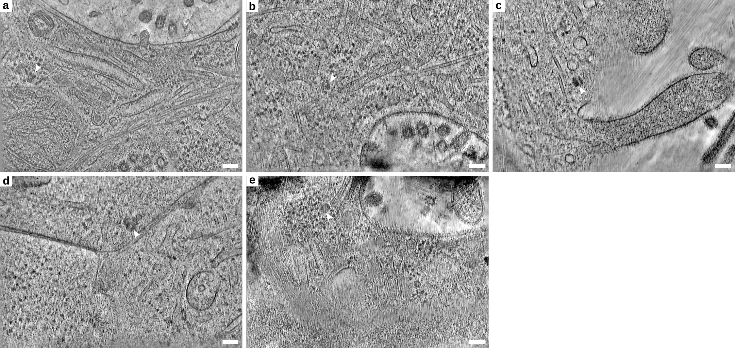
Extended data figure 5: Slices through cryo-electron tomograms showing M1 cylinders close to virus budding sites. White arrowheads indicate M1 cylinders. Scale bars: 100 nm

