Article
Supplementary Information

Interspecific Eavesdropping on Chemical Communication in the field between Taif Pomegranate, Aphis punicae, enemies, and protectors.

Nour Houda M’sakni ^{1,}*,†, Taghreed Alsufyani ^{1,}*,†, Noura J. Alotaibi ^{2,}*,†, Mona A. Almalki ¹, and Eman M. Alghamdi ³
¹ Department of Chemistry, College of Science, Taif University, P.O. Box 11099, Taif 21944, Saudi Arabia; m.awwad@tu.edu.sa (M.A.M.)
² Department of Biology, College of Science, Taif University, P.O. Box 11099, Taif 21944, Saudi Arabia;
³ Chemistry Department, Faculty of Science, King AbdulAziz University, P.O. Box 80200, Jeddah21589, Saudi Arabia; emalghamdi@kau.edu.sa (E.M.A.)
* Correspondence: taghreed.alsufyani@tu.edu.sa (T.A.); nour.h@tu.edu.sa (N.H.M.); n.alotaibi@tu.edu.sa (N.J.A.)
† These authors also contributed equally to this work.

Supplementary Tables

Supplementary Table 1. Compounds (n=30) released into the headspace at different stages of farm-scale aphid infection from May 22-27, 2021, followed by the addition of ants and then eleven female ladybirds and by the stage of adding 20 ants and 10 eleven female spotted ladybirds simultaneously. Metabolites were extracted by OLS, and identified respectively by GC-MS and NIST library and RT (tentative identification).

VOC emissions | Biomarkers | RT (min) | Treatments | S1-DVB | S2-DVB | S3-DVB-24 | S3-DVB-48
VOC emissions | Biomarkers | RT (min) | Chemicals/samples | PIN24-DVB | PIN48An24-DVB | PIN24An24Lb24-DVB | PIN48An48Lb48-DVB
Exclusive AIP | Bio 5 | 26.94 | Bio5:1-Methyl-3-tert-butylbenzene | 15.00 | 0 | 0 | 0
Exclusive AIP | Bio 6 | 26.95 | Bio6:m-Ethylcumene | 10.18 | 0 | 0 | 0
Exclusive AIP | Bio 11 | 10.6 | Bio11:3-Carene* | 2.95 | 0 | 0 | 0
Exclusive AIP | Bio 15 | 30.9 | Bio15:(+)-4-Carene | 2.12 | 0 | 0 | 0
Exclusive AIP | Bio 17 | 16.35 | Bio17:alpha-Methylbenzeneacetaldehyde | 0.06 | 0 | 0 | 0
Exclusive AIP | Bio 18 | 13.19 | Bio18:2,2,4-trimethyl-Pentane | 3.54 | 0 | 0 | 0
Exclusive AIP | Bio 22 | 37.47 | Bio22:Unknown alkane-6-3 | 0.02 | 0 | 0 | 0
Exclusive AIP | Bio 23 | 37.71 | Bio23:Unknown alkane-7-4 | 0.02 | 0 | 0 | 0
Exclusive AIP | Bio 27 | 33.99 | Bio27:Caryophyllene* | 13.07 | 0 | 0 | 0
Exclusive AIP | Bio 28 | 35.39 | Bio28: β -Farnesene* | 0.05 | 0 | 0 | 0
AIP+Lb | Bio 1 | 8.04 | Bio1:o-Xylene | 3.71 | 0.00 | 3.93 | 4.63
AIP+Lb | Bio 16 | 12.09 | bio16:Benzaldehyde* | 20.41 | 0.00 | 9.41 | 2.77
AIP+Lb | Bio 7 | 27.91 | Bio7:2-Methylnaphtalene | 14.92 | 0.00 | 0.00 | 2.17
AIP+Lb | Bio 21 | 28.79 | Bio21:Tridecane | 4.32 | 0.00 | 0.00 | 8.90
Common | Bio 2 | 8.91 | Bio2:p-Xylene | 9.63 | 4.32 | 8.73 | 5.71
Exclusive AIP + An | Bio 9 | 9.97 | bio9:Methyl methanoate | 0.00 | 0.80 | 0.00 | 0.00
Exclusive AIP + An | Bio 19 | 18.9 | Bio19:Unknown alkane-2-1 | 0.00 | 19.84 | 0.00 | 0.00
Exclusive An +Lb | Bio 8 | 8.24 | Bio8:4-Heptanone | 0.00 | 75.04 | 0.00 | 5.66
Exclusive Ladybird/Aphid interaction | Bio 3 | 11.95 | Bio3:1-Ethyl-3-methylbenzene | 0.00 | 0.00 | 1.02 | 1.29
Exclusive Ladybird/Aphid interaction | Bio 4 | 13.49 | Bio4:1,3,5-Trimethylbenzene | 0.00 | 0.00 | 3.12 | 3.53
Exclusive Ladybird/Aphid interaction | Bio 10 | 23.64 | Bio10:Methyl Salicylate* | 0.00 | 0.00 | 0.00 | 0.68
Exclusive Ladybird/Aphid interaction | Bio 12 | 12.55 | Bio12:Sabinene | 0.00 | 0.00 | 0.00 | 2.64
Exclusive Ladybird/Aphid interaction | Bio 13 | 15.2 | Bio13:Tricyclene | 0.00 | 0.00 | 60.84 | 0.00
Exclusive Ladybird/Aphid interaction | Bio 14 | 15.23 | Bio14:Limonene* | 0.00 | 0.00 | 0.00 | 27.62
Exclusive Ladybird/Aphid interaction | Bio 20 | 19.22 | Bio20:Unknown alkane-3-2 | 0.00 | 0.00 | 12.95 | 26.86
Exclusive Ladybird/Aphid interaction | Bio 24 | 37.83 | Bio24:Pentadecane* | 0.00 | 0.00 | 0.00 | 2.78
Exclusive Ladybird/Aphid interaction | Bio 25 | 46.53 | Bio25:Heptadecane* | 0.00 | 0.00 | 0.00 | 2.75
Exclusive Ladybird/Aphid interaction | Bio 26 | 14.26 | Bio26:1-Methyl-1H-imidazole | 0.00 | 0.00 | 0.00 | 2.00
Exclusive Ladybird/Aphid interaction | Bio 29 | 36.28 | Bio29:β-helmiscapene (β-Selinene) | 0.00 | 0.00 | 0.00 | 0.02
Exclusive Ladybird/Aphid interaction | Bio 30 | 48.07 | bio30:Unknown-4 | 0.00 | 0.00 | 0.00 | 0.01
Total monoterpenes |  |  |  | 5.07 | 0.00 | 60.84 | 30.26
Total sesquiterpenes |  |  |  | 13.13 | 0.00 | 0.00 | 0.02
Total ketones |  |  |  | 0.00 | 75.04 | 0.00 | 5.66
Total aldehydes |  |  |  | 20.47 | 0.00 | 9.41 | 2.77
Total esters |  |  |  | 0.00 | 0.80 | 0.00 | 0.68
Total benzenoids |  |  |  | 53.44 | 4.32 | 16.80 | 17.32
Total N-compounds |  |  |  | 0.00 | 0.00 | 0.00 | 2.00
Total alkanes |  |  |  | 7.90 | 19.84 | 12.95 | 41.28
Total unknown compounds |  |  |  | 0.00 | 0.00 | 0.00 | 0.01
AIP: Aphid-infested pomegranate, Lb: ladybird, An: ant, common: AIP + An + Lb, PIN24-DVB: Aphid-infested pomegranate after 24h, PIN48An24-DVB: Aphid-infested pomegranate (after 48h) + Ant (after 24h), PIN24An24Lb24-DVB: Aphid-infested pomegranate + Ant + Ladybirds (after 24h), PIN48An48Lb48-DVB: Aphid-infested pomegranate + Ant + Ladybirds (after 48h) were collected by Open-loop stripping systems-DVB. RT: retention time; * Some key compounds were verified by comparison with authentic standards (Alotaibi et al., 2023). All metabolites marked with a had reverse match between 700 and 990.

Supplementary Table 2. Essential and semiessential biomarkers of pattern quadruplet interaction between Aphid infested plant-Ant-Ladybird. The strategy used to identify essential and semiessential biomarkers was explained in our previous study (Alotaibi et al., 2023).

 |  | Triangle: essential biomarkers | Circle: semiessential biomarkers | Intermediar biomarkers
G-1 | PIN24-DVB | Bio5:1-Methyl-3-tert-butylbenzene  Bio6:m-Ethylcumene  Bio11:3-Carene  Bio15:(+)-4-Carene  Bio18:2,2,4-trimethyl-Pentane  Bio22:Unknown alkane-3  Bio27:Caryophyllene | Bio17:alpha-Methylbenzeneacetaldehyde  Bio23:Unknown alkane-4  Bio28:beta-Farnesene | Bio7:2-Methylnaphtalene  Bio16:Benzaldehyde
G-2 | PIN48An24-DVB | Bio9:Methyl methanoate  Bio19:Unknown alkane-1 | - | -
G-3 | PIN24An24Lb24-DVB | Bio8:2-Heptanone | Bio13:Tricyclene | -
G-4 | PIN48An48Lb48-DVB | Bio3:1-Ethyl-3-methylbenzene  Bio4:1,3,5-Trimethylbenzene  Bio10:Methyl Salicylate  Bio12:Sabinene  Bio14:Limonene  Bio20:Unknown alkane-2  Bio24:Pentadecane  Bio25:Heptadecane  Bio26:1-Methyl-1H-imidazole  Bio30:Unknown-1 | Bio29:β-helmiscapene (β-Selinene) | Bio1:o-Xylene  Bio2:p-Xylene  Bio21:Tridecane

Supplementary Figures

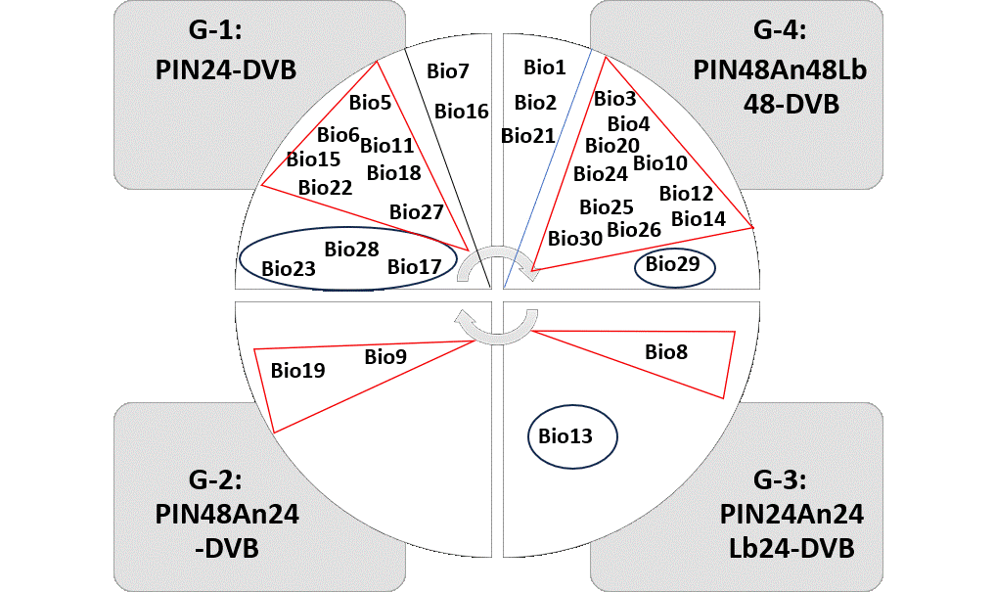
Supplementary Figure 1. Essential (triangle) and semiessential (circle:) biomarkers of pattern quadruplet interaction between Aphid infested plant-Ant-Ladybird. The strategy used to identify essential and semiessential biomarkers was explained in our previous study (Alotaibi et al., 2023).

Supplementary References

Alotaibi, N. J., Alsufyani, T., M’sakni, N. H., Almalki, M. A., Alghamdi, E. M., & Spiteller, D. (2023). Rapid Identification of Aphid Species by Headspace GC-MS and Discriminant Analysis. Insects, 14(7), 589. Retrieved from https://www.mdpi.com/2075-4450/14/7/589

