Supplementary Information

Transcriptomic analysis of TGFβ-mediated fibrosis in primary human Tenon’s fibroblasts

Author information
Zoe Pasvanis, Antony Boynes, Roy C.K. Kong, Elsa C. Chan, Raymond C.B. Wong, Jennifer Fan Gaskin

Supplementary tables
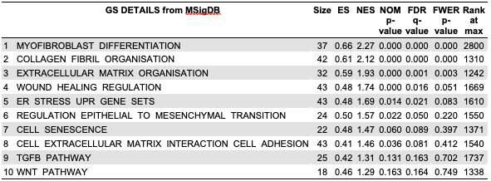
Supplementary table 1: GSEA table for TGF-B1 treatment compared to control GSEA enrichment results for the top 10 enrichment terms. ES: enrichment score, NES: normalized enrichment score, NOM p-value: nominal p-value, FDR q-value: false-discovery rate q-value, FWER p-value: familywise-error rate p-value.

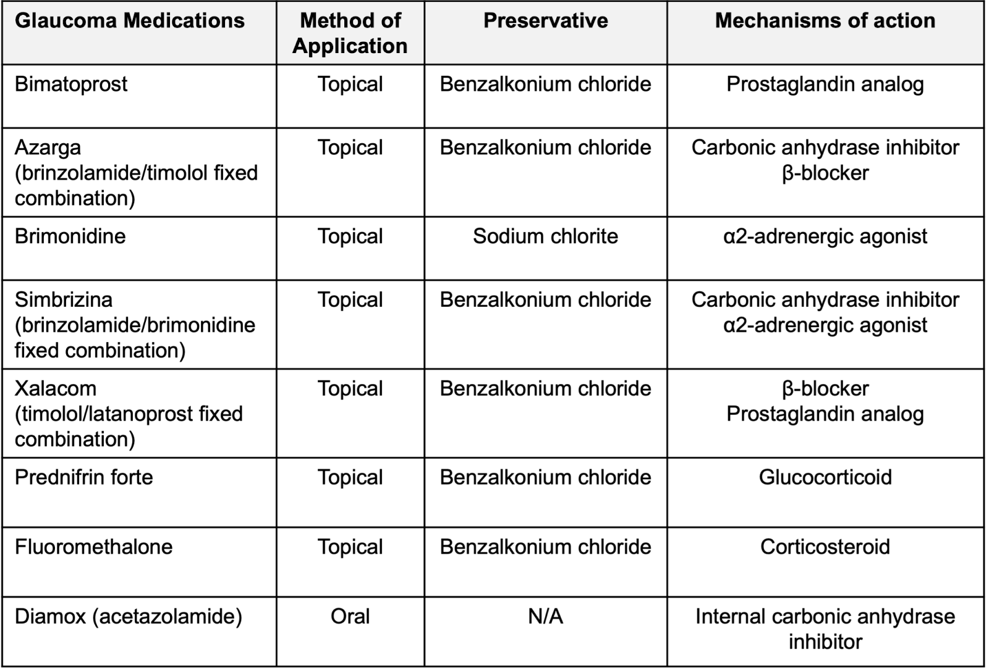

Supplementary table 2: Prescribed glaucoma medications used by patients. Glaucoma medications being used by patients at the time of tissue biopsy collection.

Supplementary figures

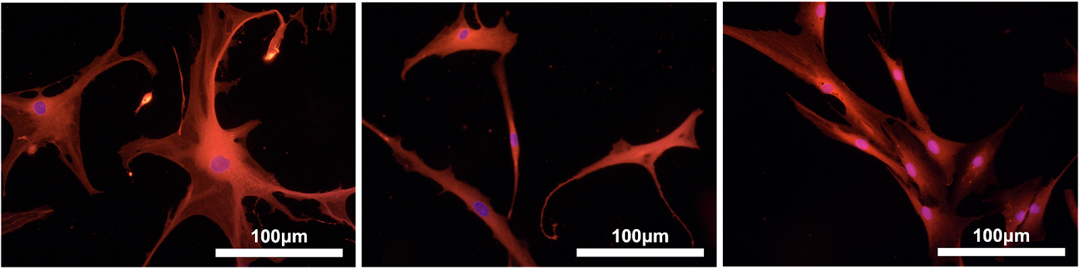

Supplementary figure 1: Characterisation of Human Tenon’s fibroblasts (HTFs) Cultured primary HTFs were stained with S100A4 (red) and nuclei counterstained with DAPI (blue). Fibroblast phenotype verified by cells presenting red-stained cytoplasm. (N=3)
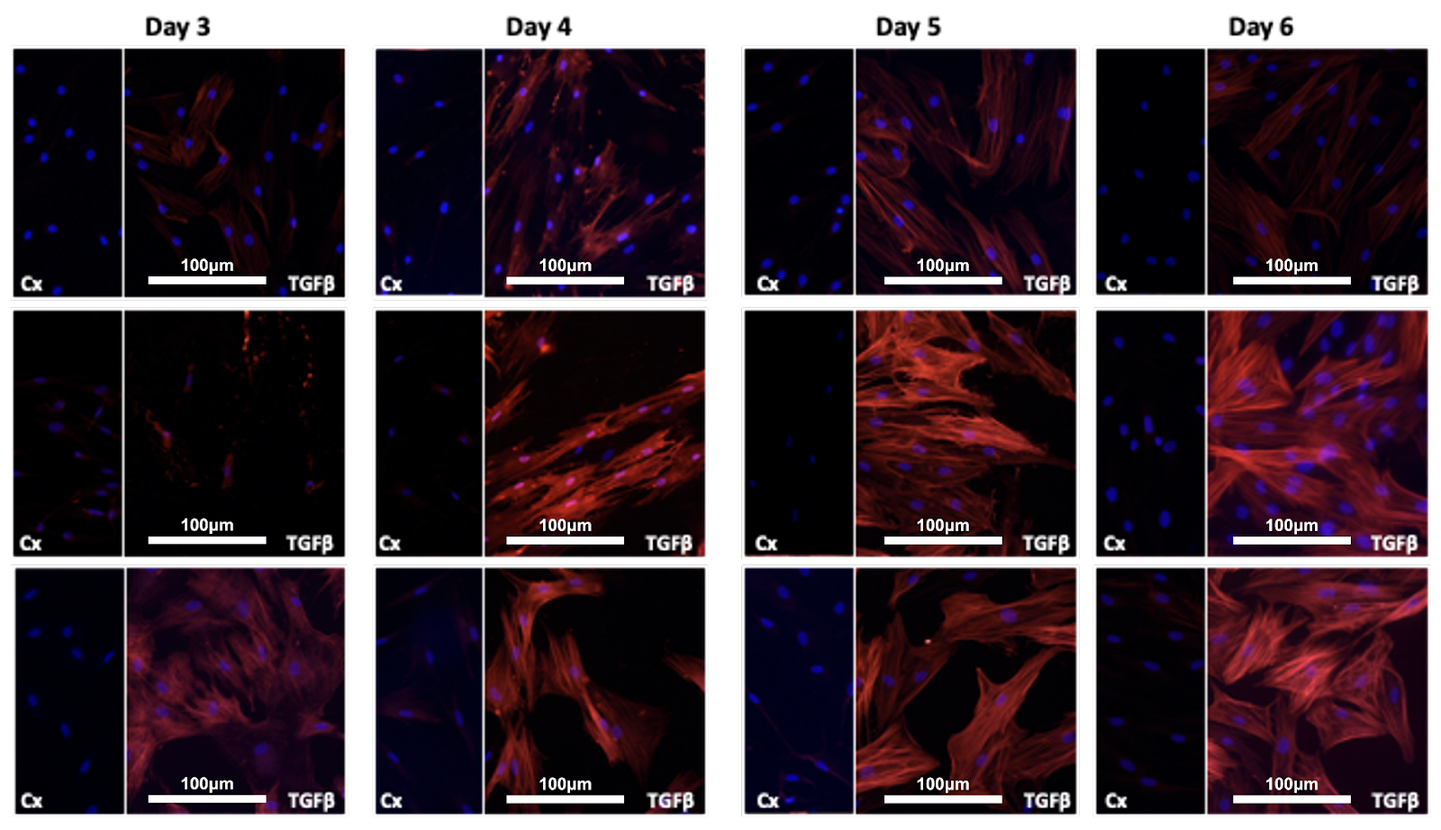
Supplementary figure 2: Time-Point Study Triplicate Phenotypic Imaging of HTFs after 3-5 days of TGFβ Treatment Cultured primary HTFs were stained with αSMA-antibody and nuclei counterstained with DAPI (blue). Red-stained fibres indicate de novo expression of αSMA in collagen stress fibres of myofibroblasts. Cx= Control sample; TGFβ = Transforming Growth Factor Beta treated sample (N=3)

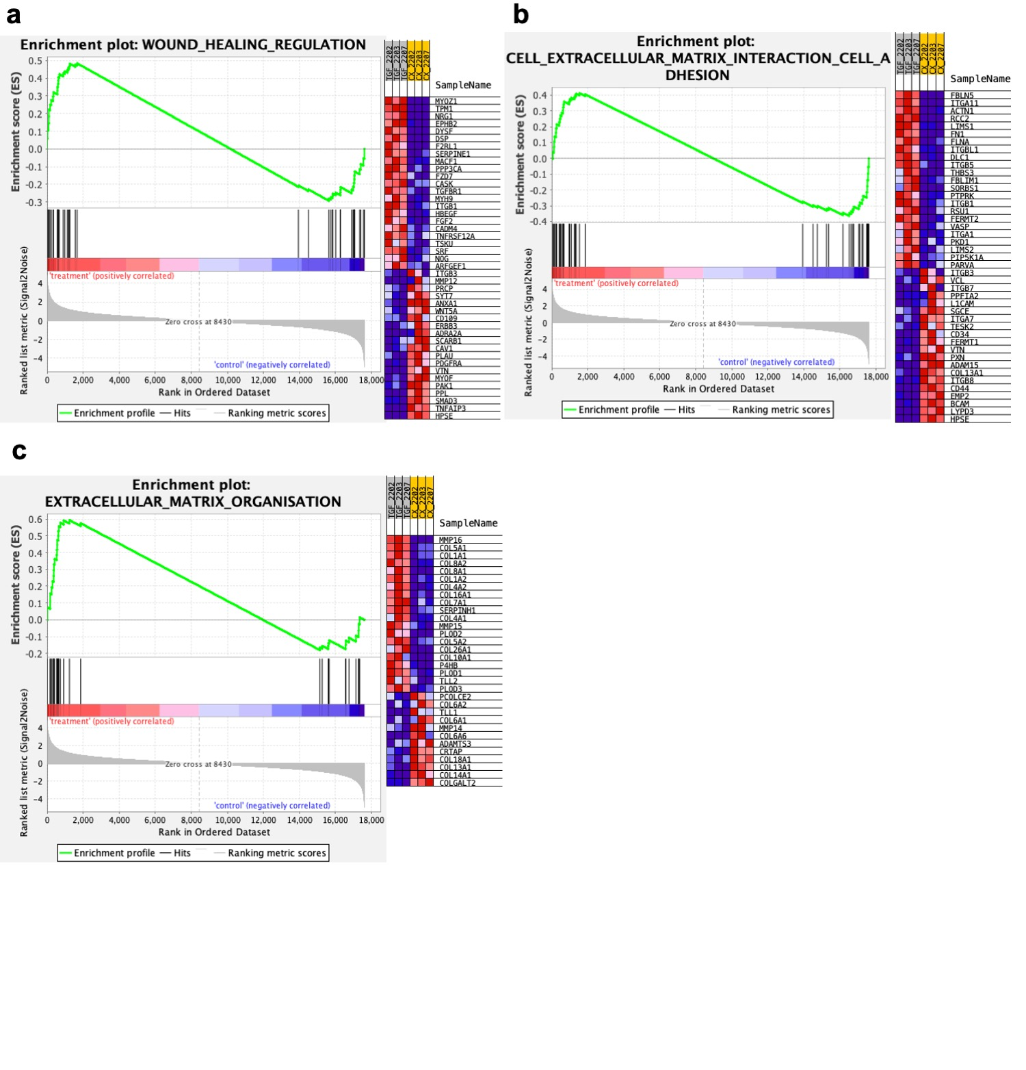Supplementary figure 3: GSEA for TGF-B treatment versus control (a) GSEA plot of wound healing regulation with GSEA standard hallmark gene set with heatmap of gene expression red = upregulated, and blue = downregulated. The enrichment score (ES) is indicated. (b) GSEA plot for cell extracellular matrix interaction cell adhesion using GSEA standard hallmark gene set. (c) GSEA plot for extracellular matrix organization using GSEA standard hallmark gene set.

