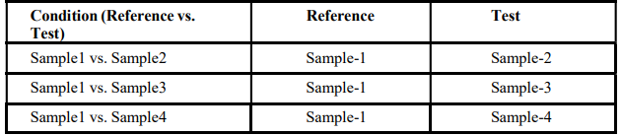
Table 1: Differential Expression Analysis
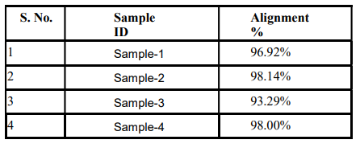
Table 2: Mapping statistics
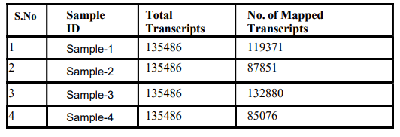
Table 3: Number of mapped transcripts in each sample

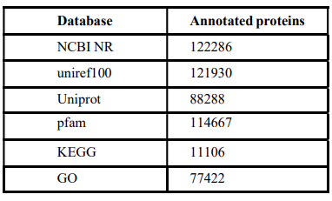
Table 4: Distribution of annotated transcripts
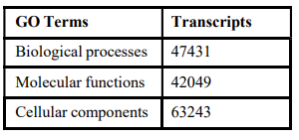
Table 5: GO distribution of transcripts
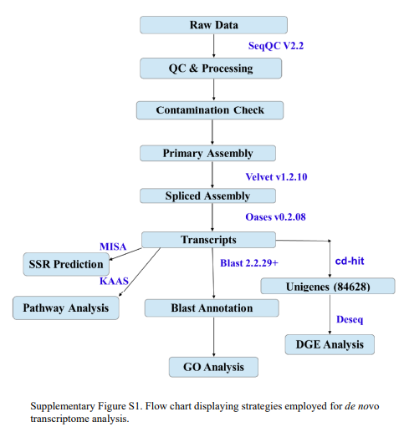
Fig 1: Flow chart displaying strategies employed for de novo transcriptome analysis

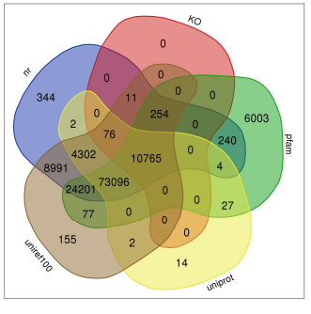
Fig 2: Distribution of annotated transcripts
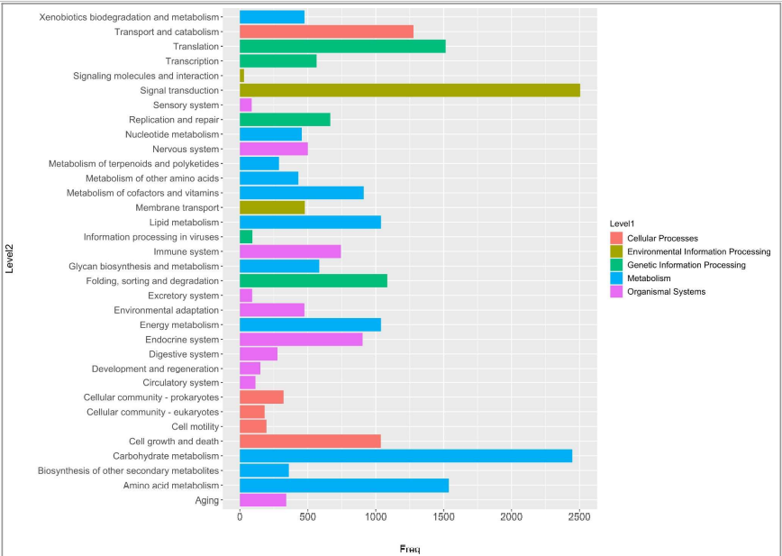

Fig 3: KO classification of Transcripts
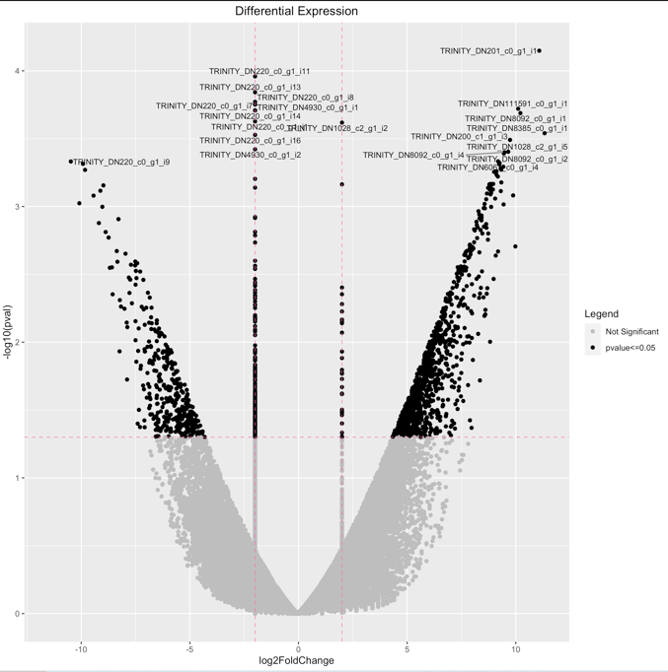
Fig 4 Volcano plot between sample 1 and sample 2
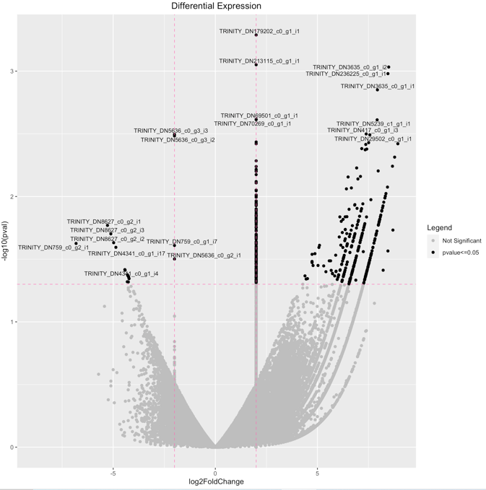
Fig 5: Volcano plot between Control and JA treated callus
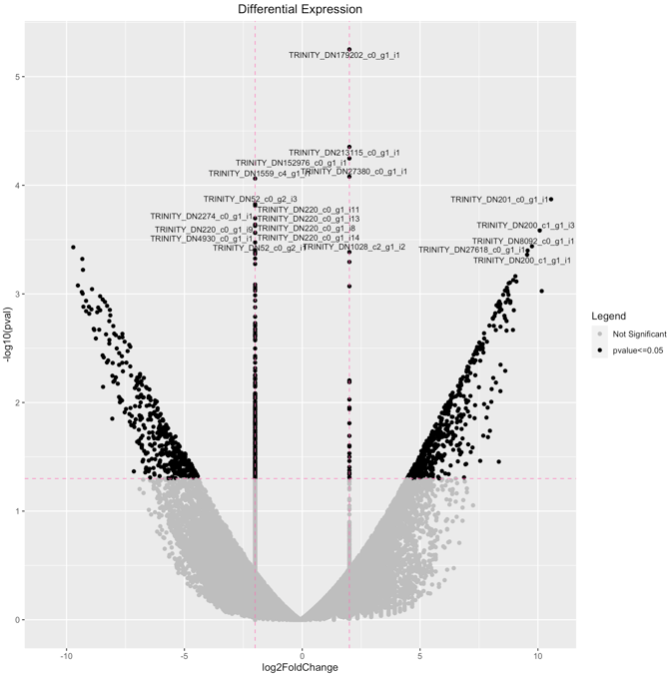
Fig 6: Sample 1 vs Sample 4 Volcano plot

