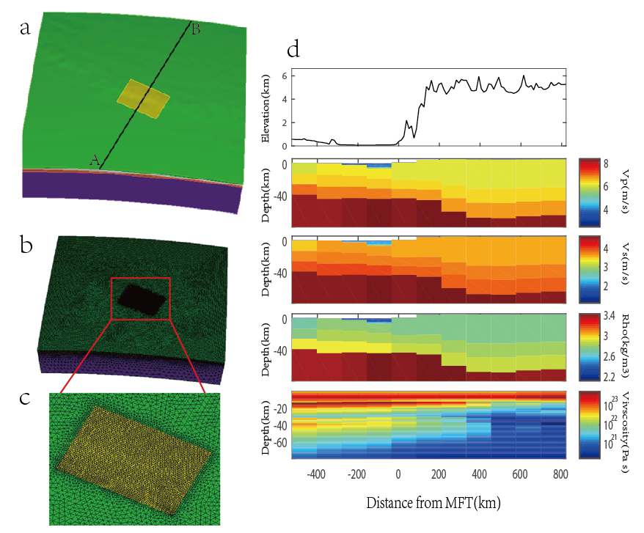
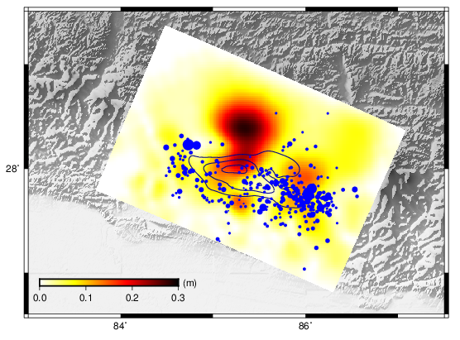 | 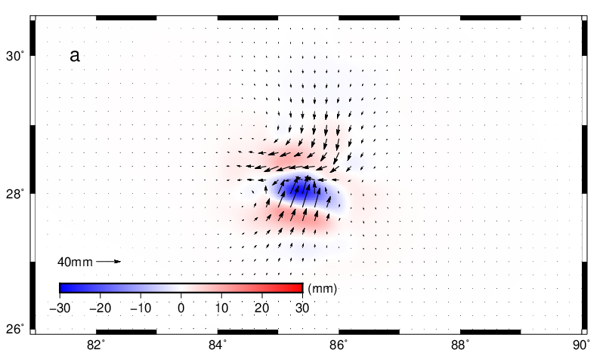
We extracted the 4.8 years postseismic deformation after 2015 Gorkha earthquake using 39 continuous GPS sites in Nepal and Tibet of China, then built a sophisticate FEM which involved totally 3-D heterogeneous material properties as well as the earth curvature and topographic surface to calculate the viscoelastic relaxation and the afterslip.

