Supplementary information: Extracting Thermodynamic, Kinetic, and Transport properties from a Simple Electrochemical pulsing protocol in Li-ion batteries
Kevin N Wood*, W. Blake Hawley, Joseph R. Gallegos, Gregory B. Less

Supplementary Note 1

Using EIS analysis to develop testing protocols
The data shown in Supplementary Fig. 1 was used to help design the pulsing experiments and inform the data analysis so that only the kinetic portion of the pulse relaxation was used. This is a one-time EIS measurement that can be used to inform analysis for like cells. Specifically, it can be used to determine internal resistance and identify the time after the pulse perturbation is removed before measuring the voltage drop. In this study we selected 2 Hz or 0.5 s after the removal of the current pulse to extracting the kinetic information. If this analysis is to be performed at the manufacturing level, multi-frequency EIS needs only to be performed one time for a specific cell, because the chemistry and geometry is the same. However, at an R&D level each time the cell geometry or chemistry changes a reference EIS spectrum should be taken and the experiment and analysis modified accordingly. In this work we recorded data every 0.1 s and the voltage drop after 0.5 s was used as the kinetic extraction point. However, to minimize data collected at a manufacturing level this data resolution should be clearly specified to limit useless data collection.

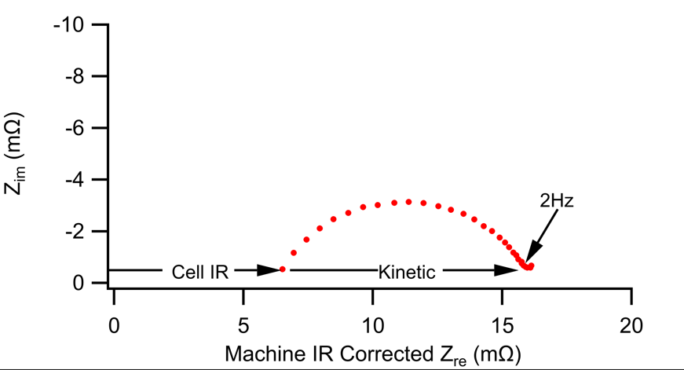
Supplementary Figure 1. EIS data used to help inform protocol setup for kinetic overpotential calculations.

Supplementary Note 2

Kinetic fitting details
Supplementary Table 1: Results for the kinetic fitting performed in Fig. 4 in the main text.
 | Charging |  |  |  |  | Discharging
 | Fitting Parameters |  |  |  | Error | Fitting Parameters |  |  |  | Error
OCV | $$j_{o}$$ | $$A$$ | $$B$$ | $$α$$ | $$R^{2}$$ | $$j_{o}$$ | $$A$$ | $$B$$ | $$α$$ | $$R^{2}$$
4.05 | 5.0567 | 0.9509 | 0.9927 | 0.3993 | 0.9991 | 4.5002 | 0.9953 | 0.9768 | 0.5699 | 0.9989
4.00 | 4.9274 | 0.9772 | 0.9985 | 0.3964 | 0.9993 | 4.5079 | 0.9953 | 0.9764 | 0.5704 | 0.9989
3.95 | 4.7455 | 0.9853 | 0.9993 | 0.4186 | 0.9997 | 4.4596 | 0.9988 | 0.9845 | 0.5712 | 0.9993
3.90 | 4.9859 | 0.9769 | 0.9988 | 0.4015 | 0.9991 | 4.4642 | 0.9998 | 0.9866 | 0.5925 | 0.9997
3.85 | 4.6604 | 0.9594 | 0.9618 | 0.4179 | 0.9993 | 4.2192 | 0.9966 | 0.9826 | 0.5667 | 0.9995
3.80 | 4.4768 | 0.9887 | 0.9995 | 0.4002 | 0.9997 | 4.6771 | 0.9982 | 0.9495 | 0.62 | 0.9999
3.75 | 4.5528 | 0.9811 | 0.9976 | 0.385 | 0.9995 | 4.5106 | 0.994 | 0.9664 | 0.6216 | 0.9995
3.70 | 4.3582 | 0.9811 | 0.9983 | 0.4115 | 0.9997 | 4.3858 | 0.9942 | 0.9745 | 0.6087 | 0.9998
3.65 | 4.2323 | 0.9837 | 0.9967 | 0.4187 | 0.9999 | 4.1159 | 0.9995 | 0.9932 | 0.5958 | 0.9996
3.60 | 4.2586 | 0.965 | 0.9993 | 0.401 | 0.9995 | 4.0527 | 1 | 0.993 | 0.5959 | 0.9998
3.55 | 4.0475 | 0.9759 | 0.9992 | 0.3949 | 0.9995 | 3.8095 | 1 | 0.9981 | 0.5778 | 0.9995
3.50 | 4.0113 | 0.9461 | 0.9995 | 0.3474 | 0.9996 | 3.9265 | 0.9992 | 0.9631 | 0.5905 | 0.999
3.45 | 3.9237 | 0.9117 | 0.9941 | 0.3364 | 0.9995 | 3.7524 | 0.998 | 0.9875 | 0.6079 | 0.9991
3.40 | 3.923733 | 0.911654 | 0.994139 | 0.336371 | 0.999472 | 3.9301 | 0.9988 | 0.9577 | 0.6425 | 0.9988

The fitting equation used for fitting the results in Supplementary Table 1 is as follows:

$$j=j_{o}\left[A e^{\frac{αnFη}{RT}}-Be^{\frac{-(1-α)nFη}{RT}}\right]$$

The fit parameters are shown in red. The variables in blue, $j$ and $η$, come from data extracted from the pulsing experiment. The rest of the variable are as follows, $n=1 mol$, $F=96485\frac{C}{mol}$, $R=8.143\frac{J}{mol K}$ and $T$ is the temperature of the experiment which was ambient temperature $T=296 K$.

It should be noted that the instrument resolution and the error in the IR calculations are of critical importance when comparing between external data sets. All cells tested on the same equipment with the same IR assumptions can be accurately compared to each other. However, comparing results from one lab to another can cause exchange current densities to vary by as much as 2-3x depending on the resolution of the system. Always take care when comparing external results.

Supplementary Note 3

Mass transport fitting details
Supplementary Table 2: Results for the transport fitting shown in Fig. 6 of the main text.
 | Charging |  | Discharge
 | Fitting Parameter | error | Fitting Parameter | error
OCV | $$D$$ | $$R^{2}$$ | $$D$$ | $$R^{2}$$
4.05 | 1.31E-12 | 0.979695 | 1.57E-12 | 0.994648
4.00 | 1.31E-12 | 0.979695 | 1.50E-12 | 0.982727
3.95 | 1.33E-12 | 0.982114 | 1.44E-12 | 0.978732
3.90 | 1.43E-12 | 0.988468 | 1.25E-12 | 0.974542
3.85 | 1.54E-12 | 0.994845 | 1.30E-12 | 0.980899
3.80 | 1.24E-12 | 0.976273 | 1.55E-12 | 0.99502
3.75 | 1.18E-12 | 0.970989 | 1.45E-12 | 0.990059
3.70 | 1.22E-12 | 0.974889 | 1.42E-12 | 0.988794
3.65 | 1.37E-12 | 0.985758 | 1.43E-12 | 0.989202
3.60 | 1.62E-12 | 0.997266 | 1.49E-12 | 0.993201
3.55 | 1.63E-12 | 0.997776 | 1.55E-12 | 0.994991
3.50 | 1.56E-12 | 0.995899 | 1.65E-12 | 0.998113
3.45 | 1.48E-12 | 0.991987 | 1.49E-12 | 0.99282
3.40 | 1.39E-12 | 0.987541 | 1.20E-12 | 0.971484

The fitting equation used for fitting the results in Supplementary Table 2 is as follows:

$$j= \frac{C z^{2} F^{2}}{2 R T}\sqrt{\frac{π D}{t}}η_{MT}$$

The fit parameters are shown in red. The variables in blue, $j$, $t$ and $η$, come from data extracted from the pulsing experiment. The rest of the variable are as follows, $z=1 mol$, $F=96485\frac{C}{mol}$, $R=8.143\frac{J}{mol K}$, $C$ is the estimated concentration of the electrolyte $C=1000\frac{mol}{m^{3}}$and $T$ is the temperature of the experiment which was ambient temperature $T=296K$. This equation was derived in the main text.
Like the kinetic fitting results, transport fitting results may vary from lab to lab, however cells tested on the same equipment with the transport extraction assumptions can be accurately compared to each other. Transport fitting results may vary by 1-3x depending on the resolution of the system used during testing.

Supplementary Note 4

Comparing pulsing results with a stacked y-axis
The following graphs help make analysis combining Fig. 2a, 3, and 5 (from the main text) easier.

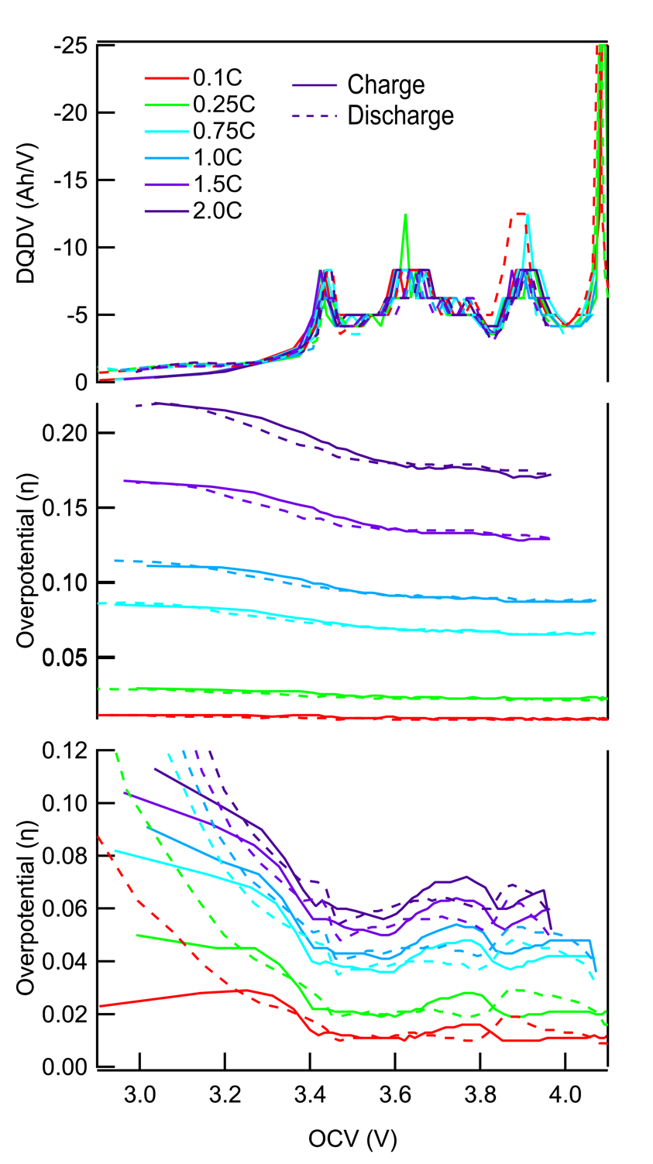
Supplementary Figure 2. Stacked view of the thermodynamic, kinetic, and transport analysis. Charge (solid lines) and discharge (dashed lines) comparing all pulses of the same capacity on a single graph. This figure may be helpful for some when evaluating this work.

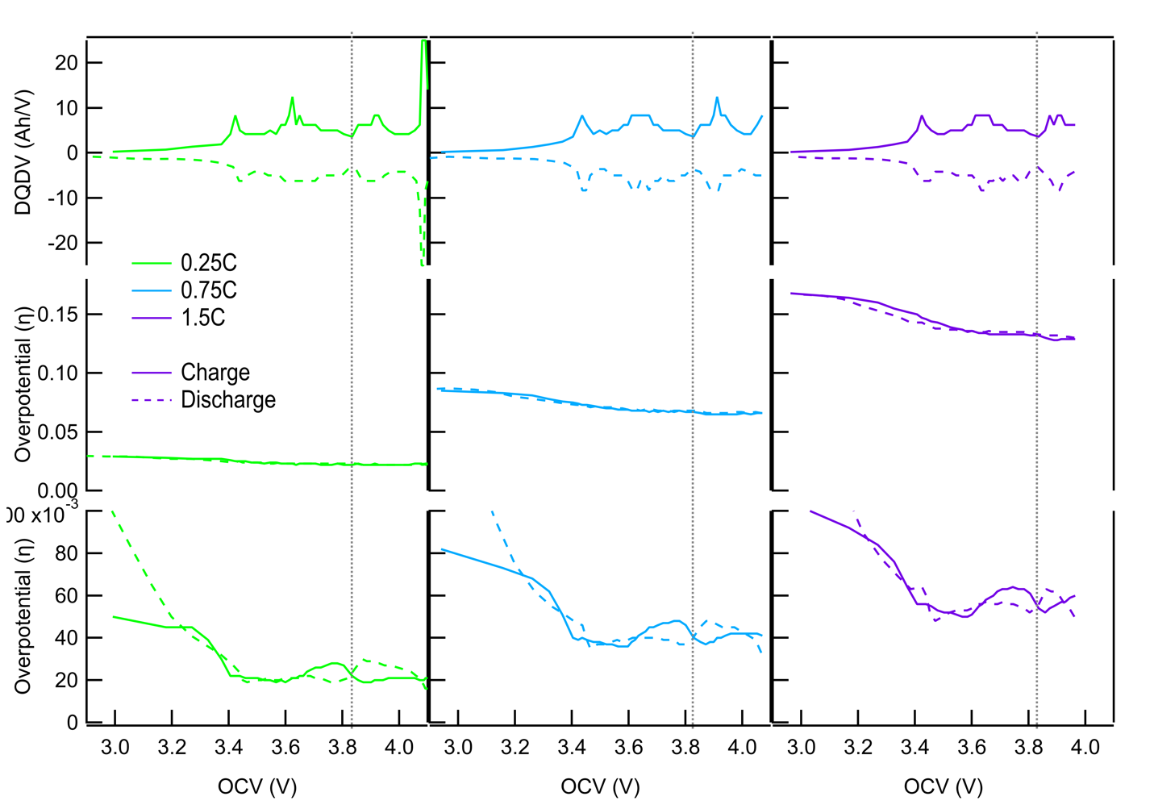
Supplementary Figure 3: Comparison of the kinetic and transport overpotentials with static DQDV as a function of C-rate. The middle lane refers to the kinetic overpotential and the bottom lane refers to the transport overpotential. The left chart (green) is for the 0.25C pulse, the center chart (blue) is for the 0.75C pulse, and the right chart (purple) is for the 1.5C pulse.

Supplementary Note 5

Gaussian s-DQDV peak fitting
Supplementary Table 3: Results for the s-DQDV peak fitting data shown in Fig. 8 of the main text.
 | Charge |  |  | Discharge
 | Area | Peak Pos | Width | Area | Peak Pos | Width | Position shift
Peak 1 | 0.641 | 4.09 | 0.024 | 1 | 4.08 | 0.023 | 0.011
Peak 2 | 2 | 4.02 | 0.403 | 0.53 | 4.01 | 0.13 | 0.01
Peak 3 | 0.269 | 3.91 | 0.069 | 0.604 | 3.9 | 0.099 | 0.009
Peak 4 | 0.611 | 3.77 | 0.17 | 0.264 | 3.78 | 0.103 | -0.012
Peak 5 | 1.021 | 3.63 | 0.103 | 1.361 | 3.66 | 0.223 | -0.03
Peak 6 | 0.378 | 3.51 | 0.1 | 0.6 | 3.5 | 0.275 | 0.007
Peak 7 | 0.307 | 3.43 | 0.036 | 0.177 | 3.44 | 0.041 | -0.014
Peak 8 | 0.452 | 3.34 | 0.256 | 0.91 | 3.16 | 0.649 | 0.18

Peak fitting for s-DQDV was performed using similar methodology to that employed by the X-ray photoelectron spectroscopy community. The peak shape for these results was based on a .3 Gauss-Lorentz factor with no asymmetry. All the fits reach convergence. The fitting range for both systems was confined from 3.0V to 4.1 V. The same fitting constraints were used for both charge and discharge analysis, therefore some small amount of peak area is cut off on discharge because the voltage dips below 3.0 V because of the different thermodynamic conditions required in lithiated silicon.

Supplementary Note 6

Manufacturing considerations
The pulsing protocol outlined in this work can be simplified to a few pulses during or after the formation cycle. As alluded to in the main text we can reduce the number of OCV regions where pulsing occurs to between 1-4 depending on the system. These pulses should be performed after a constant voltage charging step to ensure that the pulses for each cell are collected at as close to the target OCV as possible. With these considerations the added time needed to perform these pulsing experiments can be as little as a few minutes.

