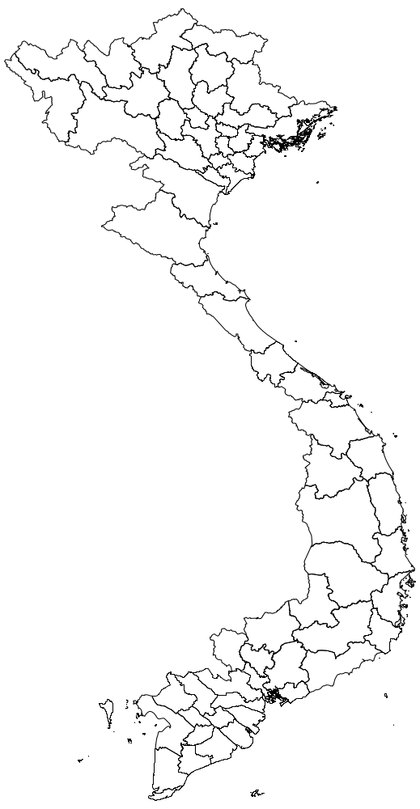
Dien Bien
Bac Giang
Quang Ninh
Tuyen Quang
Ha Noi
Lai Chau
Phu Tho
Supplementary Figure 1: Study provinces in northern Vietnam

