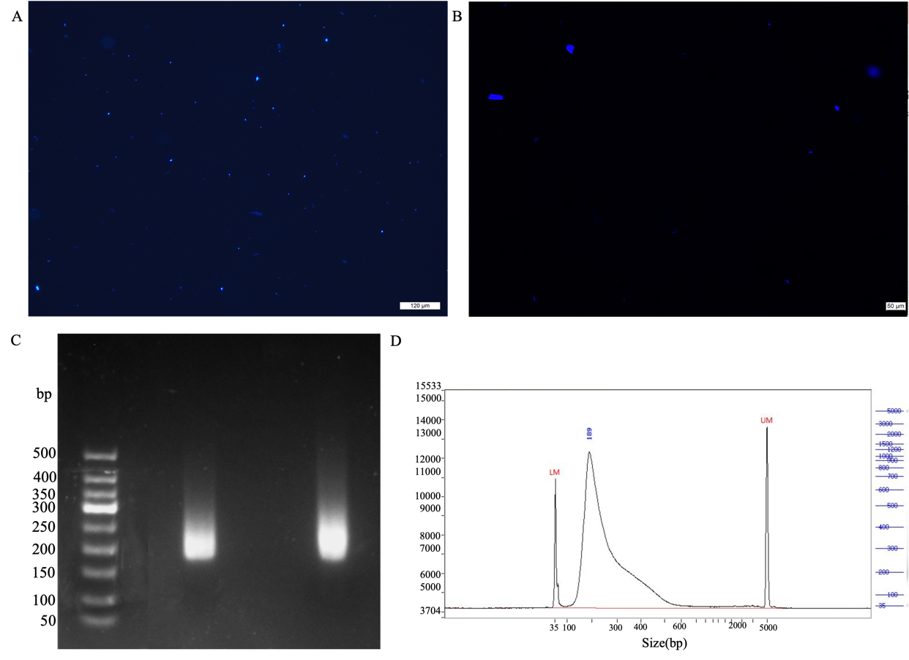
Fig.S1. Extracting nuclei and checking library in zoysiagrass. (A) Extraction of nuclei from zoysiagrass leaves. (B) Ethidium bromide-stained gel for checking nuclei. (C) Agarose gel electrophoresis of the library. (D) Library quality check.

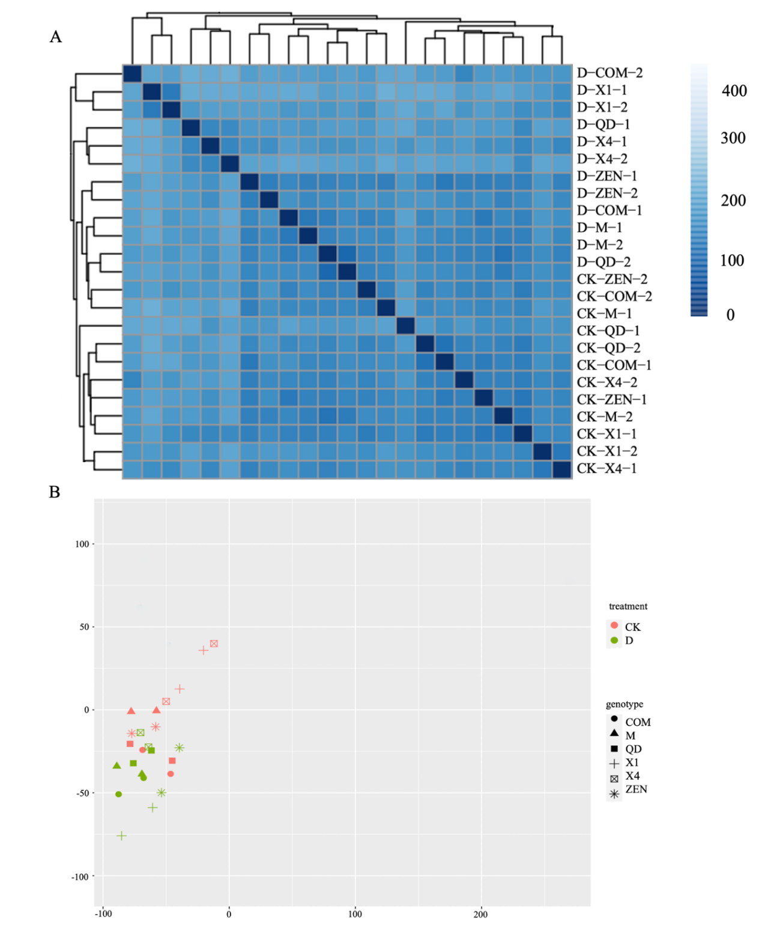

Fig.S2. Quality for RNA-seq data in zoysiagrass. (A) Reproducibility analysis of Zoysiagrass RNA-seq data using the Relative Log Expression (RLD) method. (B) Reproducibility analysis of Zoysiagrass RNA-seq data using the Variance Stabilizing Transformation (VSD) method.

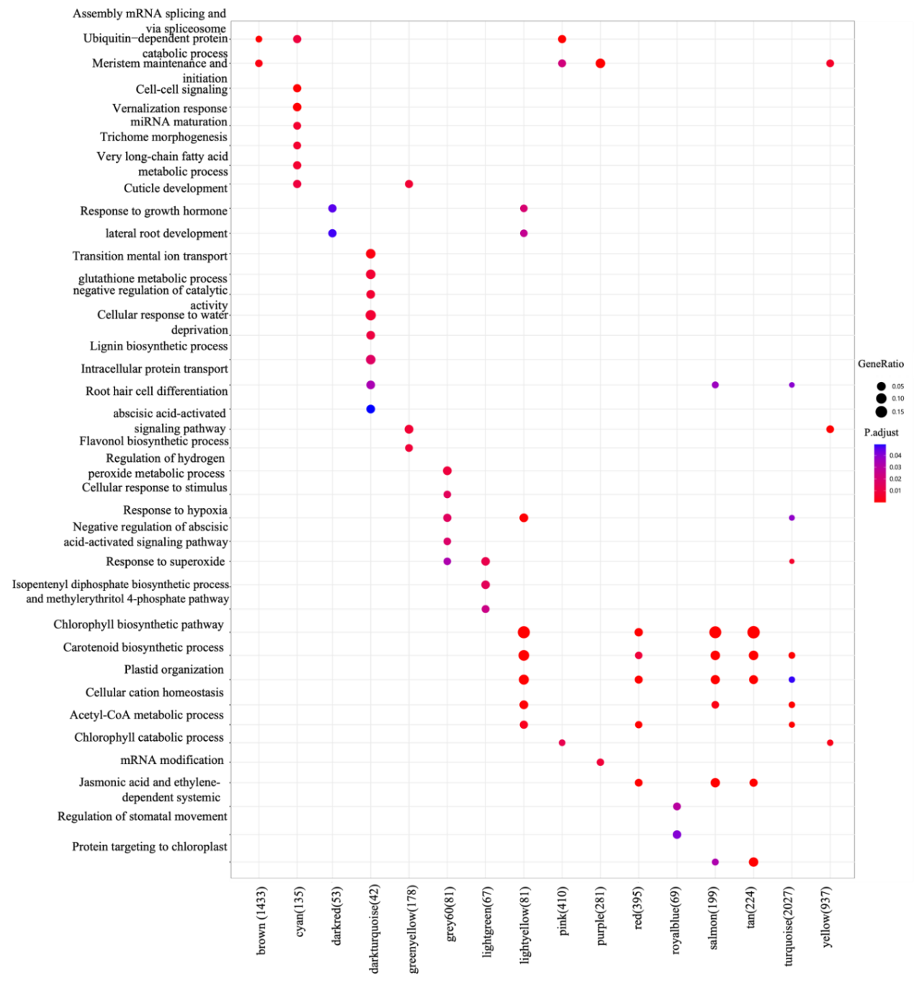
Fig.S3. Enrichment analysis of zoysiagrass.

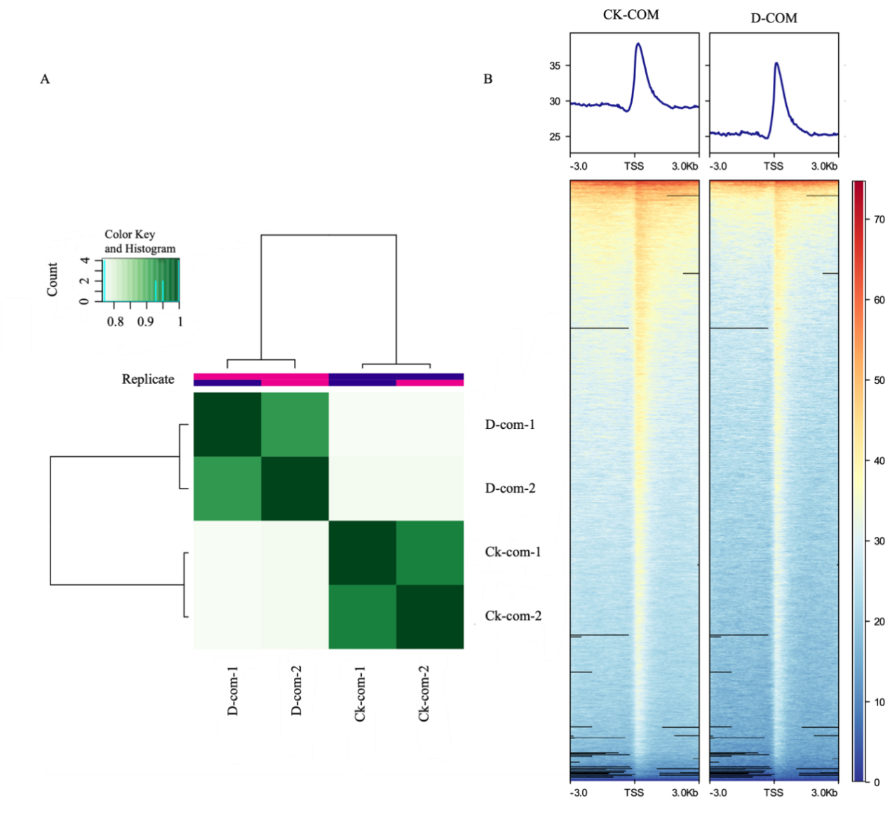
Fig.S4. Quality for isolation and ATAC-seq data in zoysiagrass. (A): Reproducibility assessment of Zoysiagrass ATAC-seq data. (B): Signal plots for calling peaks.

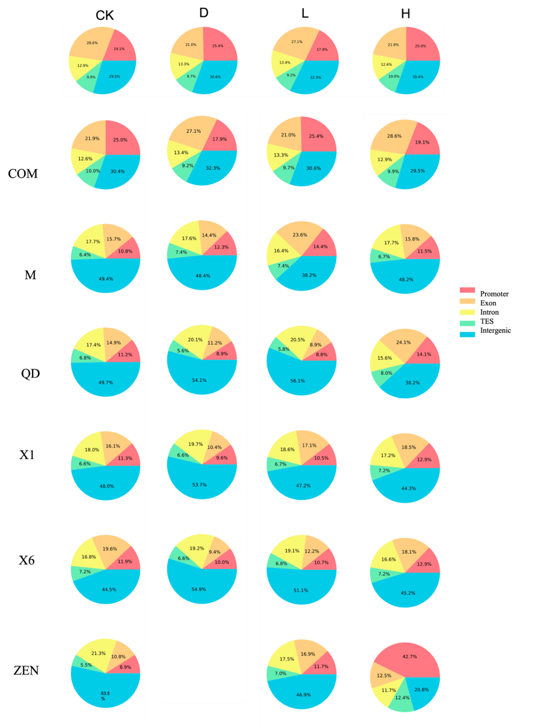
Fig.S5. Distribution of peak in gene functional elements.

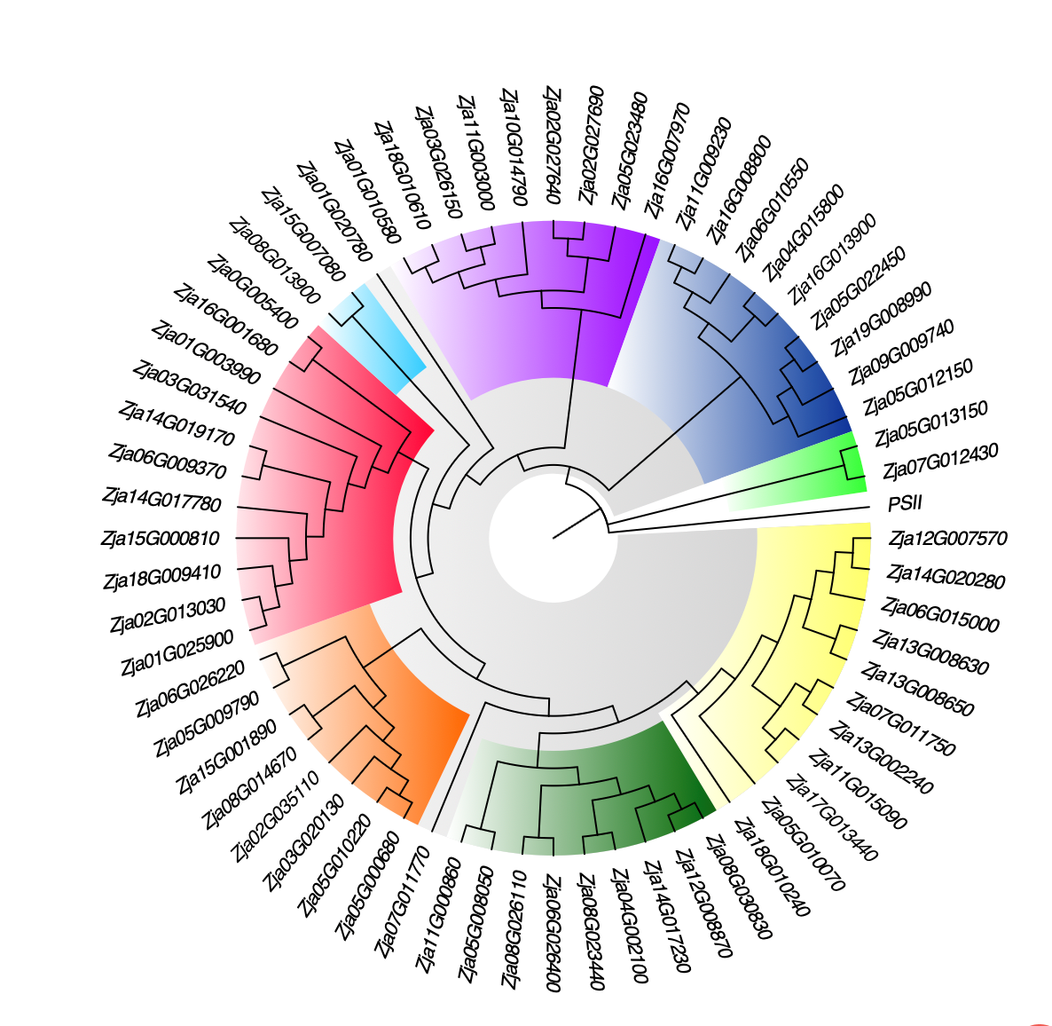
Fig.S6. Drought-resistant candidate genes in zoysiagrass
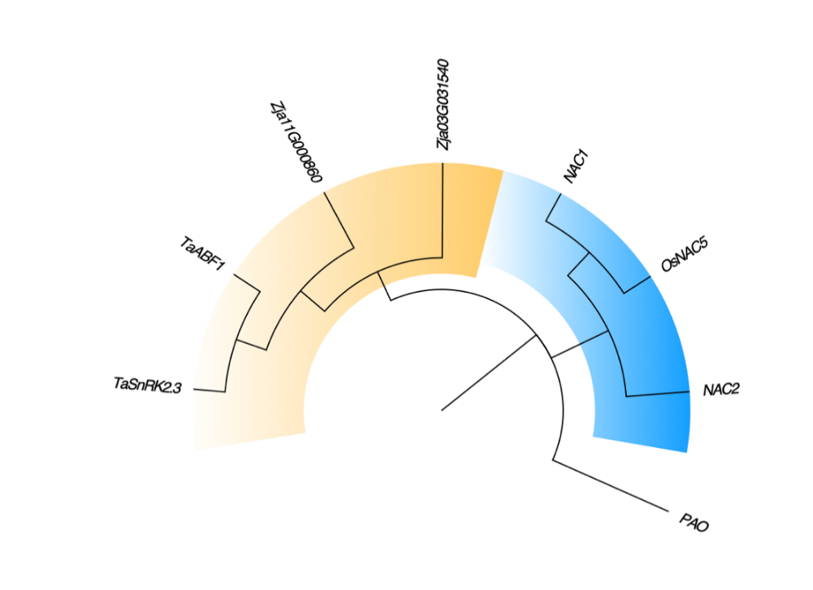
Fig.S7. Evolutionary tree of homologous genes. E-value < 1e⁻⁵.

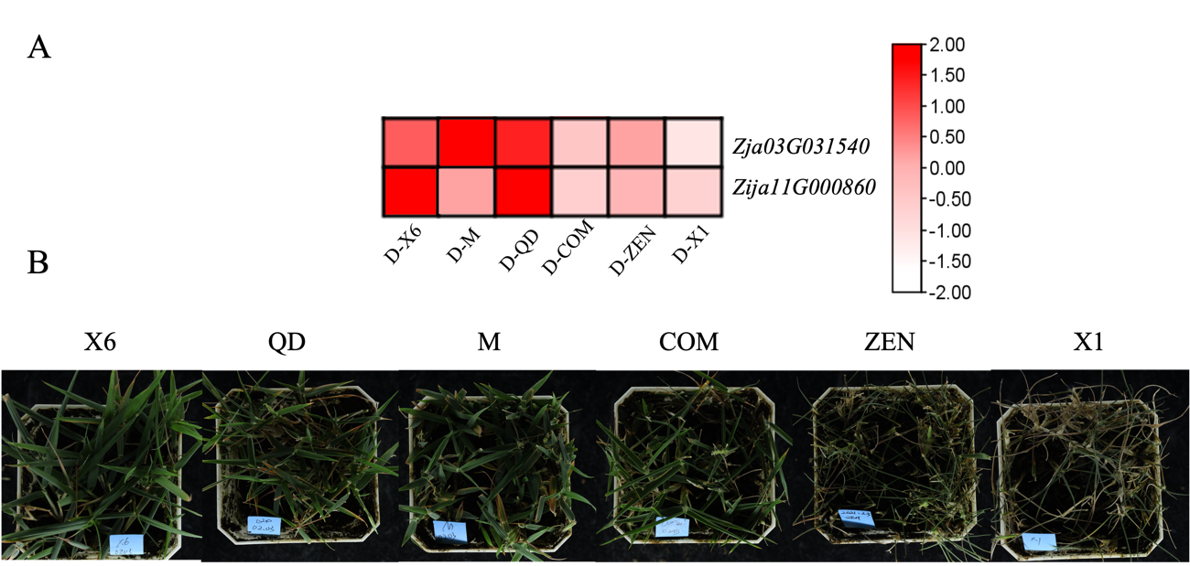
Fig.S8 The drought response of zoyssiagrass. (A) Expression of candidate drought-resistant genes in zoysiagrass. (B) Phenotypic images of zoysiagrass on the 20th day under drought stress.

Table S1. Data and analysis of ATAC-seq in zoysiagrass.
Sample name | CK dataset | CK peak | D dataset | D peak
COM | 9.45 G | 16724 | 6.24 G | 14630
M | 5.21 G | 15581 | 4.21 G | 14951
QD | 9.86 G | 22790 | 6.18 G | 3134
X1 | 4.82 G | 12618 | 4.29G | 7684
X4 | 4.21 G | 19412 | 4.65G | 13347
ZEN | 6.03 G | 30605 | 9.21 G | 19484

Table S2. Drought-related genes and its information of RT-qPCR in zoysiagrass.
Serial Number | Gene ID | Primer qPCR-F  （5’ - 3’） | Primer qPCR-R  （5’ - 3’） | Relative Expression Level | Variance
 | Zja01G003990 | CAAGCCTTACAACCCGGGAT | CAGCTTGAGCAGGATGTCCA | 3.8816 | 0.0461
 | Zja01G010580 | GGTGGTGTCGTTTCGGTACT | CAGGCTACATGGTCGGAGTC | 2.0288 | 0.5793
 | Zja01G020780 | GGTGAGAAGCCAGTTCGTGA | AGCAGAGAGAGCACTGGAGA | 3.5109 | 1.0031
 | Zja01G025900 | ACCGCCCACAGTTCTACATG | GTGTGCCTGTGCCAAATCAG | 3.3368 | 0.0021
 | Zja02G013030 | CAACATTAAGCGCGGGGATG | CCATCTTGACACGGTCACCA | 2.0836 | 1.3942
 | Zja02G018680 | CTCTCTCCTCGACCCACAGA | TCAAATTCGCGCAAACAGCA | 1.6369 | 2.7372
 | Zja02G027640 | TATCCTGCGTCGACATCAGC | AAATCAGCTGGACAGGAGCC | 0.4249 | 2.3189
 | Zja02G027690 | TATCCTGCGTCGACATCAGC | AAATCAGCTGGACAGGAGCC | 0.5417 | 0.0079
 | Zja02G035110 | TCAAATGGCGGCAACAAGTG | ACCTTCTGCATGAGGAAGCC | 2.665 | 0.0251
 | Zja03G017960 | CAACAAGACCAGGTGCGTTG | ATGACTTCTTCAGGGCTGCC | 0.6952 | 1.3149
 | Zja03G020130 | TCTGGAGGCGTGATGGAGTA | AATGTCCCCCTGCTGATTGG | 7.6413 | 0.0156
 | Zja03G026150 | TCCATCCACCAGATCCCCAT | CAGTTCGACGTCCACCTTGA | 5.2667 | 0.1423
 | Zja03G031540 | AAAAGGTGCAGTGAACCCCA | AAGCTTCGCAACTCTCCGAA | 0.2148 | 0.4267
 | Zja04G002100 | CGGCAGGACATGTCTCTCTC | ATGGGTAAACGCTCACCTGG | 10.7307 | 0.0037
 | Zja04G015800 | CGTCATCACCGCCATTCCTT | CCATCTGGAGAACCGAAGCA | 1.4109 | 0.6850
 | Zja04G032370 | CCGGCACAAAAGTCATCGAC | TCACCTCGTTCCCCATCTCT | 0.9368 | 0.0531
 | Zja05G000680 | CTGTGCCCAGTAGCATCACA | GGACGATGAGGAGATGCAGG | 5.0918 | 1.3206
 | Zja05G008050 | CGTTGGCAGACCTTGTTGTG | CCGCTGCCCATCATAAAACG | 4.929 | 0.6838
 | Zja05G009790 | TTTGCATGGCACCAATGTGG | GTAGCACCAATGGACCAGCT | 5.9464 | 0.2855
 | Zja05G010070 | TCTGCCAAACATGCCTTTGC | AAGGATGTGCGGCTCAATCA | 1.3165 | 0.4657
 | Zja05G010220 | GCGACCACCATTTCCTCTCT | GCTTCCTCCACAGTGCTCAT | 1.3318 | 0.1042
 | Zja05G012150 | TCGATGATACGACTGCTGCC | GCCAGCCTTATCATCGTCGA | 4.685 | 0.0663
 | Zja05G012980 | CCCAAGACTGCCGAGAACTT | TTTCGTGAACGCTGGTCAGA | 0.4545 | 1.9386
 | Zja05G013150 | CTGACCGGGAAGACCATCAC | GCCATAGAGTTACCGAGCCC | 7.6393 | 0.6225
 | Zja05G022450 | TCTGGGAGAGCTTTGGCAAG | CCTTGTCACCAAGCTGTTGC | 2.5741 | 0.6783
 | Zja05G023480 | GCAAGCGAGATAAAGGCTGC | TGCCCATCACCAAAACCCTT | 3.4511 | 0.0059
 | Zja06G009370 | CGGAGCCTCTTAGCCTAAGC | AGGACCAGCTCCCATCAGAT | 5.5151 | 0.0136
 | Zja06G010550 | TAGATTCGTCGCGTTACCCG | GACGACAAAACTGGTGTGGC | 13.2061 | 0.0066
 | Zja06G015000 | TCCTCTTCCTCCTCGACCTG | AGGTGTTCACTACTGGCGTG | 1.743 | 0.3078
 | Zja06G026220 | CGTCGTGTTGAACCGTTGAC | TCTGATCGCCTTCTCCAACG | 1.4613 | 1.8192
 | Zja06G026400 | AGCCGTGAGAGGAAGATTGC | GGACACCGATCATTGCAAGC | 4.0855 | 0.6063
 | Zja07G011750 | GTCCAGACCGCTAGTTTGCT | ACAGCTGCATTATGGTGCCT | 25.8072 | 0.0205
 | Zja07G011770 | CACAGGCAGATGACCGAAGT | CAAGCTGGAGTAAGCCACGA | 2.3341 | 0.5923
 | Zja07G012430 | CGGGTTCGTCAAGATGCAGA | TCCAATTCCATCCGAGCACA | 3.403 | 0.7228
 | Zja08G005310 | AAAGGGTTCCTCGCGCTG | GCTCCCTCTTCTGCAATGGT | 3.9652 | 0.0257
 | Zja08G013900 | ATCAGGGGGAAGAAGGTGGA | CCGTTCGCACAGCAATTGAT | 1.9084 | 0.8339
 | Zja08G014670 | TTCGGTGACAGCAGGAACTC | CTGTCCCCGGAATCCAGTTC | 1.8575 | 1.4550
 | Zja08G023440 | TTCTCTCCTTCCCGTGTCGA | TCAAGCCACCGTGACCAATT | 1.9243 | 0.0442
 | Zja08G026110 | TATGGGTCTGCTGCTATGCG | TGCTTACTGACACAGGCAGG | 2.4587 | 0.1527
 | Zja08G030830 | GGCTCTAGTCAAGGCTTGCA | GCACTTCCCTTTGAGAGCCT | 2.2734 | 1.1114
 | Zja09G009740 | GCCTTGTGTCCGTTAGGTCA | GGCGAGAATCCCACATCCAA | 2.8473 | 0.0172
 | Zja0G005400 | GATCTCCTGCATCGGATGGG | GTCGAAGAAGCCCTGGTTGA | 1.1837 | 0.0404
 | Zja10G014790 | AGCATAGCCTTGGGAACACC | TGCCTTTAGAGACAGCAGCC | 12.4944 | 0.4863
 | Zja11G000860 | GGCCATGTAAGGATCTCGGG | ACGACCACGCAATAAGAGCA | 0.6267 | 0.8027
 | Zja11G003000 | CTAGAGGTTGTGCTCGGAGC | GCTTCATGCCCAAAATCGCT | 4.4557 | 1.1426
 | Zja11G009230 | GGCGAGTAGGAGTCAGTTCG | ATGTCACTAGTGCCACCTGC | 1.875 | 0.0035
 | Zja11G015090 | TTCCCAGATCCCACGTTGTG | GCAATGACAACCAGATCCGC | 3.1672 | 0.0184
 | Zja12G007570 | CGAGGAGTCCATACATGCCC | CGCCGGTCGAATCTACATCA | 4.2502 | 0.1798
 | Zja12G008870 | AAGCAACTCTCATGGCCCTC | ACCATCAAGAAGGCCTCGTG | 3.4822 | 0.4441
 | Zja13G002240 | CTCCCTGGCTGAAGAAGTGG | CAGTCTTCATGTCATGCGCG | 1.5476 | 0.3657
 | Zja13G008630 | CCTCCCCTATTGTTCGAGCC | GGGGCGGTAGGATCAAGATG | 1.8485 | 6.6360
 | Zja13G008650 | GGTGGGTTCATCATGGTCGT | ACTTGTCAACGCATGCAACC | 4.149 | 0.4327
 | Zja14G017230 | TCACCTCTCTCTTCCTCCCG | CCACGCCTTCCAGTATCTCC | 2.9772 | 0.0029
 | Zja14G017780 | CAAGGTGGTTGCCATTGGTG | TTCTCCATCATGGCGACGAG | 4.2575 | 3.7851
 | Zja14G019170 | GTGTTGGGCCACGACTTTTC | GAGTAGCGATCACTCCTGGC | 0.1119 | 0.0285
 | Zja14G020280 | AGCCCTATTTCTGGTGTGGC | GCTGAAACACACCCTGCAAG | 7.9081 | 0.0005
 | Zja15G000810 | CTCTCTTCGCCAAGCTCCTC | GCACCACCTCCACCTACATT | 3.491 | 0.1224
 | Zja15G001890 | CCGCTCTACCTTGCCGTATT | AGACAACCTTCAGCTCCTGC | 4.245 | 0.7082
 | Zja15G007080 | GCACCCATCTCCTATCGACG | CGGGGAGCATGATTACCCAG | 4.4393 | 1.1596
 | Zja16G001680 | AGCGAGGACTTTGCAGAGAC | CTCGTATCCCACAGCTACGC | 1.8674 | 0.0069
 | Zja16G007970 | GCAATAAGCTTGGGCGAGTG | TGTTGTGTCAAGCCAACCCT | 2.9485 | 0.0857
 | Zja16G008800 | GCTGAGAAGAGAGGGAAGCG | AAACCGAGAACCTTGCCTCC | 20.0237 | 0.3274
 | Zja16G013900 | TGCTCAAGCCTCAACTCCTG | TCCCCTGGAGAGGTGCTATC | 2.6421 | 0.3722
 | Zja17G013440 | TCATCATGGACGTCGTCACC | CTTGGTCTGCATGACGAGGT | 1.8165 | 0.1543
 | Zja18G009390 | CGTGCTGCATTCTTCATCCG | GATCGGCACCTGAGAGGATG | 0.7329 | 0.1372
 | Zja18G009410 | TCCGGCTCTTCTGGTCAAAC | CTGTGTGGAAGAGGTTCGCT | 1.7581 | 0.0097
 | Zja18G010240 | CCAAGAAGAGGAGGGGGAGG | TCCACCCAAAACAGCCTACC | 2.1873 | 0.0014
 | Zja18G010610 | CTGGCAAGCCTACATCCACA | GCCTCGTCCATAAGAGCTCC | 0.7347 | 0.8914
 | Zja19G008990 | CAGACTGCATGTGTGTCCCT | ATCCGGTGCCTTAGAGTCCT | 0. 0472 | 0.1034
 | Zja20G005590 | ATGGGTGCTTCCTGGGAATG | CAGATTCCACGTGGAGGCTT | 2.6259 | 0.0577

