Supplementary Material
Supplementary Tables

Supplementary Table 1. Description and composition of the mock communities.
Mock community | Product name | Catalog no. | Species | Theoretical composition in Relative Abundance (%) of RRN operon
ATCC | ABRF-MGRG 10 Strain Even Mix Genomic Material | MSA-3001™ | Bacillus subtilis | 10.00
ATCC | ABRF-MGRG 10 Strain Even Mix Genomic Material | MSA-3001™ | Chromobacterium violaceum | 10.00
ATCC | ABRF-MGRG 10 Strain Even Mix Genomic Material | MSA-3001™ | Enterococcus faecalis | 10.00
ATCC | ABRF-MGRG 10 Strain Even Mix Genomic Material | MSA-3001™ | Escherichia coli | 10.00
ATCC | ABRF-MGRG 10 Strain Even Mix Genomic Material | MSA-3001™ | Halobacillus halophilus | 10.00
ATCC | ABRF-MGRG 10 Strain Even Mix Genomic Material | MSA-3001™ | Haloferax volcanii | 10.00
ATCC | ABRF-MGRG 10 Strain Even Mix Genomic Material | MSA-3001™ | Micrococcus luteus | 10.00
ATCC | ABRF-MGRG 10 Strain Even Mix Genomic Material | MSA-3001™ | Pseudoalteromonas haloplanktis | 10.00
ATCC | ABRF-MGRG 10 Strain Even Mix Genomic Material | MSA-3001™ | Pseudomonas fluorescens | 10.00
ATCC | ABRF-MGRG 10 Strain Even Mix Genomic Material | MSA-3001™ | Staphylococcus epidermidis | 10.00
Zymo | ZymoBIOMICS Microbial Community DNA Standard II (Log Distribution) | D6311 | Listeria monocytogenes | 89.90
Zymo |  | D6311 | Pseudomonas aeruginosa | 8.98
Zymo |  | D6311 | Bacillus subtilis | 0.898000
Zymo |  | D6311 | Escherichia coli | 0.089800
Zymo |  | D6311 | Salmonella enterica | 0.089800
Zymo |  | D6311 | Lactobacillus fermentum | 0.008980
Zymo |  | D6311 | Enterococcus faecalis | 0.000898
Zymo |  | D6311 | Staphylococcus aureus | 0.000090
Zymo |  | D6311 | Saccharomyces cerevisiae | NA - Fungi
Zymo |  | D6311 | Cryptococcus neoformans | NA - Fungi
Mock Community Amplicons Pooled (MCAP)  and  Mock Community gDNA Pooled (MCGD),  each with the following composition | - | - | Bacillus cereus | 4.17
 | - | - | Bifidobacterium breve | 4.17
 | - | - | Bifidobacterium infantis | 4.17
 | - | - | Bifidobacterium longum | 4.17
 | - | - | Bifidobacterium thermophilum | 4.17
 | - | - | Clostridioides difficile | 4.17
 | - | - | Clostridium perfringens | 4.17
 | - | - | Enterococcus faecalis | 4.17
 | - | - | Lacticaseibacillus paracasei | 4.17
 | - | - | Lactobacillus plantarum | 4.17
 | - | - | Lactobacillus crispatus | 4.17
 | - | - | Lactobacillus helveticus | 4.17
 | - | - | Lactococcus cremoris | 4.17
 | - | - | Lactococcus lactis | 4.17
 | - | - | Leuconostoc fallax | 4.17
 | - | - | Leuconostoc gelidum | 4.17
 | - | - | Limosilactobacillus reuteri | 4.17
 | - | - | Oenococcus oeni | 4.17
 | - | - | Pediococcus claussenii | 4.17
 | - | - | Pediococcus pentosaceus | 4.17
 | - | - | Staphylococcus aureus | 4.17
 | - | - | Streptococcus agalactiae | 4.17
 | - | - | Streptococcus mutans | 4.17
 | - | - | Weizmannia coagulans | 4.17
Supplementary Table 2. Sequences of first and second round primer pairs, with M13 sequences underlined and barcoding sequences in bold.
First round custom primers
RRN primer name | M13 PacBio tail sequence | RRN primer sequence | Full sequence
27F | /5AmMC6/GTAAAACGACGGCCAGT | AGRGTTTGATYHTGGCTCAG | /5AmMC6/GTAAAACGACGGCCAGTAGRGTTTGATYHTGGCTCAG
519F | /5AmMC6/GTAAAACGACGGCCAGT | CAGCMGCCGCGGTAA | /5AmMC6/GTAAAACGACGGCCAGTCAGCMGCCGCGGTAA
2241R | /5AmMC6/CAGGAAACAGCTATGAC | ACCRCCCC AGATHA ACT | /5AmMC6/CAGGAAACAGCTATGACACCRCCCCAGTHAAACT
2428R | /5AmMC6/CAGGAAACAGCTATGAC | CCRAMCTGTCTCACGACG | /5AmMC6/CAGGAAACAGCTATGACCCRAMCTGTCTCACGACG
Second round primers
Barcode names |  | M13 PacBio asymmetric barcode sequence
M13_PCR_Primer_bc_1001_F  M13_PCR_Primer_bc_1002_F  M13_PCR_Primer_bc_1003_F  M13_PCR_Primer_bc_1004_F  M13_PCR_Primer_bc_1005_F  M13_PCR_Primer_bc_1049_R  M13_PCR_Primer_bc_1050_R  M13_PCR_Primer_bc_1051_R  M13_PCR_Primer_bc_1052_R  M13_PCR_Primer_bc_1053_R |  | /5phos/GGTAGCACATATCAGAGTGCGGTAAAACGACGGCCAGT  /5phos/GGTAGACACACAGACTGTGAGGTAAAACGACGGCCAGT  /5phos/GGTAGACACATCTCGTGAGAGGTAAAACGACGGCCAGT  /5phos/GGTAGCACGCACACACGCGCGGTAAAACGACGGCCAGT  /5phos/GGTAGCACTCGACTCTCGCGTGTAAAACGACGGCCAGT  /5phos/GGTAGACACGTGTGCTCTCTCCAGGAAACAGCTATGAC  /5phos/GGTAGGATATACGCGAGAGAGCAGGAAACAGCTATGAC  /5phos/GGTAGCGTGTCTAGCGCGCGCCAGGAAACAGCTATGAC  /5phos/GGTAGGTGTGAGATATATATCCAGGAAACAGCTATGAC  /5phos/GGTAGCTCACGTACGTCACACCAGGAAACAGCTATGAC

Supplementary Table 3. PCR cycling conditions used to generate barcoded RRN amplicons.
First round PCR
 | 27F-2428R | 27F-2241R | 519F-2428R | 519F-2241R
Initial denaturation | 98⁰C for 30 sec | 98⁰C for 30 sec | 98⁰C for 30 sec | 98⁰C for 30 sec
15 cycles
Denaturation | 98⁰C for 10 sec | 98⁰C for 10 sec | 98⁰C for 10 sec | 98⁰C for 10 sec
Annealing | 59⁰C for 30 sec | 59⁰C for 30 sec | 64⁰C for 30 sec | 64⁰C for 30 sec
Extension | 72⁰C for 3 min 30 sec | 72⁰C for 2 min 30 sec | 72⁰C for 3 min 30 sec | 72⁰C for 2 min 30 sec
Final extension | 72⁰C for 10 min | 72⁰C for 10 min | 72⁰C for 10 min | 72⁰C for 10 min
Second round PCR
 | PacBio M13 PCR primers with 27F-2428R and 519F-2428R |  | PacBio M13 PCR primers with 27F-2241R and 519F-2241R
Initial denaturation | 98⁰C for 30 sec |  | 98⁰C for 30 sec
15 cycles
Denaturation | 98⁰C for 20 sec |  | 98⁰C for 20 sec
Annealing | 65⁰C for 15 sec |  | 65⁰C for 15 sec
Extension | 72⁰C for 3 min 30 sec |  | 72⁰C for 2 min 30 sec
Final extension | 72⁰C for 10 min |  | 72⁰C for 10 min

Supplementary Table 4. Number of reads obtained per sequencing platform for the RRN amplicons using ONT and PacBio sequencing and for the v3-v4 amplicons using Illumina sequencing.
Mock Community | RRN Primer Pair | Number of reads
Mock Community | RRN Primer Pair | PacBio | ONT | Illumina (v3-v4 primers)
ATCC | 27F-2241R | 306576 | 113557 | 525263
 | 27F-2428R | 312672 | 99368 | 525263
 | 519-2241R | 262119 | 138789 | 525263
 | 519F-2428R | 301882 | 141902 | 525263
MCAP | 27F-2241R | 257435 | 92856 | NA
 | 27F-2428R | 267127 | 88549 | NA
 | 519-2241R | 204153 | 107780 | NA
 | 519F-2428R | 259287 | 150263 | NA
MCGD | 27F-2241R | 316204 | 57461 | 588595
 | 27F-2428R | 317439 | 59625 | 588595
 | 519-2241R | 196519 | 69833 | 588595
 | 519F-2428R | 297411 | 89291 | 588595
Zymo | 27F-2241R | 192192 | 117650 | 621607
 | 27F-2428R | 151208 | 114846 | 621607
 | 519-2241R | 132610 | 113415 | 621607
 | 519F-2428R | 168171 | 140750 | 621607
Supplementary Table 5. Pairwise PERMANOVA results conducted at species level between all the classification methods and the expected community.
Classification Method | ATCC | MCAP | MCGD | Zymo
MM_FANGORN-G | 0.148 | 0.141 | 0.146 | 0.144
MM_FANGORN-R | 0.159 | 0.124 | 0.153 | 0.155
MM_rrnDB | 0.160 | 0.127 | 0.154 | 0.376
MM_MIrROR | 0.150 | 0.127 | 0.146 | 0.146
QB_FANGORN-G | 0.214 | 0.222 | 0.210 | 0.412
QB_FANGORN-R | 0.214 | 0.222 | 0.210 | 0.412
QB_rrnDB | 0.214 | 0.222 | 0.210 | 0.808
QNBT_FANGORN-G | 0.214 | 0.222 | 0.210 | 0.219
QNBT_FANGORN-R | 0.214 | 0.222 | 0.210 | 0.412
QNBT_rrnDB | 0.214 | 0.222 | 0.210 | 0.219
QVPSK_FANGORN-G | 0.214 | 0.428 | 0.210 | 0.219
QVPSK_FANGORN-R | 0.214 | 0.222 | 0.210 | 0.219
QVPSK_rrnDB | 0.214 | 0.222 | 0.210 | 0.144

Supplementary Table 6. PERMANOVA results to determine effect of RRN primer pair, clustering threshold percentage for OTU-based approaches, and classification method for each of the mock communities.
 | Model or variable | ATCC |  | MCAP |  | MCGD |  | Zymo
 | Model or variable | p value | R² | p value | R² | p value | R² | p value | R²
PacBio | With all classification methods
PacBio | RRN primer pair | 9.999e-05 | 0.066 | 9.999e-05 | 0.079 | 9.999e-05 | 0.037 | 9.999e-05 | 0.012
PacBio | Classification method | 9.999e-05 | 0.870 | 9.999e-05 | 0.729 | 9.999e-05 | 0.840 | 9.999e-05 | 0.859
PacBio | OTU clustering threshold | 0.961 | 0.006 | 0.626 | 0.017 | 0.979 | 0.005 | 0.993 | 0.002
PacBio | With the selected classification methods
PacBio | RRN primer pair | 9.999e-05 | 0.393 | 0.540 | 0.115 | 0.514 | 0.117 | 0.866 | 0.044
PacBio | Classification method | 9.999e-05 | 0.700 | 9.999e-05 | 0.894 | 9.999e-05 | 0.874 | 0.0001 | 0.716
ONT | With all classification methods
ONT | RRN primer pair | 0.049 | 0.372 | 9.999e-05 | 0.147 | 9.999e-05 | 0.131 | 0.313 | 0.093
ONT | Classification method | 0.0002 | 0.709 | 9.999e-05 | 0.833 | 9.999e-05 | 0.862 | 9.999e-05 | 0.633
ONT | With the selected classification methods
ONT | RRN primer pair | 0.052 | 0.372 | 0.698 | 0.147 | 0.765 | 0.131 | 0.890 | 0.093
ONT | Classification method | 9.999e-05 | 0.709 | 9.999e-05 | 0.833 | 9.999e-05 | 0.862 | 0.0001 | 0.633

Supplementary Table 7. Pairwise PERMANOVA results conducted at species and genus level between the RRN primer pairs for the two long-read sequencing platforms ONT and PacBio.
 | RRN Primer Pair | Species level |  |  |  | Genus level
 | RRN Primer Pair | ATCC | MCAP | MCGD | Zymo | ATCC | MCAP | MCGD | Zymo
PacBio | 27F_2241R vs 27F_2428R | 0.15 | 0.663 | 0.887 | 0.775 | 0.004 | 0.1905 | 0.934 | 0.807
PacBio | 27F_2241R vs 519F_2241R | 0.006 | 0.75 | 0.603 | 0.775 | 0.004 | 0.252 | 0.196 | 0.807
PacBio | 27F_2241R vs 519F_2428R | 0.033 | 0.663 | 0.887 | 0.775 | 0.006 | 0.1905 | 0.8436 | 0.807
PacBio | 27F_2428R vs 519F_2241R | 0.006 | 0.663 | 0.603 | 0.775 | 0.004 | 0.1905 | 0.196 | 0.807
PacBio | 27F_2428R vs 519F_2428R | 0.487 | 0.75 | 0.887 | 0.775 | 0.091 | 0.416 | 0.8436 | 0.807
PacBio | 519F_2241R vs 519F_2428R | 0.01 | 0.663 | 0.648 | 0.775 | 0.006 | 0.1905 | 0.196 | 0.807
ONT | 27F_2241R vs 27F_2428R | 0.503 | 0.6708 | 0.737 | 0.804 | 0.036 | 0.3216 | 0.693 | 0.467
ONT | 27F_2241R vs 519F_2241R | 0.15 | 0.6708 | 0.737 | 0.804 | 0.036 | 0.3216 | 0.342 | 0.467
ONT | 27F_2241R vs 519F_2428R | 0.503 | 0.6708 | 0.737 | 0.804 | 0.036 | 0.3216 | 0.3912 | 0.467
ONT | 27F_2428R vs 519F_2241R | 0.108 | 0.6708 | 0.737 | 0.804 | 0.036 | 0.3216 | 0.342 | 0.467
ONT | 27F_2428R vs 519F_2428R | 0.503 | 0.744 | 0.737 | 0.804 | 0.036 | 0.383 | 0.3912 | 0.467
ONT | 519F_2241R vs 519F_2428R | 0.108 | 0.6708 | 0.737 | 0.804 | 0.036 | 0.3216 | 0.342 | 0.467

Supplementary Table 8. Bray Curtis distance to the expected community calculated for each of the RRN amplicons generated from the four RRN primer pairs for the four mock communities at species and genus levels, and for the two long-read sequencing platforms ONT and PacBio.
Species level | RRN Primer Pair | Mock Community
Species level | RRN Primer Pair | ATCC |  | MCAP |  | MCGD |  | Zymo
PacBio | 27F-2241R | 0.53±0.05 |  | 0.53±0.16 |  | 0.64±0.11 |  | 0.10±0.08
PacBio | 27F-2428R | 0.53±0.04 |  | 0.45±0.15 |  | 0.65±0.11 |  | 0.10±0.08
PacBio | 519F-2241R | 0.64±0.04 |  | 0.53±0.16 |  | 0.63±0.15 |  | 0.06±0.05
PacBio | 519F-2428R | 0.51±0.05 |  | 0.44±0.16 |  | 0.63±0.16 |  | 0.06±0.05
ONT | 27F-2241R | 0.55±0.05 |  | 0.49±0.17 |  | 0.59±0.13 |  | 0.10±0.01
ONT | 27F-2428R | 0.54±0.04 |  | 0.45±0.18 |  | 0.60±0.13 |  | 0.10±0.01
ONT | 519F-2241R | 0.63±0.05 |  | 0.52±0.17 |  | 0.60±0.13 |  | 0.16±0.13
ONT | 519F-2428R | 0.53±0.07 |  | 0.43±0.20 |  | 0.55±0.14 |  | 0.16±0.12
Genus level | RRN Primer Pair | Mock Community
Genus level | RRN Primer Pair | ATCC | MCAP |  | MCGD |  | Zymo
PacBio | 27F-2241R | 0.45±0.04 | 0.32±0.10 |  | 0.55±0.10 |  | 0.09±0.08
PacBio | 27F-2428R | 0.44±0.05 | 0.27±0.09 |  | 0.55±0.11 |  | 0.09±0.08
PacBio | 519F-2241R | 0.54±0.05 | 0.32±0.07 |  | 0.51±0.16 |  | 0.06±0.05
PacBio | 519F-2428R | 0.41±0.05 | 0.26±0.09 |  | 0.53±0.17 |  | 0.05±0.05
ONT | 27F-2241R | 0.44±0.03 | 0.26±0.12 |  | 0.48±0.07 |  | 0.09±0.0004
ONT | 27F-2428R | 0.42±0.03 | 0.28±0.13 |  | 0.48±0.07 |  | 0.09±0.0004
ONT | 519F-2241R | 0.50±0.03 | 0.30±0.09 |  | 0.43±0.05 |  | 0.10±0.0001
ONT | 519F-2428R | 0.39±0.03 | 0.24±0.14 |  | 0.42±0.08 |  | 0.09±0.0004

Supplementary Table 9. Taxonomy profiles of the ATCC mock community at species level after the application of ≥ 0.01% relative abundance cut-off for each RRN primer pair and classification method applied, for the A) PacBio and B) ONT datasets. The symbol "-" refers an absence of Other or Unassigned taxa.
9 A). PacBio dataset
Sequencing Platform | Species | Classification Method | Relative Abundance (%)
Sequencing Platform | (expected RA at 10% for each species) | Classification Method | RRN Primer Pair
Sequencing Platform | (expected RA at 10% for each species) | Classification Method | 27F-2241R | 27F-2428R | 519F-2241R | 519F-2428R
PacBio | Bacillus subtilis | MM_FANGORN-G | 19.74 | 22.93 | 5.27 | 21.35
PacBio | Bacillus subtilis | MM_FANGORN-R | 19.74 | 22.93 | 5.27 | 21.35
PacBio | Bacillus subtilis | MM_MIrROR | 19.60 | 22.72 | 5.19 | 20.90
PacBio | Bacillus subtilis | MM_rrnDB | 15.23 | 18.16 | 2.53 | 10.08
PacBio | Bacillus subtilis | QB_FANGORN-G | 18.64 | 21.81 | 4.52 | 18.19
PacBio | Bacillus subtilis | QB_FANGORN-R | 18.64 | 21.81 | 4.52 | 18.19
PacBio | Chromobacterium violaceum | MM_FANGORN-G | 41.12 | 30.43 | 45.83 | 23.71
PacBio | Chromobacterium violaceum | MM_FANGORN-R | 41.12 | 30.43 | 45.83 | 23.71
PacBio | Chromobacterium violaceum | MM_MIrROR | 40.86 | 30.16 | 45.29 | 23.24
PacBio | Chromobacterium violaceum | MM_rrnDB | 34.73 | 25.10 | 36.92 | 19.54
PacBio | Chromobacterium violaceum | QB_FANGORN-G | 39.18 | 29.96 | 41.78 | 22.12
PacBio | Chromobacterium violaceum | QB_FANGORN-R | 39.18 | 29.96 | 41.78 | 22.12
PacBio | Enterococcus faecalis | MM_FANGORN-G | 1.35 | 1.78 | 0.94 | 1.75
PacBio | Enterococcus faecalis | MM_FANGORN-R | 1.35 | 1.78 | 0.94 | 1.75
PacBio | Enterococcus faecalis | MM_MIrROR | 1.34 | 1.77 | 0.93 | 1.71
PacBio | Enterococcus faecalis | MM_rrnDB | Not identified | Not identified | Not identified | Not identified
PacBio | Enterococcus faecalis | QB_FANGORN-G | 3.05 | 1.84 | Not identified | 1.36
PacBio | Enterococcus faecalis | QB_FANGORN-R | 3.05 | 1.84 | Not identified | 1.36
PacBio | Escherichia coli | MM_FANGORN-G | 1.81 | 2.43 | 2.51 | 2.96
PacBio | Escherichia coli | MM_FANGORN-R | 1.81 | 2.43 | 2.51 | 2.96
PacBio | Escherichia coli | MM_MIrROR | 0.03 | 0.02 | 0.07 | 0.03
PacBio | Escherichia coli | MM_rrnDB | 3.01 | 3.28 | 5.35 | 4.86
PacBio | Escherichia coli | QB_FANGORN-G | 2.70 | 2.96 | 4.73 | 4.31
PacBio | Escherichia coli | QB_FANGORN-R | 2.70 | 2.96 | 4.73 | 4.31
PacBio | Halobacillus halophilus | MM_FANGORN-G | 10.15 | 12.40 | 2.02 | 12.11
PacBio | Halobacillus halophilus | MM_FANGORN-R | 10.15 | 12.40 | 2.02 | 12.11
PacBio | Halobacillus halophilus | MM_MIrROR | 10.09 | 12.29 | 2.00 | 11.87
PacBio | Halobacillus halophilus | MM_rrnDB | 7.11 | 8.75 | 1.81 | 6.74
PacBio | Halobacillus halophilus | QB_FANGORN-G | 9.50 | 11.57 | 1.53 | 10.46
PacBio | Halobacillus halophilus | QB_FANGORN-R | 9.50 | 11.57 | 1.53 | 10.46
PacBio | Micrococcus luteus | QB_FANGORN-G | 3.92 | 2.71 | 3.76 | 4.28
PacBio | Micrococcus luteus | QB_FANGORN-R | 3.92 | 2.71 | 3.76 | 4.28
PacBio | Pseudomonas fluorescens | MM_FANGORN-G | 5.16 | 5.34 | 9.43 | 7.89
PacBio | Pseudomonas fluorescens | MM_FANGORN-R | 5.16 | 5.34 | 9.43 | 7.89
PacBio | Pseudomonas fluorescens | MM_MIrROR | 5.12 | 5.26 | 9.31 | 5.46
PacBio | Pseudomonas fluorescens | MM_rrnDB | 0.94 | 0.99 | 1.61 | 1.32
PacBio | Pseudomonas fluorescens | QB_FANGORN-G | 0.96 | 0.97 | 1.52 | 1.28
PacBio | Pseudomonas fluorescens | QB_FANGORN-R | Not identified | Not identified | Not identified | Not identified

PacBio | Staphylococcus epidermidis | MM_FANGORN-G | 10.96 | 13.61 | 15.02 | 13.26
PacBio | Staphylococcus epidermidis | MM_FANGORN-R | 10.96 | 13.61 | 15.02 | 13.26
PacBio | Staphylococcus epidermidis | MM_MIrROR | 10.89 | 13.49 | 14.84 | 13.00
PacBio | Staphylococcus epidermidis | MM_rrnDB | 5.59 | 6.73 | 7.51 | 6.74
PacBio | Staphylococcus epidermidis | QB_FANGORN-G | 10.62 | 13.39 | 13.82 | 11.90
PacBio | Staphylococcus epidermidis | QB_FANGORN-R | 10.62 | 13.39 | 13.82 | 11.90
PacBio | Other | MM_FANGORN-G | 9.69 | 11.04 | 18.93 | 16.92
PacBio | Other | MM_FANGORN-R | 9.69 | 11.04 | 18.93 | 16.92
PacBio | Other | MM_MIrROR | 12.02 | 14.26 | 22.33 | 23.74
PacBio | Other | MM_rrnDB | 33.30 | 36.91 | 44.21 | 50.62
PacBio | Other | QB_FANGORN-G | 6.28 | 9.23 | 14.95 | 13.35
PacBio | Other | QB_FANGORN-R | 1.72 | 2.01 | 3.18 | 2.90
PacBio | Unassigned | QB_FANGORN-G | 5.16 | 5.56 | 13.40 | 12.75
PacBio | Unassigned | QB_FANGORN-R | 10.67 | 13.76 | 26.69 | 24.48

9 B). ONT dataset
Sequencing Platform | Species | Classification Method | Relative Abundance (%)
Sequencing Platform | (expected RA at 10% for each species) | Classification Method | RRN Primer Pair
Sequencing Platform | (expected RA at 10% for each species) | Classification Method | 27F-2241R | 27F-2428R | 519F-2241R | 519F-2428R
ONT | Bacillus subtilis | MM_FANGORN-G | 22.08 | 25.16 | 5.15 | 21.55
ONT | Bacillus subtilis | MM_FANGORN-R | 21.79 | 24.86 | 5.10 | 20.85
ONT | Bacillus subtilis | MM_MIrROR | 22.25 | 25.43 | 5.06 | 21.31
ONT | Bacillus subtilis | MM_rrnDB | 15.73 | 18.14 | 3.95 | 15.03
ONT | Chromobacterium violaceum | MM_FANGORN-G | 35.91 | 26.27 | 42.27 | 19.80
ONT | Chromobacterium violaceum | MM_FANGORN-R | 36.03 | 26.30 | 41.74 | 19.62
ONT | Chromobacterium violaceum | MM_MIrROR | 36.21 | 26.49 | 42.27 | 19.89
ONT | Chromobacterium violaceum | MM_rrnDB | 29.56 | 20.98 | 31.20 | 13.86
ONT | Enterococcus faecalis | MM_FANGORN-G | 1.54 | 1.78 | 1.03 | 2.16
ONT | Enterococcus faecalis | MM_FANGORN-R | 1.50 | 1.77 | 1.01 | 1.71
ONT | Enterococcus faecalis | MM_MIrROR | 1.48 | 1.74 | 1.01 | 1.68
ONT | Enterococcus faecalis | MM_rrnDB | 0.08 | 0.08 | 0.07 | 0.11
ONT | Escherichia coli | MM_FANGORN-G | 2.28 | 2.54 | 4.73 | 3.78
ONT | Escherichia coli | MM_FANGORN-R | 2.23 | 2.47 | 4.59 | 3.71
ONT | Escherichia coli | MM_MIrROR | 0.15 | 0.08 | 0.33 | 0.09
ONT | Escherichia coli | MM_rrnDB | 2.24 | 2.49 | 4.77 | 3.66
ONT | Halobacillus halophilus | MM_FANGORN-G | 10.34 | 12.26 | 1.63 | 11.42
ONT | Halobacillus halophilus | MM_FANGORN-R | 10.38 | 12.29 | 1.61 | 11.33
ONT | Halobacillus halophilus | MM_MIrROR | 10.22 | 12.13 | 1.60 | 11.32
ONT | Halobacillus halophilus | MM_rrnDB | 6.84 | 8.21 | 1.40 | 5.40
ONT | Pseudomonas fluorescens | MM_FANGORN-G | 4.36 | 4.57 | 8.61 | 6.87
ONT | Pseudomonas fluorescens | MM_FANGORN-R | 4.38 | 4.58 | 8.51 | 6.82
ONT | Pseudomonas fluorescens | MM_MIrROR | 4.32 | 4.05 | 8.47 | 4.58
ONT | Pseudomonas fluorescens | MM_rrnDB | 1.43 | 1.45 | 1.43 | 1.13
ONT | Staphylococcus epidermidis | MM_FANGORN-G | 13.79 | 16.70 | 19.01 | 16.98
ONT | Staphylococcus epidermidis | MM_FANGORN-R | 13.62 | 16.61 | 19.03 | 17.11
ONT | Staphylococcus epidermidis | MM_MIrROR | 13.67 | 16.49 | 18.98 | 17.04
ONT | Staphylococcus epidermidis | MM_rrnDB | 6.20 | 7.28 | 8.16 | 6.59
ONT | Other | MM_FANGORN-G | 9.65 | 10.66 | 17.52 | 17.38
ONT | Other | MM_FANGORN-R | 10.03 | 11.05 | 18.34 | 18.76
ONT | Other | MM_MIrROR | 11.64 | 13.55 | 22.21 | 24.08
ONT | Other | MM_rrnDB | 37.86 | 41.30 | 48.90 | 54.13
ONT | Unassigned | MM_rrnDB | - | - | 0.03 | 0.03

Supplementary Table 10. Mean and Standard Deviation (SD) calculated for the Bray Curtis Dissimilarity measures obtained for each of the classification methods across the four mock communities at species and genus level.
Sequencing Platform | Species level
Sequencing Platform | Classification Method | ATCC | MCAP | MCGD | Zymo | Mean | SD
PacBio | MM_FANGORN-G | 0.47 | 0.28 | 0.45 | 0.1 | 0.32 | 0.17
PacBio | MM_FANGORN-R | 0.47 | 0.28 | 0.45 | 0.1 | 0.33 | 0.17
PacBio | MM_MIrROR | 0.53 | 0.48 | 0.54 | 0.1 | 0.41 | 0.21
PacBio | MM_rrnDB | 0.6 | 0.72 | 0.76 | 0.09 | 0.54 | 0.31
PacBio | QB_FANGORN-G | 0.49 | 0.41 | 0.77 | 0.01 | 0.42 | 0.31
PacBio | QB_FANGORN-R | 0.5 | 0.49 | 0.77 | 0.01 | 0.44 | 0.32
PacBio | QB_rrnDB | - | - | - | 0.003 | - | -
ONT | MM_FANGORN-G | 0.47 | 0.26 | 0.44 | 0.1 | 0.32 | 0.17
ONT | MM_FANGORN-R | 0.48 | 0.31 | 0.46 | 0.1 | 0.34 | 0.18
ONT | MM_MIrROR | 0.54 | 0.46 | 0.53 | 0.1 | 0.41 | 0.21
ONT | MM_rrnDB | 0.63 | 0.7 | 0.75 | 0.34 | 0.6 | 0.18
Illumina | QNBT_greengenes2 | 0.68 | - | 0.52 | 0.91 | 0.7 | 0.2
Sequencing Platform | Genus level
Sequencing Platform | Classification Method | ATCC | MCAP | MCGD | Zymo | Mean | SD
PacBio | MM_FANGORN-G | 0.37 | 0.15 | 0.39 | 0.09 | 0.25 | 0.15
PacBio | MM_FANGORN-R | 0.37 | 0.15 | 0.39 | 0.09 | 0.25 | 0.15
PacBio | MM_MIrROR | 0.37 | 0.27 | 0.41 | 0.09 | 0.28 | 0.14
PacBio | MM_rrnDB | 0.46 | 0.36 | 0.5 | 0.09 | 0.35 | 0.18
PacBio | QB_FANGORN-G | 0.39 | 0.29 | 0.73 | 0.004 | 0.35 | 0.3
PacBio | QB_FANGORN-R | 0.47 | 0.33 | 0.73 | 0.01 | 0.39 | 0.3
PacBio | QB_rrnDB | - | - | - | 0.003 | - | -
ONT | MM_FANGORN-G | 0.37 | 0.14 | 0.37 | 0.09 | 0.24 | 0.15
ONT | MM_FANGORN-R | 0.37 | 0.14 | 0.37 | 0.09 | 0.24 | 0.15
ONT | MM_MIrROR | 0.38 | 0.26 | 0.39 | 0.09 | 0.28 | 0.14
ONT | MM_rrnDB | 0.43 | 0.43 | 0.53 | 0.09 | 0.37 | 0.19
Illumina | QNBT_greengenes2 | 0.2 | - | 0.23 | 0.05 | 0.16 | 0.09
Illumina | QNBT_SILVA | 0.29 | - | 0.26 | 0.05 | 0.2 | 0.13

Supplementary Table 11. Pairwise Wilcoxon test results conducted between the classification methods for each mock community at species and genus level, detailing the p values for only those pairwise comparisons that showed statistical significance (p < 0.05).
Species level | Classification Method 1 | Classification Method 2 | p value | sig.
PacBio | MM_rrnDB | MM_FANGORN-G | 0.00076 | ***
PacBio | QB_FANGORN-G | MM_FANGORN-G | 0.00520 | **
PacBio | QB_FANGORN-R | MM_FANGORN-G | 0.01084 | *
PacBio | QB_rrnDB | MM_FANGORN-G | 0.00001 | ****
PacBio | MM_rrnDB | MM_FANGORN-R | 0.00076 | ***
PacBio | QB_FANGORN-G | MM_FANGORN-R | 0.00520 | **
PacBio | QB_FANGORN-R | MM_FANGORN-R | 0.01084 | *
PacBio | QB_rrnDB | MM_FANGORN-R | 0.00001 | ****
PacBio | MM_rrnDB | MM_MIrROR | 0.00006 | ****
PacBio | QB_FANGORN-G | MM_MIrROR | 0.00281 | **
PacBio | QB_FANGORN-R | MM_MIrROR | 0.00701 | **
PacBio | QB_rrnDB | MM_MIrROR | 0.00001 | ****
PacBio | QB_rrnDB | MM_rrnDB | 0.00001 | ****
PacBio | QB_rrnDB | QB_FANGORN-G | 0.01084 | *
PacBio | QB_rrnDB | QB_FANGORN-R | 0.01084 | *
ONT | MM_rrnDB | MM_FANGORN-G | 0.00001 | ****
ONT | MM_rrnDB | MM_FANGORN-R | 0.00114 | **
ONT | MM_rrnDB | MM_MIrROR | 0.000005 | ****
Genus level | Classification Method 1 | Classification Method 2 | p value | sig.
PacBio | MM_rrnDB | MM_FANGORN-G | 0.00183 | **
PacBio | QB_FANGORN-G | MM_FANGORN-G | 0.01693 | *
PacBio | QB_FANGORN-R | MM_FANGORN-G | 0.03313 | *
PacBio | QB_rrnDB | MM_FANGORN-G | 0.00008 | ****
PacBio | MM_rrnDB | MM_FANGORN-R | 0.00336 | **
PacBio | QB_FANGORN-G | MM_FANGORN-R | 0.01969 | *
PacBio | QB_FANGORN-R | MM_FANGORN-R | 0.04127 | *
PacBio | QB_rrnDB | MM_FANGORN-R | 0.00008 | ****
PacBio | MM_rrnDB | MM_MIrROR | 0.00008 | ****
PacBio | QB_FANGORN-G | MM_MIrROR | 0.00290 | **
PacBio | QB_FANGORN-R | MM_MIrROR | 0.00670 | **
PacBio | QB_rrnDB | MM_MIrROR | 0.00008 | ****
PacBio | QB_rrnDB | MM_rrnDB | 0.00016 | ***
PacBio | QB_rrnDB | QB_FANGORN-G | 0.01969 | *
PacBio | QB_rrnDB | QB_FANGORN-R | 0.01693 | *
ONT | MM_rrnDB | MM_FANGORN-G | 0.000002 | ****
ONT | MM_rrnDB | MM_FANGORN-R | 0.000003 | ****
ONT | MM_rrnDB | MM_MIrROR | 0.00000005 | ****

Supplementary Figures
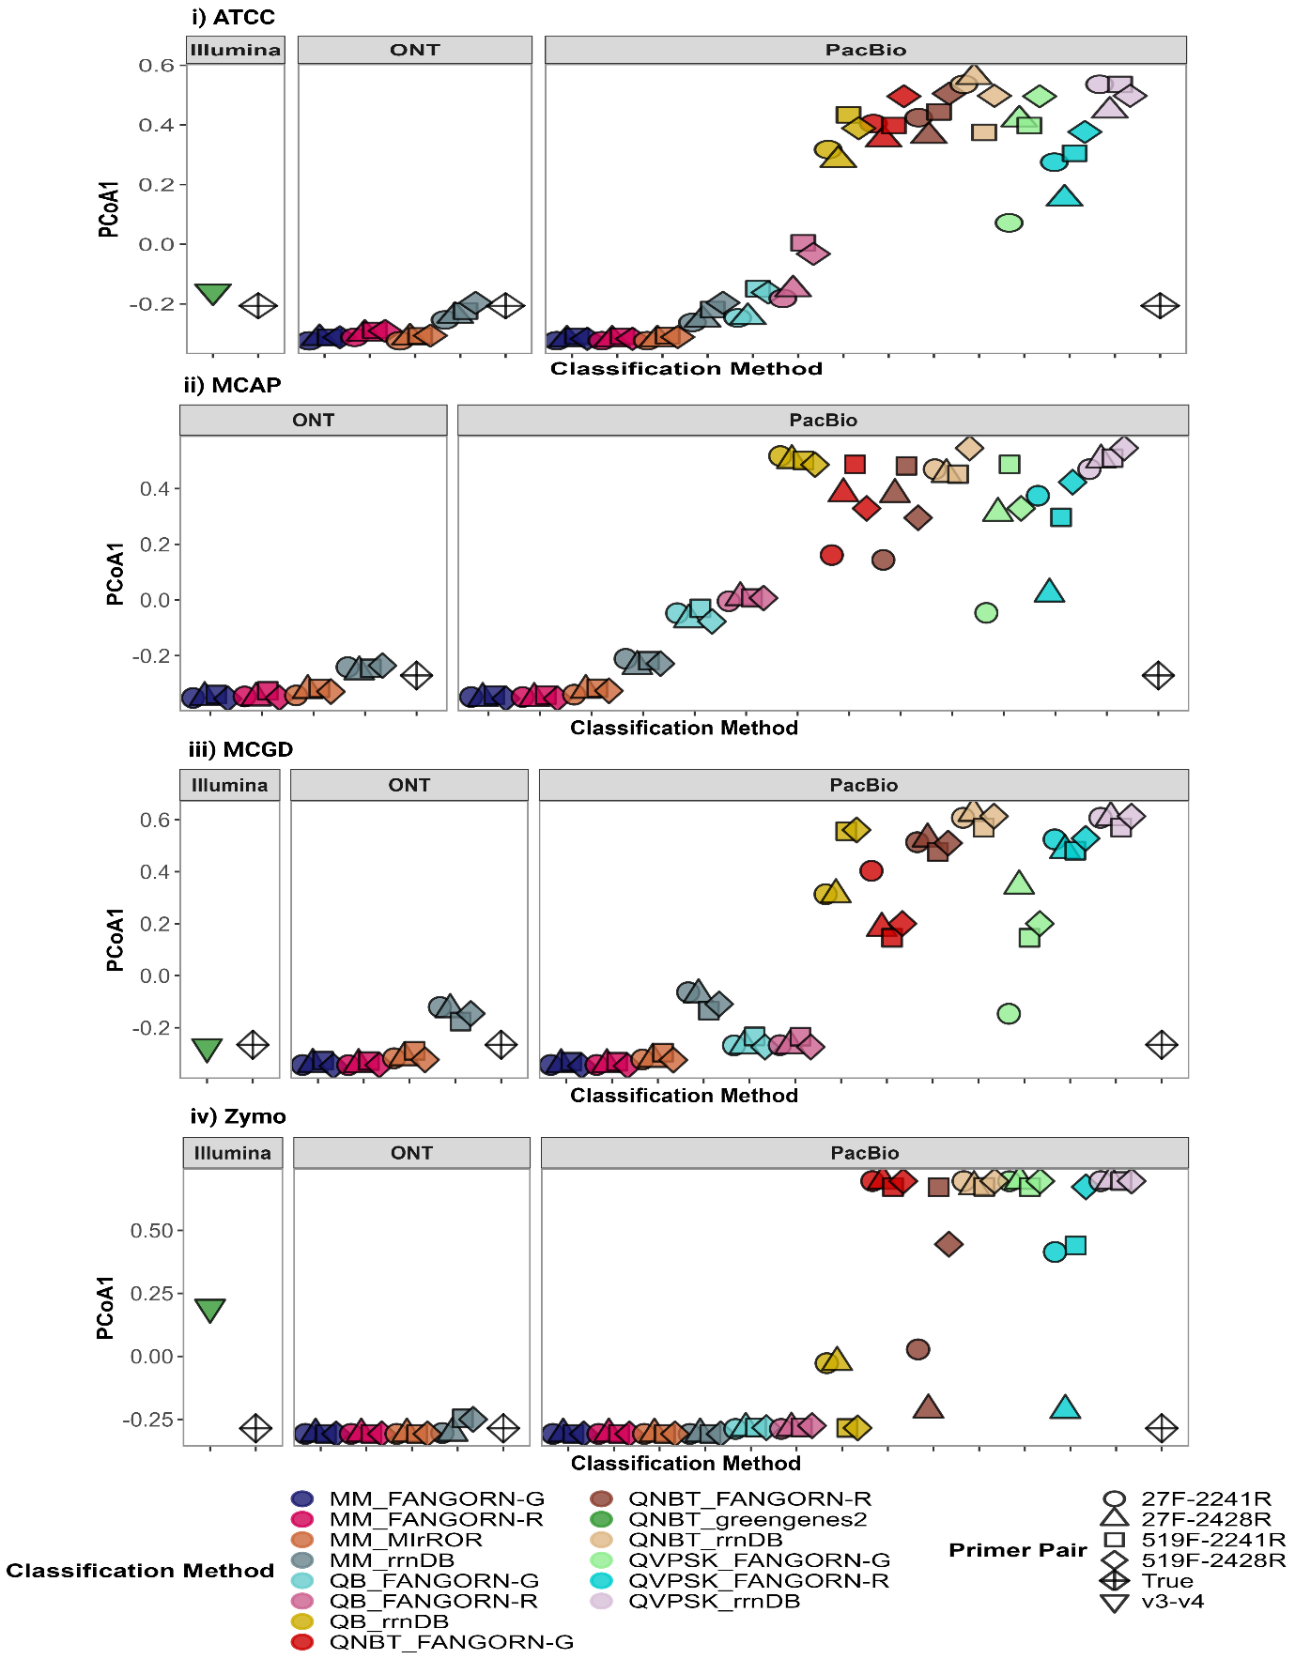
Supplementary Figure 1. Dot plots of the PCoA component (y axis) calculated using the Bray Curtis Dissimilarity matrix against the classification methods (x axis) for each of the four mock communities (i – iv) at species level, and separated by sequencing platform with Illumina including the v3-v4-based approaches and ONT and PacBio including the RRN-based approaches. Here the expected community is labelled as True (see Primer pair legend for shape) and the classification methods clustering closer (in terms of the y axis value) to the point “True” were selected for further analysis.
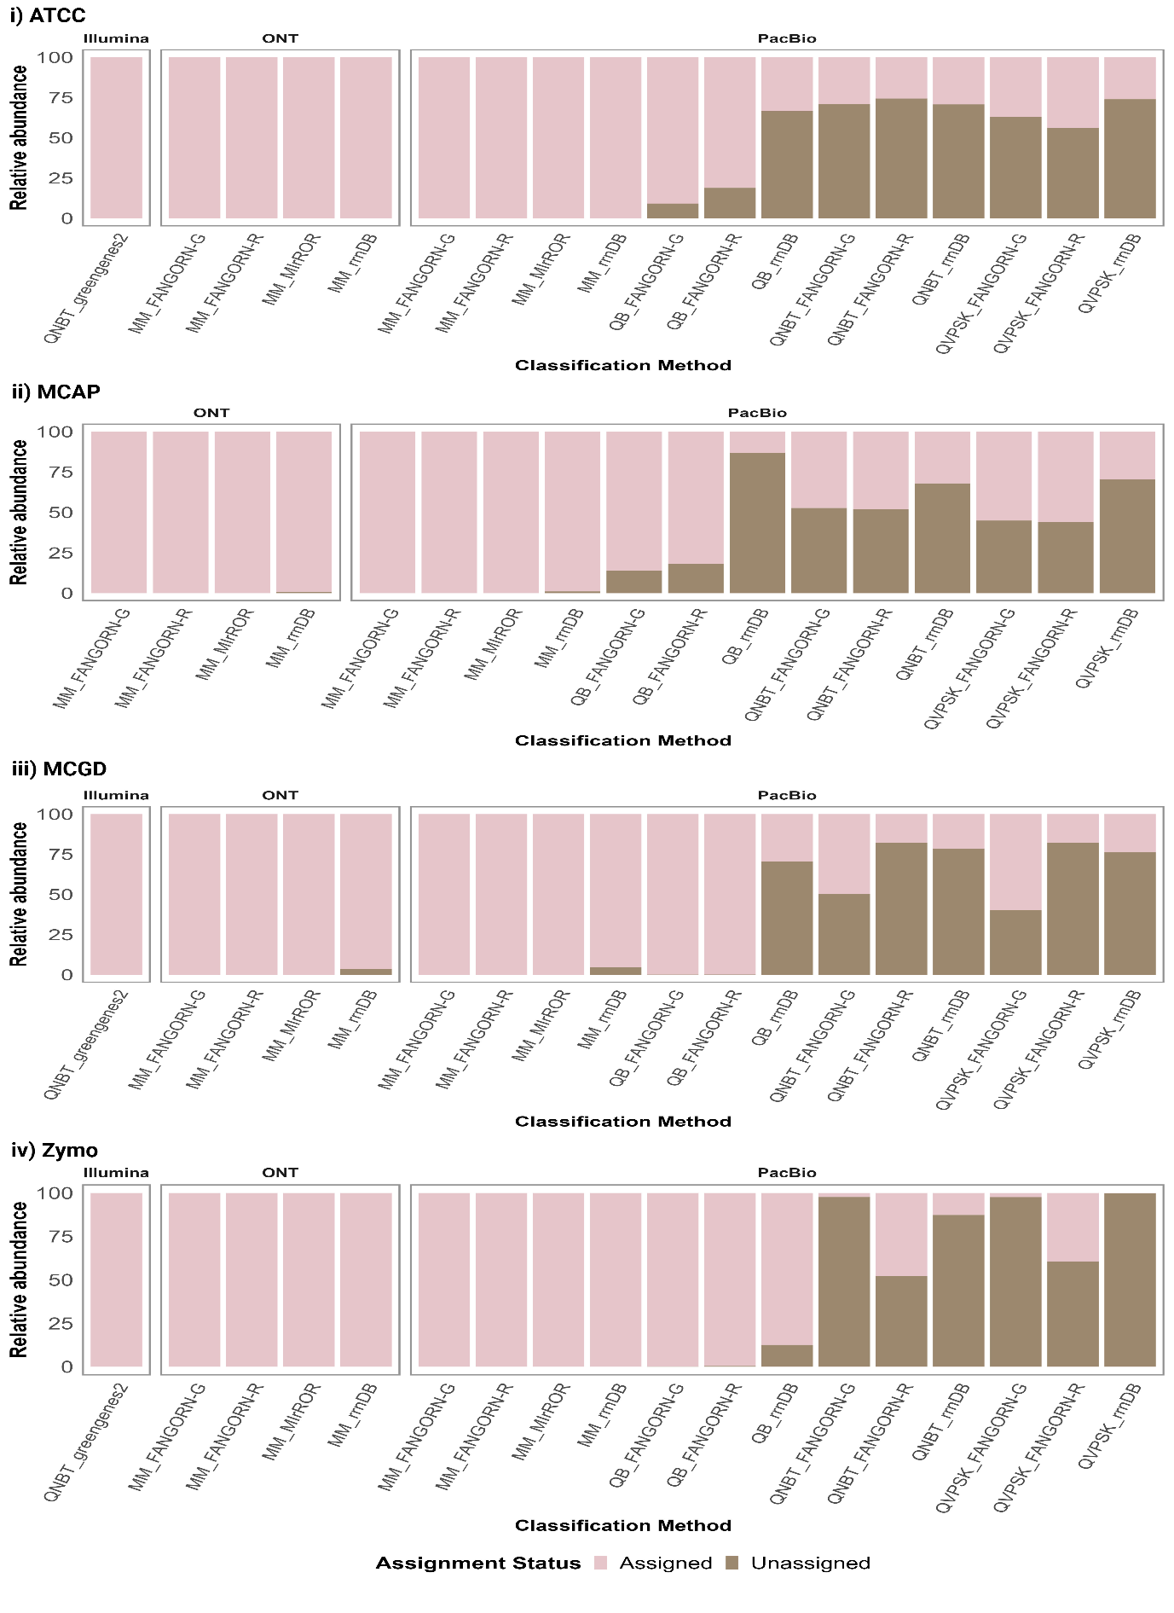
Supplementary Figure 2. Bar plots illustrating the relative abundance (y axis) assigned vs unassigned taxa classified at species level by the classification methods (x axis) for each of the four mock communities (i - iv), split by sequencing platform. Higher numbers of unassigned taxa were found corresponding to the classification methods that clustered further away from “True” in Supplementary Figure 1 and hence were excluded from further analysis.
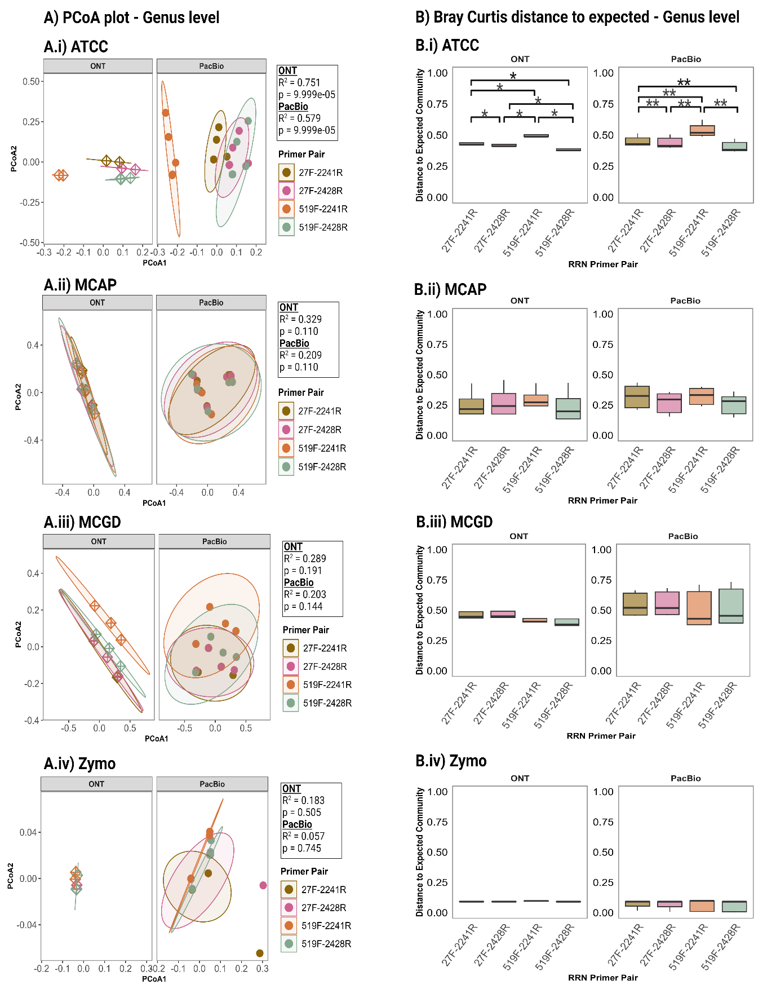
Supplementary Figure 3. (A) PCoA plots showing the clustering patterns of the RRN amplicons generated from the four RRN primer pairs at genus level divided by sequencing platform for each mock community (i - iv) with the boxes to the right demonstrating the PERMANOVA R² and p values for the RRN amplicons for the two sequencing platforms; (B) Box plots showing the Bray Curtis distance to the expected community (y axis) for the four RRN amplicons (x axis) at genus level segmented by sequencing platform for each mock community (i - iv).
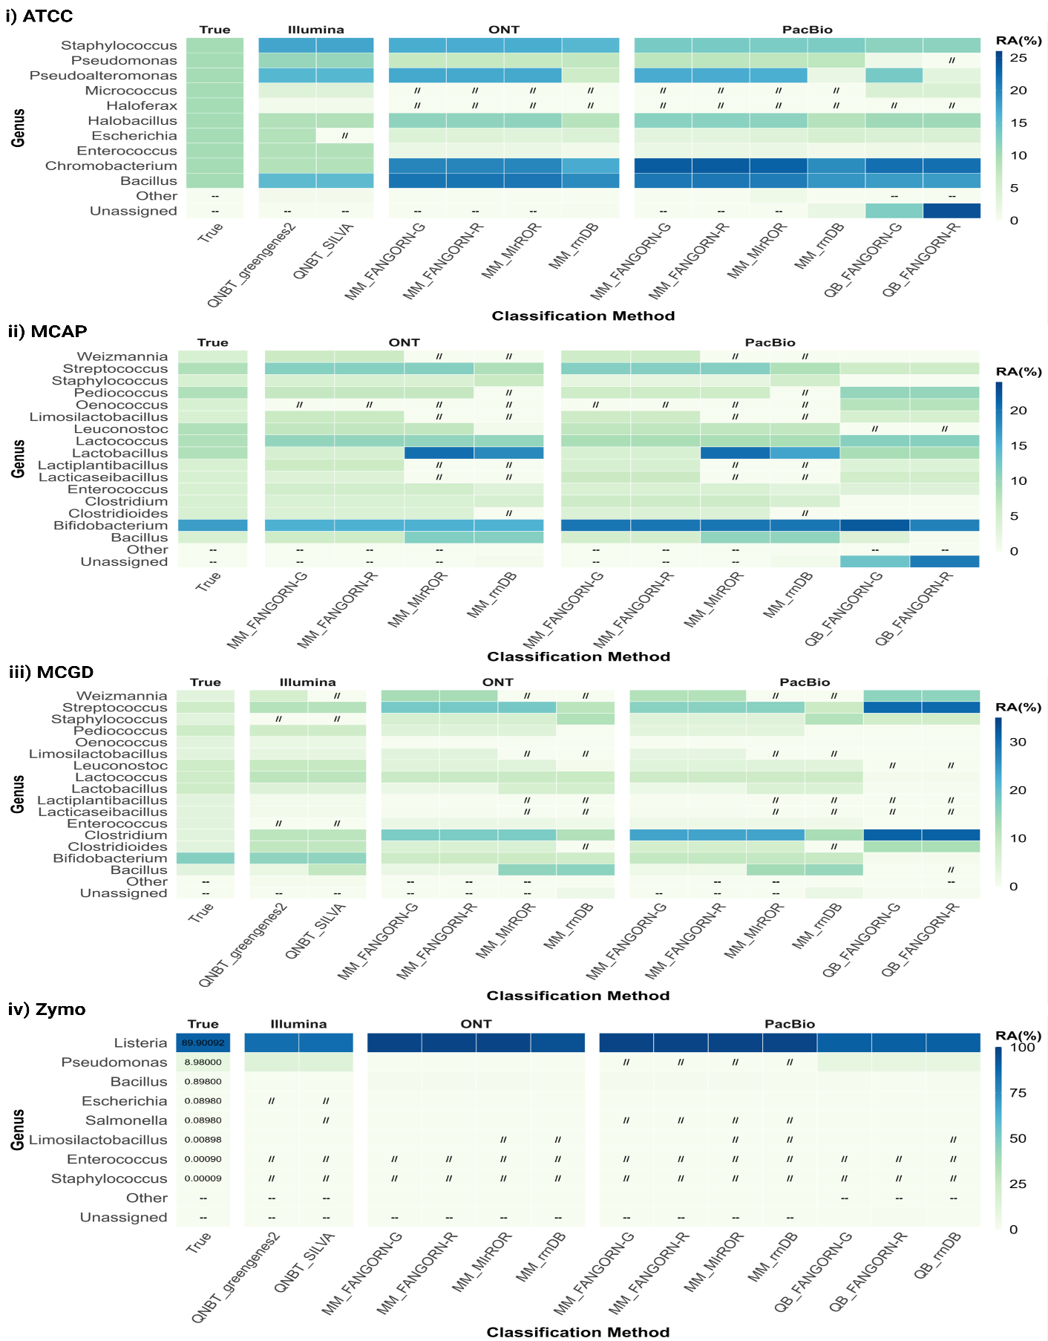
Supplementary Figure 4. Heatmaps demonstrating the Relative Abundance (RA scale to the right of each plot) estimates provided by each of the classification methods (x axis) for the genus (y axis) present within the mock communities (i - iv) vs the expected relative abundances (labelled as True), partitioned per sequencing platform. The symbol “//” indicates a lack of detection for a truly present species within the mock community, and “--” shows an absence of Other or Unassigned taxa.
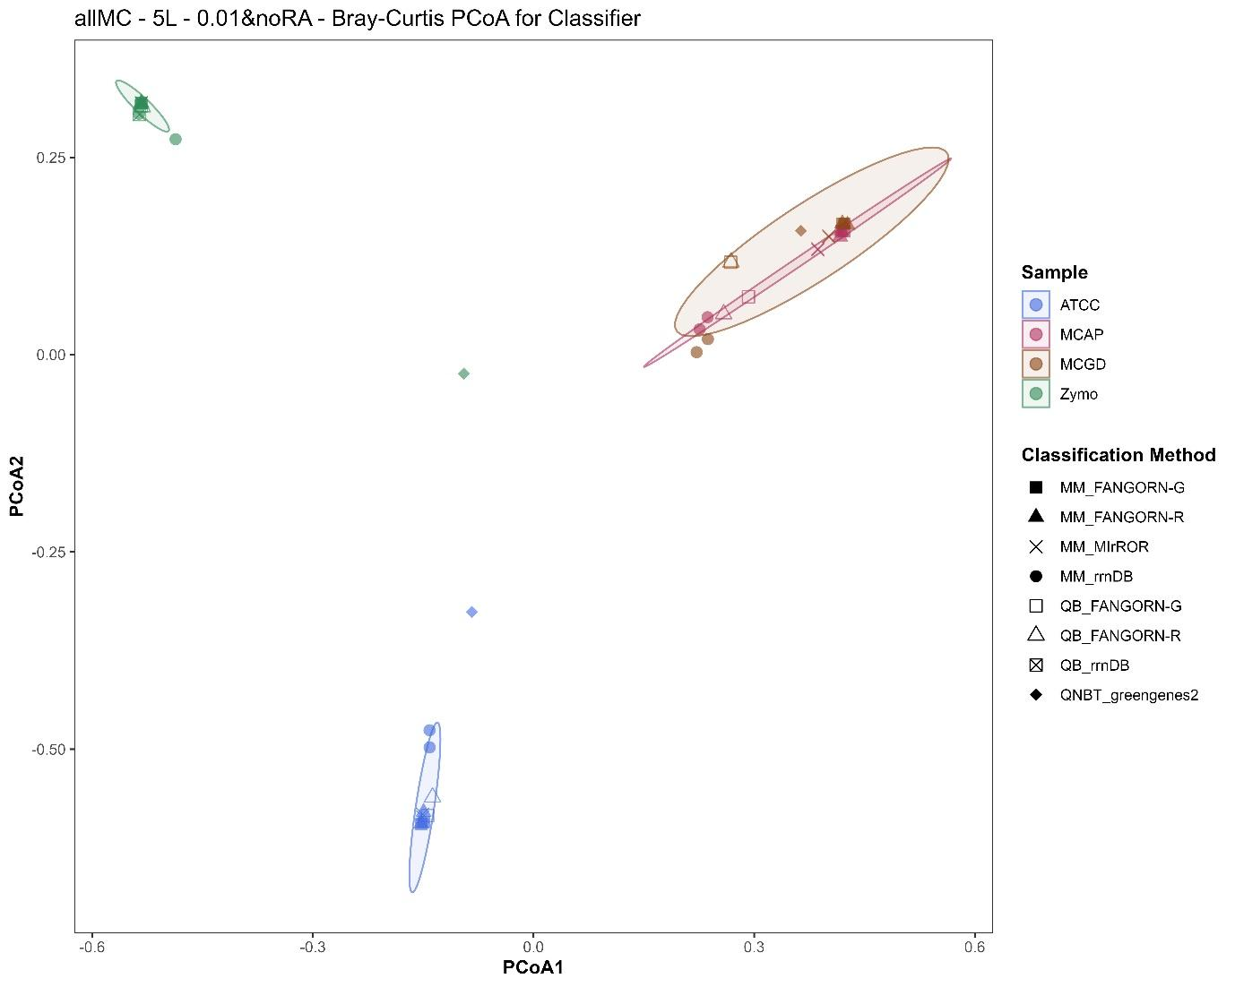
Supplementary Figure 5. PCoA plot illustrating the clustering between the four mock communities at species level, where the two mock communities ATCC and Zymo are seen to be distinct, and the in-house mock communities with the RRN amplicons-pooled (MCAP) and gDNA-pooled (MCGD) versions overlapping each other indicating similar representations between the two versions by the classification methods.

