Supplementary Data
Synthesis and novel derivatives of indazoles with DFT studies
Bandaru Gopi¹, Vijayaparthasarathi Vijayakumar²
Centre of Organic and Medicinal Chemistry, Department of Chemistry, School of Advanced Science, VIT-Vellore,632014
Table of contents
- General methods…………………………………………………………1-1
- Scheme and Experimental procedure…………………………………....1-4
- ¹H and ¹³C NMR, Dept-135, COSY, HSQC, IR and HRMS spectra of the compounds……………………4-90
- DFT studies indazole derivatives with HOMO and LUMO values and Docking results from (8a-8z) 3-carboxamide indazole derivatives……………………………………….………………90-114

1. General methods
All the reactions were carried out in round bottom flasks. All the solvents and chemical materials were purchased from commercial sources. The 1-butyl-1H-indazole-3-carboxamide was prepared according to the reported protocols. ¹H and ¹³C NMR spectra were recorded on Bruker Avance400 spectrometer and are referred to the residual solvent signal CDCl₃: (7.26) for ¹H and (77.16) for ¹³C NMR: dimethyl sulfoxide-d₆ (2.50) for ¹H and (39.50) for ¹³C NMR: chemical shift (δ) 3is given in ppm and coupling constant (J) were measured in Hz. The following abbreviations are used: s- singlet, d-doublet, dd-doublet of doublet, t-triplet, td-triplet of doublet, dt- doublet of triplet, q-quartet, qd- quartet of doublet, qn-quintet, br-broad, m-multiplet. HRMS ESI-MS was recorded using Xeo G2 XS OT of (water) and values are given m/z. Colum chromatography was carried out using silica gel (100-200 mesh) packed in a glass column. Analytical TLC was carried out on Macherey-Nagel 60 F245 aluminium-backed silica gel plates.
2. Scheme and Experimental procedure for indazole derivative
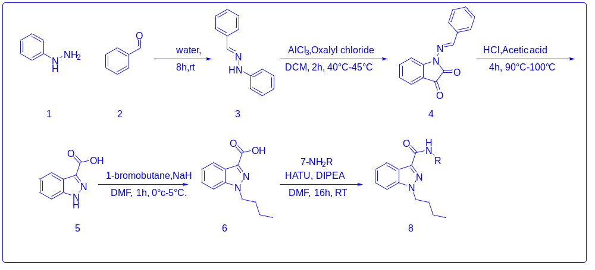
Table-1
2.1. Preparation of 2-benzylidene-1-phenylhydrazine (3):
To a stirred solution of phenyl hydrazine (50 gm) in water (500mL, 10 vol), add benzaldehyde (equivalent) very slowly at room temperature and stir for 8h. TLC showed the completion of starting material. Filter off the solid washed with water (150 mL) and chilled isopropyl alcohol (50 mL), and dry the solid under the oven at 70°C to 80°C for 8h to get 2-benzylidene-1-phenylhydrazine as a white solid
2.2. Preparation of 1H-indazole-3-carboxalic acid (5):
To a stirred solution of 2-benzylidene-1-phenylhydrazine (70 gm) in DCM (500 mL), oxalyl chloride (1.05 equivalent) was added at room temperature and stirred at 40°C to 45°C for 2h. TLC showed the completion of 2-benzylidene-1-phenylhydrazine, add aluminium trichloride (1.5 equivalent) at 40°C to 45°C and stir for 2h. TLC showed the completion of the intermediate (oxalyl chloride intermediate). Poured the reaction mixture into cooled water (350 mL), wash the combined organic layer and extract the aqueous layer with DCM (2x200 mL), wash the combined organic layer with 10% HCl and brine solution. Dry the organic layer over sodium sulphate and concentrated under reduced pressure. To the obtained crude add acetic acid (300 mL) and conc. HCl (100 mL), heated at 90°C to 100°C for 4h. Cool the reaction mixture to room temperature and stir for 2h. Filter off the solid material and washed with water. Dissolve the obtained solid into 5N sodium hydroxide solution, filter off the solid, wash with water, and discard the solid material. Take the aqueous layer into round bottom flask, and acidify the layer with conc. HCl up to pH 2, stir for 30 min and filter off the solid, wash the solid with water and dry the solid material under oven at 80°C for 4-5h to get 1H-indazole-3-carboxylic off white solid.
2.3. Preparation of 1-butyl-1H-indazole-3-carboxylic acid:
To a stirred suspension of sodium hydride (1.2 equivalent) in DMF (250 mL), add 1H-indazole-carboxylic acid (50 gm) dissolved in DMF (150 mL) at 5°C and stir for 1h. To this reaction, mass adds 1-Bromobutane (1.05 equivalent) at 10°C and stir at room temperature for 8h. TLC showed the completion of starting material and the formation of the non-polar spot. Quenched the reaction mass into ice water, wash the aqueous layer with ethyl acetate, and acidify the organic layer using con. HCl up to pH reaches 1, extract the layer with ethyl acetate (2 x 200 mL), wash the organic layer with brined solution (2 x 100 mL), dry over sodium sulphate and concentrate. The obtained crude was stirred in n-hexane at 15°C for 1h. Filter off the solid compound, wash with chilled hexane, after that washed with sodium bicarbonate and organic layer was acidify with conc. HCl up to PH 2, concerted organic layer under reduced pressure to obtained solid was dried in oven at 50°C-60°C to get 1-butyl-1H-indazole-3-carboxylic acid as off white solid.
2.4. General Procedure for the synthesis 8a-8z:
To a stirred solution of 1-butyl-1H-indazole-3-carboxylic acid (250 mg, 1.146mmol) was dissolved in DMF (10 mL), HATU (2 equivalents) and DIPEA (3 equivalents) were added to the reaction mixture, then commercial amines (2 equivalents) were added. The reaction mixture was stirred at room temperature for 8-16h. After completion of the reaction, the resultant reaction mixture was poured into water, the solution was extracted with water and ethyl acetate (4 x 20 mL). The organic layer was dried with anhydrous sodium sulphate and the solvent was removed under reduced pressure to afford crude product. The crude was purified by silica gel chromatography to obtain pure products 8a-8z.
2.5. Plausible mechanism:
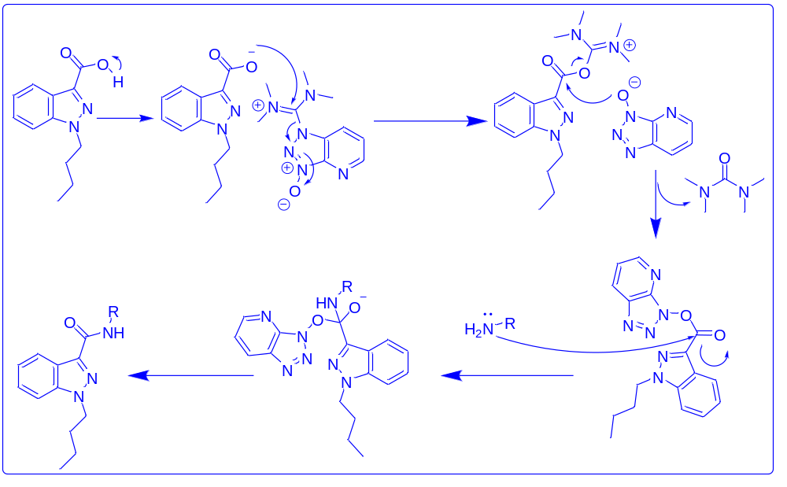
Table-2
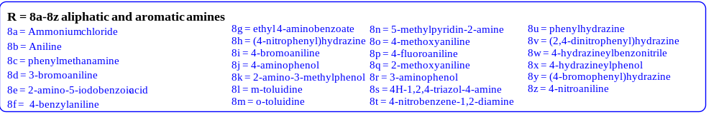
Table-3
2.6. Acid- Amide cross-coupling derivatives of indazole amides (8a-8z)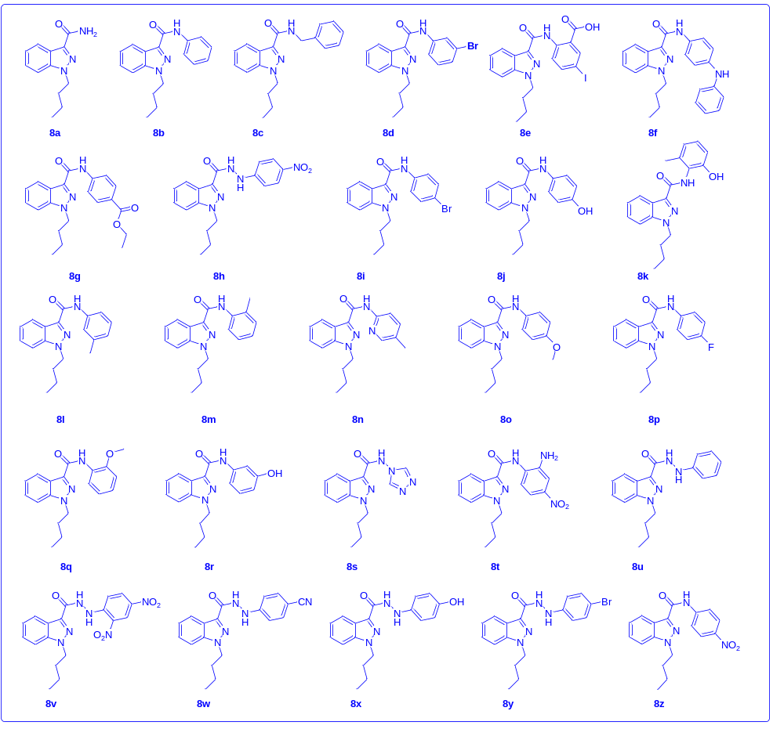
Table-4

3. ¹H and ¹³C NMR, Dept-135, COSY, HSQC, IR and HRMS spectra of the compounds
¹H-NMR [400MHz, DMSO-d₆] spectrum of 1-benzylidene-2-phenyl hydrazine(3). 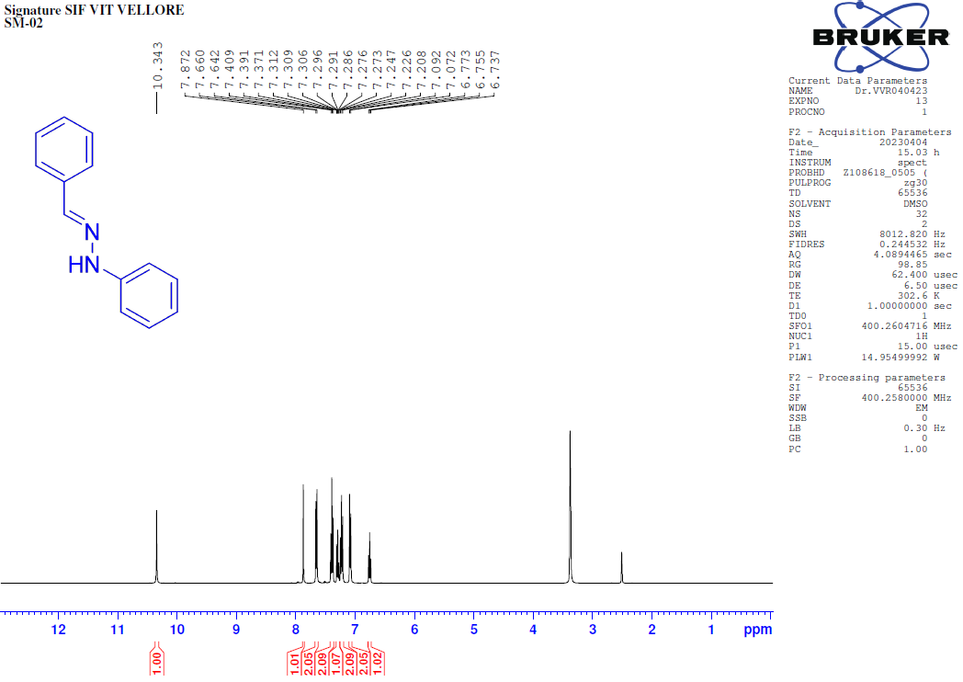
¹H-NMR [400MHz, DMSO-d₆] spectrum of 1H-indazole-3-carboxalic acid (5).
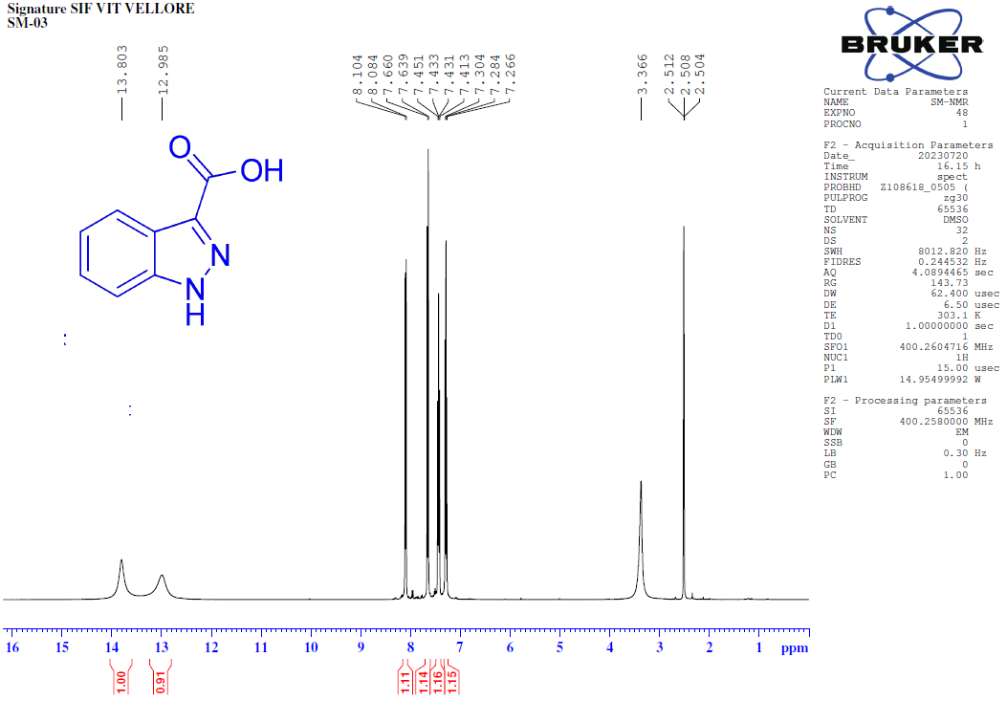
¹H-NMR [400MHz, DMSO-d₆] spectrum of 1-butyl-1H-indazole-3-carboxylic acid (6).
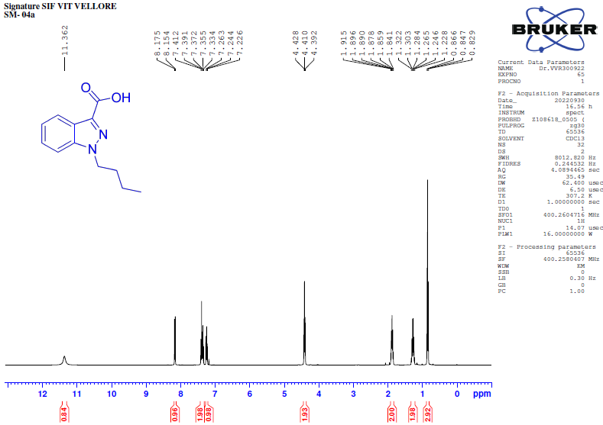
¹H-NMR [400MHz, DMSO-d₆] spectrum of 1-butyl-1H-indazole-3-carboxamide (8a).
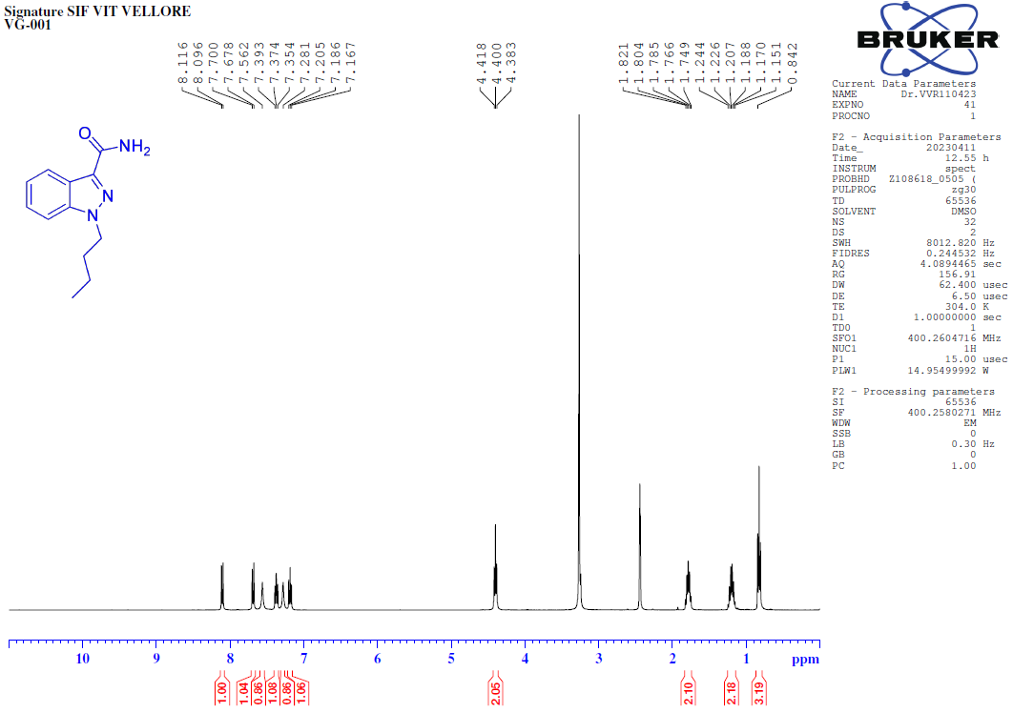
¹³C-NMR [100MHz, DMSO-d₆] spectrum of 1-butyl-1H-indazole-3-carboxamide (8a). 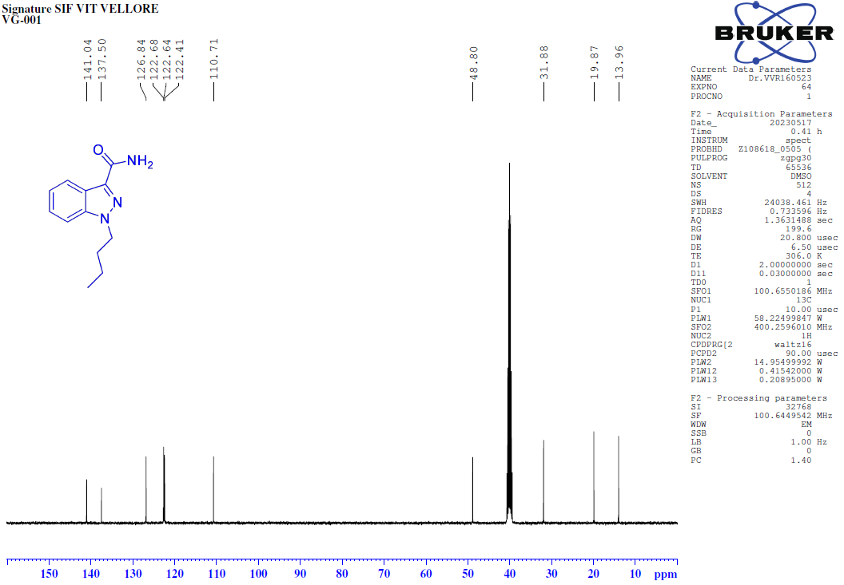
135-DEPT-NMR [100MHz, DMSO-d₆] spectrum of 1-butyl-1H-indazole-3-carboxamide (8a). 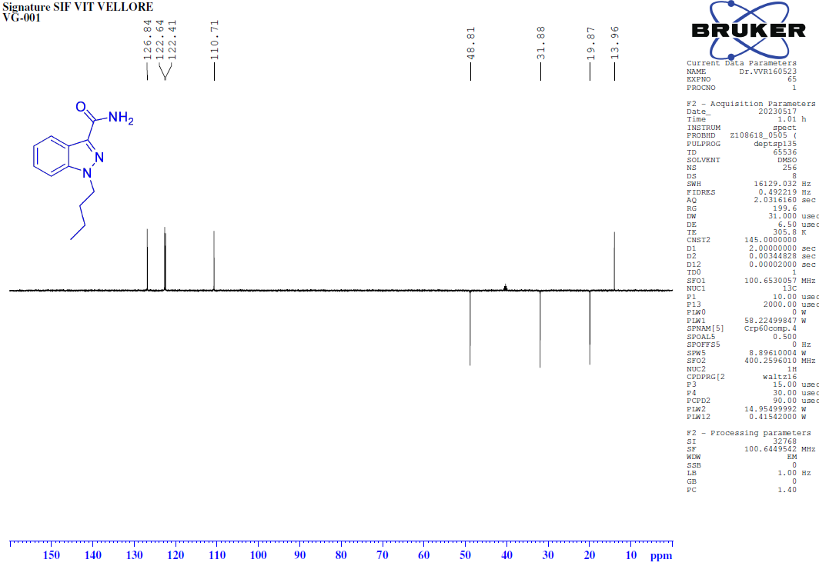
COSY-NMR [400MHz, DMSO-d₆] spectrum of 1-butyl-1H-indazole-3-carboxamide (8a).
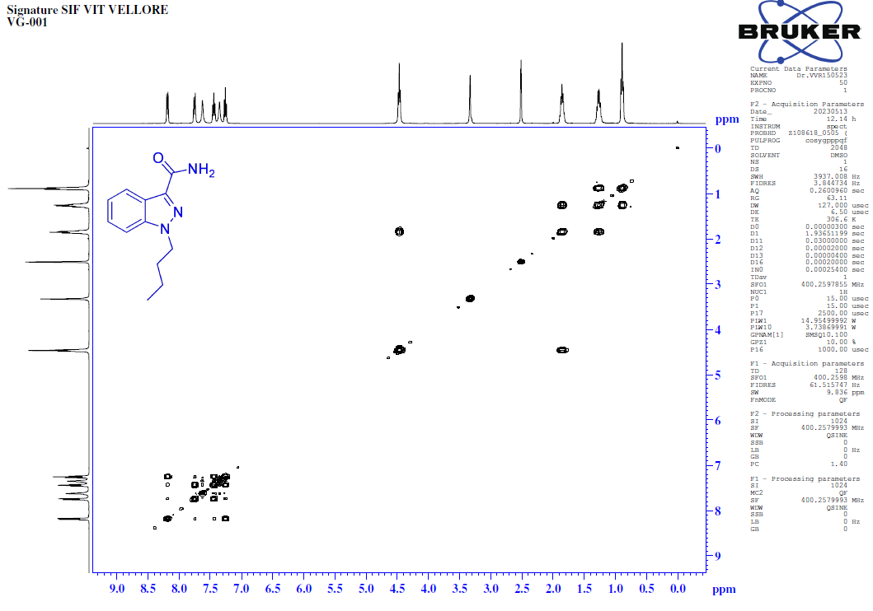
HSQC-NMR [400MHz, DMSO-d₆] spectrum of 1-butyl-1H-indazole-3-carboxamide (8a). 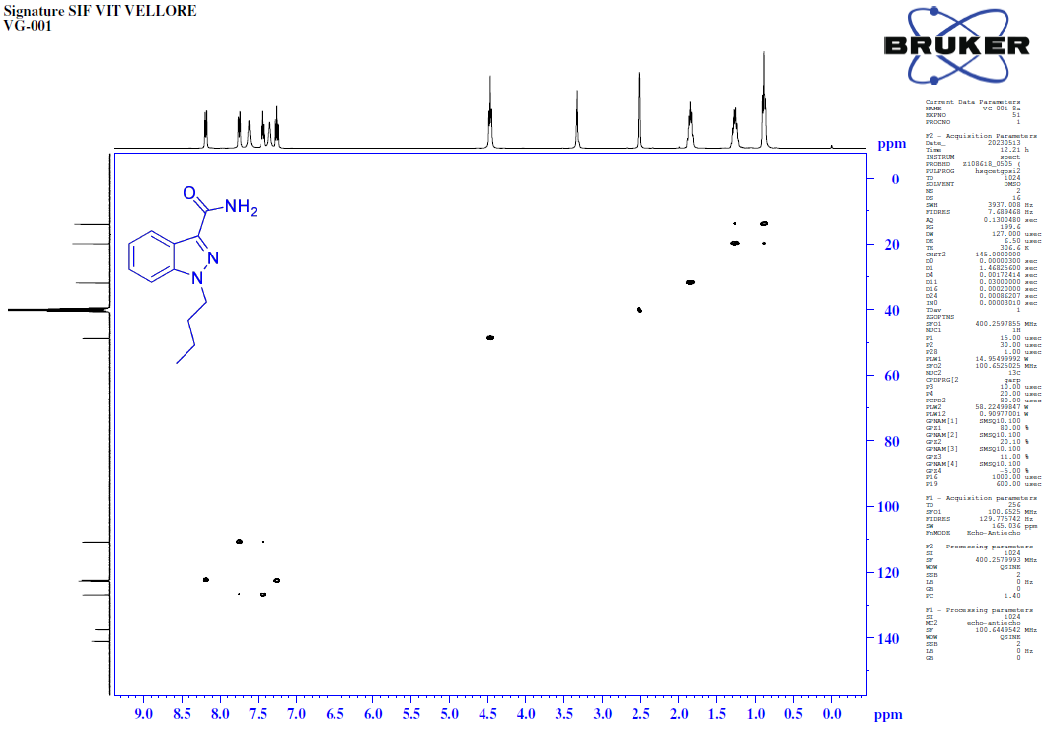
FT-IR spectrum of 1-butyl-1H-indazole-3-carboxamide (8a). 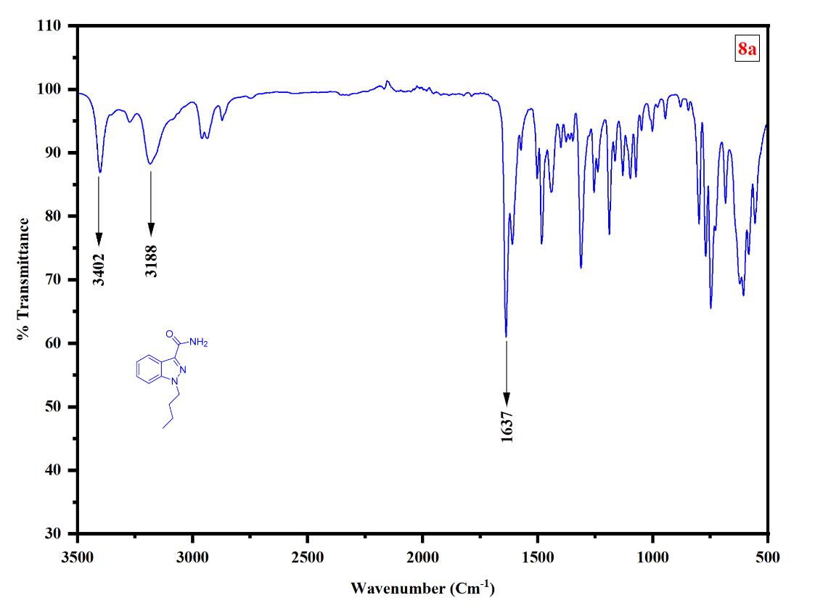
HRMS of 1-butyl-1H-indazole-3-carboxamide (8a)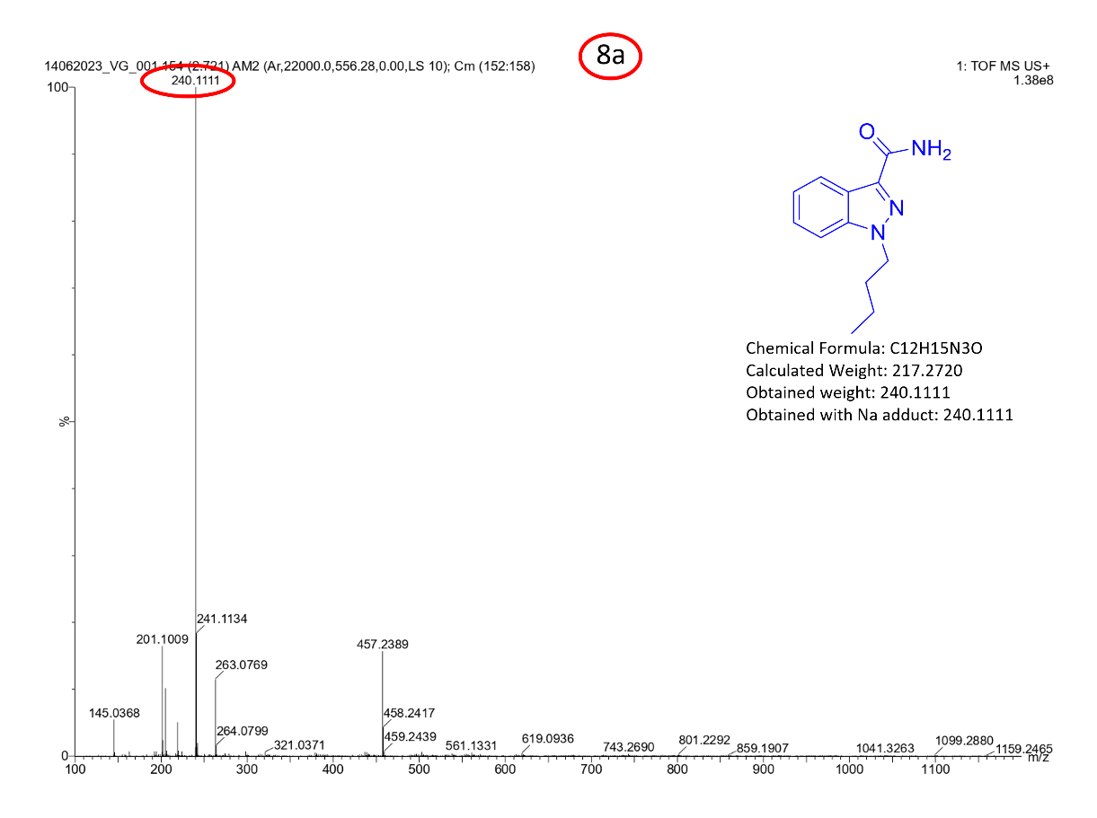

¹H-NMR [400MHz, DMSO-d₆] spectrum of 1-butyl-N-phenyl-1H-indazole-3-carboxamide (8b).
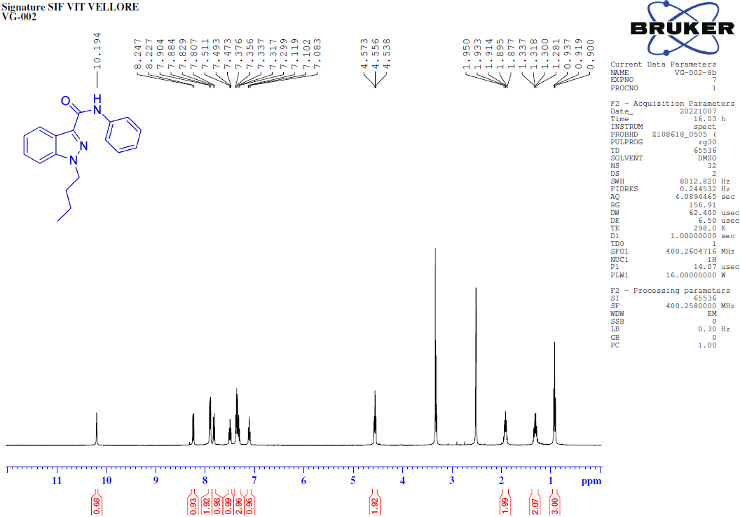
¹³C-NMR [100MHz, DMSO-d₆] spectrum of 1-butyl-N-phenyl-1H-indazole-3-carboxamide (8b). 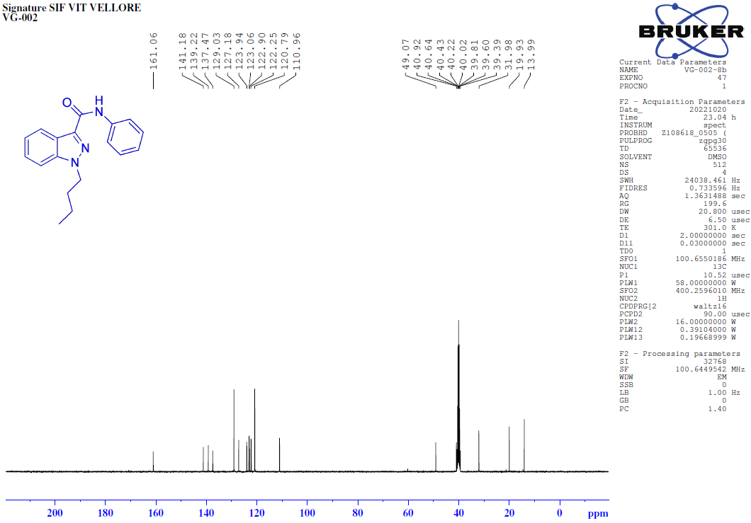
135-DEPT-NMR [100MHz, DMSO-d₆] spectrum of 1-butyl-N-phenyl-1H-indazole-3-carboxamide (8b).
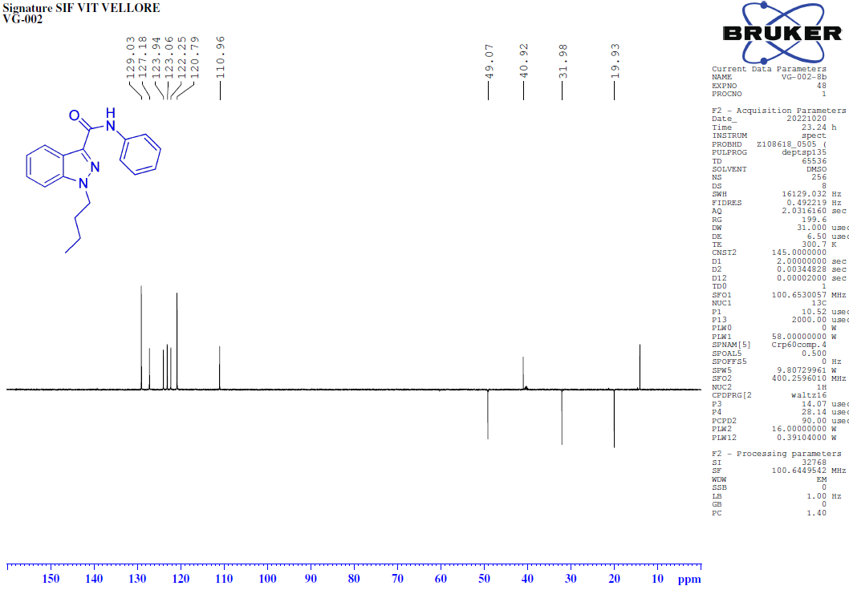
COSY-NMR [400MHz, DMSO-d₆] spectrum of 1-butyl-N-phenyl-1H-indazole-3-carboxamide (8b).
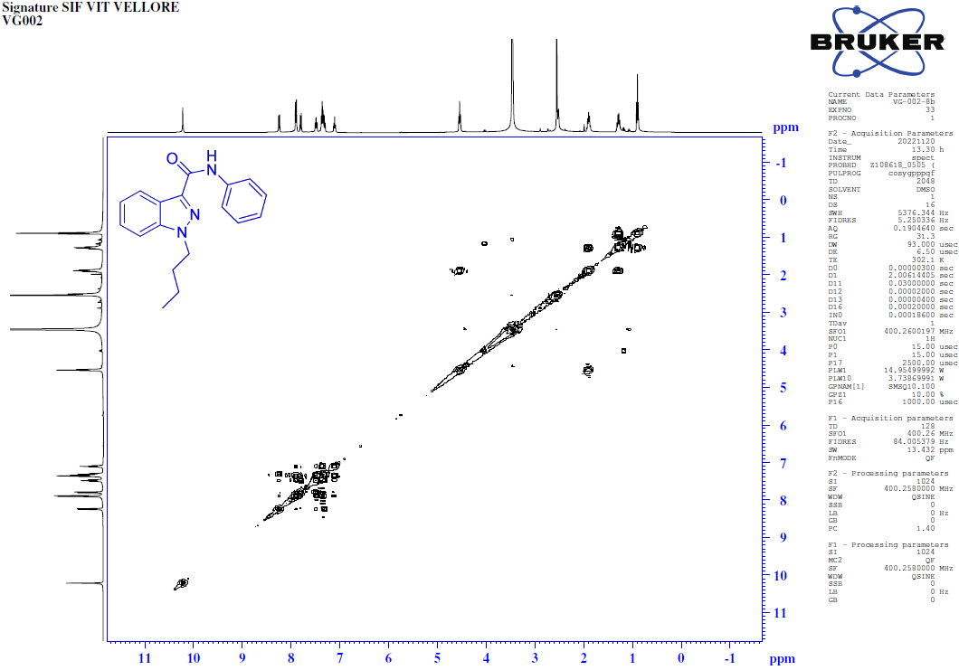
HSQC-NMR [400MHz, DMSO-d₆] spectrum of 1-butyl-N-phenyl-1H-indazole-3-carboxamide (8b).
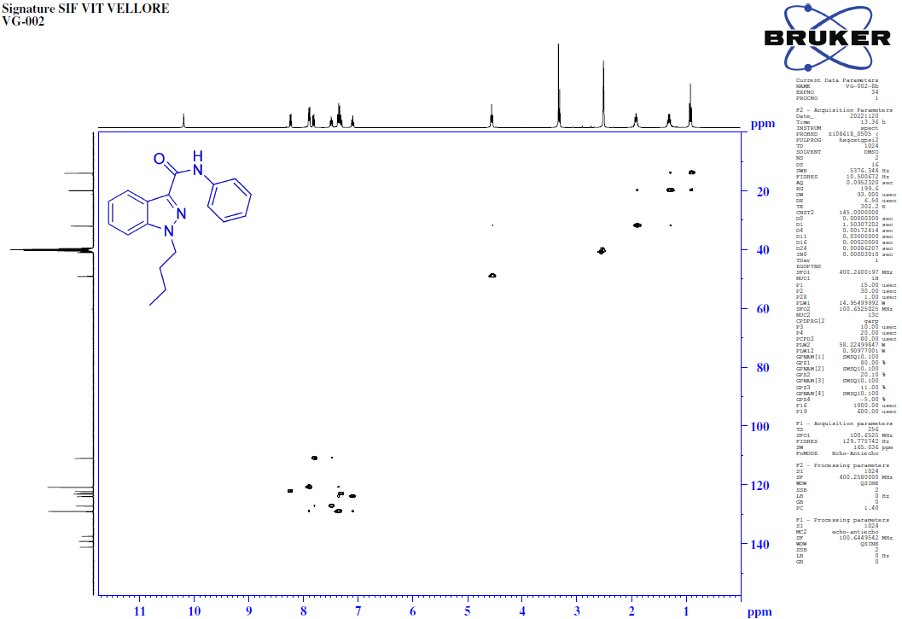
FT-IR spectrum of 1-butyl-N-phenyl-1H-indazole-3-carboxamide (8b).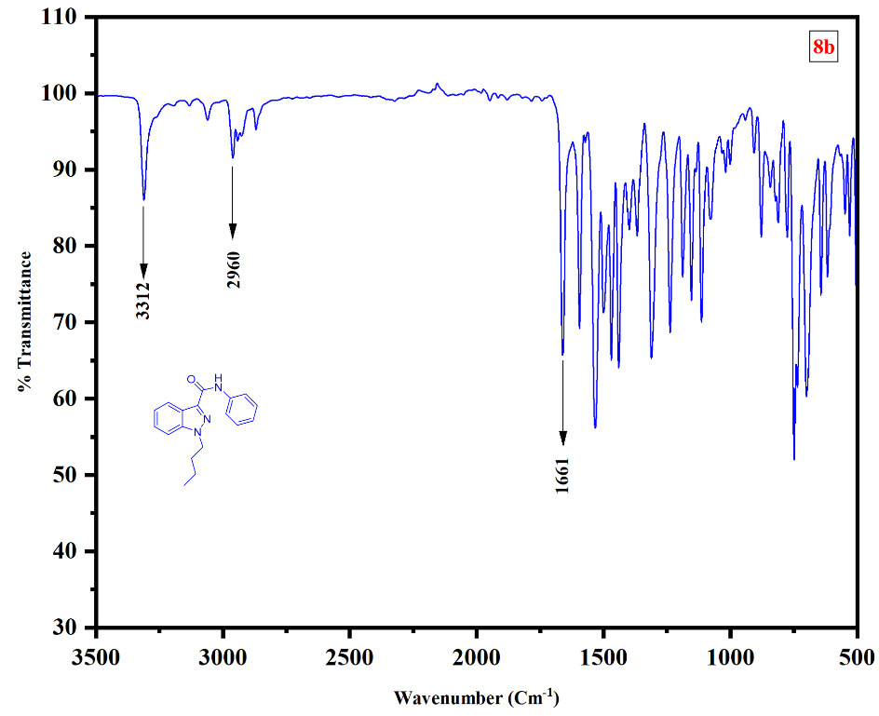
HRMS of 1-butyl-N-phenyl-1H-indazole-3-carboxamide (8b).
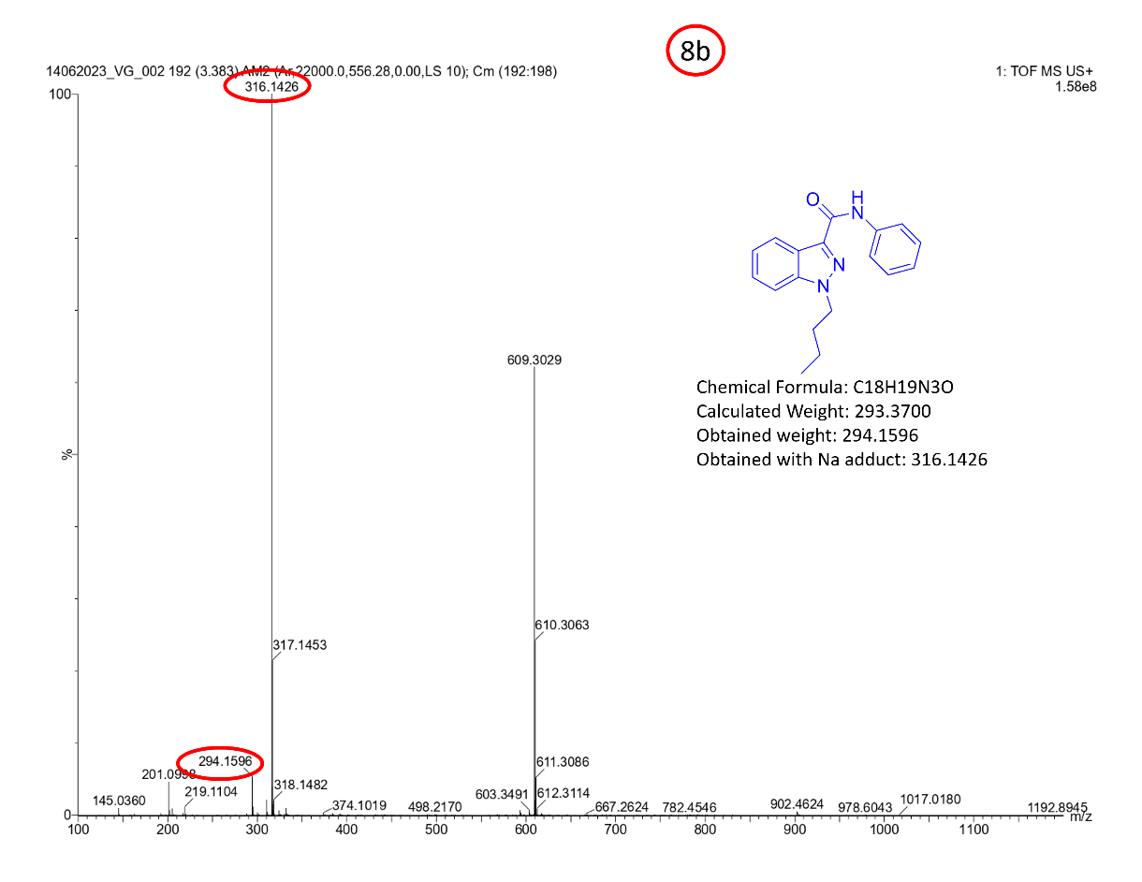

¹H-NMR [400MHz, DMSO-d₆] spectrum of N-benzyl-1-butyl-1H-indazole-3-carboxamide (8c).
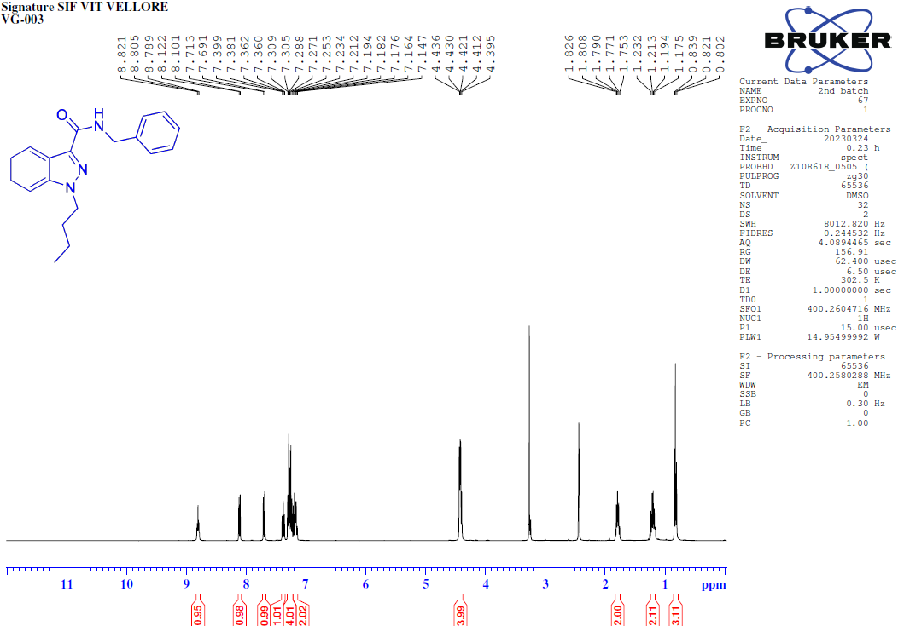
¹³C-NMR [100MHz, DMSO-d₆] spectrum of N-benzyl-1-butyl-1H-indazole-3-carboxamide (8c). 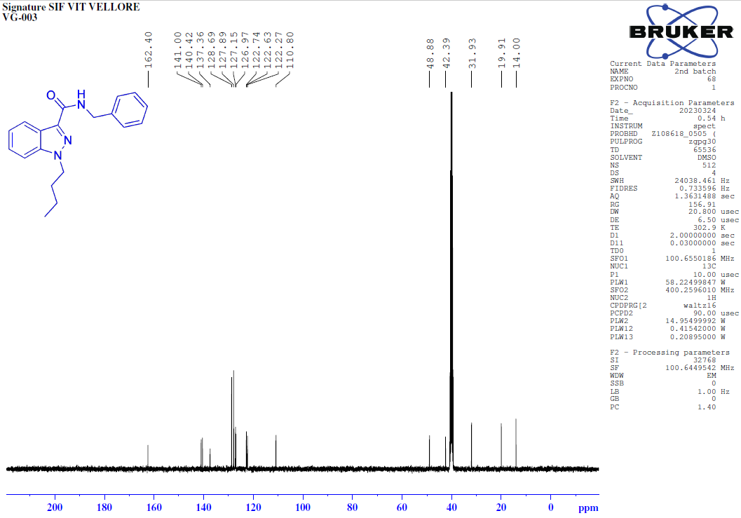
135-DEPT-NMR [100MHz, DMSO-d₆] spectrum of N-benzyl-1-butyl-1H-indazole-3-carboxamide (8c).
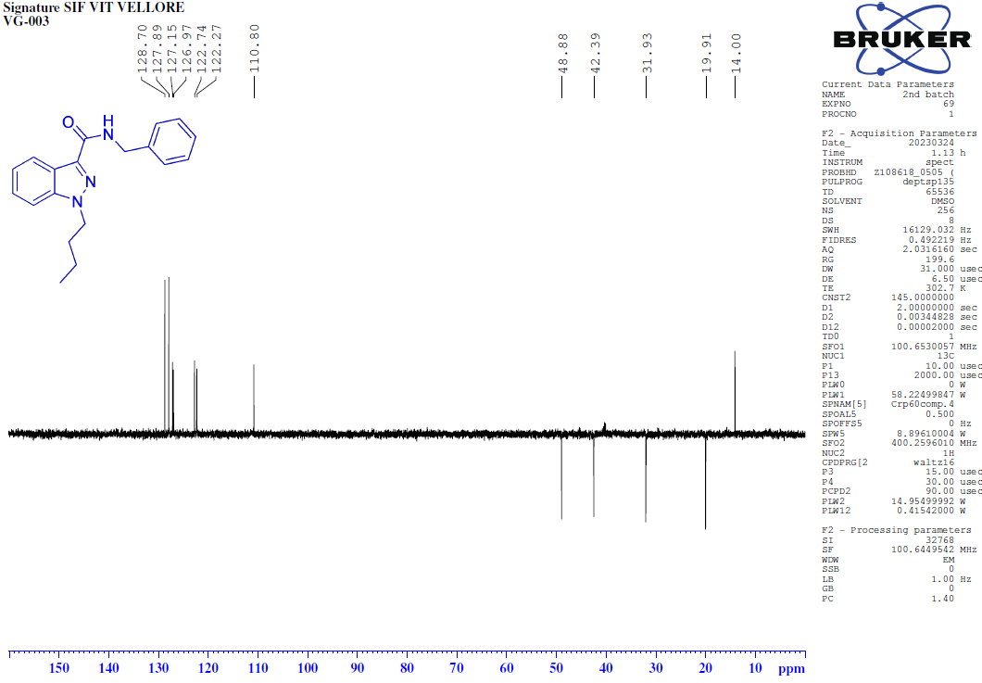COSY-NMR [400MHz, DMSO-d₆] spectrum of N-benzyl-1-butyl-1H-indazole-3-carboxamide (8c).
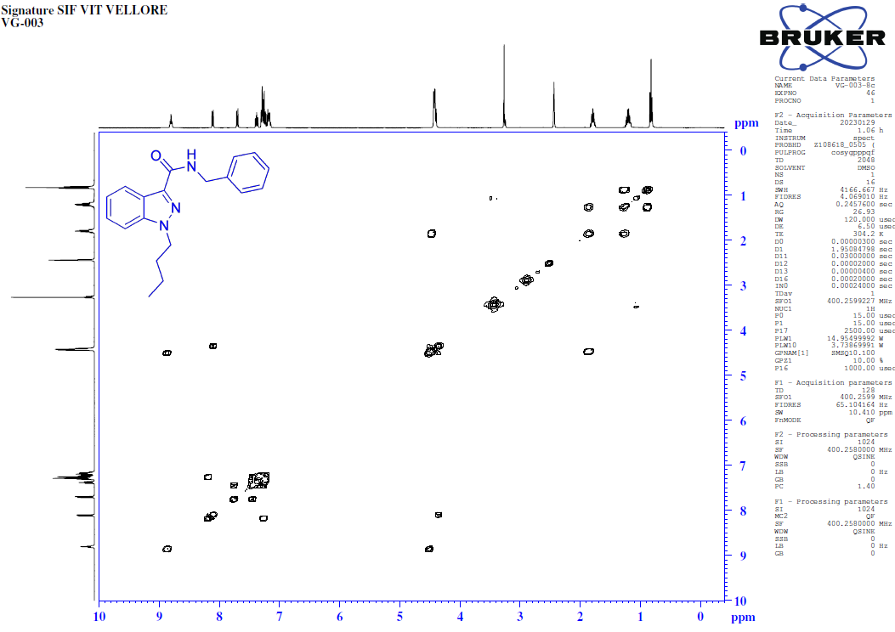
HSQC-NMR [400MHz, DMSO-d₆] spectrum of N-benzyl-1-butyl-1H-indazole-3-carboxamide (8c).
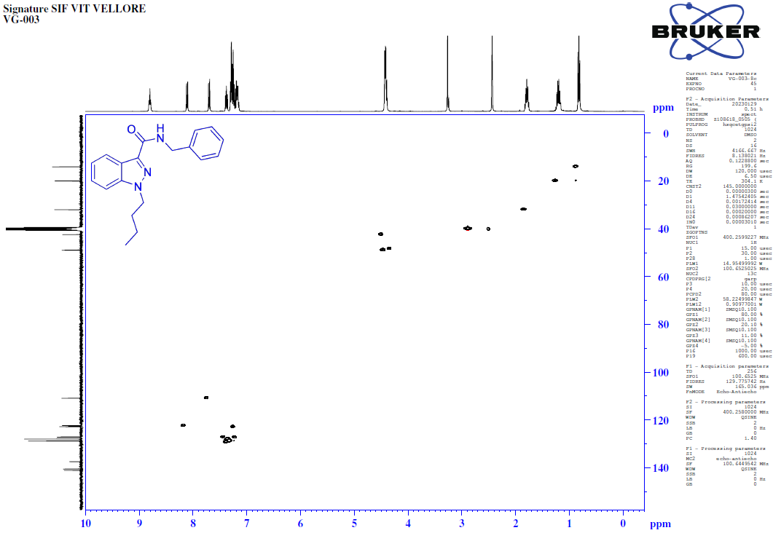
FT-IR spectrum of N-benzyl-1-butyl-1H-indazole-3-carboxamide (8c).
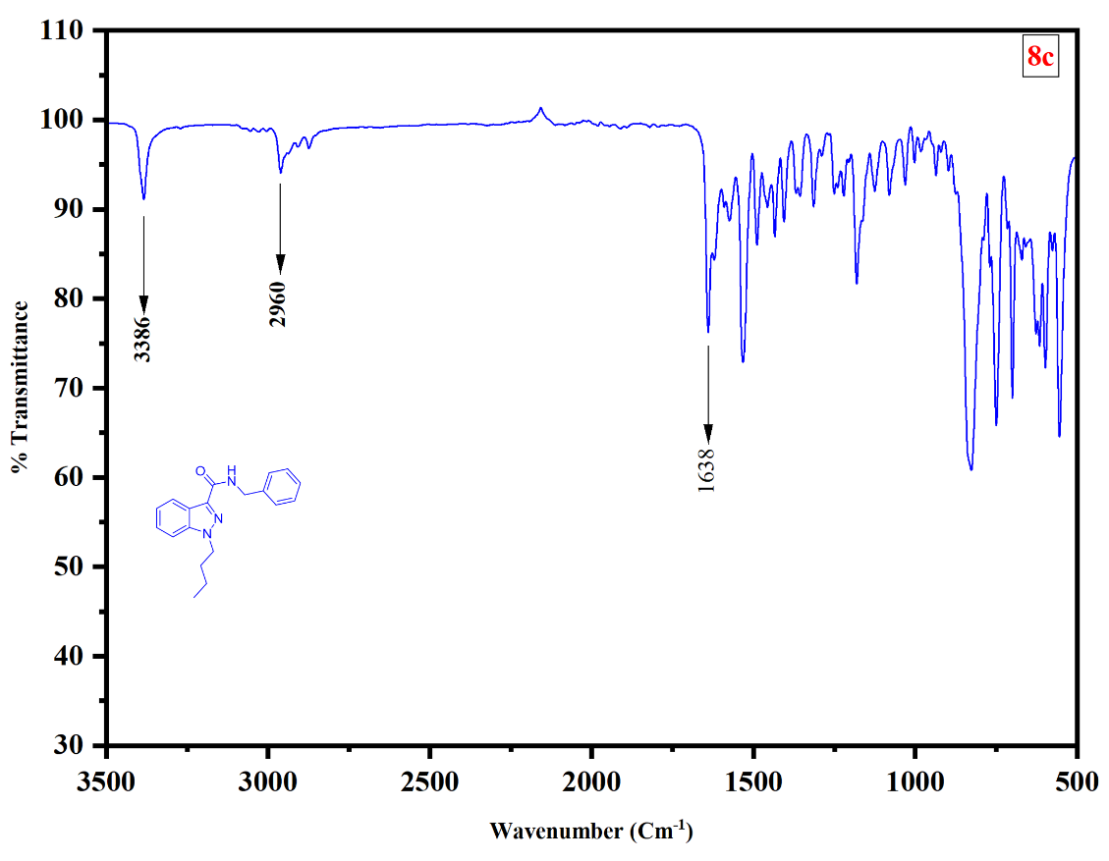
HRMS of N-benzyl-1-butyl-1H-indazole-3-carboxamide (8c).
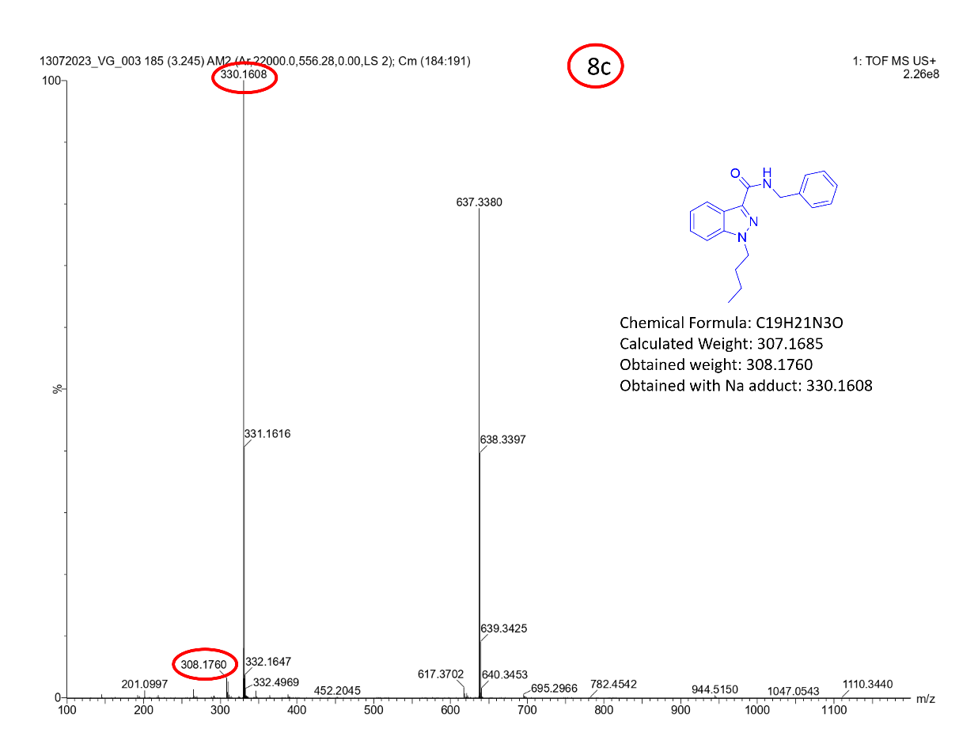
¹H-NMR [400MHz, DMSO-d₆] spectrum of 1-butyl-N-(6-methylpyridine-2yl)-1H-indazole-3-carboxamide (8d).
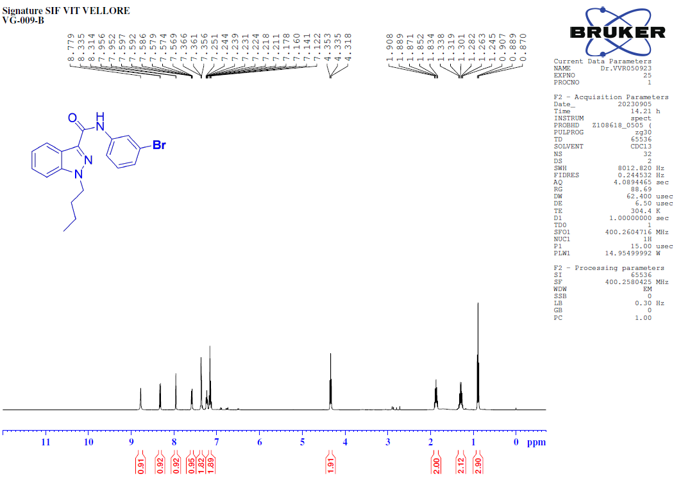
¹³C-NMR [100MHz, DMSO-d₆] spectrum of 1-butyl-N-(6-methylpyridine-2yl)-1H-indazole-3-carboxamide (8d).
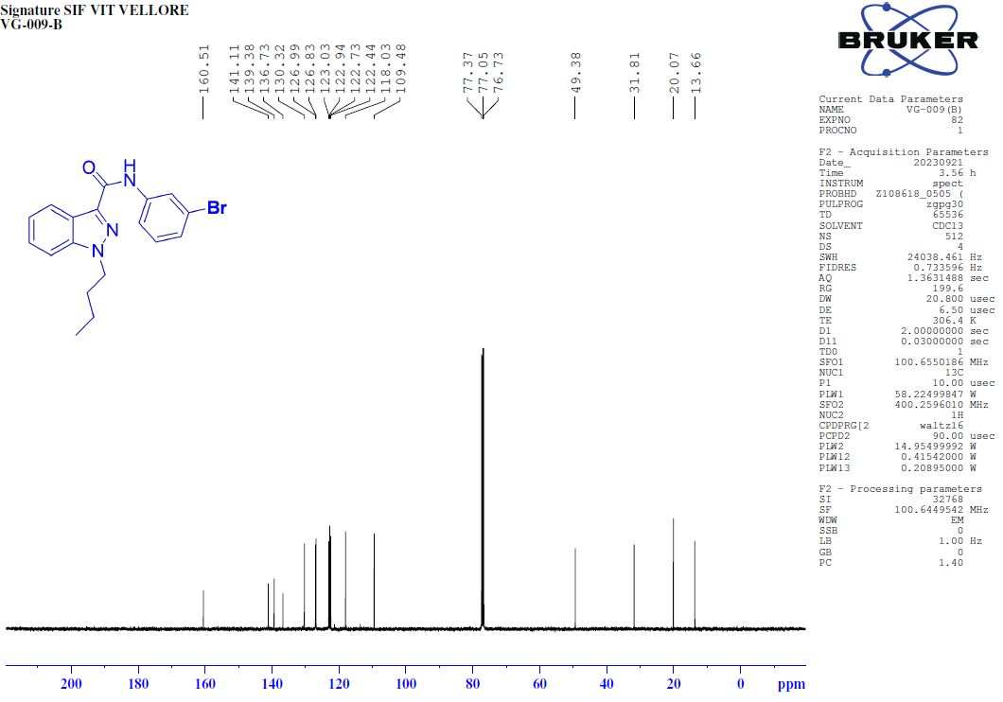
135-DEPT-NMR [100MHz, DMSO-d₆] spectrum of 1-butyl-N-(6-methylpyridine-2yl)-1H-indazole-3-carboxamide (8d).
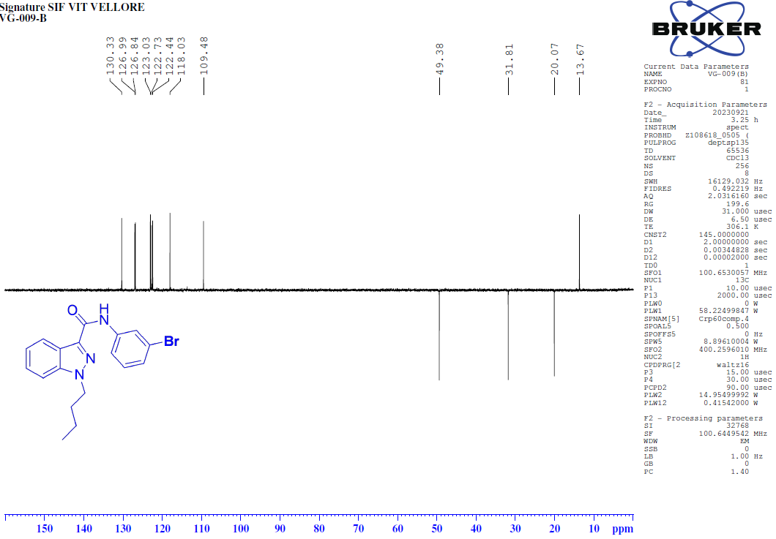
COSY-NMR [400MHz, DMSO-d₆] spectrum of 1-butyl-N-(6-methylpyridine-2yl)-1H-indazole-3-carboxamide (8d).
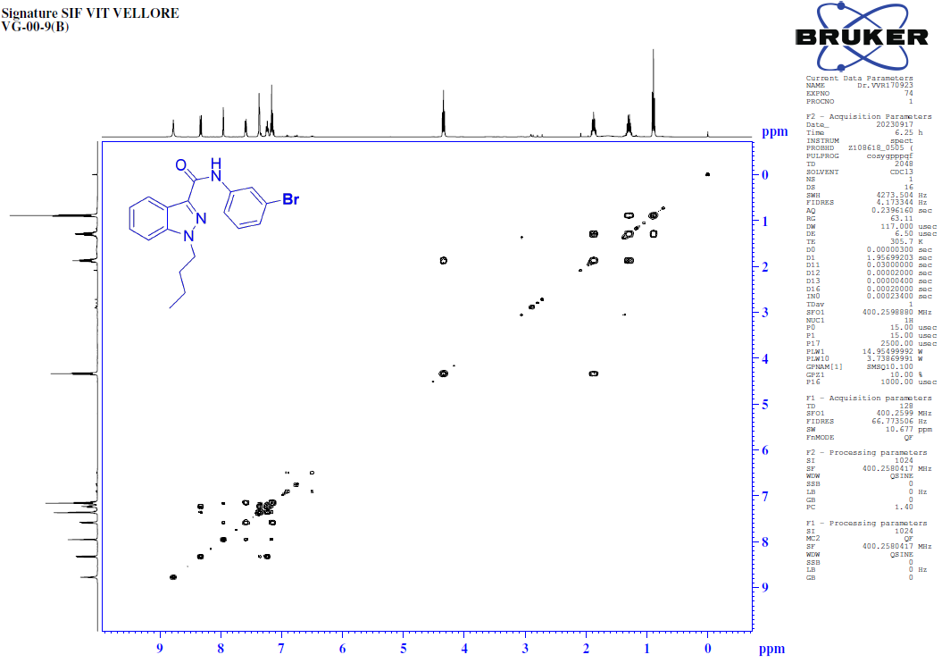
HSQC-NMR [400MHz, DMSO-d₆] spectrum of 1-butyl-N-(6-methylpyridine-2yl)-1H-indazole-3-carboxamide (8d).
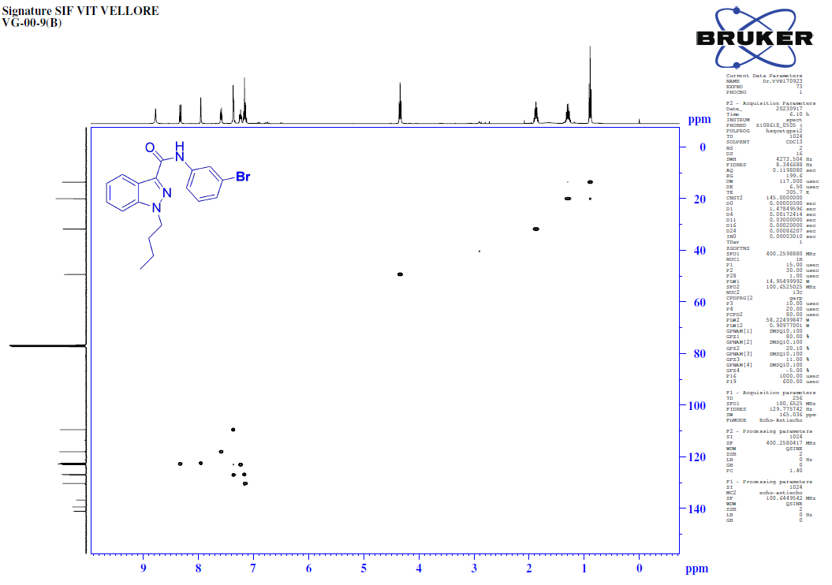
FT-IR spectrum of 1-butyl-N-(6-methylpyridine-2yl)-1H-indazole-3-carboxamide (8d).
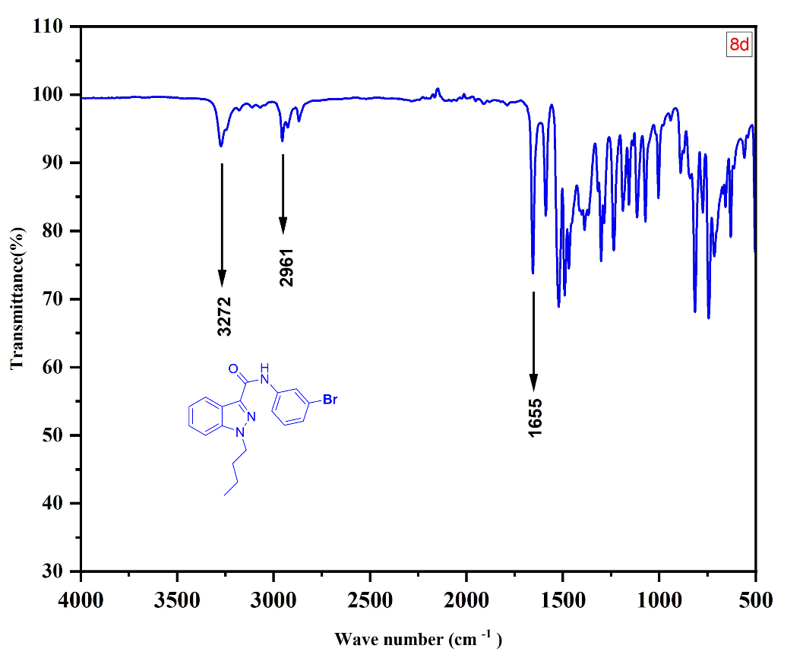
HRMS of 1-butyl-N-(6-methylpyridine-2yl)-1H-indazole-3-carboxamide (8d).
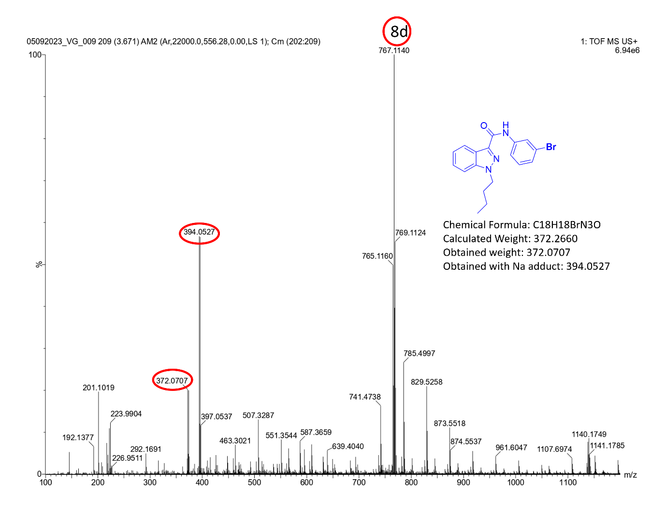
¹H-NMR [400MHz, DMSO-d₆] spectrum of 2-(1-butyl-1H-indazole -3-carboxamido)-5-iodobenzoic acid (8e).
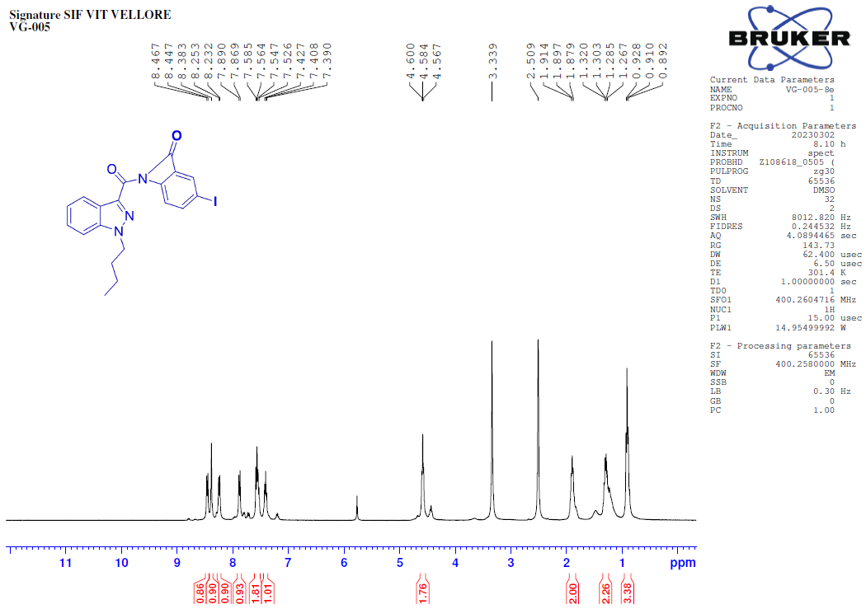 ¹³C-NMR [100MHz, DMSO-d₆] spectrum of 2-(1-butyl-1H-indazole -3-carboxamido)-5-iodobenzoic acid (8e).
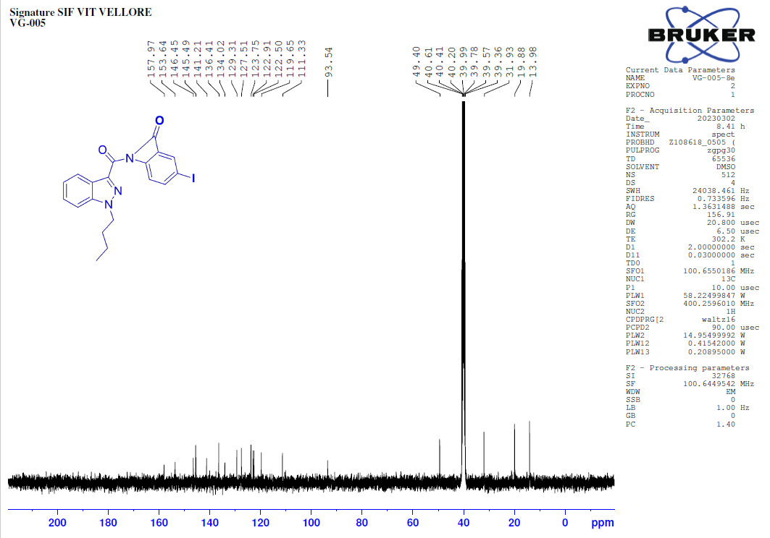
135-DEPT-NMR [100MHz, DMSO-d₆] spectrum of 2-(1-butyl-1H-indazole -3-carboxamido)-5-iodobenzoic acid (8e).
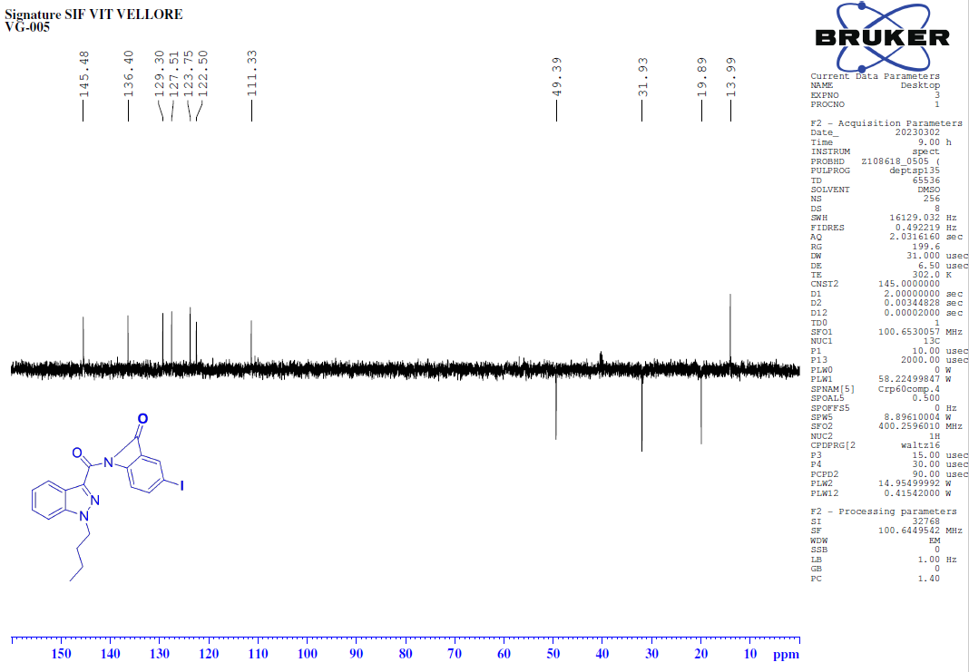
COSY-NMR [400MHz, DMSO-d₆] spectrum of 2-(1-butyl-1H-indazole -3-carboxamido)-5-iodobenzoic acid (8e).
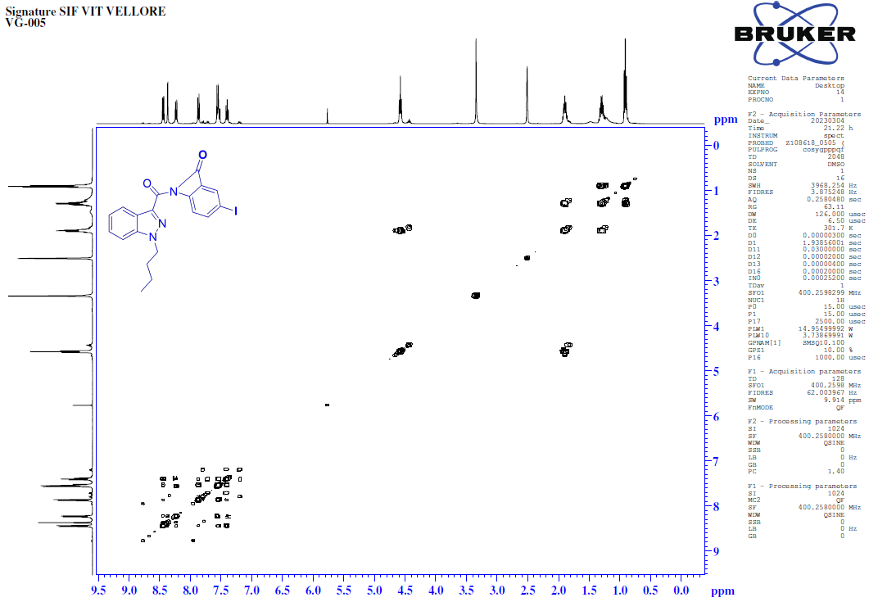
HSQC-NMR [400MHz, DMSO-d₆] spectrum of 2-(1-butyl-1H-indazole -3-carboxamido)-5-iodobenzoic acid (8e).
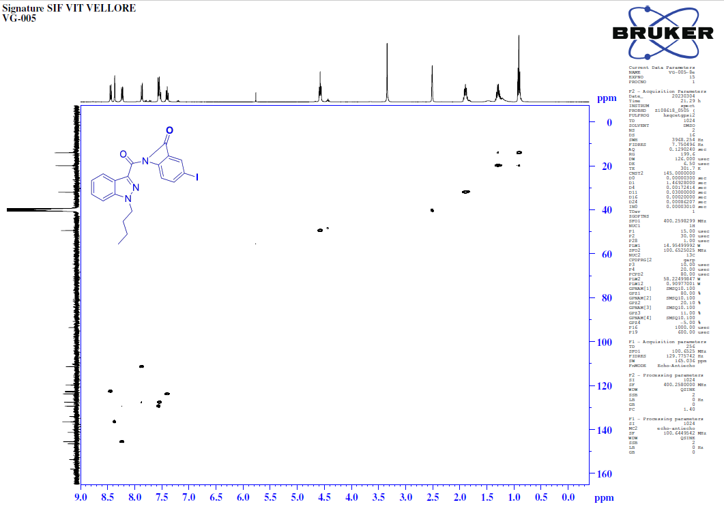
FT-IR spectrum of 2-(1-butyl-1H-indazole -3-carboxamido)-5-iodobenzoic acid (8e).
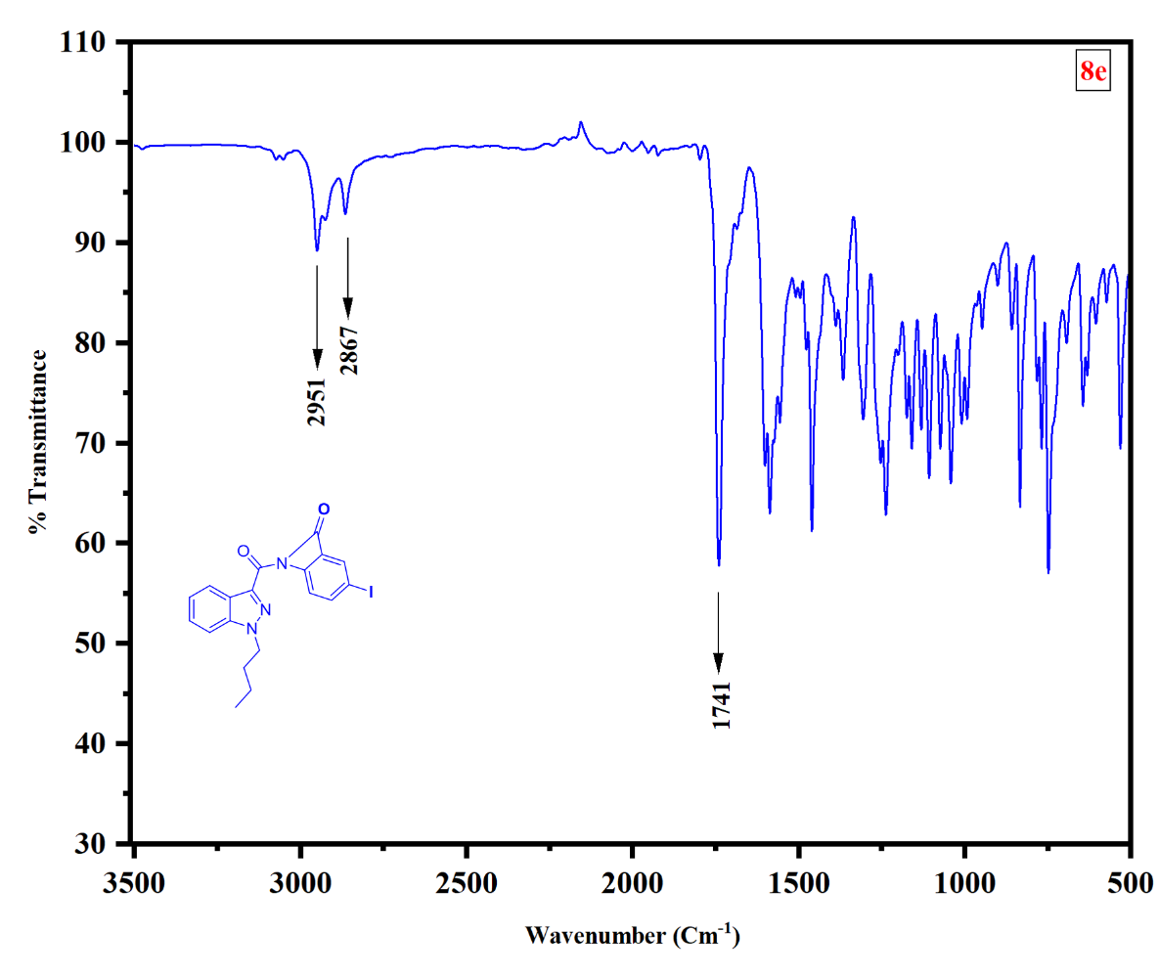
HRMS of 2-(1-butyl-1H-indazole -3-carboxamido)-5-iodobenzoic acid (8e).
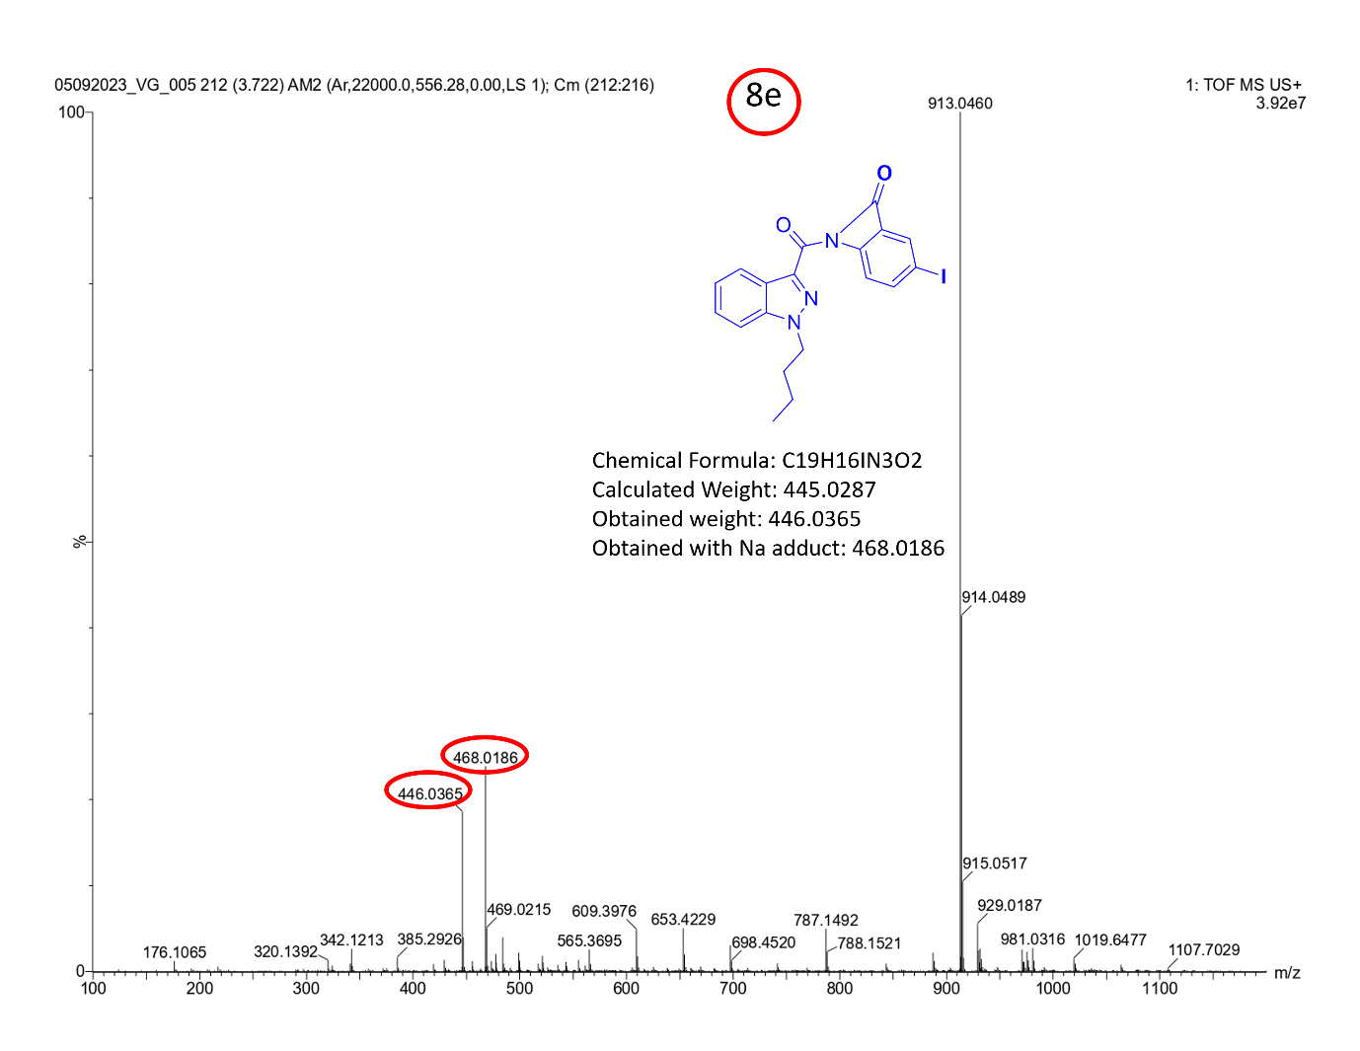
¹H-NMR [400MHz, DMSO-d₆] spectrum of 1-butyl-N-(4-(phenylamino) phenyl)-1H-indazole-3-carboxamide (8f).
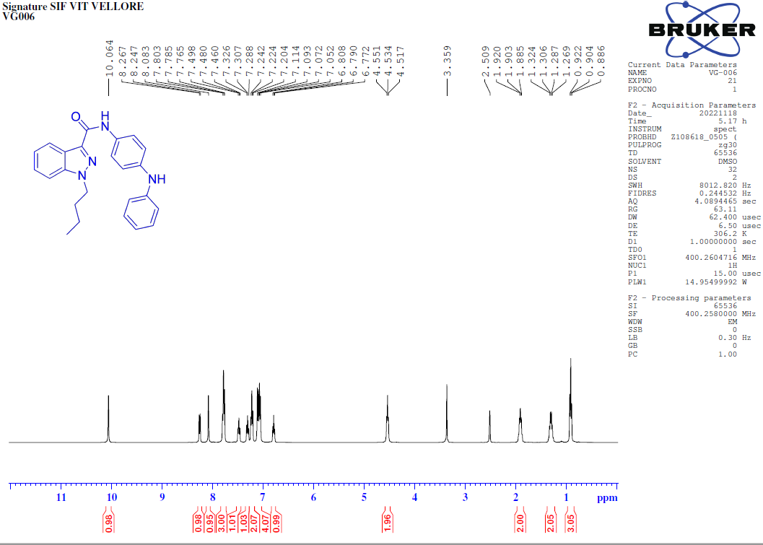
¹³C-NMR [100MHz, DMSO-d₆] spectrum of 1-butyl-N-(4-(phenylamino) phenyl)-1H-indazole-3-carboxamide (8f).
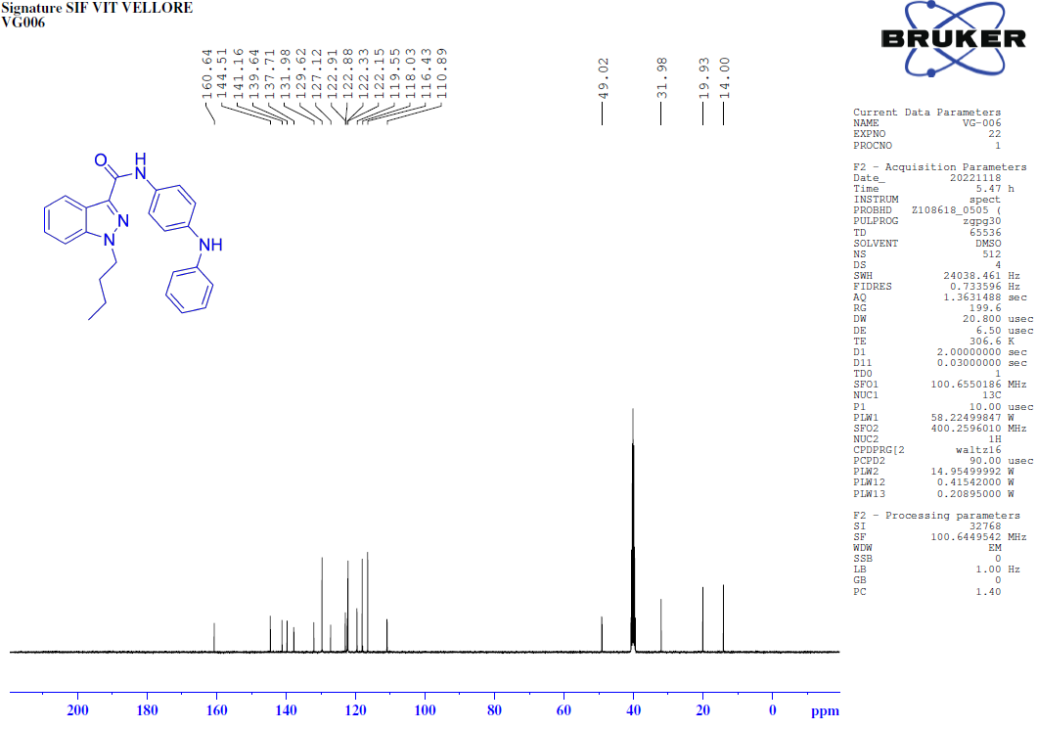
135-DEPT-NMR [100MHz, DMSO-d₆] spectrum of 1-butyl-N-(4-(phenylamino)phenyl)-1H-indazole-3-carboxamide (8f).
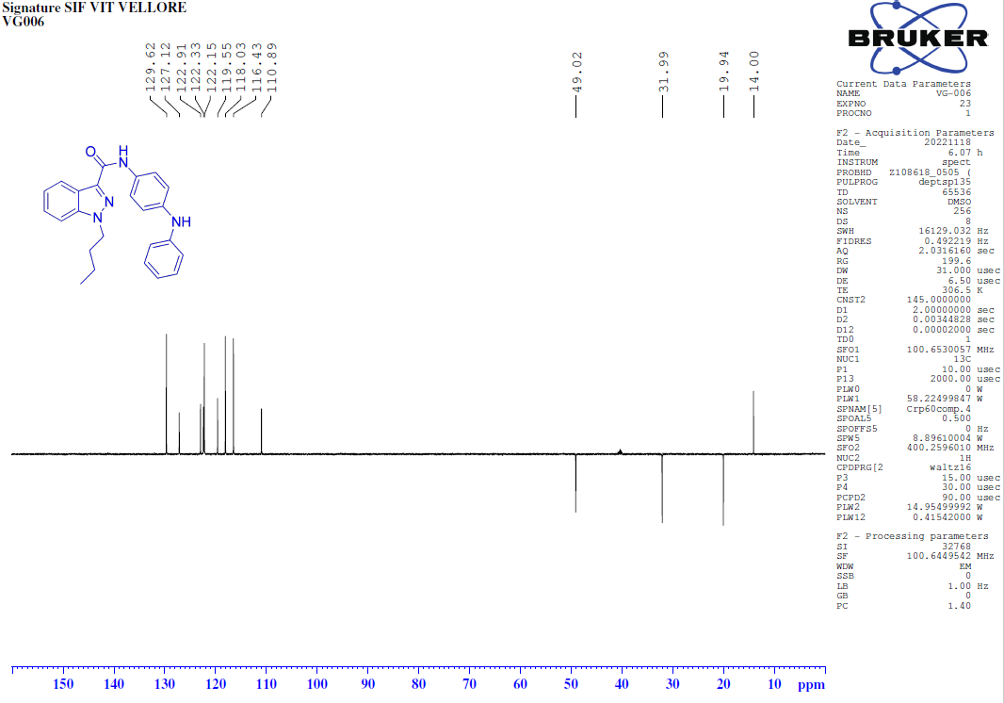
COSY-NMR [400MHz, DMSO-d₆] spectrum of 1-butyl-N-(4-(phenylamino)phenyl)-1H-indazole-3-carboxamide (8f).
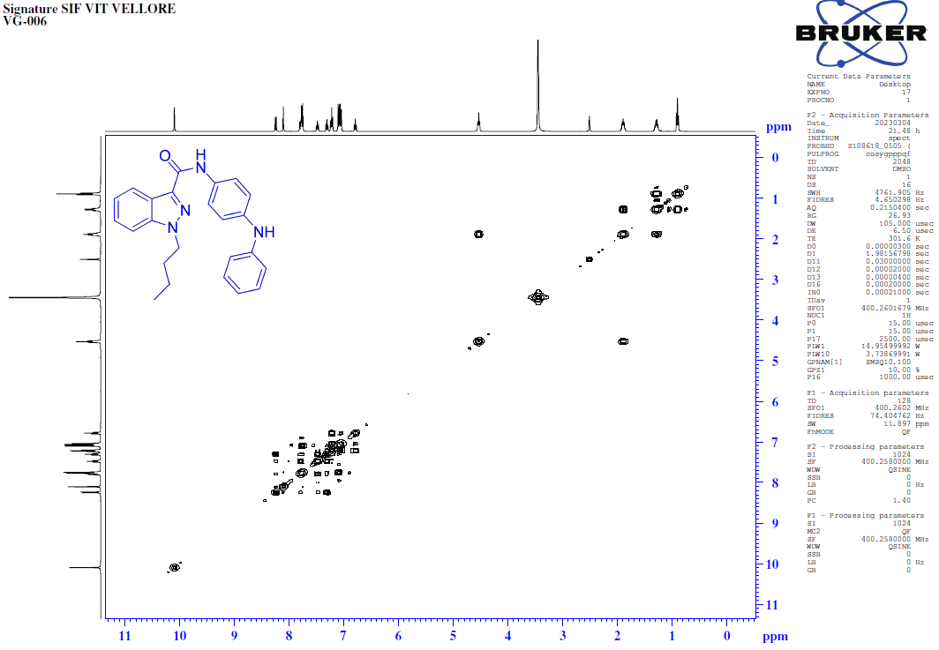
HSQC-NMR [400MHz, DMSO-d₆] spectrum of 1-butyl-N-(4-(phenylamino)phenyl)-1H-indazole-3-carboxamide (8f).
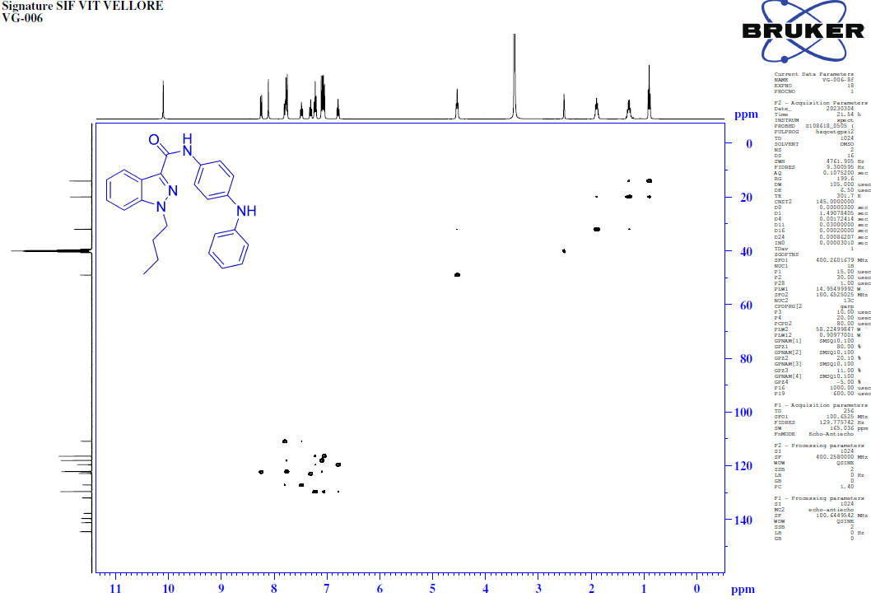
FT-IR spectrum of 1-butyl-N-(4-(phenylamino)phenyl)-1H-indazole-3-carboxamide (8f).
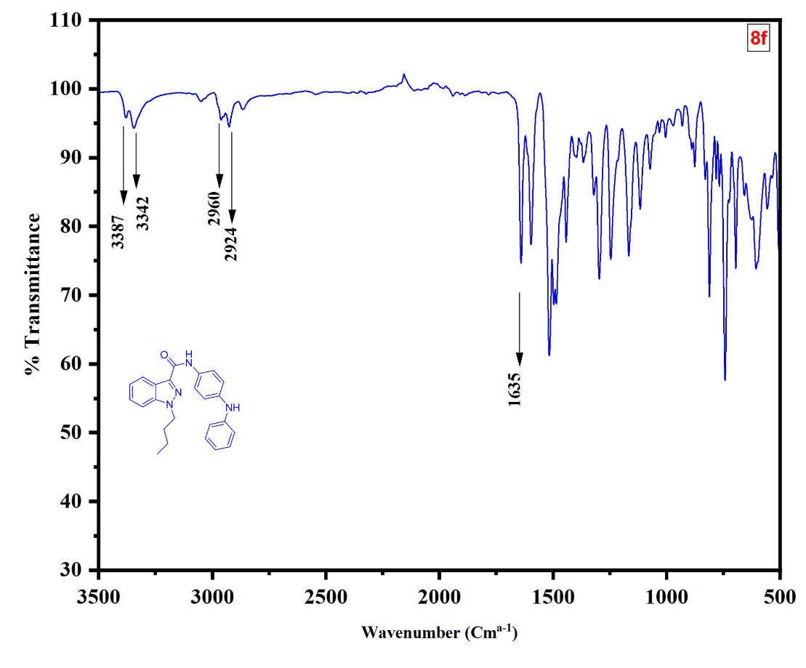
HRMS of 1-butyl-N-(4-(phenylamino)phenyl)-1H-indazole-3-carboxamide (8f).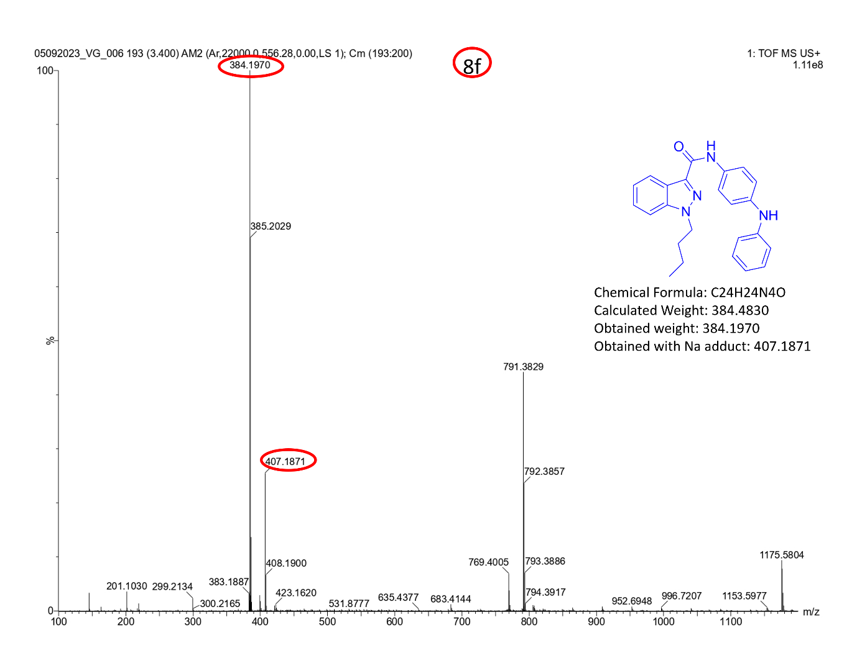
¹H-NMR [400MHz, DMSO-d₆] spectrum of 1-butyl-N-(4-nitophenyl)-1H-indazole-3-carboxamide (8g).
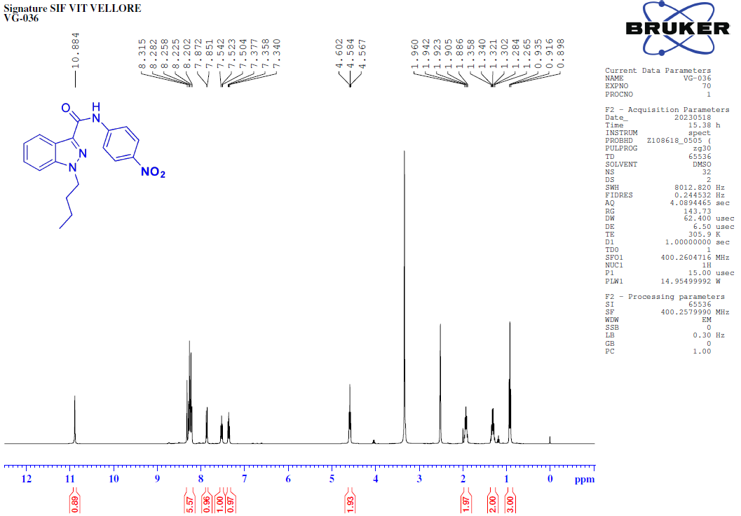
¹³C-NMR [100MHz, DMSO-d₆] spectrum of 1-butyl-N-(4-nitophenyl)-1H-indazole-3-carboxamide (8g).
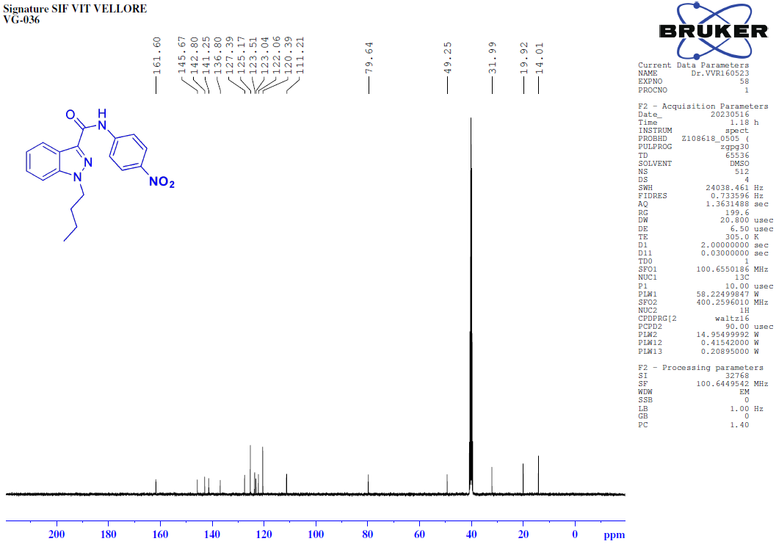
135-DEPT-NMR [400MHz, DMSO-d₆] spectrum of 1-butyl-N-(4-nitophenyl)-1H-indazole-3-carboxamide (8g).
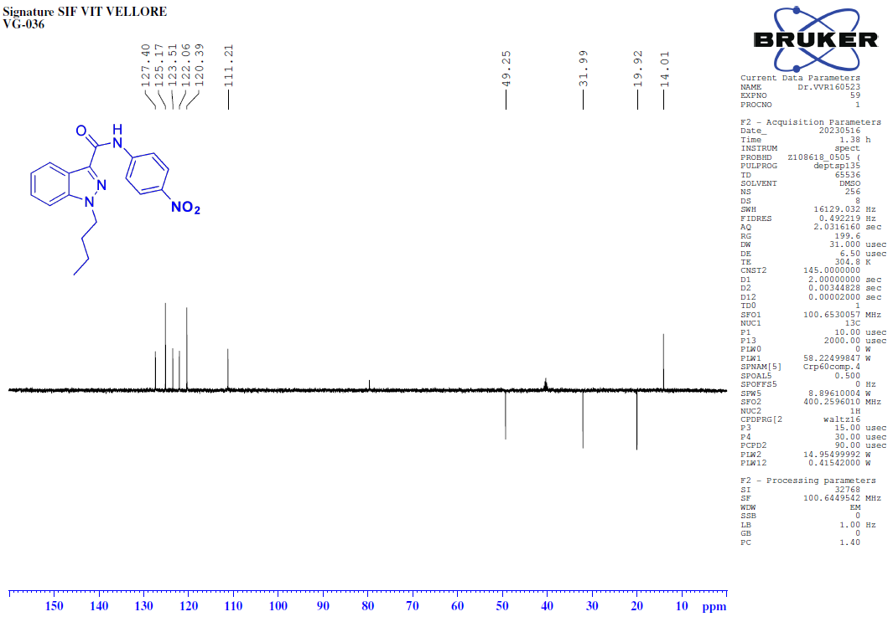
FT-IR spectrum of 1-butyl-N-(4-nitophenyl)-1H-indazole-3-carboxamide (8g).
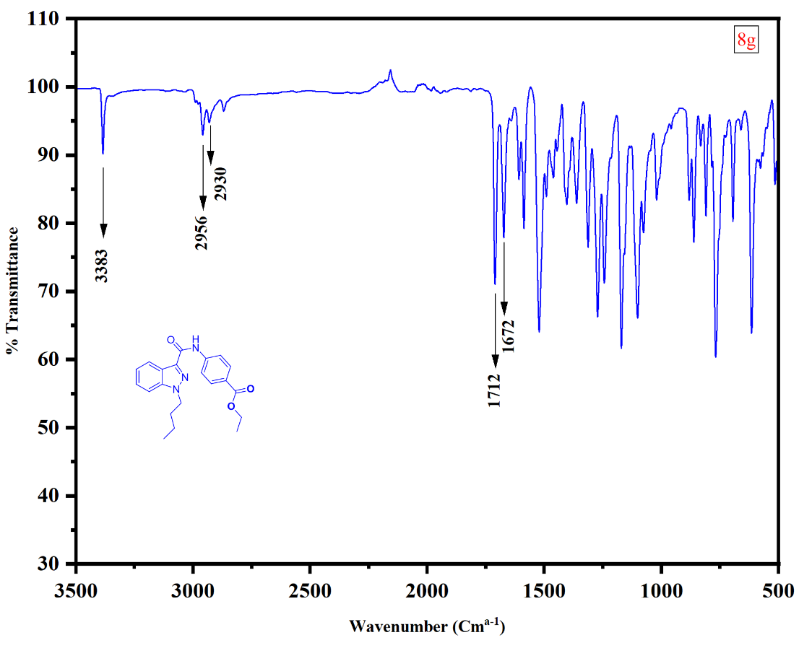
HRMS of 1-butyl-N-(4-nitophenyl)-1H-indazole-3-carboxamide (8g).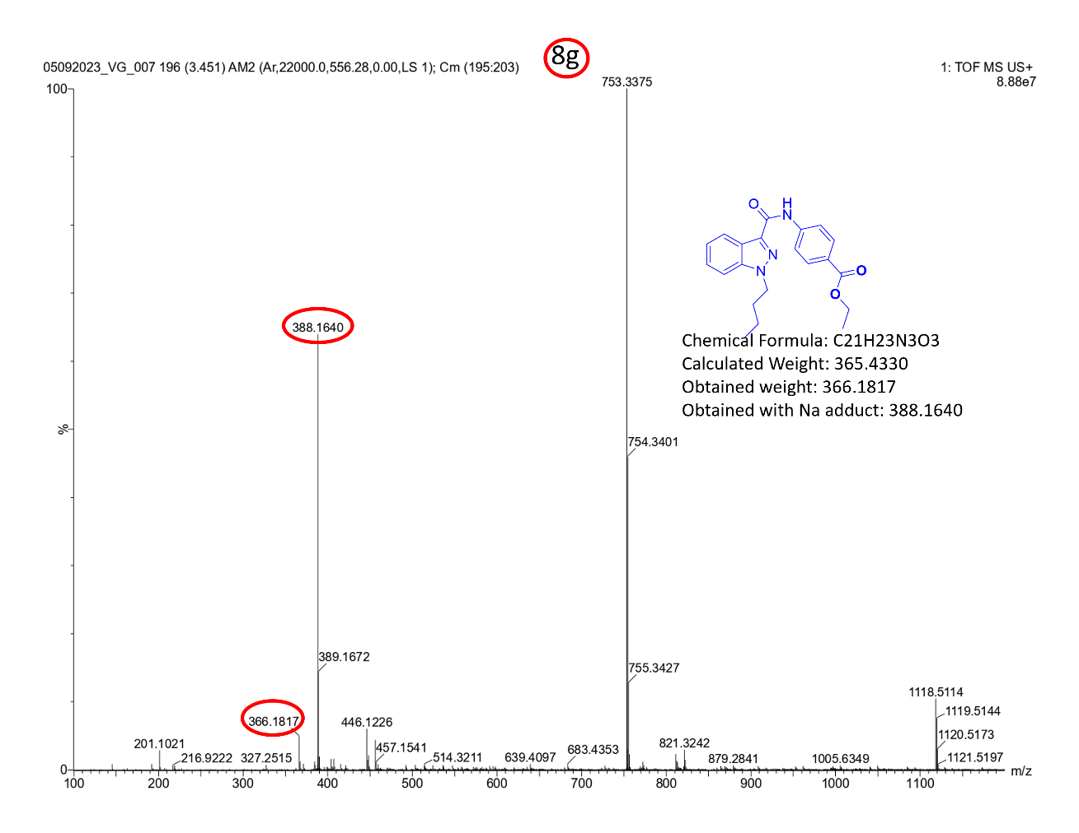
¹H-NMR [400MHz, DMSO-d₆] spectrum of 1-butyl-N-(4-nitrophenyl)-1H-indazole-3-carbohydrazide (8h).
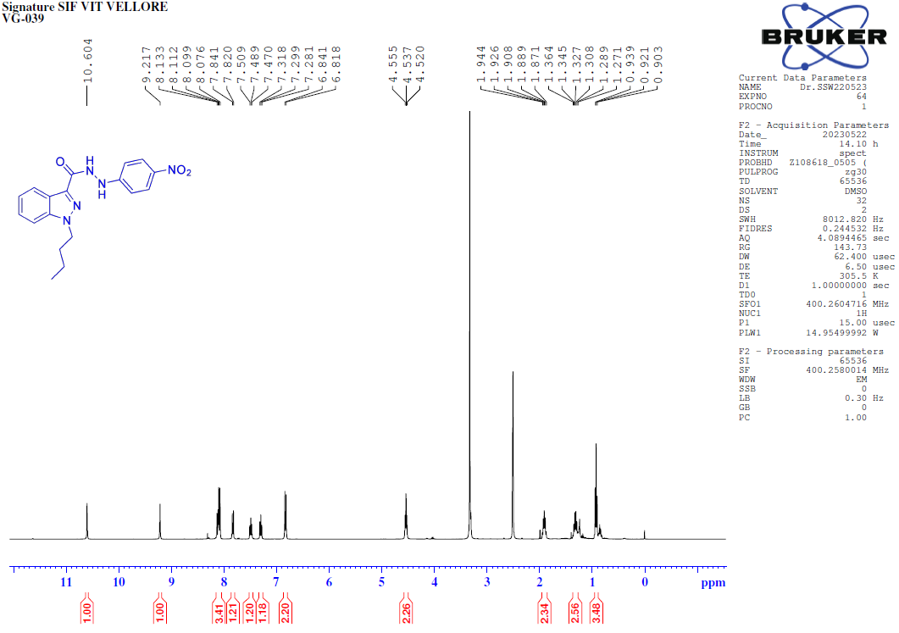
¹³C-NMR [100MHz, DMSO-d₆] spectrum of 1-butyl-N-(4-nitro phenyl)-1H-indazole-3-carbohydrazide (8h).
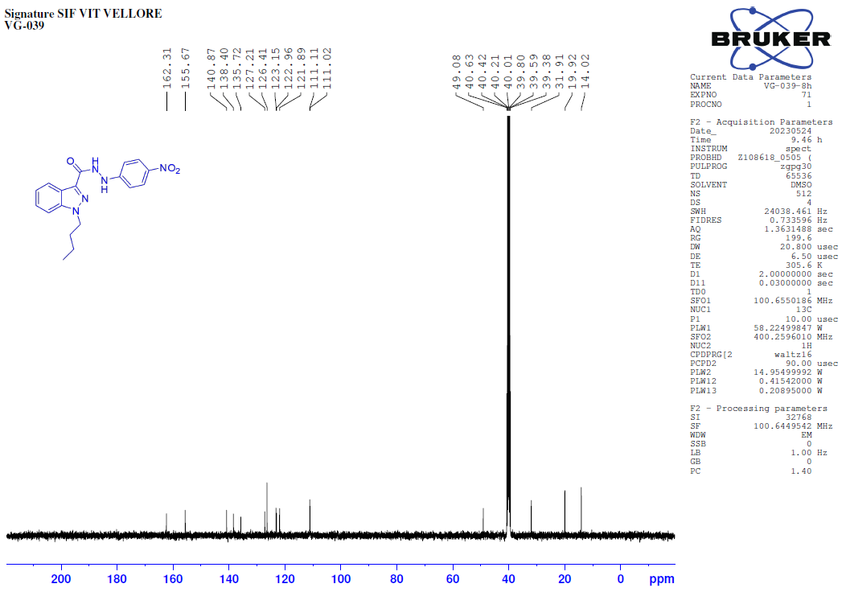

135-DEPT-NMR [100MHz, DMSO-d₆] spectrum of 1-butyl-N-(4-nitrophenyl)-1H-indazole-3-carbohydrazide (8h).
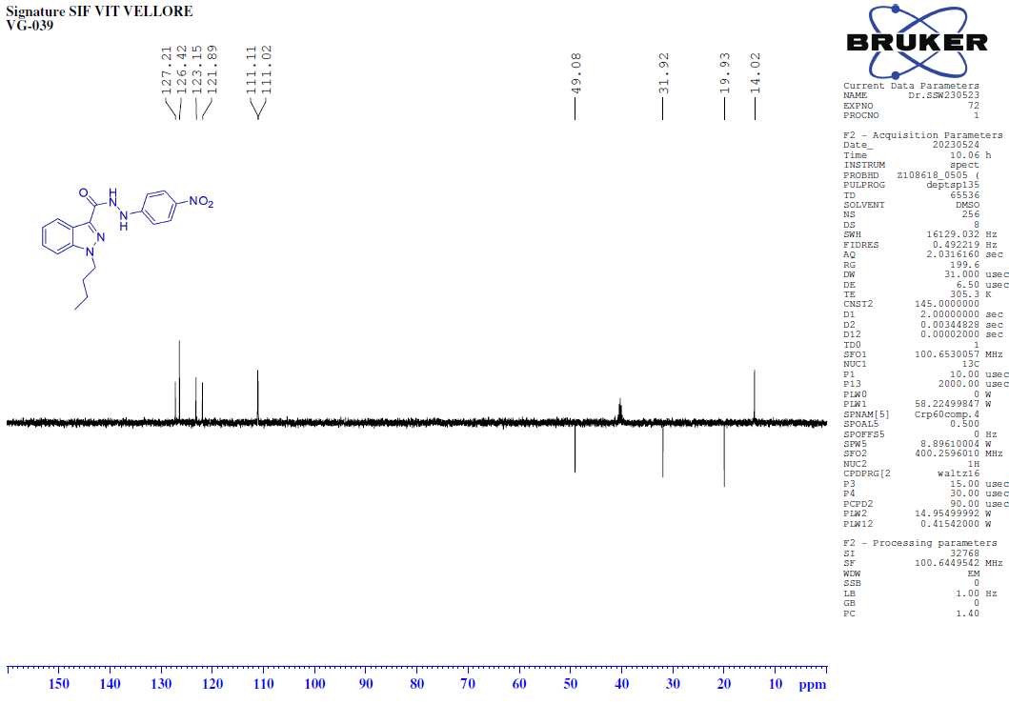
FT-IR spectrum of 1-butyl-N-(4-nitrophenyl)-1H-indazole-3-carbohydrazide (8h).
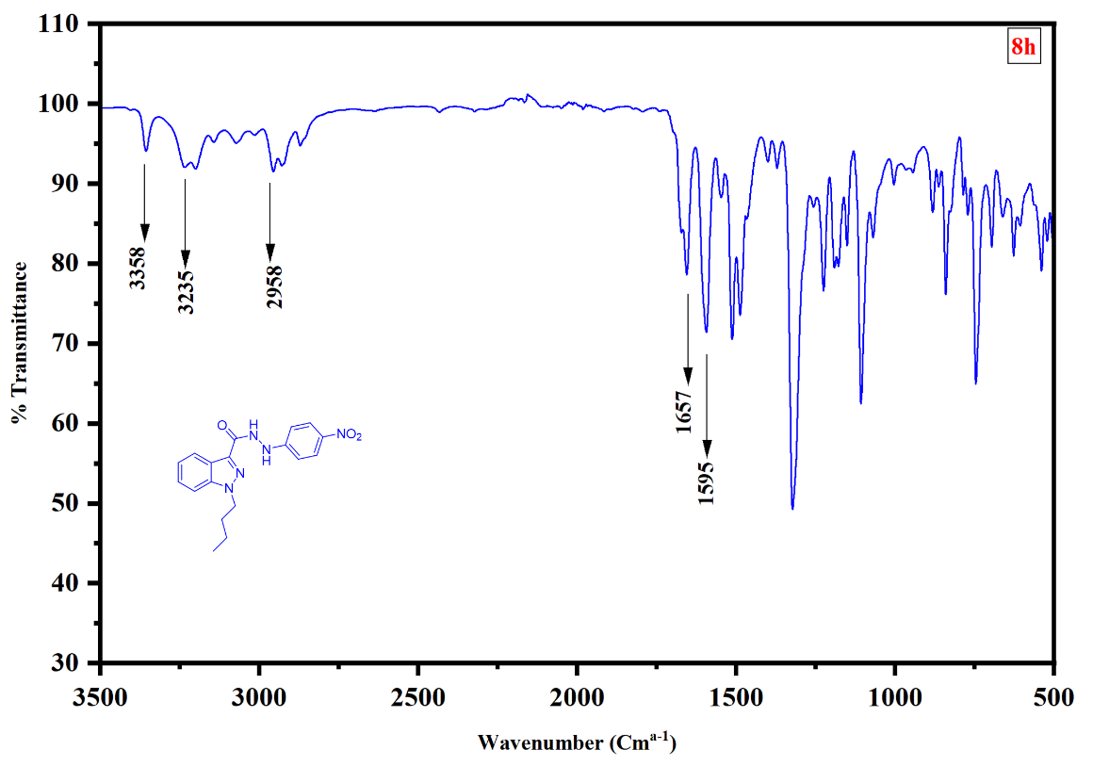
HRMS of 1-butyl-N-(4-nitrophenyl)-1H-indazole-3-carbohydrazide (8h).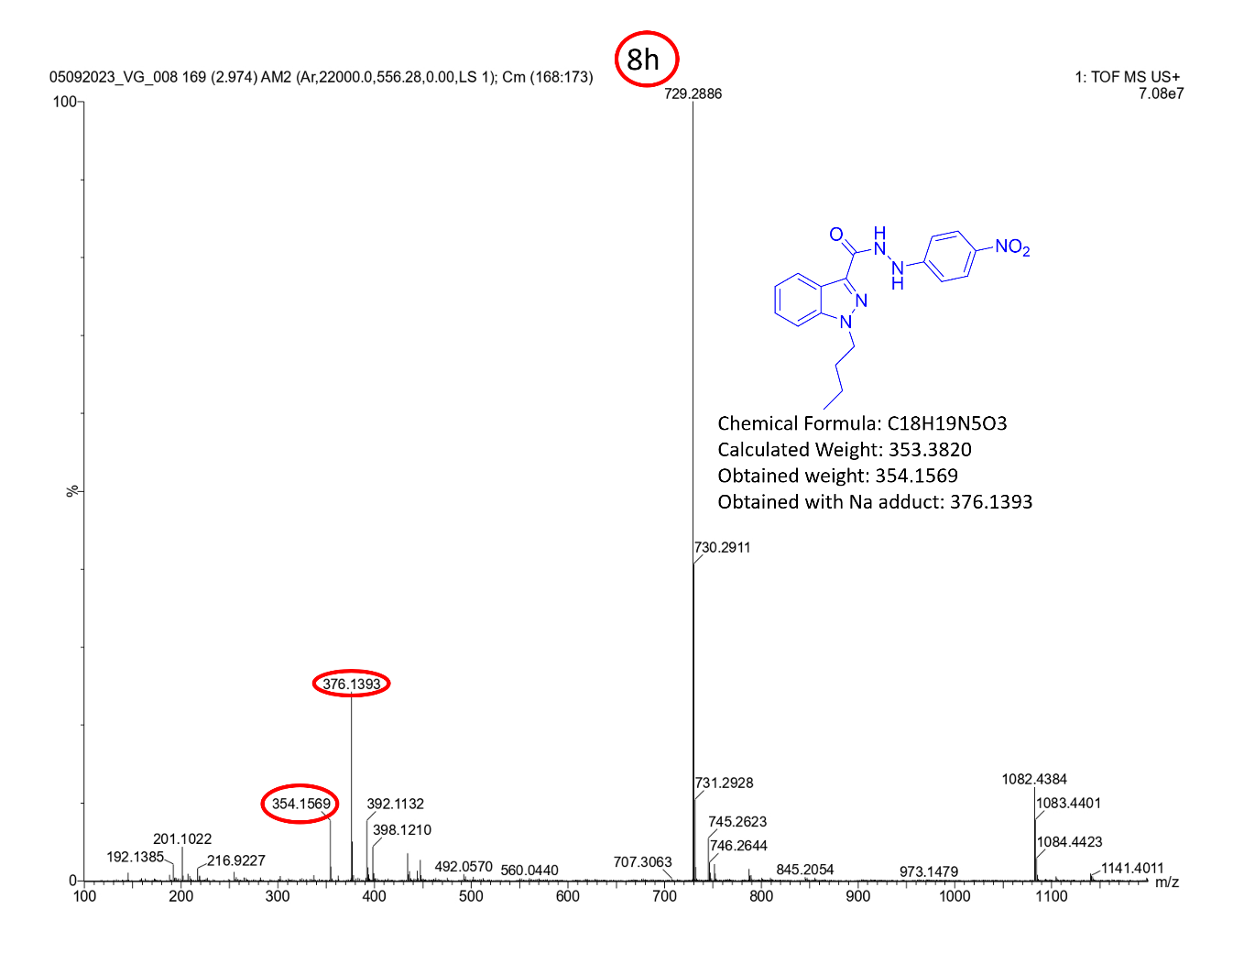
¹H-NMR [400MHz, DMSO-d₆] spectrum of N-(4-Bromophenyl)-1-butyl-1H-indazole-3-carboxamide (8i).
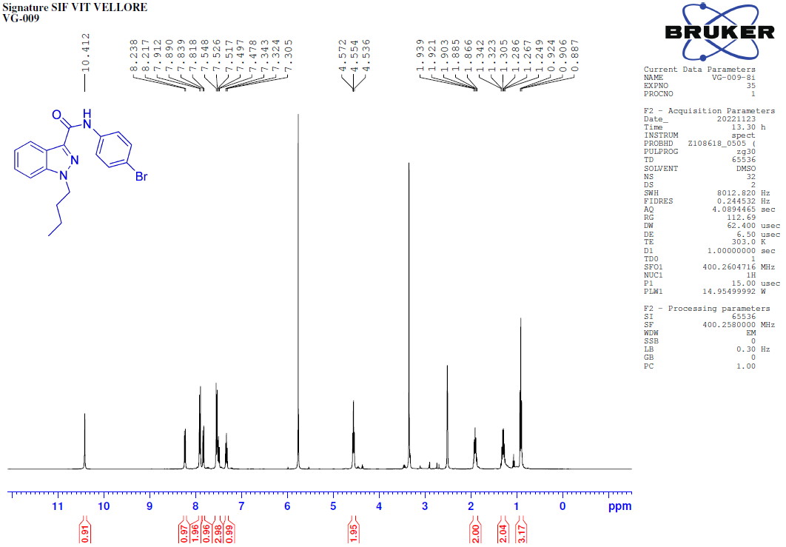
¹³C-NMR [100MHz, DMSO-d₆] spectrum of N-(4-Bromophenyl)-1-butyl-1H-indazole-3-carboxamide (8i).
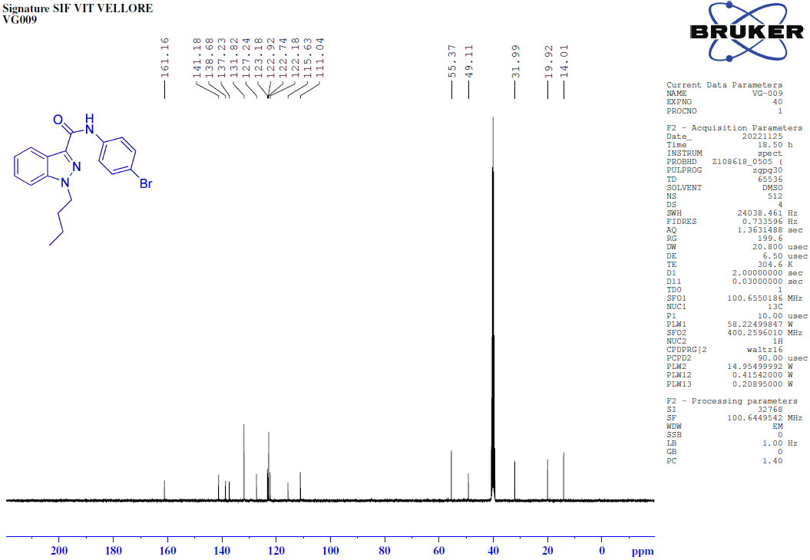
135-DEPT-NMR [100MHz, DMSO-d₆] spectrum of N-(4-Bromophenyl)-1-butyl-1H-indazole-3-carboxamide (8i).
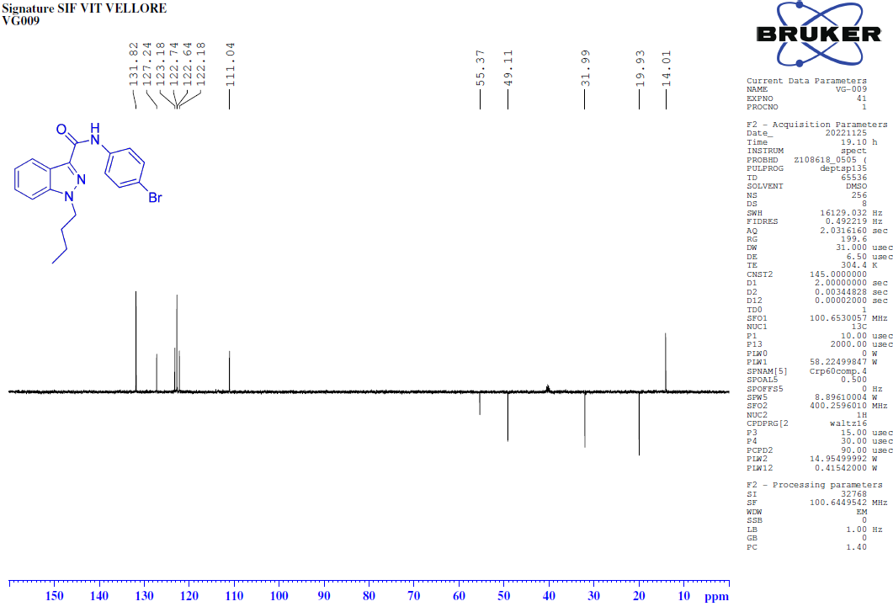
COSY-NMR [400MHz, DMSO-d₆] spectrum of N-(4-Bromophenyl)-1-butyl-1H-indazole-3-carboxamide (8i).
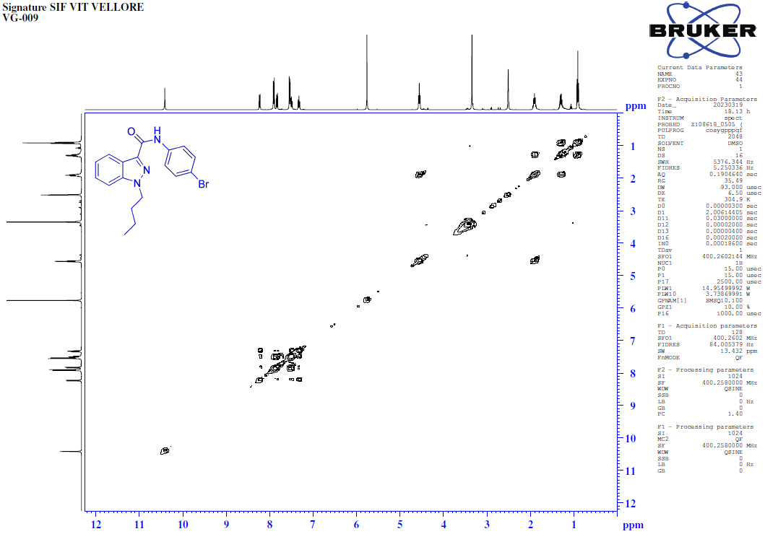
HSQC-NMR [400MHz, DMSO-d₆] spectrum of N-(4-Bromophenyl)-1-butyl-1H-indazole-3-carboxamide (8i).
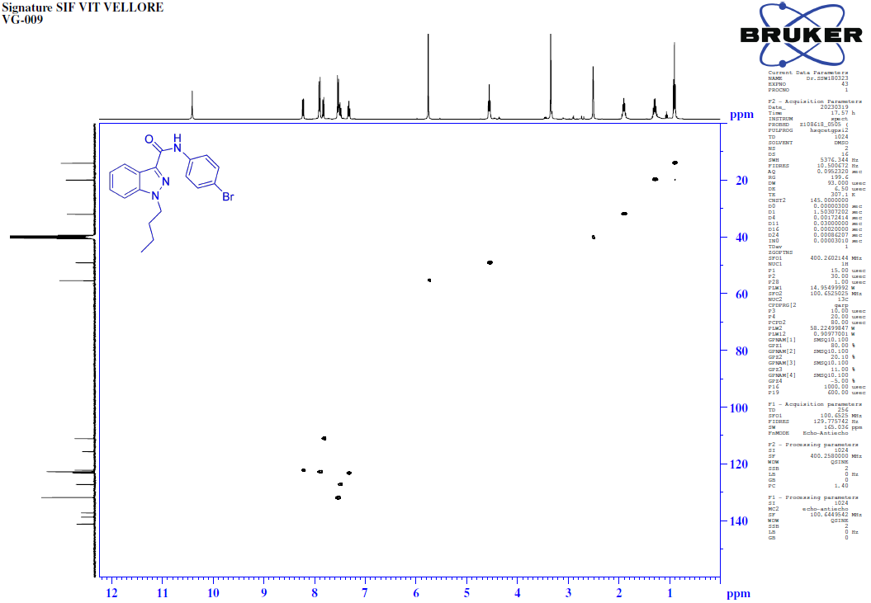
FT-IR spectrum of N-(4-Bromophenyl)-1-butyl-1H-indazole-3-carboxamide (8i).
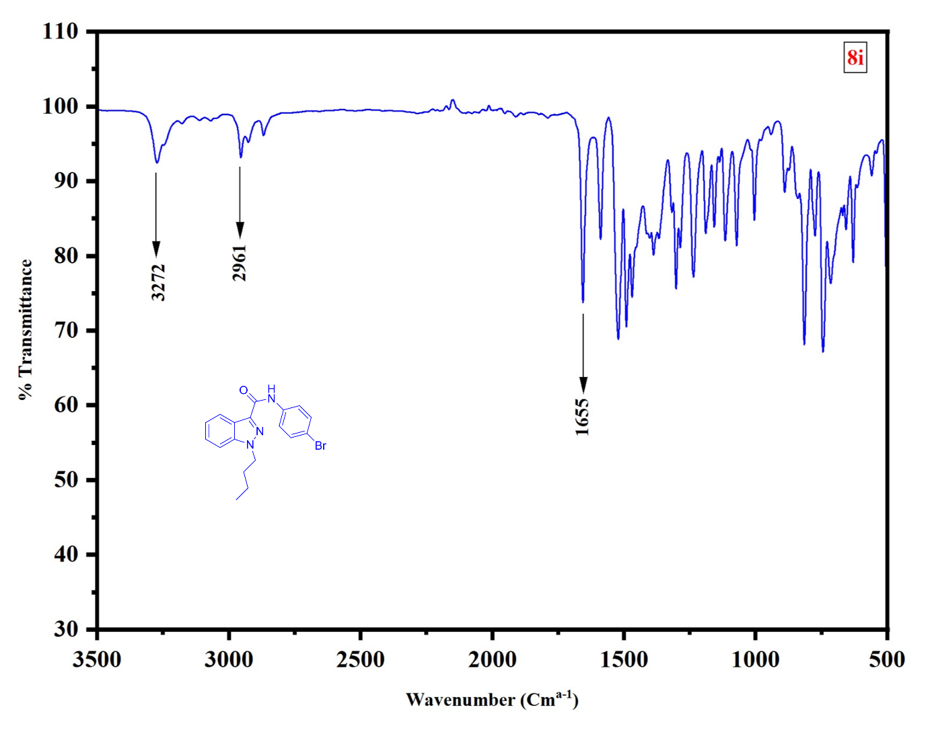
HRMS of N-(4-Bromophenyl)-1-butyl-1H-indazole-3-carboxamide (8i).
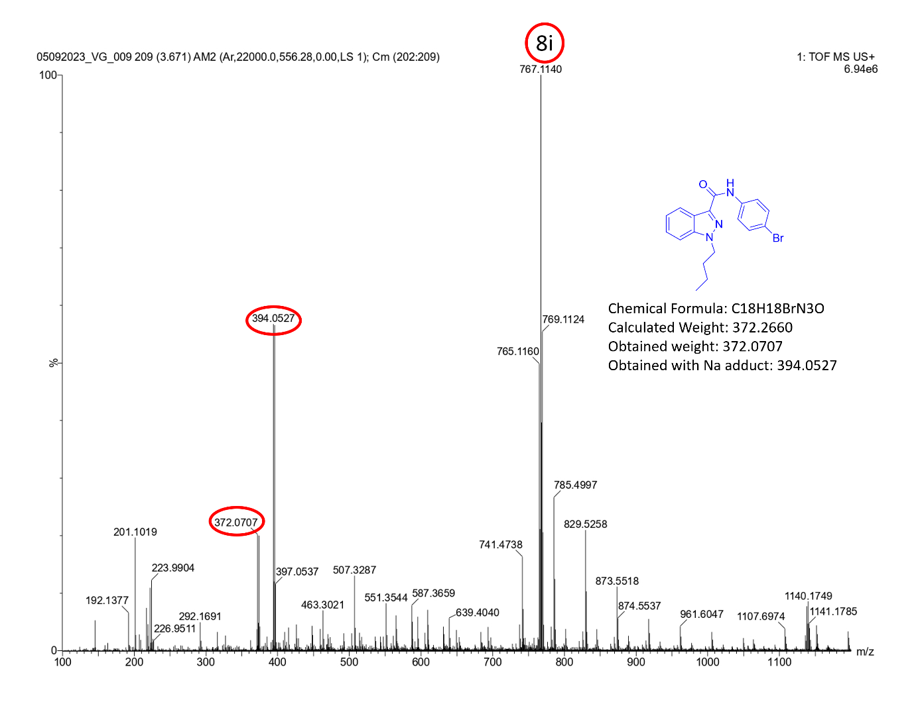
¹H-NMR [400MHz, DMSO-d₆] spectrum of 1-butyl-N-(4-hydroxypheny)-1H-indazole-3-carboxamide (8j).
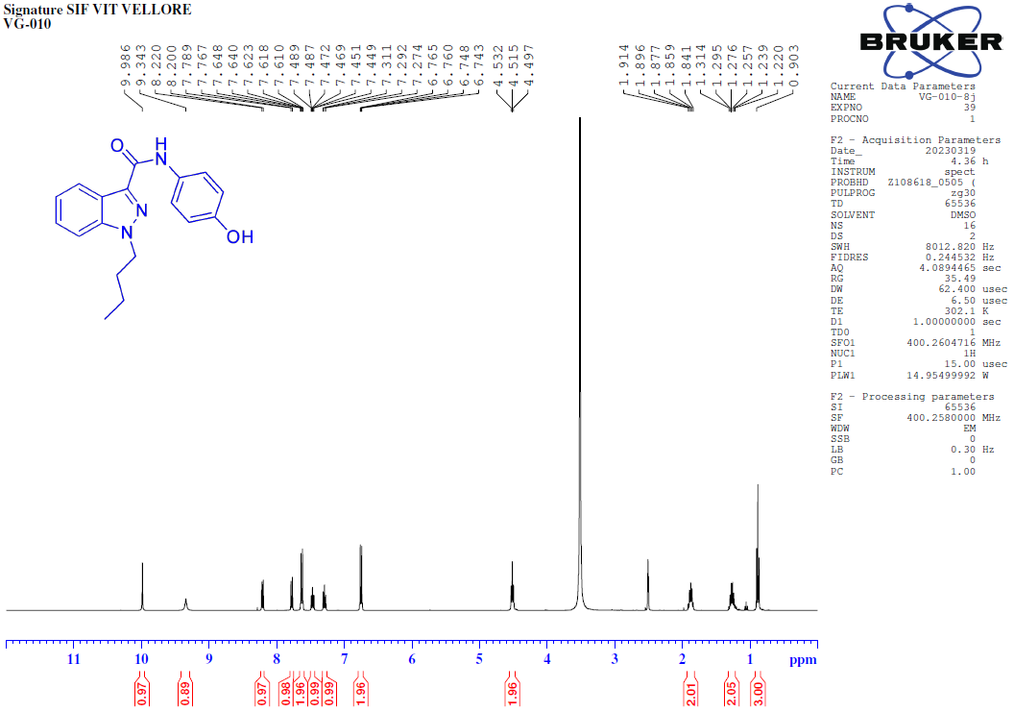
¹³C-NMR [100MHz, DMSO-d₆] spectrum of 1-butyl-N-(4-hydroxypheny)-1H-indazole-3-carboxamide (8j).
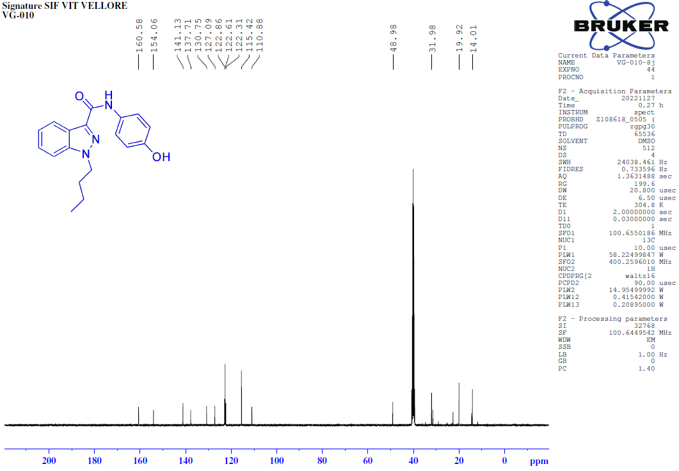
135-DEPT-NMR [100MHz, DMSO-d₆] spectrum of 1-butyl-N-(4-hydroxypheny)-1H-indazole-3-carboxamide (8j).
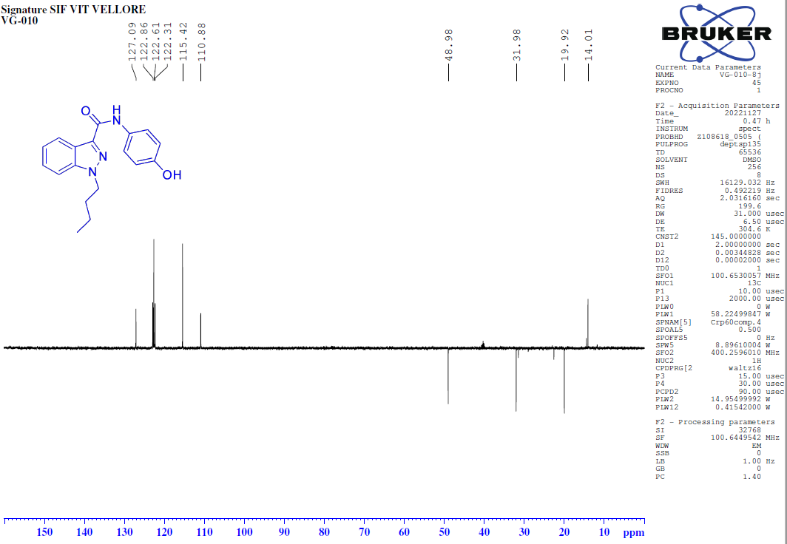
COSY-NMR [400MHz, DMSO-d₆] spectrum of 1-butyl-N-(4-hydroxypheny)-1H-indazole-3-carboxamide (8j).
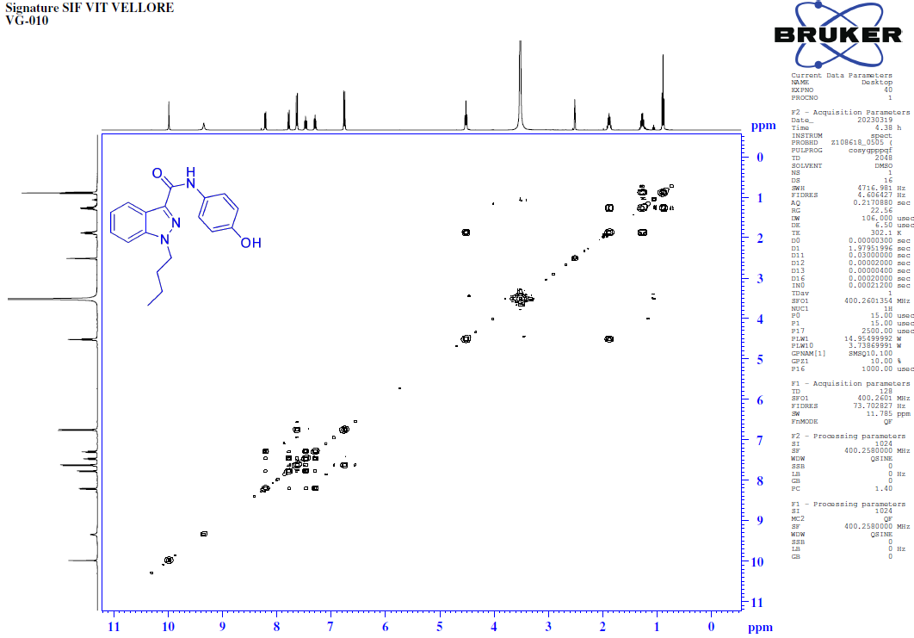 HSQC-NMR [400MHz, DMSO-d₆] spectrum of 1-butyl-N-(4-hydroxypheny)-1H-indazole-3-carboxamide (8j).
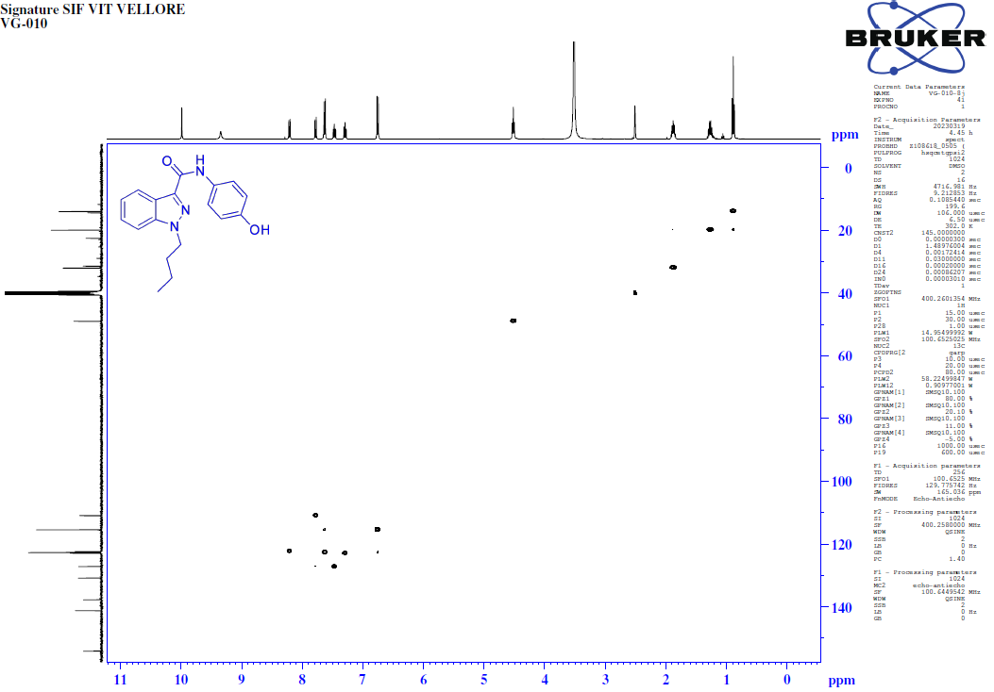
FT-IR spectrum of 1-butyl-N-(4-hydroxypheny)-1H-indazole-3-carboxamide (8j).
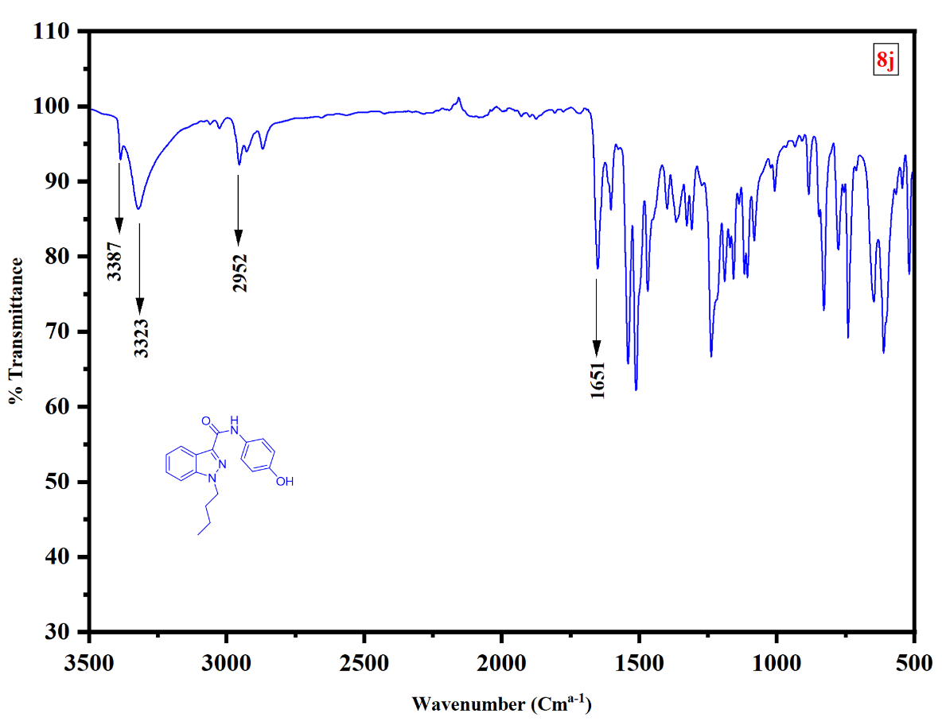
HRMS of 1-butyl-N-(4-hydroxypheny)-1H-indazole-3-carboxamide (8j).
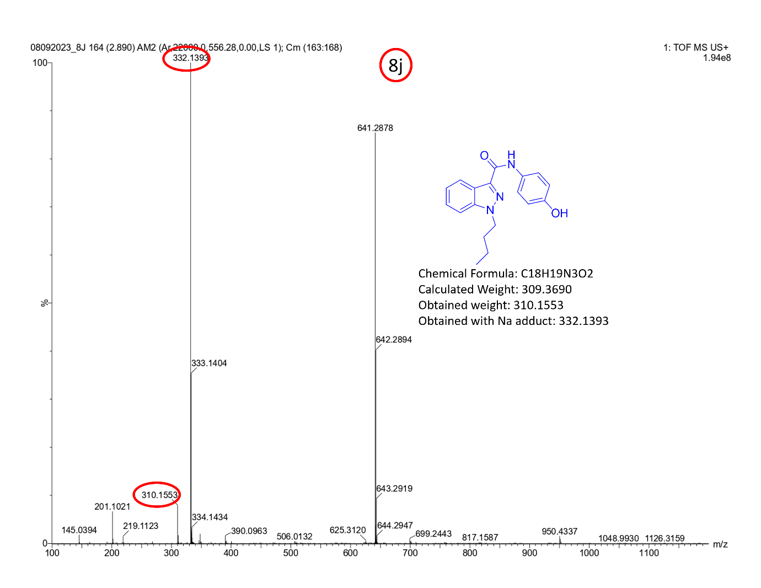
¹H-NMR [400MHz, DMSO-d₆] spectrum of 1-butyl-N-(2-hydroxy-6-methylpheny)-1H-indazole-3-carboxamide (8k).
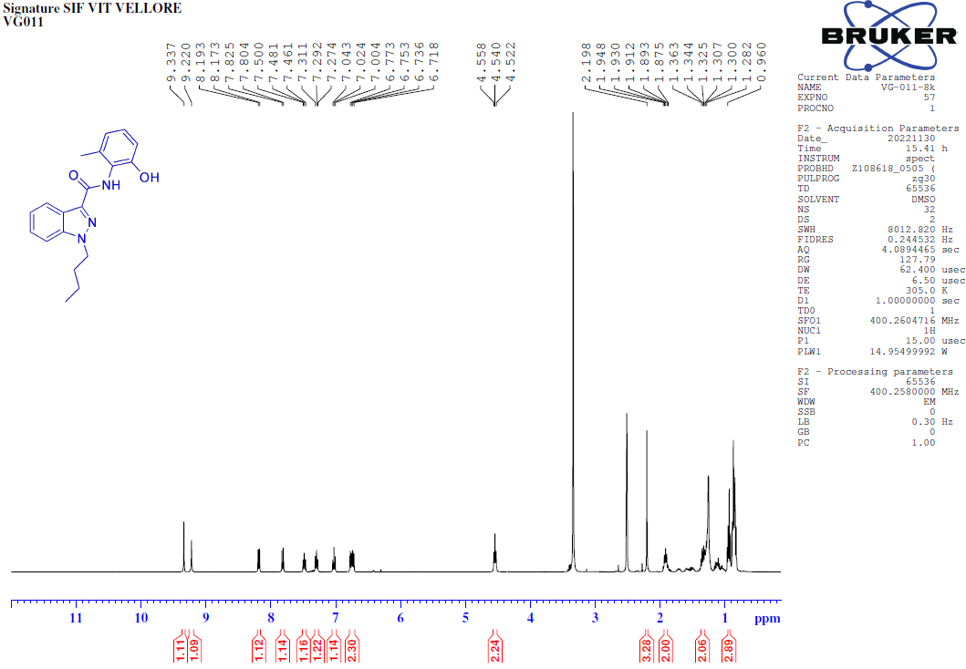
¹³C-NMR [100MHz, DMSO-d₆] spectrum of 1-butyl-N-(2-hydroxy-6-methylpheny)-1H-indazole-3-carboxamide (8k).
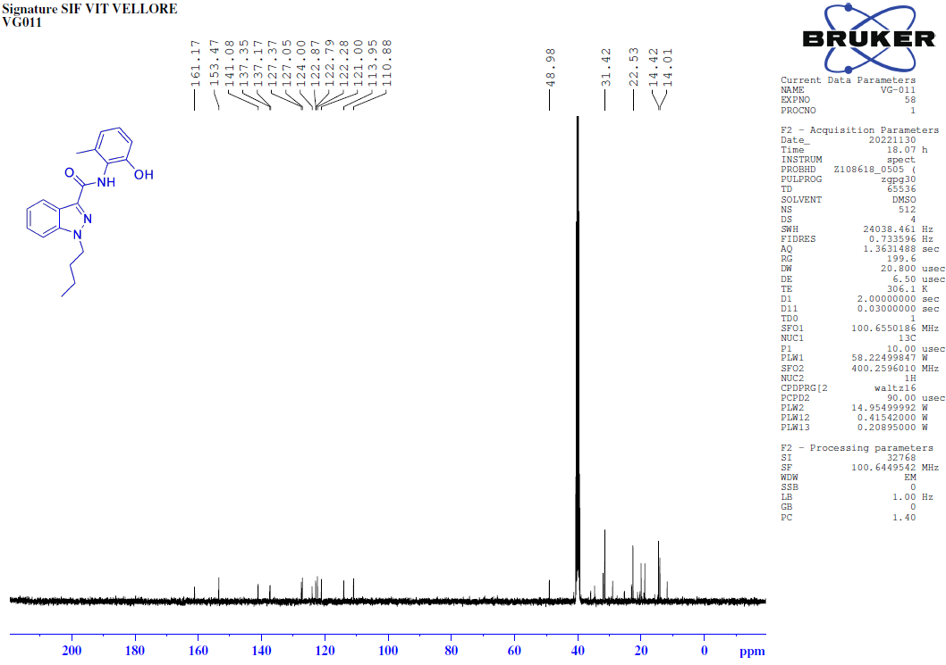135-DEPT-NMR [100MHz, DMSO-d₆] spectrum of 1-butyl-N-(2-hydroxy-6-methylpheny)-1H-indazole-3-carboxamide (8k).
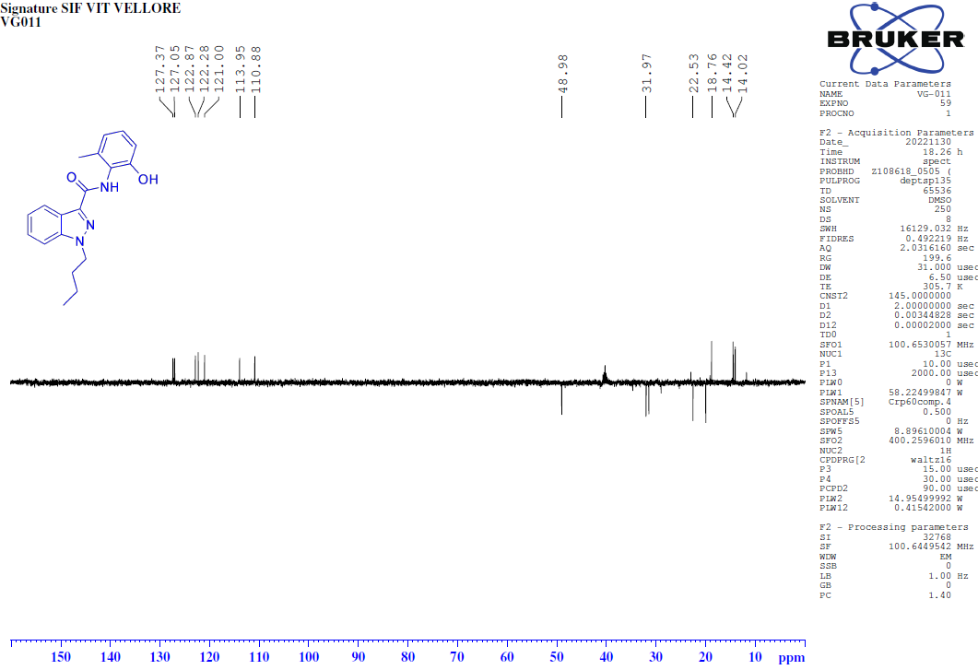
FT-IR spectrum of 1-butyl-N-(2-hydroxy-6-methylpheny)-1H-indazole-3-carboxamide (8k). 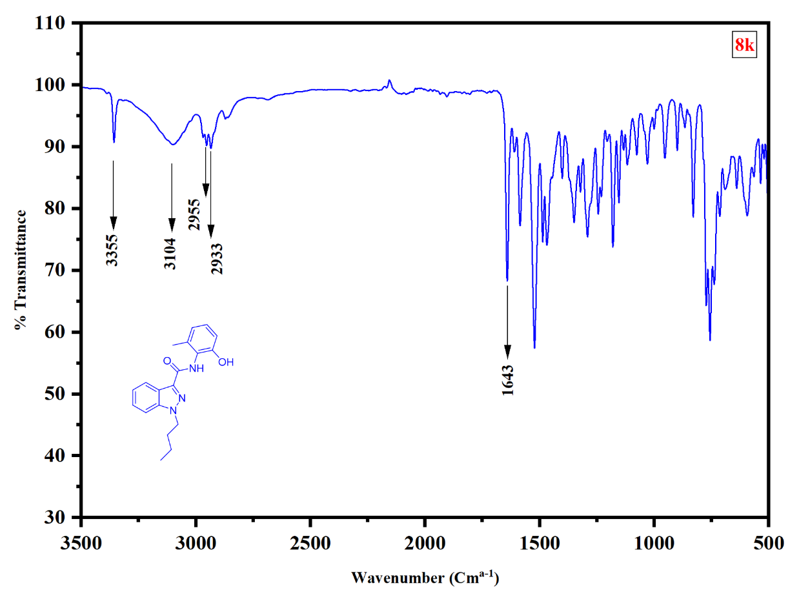
HRMS of 1-butyl-N-(2-hydroxy-6-methylpheny)-1H-indazole-3-carboxamide (8k).
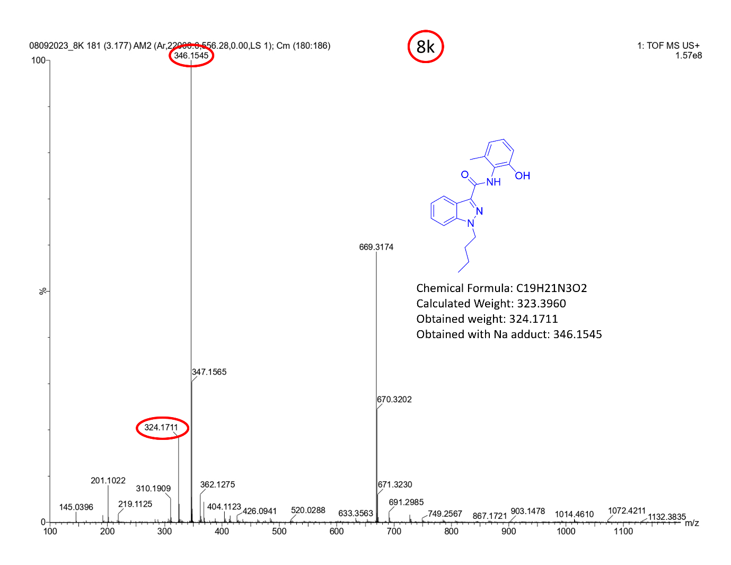

¹H-NMR [400MHz, DMSO-d₆] spectrum of 1-butyl-N-(m-tolyl)-1H-indazole-3-carboxamide (8l). 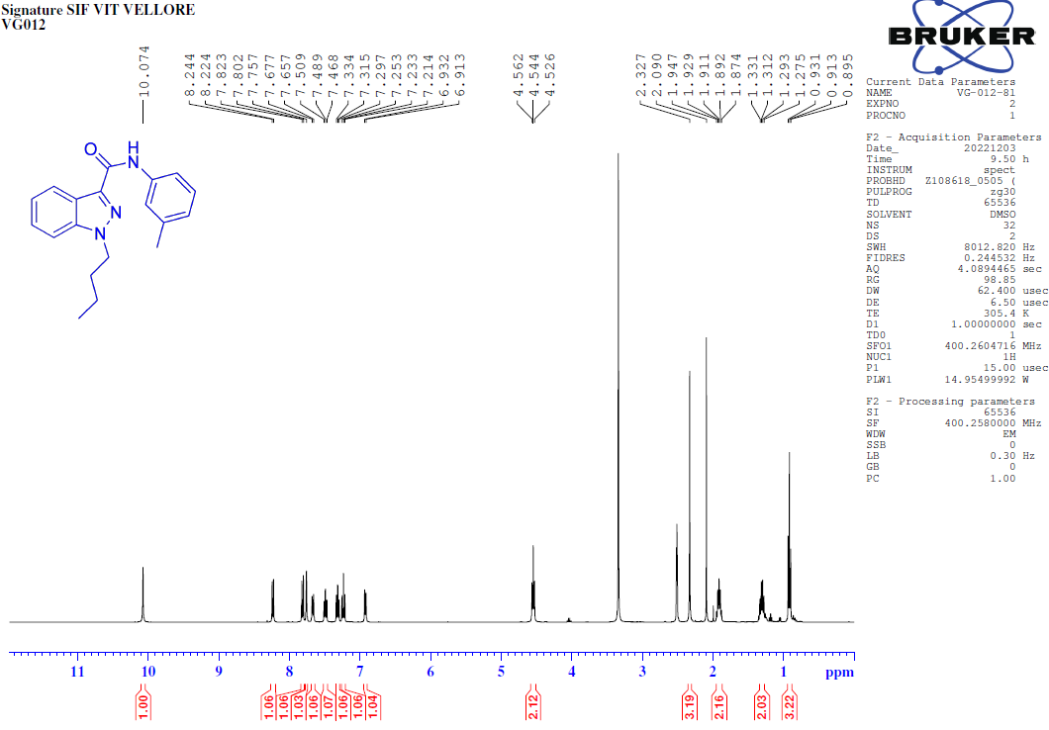¹³C-NMR [100MHz, DMSO-d₆] spectrum of 1-butyl-N-(m-tolyl)-1H-indazole-3-carboxamide (8l). 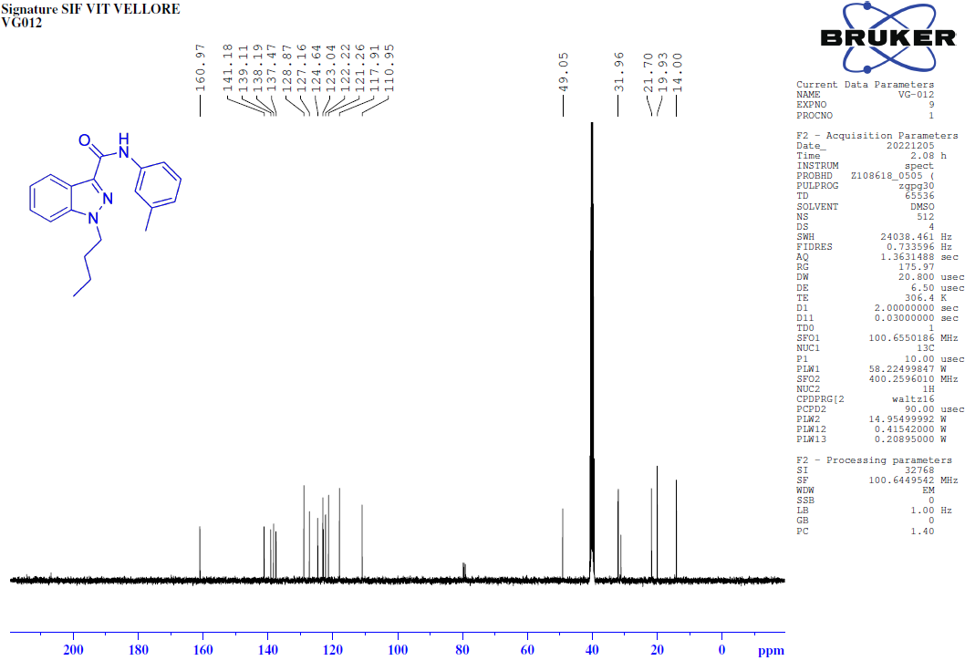
135-DEPT-NMR [100MHz, DMSO-d₆] spectrum of 1-butyl-N-(m-tolyl)-1H-indazole-3-carboxamide (8l).
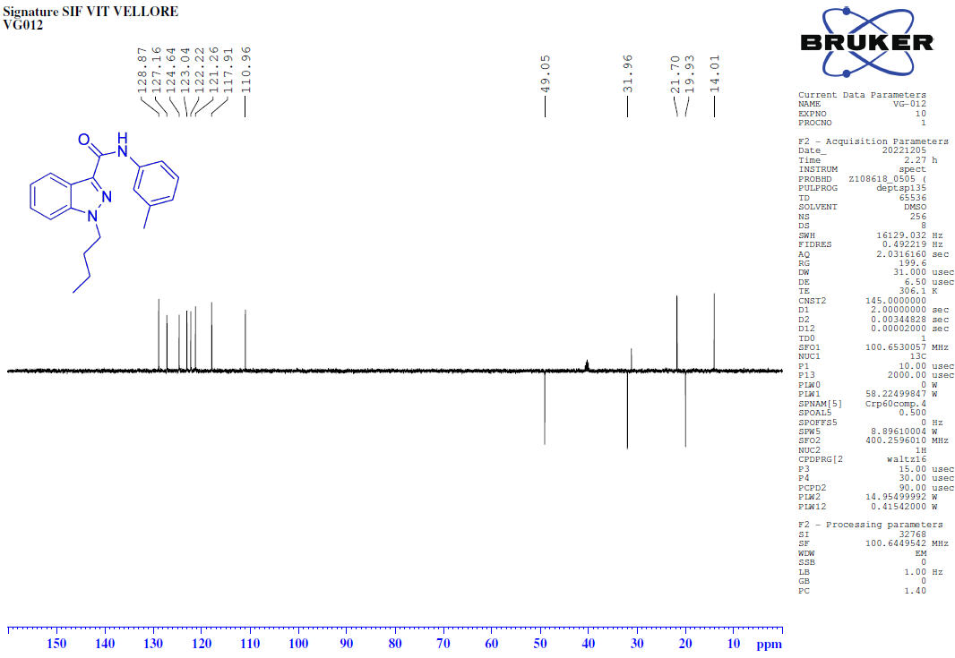COSY-NMR [400MHz, DMSO-d₆] spectrum of 1-butyl-N-(m-tolyl)-1H-indazole-3-carboxamide (8l).
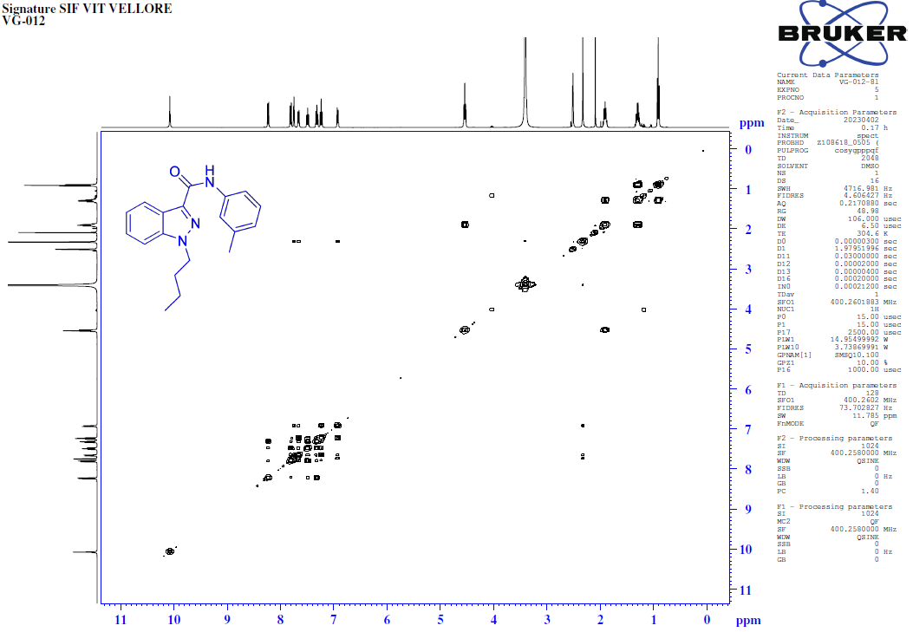HSQC-NMR [400MHz, DMSO-d₆] spectrum of 1-butyl-N-(m-tolyl)-1H-indazole-3-carboxamide (8l).
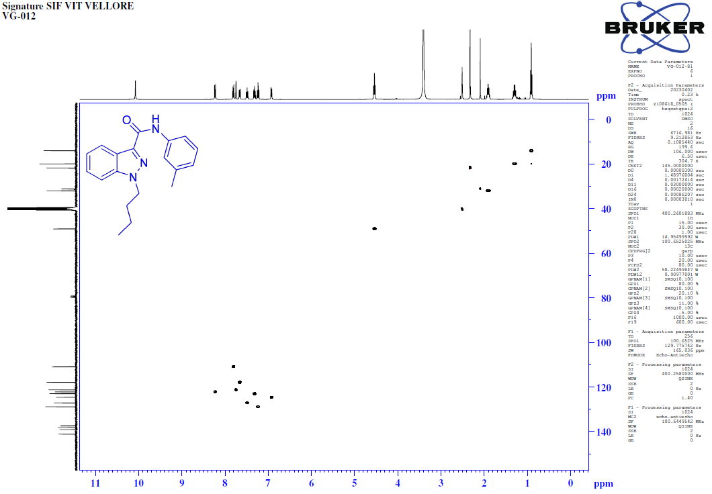
FT-IR spectrum of 1-butyl-N-(m-tolyl)-1H-indazole-3-carboxamide (8l).
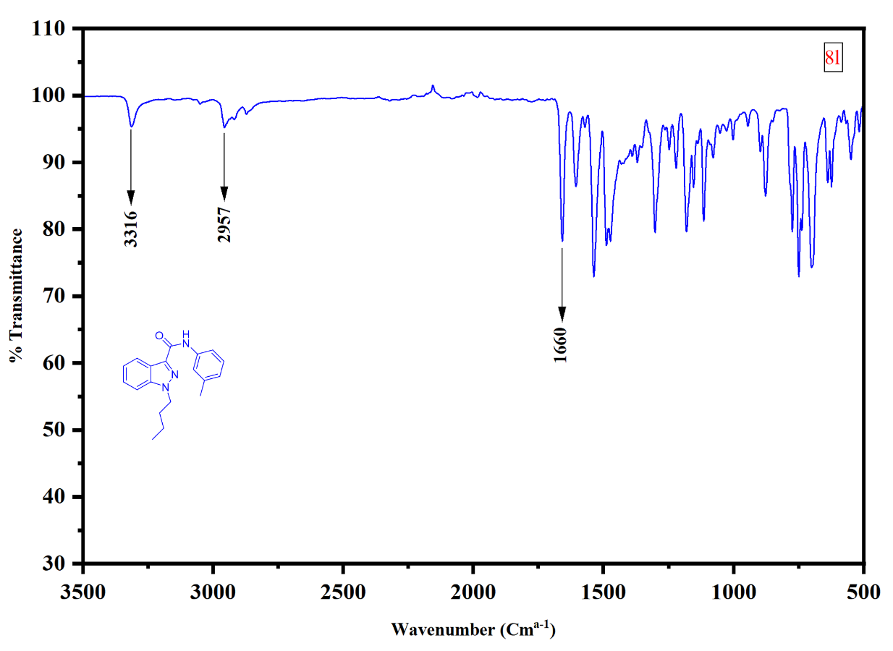
HRMS of 1-butyl-N-(m-tolyl)-1H-indazole-3-carboxamide (8l).
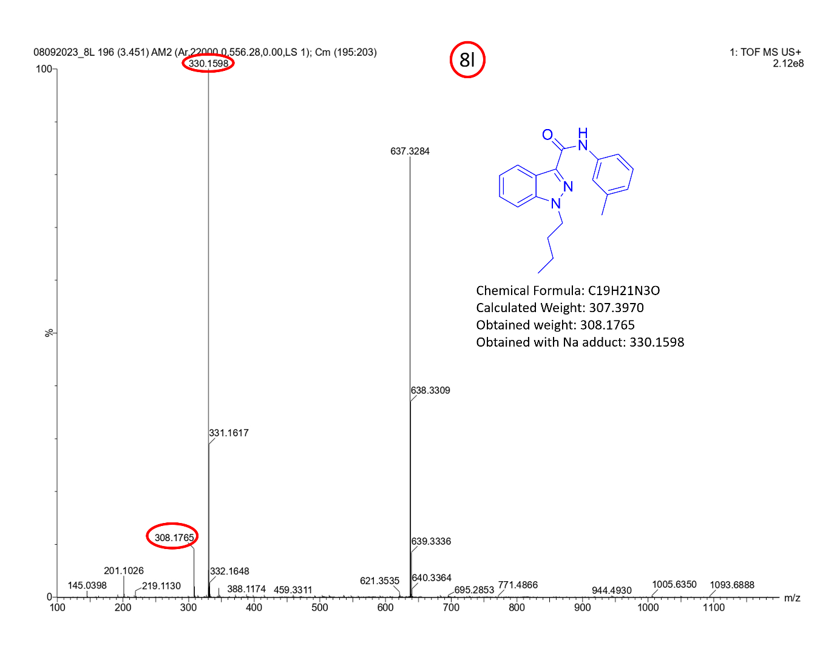

¹H-NMR [400MHz, DMSO-d₆] spectrum of 1-butyl-N-(-tolyl)-1H-indazole-3-carboxamide (8m).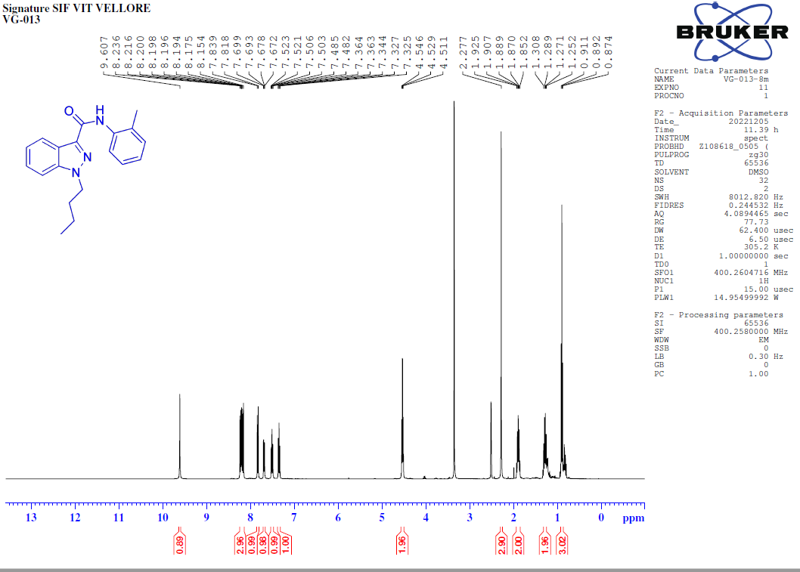
¹³C-NMR [100MHz, DMSO-d₆] spectrum of 1-butyl-N-(o-tolyl)-1H-indazole-3-carboxamide (8m).
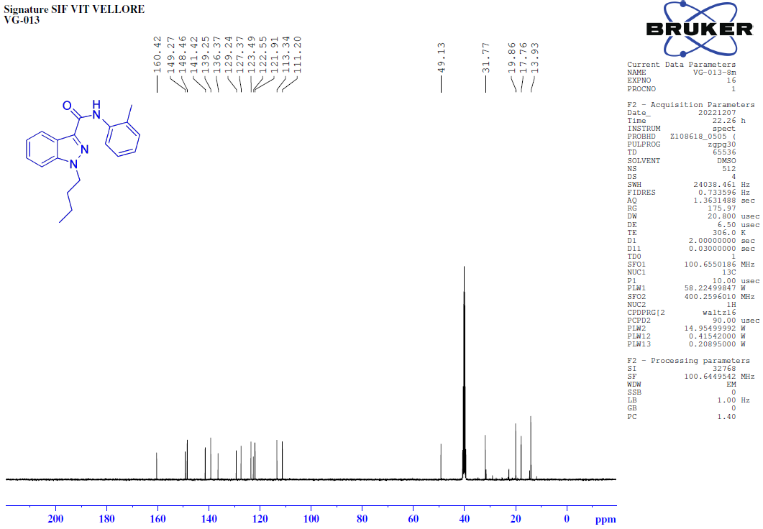
135-DEPT-NMR [100MHz, DMSO-d₆] spectrum of 1-butyl-N-(o-tolyl)-1H-indazole-3-carboxamide (8m).
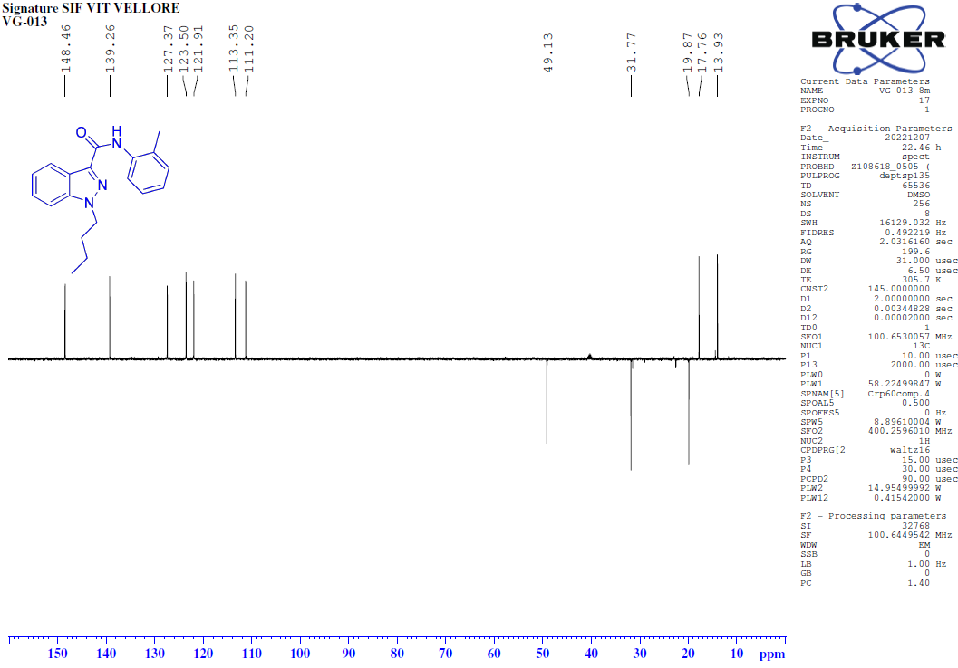
COSY-NMR [400MHz, DMSO-d₆] spectrum of 1-butyl-N-(o-tolyl)-1H-indazole-3-carboxamide (8m).
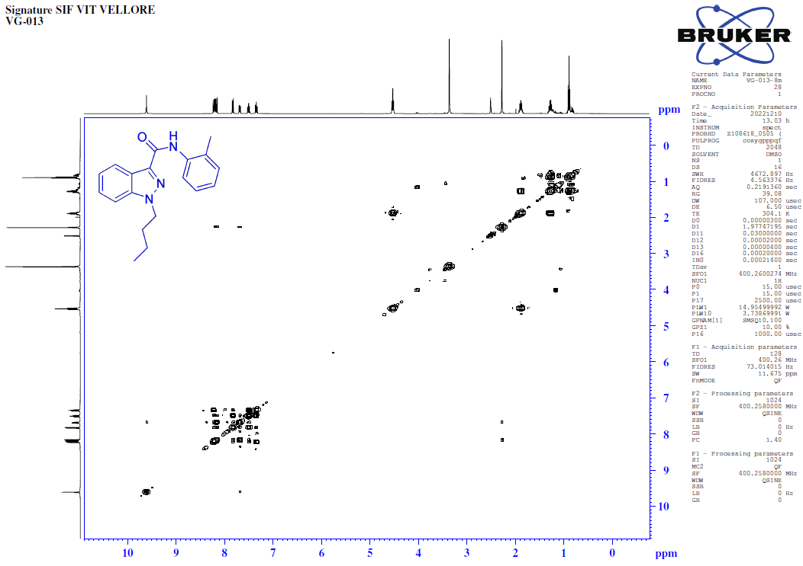
HSQC-NMR [400MHz, DMSO-d₆] spectrum of 1-butyl-N-(o-tolyl)-1H-indazole-3-carboxamide (8m).
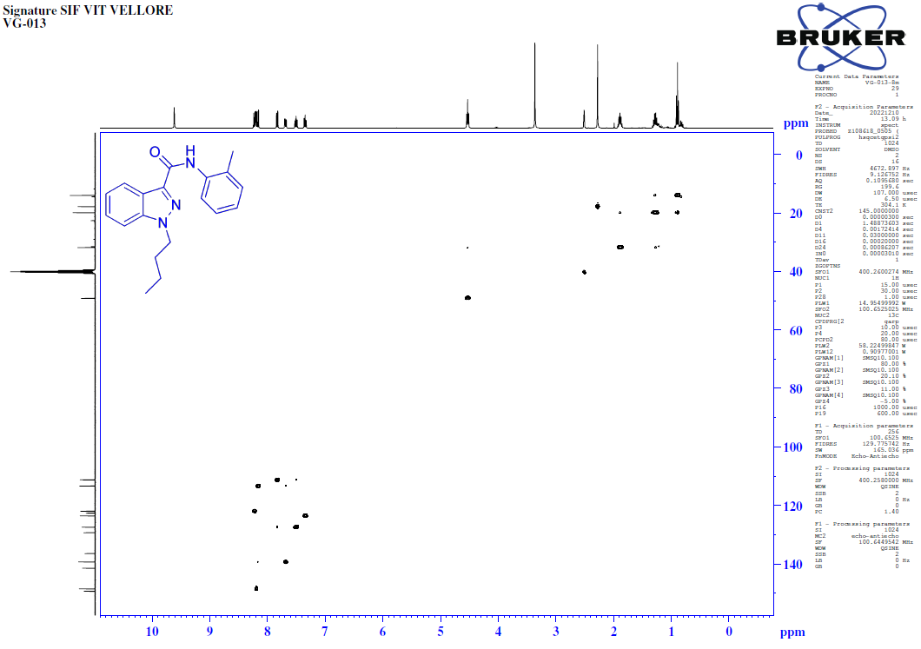
FT-IR spectrum of 1-butyl-N-(o-tolyl)-1H-indazole-3-carboxamide (8m).
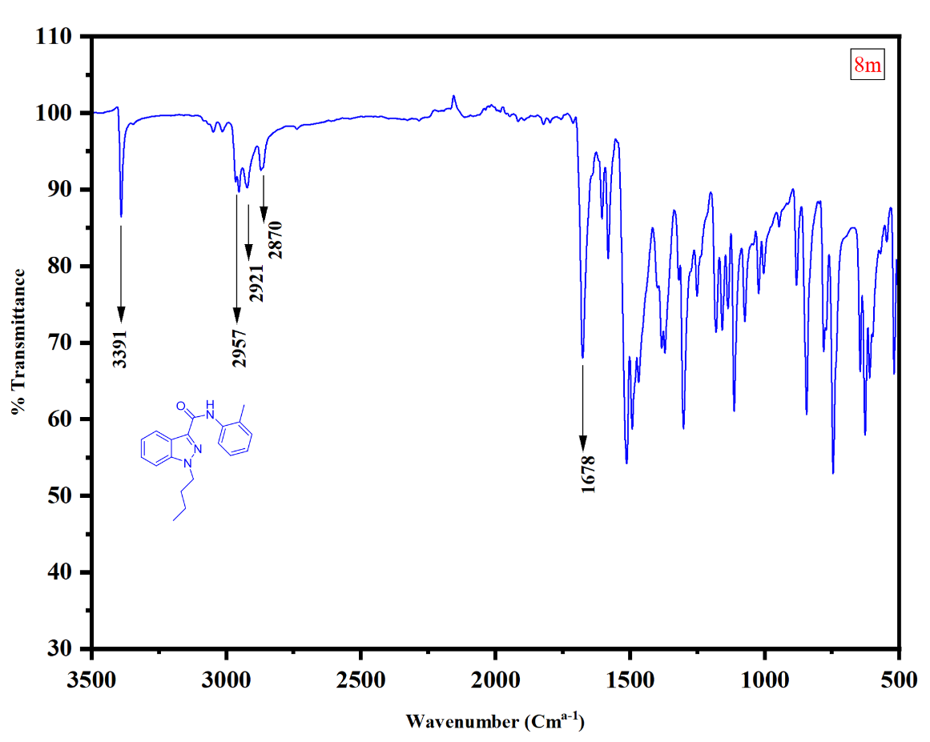
HRMS of 1-butyl-N-(o-tolyl)-1H-indazole-3-carboxamide (8m).
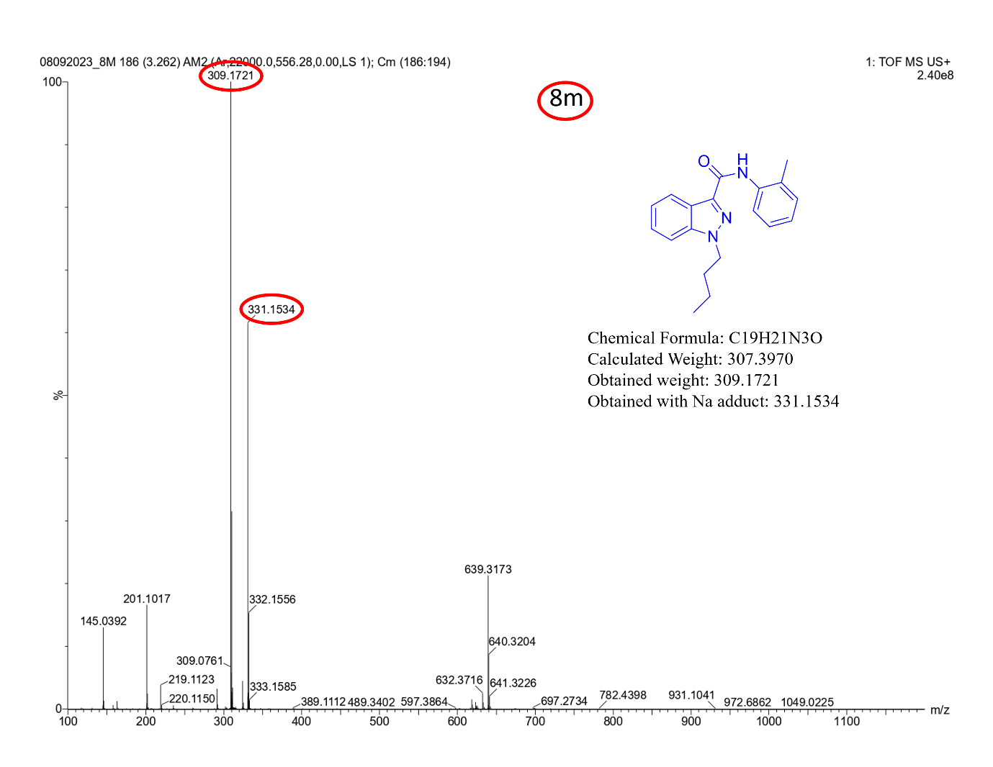

¹H-NMR [400MHz, DMSO-d₆] spectrum of 1-butyl-N-(5-methylpyridin-2-yl)-1H-indazole-3-carboxamide (8n).
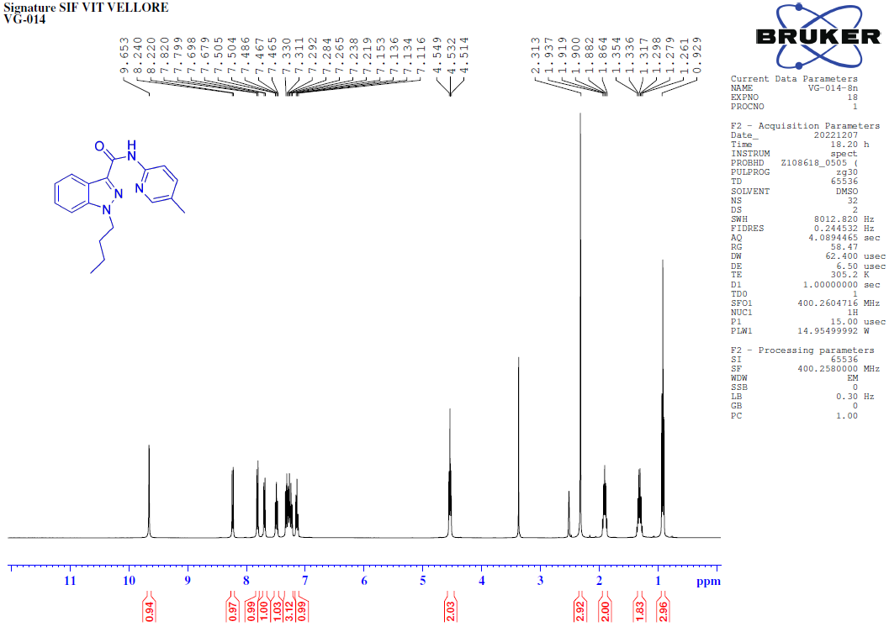
¹³C-NMR [100MHz, DMSO-d₆] spectrum of 1-butyl-N-(5-methylpyridin-2-yl)-1H-indazole-3-carboxamide (8n).
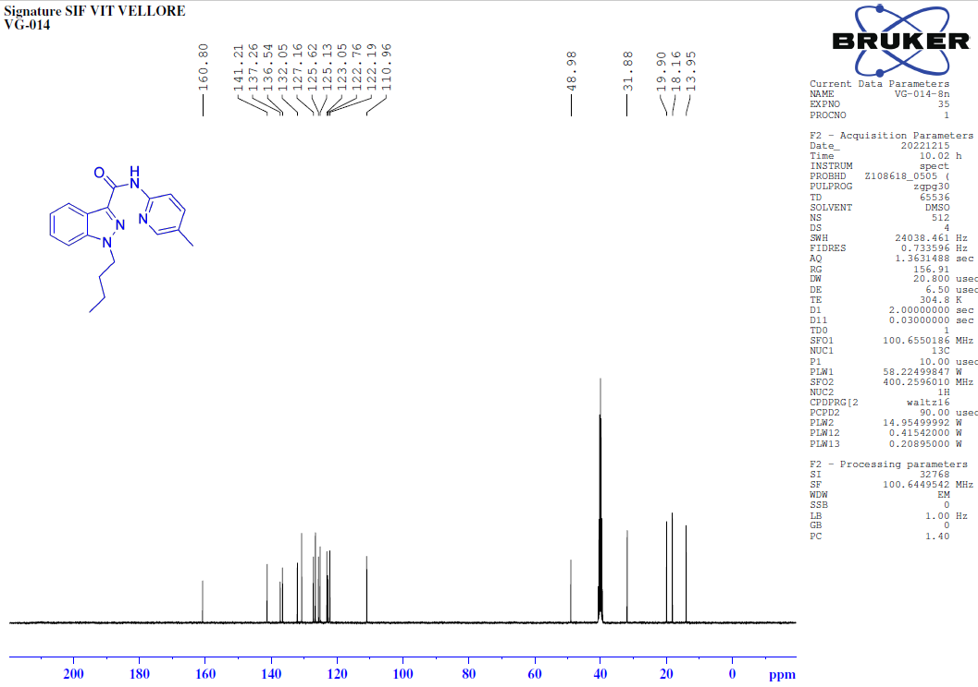
135-DEPT-NMR [100MHz, DMSO-d₆] spectrum of 1-butyl-N-(5-methylpyridin-2-yl)-1H-indazole-3-carboxamide (8n).
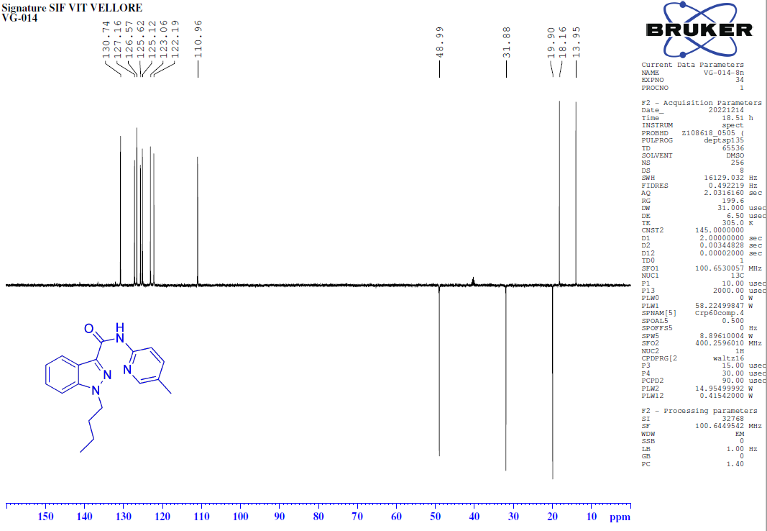
COSY-NMR [400MHz, DMSO-d₆] spectrum of 1-butyl-N-(5-methylpyridin-2-yl)-1H-indazole-3-carboxamide (8n).
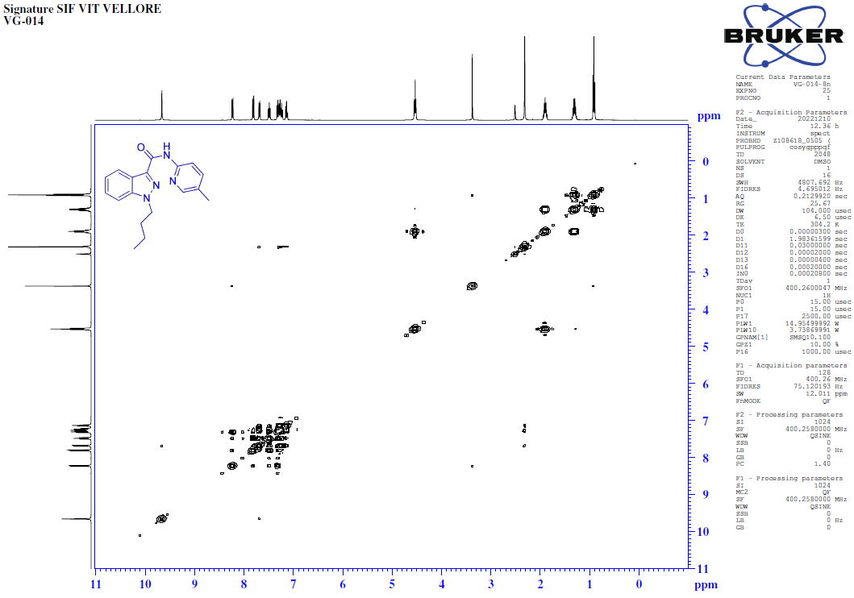
HSQC-NMR [400MHz, DMSO-d₆] spectrum of 1-butyl-N-(5-methylpyridin-2-yl)-1H-indazole-3-carboxamide (8n).
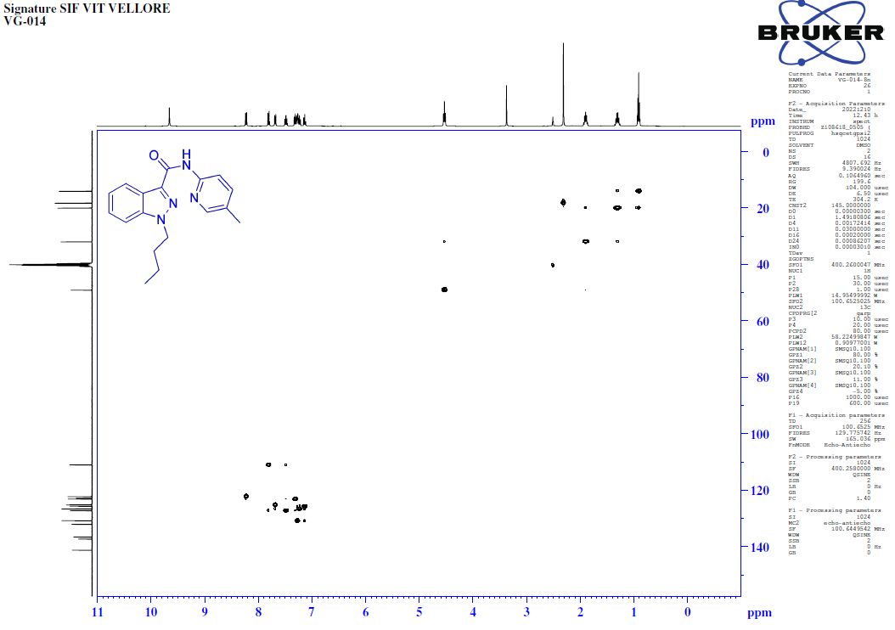
FT-IR spectrum of 1-butyl-N-(5-methylpyridin-2-yl)-1H-indazole-3-carboxamide (8n).
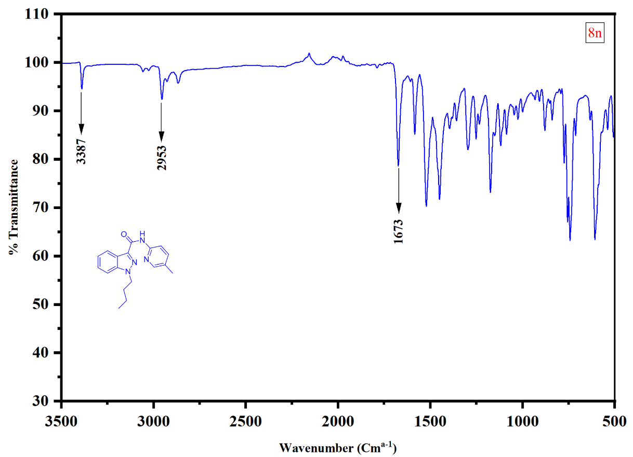
HRMS of 1-butyl-N-(5-methylpyridin-2-yl)-1H-indazole-3-carboxamide (8n).

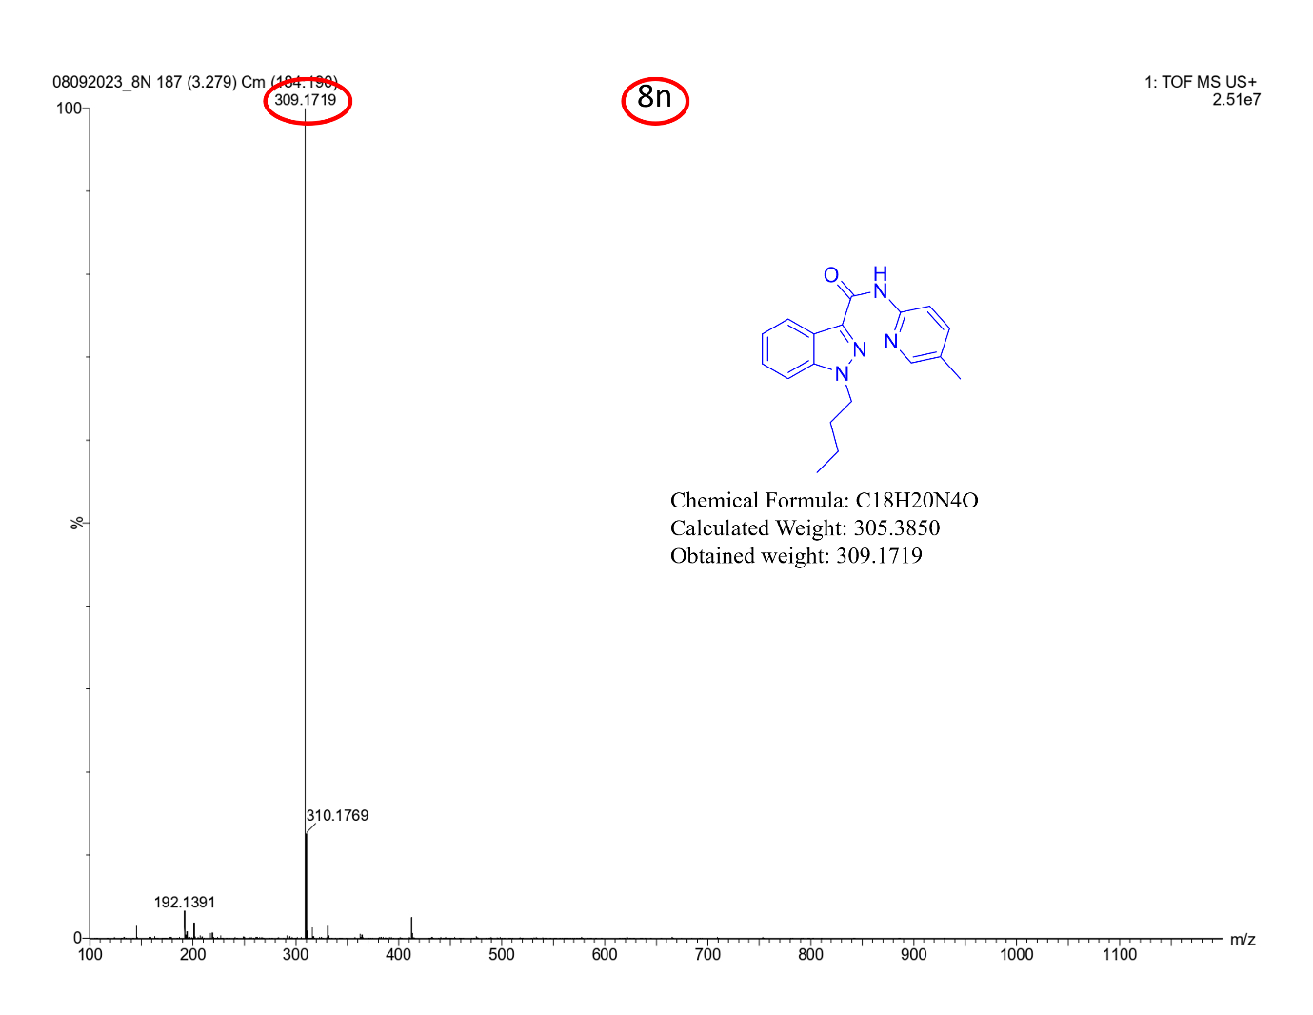
¹H-NMR [400MHz, DMSO-d₆] spectrum of 1-butyl-N-(4-methoxyphenyl)-1H-indazole-3-carboxamide (8o).
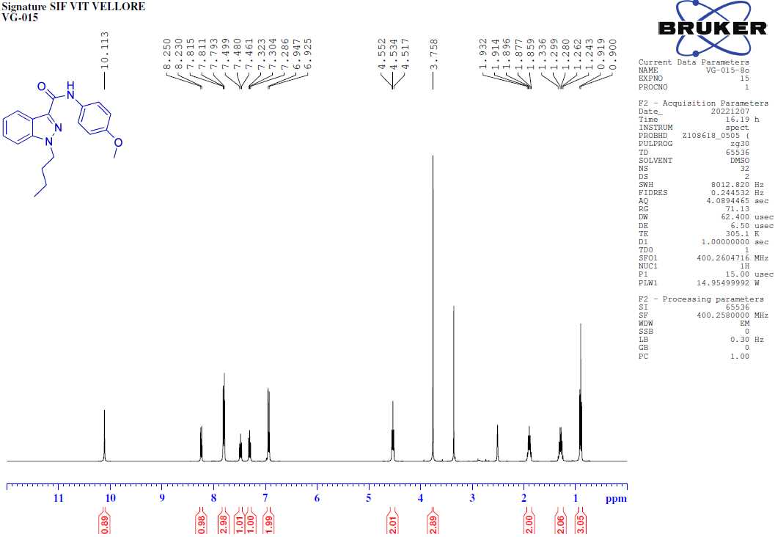
¹³C-NMR [400MHz, DMSO-d₆] spectrum of 1-butyl-N-(4-methoxyphenyl)-1H-indazole-3-carboxamide (8o).
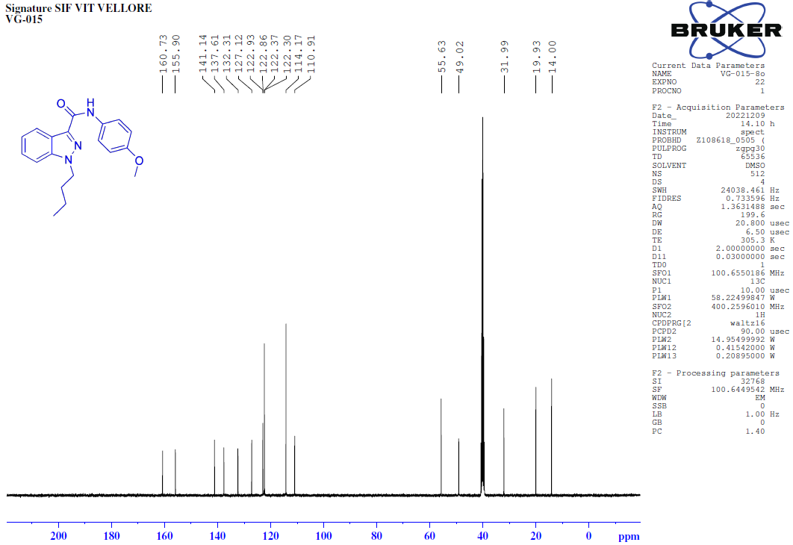
135-DEPT-NMR [400MHz, DMSO-d₆] spectrum of 1-butyl-N-(4-methoxyphenyl)-1H-indazole-3-carboxamide (8o).
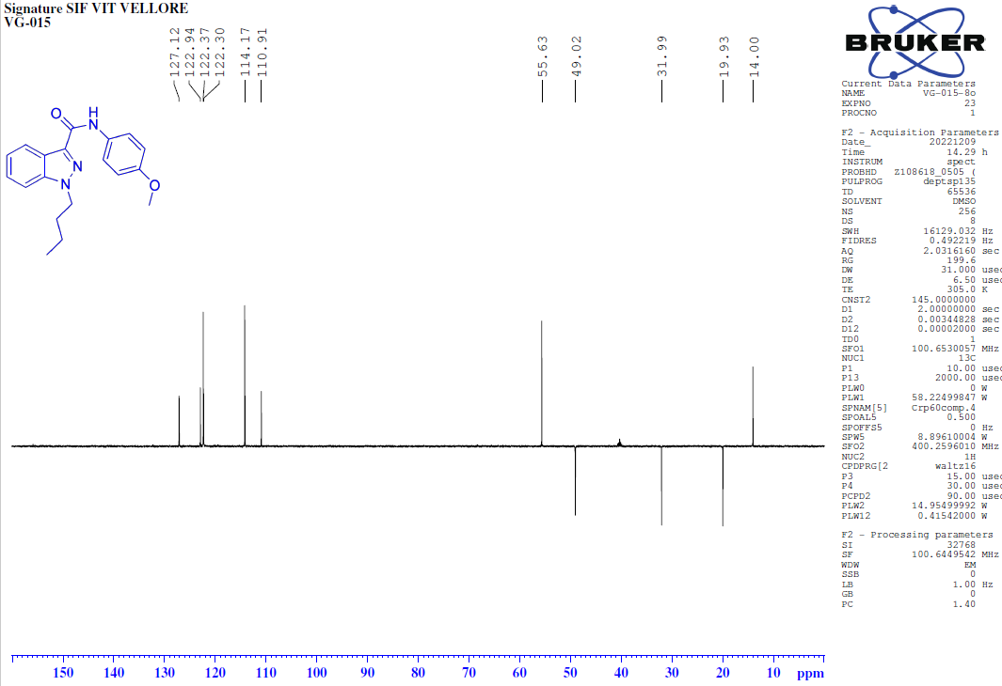
COSY-NMR [400MHz, DMSO-d₆] spectrum of 1-butyl-N-(4-methoxyphenyl)-1H-indazole-3-carboxamide (8o).
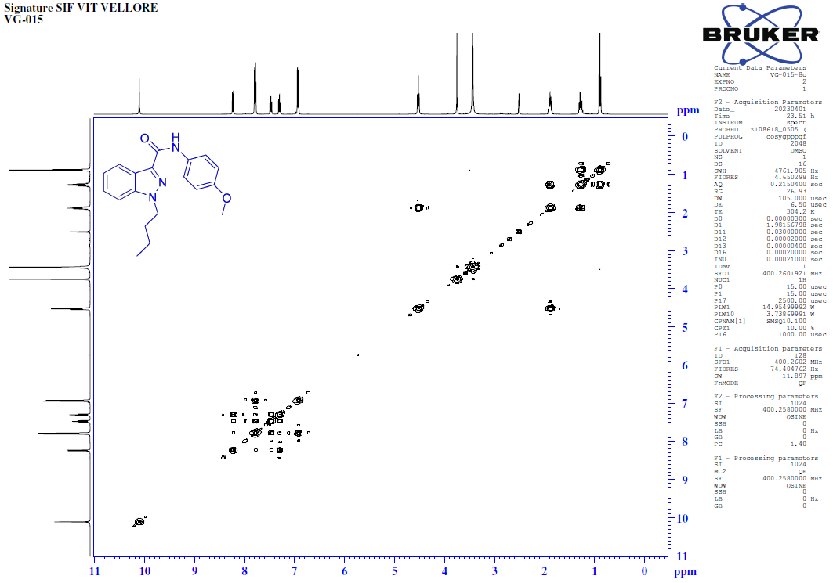
HSQC-NMR [400MHz, DMSO-d₆] spectrum of 1-butyl-N-(4-methoxyphenyl)-1H-indazole-3-carboxamide (8o).
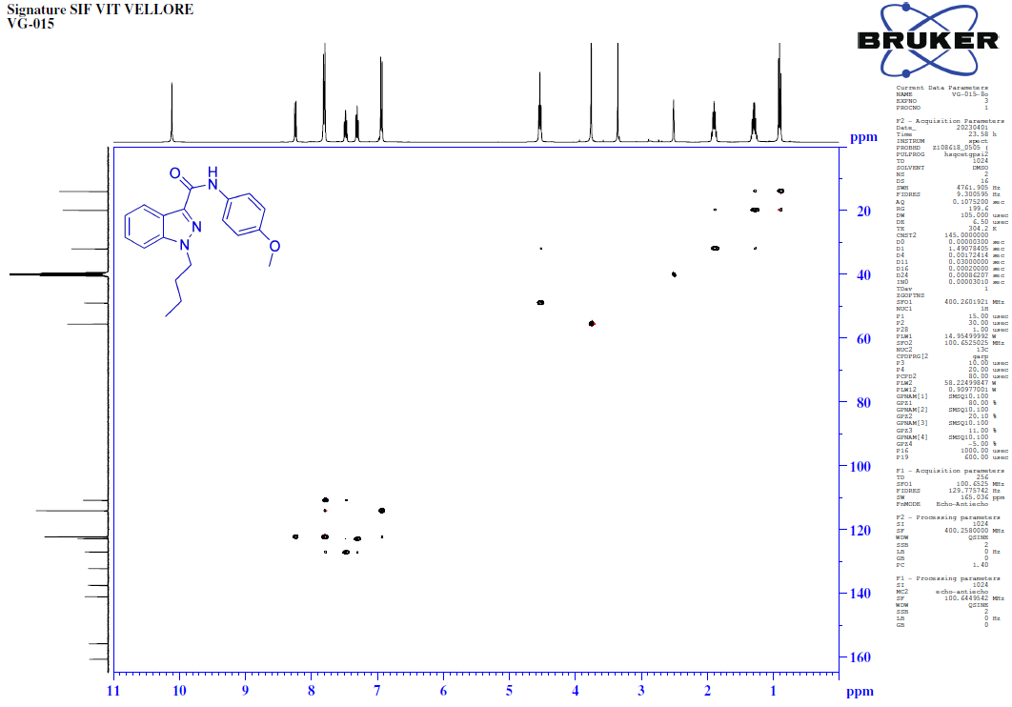
FT-IR spectrum of 1-butyl-N-(4-methoxyphenyl)-1H-indazole-3-carboxamide (8o).
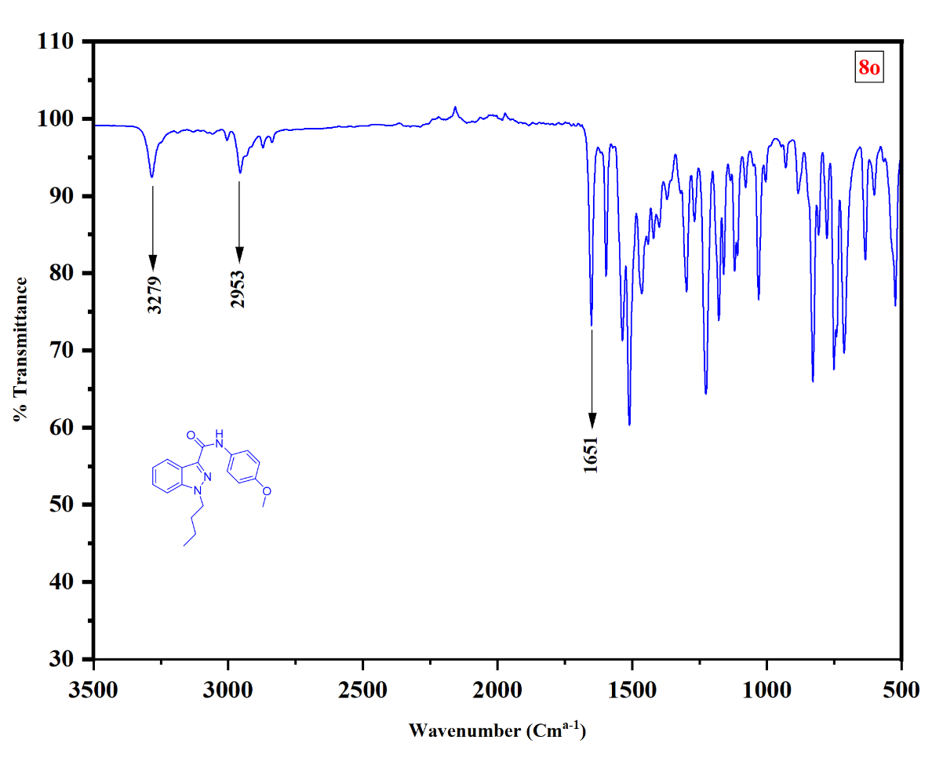
HRMS of 1-butyl-N-(4-methoxyphenyl)-1H-indazole-3-carboxamide (8o).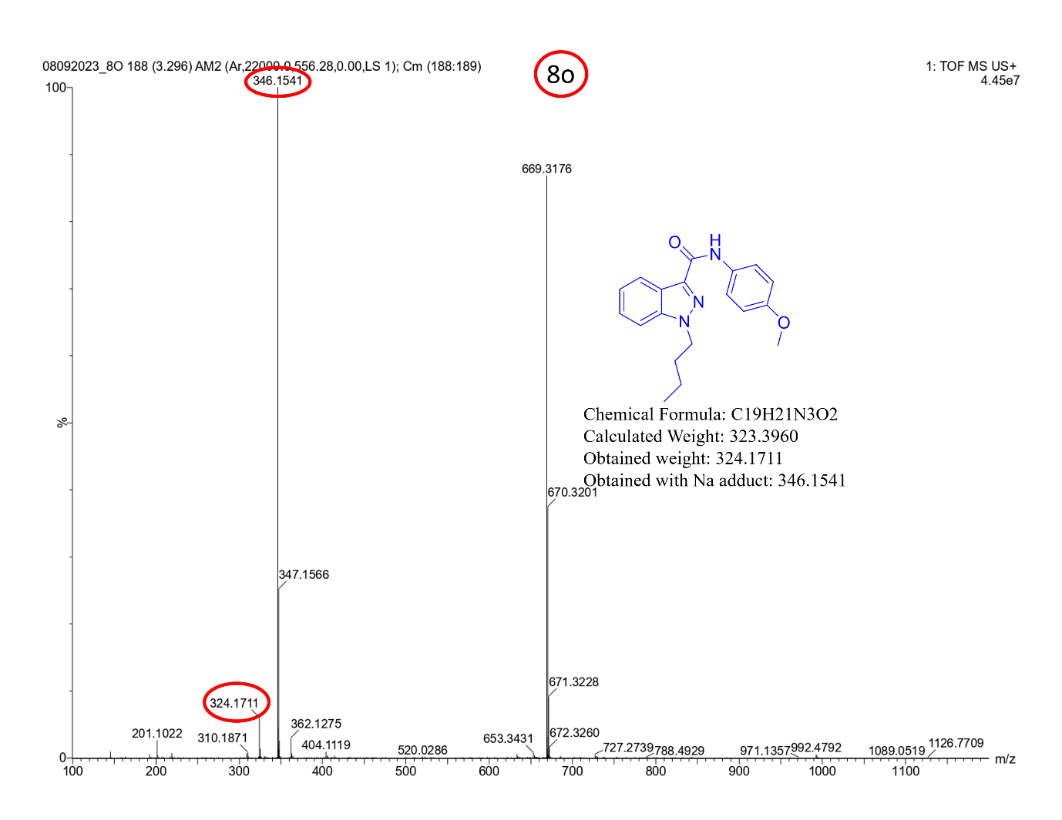
¹H-NMR [400MHz, DMSO-d₆] spectrum of 1-butyl-N-(4-fluorophenyl)-1H-indazole-3-carboxamide (8p).
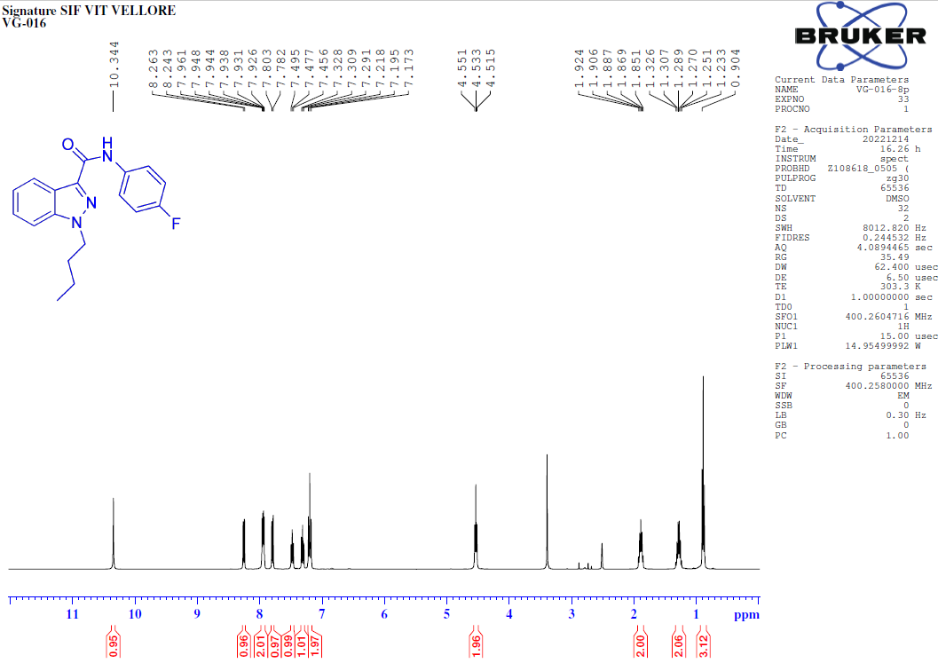
¹³C-NMR [100MHz, DMSO-d₆] spectrum of 1-butyl-N-(4-fluorophenyl)-1H-indazole-3-carboxamide (8p).
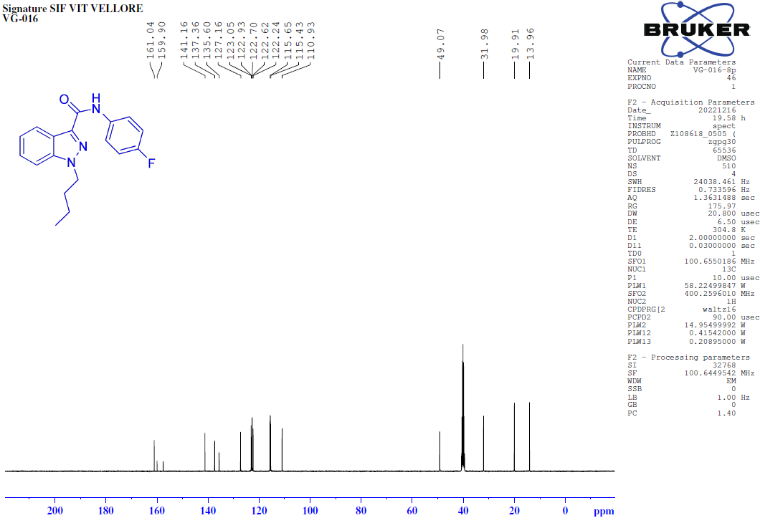
135-DEPT-NMR [100MHz, DMSO-d₆] spectrum of 1-butyl-N-(4-fluorophenyl)-1H-indazole-3-carboxamide (8p).
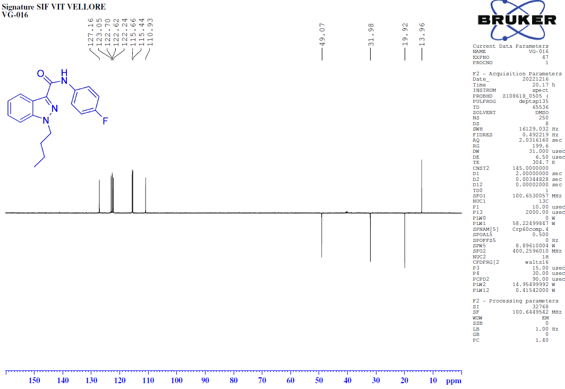
FT-IR spectrum of 1-butyl-N-(4-fluorophenyl)-1H-indazole-3-carboxamide (8p).
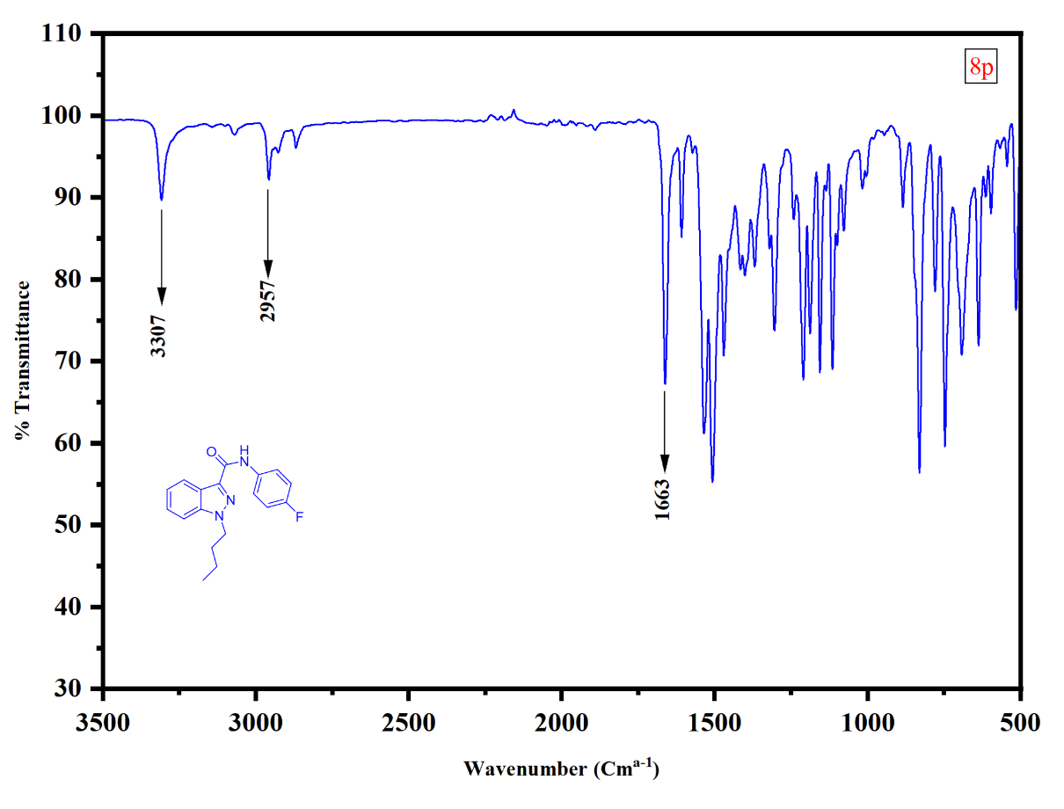
HRMS of 1-butyl-N-(4-fluorophenyl)-1H-indazole-3-carboxamide (8p).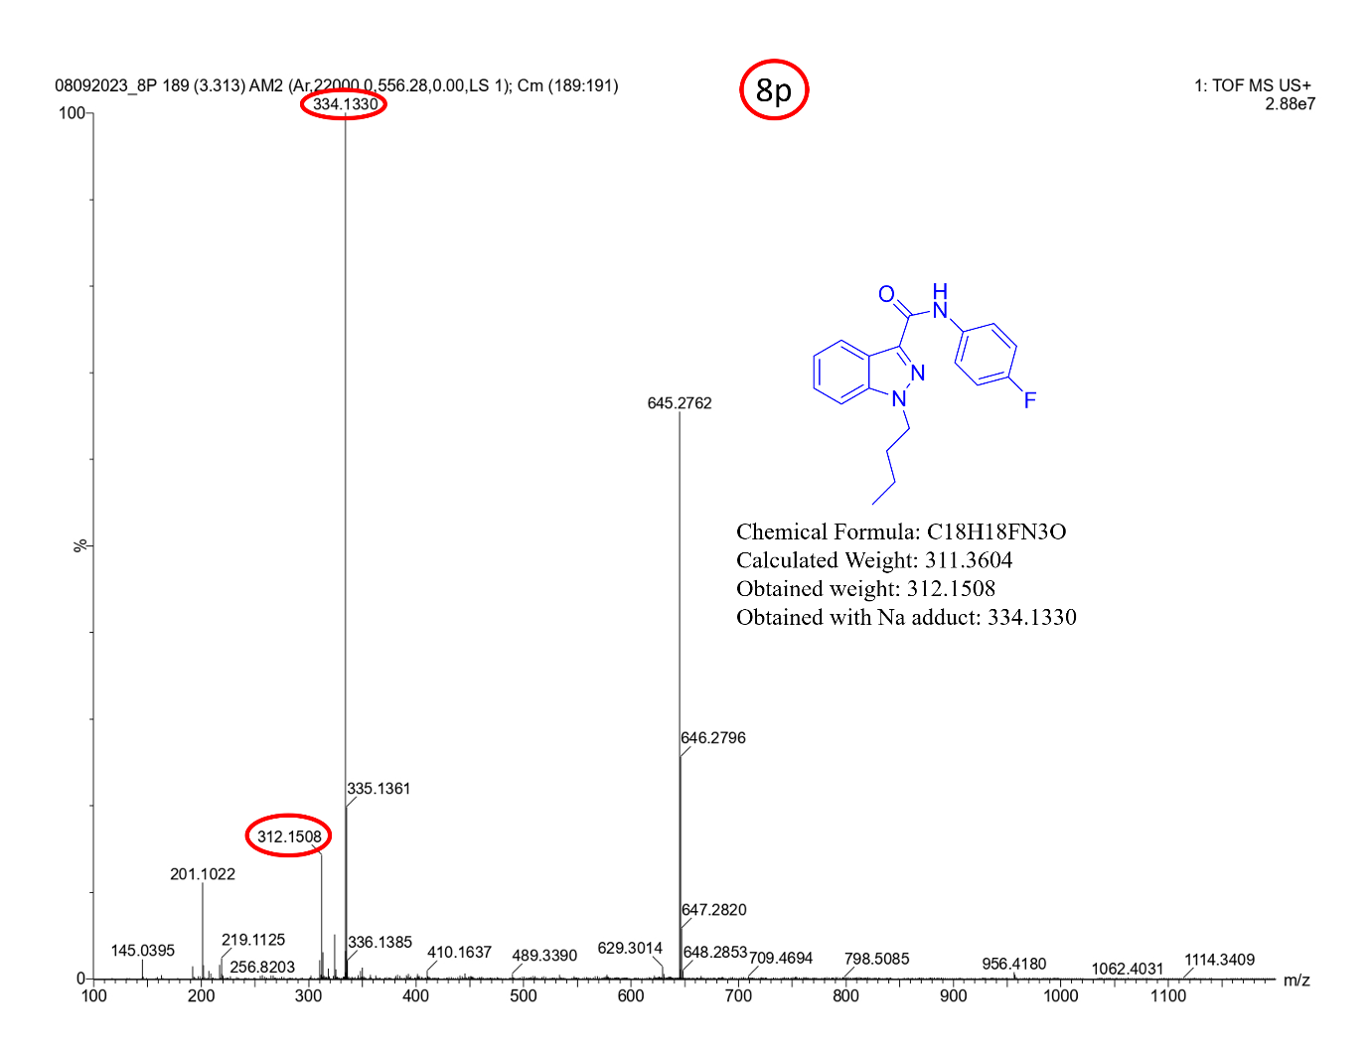
¹H-NMR [100MHz, DMSO-d₆] spectrum of 1-butyl-N-(2-methoxyphenyl)-1H-indazole-3-carboxamide (8q).
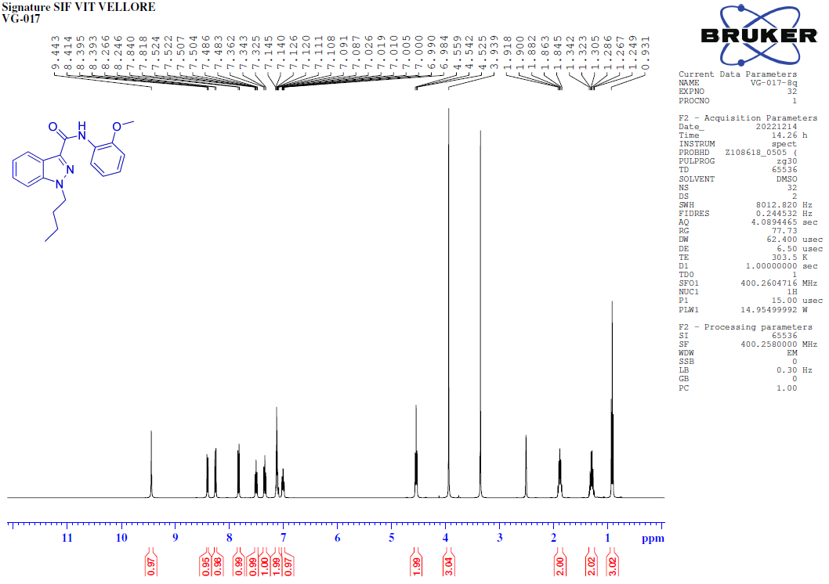
¹H-NMR [400MHz, DMSO-d₆] spectrum of 1-butyl-N-(2-methoxyphenyl)-1H-indazole-3-carboxamide (8q).
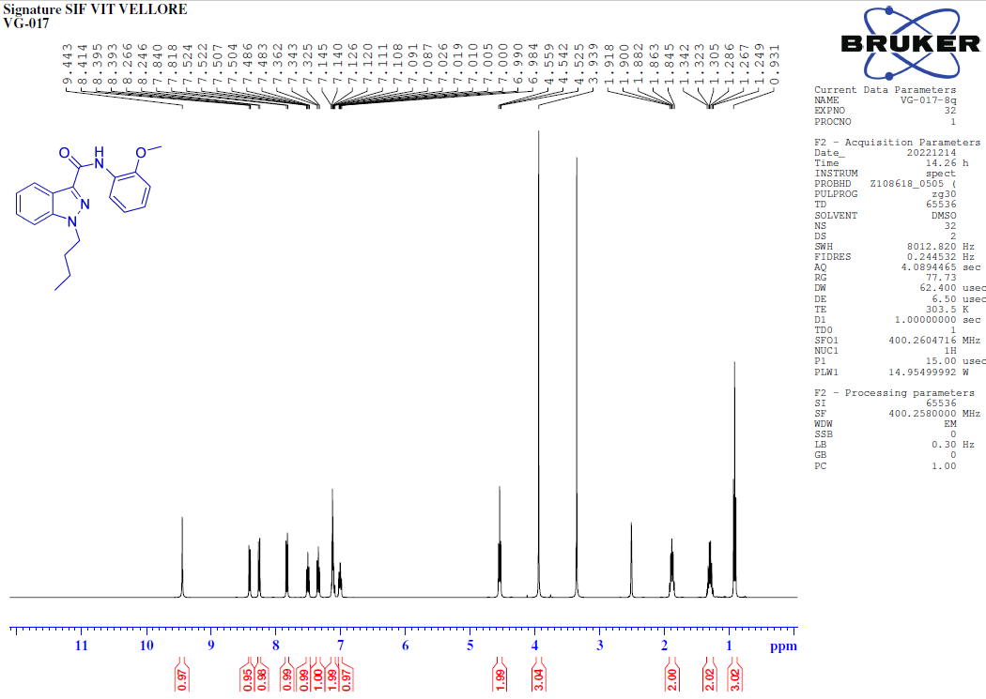
¹³C-NMR [100MHz, DMSO-d₆] spectrum of 1-butyl-N-(2-methoxyphenyl)-1H-indazole-3-carboxamide (8q).
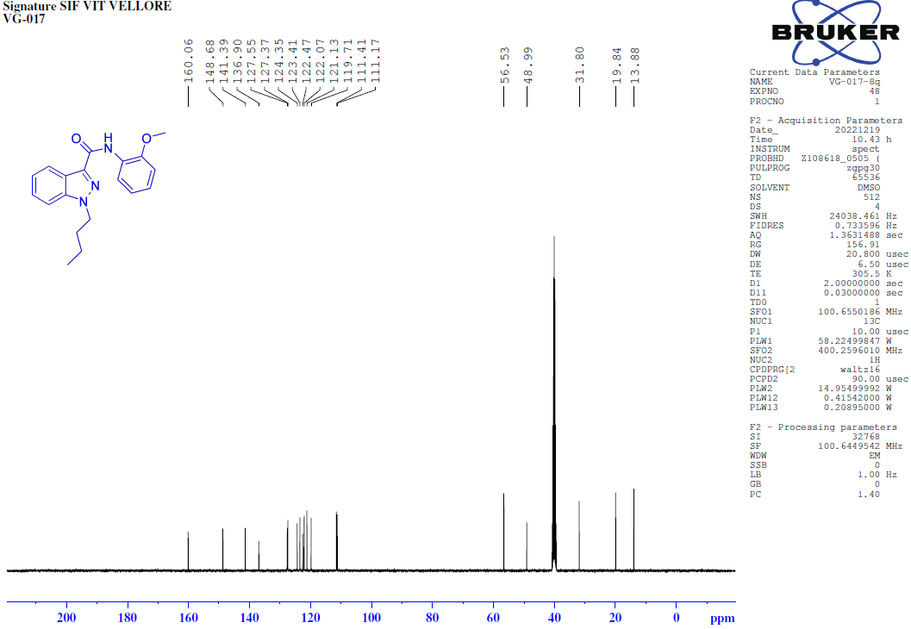
135-DEPT-NMR [100MHz, DMSO-d₆] spectrum of 1-butyl-N-(2-methoxyphenyl)-1H-indazole-3-carboxamide (8q).
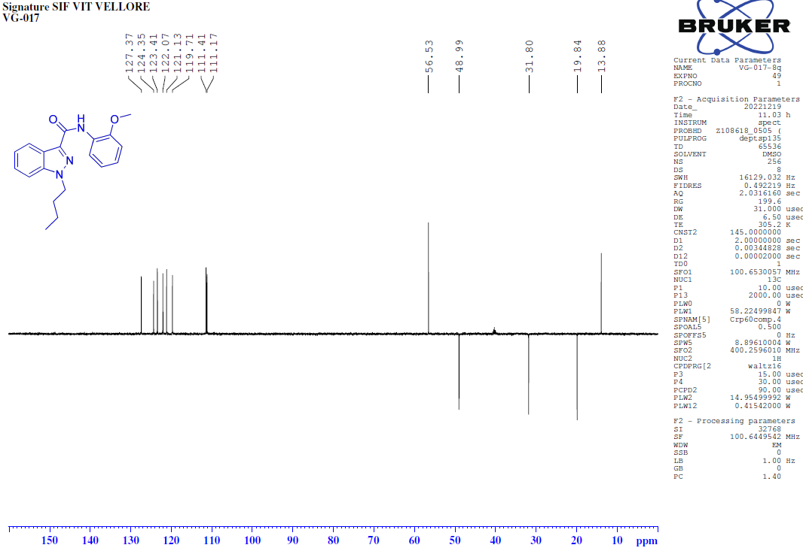
FT-IR spectrum of 1-butyl-N-(2-methoxyphenyl)-1H-indazole-3-carboxamide (8q).
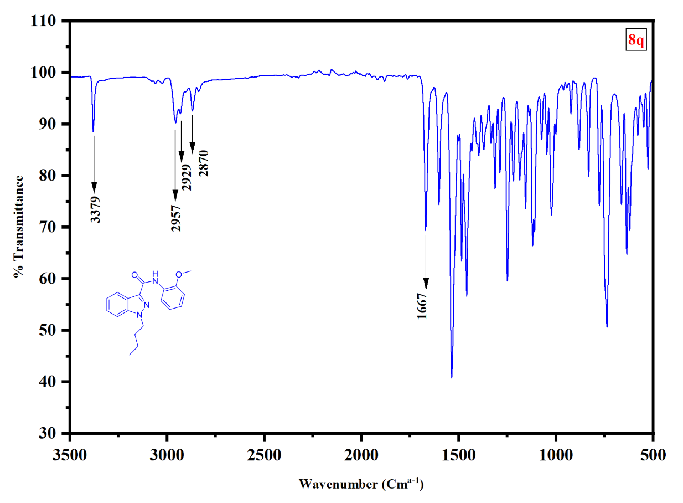
HRMS of 1-butyl-N-(2-methoxyphenyl)-1H-indazole-3-carboxamide (8q).
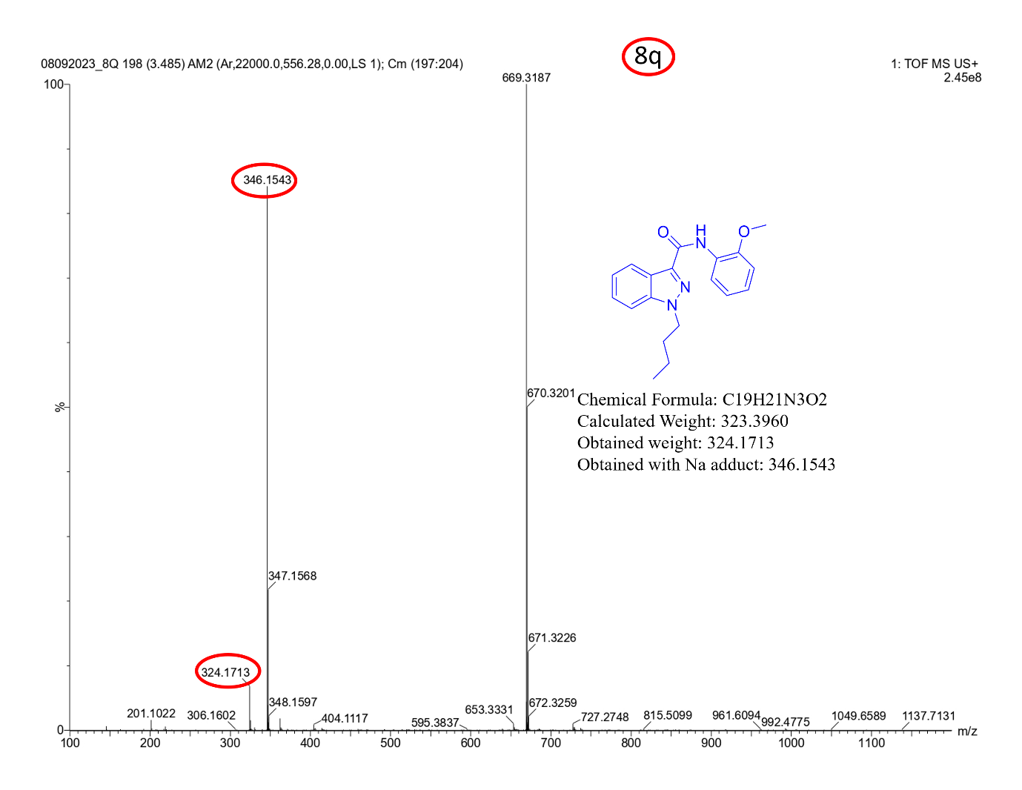
¹H-NMR [400MHz, DMSO-d₆] spectrum of 1-butyl-N-(3-hydroxyphenyl)-1H-indazole-3-carboxamide (8r).
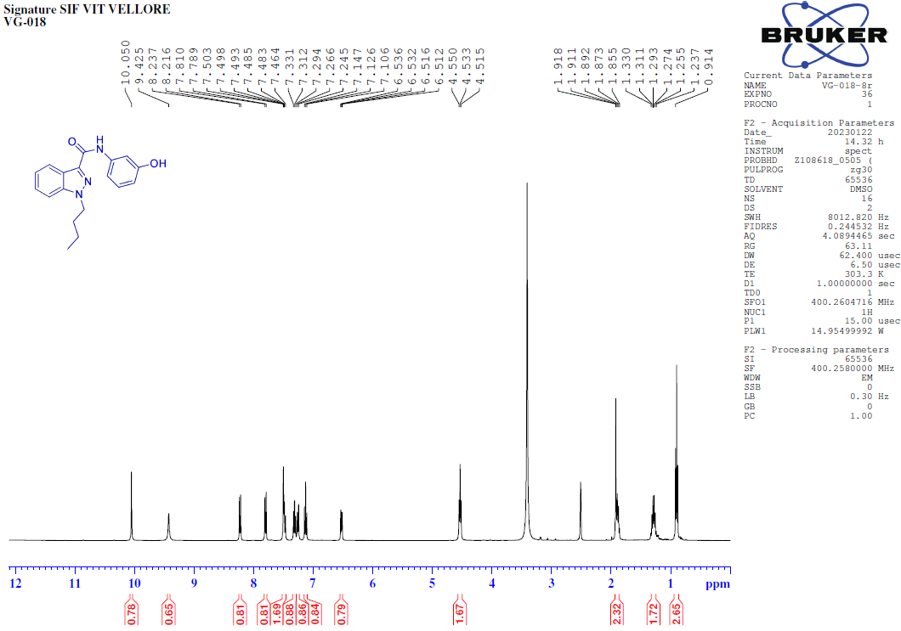
¹³C-NMR [100MHz, DMSO-d₆] spectrum of 1-butyl-N-(3-hydroxyphenyl)-1H-indazole-3-carboxamide (8r).
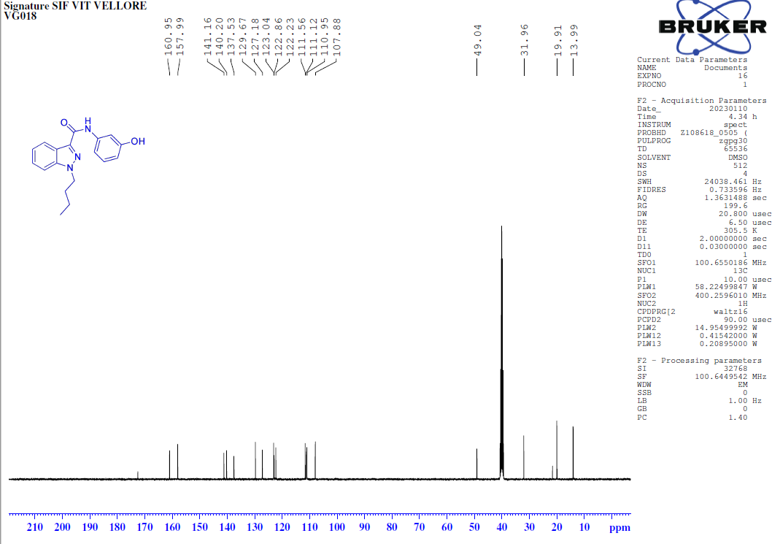
135-DEPT-NMR [100MHz, DMSO-d₆] spectrum of 1-butyl-N-(3-hydroxyphenyl)-1H-indazole-3-carboxamide (8r).
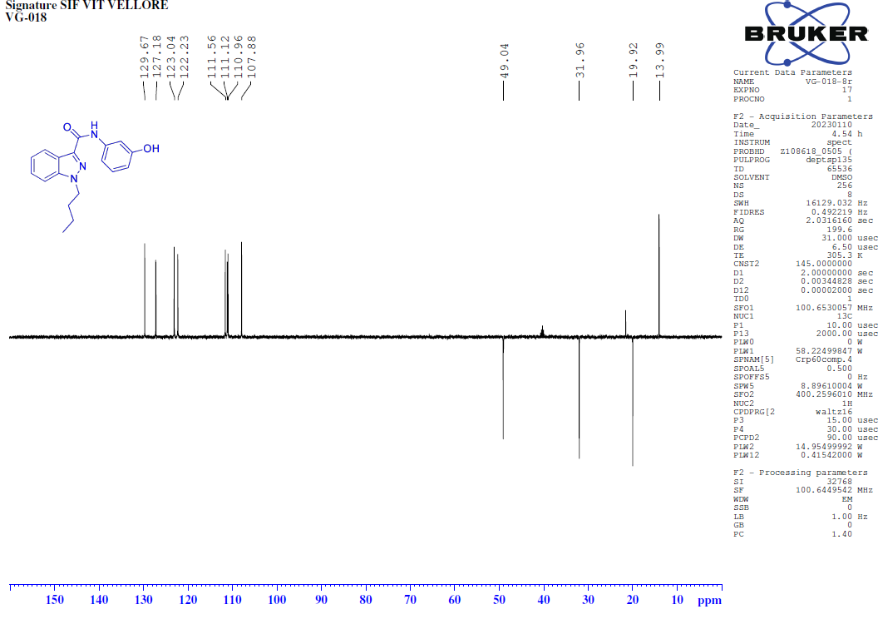
COSY-NMR [400MHz, DMSO-d₆] spectrum of 1-butyl-N-(3-hydroxyphenyl)-1H-indazole-3-carboxamide (8r).
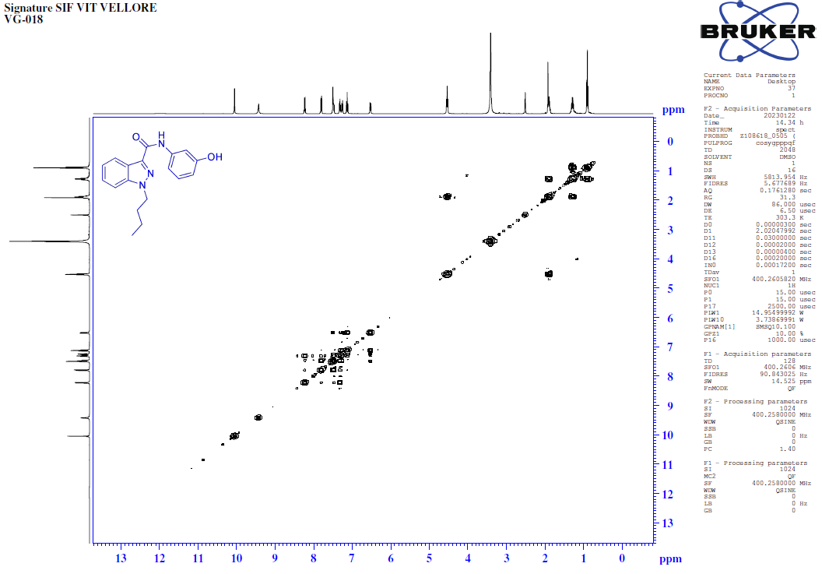 HSQC-NMR [400MHz, DMSO-d₆] spectrum of 1-butyl-N-(3-hydroxyphenyl)-1H-indazole-3-carboxamide (8r).
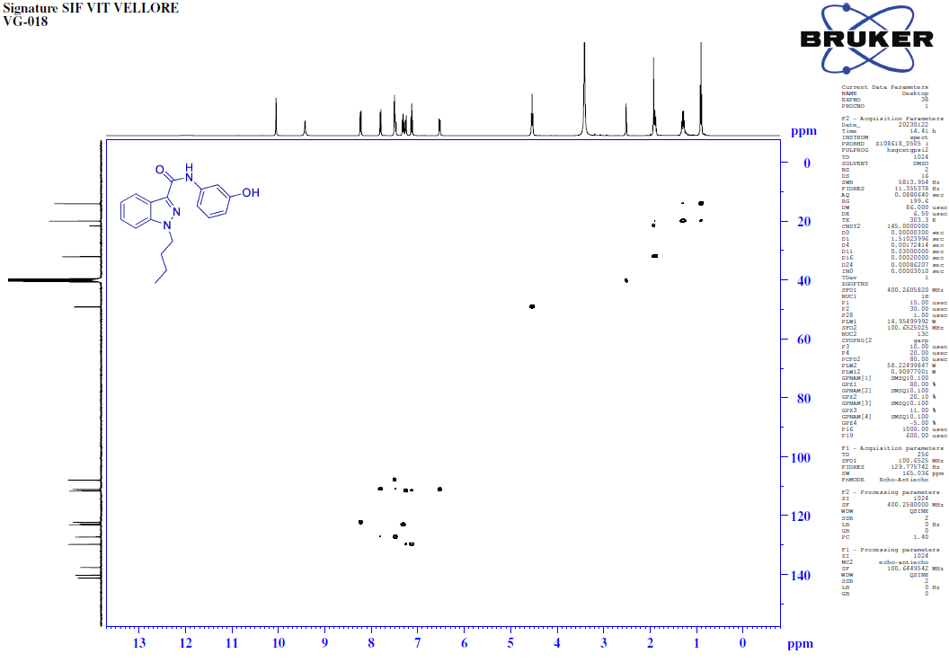
FT-IR spectrum of 1-butyl-N-(3-hydroxyphenyl)-1H-indazole-3-carboxamide (8r).
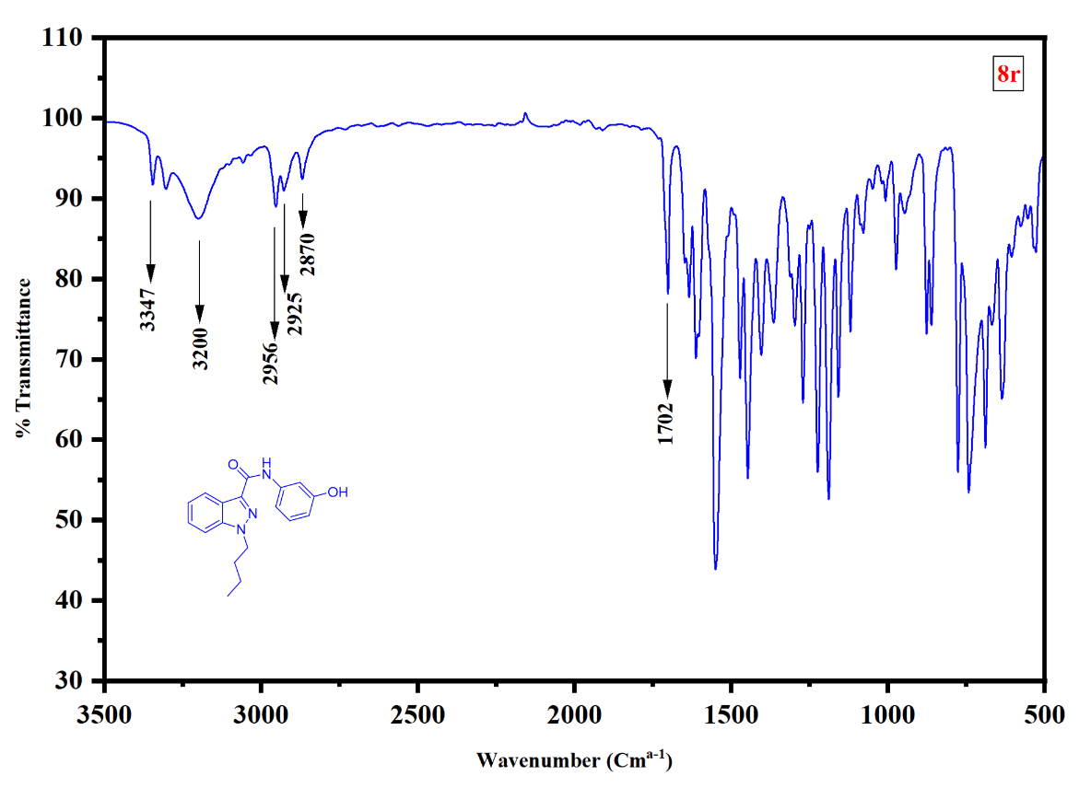
HRMS of 1-butyl-N-(3-hydroxyphenyl)-1H-indazole-3-carboxamide (8r).

¹H-NMR [400MHz, DMSO-d₆] spectrum of 1-butyl-N-(4H-1,2,4-triazol-4-yl)-1H-indazole-3-carboxamide (8s).
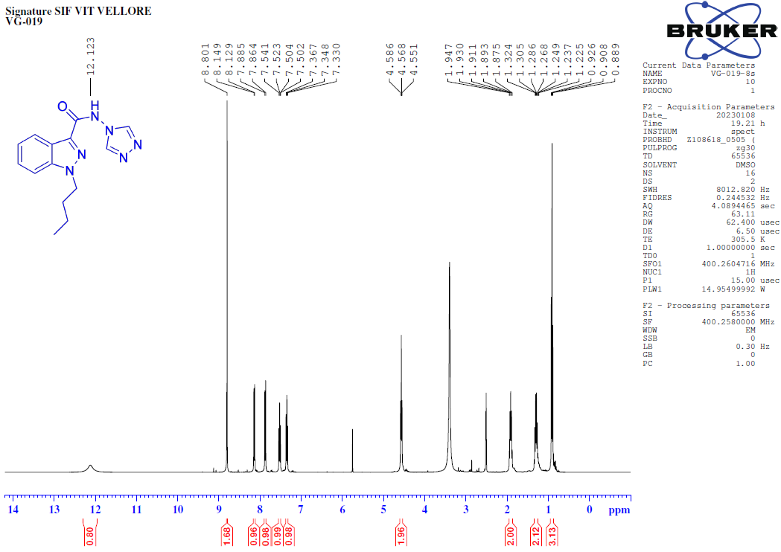
¹³C-NMR [100MHz, DMSO-d₆] spectrum of 1-butyl-N-(4H-1,2,4-triazol-4-yl)-1H-indazole-3-carboxamide (8s).
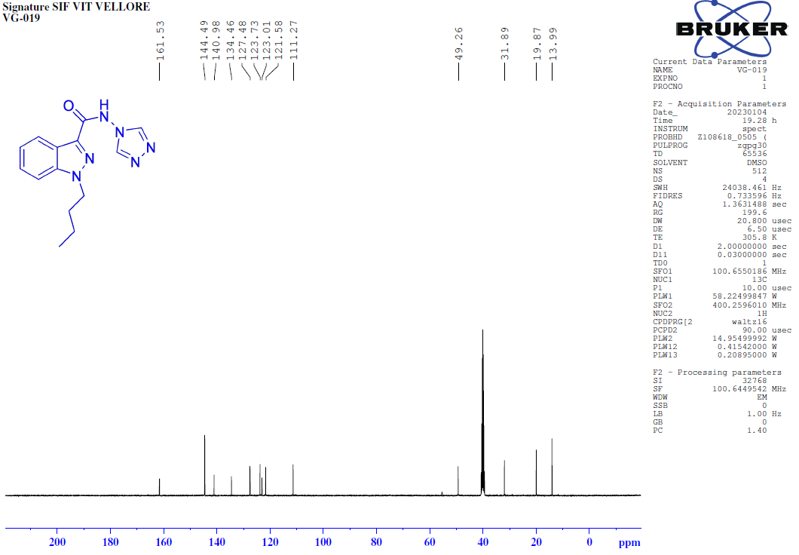
135-DEPT-NMR [100MHz, DMSO-d₆] spectrum of 1-butyl-N-(4H-1,2,4-triazol-4-yl)-1H-indazole-3-carboxamide (8s).
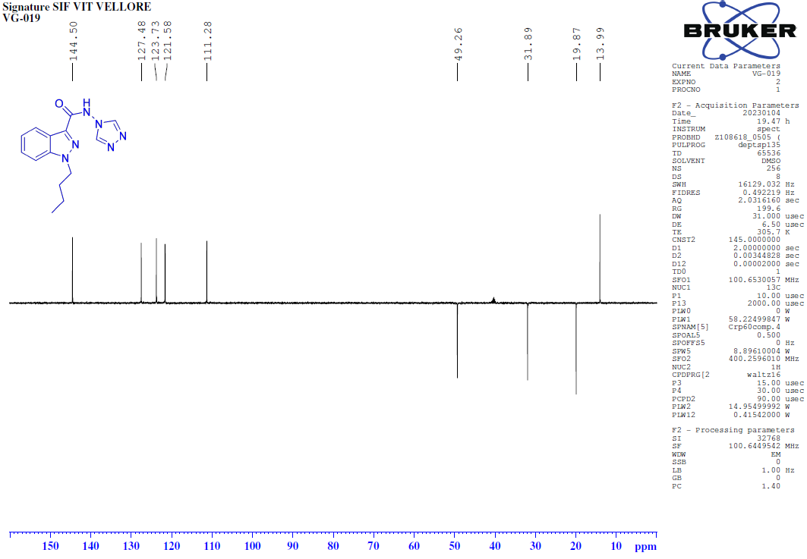
COSY-NMR [400MHz, DMSO-d₆] spectrum of 1-butyl-N-(4H-1,2,4-triazol-4-yl)-1H-indazole-3-carboxamide (8s).
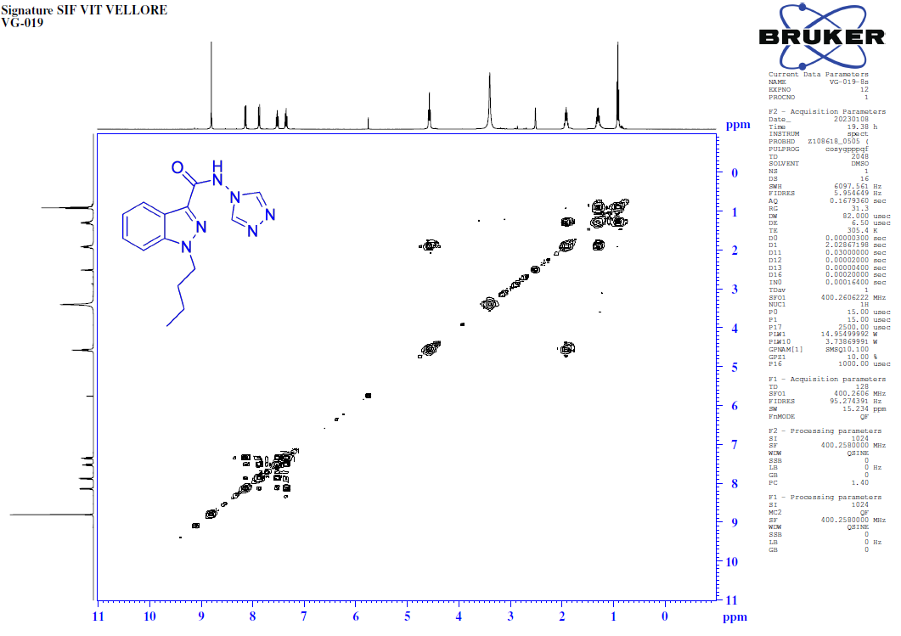
HSQC-NMR [400MHz, DMSO-d₆] spectrum of 1-butyl-N-(4H-1,2,4-triazol-4-yl)-1H-indazole-3-carboxamide (8s).
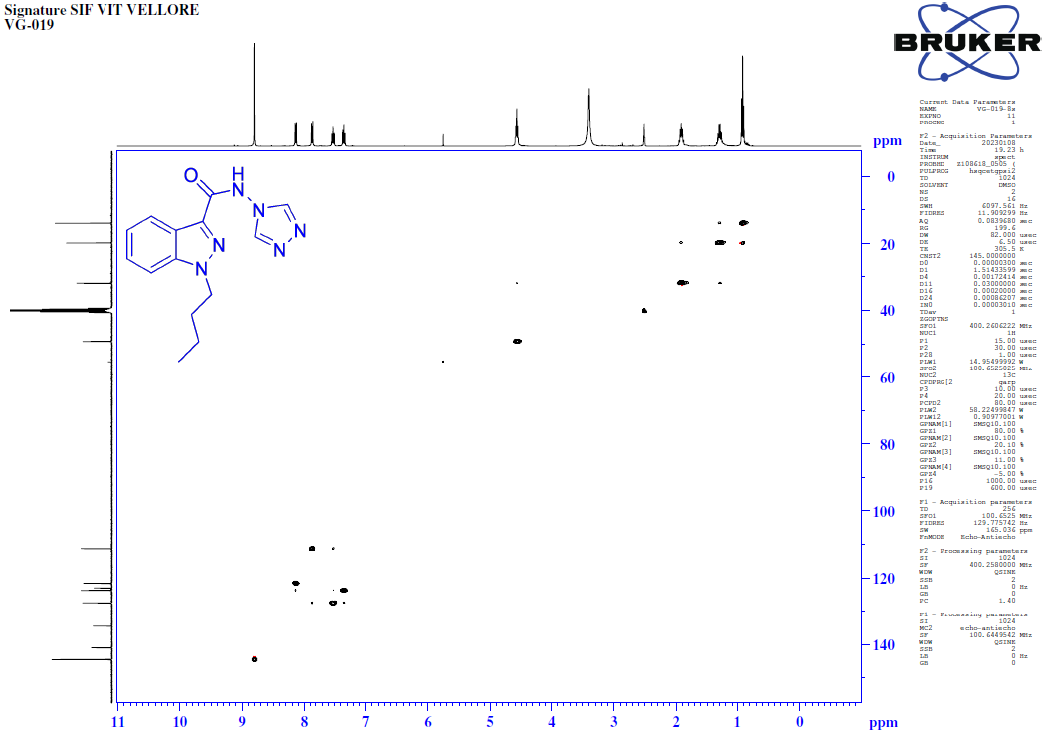
FT-IR spectrum of 1-butyl-N-(4H-1,2,4-triazol-4-yl)-1H-indazole-3-carboxamide (8s).
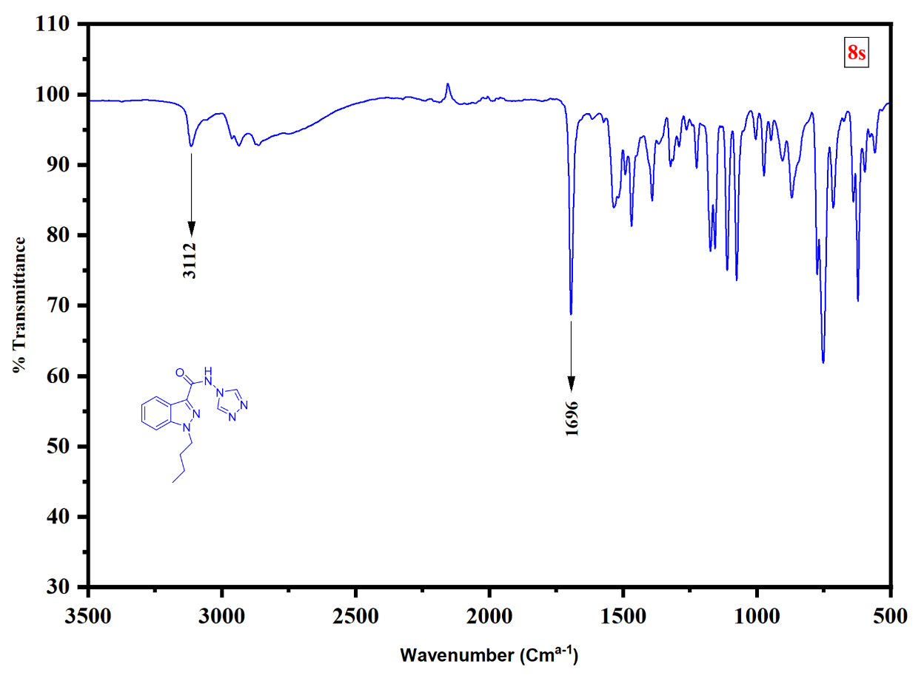
HRMS of 1-butyl-N-(4H-1,2,4-triazol-4-yl)-1H-indazole-3-carboxamide (8s).
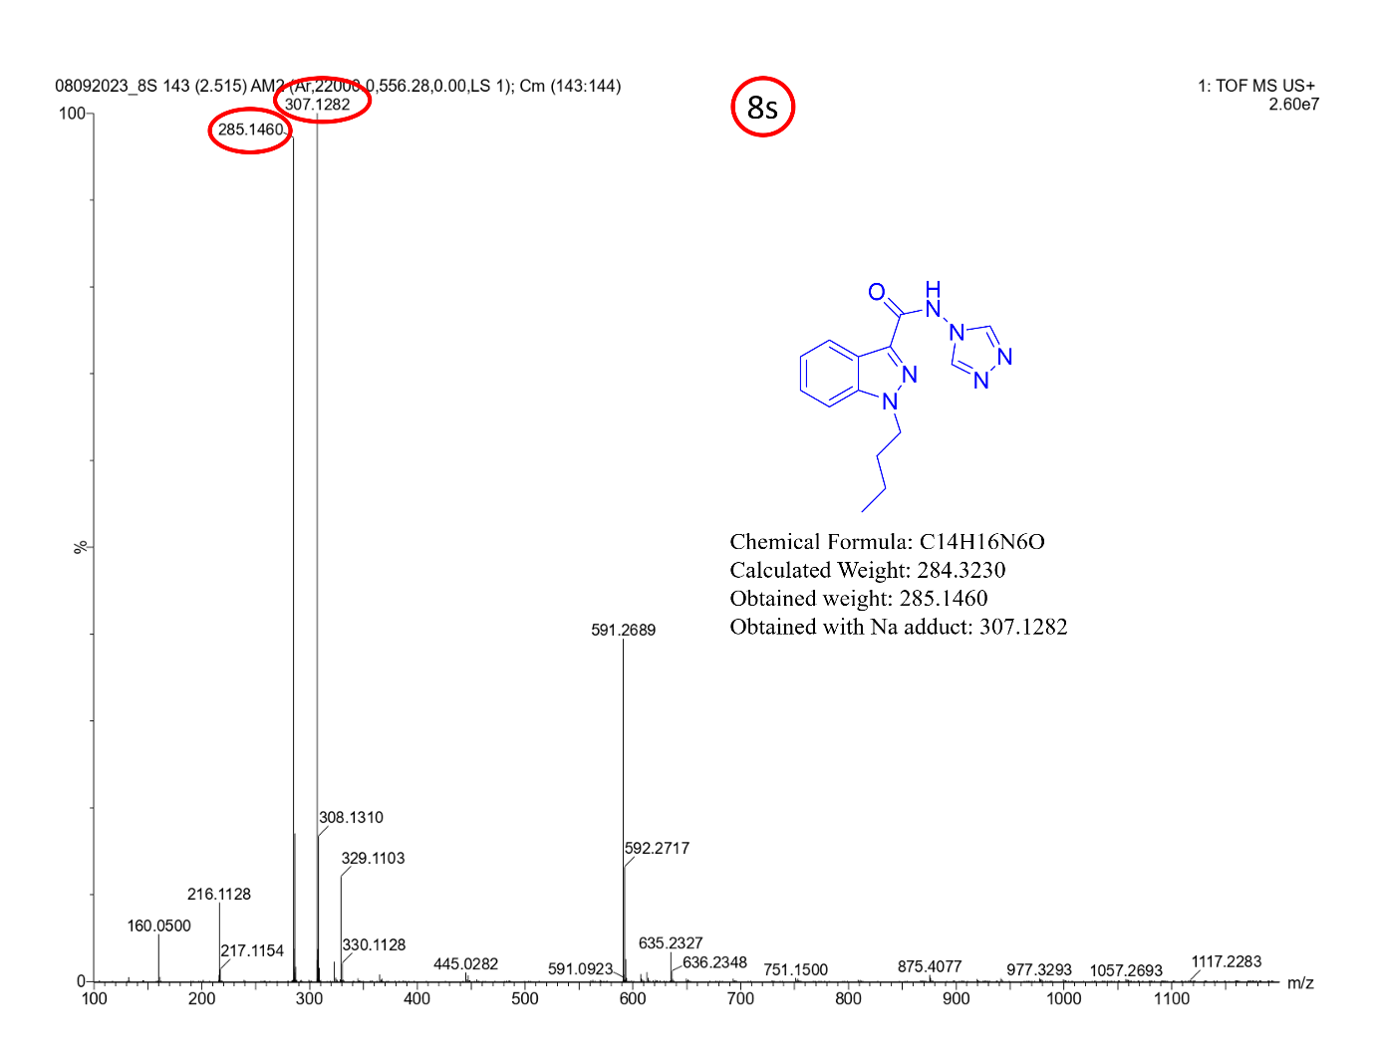
¹H-NMR [400MHz, DMSO-d₆] spectrum of N-(2-amino-4-nitrophenyl)-1-butyl-1H-indazole-3-carboxamide (8t).
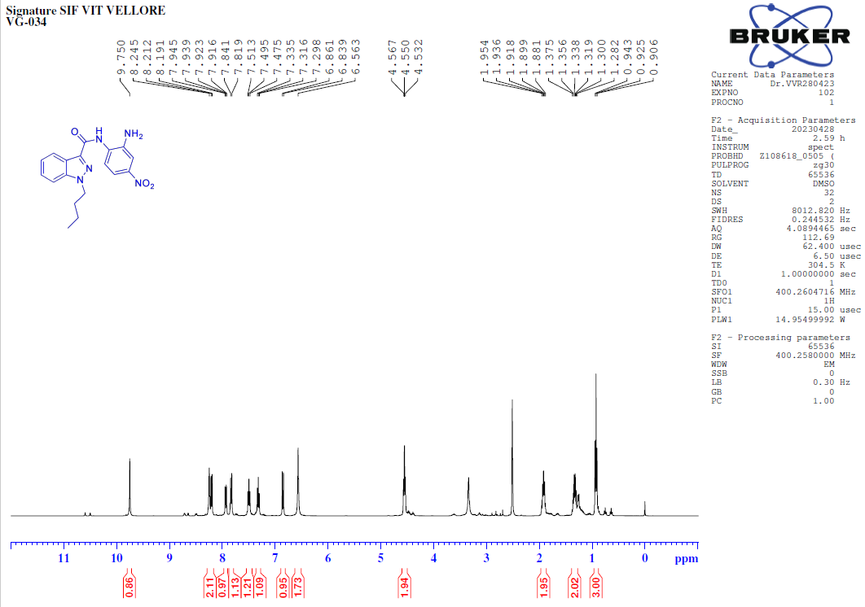
¹³C-NMR [400MHz, DMSO-d₆] spectrum of N-(2-amino-4-nitrophenyl)-1-butyl-1H-indazole-3-carboxamide (8t).
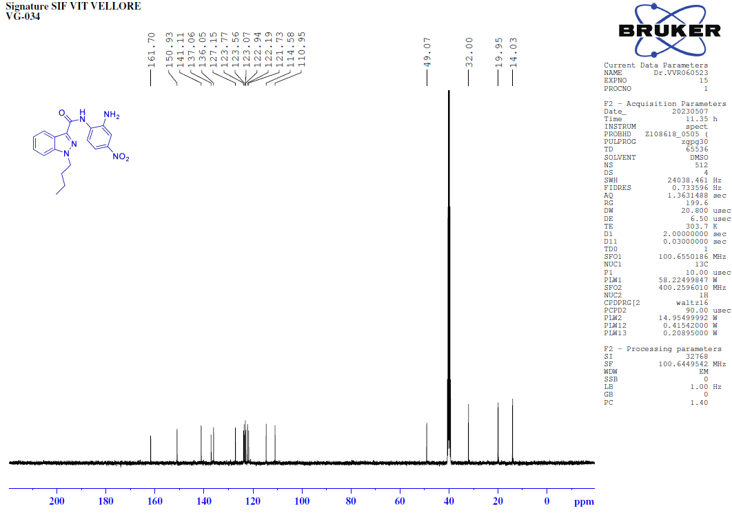
FT-IR spectrum of N-(2-amino-4-nitrophenyl)-1-butyl-1H-indazole-3-carboxamide (8t).
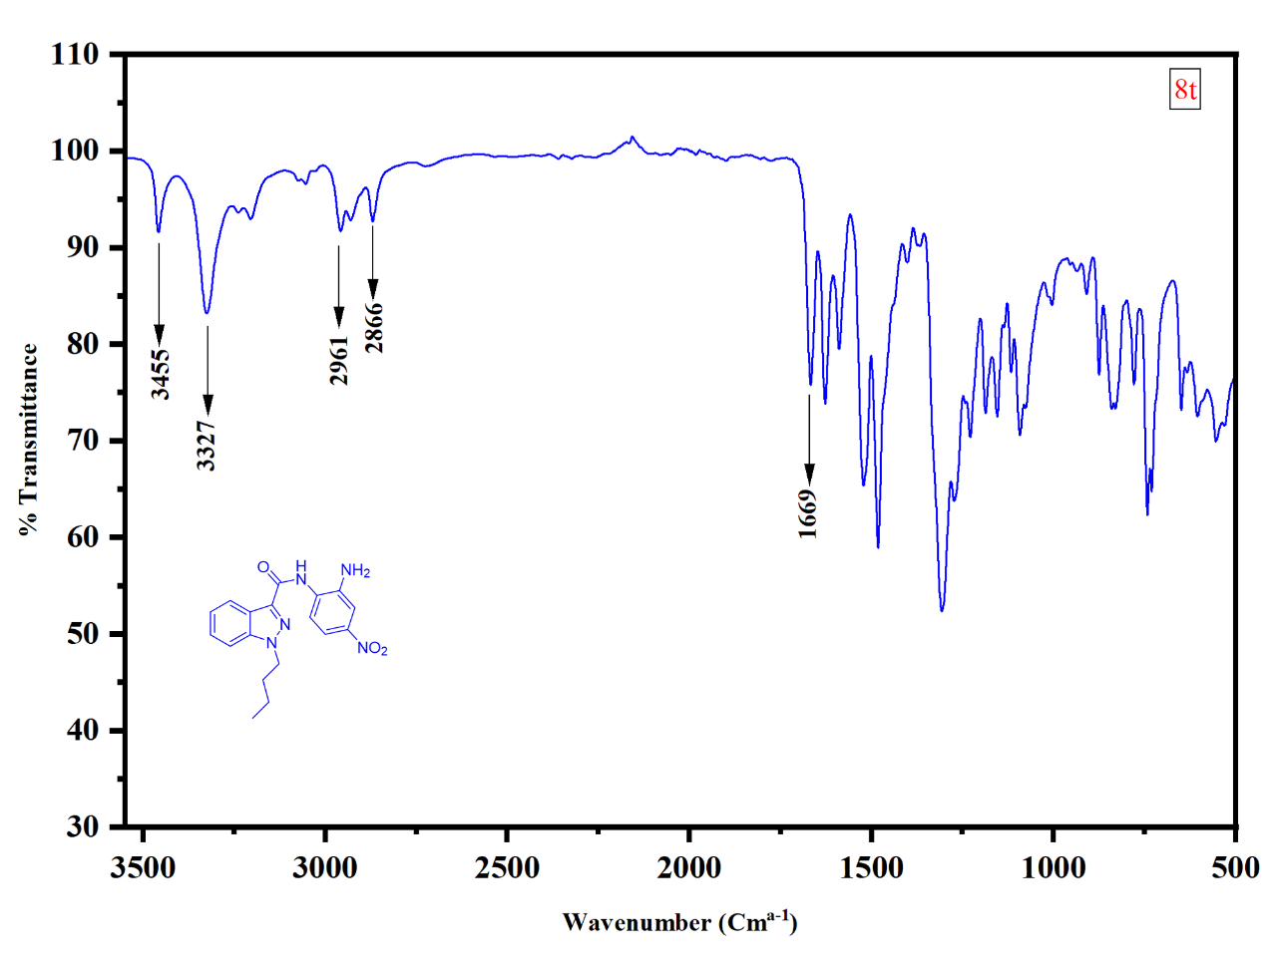
HRMS of N-(2-amino-4-nitrophenyl)-1-butyl-1H-indazole-3-carboxamide (8t).
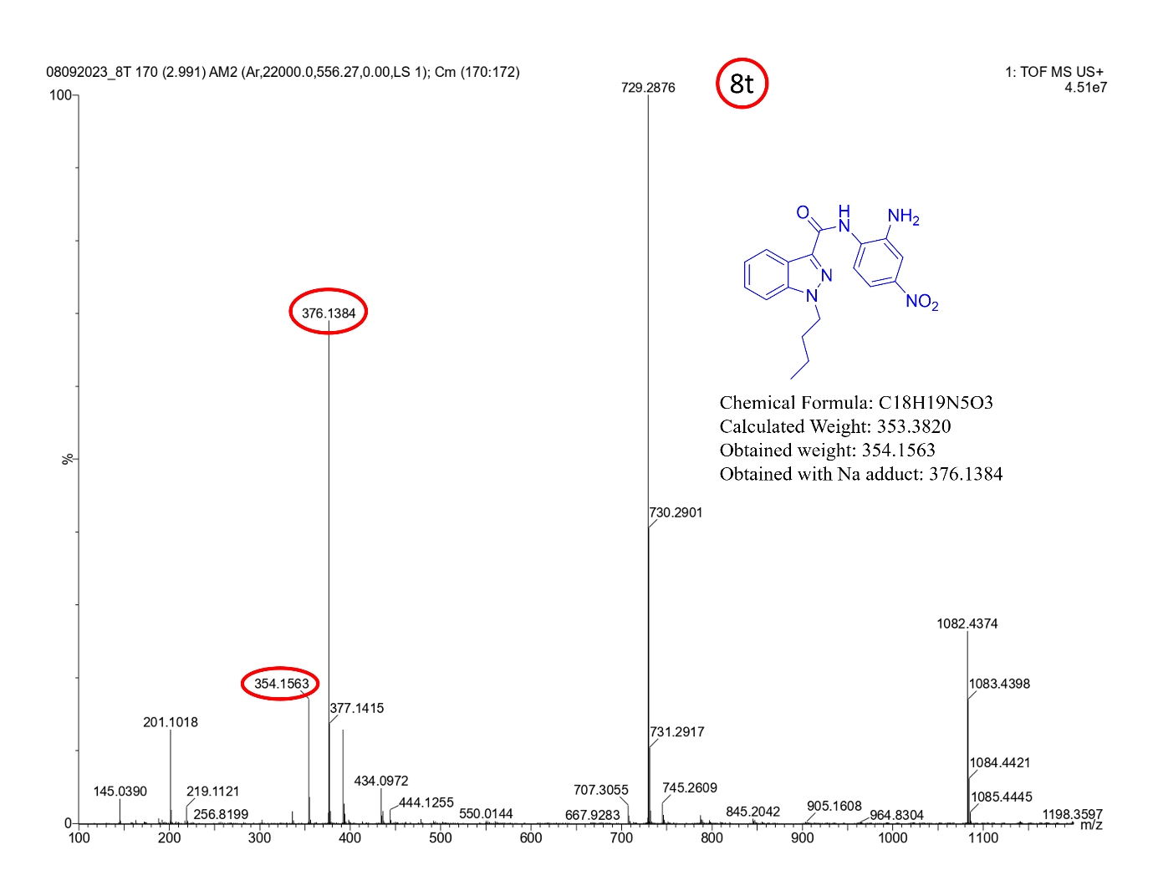
¹H-NMR [400MHz, DMSO-d₆] spectrum of 1-butyl-N-phenyl-1H-indazole-3-carbohydrazide (8u).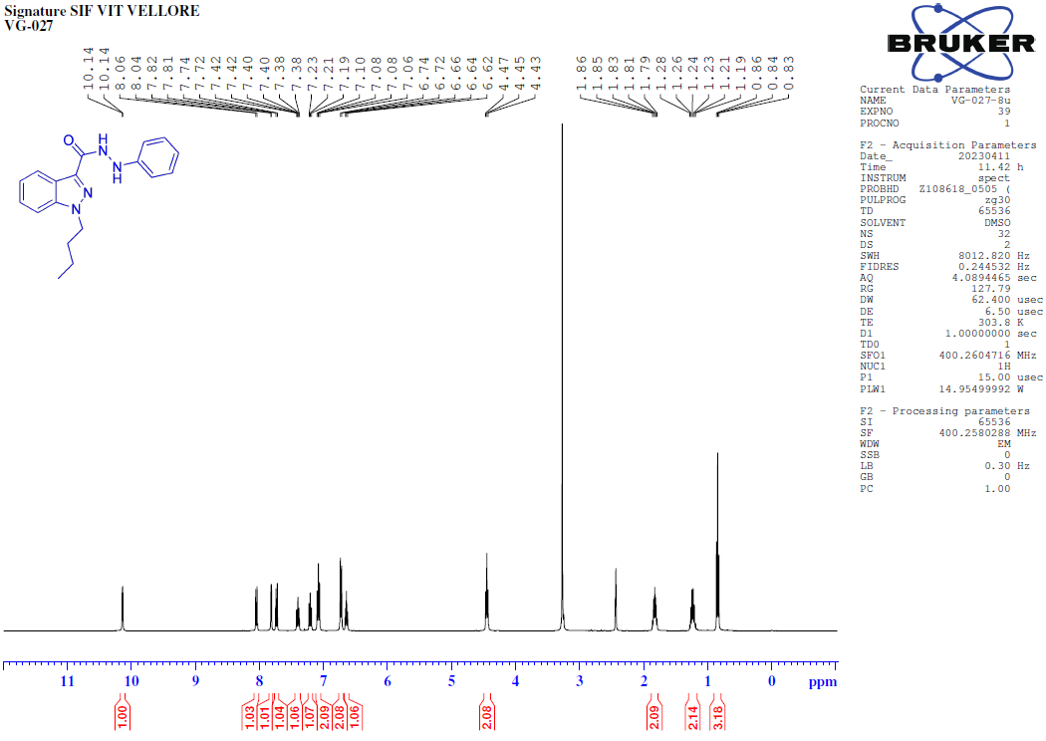 ¹³C-NMR [100MHz, DMSO-d₆] spectrum of 1-butyl-N-phenyl-1H-indazole-3-carbohydrazide (8u).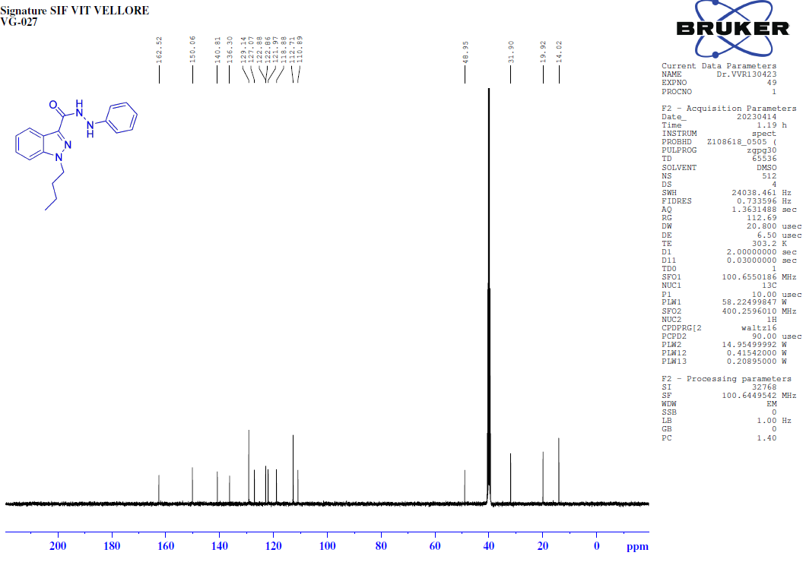
135-DEPT-NMR [100MHz, DMSO-d₆] spectrum of 1-butyl-N-phenyl-1H-indazole-3-carbohydrazide (8u).
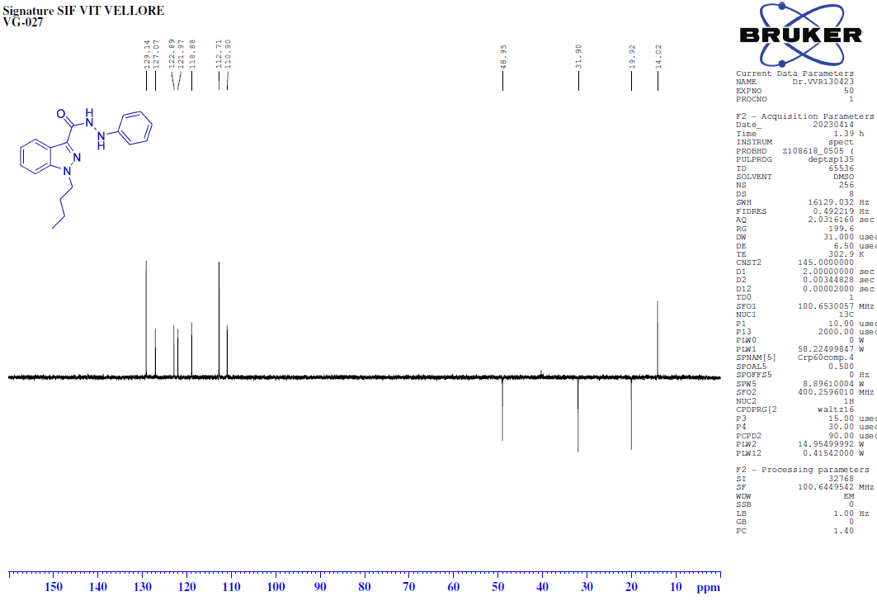
FT-IR spectrum of 1-butyl-N-phenyl-1H-indazole-3-carbohydrazide (8u).
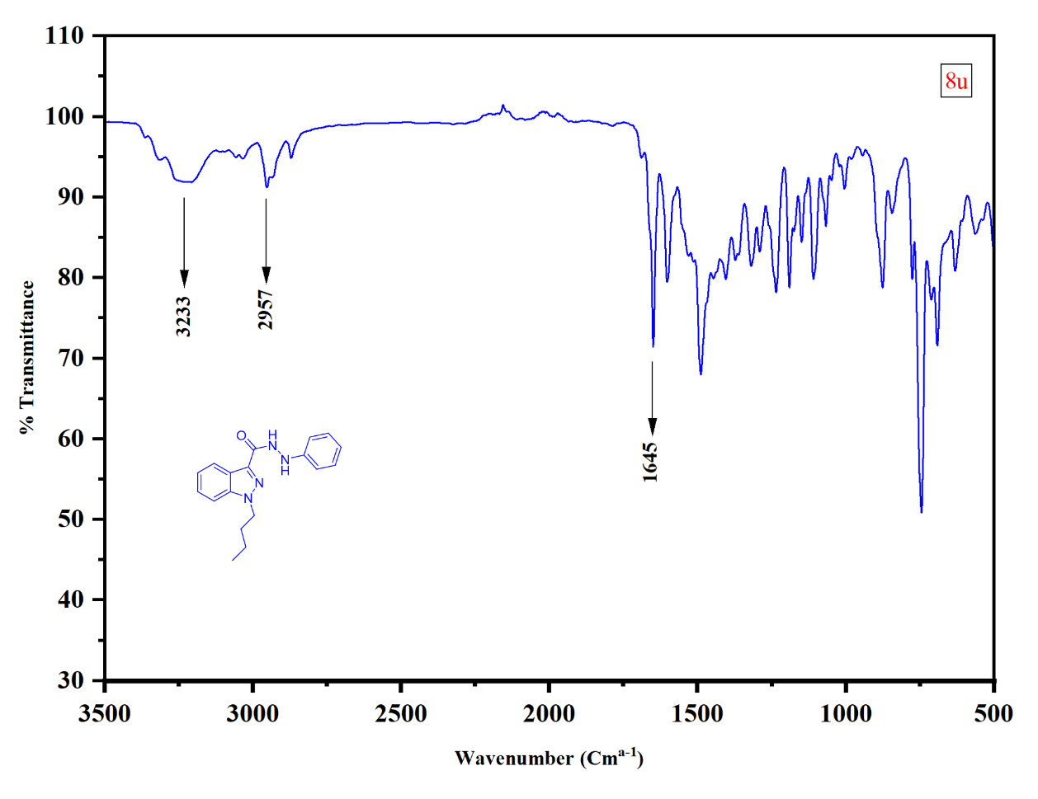
HRMS of 1-butyl-N-phenyl-1H-indazole-3-carbohydrazide (8u).
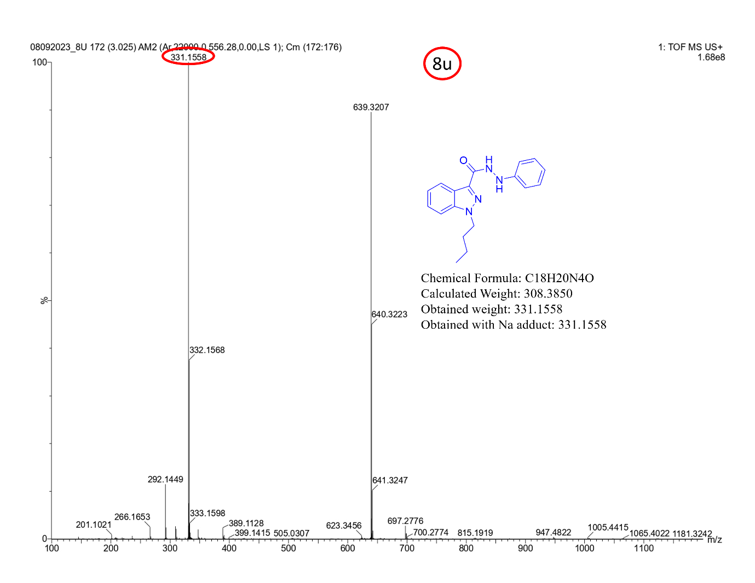

¹H-NMR [400MHz, DMSO-d₆] spectrum of 1-butyl-N-(2,4-dinitrophenyl)-1H-indazole-3-carbohydrazide (8v).
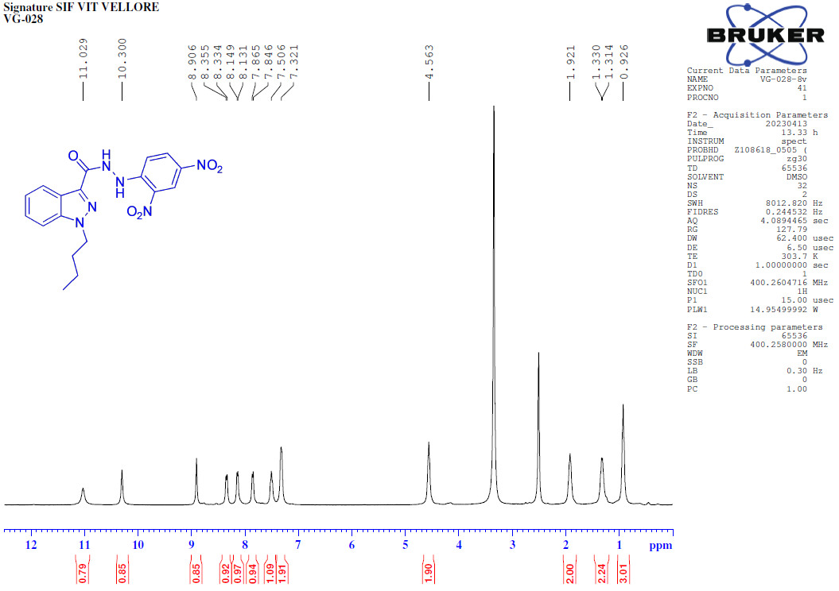
¹³C-NMR [100MHz, DMSO-d₆] spectrum of 1-butyl-N-(2,4-dinitrophenyl)-1H-indazole-3-carbohydrazide (8v).
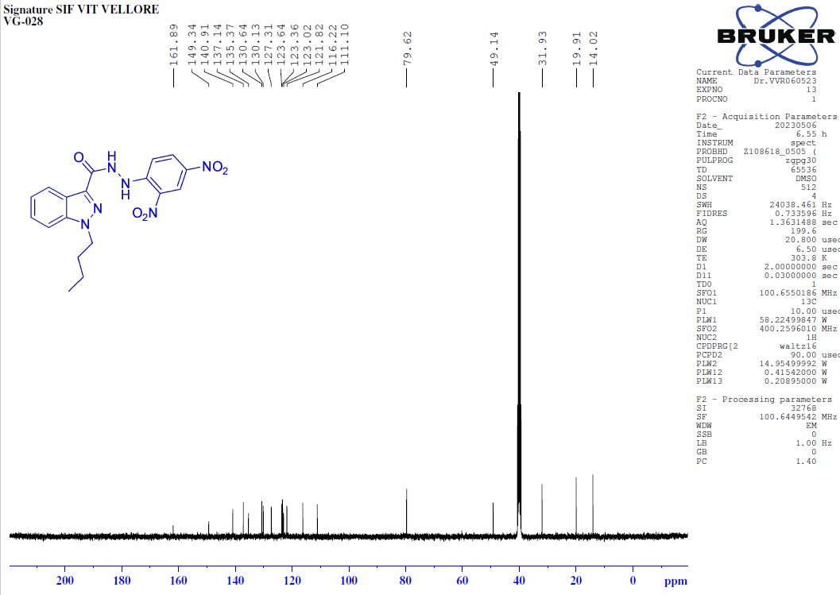135-DEPT-NMR [100MHz, DMSO-d₆] spectrum of 1-butyl-N-(2,4-dinitrophenyl)-1H-indazole-3-carbohydrazide (8v).
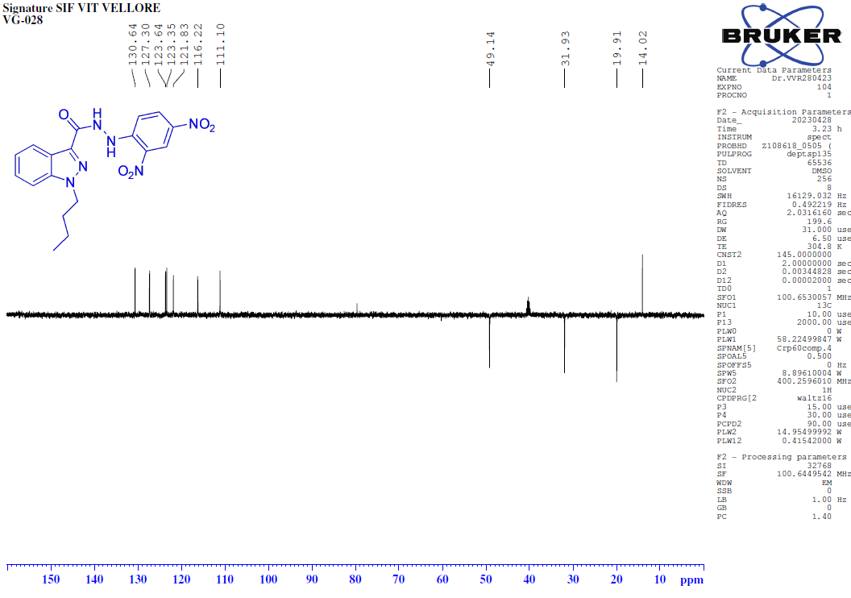
FT-IR spectrum of 1-butyl-N-(2,4-dinitrophenyl)-1H-indazole-3-carbohydrazide (8v).
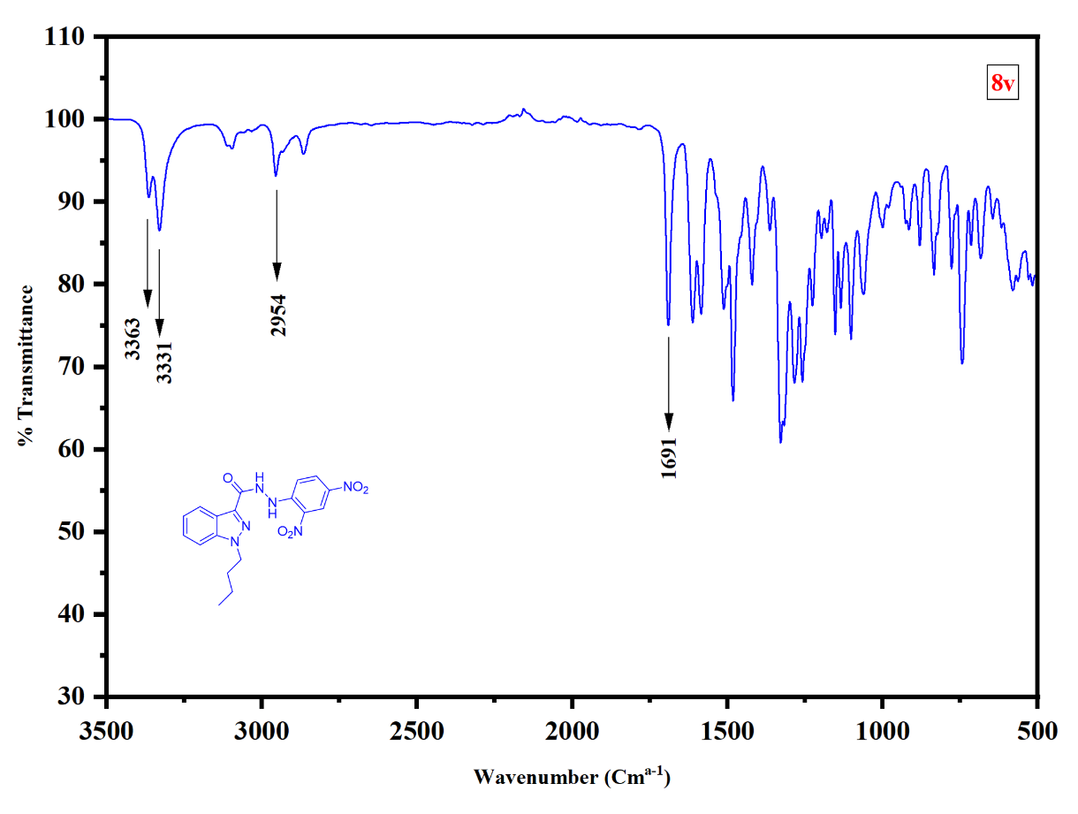
HRMS of 1-butyl-N-(2,4-dinitrophenyl)-1H-indazole-3-carbohydrazide (8v).
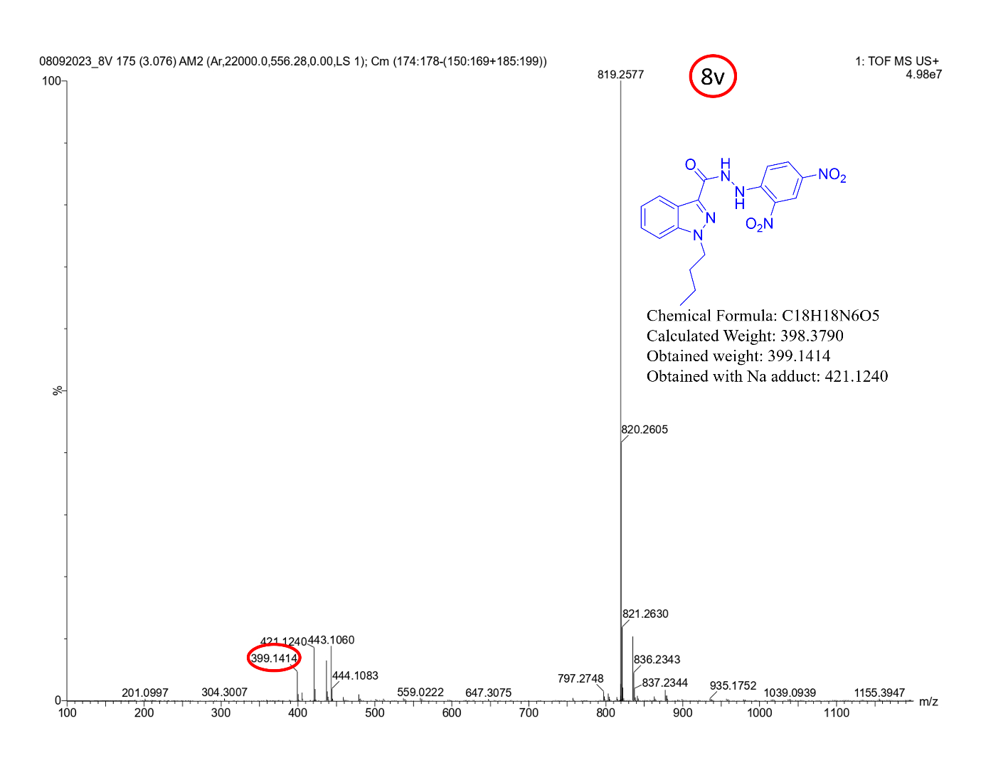

¹H-NMR [100MHz, DMSO-d₆] spectrum of 1-butyl-N-(4-cyanophenyl)-1H-indazole-3-carbohydrazide (8W).
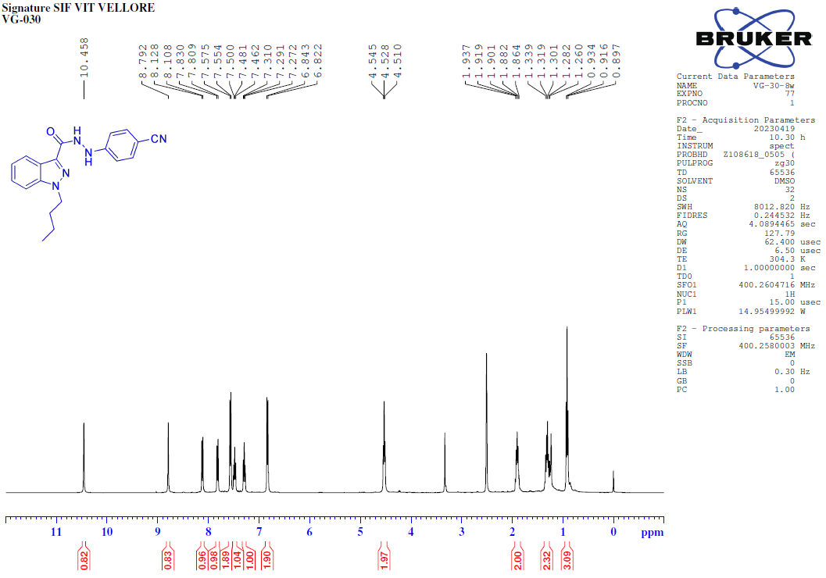¹³C-NMR [100MHz, DMSO-d₆] spectrum of 1-butyl-N-(4-cyanophenyl)-1H-indazole-3-carbohydrazide (8W).

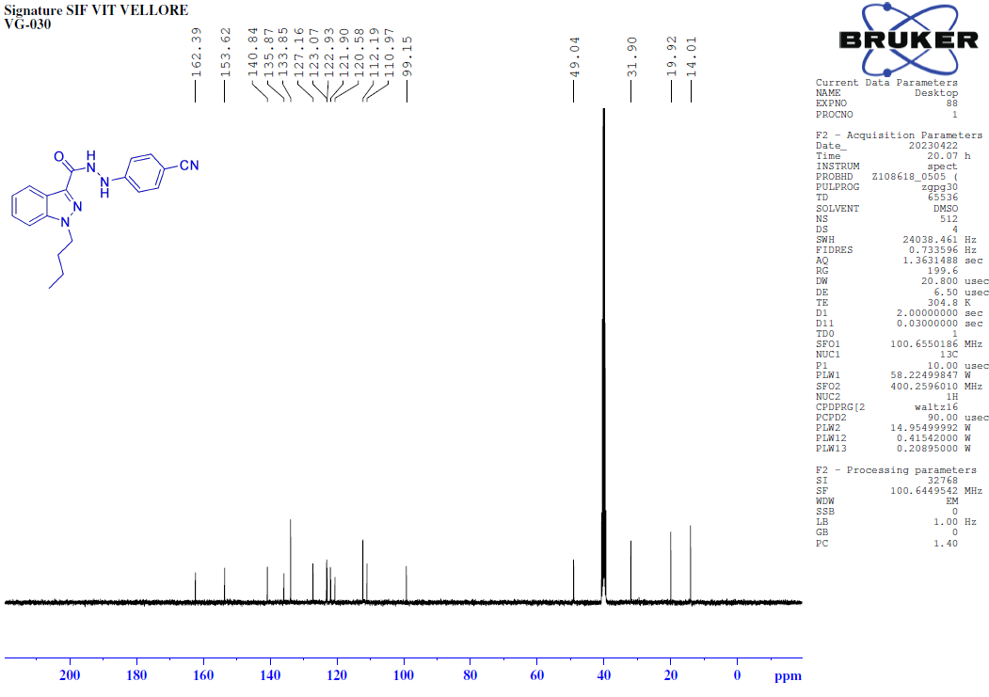
135-DEPT-NMR [100MHz, DMSO-d₆] spectrum of 1-butyl-N-(4-cyanophenyl)-1H-indazole-3-carbohydrazide (8W).
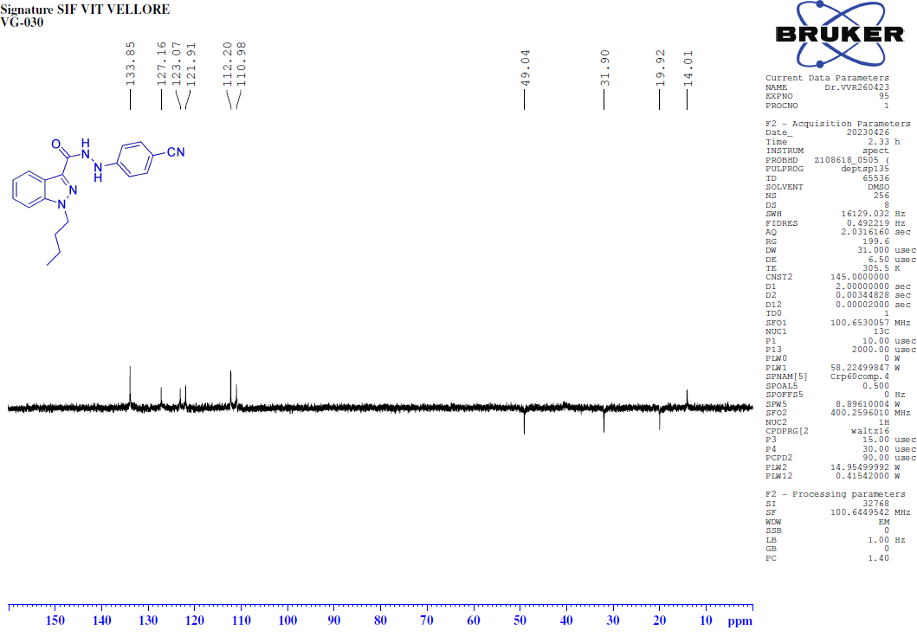
FT-IR spectrum of 1-butyl-N-(4-cyanophenyl)-1H-indazole-3-carbohydrazide (8W).
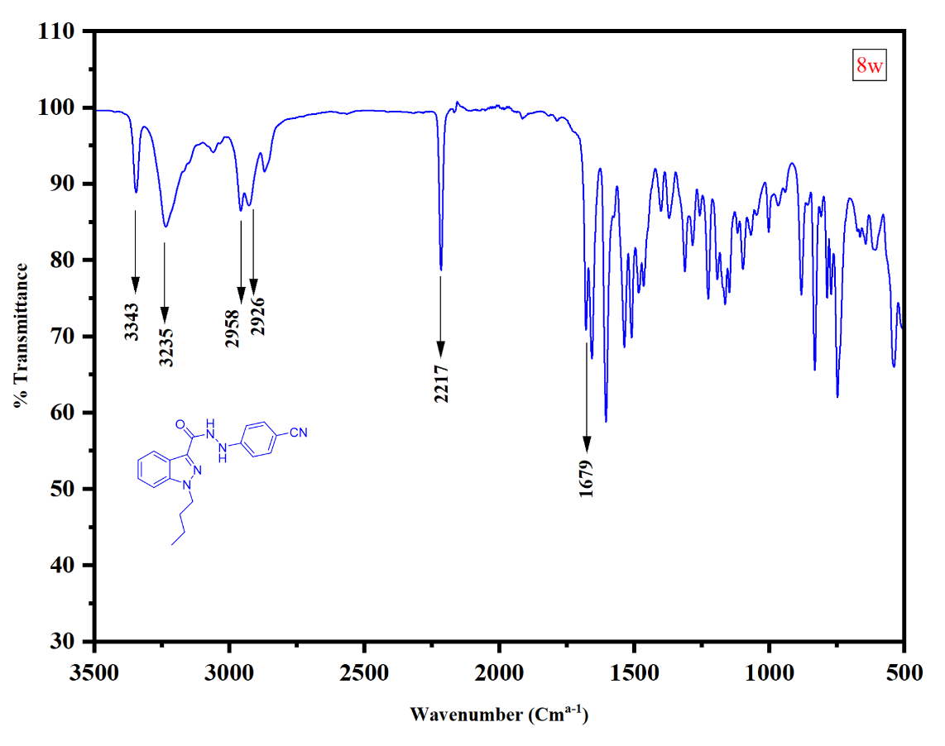
HRMS of 1-butyl-N-(4-cyanophenyl)-1H-indazole-3-carbohydrazide (8W).
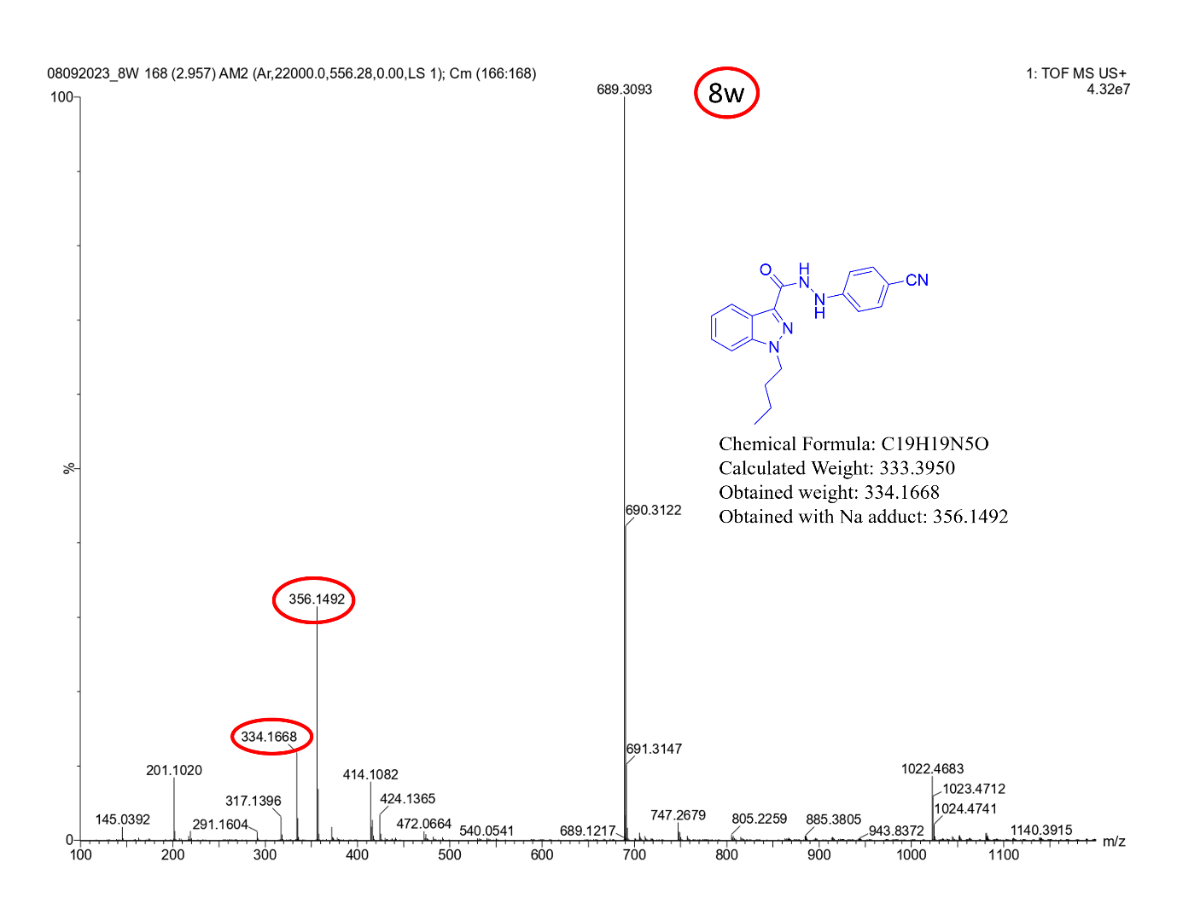
¹H-NMR [400MHz, DMSO-d₆] spectrum of 1-butyl-N-(4-hydroxyphenyl)-1H-indazole-3-carbohydrazide (8x).
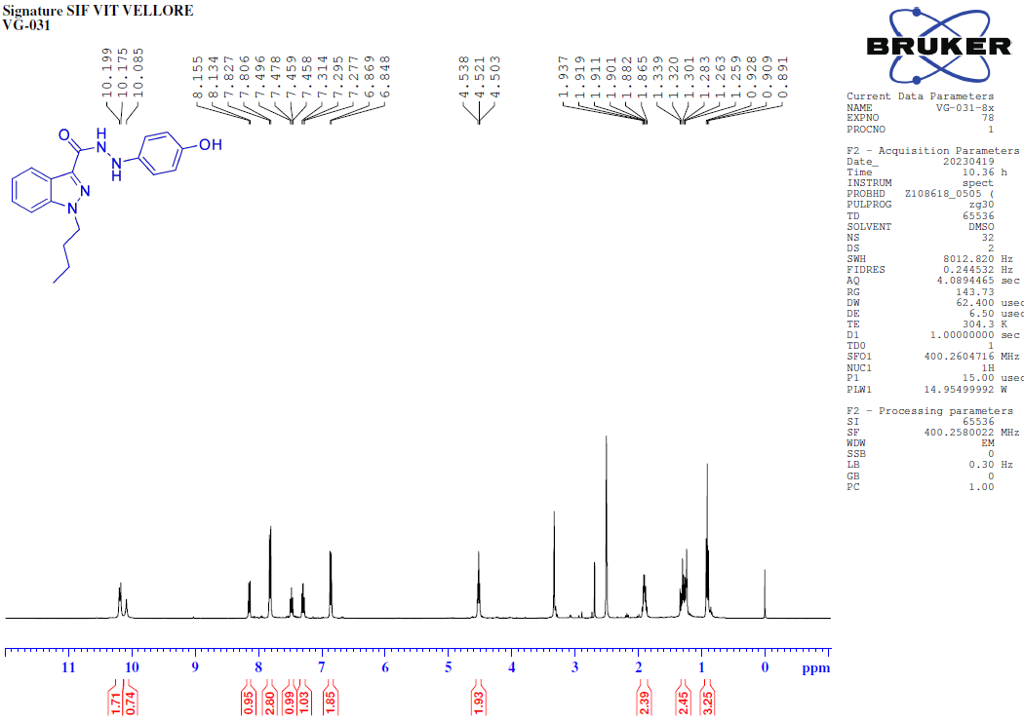¹³C-NMR [100MHz, DMSO-d₆] spectrum of 1-butyl-N-(4-hydroxyphenyl)-1H-indazole-3-carbohydrazide (8x).
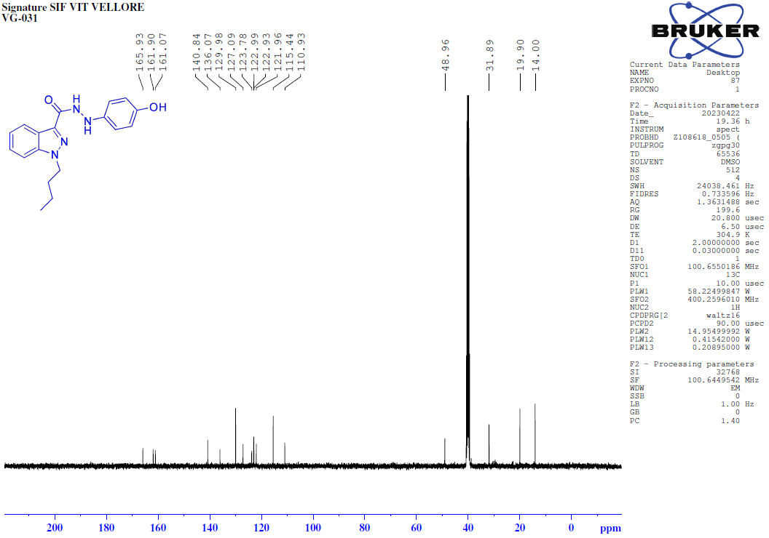
135-DEPT-NMR [100MHz, DMSO-d₆] spectrum of 1-butyl-N-(4-hydroxyphenyl)-1H-indazole-3-carbohydrazide (8x).
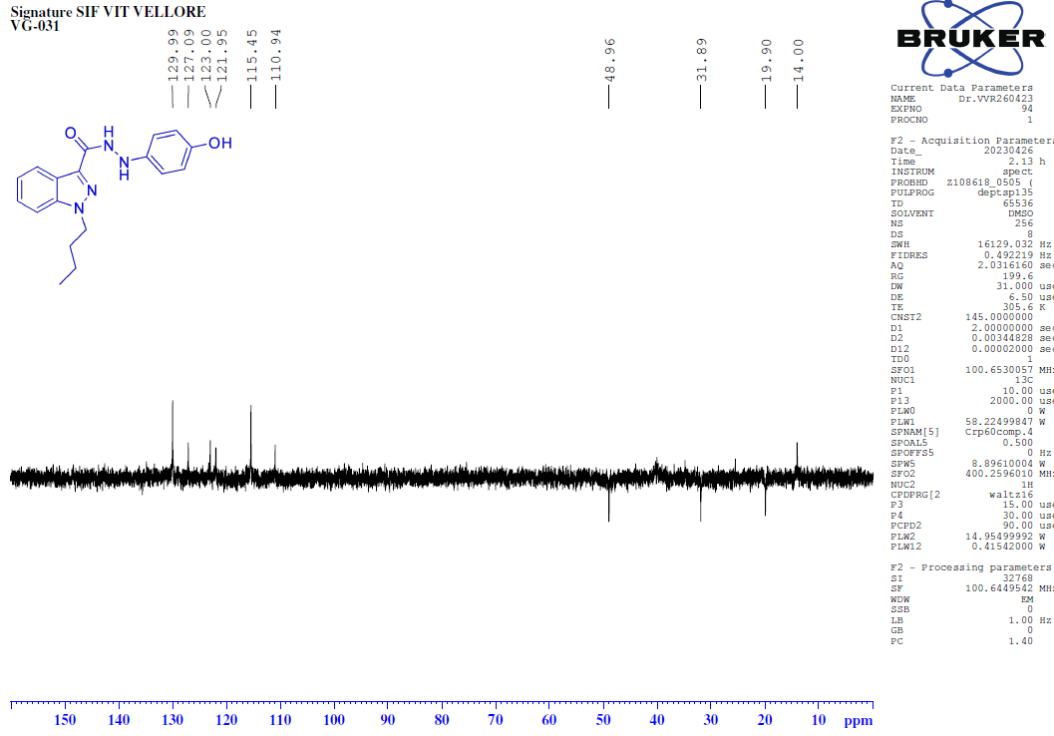
FT-IR spectrum of 1-butyl-N-(4-hydroxyphenyl)-1H-indazole-3-carbohydrazide (8x).
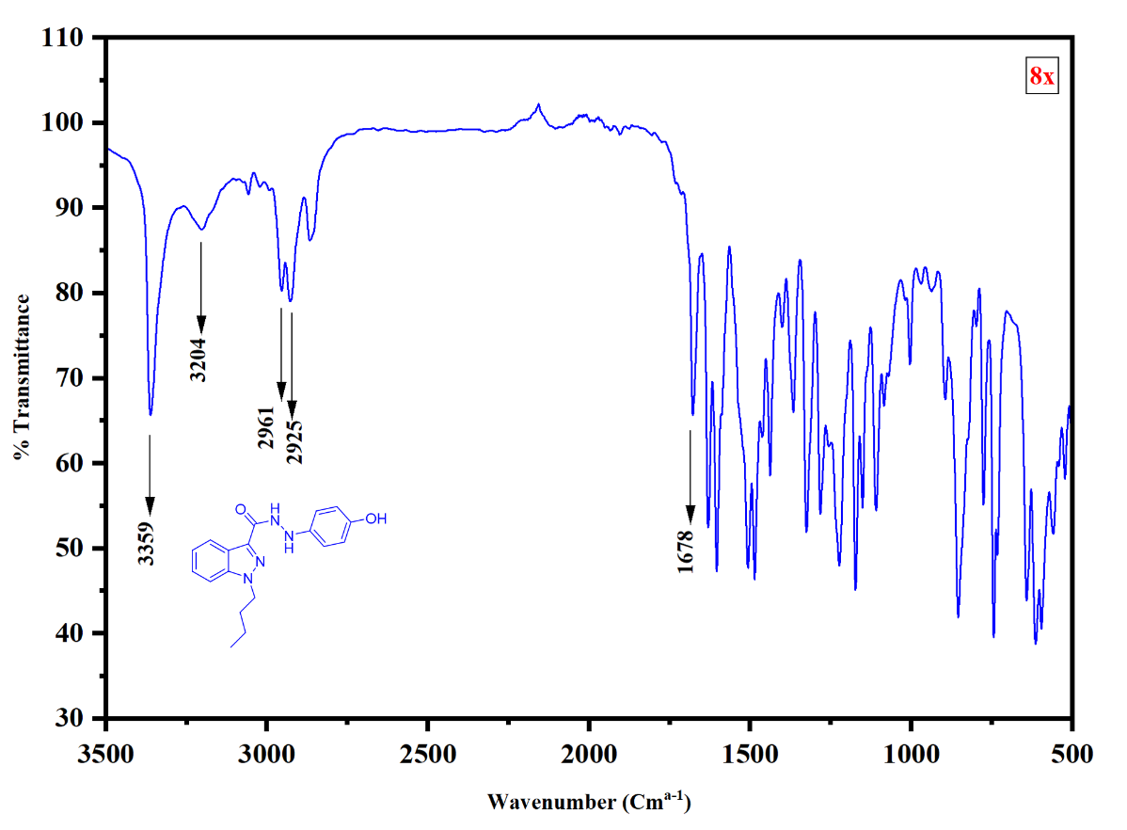
HRMS of 1-butyl-N-(4-hydroxyphenyl)-1H-indazole-3-carbohydrazide (8x).
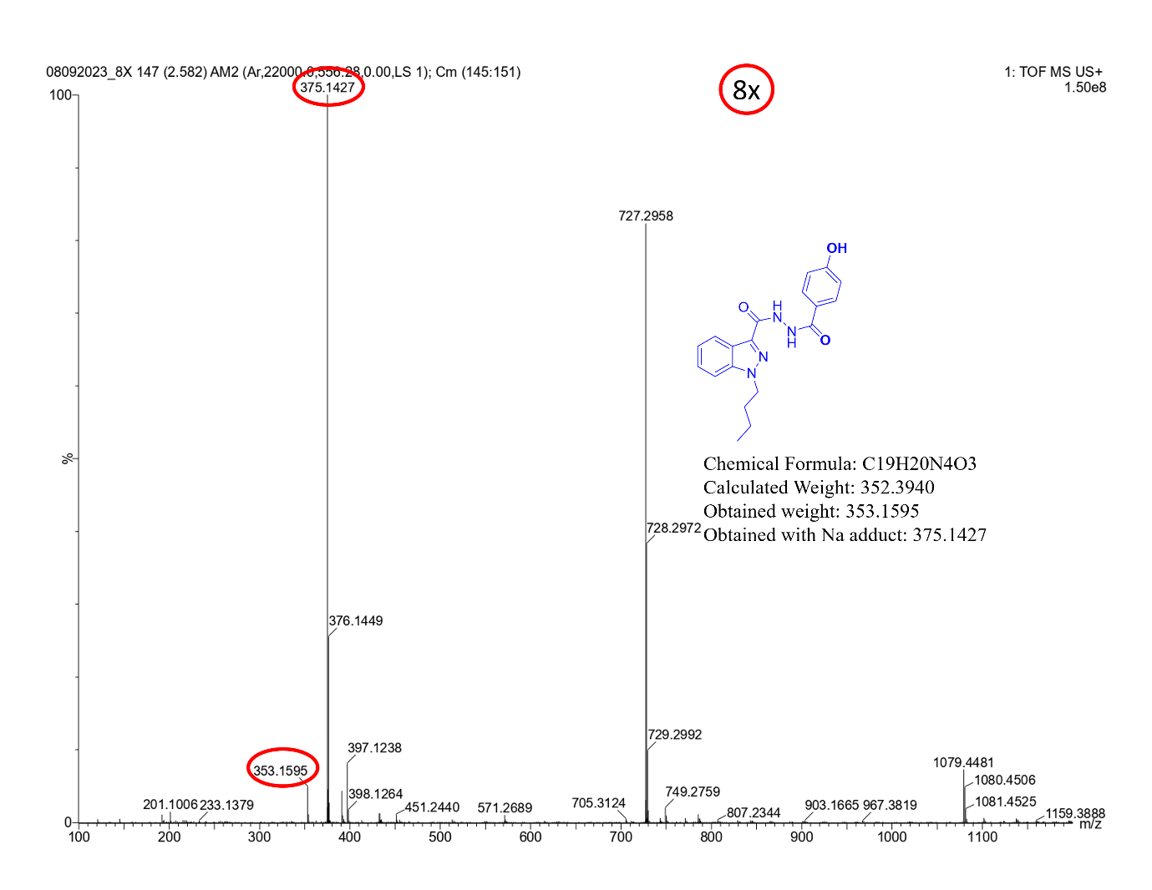
¹H-NMR [400MHz, DMSO-d₆] spectrum of N-(4-bromophenyl)1butyl-1H-indazole-3-carbohydrazide (8y).
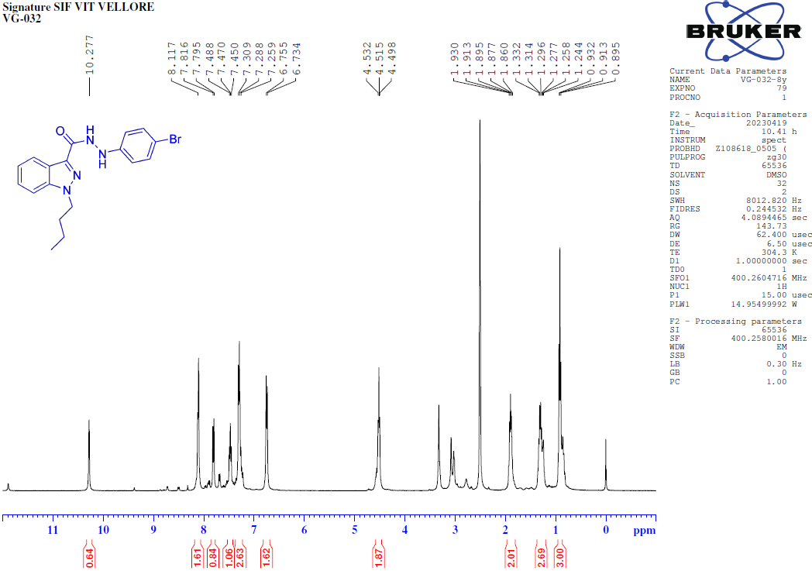
¹³C-NMR [100MHz, DMSO-d₆] spectrum of N-(4-bromophenyl)1butyl-1H-indazole-3-carbohydrazide (8y).
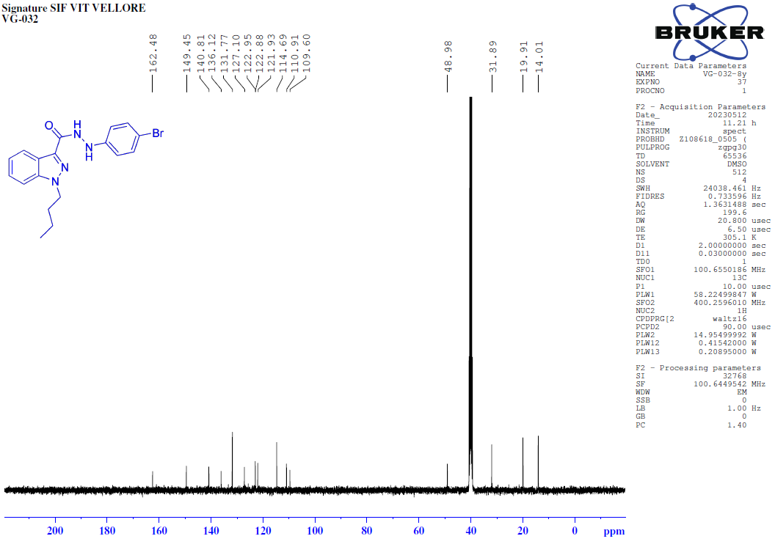
135-DEPT-NMR [100MHz, DMSO-d₆] spectrum of N-(4-bromophenyl)1butyl-1H-indazole-3-carbohydrazide (8y).
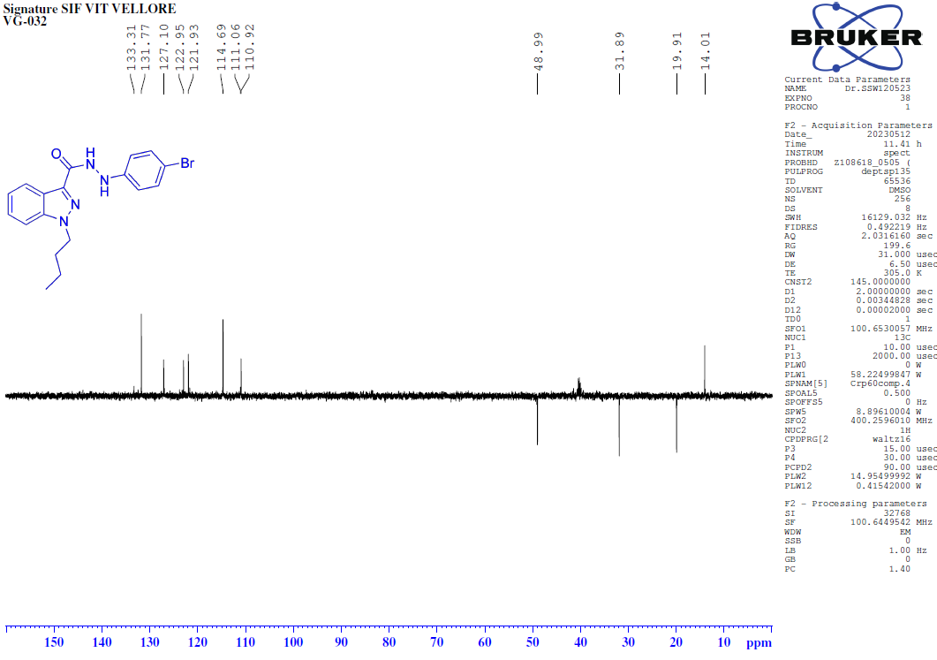 FT-IR spectrum of N-(4-bromophenyl)1butyl-1H-indazole-3-carbohydrazide (8y).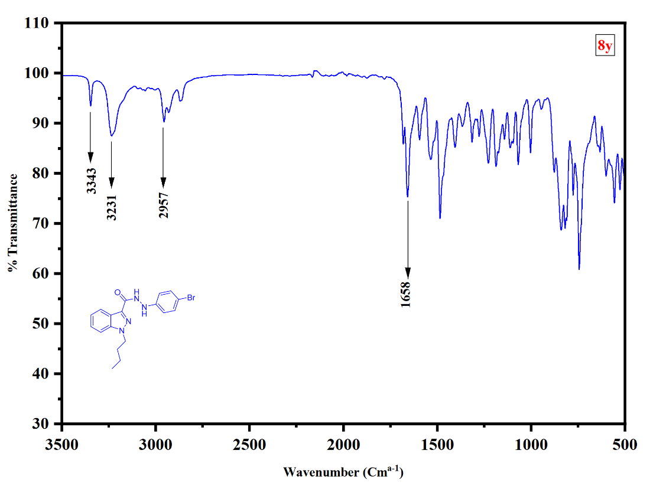
HRMS of N-(4-bromophenyl)1butyl-1H-indazole-3-carbohydrazide (8y).
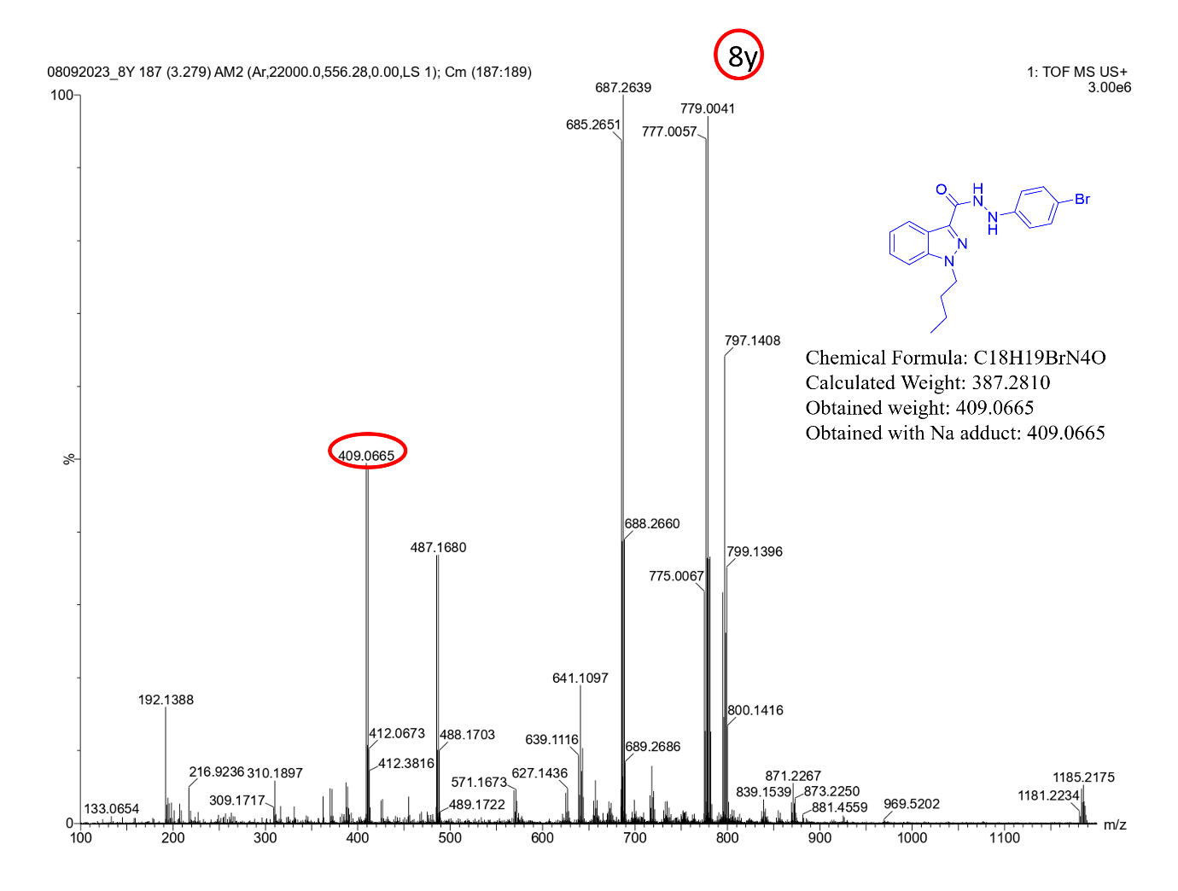
¹H-NMR [400MHz, DMSO-d₆] 1-Butyl-1H-indazole-3-carboxylic acid to 1-butyl-N-(4-nitrophenyl)-1H-indazole-3-carboxamide (8z).
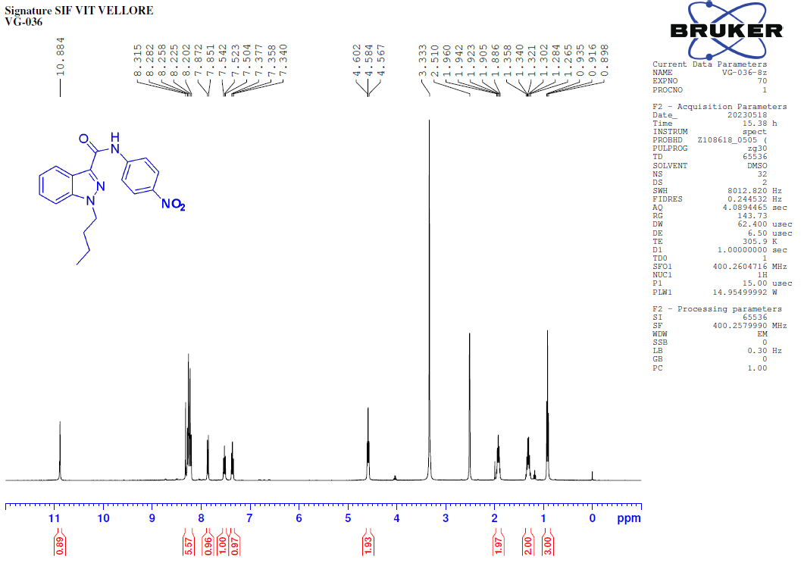
¹³C-NMR [100MHz, DMSO-d₆] 1-Butyl-1H-indazole-3-carboxylic acid to 1-butyl-N-(4-nitrophenyl)-1H-indazole-3-carboxamide (8z).
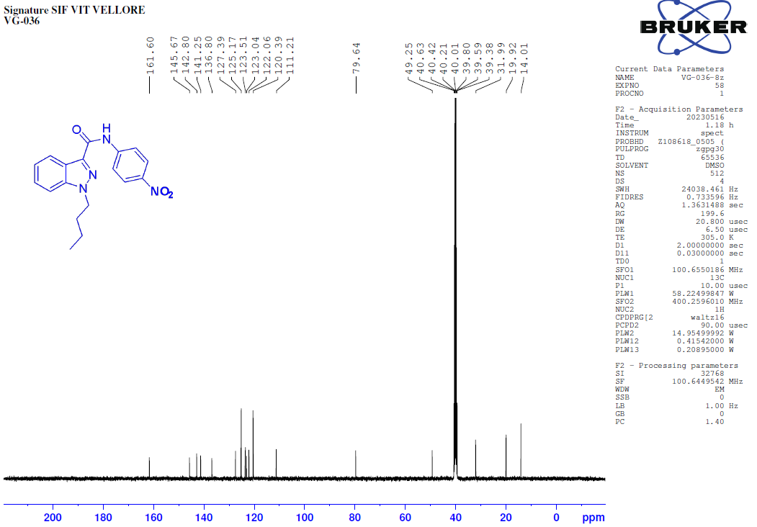
¹³⁵C-NMR [100MHz, DMSO-d₆] 1-Butyl-1H-indazole-3-carboxylic acid to 1-butyl-N-(4-nitrophenyl)-1H-indazole-3-carboxamide (8z).
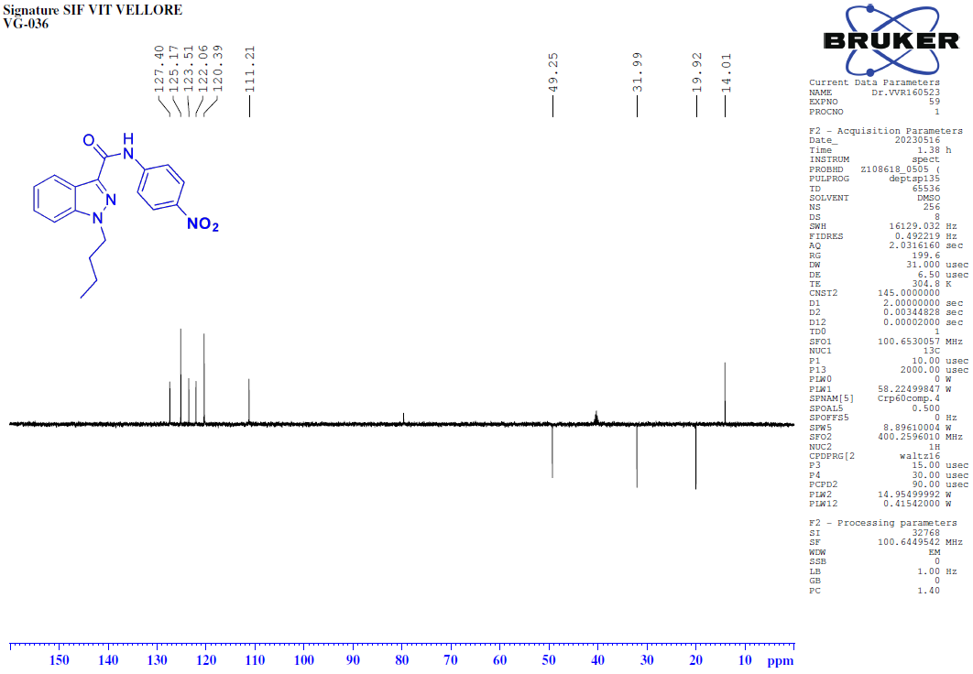
FT-IR spectrum of 1-Butyl-1H-indazole-3-carboxylic acid to 1-butyl-N-(4-nitrophenyl)-1H-indazole-3-carboxamide (8z).
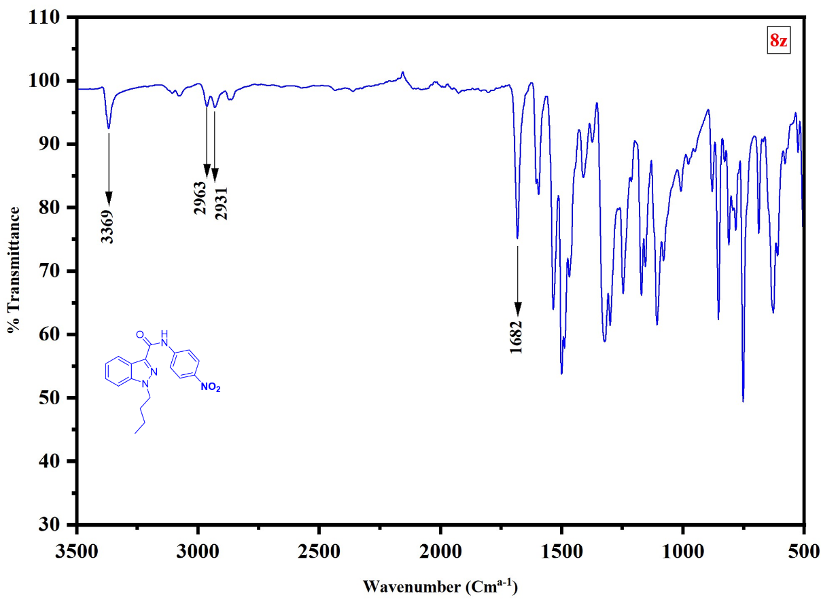
HRMS of 1-butyl-N-(4-nitrophenyl)-1H-indazole-3-carboxamide (8z).
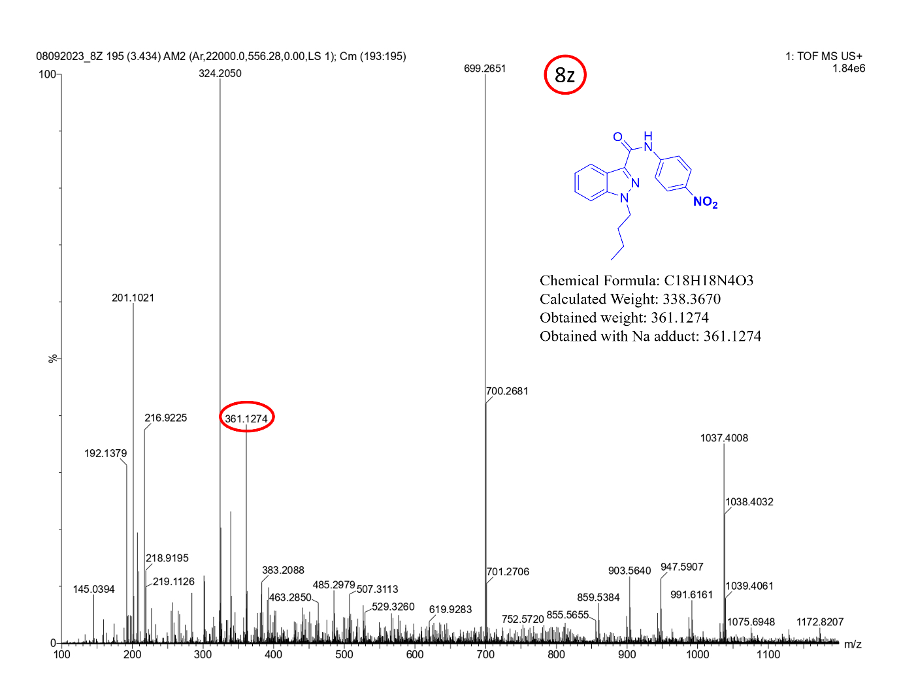

5.DFT studies indazole derivatives with HOMO and LUMO values
S. No: | COMPOUND | HOMO | LUMO | ΔE = E_{LUMO}-E_{HOMO}
1 | 8a | -6.0453 | -0.86238 | 5.18292
2 | 8b | -5.51394 | -1.07163 | 4.44231
3 | 8c | -5.88654 | -0.81999 | 5.06655
4 | 8d | -6.12522 | -2.65032 | 3.4749
5 | 8e | -5.7888 | -1.17666 | 4.61214
6 | 8f | -4.44879 | -0.98955 | 3.45924
7 | 8g | -5.89761 | -1.40211 | 4.4955
8 | 8h | -5.65434 | -2.31201 | 3.34233
9 | 8i | -5.62275 | -1.21878 | 4.40397
10 | 8j | -5.14566 | -1.04112 | 4.10454
11 | 8k | -5.23692 | -0.92853 | 4.30839
12 | 8l | -5.44563 | -1.05111 | 4.39452
13 | 8m | -5.41485 | -1.07244 | 4.34241
14 | 8n | -5.67216 | -1.00143 | 4.67073
15 | 8o | -5.11137 | -1.0287 | 4.08267
16 | 8p | -5.5039 | -1.15128 | 4.35262
17 | 8q | -5.21937 | -0.92529 | 4.29408
18 | 8r | -5.47317 | -1.14426 | 4.32891
19 | 8s | -6.34878 | -1.4283 | 4.92048
20 | 8t | -5.27715 | -2.60523 | 2.67192
21 | 8u | -6.8823 | -2.45457 | 4.42773
22 | 8v | -6.36687 | -3.59964 | 2.76723
23 | 8w | -5.08923 | -1.32435 | 3.76488
24 | 8x | -6.67332 | -2.42568 | 4.24764
25 | 8y | -4.24305 | -1.00143 | 3.24162
26 | 8z | -6.4638 | -2.77776 | 6.68604

DFT studies indazole derivatives HOMO &LUMO (8a-8z)
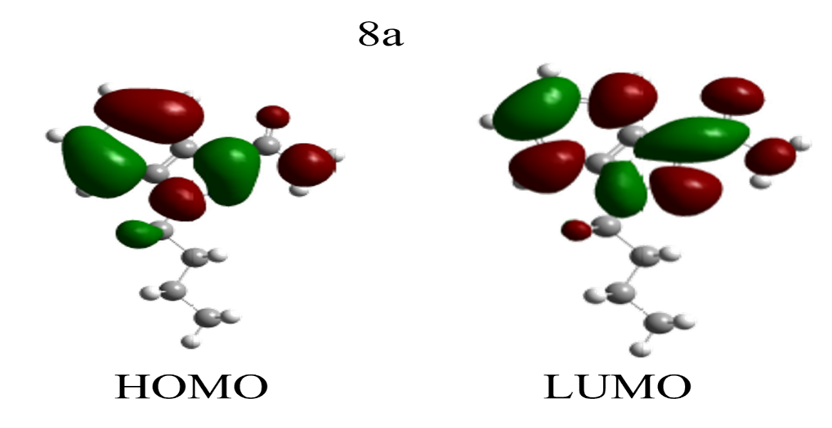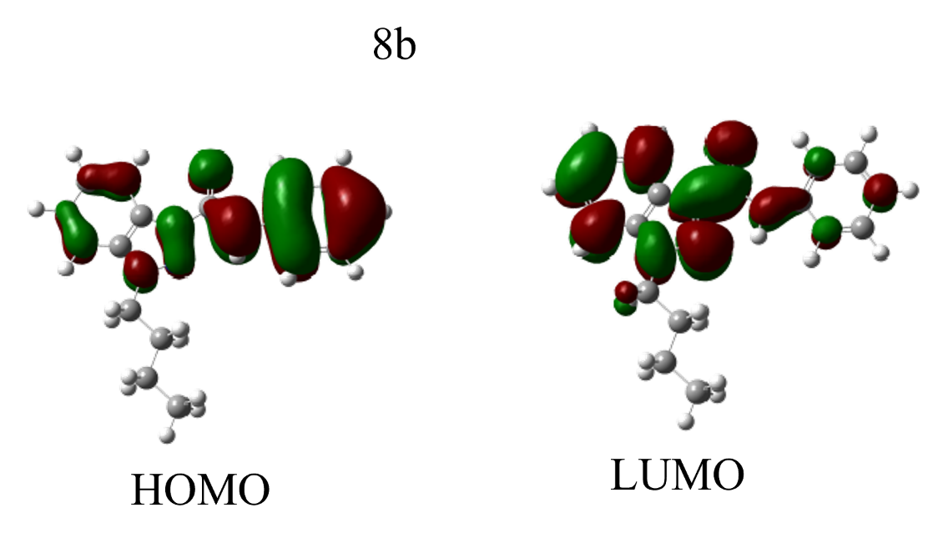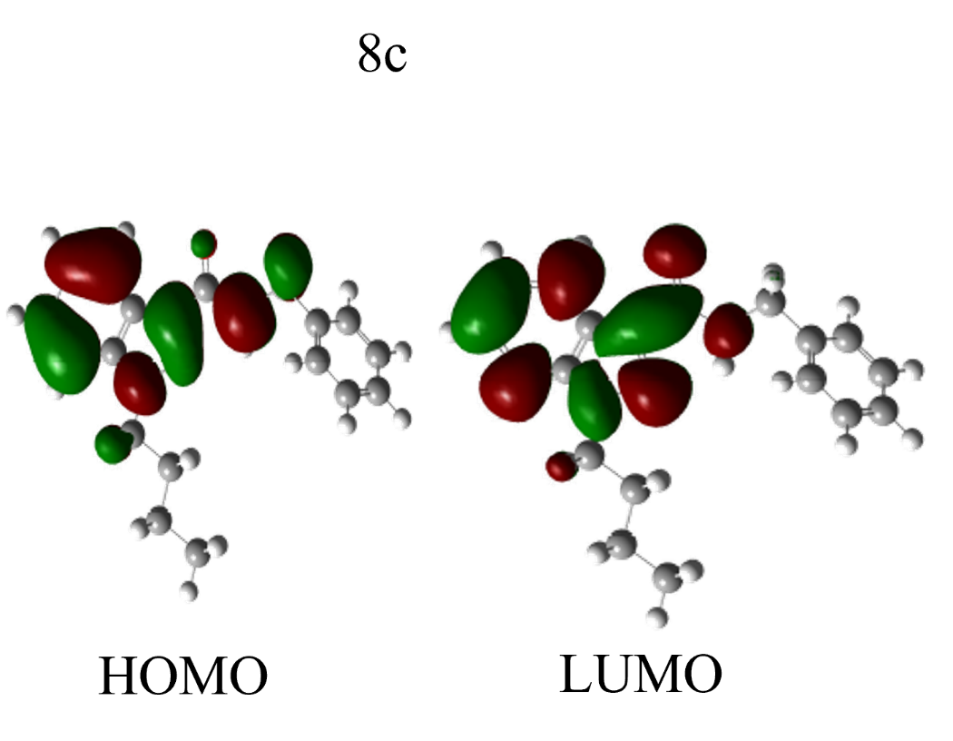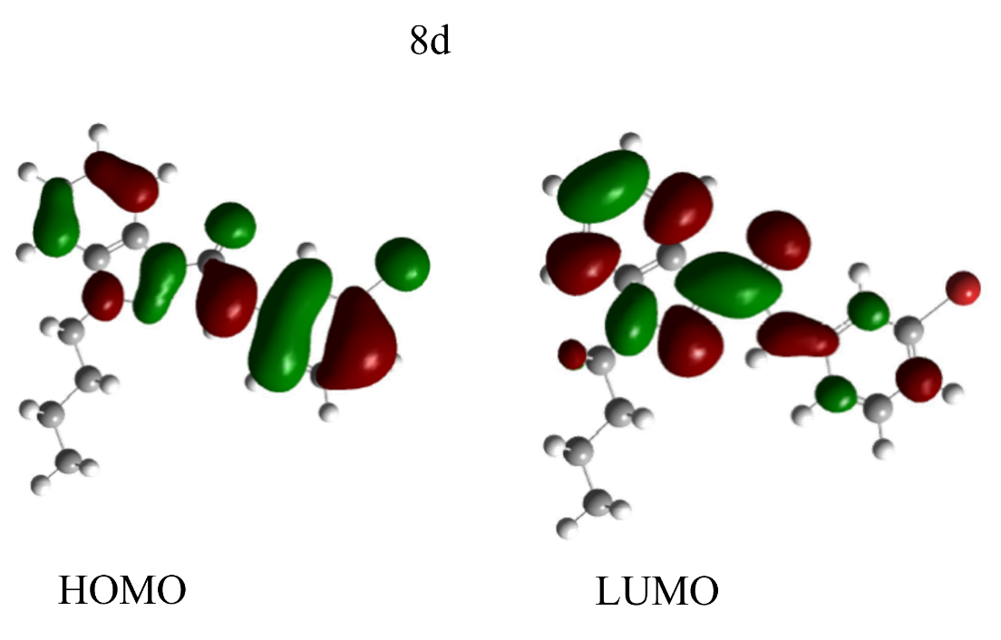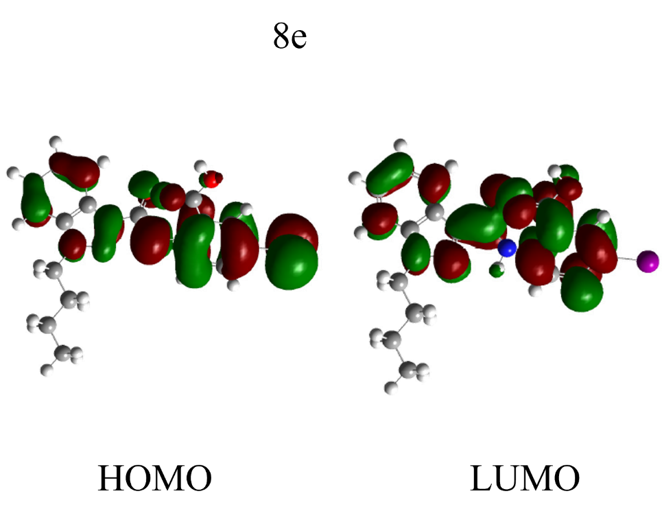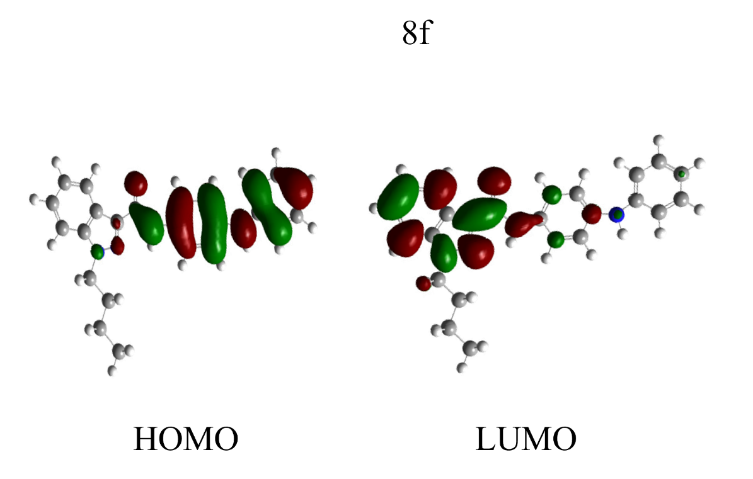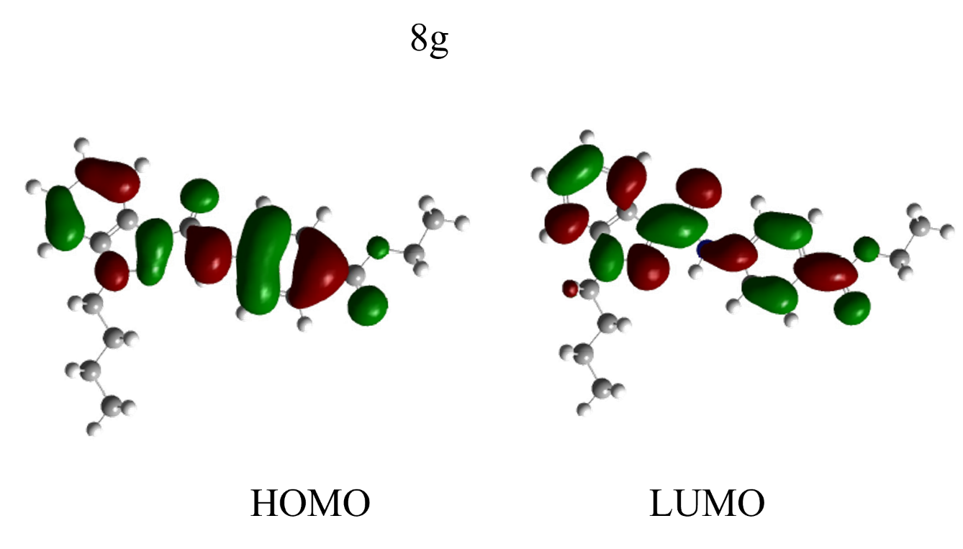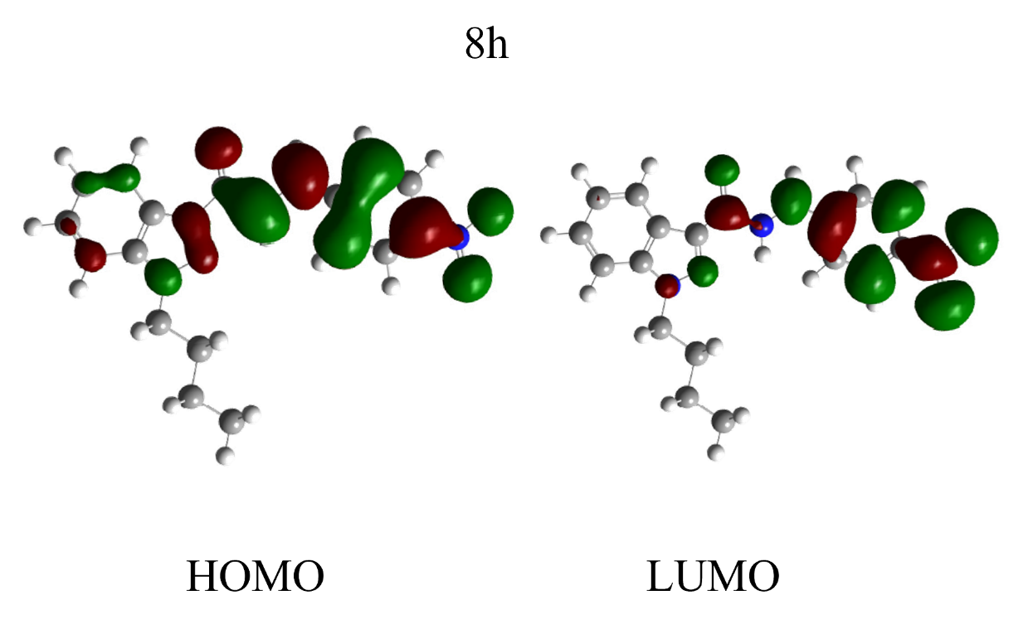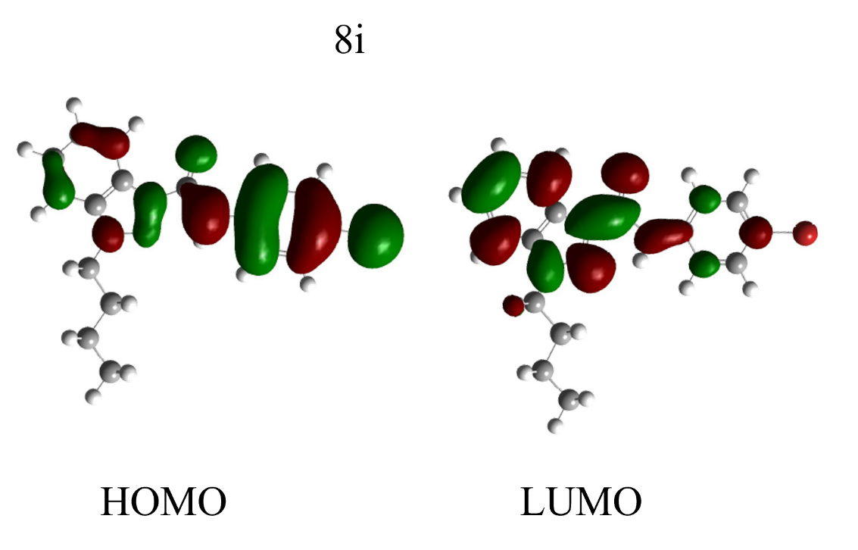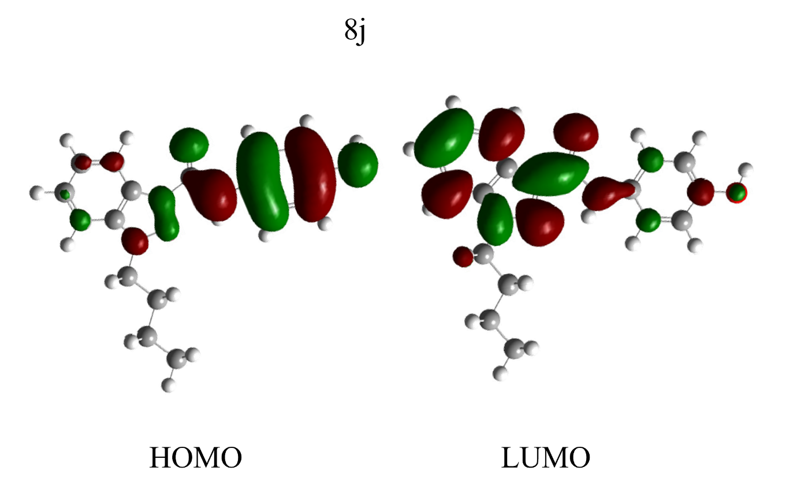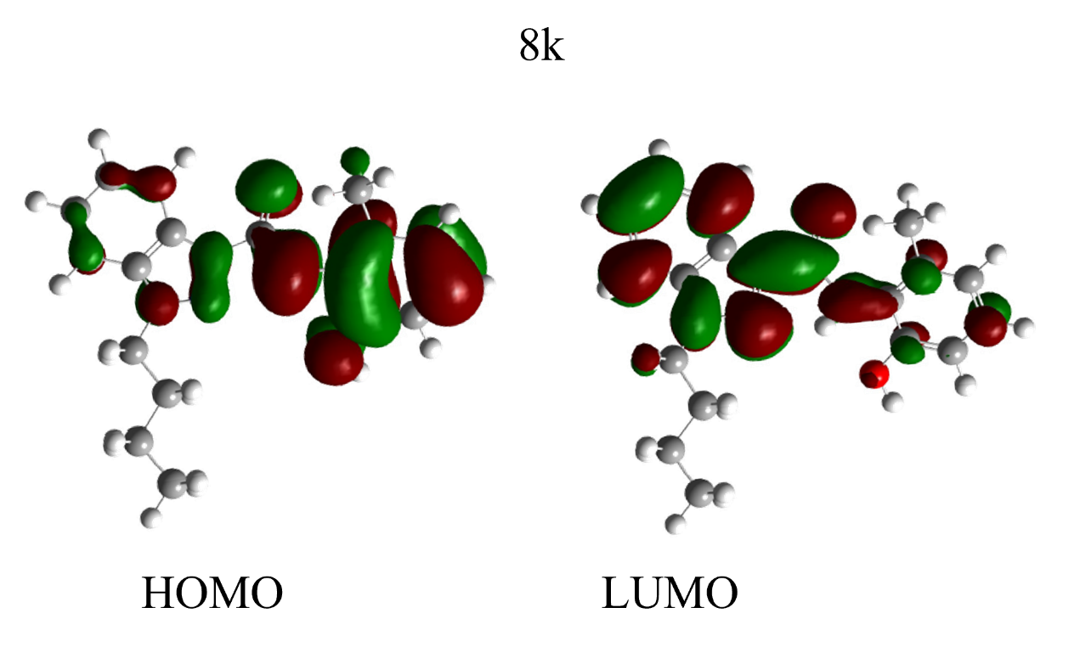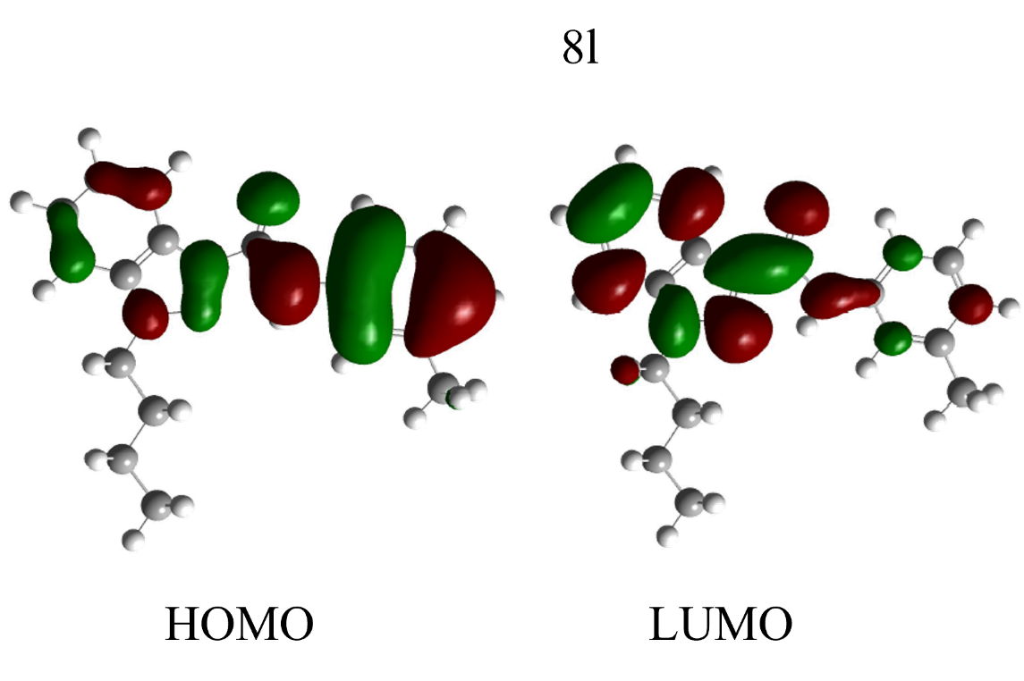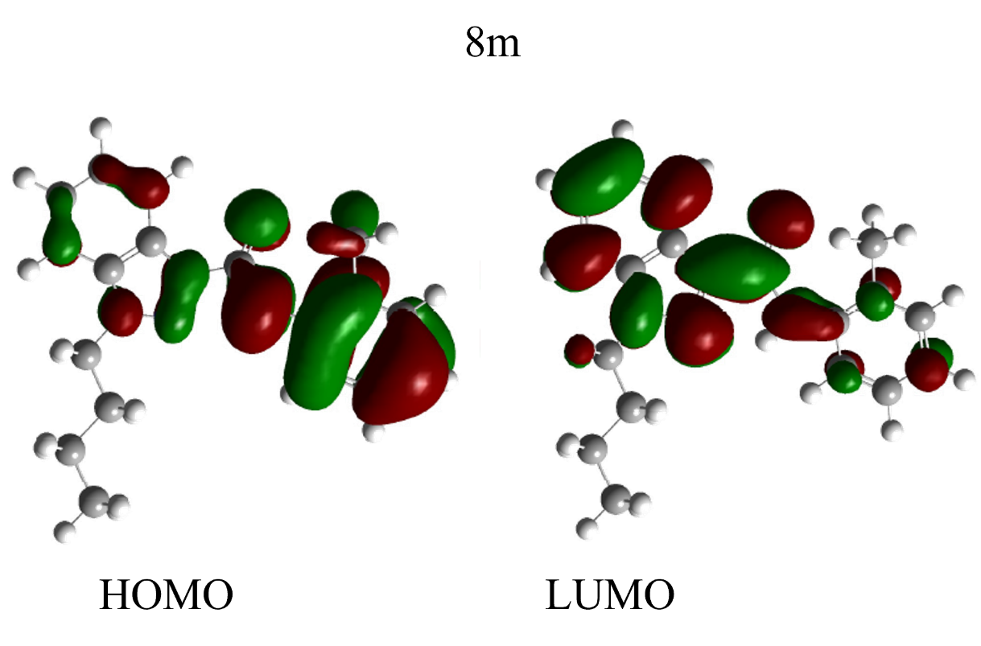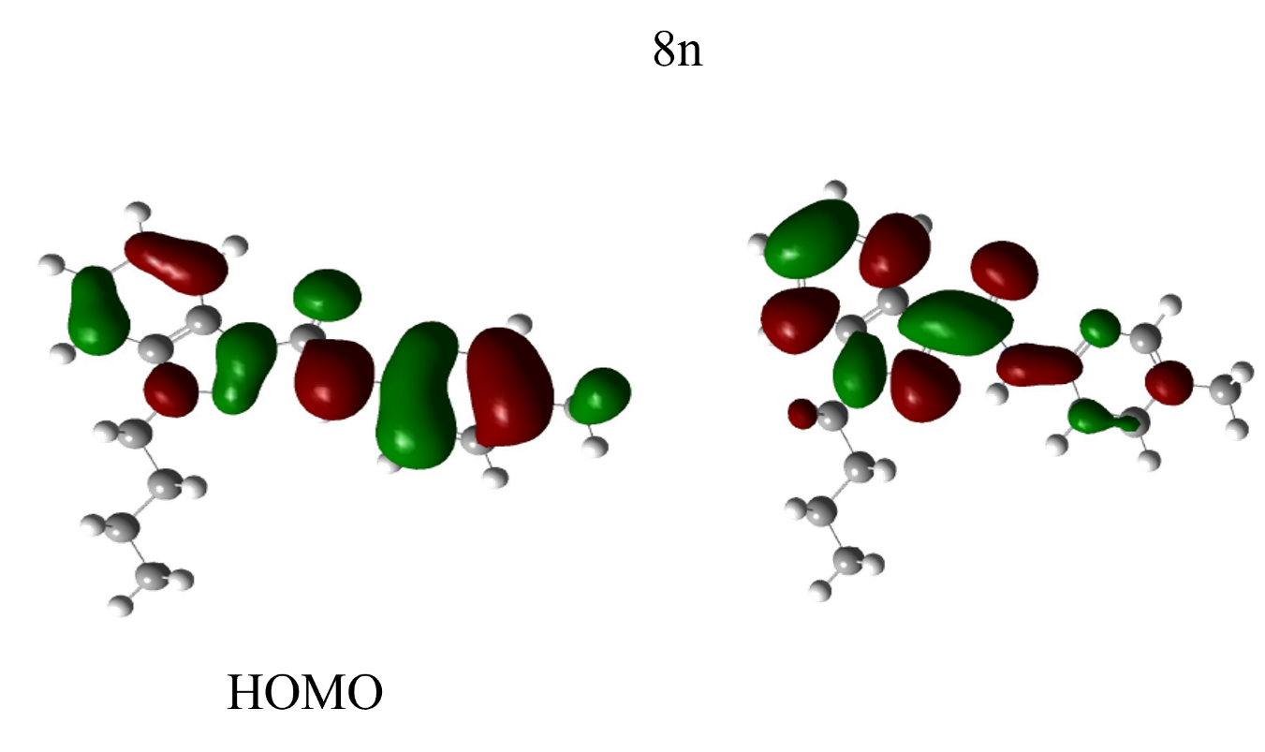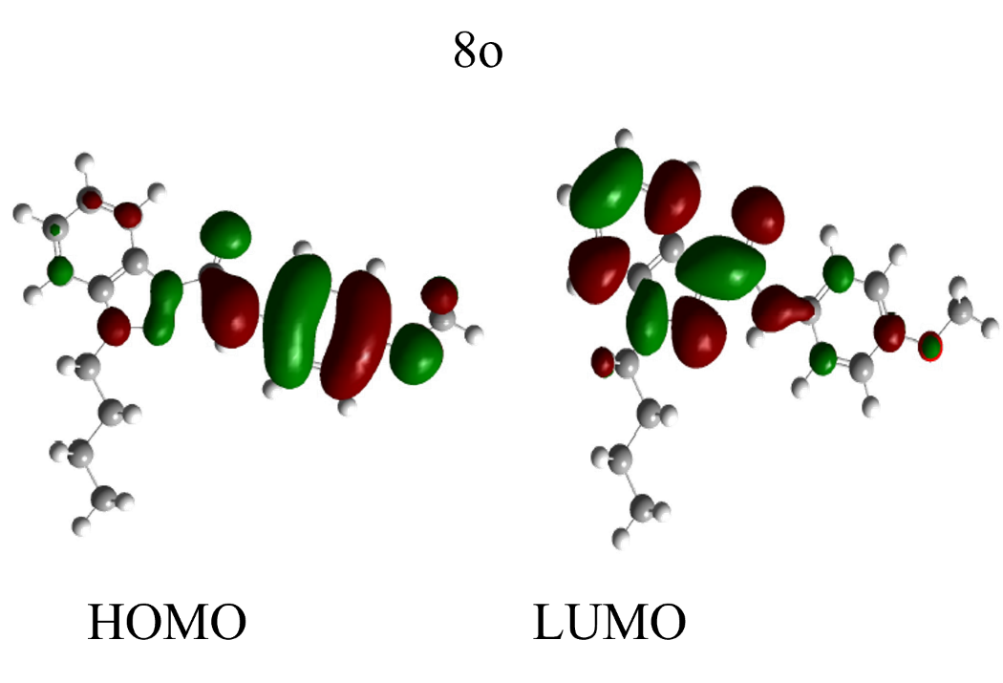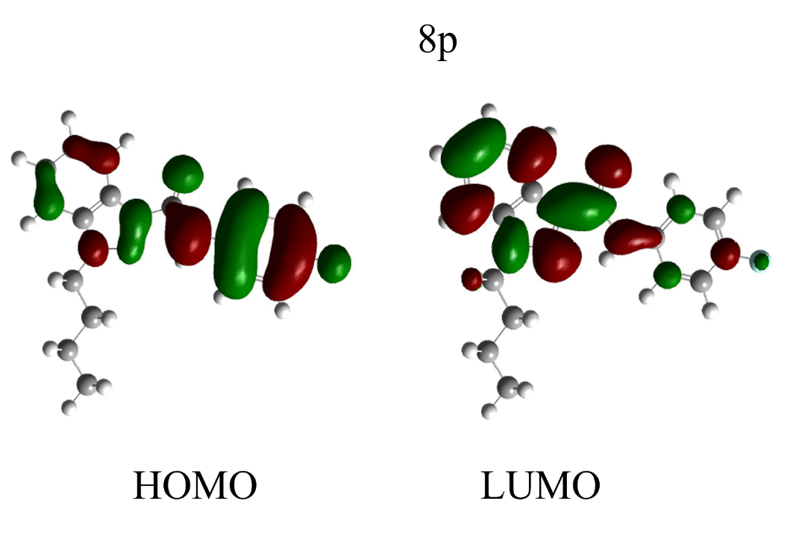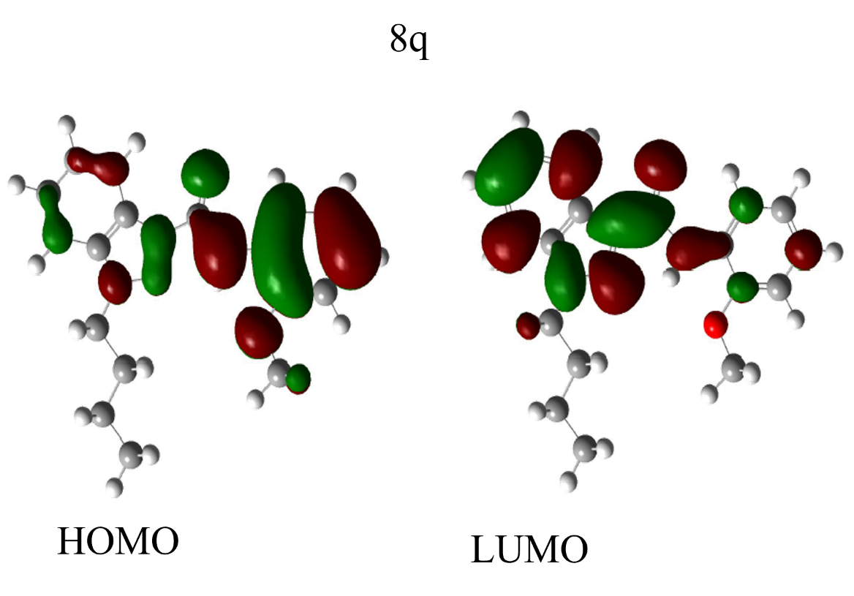
Molecular Electrostatic Potential surface of synthesized indazole derivatives
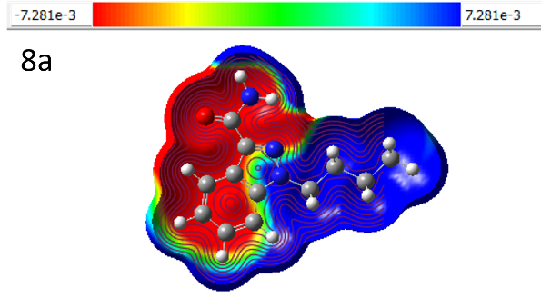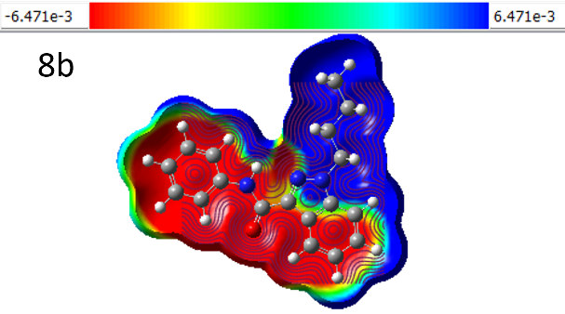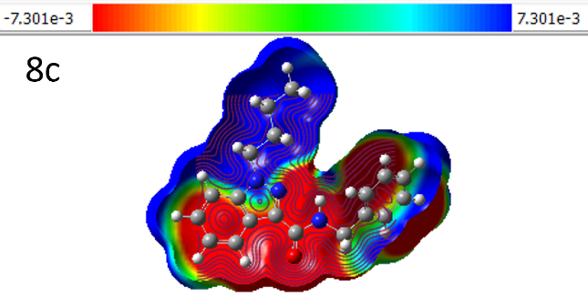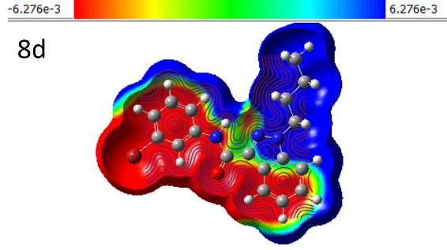
Docking results from (8a-8z) 3-carboxamide indazole derivatives

S.no/Compound | ΔG_{binding energy} (Kcal/mol) | Ki (micromolar)  [Temperature = 298.15 k] need to change nanomolar to micro molar | H bond energy (Kcal/mol)
8a | -7.03 | 7.00 | -8.24
8b | -9.38 | 133.69 | -10.84
8c | -10.51 | 19.74 | -12.19
8d | -9.51 | 106.73 | -10.67
8e | -10.23 | 31.66 | -11.48
8f | -10.59 | 17.28 | -12.66
8g | -10.21 | 32.61 | -12.50
8h | -10.56 | 18.24 | -12.48
8i | -10.47 | 21.07 | -11.93
8j | -9.12 | 207.41 | -10.84
8k | -9.94 | 51.93 | -11.70
8l | -9.77 | 69.21 | -11.24
8m | -10.18 | 34.63 | -11.59
8n | -9.55 | 100.18 | -11.00
8o | -9.94 | 51.34 | -11.62
8p | -9.71 | 76.64 | -11.15
8q | -10.22 | 32.11 | -11.92
8r | -9.83 | 61.84 | -11.56
8s | -8.36 | 729.01 | -9.81
8t | -10.72 | 13.89 | -12.63
8u | -10.38 | 24.47 | -12.09
8v | -11.77 | 2.35 | -13.47
8w | -11.64 | 2.94 | -13.33
8x | -10.32 | 27.09 | -12.31
8y | -11.52 | 3.61 | -13.21
8z | -10.81 | 11.9 | -12.40

The binding pattern of indazole derivatives with PBD-6FEW. A) represents 3D surface representation, B) represents active ligand catalytic centre of the protein target, C) 2D-schematic LigPlot interactions shown for the docked pose of indazole derivatives shown by the spokes
