The original blots for the figures
Fig. 1D-REDD1
marker | Control | Z11 | Z11  ΔrfbD | Z11  ΔrfbD  ::rfbD
Fig. 1D-LC3
marker | Control | Z11 | Z11  ΔrfbD | Z11  ΔrfbD  ::rfbD
Fig. 1D-β-actin
marker | Control | Z11 | Z11  ΔrfbD | Z11  ΔrfbD  ::rfbD

Fig. 2A-REDD1
marker | Control | NC | 581 | 676 | 763 | 581+  676 | 676+  763 | 581+  763
Fig. 2A-β-actin
marker | Control | NC | 581 | 676 | 763 | 581+  676 | 676+  763 | 581+  763
Fig. 2B-LC3
marker | siRNA NC |  |  |  | siRNA 676+763
marker | Control | Z11 | Z11  ΔrfbD | Z11  ΔrfbD  ::rfbD | Control | Z11 | Z11  ΔrfbD | Z11  ΔrfbD  ::rfbD
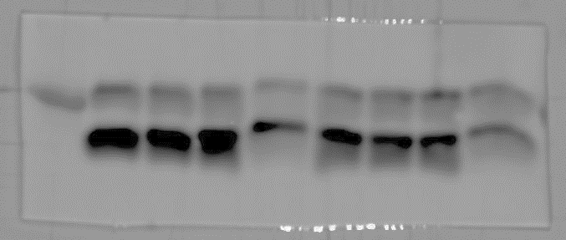
Gray scale | LC3-Ⅱ | 27.334 | 25.565 | 23.84 | 16.221 | 21.992 | 24.055 | 27.919 | 24.175
Gray scale | LC3-Ⅰ | 92.138 | 83.67 | 86.001 | 47.441 | 68.513 | 60.849 | 57.258 | 32.743
Fig. 2B-p62
marker | siRNA NC |  |  |  | siRNA 676+763
marker | Control | Z11 | Z11  ΔrfbD | Z11  ΔrfbD  ::rfbD | Control | Z11 | Z11  ΔrfbD | Z11  ΔrfbD  ::rfbD

Fig. 2B-REDD1
marker | siRNA NC |  |  |  | siRNA 676+763
marker | Control | Z11 | Z11  ΔrfbD | Z11  ΔrfbD  ::rfbD | Control | Z11 | Z11  ΔrfbD | Z11  ΔrfbD  ::rfbD

Fig. 2B-β-actin
marker | siRNA NC |  |  |  | siRNA 676+763
marker | Control | Z11 | Z11  ΔrfbD | Z11  ΔrfbD  ::rfbD | Control | Z11 | Z11  ΔrfbD | Z11  ΔrfbD  ::rfbD

Fig. 3C-LC3
marker | pCMV-myc |  |  |  | pCMV-myc-REDD1
marker | Control | Z11 | Z11  ΔrfbD | Z11  ΔrfbD  ::rfbD | Control | Z11 | Z11  ΔrfbD | Z11  ΔrfbD  ::rfbD
Gray scale | LC3-Ⅱ | 6.56 | 6.506 | 5.06 | 7.382 | 13.787 | 10.374 | 7.894 | 9.333
Gray scale | LC3-Ⅰ | 35.267 | 57.603 | 47.078 | 95.971 | 155.753 | 145.56 | 157.882 | 149.592
Fig. 3C-p62
marker | pCMV-myc |  |  |  | pCMV-myc-REDD1
marker | Control | Z11 | Z11  ΔrfbD | Z11  ΔrfbD  ::rfbD | Control | Z11 | Z11  ΔrfbD | Z11  ΔrfbD  ::rfbD

Fig. 3C-β-actin
marker | pCMV-myc |  |  |  | pCMV-myc-REDD1
marker | Control | Z11 | Z11  ΔrfbD | Z11  ΔrfbD  ::rfbD | Control | Z11 | Z11  ΔrfbD | Z11  ΔrfbD  ::rfbD

Fig. 3C-REDD1
marker | pCMV-myc |  |  |  | pCMV-myc-REDD1
marker | Control | Z11 | Z11  ΔrfbD | Z11  ΔrfbD  ::rfbD | Control | Z11 | Z11  ΔrfbD | Z11  ΔrfbD  ::rfbD

