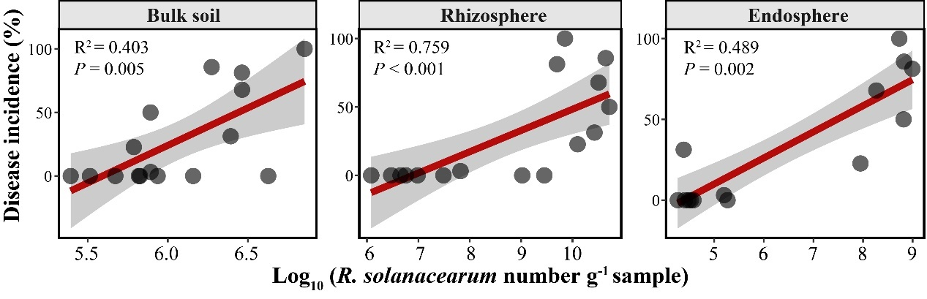
Figure S1. Linear regression showing the relationship between the tomato bacterial wilt incidence and the density of pathogen R. solanacearum in bulk soil, rhizosphere, and endosphere, respectively.
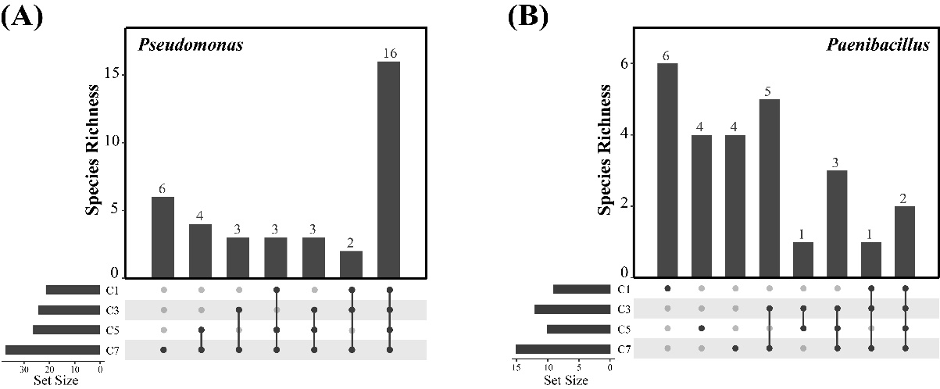 Figure S2. Upset diagrams showing the amount of specific OTUs in Pseudomonas (A) and Paenibacillus (B) at different monocropping cycles.
Table S1 The pathogen density in bulk soil, rhizosphere, and endosphere at different monocropping cycles
 | Treatments | Mean | Standard Error | min | max | 95%CI− | 95%CI+
B-filc | C1 | 1.41E+06 | 8.01E+05 | 2.47E+05 | 4.24E+06 | 3.53E+05 | 3.24E+06
B-filc | C3 | 1.70E+06 | 5.09E+05 | 6.60E+05 | 2.90E+06 | 6.90E+05 | 2.69E+06
B-filc | C5 | 2.49E+06 | 1.38E+06 | 3.26E+05 | 7.15E+06 | 4.70E+05 | 5.51E+06
B-filc | C7 | 1.50E+06 | 4.19E+05 | 7.79E+05 | 2.91E+06 | 8.22E+05 | 2.40E+06
R-filc | C1 | 3.60E+06 | 4.20E+05 | 1.21E+06 | 5.70E+06 | 8.22E+05 | 2.40E+06
R-filc | C3 | 7.94E+09 | 5.71E+09 | 3.08E+07 | 2.67E+10 | 4.84E+07 | 2.12E+10
R-filc | C5 | 1.59E+10 | 8.59E+09 | 9.64E+06 | 4.41E+10 | 3.14E+09 | 3.49E+10
R-filc | C7 | 2.20E+10 | 1.10E+10 | 1.05E+09 | 5.20E+10 | 1.94E+09 | 4.70E+10
E-filc | C1 | 3.15E+04 | 3.01E+03 | 2.58E+04 | 3.83E+04 | 2.58E+04 | 3.83E+04
E-filc | C3 | 2.47E+08 | 2.16E+08 | 1.85E+04 | 9.89E+08 | 2.14E+04 | 7.41E+08
E-filc | C5 | 3.23E+08 | 1.41E+08 | 1.86E+05 | 6.68E+08 | 4.44E+07 | 6.02E+08
E-filc | C7 | 2.80E+08 | 1.58E+08 | 3.38E+04 | 6.56E+08 | 3.38E+04 | 6.56E+08
Note: “B-filc”, “R-filc”, and “E-filc” reprsents the density of Ralstonia solanacearum in bulk soil, Rhizospehre, and endosphere, respectively; “C1”, “C3”, “C5”, and “C7” represent the first, third, fifth and seventh monocropping cycles; 95%CI⁻: the lower 95% confidence interval, 95%CI⁺: the upper 95% confidence interval.
Table S2 The relative contribution of the niche and monocropping time to variation in the bacterial community composition
 | Df | Sums of squares | Mean squares | F.Model | Variation (R²) | Pr (>F)
Monocropping cycles | 3 | 1.901 | 0.634 | 5.471 | 0.123 | 0.001
Niche | 2 | 7.076 | 3.538 | 30.544 | 0.456 | 0.001
Monocropping cycles×Niche | 6 | 2.599 | 0.433 | 3.739 | 0.167 | 0.002
Residuals | 34 | 3.939 | 0.116 |  | 0.254
Total | 45 | 15.515 |  |  | 1.000
Note: The niche (the bulk soil, rhizosphere, and endosphere) and monocropping time (cropping cycles 1, 3, 5, and 7) was used as assumed influence factors in operations.
Table S3 The relationship between the top 40 dominant genera in bulk soil and tomato wilt disease
Genus | log₁₀(B_fliC) |  | Ralstnoia |  | Disease Incidence
Genus | r | P | r | P | r | P
norank_f__norank_o__Vicinamibacterales | 0.123 | 0.704 | 0.269 | 0.398 | 0.221 | 0.491
Streptomyces | -0.580* | 0.048 | -0.626* | 0.029 | -0.658* | 0.020
norank_f__norank_o__Gaiellales | -0.334 | 0.288 | -0.044 | 0.892 | -0.260 | 0.414
norank_f__Vicinamibacteraceae | 0.130 | 0.687 | 0.239 | 0.454 | 0.276 | 0.385
norank_f__67.14 | -0.245 | 0.443 | -0.154 | 0.632 | -0.349 | 0.266
Nocardioides | -0.031 | 0.923 | 0.239 | 0.455 | -0.153 | 0.635
Gaiella | -0.178 | 0.581 | 0.041 | 0.901 | -0.121 | 0.708
Chujaibacter | -0.236 | 0.461 | -0.185 | 0.565 | -0.071 | 0.826
Bacillus | -0.298 | 0.347 | -0.274 | 0.388 | -0.470 | 0.123
Lysobacter | 0.409 | 0.187 | 0.328 | 0.298 | 0.075 | 0.817
Gemmatimonas | -0.074 | 0.818 | 0.130 | 0.687 | 0.263 | 0.408
norank_f__JG30.KF.CM45 | -0.514 | 0.087 | -0.417 | 0.178 | -0.530 | 0.076
Marmoricola | -0.260 | 0.414 | -0.350 | 0.264 | -0.583* | 0.047
norank_f__Chitinophagaceae | -0.069 | 0.830 | -0.247 | 0.438 | 0.064 | 0.843
norank_f__Gemmatimonadaceae | 0.086 | 0.789 | 0.351 | 0.264 | 0.206 | 0.520
norank_f__SC.I.84 | 0.381 | 0.222 | 0.537 | 0.072 | 0.481 | 0.114
Solirubrobacter | -0.049 | 0.879 | 0.065 | 0.840 | -0.249 | 0.435
RB41 | -0.002 | 0.995 | 0.169 | 0.601 | 0.021 | 0.947
norank_f__norank_o__C0119 | 0.000 | 0.999 | 0.046 | 0.886 | -0.068 | 0.835
Arthrobacter | 0.172 | 0.593 | 0.393 | 0.206 | 0.242 | 0.449
norank_f__Roseiflexaceae | 0.071 | 0.826 | -0.100 | 0.758 | -0.335 | 0.288
norank_f__norank_o__norank_c__KD4.96 | 0.155 | 0.631 | 0.354 | 0.260 | 0.082 | 0.800
unclassified_k__norank_d__Bacteria | 0.179 | 0.577 | 0.337 | 0.284 | -0.142 | 0.659
Nitrospira | -0.455 | 0.137 | -0.408 | 0.187 | -0.541 | 0.069
unclassified_f__Intrasporangiaceae | -0.287 | 0.366 | 0.040 | 0.901 | 0.064 | 0.843
MND1 | 0.067 | 0.837 | 0.221 | 0.490 | 0.061 | 0.852
norank_f__WD2101_soil_group | 0.307 | 0.332 | 0.143 | 0.657 | 0.524 | 0.080
Bryobacter | 0.126 | 0.696 | 0.351 | 0.263 | 0.534 | 0.074
Pseudolabrys | 0.098 | 0.763 | 0.193 | 0.548 | 0.342 | 0.277
norank_f__norank_o__Elsterales | -0.062 | 0.848 | 0.246 | 0.440 | 0.281 | 0.376
Ellin6067 | -0.010 | 0.974 | 0.082 | 0.799 | 0.146 | 0.651
Luteimonas | 0.060 | 0.853 | 0.054 | 0.868 | 0.153 | 0.635
norank_f__norank_o__norank_c__TK10 | 0.048 | 0.881 | 0.232 | 0.468 | -0.050 | 0.878
Microvirga | 0.103 | 0.750 | 0.229 | 0.475 | -0.011 | 0.974
Jatrophihabitans | -0.244 | 0.445 | -0.441 | 0.152 | -0.427 | 0.166
norank_f__norank_o__SBR1031 | 0.450 | 0.142 | 0.517 | 0.085 | 0.445 | 0.147
unclassified_f__Rhodanobacteraceae | -0.158 | 0.623 | -0.355 | 0.257 | -0.153 | 0.635
Burkholderia.Caballeronia.Paraburkholderia | -0.323 | 0.306 | -0.375 | 0.230 | -0.023 | 0.943
Sphingomonas | -0.159 | 0.622 | -0.088 | 0.786 | 0.281 | 0.376
norank_f__norank_o__Rokubacteriales | 0.043 | 0.895 | 0.167 | 0.604 | 0.128 | 0.691
Note: The relationship between the density or relative abundance of Ralstonia solanacearum and the relative abundance of Streptomyces was determined by Pearson correlation analysis; while the correlation between the wilt disease incidence and the relative abundance of Streptomyces was calculated using Spearman analysis.
“B_fliC” represents the density of Ralstonia solanacearum in bulk soil; “*” indicate statistically significant influence at P < 0.05.
Cycles | pH | Ec | SOC | TN | TP | TK | NO₃⁻-N | NH₄⁺-N | AP | AK
Cycles | pH | Ec | g/kg | g/kg | g/kg | g/kg | mg/kg | mg/kg | mg/kg | mg/kg
C1 | 6.9±0.3a | 0.33±0.11a | 12.59±0.53a | 1.71±0.1 ab | 1.73±0.19a | 15.01±0.40a | 84.45±40.15a | 21.89±4.31c | 154.60±20.92b | 210.63±22.95a
C3 | 6.4±0.2b | 0.41±0.08a | 9.60±0.95b | 1.51±0.10c | 1.23±0.18c | 15.53±0.65a | 117.65±32.98a | 38.47±12.74b | 141.39±25.01b | 215.63±26.80a
C5 | 5.6±0.3c | 0.46±0.14a | 9.50±0.81b | 1.57±0.10bc | 1.38±0.10bc | 16.07±0.89a | 122.18±45.10a | 12.08±3.28c | 174.34±18.81b | 231.88±34.30a
C7 | 5.9±0.2c | 0.75±0.56a | 9.63±0.74b | 1.78±0.09a | 1.51±0.07b | 15.58±0.39a | 57.01±5.18a | 51.26±5.33a | 207.77±15.03a | 196.25±41.81a
Table S4 The content of soil pH, Ec, and main elements at different monocropping cycles
Note: “C1”, “C3”, “C5”, and “C7” represent the first, third, fifth and seventh monocropping cycles.

Table S5 The content of soil available medium and trace elements at different monocropping cycles
Cycles | Ca | Mg | S | Fe | Mn | Cu | Zn | Ni
Cycles | g/kg | g/kg | mg/kg | mg/kg | mg/kg | mg/kg | mg/kg | mg/kg
C1 | 2.82±0.23 b | 0.29±0.07 b | 140.10±82.82 b | 12.69±3.30 b | 31.44±7.92 b | 2.67±0.26 b | 10.68±0.98 a | 1.18±0.18 ab
C3 | 2.51±0.16 bc | 0.26±0.02 b | 131.06±27.33 b | 16.73±6.48 b | 35.39±5.89 b | 2.09±0.38 b | 8.19±1.31 b | 0.99±0.10 b
C5 | 2.07±0.23 c | 0.21±0.03 b | 170.58±43.12 b | 31.42±6.02 b | 35.5±17.28 b | 2.19±0.17 b | 7.00±0.85 b | 1.32±0.19 a
C7 | 4.06±0.63 a | 0.41±0.10 a | 256.63±52.46 a | 67.19±25.24 a | 87.47±29.09 a | 3.53±0.50 a | 7.23±0.34 b | 1.27±0.10 a
Note: “C1”, “C3”, “C5”, and “C7” represent the first, third, fifth and seventh monocropping cycles.
 | Richness | Shannon | Pielou | Chao1
C | 3329±186 a | 9.53±0.12 a | 0.81±0.01 a | 3384.3±198.0 a
S | 3096±319 a | 8.65±0.75 a | 0.75±0.06 a | 3204.2±337.9 a
C+R | 1707±695 b | 5.05±2.06 b | 0.47±0.17 a | 1738.2±712.6 b
S+R | 2067±256 b | 6.01±1.16 b | 0.54±0.10 a | 2138.2±269.5 b
Table S6 The alpha diversity of rhizosphere bacterial communities
Note: “C” and “S” represent the treatment of conductive soil and suppressive soil, respectively; “C+R” and “S+R” represent the treatment of conductive soil and suppressive soil with R. solanacearum inoculation, respectively.

