Supplementary Online Content

eSupplement 1. Details of the statistical model.
eFigure 1. Diagram of Wearing Masks.
eTable 1. The values of SM or N95 mask intervention for all outcome measures by time point.
eTable 2. Effect of treatment, period and carryover for the crossover study.
eTable 3. Estimated mean change in physiological indices and VAS of subjective sensations between baseline and each time point.

eSupplement 1. Details of the statistical model:
The additional linear mixed-effects models were constructed that included all observations to evaluate of period effects and period-by-treatment interactions (representing carryover effects), none of which were found to be statistically significant or had a substantial impact on the estimated treatment effect when incorporated into the model. For the analysis of primary and secondary variables, linear mixed model fit contrasts were used to estimate within-group and between-group differences at each time point vs. baseline. Let $Y_{ijkt}$ is the observation (variables change from baseline) of the j^{th} (j=1,2, ...... 10) subject in i^{th} (i=1,2) sequence at the t^{th} (t=T1,T2,T3,T4,T5) Time in the k^{th} (k=1,2) stage.
We started with a full model and sequentially assessed each term to reach a parsimonious model. The full model can be written as
$$Y_{ijkt}=β_{0}+X_{BL}+β_{1}X_{Treat}+β_{2}X_{Time}+β_{12}X_{Treat}X_{Time}+s_{0ij}+s_{1ij}X_{Time}+ξ_{ijt}$$
In these models, Time was considered as a categorical variable, that Time was a 5variable (T1,T2,T3,T4,T5) , it was equivalent to four dummy variables and therefore $β_{2}$, $β_{12}$ will consist of four different coefficients, where was the difference between T2-5 time point and the T1 time point. It was implied that the coefficient for the T1 $β_{20}=0$. $s_{ij}$ was a random subject effect term include both intercept($s_{0ij}$) and slope($s_{1ij}$) for Time and s_{ij} was assumed to be independently and identically distributed with $N(0,σ^{2})$. $ξ_{ijk}$ was error term and was assumed to be independently and identically distributed with $N\left(0,σ^{2}\right).$
The residual plot was checked to ensure that there was no significant deviation in the homogeneity or normality of variance. The estimated marginal means (EMMs) were examined at different time points and intervention measures, which allowed us to have a clearer understanding of the changes between them.

eFigure 1. Diagram of Wearing Masks.
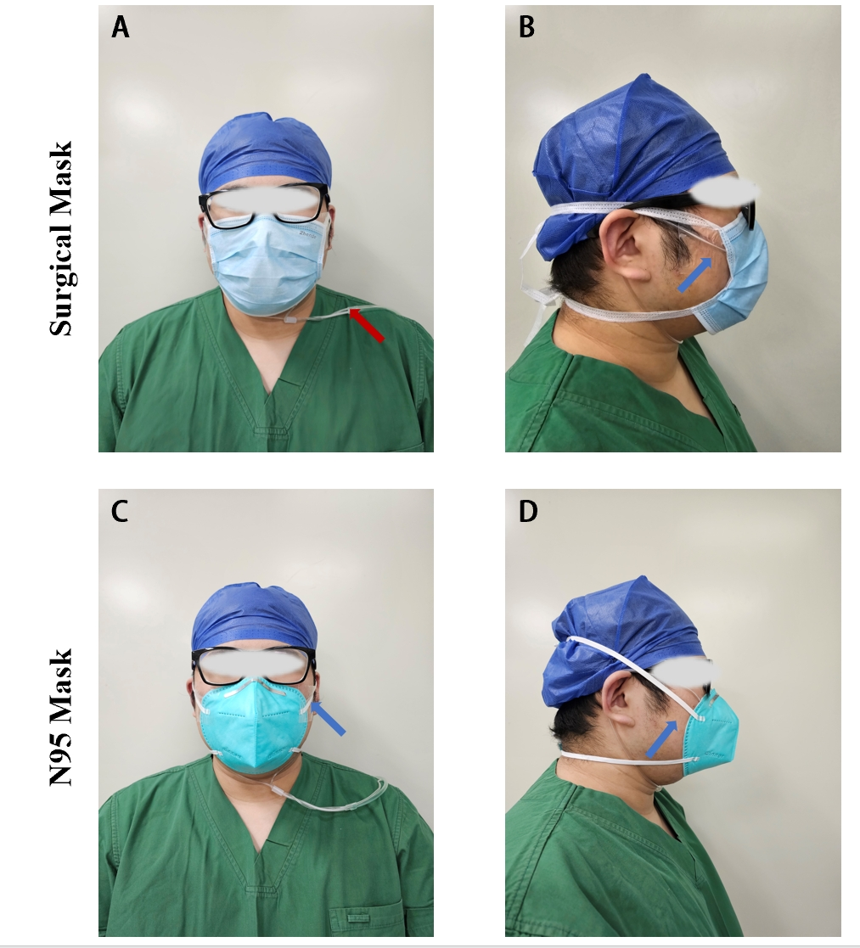
To ensure the airtightness of the mask, a sterile wound dressing was used to fix the sampling tube between the mask and skin.
The blue arrow represented sterile wound dressing; the red arrow represented the nasal sampling tube.
Outcomes |  | T0 | T1 | T2 | T3 | T4 | T5
PvCO₂ (mmHg) | SM | 47.1 (4.1) | NA | NA | NA | NA | 49.0 (3.8)
PvCO₂ (mmHg) | N95 | 47.1 (4.1) | NA | NA | NA | NA | 50.4 (4.0)
pH | SM | 7.353 (0.037) | NA | NA | NA | NA | 7.345 (0.030)
pH | N95 | 7.353 (0.037) | NA | NA | NA | NA | 7.337 (0.035)
PvO₂ (mmHg) | SM | 39.0 (3.9) | NA | NA | NA | NA | 37.7 (4.1)
PvO₂ (mmHg) | N95 | 39.0 (3.9) | NA | NA | NA | NA | 37.6 (4.0)
HCO₃⁻ (mmol/L) | SM | 25.2 (1.0) | NA | NA | NA | NA | 25.8 (0.7)
HCO₃⁻ (mmol/L) | N95 | 25.2 (1.0) | NA | NA | NA | NA | 26.0 (0.7)
PetCO₂ (mmHg) | SM | 37.3 (2.6) | 39.7 (2.8) | 40.3 (2.5) | 40.3 (2.6) | 40.5 (2.9) | 40.5 (2.6)
PetCO₂ (mmHg) | N95 | 37.4 (2.6) | 39.7 (2.8) | 40.5 (2.4) | 40.5 (2.8) | 40.5 (2.8) | 40.6 (2.9)
SpO₂ (%) | SM | 97.2 (1.0) | 96.9 (1.03) | 97.3 (1.5) | 97.1 (1.2) | 97.1 (1.3) | 96.9 (1.1)
SpO₂ (%) | N95 | 97.3 (1.0) | 96.9 (0.8) | 97.0 (1.4) | 97.0 (1.0) | 97.2 (1.3) | 97.3 (1.1)
RR (breaths/min) | SM | 16.9 (2.7) | 17.1 (2.7) | 17.1 (2.5) | 17.5 (3.0) | 17.8 (3.4) | 18.1 (3.1)
RR (breaths/min) | N95 | 17.0 (2.7) | 17.2 (2.7) | 17.3 (2.8) | 17.4 (2.7) | 18.0 (3.5) | 18.8 (2.7)
PR (beats/min) | SM | 83.4 (12.9) | 84.3 (12.7) | 83.1 (13.6) | 81.2 (10.9) | 81.6 (10.4) | 81.5 (10.9)
PR (beats/min) | N95 | 83.4 (12.7) | 84.7 (12.5) | 84.0 (13.2) | 81.3 (11.1) | 82.5 (10.6) | 81.8 (10.4)
SBP (mmHg) | SM | 119.0 (11.1) | 117.7 (11.1) | 119.7 (10.2) | 118.5 (11.6) | 119.3 (11.1) | 118.0 (11.3)
SBP (mmHg) | N95 | 118. 5 (11.1) | 117.4 (11.1) | 119.4 (11.2) | 120.1 (11.8) | 118.0 (11.9) | 118.3 (10.9)
DBP (mmHg) | SM | 77.0 (8.2) | 76.2 (8.4) | 77.4 (8.6) | 76.0 (8.5) | 76.6 (8.1) | 75.7 (8.4)
DBP (mmHg) | N95 | 75.5 (7.2) | 76.3 (7.1) | 75.2 (7.5) | 77.2 (8.3) | 76.6 (7.2) | 76.2 (7.6)
VAS of Dyspnea | SM | 0.0 (0.0-0.0) | 0.0 (0.0-0.0) | 0.0 (0.0-0.0) | 1.0 (0.0-1.0) | 1.0 (0.0-2.0) | 1.0 (1.0-3.0)
VAS of Dyspnea | N95 | 0.0 (0.0-0.0) | 0.0 (0.0-0.0) | 0.0 (0.0-0.8) | 1.0 (1.0-1.0) | 2.0 (1.0-3.0) | 3.0 (2.0-3.0)
VAS of Headache | SM | 0.0 (0.0-0.0) | 0.0 (0.0-0.0) | 0.0 (0.0-0.0) | 0.5 (0.0-1.0) | 1.0 (0.3-2.0) | 2.0 (1.0-3.0)
VAS of Headache | N95 | 0.0 (0.0-0.0) | 0.0 (0.0-0.0) | 0.0 (0.0-0.8) | 1.0 (1.0-2.0) | 2.0 (2.0-3.0) | 3.0 (2.0-4.0)
VAS of Palpitation | SM | 0.0 (0.0-0.0) | 0.0 (0.0-0.0) | 0.0 (0.0-0.0) | 0.0 (0.0-1.0) | 1.0 (0.0-2.0) | 1.0 (1.0-2.8)
VAS of Palpitation | N95 | 0.0 (0.0-0.0) | 0.0 (0.0-0.0) | 0.0 (0.0-0.8) | 1.0 (1.0-2.0) | 2.0 (1.0-3.0) | 3.0 (2.0-3.0)
eTable 1. The values of SM or N95 mask intervention for all outcome measures by time point.
Values are presented as the mean (SD) or median (IQR).
Abbreviations: SM, surgical mask; PvCO₂, venous carbon dioxide partial pressure (PvCO₂); HCO₃⁻, bicarbonate; PvO₂, venous oxygen pressure; PetCO₂, partial pressure of end-tidal carbon dioxide; SpO₂, peripheral blood oxygen saturation; RR, respiratory rate; PR, pulse rate; SBP, systolic blood pressure; DBP, diastolic blood pressure; VAS, visual analogue scale.

Variable | Treatment |  | Period |  | Carryover
Variable | T value | P value | T value | P value | T value | P value
PvCO₂ (mmHg) | 4.72 | <0.001 | 0.81 | 0.427 | 0.73 | 0.478
pH | -1.84 | 0.082 | -0.77 | 0.450 | -0.36 | 0.723
PvO₂ (mmHg) | -0.24 | 0.815 | -1.62 | 0.123 | 0.63 | 0.535
HCO₃⁻ (mmol/L) | 1.22 | 0.240 | -0.39 | 0.703 | 1.27 | 0.221
PetCO₂ (mmHg) | 0.38 | 0.702 | 0.49 | 0.625 | -0.87 | 0.397
SpO₂ (%) | -1.45 | 0.150 | -0.41 | 0.680 | 1.55 | 0.135
RR (breaths/min) | -0.47 | 0.637 | -0.5 | 0.619 | -1.07 | 0.296
PR (beats/min) | 0.48 | 0.631 | -0.29 | 0.778 | -1.61 | 0.123
SBP (mmHg) | -0.04 | 0.968 | 0.53 | 0.600 | 0.85 | 0.403
DBP (mmHg) | -0.50 | 0.620 | -0.64 | 0.522 | 0.58 | 0.563
eTable 2. Effect of treatment, period and carryover for the crossover study.

Abbreviations: PvCO₂, venous carbon dioxide partial pressure; HCO₃⁻, bicarbonate; PvO₂, venous oxygen pressure; PetCO₂, partial pressure of end-tidal carbon dioxide; SpO₂, peripheral blood oxygen saturation; RR, respiratory rate; PR, pulse rate; SBP, systolic blood pressure; DBP, diastolic blood pressure.
Effect of treatment, period and carryover were estimated using the linear mixed model.

eTable 3. Estimated mean change in physiological indices and VAS of subjective sensation between baseline and each time point.
Variable |  | Estimated change between baseline and each time point, mean (95% CI)
 |  | SM | N95 mask | N95 mask vs.SM | P value
PetCO₂ (mmHg) | T1 | 2.4(1.8,3.0) | 2.3(1.7,2.9) | -0.1(-0.4,0.3) | 0.667
PetCO₂ (mmHg) | T2 | 3.0(2.3,3.8) | 3.2(2.4,3.9) | 0.2(-0.2,0.5) | 0.390
PetCO₂ (mmHg) | T3 | 3.0(2.2,3.9) | 3.1(2.3,4.0) | 0.1(-0.2,0.4) | 0.566
PetCO₂ (mmHg) | T4 | 3.2(2.2,4.2) | 3.1(2.2,4.1) | -0.1(-0.4,0.3) | 0.667
PetCO₂ (mmHg) | T5 | 3.2(2.3,4.1) | 3.3(2.4,4.1) | 0.0(-0.3,0.4) | 0.886
SpO2 (%) | T1 | -0.3(0.7,0.1) | -0.4(-0.8,0.0) | -0.1(-0.5,0.3) | 0.714
SpO2 (%) | T2 | 0.1(-0.3,0.5) | -0.3(-0.7,0.1) | -0.4(-0.8,0) | 0.052
SpO2 (%) | T3 | -0.1(-0.5,0.3) | -0.3(-0.7,0.1) | -0.2(-0.6,0.2) | 0.329
SpO2 (%) | T4 | -0.1(-0.4,0.3) | -0.1(-0.5,0.3) | -0.1(-0.4,0.3) | 0.807
SpO2 (%) | T5 | -0.3(-0.7,0.1) | 0.0(-0.4,0.4) | 0.3(-0.1,0.7) | 0.180
RR (breaths/min) | T1 | 0.2(-0.4,0.8) | 0.1(-0.4,0.7) | -0.1(-0.6,0.4) | 0.774
RR (breaths/min) | T2 | 0.2(-0.5,0.9) | 0.3(-0.5,1) | 0.1(-0.4,0.6) | 0.774
RR (breaths/min) | T3 | 0.6(-0.4,1.5) | 0.3(-0.6,1.3) | -0.3(-0.8,0.3) | 0.339
RR (breaths/min) | T4 | 0.9(-0.1,1.9) | 1.0(-0.1,2.0) | 0.1(-0.4,0.6) | 0.774
RR (breaths/min) | T5 | 1.2(0.6,1.8) | 1.8(1.2,2.4) | 0.6(0.1,1.1) | 0.023
PR (beats/min) | T1 | 0.9(-2.0,3.9) | 1.3(-1.6,4.3) | 0.4(-2.0,2.8) | 0.746
PR (beats/min) | T2 | -0.3(-3.2,2.6) | 0.6(-2.3,3.5) | 0.9(-1.5,3.3) | 0.467
PR (beats/min) | T3 | -2.2(-5.1,0.8) | -2.1(-5.0,0.8) | 0.1(-2.3,2.5) | 0.952
PR (beats/min) | T4 | -1.8(-4.7,1.1) | -0.9(-3.8,2.1) | 0.9(-1.5,3.3) | 0.455
PR (beats/min) | T5 | -1.9(-4.8,1.1) | -1.6(-4.6,1.3) | 0.3(-2.2,2.7) | 0.840
SBP (mmHg) | T1 | -1.4(-4.7,2.0) | -1.1(-4.4,2.2) | 0.3(-3.7,4.2) | 0.902
SBP (mmHg) | T2 | 0.7(-2.6,4.0) | 0.9(-2.4,4.2) | 0.2(-3.8,4.2) | 0.922
SBP (mmHg) | T3 | -0.5(-3.8,2.8) | 1.7(-1.7,5.0) | 2.2(-1.8,6.1) | 0.291
SBP (mmHg) | T4 | 0.3(-3,3.6) | -0.5(-3.8,2.9) | -0.8(-4.7,3.2) | 0.712
SBP (mmHg) | T5 | -1.1(-4.4,2.3) | -0.2(-3.5,3.1) | 0.9(-3.1,4.8) | 0.676
DBP (mmHg) | T1 | -0.8(-4.7,3.1) | 0.8(-3.1,4.7) | 1.6(-2.9,6.1) | 0.490
DBP (mmHg) | T2 | 0.5(-3.4,4.3) | -0.4(-4.2,3.5) | -0.8(-5.3,3.7) | 0.730
DBP (mmHg) | T3 | -1.0(-4.9,2.9) | 1.7(-2.2,5.6) | 2.7(-1.8,7.2) | 0.244
DBP (mmHg) | T4 | -0.4(-4.3,3.5) | 1.1(-2.8,4.9) | 1.5(-3.1,6.0) | 0.531
DBP (mmHg) | T5 | -1.3(-5.2,2.6) | 0.7(-3.2,4.5) | 2(-2.6,6.5) | 0.400
VAS of Dyspnea | T1 | 0.1(-0.3,0.5) | 0.1(-0.3,0.5) | 0.0(-0.3,0.3) | 0.99
VAS of Dyspnea | T2 | 0.3(-0.1,0.6) | 0.3(-0.1,0.7) | 0.1(-0.3,0.4) | 0.756
VAS of Dyspnea | T3 | 0.8(0.4,1.1) | 1.3(0.9,1.7) | 0.6(0.2,0.9) | <0.001
VAS of Dyspnea | T4 | 1.0(0.6,1.4) | 2.0(1.6,2.3) | 1.0(0.6,1.3) | <0.001
VAS of Dyspnea | T5 | 1.8(1.4,2.1) | 2.9(2.5,3.2) | 1.1(0.8,1.4) | <0.001
VAS of Headache | T1 | 0.1(-0.3,0.4) | 0.1(-0.3,0.4) | 0.0(-0.3,0.3) | 0.99
VAS of Headache | T2 | 0.3(-0.1,0.6) | 0.3(0.0,0.6) | 0.1(-0.2,0.3) | 0.732
VAS of Headache | T3 | 0.7(0.3,1.0) | 1.3(1.0,1.6) | 0.7(0.4,0.9) | <0.001
VAS of Headache | T4 | 1.1(0.8,1.4) | 2.3(1.9,2.6) | 1.2(0.9,1.4) | <0.001
VAS of Headache | T5 | 1.9(1.6,2.2) | 2.9(2.6,3.2) | 1.0(0.7,1.3) | <0.001
VAS for Palpitation | T1 | 0.1(-0.2,0.3) | 0.1(-0.2,0.3) | 0.0(-0.3,0.3) | 0.99
VAS for Palpitation | T2 | 0.2(-0.1,0.4) | 0.3(0.0,0.6) | 0.2(-0.1,0.4) | 0.289
VAS for Palpitation | T3 | 0.5(0.2,0.7) | 1.3(1.0,1.5) | 0.8(0.5,1.1) | <0.001
VAS for Palpitation | T4 | 1.0(0.7,1.2) | 1.7(1.4,1.9) | 0.7(0.4,1.0) | <0.001
VAS for Palpitation | T5 | 1.4(1.1,1.6) | 2.4(2.1,2.6) | 1.0(0.7,1.3) | <0.001
Abbreviations: PetCO₂, partial pressure of end-tidal carbon dioxide; SpO₂, peripheral blood oxygen saturation; RR, respiratory rate; PR, pulse rate; SBP, systolic blood pressure; DBP, diastolic blood pressure; VAS, visual analogue scale.
The mean differences between SM group and N95 mask group were estimated using the linear mixed model.

