Table 1. Optimization of reaction conditions.ª
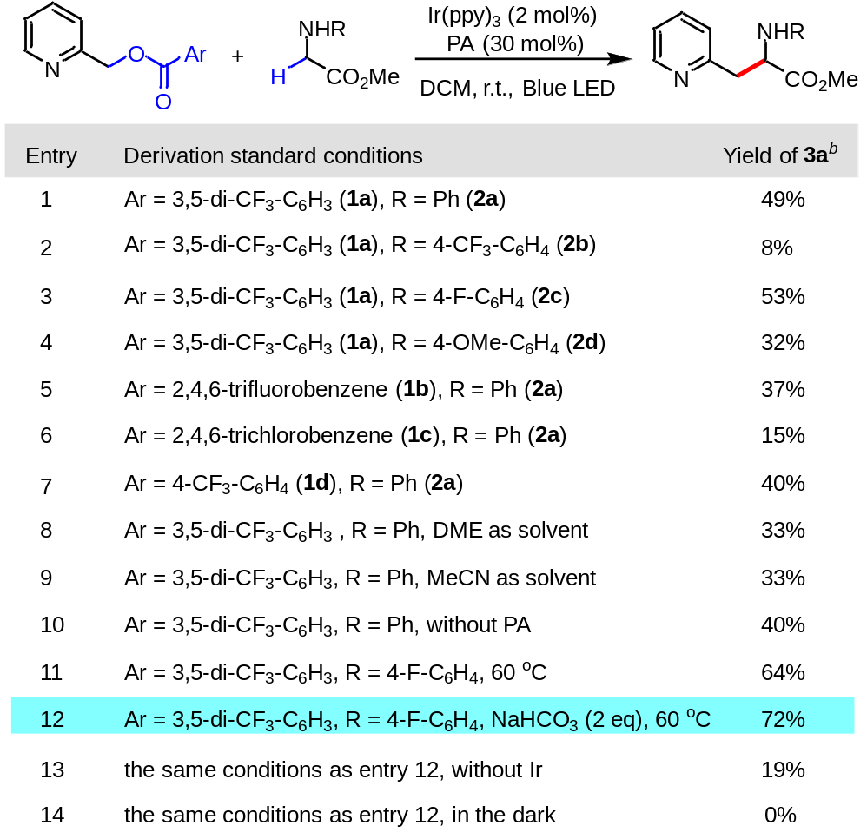
ªPerformed with alcohol 1a (0.2 mmol, 2.0 equiv), amine 2a (0.1 mmol, 1.0 equiv), in 1.0 mL of CH₂Cl₂, 16 h. ^{b}Yields were determined by isolation. See Supporting Information for experimental details.
Table 2. Substrate investigation for the heterobenzylic alcohols.ª
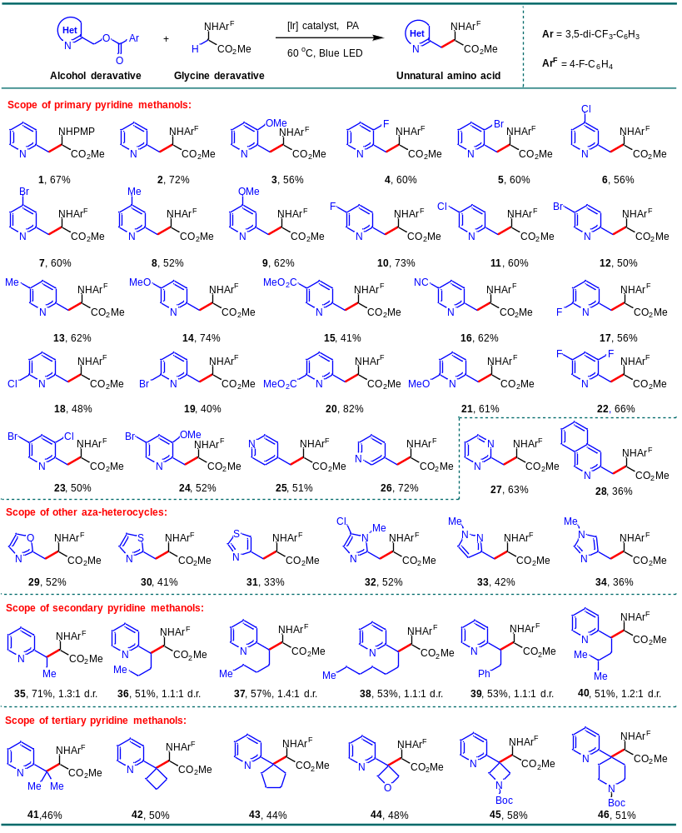
ªAll of the yields were isolated yields (for details see Supplementary Information). The diastereomeric ratio was determined by isolation yield.
Table 3. Substrate investigation for the amines and synthetic applications.
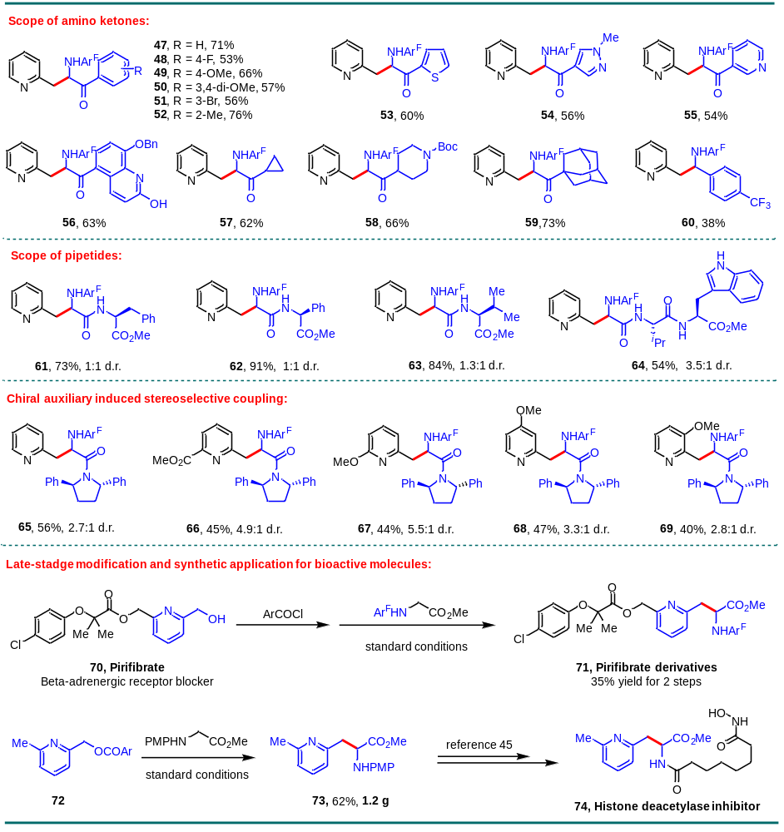
ªAll of the yields were isolated yields (for details see Supplementary Information). The diastereomeric ratio was determined by isolation yield.

