Supporting Information
Preparation and Characterization of Biodegradable Polyester/Natural Protein Electrospun Nanofiber with Wound Healing Activity

Chin-San Wu^{1,}*, Shan-Shue Wang¹ , Dung-Yi Wu²

¹Department of Applied Cosmetology, Taiwan Steel University of Science and Technology, Kaohsiung City, Taiwan 82101, Republic of China
²Department of Materials Science and Engineering, Johns Hopkins University, Baltimore, MD 21218, USA

* Corresponding author. Tel: +886-7-6077685; Fax: +886-7-6077788;
E-mail address: cws1222@tsust.edu.tw,t50008@ tsust.edu.tw (C.-S. Wu)

Water absorption percentage
The water absorption percentage (W₁%) was then calculated using the following formula, which provided the weight gain as a percent:
$W_{1}\%= \frac{(W_{b}-W_{a})}{W_{a}}×100\%$ (1)
W_{a}: The weight of the dry samples was measured and recorded.
W_{b}: After withdrawing a sample from the water, surface moisture was removed using clean paper, and the film mass was measured and recorded.

Table S1. Formulation composites support designations and compositions

Sample code | Component
Sample code | PCL  (wt%) | PCL-g-MA  (phr) | LP  (wt%)
PCL | 100 | － | －
PCL/LP 5wt% | 95 | － | 5
PCL/ LP 10wt% | 90 | － | 10
PCL/ LP 15wt% | 85 | － | 15
PCL/ LP 20wt% | 80 | － | 20
MPCL | 100 | 10 | －
MPCL/ LP 5wt% | 95 | 10 | 5
MPCL/ LP 10wt% | 90 | 10 | 10
MPCL/ LP 15wt% | 85 | 10 | 15
MPCL/ LP 20wt% | 80 | 10 | 20
PCL: polycaprolactone; MPBSL: modified PCL [(added compatibility maleic anhydride (MA) grafted PCL (PCL-g-MA)]; LP : larvae protein powder.

Table S2. Effects of larvae protein powder (LP) content on the tensile properties of polycaprolactone (PCL)/LP and modified PCL (MPCL)/LP nanofibers.
LP | PCL/LP |  |  | MPCL/LP
(wt%) | E(MPa) | δ (MPa) | ε(%) | E (MPa) | δ (MPa) | ε(%)
0 | 37.6±5.1 | 3.35±0.13 | 183.6±5.6 | 36.8±5.2 | 3.26±0.16 | 182.8±5.7
5 | 32.3±5.8 | 2.81±0.15 | 150.5±5.8 | 40.3±5.7 | 3.56±0.20 | 151.3±5.9
10 | 27.7±6.0 | 2.39±0.17 | 120.8±6.0 | 48.8±5.8 | 3.86±0.23 | 131.2±6.2
15 | 23.6±6.1 | 2.13±0.17 | 111.3±6.2 | 45.3±5.9 | 3.78±0.25 | 128.5±6.3
20 | 20.3±6.2 | 1.61±0.18 | 109.5±6.5 | 43.1±6.0 | 3.72±0.28 | 126.3±6.5
δ: tensile strength, ε: elongation at failure, E: Young's modulus.

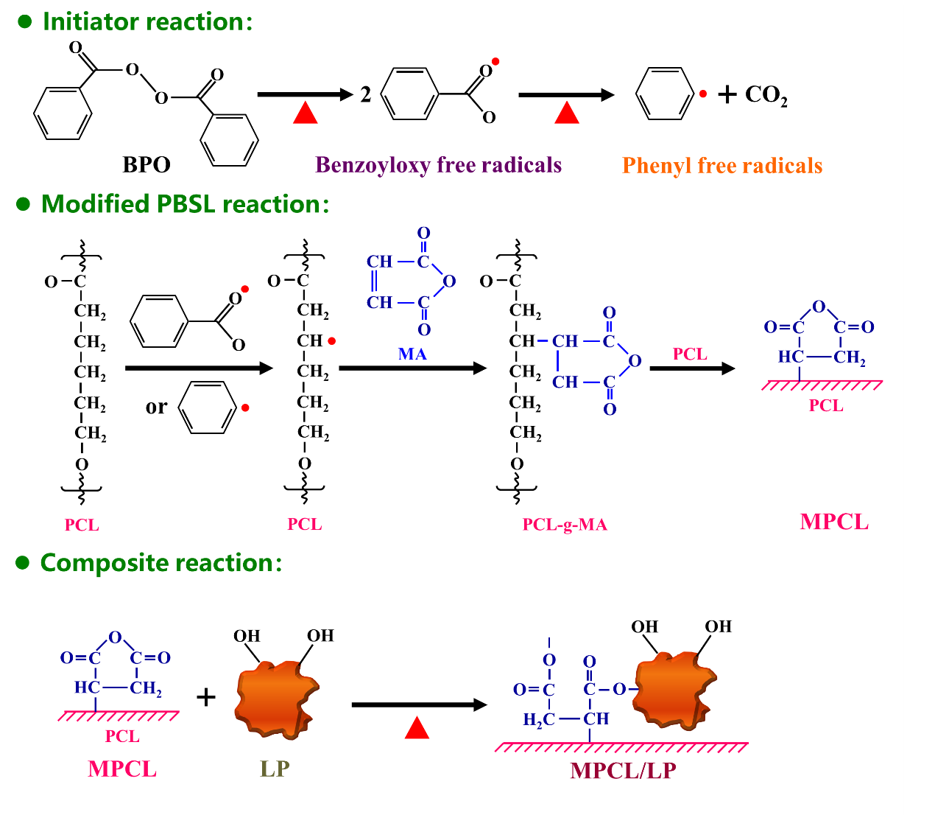

Scheme S1 Chemical reaction of MPCL and preparation of the MPCL/LP nanofibers,

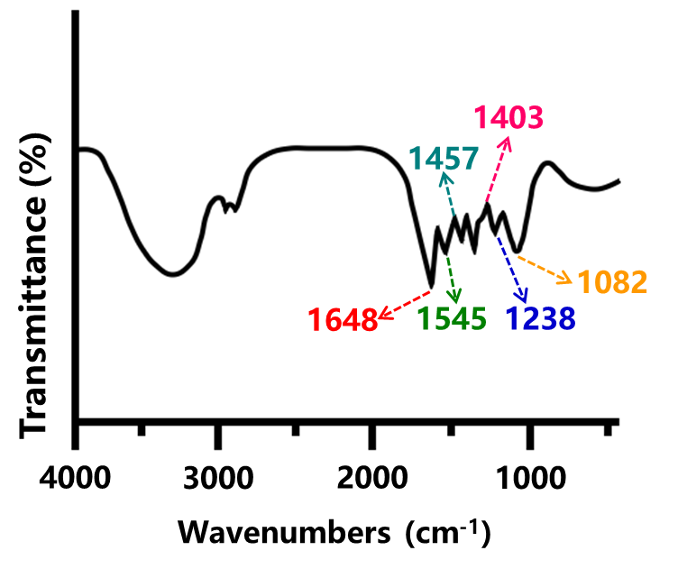

Figure S1. Fourier transform-infrared spectra of LP.

