Supplementary Material:

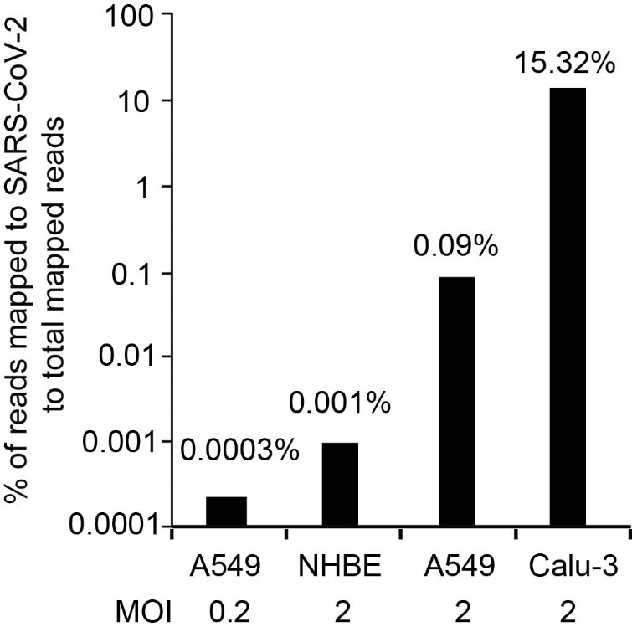
Fig. S1. Related to Fig. 1, viral dose and cell type influences SARS-CoV-2 replication. Bar graph indicates percentage of reads mapped to SARS-CoV-2 genome to total mapped reads of human cells infected with SARS-CoV-2.

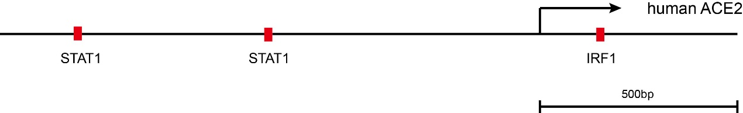
Fig. S2. Related to Fig. 1, potential binding sites of IRF1 and STAT1 at human ACE2. Scheme displays locations of potential genomic binding sites of IRF1 and STAT1 near transcription start site of human ACE2 gene.

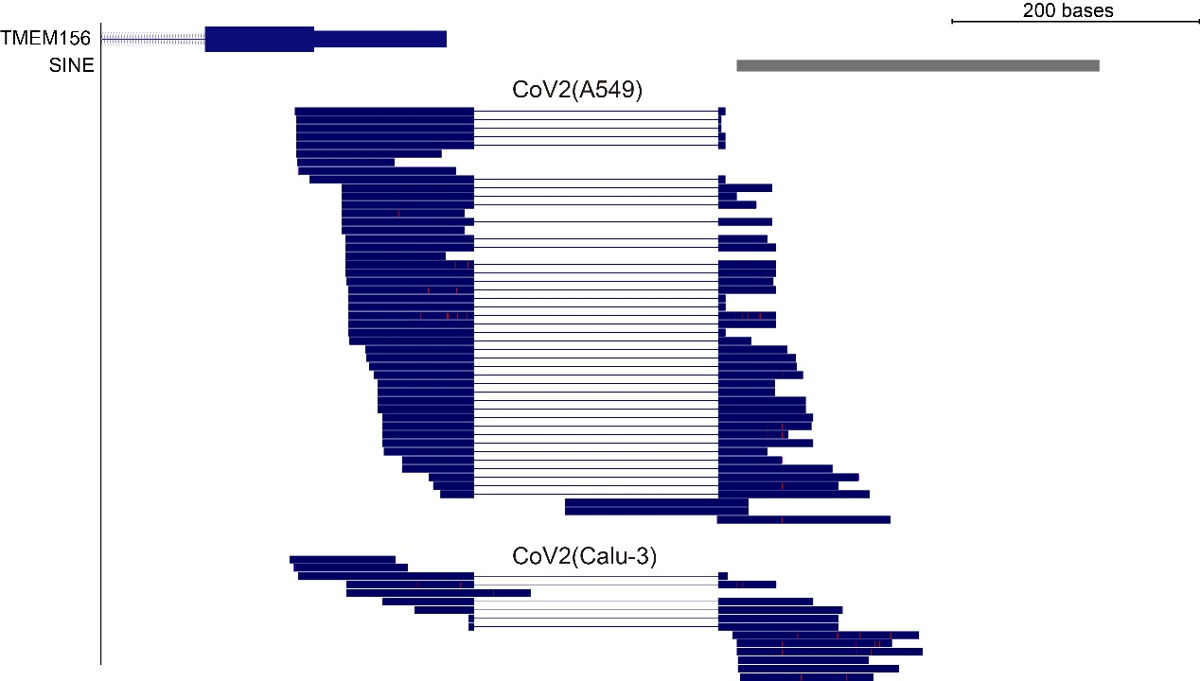
Fig. S3. Related to Fig. 5, representative alignment near SINE-UTR junction at TMEM156 locus in SARS-CoV-2 infected A549 or Calu-3 cells.

